SPECTRAL CHARACTERISTICS OF GROUND MOTION AND DYNAMIC ROBUSTNESS OF ISOLATED STRUCTURES

DOI 10.37153/2686-7974-2019-16-248-256

Yongfeng DU, Chen SHI, Yalong WANG

ABSTRACT

Spectral characteristics, one of the three parameters measuring effect of ground motions, has great significance on structural damage and progressive collapse. At present, the description of spectral characteristics is not unique. The study on the effect of spectral characteristics on structural response, damage and progressive collapse is not sufficient.
According to the mechanical behavior of base-isolated structures subjected to seismic action, the calculation formula and evaluation index of dynamic robustness of base-isolated structure were proposed in order to analyze the structural dynamic robustness under earthquake. A base-isolated structure was analyzed using Perform-3D. The effect of spectral characteristics and peak acceleration of ground motion on dynamic robustness of base-isolated structures was investigated. The results demonstrate that the evaluation index of dynamic robustness could be used to quantitatively analyze the ability of base-isolated structures to resist lateral collapse under earthquake action. A random robustness index was proposed based on the reliability theory considering double randomness of both structure and seismic signals. When the spectral characteristics are close to the natural frequency of the structure, the dynamic robustness of the structure is smaller. While if one considers either randomness of structures or randomness of seismic signals only, the progressive collapse resistant ability of the isolated structure may be overestimated.

Keywords: base-isolated structure; spectral characteristics; progressive collapse; horizontal increment collapse; dynamic robustness

1. INTRODUCTION

Structural robustness refers to the ability of a structural system to have a disproportionate damage to the overall failure without causing local damage to the structure in the event of an accident (LYU, 2011). Progressive collapse of structures is a typical disproportionate failure, so the problem of robustness is directly related to progressive collapse. Preliminary investigation of the progressive collapse problem of isolated structures shows that , when its beam and column of the super structural failure, the progressive collapse dynamic response of isolated structures is almost the save with the fixed-base structures under vertical load (DU, 2018). With the failure of rubber bearings, the structure's resistance to progressive collapse is weak, especially the horizontal earthquake is included, the collapse resistance of the structure will be lower. Therefore, it is necessary to study the anti-progressive collapse robustness of the isolated structure subjected to the vertical imbalance and multi-directional coupled dynamic excitation.
Randomness of ground motions often has a large effect on the analysis results of structural seismic response, and especially reflect the differences of each frequency harmonic motion modes of ground motion, which is directly related to damage degree of structures. Kitamura(2008), Pan (2013), Du (2015), et al, have studied on the effects resulting from ground motion spectral characteristics and peak values on the damage of isolated structures. But there are still few studies on the combination of spectral characteristics and the collapse mechanism of isolated structures. The displacement of isolated structure varies with time under earthquake action as well as natural frequency. It can be seen that the spectral characteristics of ground motions affect the seismic response of isolated structures which is very complex. Especially when some bearings begin to failure and the structure enters collapse limit state, this effect will be more complex. Therefore, the study on the capacity of anti-collapse affected by spectral characteristics of ground motions of isolated structures is very necessary.
Besides the randomness of ground motion characteristics, which has a great influence on the structure, there are also many uncertainty factors in the structure itself. and LYU (2010), SHI(2011)and Yu (2012) shows that structural randomness will lead logarithmic standard deviation for seismic collapse resistance of structure to increase. It is particularly noteworthy that when the structure approaches to collapse, there will be an amplification coupling effect between the randomness of ground motion and the randomness of structure, which will have a great influence on the robustness of progressive collapse of structures. Therefore, the study on the robustness of progressive collapse of structures considering dual randomness of structures and ground motion is particularly important.
In this paper, the average frequency index is used to describe the spectral characteristics of ground motion. And the dynamic robustness index considering the most disadvantageous performance of bearing is used to study the influence of dynamic robustness of isolated structures affected by ground motion spectral characteristics. Besides, based on the secondary fourth moment reliability theory proposing randomness robustness index to analyze the influence affected by randomness on the robustness of isolated structures.

2. THE SPECTRUM CHARACTERISTIC DESCRIPTION

At present, there is no uniform method for the spectral characteristics of ground motion. According to the method of defining the mean period of ground motion in reference (Rathje, 1998), this paper puts forward that the characteristic frequency parameter ‘average frequency’ of the whole frequency spectrum of ground motion is used to express the frequency spectrum characteristic of ground motion. The formula for calculating the average frequency is as shown in Equation 1.

$f^{*}=\frac{\sum{C_{i}^{2}}}{\sum{{C_{i}^{2}}/{f_{i}}}}, 0.25Hz≤f^{*}≤20Hz$ (1)

In the formula, f_{i} is the discrete frequency point between 0.25Hz~20Hz and C_{i} is the discrete Fourier amplitude corresponding to the frequency point f_{i}.

3. DYNAMIC ROBUSTNESS INDEX OF ISOLATED STRUCTURE

3.1 Dynamic robustness index based on pedestal performance

Under horizontal earthquake, when the shear strain of the isolated bearing increases, the effective area of the core area is decreased, and the ultimate vertical bearing capacity decreases due to the P-Δ effect. Considering the shear deformation capacity and shear-compression bearing capacity of each isolation bearing(WU, 2014), the dynamic robustness calculation formula considering the most unfavorable performance of the isolation bearing is presented as follows:

$I_{i}={\left(\frac{γ_{iu}-γ_{i}}{γ_{iu}}\right)}^{2}\frac{σ_{iu}}{σ_{i}}, i=1,2,…n$ (2)

In the formula, I_{i} is the dynamic robustness coefficient of the i isolation support; $γ_{i}$ is the shear strain of the i isolation support, which is the ratio of the horizontal displacement of the upper and lower plate of the bearing to the total thickness of the rubber layer; $γ_{iu}$ is the ultimate shear strain of the i isolation support. When $γ_{i}>γ_{iu}$, take $γ_{i}=γ_{iu}$; $σ_{i}$ is the compressive stress of the i isolation support; $σ_{iu}$ is the ultimate compressive stress of the i isolation support, the ultimate compressive stress is 6 times of the design compressive stress, and n is the total number of the isolated bearings.
Taking the i isolation layer as the research object, according to the most unfavorable failure situation of the isolation support, the dynamic robustness calculation formula of the base isolated structure is presented as follows:

$R=min\left\{I_{i}\right\}, i=1,2,…n$ (3)

In the formula, R is the dynamic robustness index of base-isolated structure, and Ii is the dynamic robustness coefficient of the isolated bearing.
When R = 0, the dynamic robustness of the structure is insufficient, the shear strain of the isolated bearing exceeds the ultimate shear strain, and when R > 0, the dynamic robustness of the structure increases with the increase of R.

3.2 Dynamic robustness index considering structure-earthquake motion double random

Regarding the maximum vertical load on isolated structures as the integral vertical ultimate bearing capacity of structure, describing maximum vertical load of structure by using load factor, so the limit state equation of intact structure and damaged structure under the action of vertical load are (Li Yungui, 1992):

$Z_{U}=g(α_{U})=α_{U}(X)(D+L)-D-L$ (4)

$Z_{R}=g(α_{R})=α_{R}(X)(D+0.25L)-D-L$ (5)

Among them, $α_{U}$ 、$α_{R}$ are the ultimate load coefficients of intact structure and damaged structure respectively, D is dead load, L is live load.
Using Taylor series expansion method can be approximately calculated first four moments of intact structural performance function $μ_{Z_{U}}$、$μ_{Z_{U}2}$ 、$μ_{Z_{U}3}$ and $μ_{Z_{U}4}$.
Standardizing Z_{U} to $Y_{U}=\frac{Z_{U}-μ_{Z_{U}}}{{\text{σ}}_{Z_{U}}}$, the maximum entropy probability density function is shown in equation:

$\int_{-∞}^{+∞}{y_{u}^{i}}\text{exp}\left(-\right)d_{y}={\text{ρ}}_{ui}$ (6)

After solving a_{j}, the failure probability of intact structure can be calculated as follows:

$P_{fu}=P(Z_{u}≤0)=P\left(Y≤-\frac{μ_{Z_{u}}}{{\text{σ}}_{Z_{u}}}\right)=\int_{-∞}^{-\frac{μ_{Z_{u}}}{{\text{σ}}_{Z_{u}}}}{exp\left(-\right)}d_{y}$ (7)

The reliability of the intact structure is obtained as shown in equation (8):

$β_{u}=-Ф^{-1}(P_{fu})$ (8)

Similarly, the reliability of damaged structures is calculated as shown in equation (9):

$β_{r}=-Ф^{-1}(P_{fr})$ (9)

After obtaining the reliability index of intact and damaged structures, using reliability index to calculate robustness coefficient of structures, as shown in equation (10) (Frangopol, 1987):

$I_{β}=\frac{β_{u}}{β_{u}-β_{r}}$ (10)

The collapse limit of the structure is 1, when the value is less than 1, it indicates that the structure occurs the progressive collapse.

3.3 Dynamic robustness analysis based on bearing performance

3.3.1 Calculation example model

Taking an engineering example as the background, the total height of the structure is 19.8m, and the height of each layer is 3.3m. Site categories for Ⅱ, construction category of b class. The seismic fortification intensity is 8 degrees and the basic seismic acceleration is 0.2g. The design seismic group is the second group. The concrete strength grade is C30, the longitudinal reinforcement is HRB400, the stirrup is HPB300, the beam section size is 300mm 500mm, and the column section size is 600mm 600mm. The thickness of the plate is 150mm, the constant load of the plate surface is 5kN/m2 (including the dead weight of the floor), and the live load is 2kn /m2. LRB500 is adopted for the isolation bearing, and the damping ratio of the isolation bearing is 0.275.

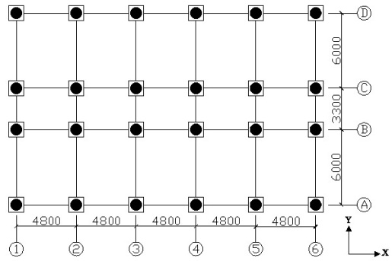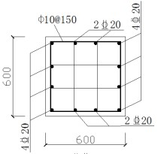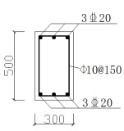

Frame column Frame column
(a) Layout plan (b)Beam and column reinforcement diagram

Figure 1. Structure infographic

3.3.2 Robustness analysis

The seismic acceleration peak value is adjusted to 0.1g, 0.2g, 0.4g and 0.6g, respectively. According to formula (2)-(3), the dynamic robustness indexes of the structure under different spectral characteristics and seismic actions with different peak accelerations are calculated as shown in table 1 and figure 2.

Table 1. Dynamic robustness

Spectral characteristics |  | PGA(g)
 | 0.1g | 0.2g | 0.4g | 0.6g
0.775 | 4.262 | 1.238 | 0 | 0
0.962 | 3.806 | 1.307 | 0 | 0
1.031 | 4.745 | 3.046 | 0.618 | 0
1.042 | 4.519 | 2.700 | 0 | 0
1.111 | 4.707 | 3.263 | 0.038 | 0
1.220 | 5.213 | 2.013 | 0 | 0
1.299 | 4.372 | 3.010 | 0.650 | 0
1.299 | 4.822 | 3.565 | 2.667 | 0
1.333 | 4.860 | 4.084 | 2.407 | 0
1.370 | 4.482 | 3.413 | 1.378 | 0
1.493 | 4.899 | 2.905 | 0.271 | 0
1.695 | 4.408 | 2.940 | 0.008 | 0
1.754 | 5.620 | 4.507 | 1.984 | 0
1.887 | 5.055 | 4.043 | 0.807 | 0
1.923 | 5.497 | 4.167 | 1.984 | 0
2.128 | 5.253 | 3.721 | 3.118 | 0
2.222 | 5.620 | 5.180 | 4.002 | 2.100
2.439 | 5.415 | 4.638 | 2.282 | 0
2.564 | 5.538 | 4.550 | 3.527 | 1.593
2.703 | 5.620 | 5.273 | 4.125 | 1.090
2.778 | 5.662 | 5.134 | 4.594 | 2.600

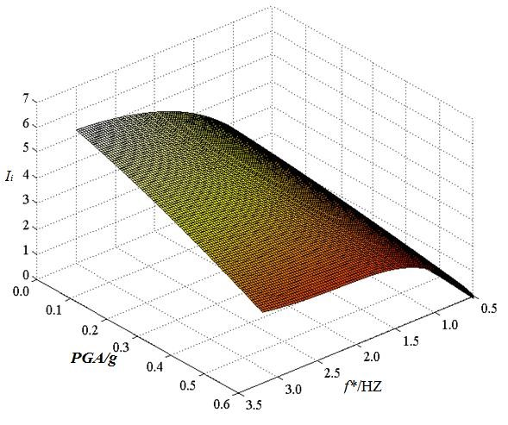
Figure 2. Influence of ground motion characteristics on dynamic robustness index

It can be seen from table 1, when the peak acceleration of the earthquake is 0.1g, 0.2g, 0.4g and 0.6g respectively, the dynamic robustness index gradually increases with the increase of the spectral characteristics of the ground motion. This is because when the local vibration frequency spectrum is small, it is closer to the natural vibration frequency of the base isolation structure, which leads to the occurrence of quasi-resonance effect and the increase in the deformation of the isolation layer, resulting in a small index of dynamic robustness. When the local vibration spectrum is large, the quasi-resonance effect cannot occur with the base isolation structure, so the dynamic robustness index is large.
It can be seen from figure 2 that the seismic spectrum characteristics and peak acceleration have a great influence on the dynamic robustness of the base-isolated structure. With the increase of the peak acceleration, the robustness index decreases gradually, which is mainly because the larger peak acceleration will cause greater deformation of the isolation bearing, thus leading to the decrease of robustness. With the increase of the spectral characteristics, the robustness index increases gradually, which is mainly because the small spectral characteristics are closer to the natural vibration frequency of the base isolation structure, and thus the quasi-resonance effect occurs. The response of the isolation bearing is amplified, leading to the reduction of robustness.

3.4 Robustness Analysis

3.4.1 Example Model

Taking an engineering example as the background. The seismic fortification category of this structure is Class B, seismic fortification intensity is 8 degrees (0.2g), seismic grouping for the third group, Site categories for Ⅱ. The seismic isolation bearing adopts LRB600: effective diameter 600mm, vertical stiffness 2312kN/mm, horizontal stiffness 1641kN/m, equivalent damping ratio 0.15. The beam and column longitudinal ribs are all HRB400, and the concrete strength grade is C30. The structure has 7 layers, and each layer has a height of 3.3 m. The plan view and section reinforcement diagram are shown in Figure 3.

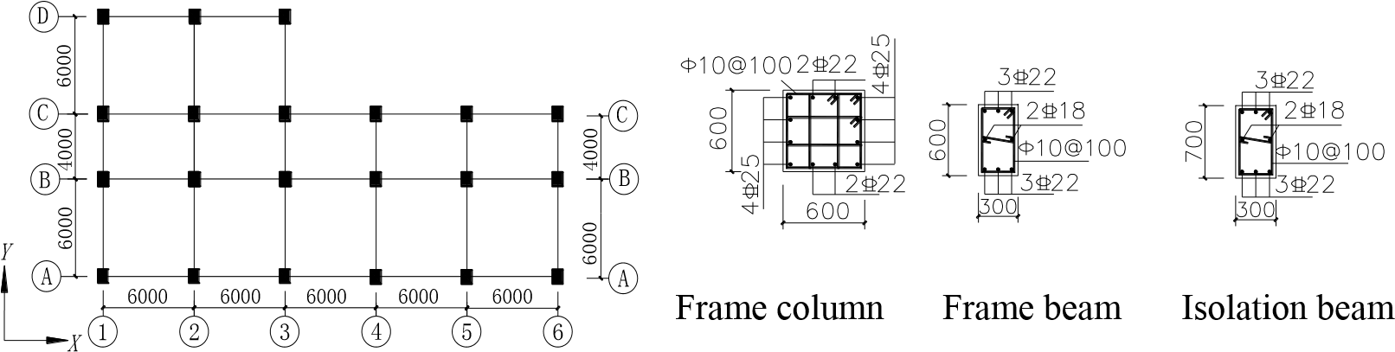

(a) Layout plan (b) Beam and column reinforcement diagram

Figure 3. Structural plane and Reinforcement details

The probability model is used to describe the randomness of the upper structural parameters, as shown in Table 2. Due to the current description of the randomness of the probability density function for each parameter of the isolation bearing, the convexity model is used to describe the randomness of the isolation bearing. The basic random variables are shown in Table 3.

Table 2. Basic random variables of the structure

Parameter Type | Random  Variables | Average | Coefficient of  variation | Distribution type
Load | Constant load Live load | 26.5kN/m³  0.98 kN/m³ | 0.10 0.45 | Normality Gamma
C30 | Unconstrained area | 26.1 kN/m³ | 0.14 | Lognormal
 | constrained area | 33.6 kN/m³ | 0.21 | Lognormal
HRB400 | tensile strength | 451 kN/m³ | 0.07 | Lognormal

Table 3. Basic random variables of the bearing

Bearing type | Random Variables | Average | Deviation | Standardized variable | Convex model
LRB600 | Yield strength | 90.4kN | 20% | M1 | M1+ M2≤1
 | Pre-yield stiffness | 9262kN/m | 20% | M2
 | Post-yield stiffness | 926kN/m | 20% | M2

The sample space can be formed after the random variables of each parameter are obtained: 1) According to the structure and the basic parameter distribution type of the support, 1000 samples are generated for each parameter, and a total of 8*1000 samples are formed. Using the Latin Super cube principle, 20 times were extracted to form a total of 20 structural samples. 2) The extracted seismic wave randomly corresponds to the structure sample one by one, forming 20 structural-ground vibration samples.

3.4.2 Robustness Analysis

The structural stochastic robustness index is calculated using equations (4)-(10) and is listed in Table 4. The structural robustness coefficient and the collapse criticality are collectively plotted in Figure 4.The collapse limit of the structure is 1, and when the value is less than 1, it indicates that the structure collapses.(1-1 indicates that only the structure is considered to be random and the seismic action is not considered;1-2 means that only structural randomness is considered and seismic action is considered;2 means that only ground motion randomness is considered; 3 means structure-ground motion double random).

Table 4. Rand robustness index
0
1
2
3
I
β
The critical value
Working condition | βu | β_{r} | I_{β}
1-1 | 18.140 | 10.209 | 2.287
1-2 | 9.940 | 5.470 | 2.223
2 | 24.255 | 13.336 | 2.222
3 | 9.01 | 4.73 | 2.105
1-1 1-2 2 3

Figure 4. Robustness comparison of different
randomness

From Figure 4, it can be seen intuitively that in this paper, when the ground vibration is 0.4g, this three kinds of working conditions, considering random structure, considering random seismic, considering double randomness, are higher than the collapse criticality, there is no vertical progressive collapse, and the structural robustness is reduced after considering double random, The robustness coefficient of structural resistance to progressive collapse is lower, which indicates that the structure is more prone to vertical progressive collapse.

4. EXAMPLE ANALYSIS

4.1 Selection of ground motion

The ground motion records were randomly selected, and the average frequency of the ground motion was calculated by using formula (1). The ground motion was divided into groups according to the average frequency. The first group (GM1) was the ground motion with serial number from 1 to 10, and the frequency spectrum was 0.775Hz~1.235Hz. In the second group (GM2), the ground motions with serial Numbers from 11 to 20 were taken, and the spectral characteristics were 1.299Hz~1.887Hz. In the third group (GM3), the ground motions with serial Numbers of 21~30 were taken, and the spectral characteristics were 2.128Hz~2.778Hz. Due to limited space, some seismicity records are listed as shown in table 5.

Table 5. Information of partial earthquake wave

Ground motion group | Serial  number | Earthquake wave | years | Magnitude | Spectral characteristics  （Hz）
GM1 | 1  2 | Kocaeli Turkey  Manjil, Iran | 1999  1990 | 7.5  7.4 | 0.775  0.935
 | 10 | Taiwan SMART1(45) | 1986 | 7.3 | 1.235
GM2 | 11  15 | Coalinga-01 Cape Mendocino | 1983  1992 | 6.4  7.0 | 1.299  1.493
 | 20 | Chalfant Valley-02 | 1986 | 6.2 | 1.923
GM3 | 21  26 | Norcia, Italy Northwest China-04 | 1979  1997 | 5.9  5.8 | 2.128  2.564
 | 30 | Borah Peak, ID-01 | 1983 | 6.9 | 2.778

5. CONCLUSION

- The dynamic robustness index based on bearing performance and the double random robustness index, both can effectively evaluate the anti-collapse robustness of the isolated structure.
- Peak acceleration and spectrum characteristics of earthquake motion have great influence on the dynamic robustness of base-isolated structures. The robustness coefficient decreases with the increase of peak acceleration; the robustness coefficient increases with the increase of spectral characteristics.
- Structural and seismic randomness have great influence on the robustness of isolated structures to progressive collapse, especially when considering double random, there is a coupling amplification effect; when analyzing the robustness of continuous collapse of isolated structures under earthquake action. Therefore, the influence of randomness of structure and ground motion should be considered simultaneously when analyzing the robustness of continuous collapse of isolated structures under seismic action.

6. ACKNOWLEDGEMENT

This research is financially supported in part by the Natural Science Foundation of China under Project No. 51778276 and 51578274, and in part by the Key R&D Plan of Gansu province under Project No. 18YF1FA067. This support is gratefully acknowledged.

7. REFERENCES

LYU Dagang, SONG Pengyan, CUI Shuangshuang. (2011) Structural robustness and its assessment indicators. Journal of Building Structures, 32(11):44-54.
DU Yongfeng，DUAN Haocai，XU Tianni. (2018) Vertical progressive collapse mechanism and influencing factors of base-isolated structures. Journal of vibration and shock, 37(05):257-264
HUANG Xiaoning. (2017) Torsional-resistance design and study on seismic collapse reliability based on double random of frame-shear-wall isolated structure. Lanzhou: Lanzhou university of technology, 87-107(In Chinese)
BAO Chao. (2015) Research on progressive collapse mechanism and resistance performance of vertically irregular base-isolated structure. Lanzhou:Lanzhou university of technology, 123-135(In Chinese)
ZHANG Shang-rong，TAN Ping, DU Yongfeng. (2014) Seismic fragility analysis of Inter- story isolation structures based on response surface method. Journal of vibration and shock, 33(15)：42-48
Kitamura H，Takenaka Y，Tamura K．(2008) Seismic performance of seismic-isolated building for long-period ground motion and limited performance of seismic isolator． ASCE Conf．Proc． 315:1-12．
DU Dongsheng，WANG Shu-guang，LIU Wei-qing. (2015) Influences of spectral characteristics of earthquake ground motion on seismic responses and damages of base isolated structures. Journal of vibration and shock, 34(20): 203-208+213.
PAN Yi, JI Chenlong, LU Liheng. (2013) Effects of ground motion characteristics on bilateral seismic responses of base-isolated structures. China Civil Engineering Journal, 46 (05) :50-55.
YU Xiaohui, LYU Dagang. (2012) Seismic collapse fragility analysis considering structural uncertainties[J]. Journal of Building Structures, 2012,33(10):8-14.
LYU Da-gang, YU Xiao-hui, WANG Guang-yuan.(2010)Single record random incremental dynamic analysis. Engineering mechanics,27(S1):53-58.
SHI wei, YE Lieping, LU Xinzheng. (2011) Study on the collapse-resistant capacity of RC-frames with different seismic fortification levels. Engineering mechanics . 28(03):41-48+68.
Rathje E M， Abrahamson N A， Bray J D．(1998) Simplified frequency content estimates of earthquake ground motions J． Geotech． Eng． Div．，Am． Soc． Civ． Eng． 124 ( 2) : 150-159．
WU Zhongtie，DU Yongfeng，ZHU Qiankun. (2014) Analysis of horizontal stiffness of laminated rubber bearingsfor different boundary conditions. Journal of Building Structures, 35(4):208-214.
Li Yungui, Zhao Guofan. (1992) Reliability analysis of structures based on maximum entropy theory. Journal of Dalian University of Technology, (04):455-459.
Frangopol D M, Curley J P. (1987) Effects of damage and redundancy on structural reliability. Journal of Structural Engineering, ASCE, 113(7): 1533-1549.

Yongfeng DU, Professor, Institute of Earthquake Protection and Disaster Mitigation, Lanzhou University of Technology, Lanzhou, China, dooyf@lut.cn
Chen SHI, PhD Student, Institute of Earthquake Protection and Disaster Mitigation, Lanzhou University of Technology, Lanzhou, China, tthhblue@163.com
Yalong WANG, Master Student, Institute of Earthquake Protection and Disaster Mitigation, Lanzhou University of Technology, Lanzhou, China, lutylwang@sohu.com

