Seismic Performance of Steel Moment-Resisting Frame Retrofitted with Linear and Nonlinear Viscous Dampers

DOI 10.37153/2686-7974-2019-16-141-152

Bryan CHALARCA, André FILIATRAULT, Daniele PERRONE

ABSTRACT

The implementation of linear and nonlinear viscous dampers improves the seismic performance of a structure. The velocity coefficient which governs the hysteretic behavior of nonlinear viscous dampers modifies the seismic response and consequently the seismic performance of the structure. A six-story steel moment-resisting frame building was selected as an archetype structure to investigate the effect of nonlinear viscous dampers on its seismic performance. This building, incorporating brittle beam-column connections common in the pre-Northridge earthquake designs, was retrofitted with different configurations of viscous dampers to improve its seismic performance. Linear and nonlinear viscous dampers were designed by following two different design approach: 1) a uniform distribution design approach in which similar dampers are introduced at every level of the structure and 2) an equivalent lateral stiffness distribution design approach for which proportional damping is preserved. An incremental dynamic analysis was carried out with the FEMA P695 far-field ground motion set. The seismic performance of the archetype building was evaluated in terms of collapse capacity, median peak inter-story drifts, and median peak damper forces. The results showed a considerable improvement of the seismic performance with the implementation of fluid viscous dampers. However, the design approach and the velocity coefficient modified the seismic response, affecting the seismic demand on the structure.

Keywords: Fluid viscous dampers; Linear viscous dampers; Nonlinear viscous dampers; Collapse capacity; Seismic retrofitting.

1. INTRODUCTION

Adding supplemental damping through the implementation of fluid viscous dampers has demonstrated to be a feasible methodology to improve the seismic performance of structures (Seo et al, 2014; Chalarca, 2017; Del Gobbo et al, 2018). However, the type of viscous dampers (i.e. linear and nonlinear) modifies the seismic response of the structure and consequently its seismic performance. The force in a fluid viscous damper, F(t), depends on the relative velocity between the two ends of the device and is governed by the following equation:

$F\left(t\right)=C sgn\left(\dot{x}\left(t\right)\right)*{\left|\dot{x}\left(t\right)\right|}^{α_{vd}}$ (1)

where C is the damping constant, sgn is the sign function, 𝑥̇(𝑡) is the relative velocity between the two ends of the viscous damper at a time t, and α_{vd} is a velocity coefficient that defines the velocity-force relationship of the damper and, consequently, the shape of its force-displacement hysteresis loop. When the velocity coefficient is equal to unity, the force in the damper is linearly proportional to the relative velocity. In the other hand, when a velocity coefficient smaller than unity is implemented, the force is not linearly proportional to the velocity, showing larger forces at lower velocities and limiting the maximum forces at high velocities. Additionally, the force-displacement hysteresis loop of nonlinear viscous dampers transits from an elliptical to a rectangular shape when the velocity coefficient is reduced, causing that the maximum forces in the structure to converge with larger forces in the viscous dampers, thereby increasing the seismic demand on the structural elements.
To evaluate the impact of the velocity coefficient on the seismic performance of a structure retrofitted with fluid viscous dampers, a six-story steel moment-resisting frame building was selected from the SAC Steel Project (ATC, 1994) as case study building. The building was equipped with linear and nonlinear viscous dampers designed by following two design approach: 1) a uniform damping distribution design approach in which a unique damping coefficient is assigned to all the dampers in the structure, and 2) an equivalent lateral stiffness design approach in which the damping coefficients are distributed based on the lateral floor stiffness of the original structure, thereby preserving proportional damping. The fluid viscous dampers were designed to provide the building with 10%, 20% and 35% of supplemental damping in its first elastic mode of vibration. An incremental dynamic analysis was carried out for the FEMA P695 far-field ground motion set (FEMA, 2009) scaled to ten different intensities. The median peak inter-story drifts, as well as the median peak damper forces, were analyzed to evaluate the effects of the amount of added supplemental damping, the velocity coefficient and the design approach. Additionally, the probability of collapse was calculated for two seismic intensities equivalents to the design earthquake (DE) and the maximum considered earthquake (MCE), as defined by the ASCE 7-16 (ASCE, 2017) for a seismic design category D in Los Angeles, United States.

2. CASE STUDY BUILDING

A six-story steel moment-resisting frame was selected from the SAC Steel Project (ATC, 1994) as case study building. This structure is assumed to be located in the city of Los Angeles and was designed by following the 1994 Uniform Building Code (ICBO, 1994). The building was initially proposed by Tsai and Popov (1988) and modified by Hall (1995). The seismic force-resisting system is composed of moment-resisting frames with three bays in the North-South direction and braced frames with four bays in the East-West direction. The internal columns were designed to carry only gravity loads. The North-South frame was selected for this study, as shown in Figure 1. The beam-column joints are characterized by brittle failure mechanisms typical on frames connections designed before the 1994 Northridge earthquake. The building was modeled based on the following assumptions and properties (Christopoulos and Filiatrault, 2006):
• Due to the structure’s symmetry, only half of the building was modeled.
• The seismic masses that corresponds to half of the building are 0.19 and 0.26 kNs²⁄mm for the roof and typical floor, respectively.
• The fundamental period of the structure in the North-South direction is equal to 1.30 s.
• The exterior frame was modeled with a gravity column that represents all the interior frame columns. The total gravity loads acting on the interior columns were applied to this gravity column. This approach allowed to model P-Δ effects.
• The exterior frame and the gravity column were constrained in the horizontal direction to simulate rigid diaphragms.
• The slab participation as a composite beam was not included.
• A lumped plasticity approach was assumed for which plastic hinges were introduced at both ends of all frame members.
• The plastic moment resistance at the hinges was based on an expected yield strength of 290 MPa.
• Rigid-end offsets were specified at the end of the frame members to account for the actual size of the members at the joints.
• The panel zones of the beam-column connections were assumed to be stiff and strong enough to avoid any panel shear deformation and yielding under strong earthquakes.
• To capture the potential brittle failure of the welded beam to column connection, a flexural strength degradation model was introduced at the end of the column, and beam elements causing a reduction of the moment capacity to 1% of the associated yield moment past a curvature ductility of 11.
• The model was characterized by an inherent initial stiffness proportional Rayleigh damping with 5% of critical damping applied to the first and the second elastic modes of vibration.
• The viscous dampers were attached to chevron braces in the central bay of each moment-resisting frame.

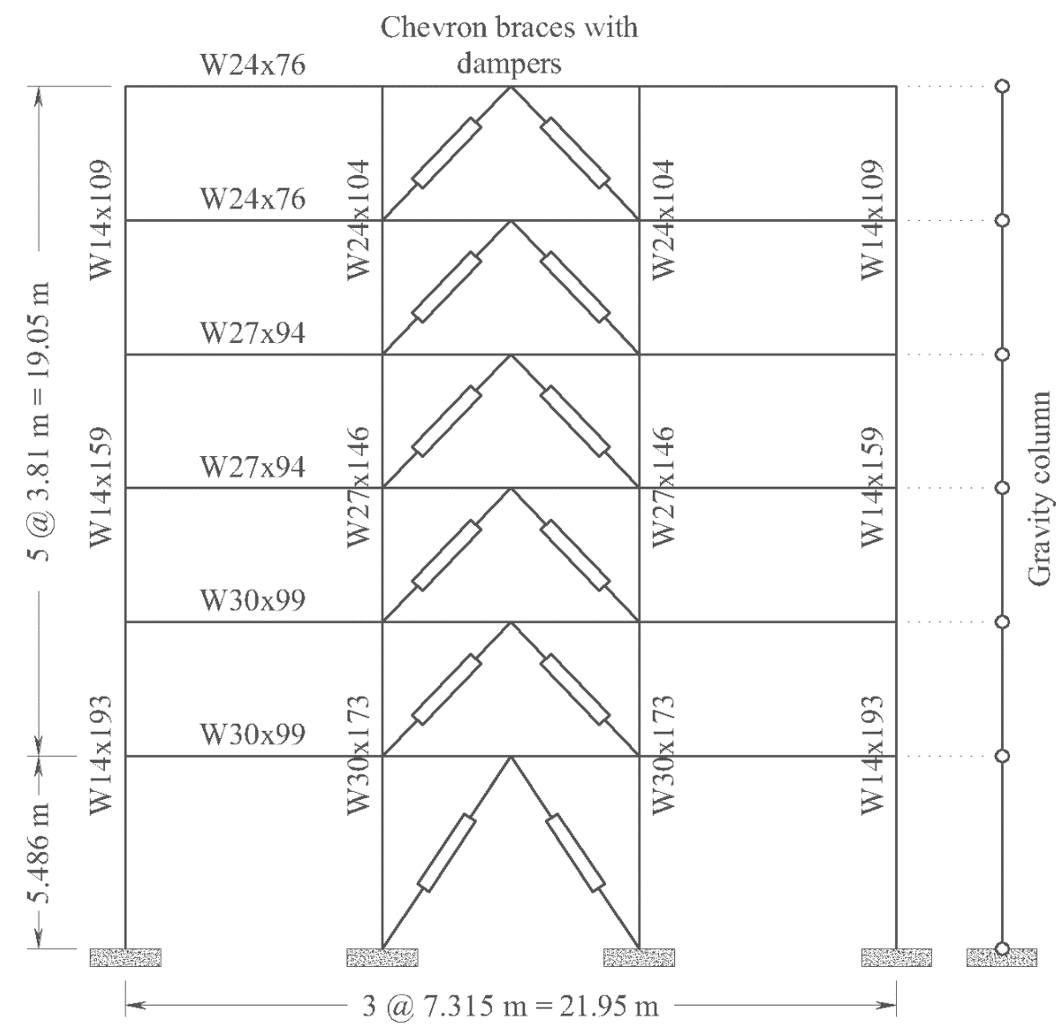

Figure 1. North-South moment-resisting frame of the case study building.

3. MODELING AND ANALYSIS

The case study building was modeled in the OpenSees software (McKenna et al., 2010). The structural members were modeled with “beamWithHinges” elements. The fluid viscous dampers were modeled using the “ViscousDamper” material assigned to “TwoNodeLink” elements. The ViscousDamper material represents a Maxwell fluid with a spring element and a dashpot element connected in series. Based on Wang (2017) and Akcelyan et al. (2016) a stiffness value of 150 kN/mm was selected for all viscous dampers.
An incremental dynamic analysis was carried out using the far-field ground motion set proposed in the FEMA P695 document (FEMA, 2009). This set is composed of 22 records (44 individual components) that represent the characteristics of the seismicity in the Western United States. The ground motions were scaled to ten different intensities based on the median spectral acceleration at a period equal to one second (S_{a}(T=1.0)). This scaling period was selected since it is close to the fundamental period of the case study building and Sa(T=1.0) is a mapped value in ASCE 7-16. Two particular intensities, corresponding to the ASCE 7-16 (ASCE, 2017) design earthquake (DE) S_{a}(T=1.0) = 0.6 g and to the maximum considered earthquake (MCE) S_{a}(T=1.0) = 0.9 g, were investigated in detail. Figure 2 shows the median acceleration spectrum of the ground motion set scaled to DE and MCE intensities. Based on the results of the incremental dynamic analysis and since a strength degradation model was implemented in each plastic hinge region, side-sway collapse mechanisms were explicitly modeled, collapse fragility functions were calculated using the maximum likelihood estimation method proposed by Baker (2011, 2015). Finally, the collapse fragility functions were corrected by following the FEMA P695 methodology (FEMA, 2009), considering the spectral shape factor and different sources of uncertainty.
In order to assess the seismic performance of the building, median peak inter-story drifts, median peak damper forces and probability of collapse were calculated for the different configurations at DE and MCE intensities. Only the records that did not cause the collapse of the building were considered to calculate the median peak inter-story drifts and the median peak damper forces. The control building (without viscous dampers) was the only model for which some collapses were observed, in particular, two collapses at the MCE intensity were recorded.

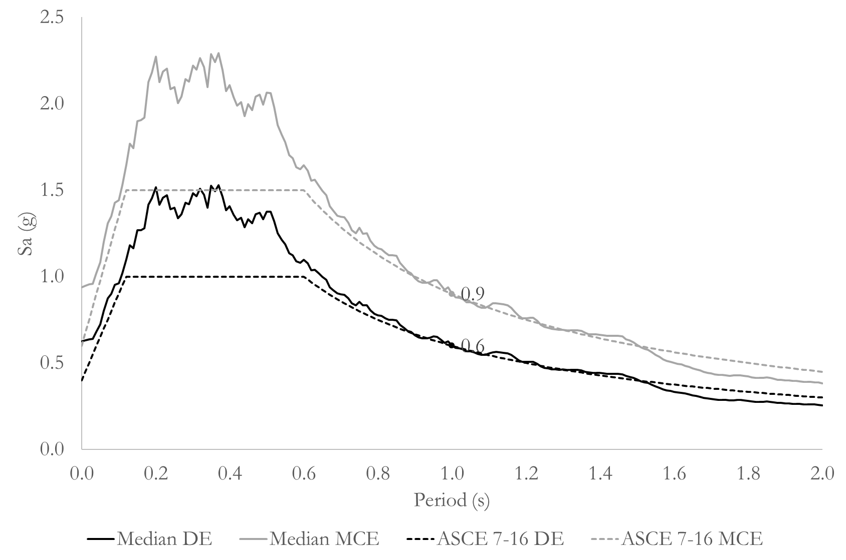

Figure 2. Median acceleration response spectra of the FEMA P695 far-field ground motion set scaled to DE and MCE intensity levels.

4. DESIGN OF VISCOUS DAMPERS

Two approaches were used to design the viscous dampers: 1) a uniform damping distribution (UD) in which a unique damping coefficient was assigned to all dampers along the building’s height, and 2) an equivalent lateral stiffness (ELS) design approach in which the damping coefficients of the viscous dampers were distributed along the building’s height based on the floor lateral stiffness, thereby maintaining proportional damping. Only a summary of the two design procedures is provided herein. Both procedures are explained in detail by Christopoulos and Filiatrault (2006).

4.1 Uniform Damping (UD) Distribution Design Approach

With this approach, a unique damping coefficient is given to all viscous dampers installed in the building. The procedure proposed by Zhang and Soong (1992) and Lopez-Garcia (2001) was used to calculate the single damping constant, C, along the building’s height.
The energy dissipated per cycle by a viscous damper, E_{vd}, is equal to the area under the curve of its force-displacement relationship (described in Equation 1) and is given by:

$E_{vd}=\int_{0}^{{2π}/ω}{F\left(t\right)}\dot{x}\left(t\right)dt=4 C {\left(X_{o}ω\right)}^{α_{vd}+1}\int_{0}^{π/{2ω}}{\cos^{α_{vd}+1}\left(ωt\right)dt}$ (2)

where X_{o} is the displacement amplitude between the two ends of the damper, ω is the circular forcing frequency assumed as the fundamental frequency of the case study building. Solving the integral on the right side of Equation 2 yields:

$E_{vd}=2\sqrt{π} C {\left(X_{o}\right)}^{α_{vd}+1}ω^{α_{vd}}\frac{Γ\left(1+\frac{α_{vd}}{2}\right)}{Γ\left(\frac{3}{2}+\frac{α_{vd}}{2}\right)}$ (3)

where Γ is the gamma function. Based on Equation 3, and assuming the structure response is dominated by the fundamental mode with period T₁, the energy dissipated by all the dampers in one cycle, E_{vd}, is equal to:

$E_{vd}=\sum_{i=1}^{N_{d}}{\frac{2\sqrt{π} C δ_{i}^{α_{vd}+1}\cos^{α_{vd}+1}\left(γ_{i}\right)*{(2π)}^{α_{vd}}\frac{Γ\left(1+\frac{α_{vd}}{2}\right)}{Γ\left(\frac{3}{2}+\frac{α_{vd}}{2}\right)}}{{T_{1}}^{α_{vd}}}}$ (4)

where δ_{i} is the inter-story drift at the story where the i^{th} damper is located, N_{d} is the total number of dampers in the structure, and γ_{i} is the inclination angle of the i^{th} damper. Since the viscous dampers do not add supplemental stiffness to the structure, the total recoverable elastic strain of the system, E_{es}, is defined only by the floor stiffness, k_{i}, and the inter-story drift, δ_{i}.

$E_{es}=\frac{1}{2}\sum_{i=1}^{N_{f}}{k_{i}δ_{i}^{2}}$ (5)

where N_{f} is the number of floors. The damping coefficient, C, is obtained by replacing Equations 4 and 5, and the target the first modal damping ratio, ξ₁, (to be provided by the viscous dampers) in the Jacobsen’s damping model (Jacobsen, 1930):

$C=\frac{ξ_{1}T_{1}^{α_{vd}}\sqrt{π}\sum_{i=1}^{N_{f}}{k_{i}δ_{i}^{2}}}{{\left(2π\right)}^{α_{vd}}\left(\frac{Γ\left(1+\frac{α_{vd}}{2}\right)}{Γ\left(\frac{3}{2}+\frac{α_{vd}}{2}\right)}\right)\sum_{i=1}^{N_{d}}{δ_{i}^{α_{vd}+1}\cos^{α_{vd}+1}\left(γ_{i}\right)}}$ (6)

For this procedure, the inter-story drift 𝛿_{𝑖} was calculated from the inelastic mode shape. Mohammadjavad et al. (2014) proposed the inelastic mode shape as the horizontal displacement of each floor when the building loses 20% of its maximum strength (0.8V_{max}) in a pushover analysis. This point is defined in the FEMA P695 methodology as the ultimate displacement δ_{ult} (FEMA, 2009). Table 1 shows the damping coefficients calculated based on the UD design approach.

Table 1. Damping coefficients for the linear and nonlinear viscous dampers designed with the UD approach.

ξ₁ | C_{L} (kN*s/mm) | C_{NL}  (kN*(s/mm) ^{α})
 | α_{vd} = 1.0 | α_{vd} = 0.9 | α_{vd} = 0.7 | α_{vd} = 0.5 | α_{vd} = 0.3 | α_{vd} = 0.2
10 % | 5.00 | 9.0 | 29.0 | 90.0 | 274 | 475
20 % | 10.0 | 19.0 | 58.0 | 179 | 548 | 951
35 % | 18.0 | 32.0 | 101 | 314 | 958 | 1664

4.2 Equivalent Lateral Stiffness (ELS) Design Approach

With this approach, the damping coefficients of the viscous dampers are distributed along the building’s height based on the lateral stiffness of each floor. Therefore, the damping ratios are the same than the lateral stiffness ratios along the building height. The damping coefficient at a story n can be calculated from the lateral stiffness of that floor since the introduction of linear viscous dampers in regular structures produces a stiffness proportional damping matrix (Christopoulos and Filiatrault, 2006).
A fictitious braced structure is created by adding springs with stiffness ${\hat{k}}_{0}$ at the location of the viscous dampers keeping the inter-story lateral stiffness ratios of the original structure. The stiffness of the fictitious springs should be set such that the period of the fictitious braced structure, ${\hat{T}}_{1}$, is equal to (Christopoulos and Filiatrault, 2006):

${\hat{T}}_{1}=\frac{T_{1}}{\sqrt{2ξ_{1}+1}}$ (7)

Then, the damping coefficients for linear viscous dampers,$C_{L}$, can be calculated from:

$C_{L}=\frac{T_{1}}{2π}{\hat{k}}_{0}$ (8)

To design the nonlinear viscous dampers, a methodology based on energy is used. An equivalent nonlinear viscous damper can be calculated from a linear viscous damper by equating the energy dissipated in one cycle for a given frequency, ω, and displacement amplitude, X_{o}. Equating Equation 3 for both a linear and nonlinear viscous damper respectively, and solving for the nonlinear damping coefficient, C_{NL}:

$C_{NL}=C_{L}\frac{\sqrt{π}}{2} {\left({ωX}_{o}\right)}^{1-α_{vd}}\frac{Γ\left(\frac{3}{2}+\frac{α_{vd}}{2}\right)}{Γ\left(1+\frac{α_{vd}}{2}\right)}$ (9)

For this study, ω was assumed to be the fundamental frequency of the building, and X_{o} was taken as the median plus one standard deviation of the relative displacement of the linear viscous dampers for a given floor from the nonlinear time history analysis at MCE intensity. Table 2 shows the damping coefficients calculated by following the equivalent lateral stiffness design approach.

Table 2. Damping coefficients for the linear and nonlinear viscous dampers designed with the ELS approach.

Story | C_{L} | C_{NL}
 | (kN*s/mm) | (kN*(s/mm) ^{α})
 | α_{vd} = 1.0 | α_{vd} = 0.9 | α_{vd} = 0.7 | α_{vd} = 0.5 | α_{vd} = 0.3 | α_{vd} = 0.2
ξ₁ = 10 %
6 | 4.00 | 5.00 | 12.0 | 27.0 | 60.0 | 91.0
5 | 4.00 | 6.00 | 14.0 | 35.0 | 88.0 | 139
4 | 5.00 | 7.00 | 19.0 | 50.0 | 130 | 211
3 | 6.00 | 9.00 | 26.0 | 73.0 | 209 | 352
2 | 6.00 | 9.00 | 28.0 | 87.0 | 265 | 462
1 | 5.00 | 8.00 | 26.0 | 84.0 | 273 | 491
ξ₁ = 20 %
6 | 8.00 | 10.0 | 22.0 | 46.0 | 97.0 | 141
5 | 8.00 | 11.0 | 26.0 | 62.0 | 147 | 227
4 | 10.0 | 14.0 | 35.0 | 870 | 215 | 340
3 | 11.0 | 16.0 | 43.0 | 116 | 311 | 510
2 | 13.0 | 20.0 | 56.0 | 161 | 461 | 780
1 | 9.00 | 14.0 | 45.0 | 141 | 445 | 789
ξ₁ = 35 %
6 | 15.0 | 19.0 | 38.0 | 75.0 | 150 | 213
5 | 14.0 | 19.0 | 43.0 | 99.0 | 226 | 343
4 | 18.0 | 25.0 | 59.0 | 140 | 333 | 514
3 | 20.0 | 28.0 | 70.0 | 177 | 444 | 703
2 | 23.0 | 33.0 | 89.0 | 238 | 635 | 1039
1 | 17.0 | 26.0 | 80.0 | 241 | 731 | 1272

5. NuMERICAL RESULTS

The probability of collapse, the median peak inter-story drifts, and the median peak damper forces were calculated for the original building, as well as for the building retrofitted with the various configurations of viscous dampers described above. To compare the influence of the damper’s velocity coefficient, a normalization of the results for the configurations equipping nonlinear dampers with respect to the results of the building equipped with linear dampers was carried out.

5.1 Probabilities of Collapse

Figure 3 shows the probabilities of collapse at the DE and MCE intensity levels for the different configurations of viscous dampers, as well as for the original (control) structure. The FEMA P695 requires a probability of collapse below 10% at MCE intensity for a code-compliant seismic-resisting structural system. The case study building fulfills this requirement showing a probability of collapse at MCE intensity level of 4.98%. Lower probabilities of collapse are observed for the structures retrofitted with viscous dampers compared to that of the control structure. As expected, the probabilities of collapse reduce with increasing values of added supplemental damping. In the buildings equipped with linear viscous dampers, as well as for the buildings with nonlinear viscous dampers with velocity coefficients close to unity (i.e. α_{vd} equal to 0.9 and 0.7), there are no significant differences in the probabilities of collapse between the ELS and UD design approaches. With smaller velocity coefficients, however, the probability of collapse tends to increase. This increase in the probability of collapse with decreasing velocity coefficients is more evident with the building retrofitted with dampers designed by the UD design approach in which the probability of collapse is up to 2.2 times that of the buildings designed by the ELS design dampers.

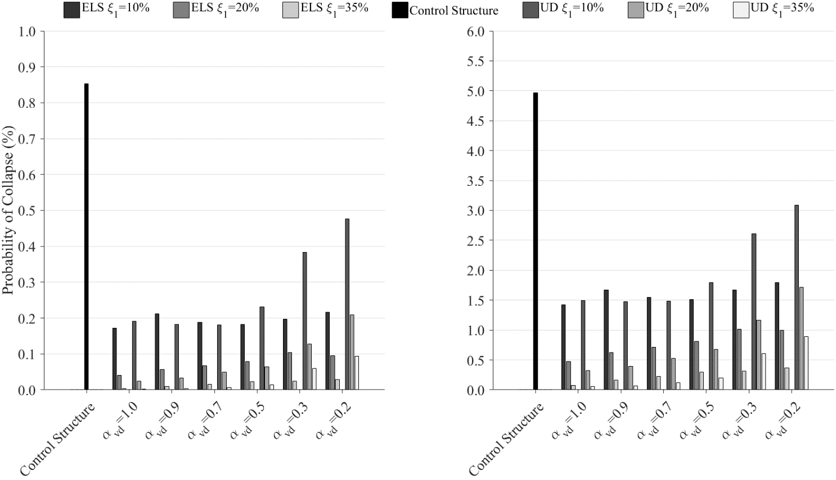

Figure 3. Probabilities of collapse at DE (left) and MCE (right) intensity levels.

5.2 Median Peak Inter-Story Drifts

Figures 4 to 6 show the absolute and normalized values of the median peak inter-story drifts for buildings incorporating viscous dampers designed by both UD an ELS approaches at the DE intensity level. The results show a significant reduction in the median peak inter-story drifts in the buildings retrofitted with viscous dampers. However, the design approach, the amount of added supplemental damping, and the velocity coefficient affect considerably the results. By reducing the velocity coefficient and increasing the added supplemental damping, the median peak inter-story drifts are increased. The buildings incorporating a target supplemental damping of 10% of critical and nonlinear viscous dampers designed by the UD approach show a better performance compare to the same buildings incorporating linear dampers. In the case of the nonlinear dampers designed by the ELS approach, the buildings incorporating nonlinear viscous dampers show better performance at the bottom stories and a worse performance at the top stories. This difference is reduced by increasing the supplemental damping, resulting in larger inter-story drifts along the building’s height.

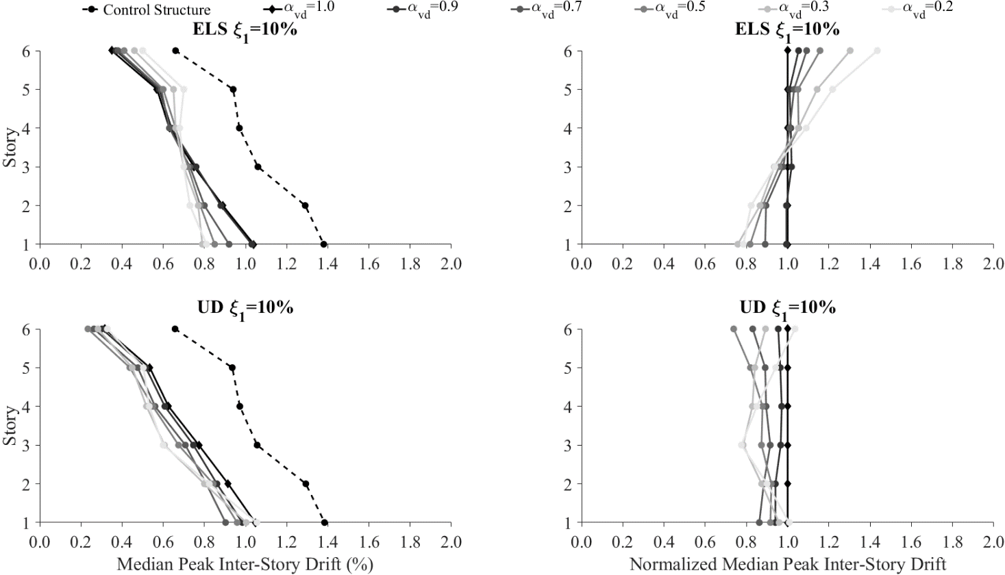

Figure 4. Absolute and normalized median peak inter-story drift at DE intensity level with ξ₁ = 10%.

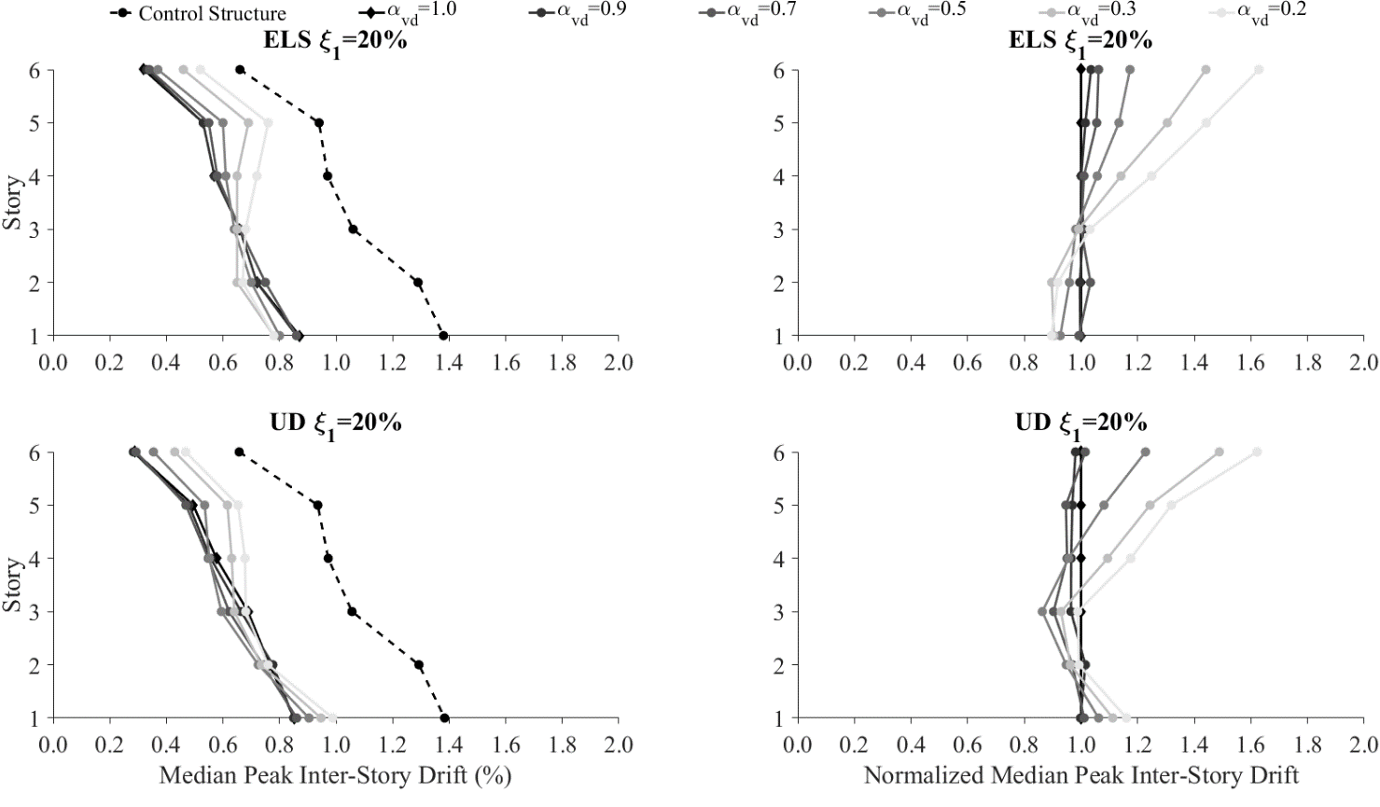

Figure 5. Absolute and normalized median peak inter-story drift at DE intensity level with ξ₁ = 20%.

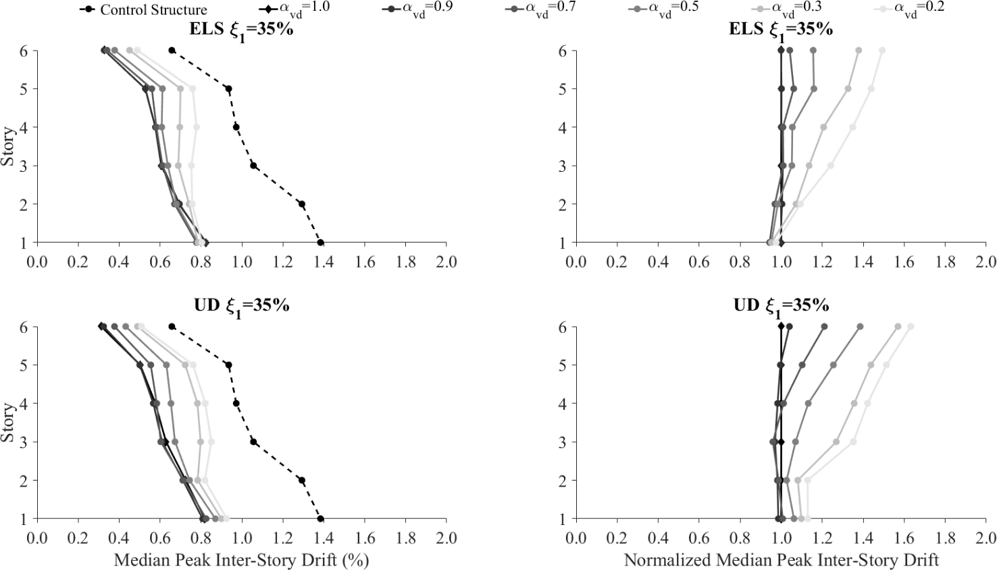

Figure 6. Absolute and normalized median peak inter-story drift at DE intensity level with ξ₁ = 35%

5.3 Median Peak Damper Forces

Figures 7 to 9 show the absolute and normalized values of the median peak damper forces for buildings incorporating both viscous dampers design approach at DE intensity level. The median peak damper forces are highly influenced by the design approach, the added supplemental damping and the velocity coefficient of the dampers. In the case of the buildings retrofitted with viscous dampers designed by following the UD design approach, larger damper forces along the buildings’ height are obtained when the velocity coefficient is reduced. This amplification of the damper forces for the nonlinear dampers with a velocity coefficient equal to 0.2 can be up to twice the force induced in the corresponding linear dampers. For buildings incorporating dampers designed by the ELS design approach, a reduction of the median peak damper forces is observed at the top stories and an increase at the bottom stories (about 1.6 times the force of linear dampers for the nonlinear damper with a velocity coefficient equal to 0.2 at the bottom story). The differences in the median peak damper forces between the linear and nonlinear dampers are reduced by increasing the added supplemental damping.

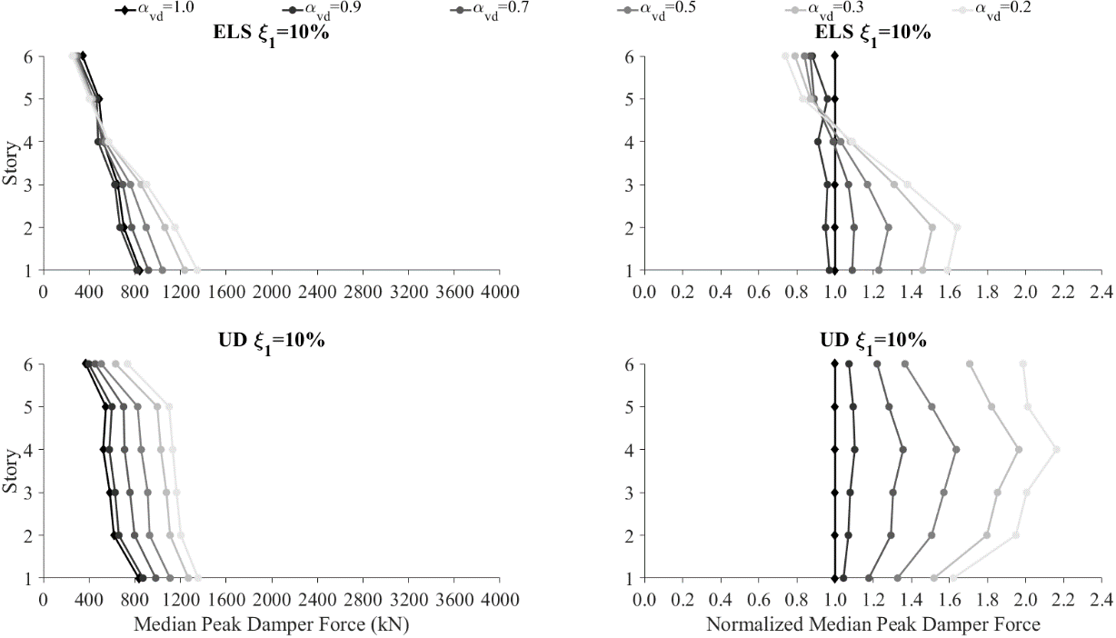

Figure 7. Absolute and normalized median peak damper forces at DE intensity level with ξ₁ = 10%
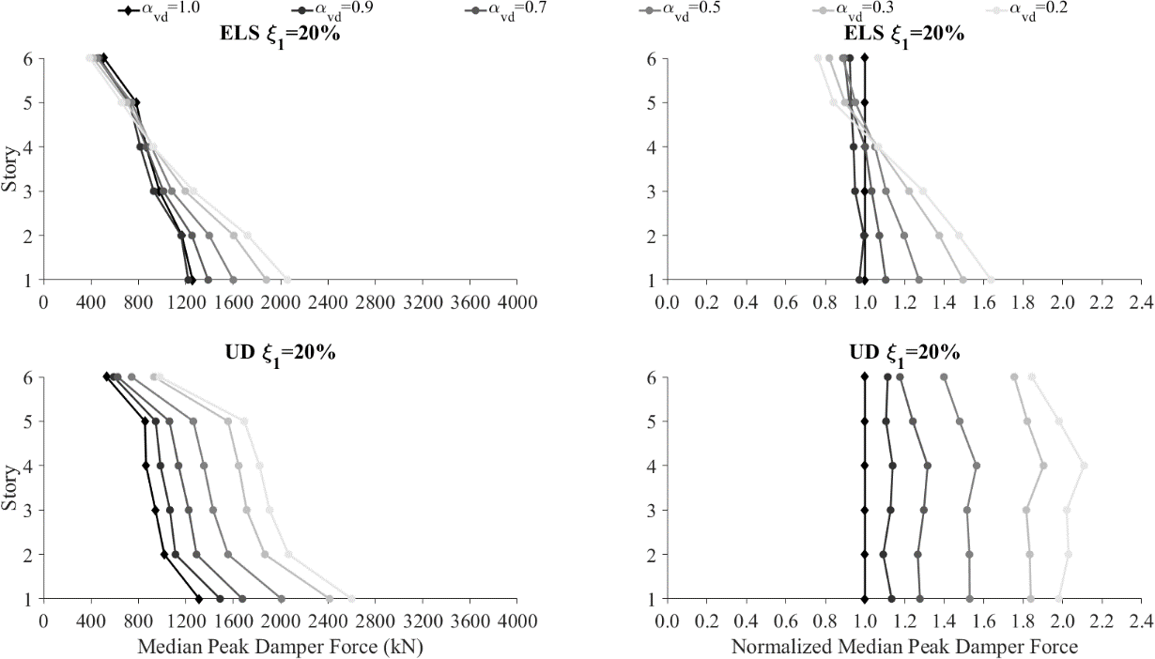

Figure 8. Absolute and normalized median peak damper forces at DE intensity level with ξ₁ = 20%

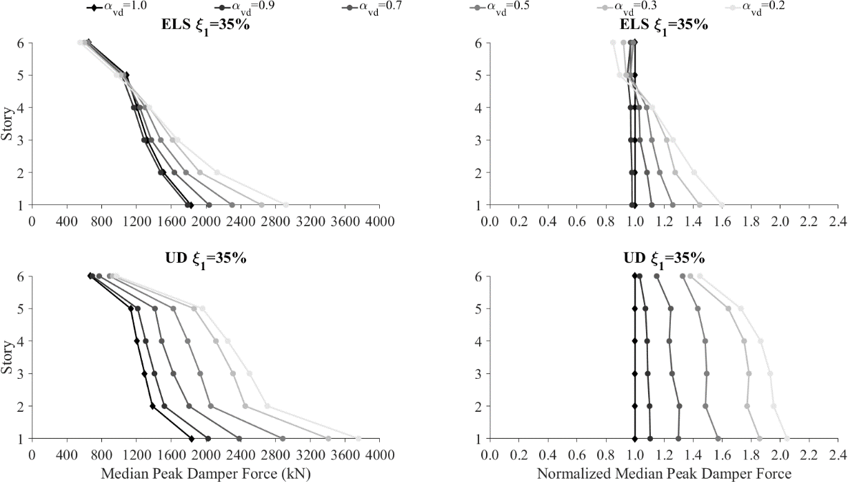

Figure 9. Absolute and normalized median peak damper forces at DE intensity level with ξ₁ = 35%

5.4 Discussion

Adding supplemental damping through the implementation of fluid viscous dampers improves the seismic performance of the case study building in terms of probability of collapse and inter-story drift. However, the velocity coefficient of the viscous dampers, the added supplemental damping, and the methodology used to design the viscous dampers have a significant impact on the results. Reducing the velocity coefficient leads to an increase in the probability of collapse, particularly for the dampers designed by following the UD design approach. The median peak inter-story drifts and damper forces are also affected; larger damper forces are observed by decreasing the velocity coefficient. A similar trend is observed for the inter-story drifts at high targeted supplemental damping ratios. Although the force-velocity relationship of nonlinear viscous dampers limits the maximum force in the damper’s at large velocities, at low velocities the nonlinear dampers develop larger forces than the linear viscous dampers. This explains the increase of the damper forces when reducing the velocity coefficient. Additionally, smaller velocity coefficients produce more rectangular force-displacement hysteresis loops, which tend to cause the maximum forces in the structure to become in phase with larger forces in the viscous dampers, thereby increasing the demand on the structural members and consequently reducing the seismic performance.

6. Conclusions

The implementation of fluid viscous dampers to improve the seismic performance of a structure is a feasible technology that has been largely studied for many years. Nevertheless, the methodology used to design the viscous dampers, the targeted supplemental damping ratio and the damper’s velocity coefficient modify the seismic behavior of the retrofitted structure and subsequently its performance. In order to assess the seismic performance of a structure retrofitted with viscous dampers, a six-story steel moment-resisting frame building was selected from the SAC Steel Project. A retrofitting of the building was proposed by using linear and nonlinear viscous dampers designed by following two design approaches: 1) a uniform damping distribution in which a unique damping coefficient is assigned to all the dampers in the structure, and 2) an equivalent lateral stiffness distribution in which the damping coefficients are distributed based on the lateral floor stiffness of the original structure, thereby preserving proportional damping. An incremental dynamic analysis was carried out with the FEMA P695 far-field ground motion set scaled to ten different intensities in order to obtain the collapse fragility functions of the diverse configurations. These fragility functions were corrected by following the recommendations of FEMA P695 to take into account spectral shape factor and diverse sources of uncertainty. The seismic performance was assessed in terms of probability of collapse, median peak inter-story drifts, and median peak damper forces. Additionally, a normalization of the results for the buildings with nonlinear dampers with respect to the buildings with linear dampers was conducted to evaluate the effects of varying the velocity coefficient.
The results show that the implementation of viscous dampers generally improves the seismic performance of the six-story building. The probability of collapse was reduced for all the damper configurations, being smaller for larger targeted supplemental damping ratios. The velocity coefficient of the viscous dampers also affected the probability of collapse, showing larger probabilities of collapse at lower velocity coefficient values. This is more evident in the building equipped with dampers designed by following the uniform damping distribution. The median peak damper forces showed an increase when reducing the velocity coefficient and when increasing the targeted damping ratio. An increase up to twice the damper forces of linear dampers was observed for nonlinear dampers with a velocity coefficient of 0.2. A similar trend was observed for the median inter-story drifts reaching inter-story drifts up to 1.6 times the inter-story drift of buildings equipped with linear dampers.

7. Acknowledgments

The work presented in this paper has been developed within the framework of the project “Dipartimenti di Eccellenza”, funded by the Italian Ministry of Education, University and Research at IUSS Pavia. The authors gratefully also acknowledge the Italian Department of Civil Protection (DPC) for their financial contributions to this study through the ReLUIS 2019-2021 Project (Work Package 17 - Contributi Normativi Per Elementi Non Strutturali).

8. References

Akcelyan S., Lignos D. G., Hikino T. and Nakashima M. (2016) Evaluation of simplified and state-of-the-art analysis procedures for steel frame buildings equipped with supplemental damping devices based on e-defense full-scale shake table tests. ASCE Journal of Structural Engineering, ISSN: 0733-9445. 142 (6).
ASCE (2017) Minimum design loads and associated criteria for buildings and other structures ASCE/SEI 7-16. American Society of Civil Engineers, USA.
ATC (1994) Proceedings of the invitational workshop on steel seismic issues. Structural Engineers Association of California, Applied Technology Council, Los Angeles, USA.
Baker, J. W. (2011) Fitting fragility functions to structural analysis data using maximum likelihood estimation. Baker Research Group, Stanford, United States.
Baker, J. W. (2015) Efficient analytical fragility function fitting using dynamic structural analysis. Earthquake Spectra, ISSN: 8755-2930. 31 (1): 579-599.
Chalarca B. (2017) Collapse capacity of steel buildings retrofitted with linear and nonlinear viscous dampers. Master thesis, University School for Advanced Studies IUSS Pavia, Pavia, Italy.
Christopoulos, C. and Filiatrault, A. (2006) Principles of passive supplemental damping and seismic isolation. IUSS Press, ISBN: 88-7358-037-8, Pavia, Italy.
Del Gobbo G. M., Blakeborough A. and Williams M.S. (2018) Improving total-building seismic performance using linear fluid viscous dampers. Bulletin of Earthquake Engineering, ISSN: 1570-761X. 16 (9): 4249-4272.
FEMA (2009) Quantification of building seismic performance factors FEMA P695. Federal Emergency Management, Washington D.C., USA.
Hall, J. F. (1995) Parameter study of the response of moment-resisting steel frame buildings to near-source ground motions. Technical Report SAC95-05: Parametric Analytical Investigation of Ground Motions and Structural Response, Sacramento, USA.
ICBO (1994) Uniform Building Code, International Conference of Building Officials, Whittier, USA.
Jacobsen L.S. (1930) Steady forced vibrations as influenced by damping. Transactions of ASME; 52 (1): 169-181.
Lopez-García, D. (2001) A simple method for the design of optimal damper configurations in mdof structures. Earthquake Spectra, ISSN: 8755-2930. 17 (3): 387-398.
McKenna, F., Scott, M.H. and Fenves, G.L. (2010) Nonlinear finite element analysis software architecture using object composition. Journal of Computing in Civil Engineering, ISSN: 1943-5487. 24 (1): 95-107.
Mohammadjavad, H., Filiatrault, A. and Aref, A. (2014) simplified seismic collapse capacity-based evaluation and design of frame buildings with and without supplemental damping systems. Earthquake Engineering to Extreme Events MCEER, Buffalo, USA.
Seo C. Y., Karavasilis T. L., Ricles J. M. and Sause R. (2014) Seismic performance and probabilistic collapse resistance assessment of steel moment resisting frames with fluid viscous dampers. Earthquake Engineering and Structural Dynamics, ISSN: 0098-8847. 43 (14): 2135-2154.
Tsai, K. C. and Popov, E. P. (1988) Steel beam-column joints in seismic moment resisting frames, Report No. UCB/EERC-88/19. Earthquake Engineering Research Center UC Berkeley, Berkeley, USA.
Wang, S. (2017) Enhancing seismic performance of tall buildings by optimal design of supplemental energy-dissipation devices. Doctoral thesis, University of California, Berkeley, USA.
Zhang, R. H., and Soong, T. T. (1992) Seismic design of viscoelastic dampers for structural applications. ASCE Journal of Structural Engineering; ISSN: 0733-9445. 118 (5).

Ph.D. Candidate, University School for Advanced Studies IUSS Pavia, Pavia, Italy, bryan.chalarca@iusspavia.it
Professor, Department of Civil, Structural and Environmental Engineering, State University of New York at Buffalo, Buffalo, USA & University School for Advanced Studies IUSS Pavia, Pavia, Italy, af36@buffalo.edu
Postdoctoral Researcher, University School for Advanced Studies IUSS Pavia, Pavia, Italy, daniele.perrone@iusspavia.it

