ON THE MAXIMUM GROUND MOTION DIRECTION AND RESPONSE OF SEISMICALLY ISOLATED STRUCTURES

DOI 10.37153/2686-7974-2019-16-133-140

Esengul CAVDAR, Gokhan OZDEMIR,

ABSTRACT

This study investigates the dependency of the orientation of ground motions at which the maximum isolator displacement of seismically isolated structures occurs. For this purpose, a set of near-field ground motion records are selected and modified by rotating through 90° with intervals of 10°. The original and rotated forms of ground motions are used to perform nonlinear response history analyses. The seismic isolation system of the analyzed structure is composed of lead rubber bearings (LRBs). To determine the effect of seismic isolation characteristics on the maximum orientation of ground motions, isolation period and characteristic strength-to-weight ratio are the parameters considered in the analyses. Moreover, the significance of employing a deteriorating or a non-deteriorating hysteretic representation for modeling of LRBs on the orientation of maximum ground motion direction is addressed. Results revealed that maximum ground motion direction for a seismically isolated structure changes due to change in seismic isolation characteristics and the hysteretic representation of isolator unit.

Keywords: Maximum direction, Seismic isolation, Bidirectional analyses, Lead rubber bearing.

1. INTRODUCTION

To perform a code-compliant Nonlinear Response History Analysis (NRHA) of seismically isolated structures idealized by 3-Dimensional (3D) models, it is required to consider both orthogonal horizontal components of ground motion records. In such a case, horizontal components of a ground motion record are subjected to structural model simultaneously. ASCE/SEI 7-10 (2010) further states that orthogonal horizontal components of ground motions shall be rotated to Fault Normal (FN) and Fault Parallel (FP) directions when the analyzed structure is at a site with a distance less than 5 km from an active fault that dominates the earthquake hazard. According to this statement, it is assumed that maximum response quantities of the analyzed structure will be recorded at FN or FP directions. Thus, as-recorded ground motions may be used in their rotated forms. In recent studies (Tezcan and Alhan, 2001; Khoushnoudian and Poursha, 2004; Rigato and Medina, 2007; Goda and Taylor, 2012; Kalkan and Kwong, 2012,2014), rotation of ground motion records is of concern in order to obtain maximum-direction ground motion defined as the direction of rotated horizontal ground motion components so that response quantity under consideration is maximum. Outputs of the studies cited here revealed that ground motion orientation has a significant effect on the structural response. Furthermore, Athanatopoulou (2005) has performed a research on rotation of ground motions considering linear multidegree-of-freedom structures and showed that response quantity under investigation can be even 80% larger than the ones obtained by using as-recorded ground motion. The author also stated that maximum-direction varies due to change in both employed ground motion pairs and response quantity under consideration. Conclusions of Athanatopoulou (2005) are also confirmed by Kalkan and Kwong (2012, 2014). In their study, Kalkan and Kwong (2014) have assessed the efficiency of code prescribed dynamic analysis method restricted only for FN/FP directions where a six-story reinforced concrete structure is subjected to twenty pairs of nearfault ground motions rotated through 180° with 5° increment. Authors also showed that considering FN/FP directions of ground motions may not necessarily result in maximum response quantity among all possible rotated versions of ground motions. Discussions presented above are for short-period structures and did not address the response of seismically isolated structures. In their study, Ozdemir et al. (2016) focused on variation of maximum isolator displacements due to ground motion orientation. Ozdemir et al. (2016) demonstrated that ground motion orientation at which maximum isolator displacement is obtained, is dependent of the ground motion pairs. Similarly, in their research, Mavronicola et al. (2017) have investigated the variation in maximum-direction of motions for seismically isolated structures. In this parametric study, Mavronicola et el. (2017) pointed out that maximum-direction is sensitive to change in isolator characteristics.
The previous studies mostly focused on fixed-base structures either with linear idealizations by MDOF models or nonlinear representations by single-degree-of –freedom (SDOF) models. Only a few of them focused on the effect of ground motion orientation when seismically isolated structures are of concern. However, none of the previous studies have addressed the effect of bilinear force-deformation curve used to idealize the hysteretic behavior of seismic isolators. In the present study, maximum-direction issue is studied in a comparative manner. Accordingly, considered as-recorded ground motions are rotated through 90º with 10º intervals. Both as-recorded and rotated ground motions pairs are subjected to seismically isolated building via structural analysis program Opensees (2009). In order to determine whether the maximum-direction of a ground motion is dependent of hysteretic representation of seismic isolator or not, both deteriorating and non-deteriorating bilinear force-displacement curves are used in modeling of isolator units. The seismic isolation units are assumed to be composed of Lead Rubber Bearings (LRBs) and their deteriorating hysteretic behavior is modeled in accordance with the proposal of Kalpakidis et al. (2009a,b). The parameters involved in the analyses are characteristic strength to weight ratio of isolators and isolation period.

2. DIMENSIONAL STRUCTURAL MODEL

The analyzed seismically isolated structure is a three-story steel frame building designed for National Earthquake Hazard Reduction Program (NEHRP). It is symmetric in both vertical and horizontal directions. Plan dimensions are 36 m x 54 m with identical span lengths whereas the height of the building is 9 m with 3 m story height. Seismic isolation units are composed of 35 LRBs located below each column at the base level. LRBs are modeled by bilinear force-displacement curves while the frame members of superstructure are modeled to be elastic. Accordingly, modulus of elasticity and Poisson’s ratio are 200 GPa and 0.3, respectively. The first and second floor weight are equal while the third floor weight is 75% of others and the total weight above the isolation system is 73000 kN. The 3-dimensional view of the structural model and distribution of isolation units are illustrated in Figure 1.

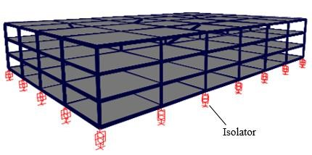
Figure 1. 3-Dimensional model of the analyzed seismically isolated structure.

Properties used to construct the non-deteriorating force-displacement curve for LRBs corresponds to lower bound characteristics. Based on the results of characterization tests performed with LRBs under cyclic loading compatible with design earthquake, lower bound properties are computed by taking the average of three consecutive cycles. On the other hand, the deteriorating force-displacement relation is constructed based on the initial strength of LRB obtained from the first cycle of characterization tests. Kalpakidis et al. (2009a,b) showed that the gradual reduction in strength of LRB is mainly due to increase in lead core temperature. Accordingly, initial strength of LRB decreases as a function of lead core temperature and updated by means of Equation (1) at each loading step. In Equation (1), σ_{YL}(T_{L}) is the instantaneous temperature (T_{L}) dependent yield stress of lead, _{YL0} is the initial yield stress of lead and E₂ is constant and equals to 0.0069. Figure 2 shows representative force-displacement curves for both deteriorating and non-deteriorating hysteretic behavior of LRBs.

${\text{σ}}_{YL}\left(T_{L}\right)={\text{σ}}_{YL0}∙exp⁡(-E_{2}∙T_{L})$ (1)

400 400
Isolator Force (kN)

-400
-200
0
200
-200
-100
0
100
200
-400
-200
0
200
-200
-100
0
100
200
Isolator Displacement (mm)
a) b)

Figure 2. Bilinear force-displacement curves of LRBs for a) Deteriorating, b) Non-deteriorating idealizations.

Apart from non-deteriorating representation, in order to employ the deteriorating force-displacement curve, geometric properties of LRBs needs to be considered. Thus, in the iterative method for design of isolator units also involves the stability checks considering geometric properties. In order to perform parametric analyses, Q/W ratios are selected to be 0.09, 0.105, 0.120, 0.135 and isolation periods are 2.25s, 2.50s, 2.75s, 3.00s. The rationale for using such values for Q/W ratio and isolation period (T_{iso}) is the suggestion of Dicleli (2006) for design of seismically isolated structures in case of near-fault conditions. Table 1 presents the characteristics of LRBs used in the analyses. In Table 1, n stands for total number of rubber plates and a represents the radius of lead core. The yield displacement, D_{y}, of both deteriorating and non-deteriorating curves is taken 25mm and each rubber plate and steel plate thickness was chosen as 7mm and 3mm, respectively. The height of the isolator, h_{L} is equal to (nx7+(n-1)x3) equation.

Table 1. Properties of Lead Rubber Bearings

Fy (kN) k_{e} (N/mm)  n  LB Temp LB Temp LB | k_{d}/k_{e}  Temp | T_{iso} (s) | h_{L} (mm) | t_{s} (mm)
Q/W=0.09; α=77.5mm; Q_{low}=187.7 kN, Q_{temp}=254.7 kN
41 212 278 8,460 11,123 0.11 | 0.084 | 3.00 | 411 | 120
Q/W=0.105; α=83.5mm; Q_{low}=219 kN, Q_{temp}=295.7 kN
23 262 338 10,458 13,506 0.16 | 0.124 | 2.25 | 229 | 66
29 253 329 10,123 13,170 0.133 | 0.102 | 2.50 | 290 | 84
34 248 324 9,899 12,947 0.113 | 0.086 | 2.75 | 341 | 99
41 243 319 9,714 12,762 0.096 | 0.073 | 3.00 | 411 | 120
Q/W=0.120; α=89.5mm; Q_{low}=250.3 kN, Q_{temp}=339.7 kN
41 274 363 10,969 14,523 0.085 | 0.064 | 3.00 | 411 | 120
Q/W=0.135; α=95mm; Q_{low}=281.6 kN, Q_{temp}=382.8 kN
41 306 406 12,223 16,244 0.076 | 0.057 | 3.00 | 411 | 120

3. GROUND MOTION PAIRS USED IN ANALYSES

11 pairs of ground motion records having similar characteristics in terms of magnitude, closest distance to fault and soil class are employed in the analyses. Having closest distance to fault rupture less than 20 km, considered ground motion pairs are assumed to be near-field records (Somerville et al. 1997). Table 2 shows properties of employed ground motion pairs where PGA is peak ground acceleration, PGV is peak ground velocity and PGD is peak ground displacement. Soil classification is as per NEHRP.

Table 2. Properties of ground motions used in the analyses.

# | Name | Station | Mw | Rrup (km) | Component | PGA (g) | PGV (cm/s) | PGD (cm) | Soil Class
1 | Imperial Valley | El Centro Array #10 | 6.5 | 6.2 | 50  320 | 0.17  0.22 | 47.5  41.2 | 31.1  18 | D
2 | Imperial Valley | El Centro Array #8 | 6.5 | 3.9 | 140  230 | 0.6  0.45 | 54.2  49.2 | 32.2  35.3 | D
3 | Kocaeli | Duzce | 7.5 | 15.4 | 180  270 | 0.31  0.36 | 58.9  46.4 | 44.2  17.6 | D
4 | Kocaeli | Yarimca | 7.5 | 4.8 | 60  330 | 0.27  0.35 | 65.7  62.2 | 57.2  51.1 | D
5 | Chi-Chi | TCU101 | 7.6 | 2.1 | W  N | 0.2  0.25 | 67.9  49.4 | 75.5  35.1 | C
6 | Duzce | Duzce | 7.1 | 6.6 | 270  180 | 0.54  0.35 | 83.5  60 | 51.8  41.8 | D
7 | Erzincan | Erzincan | 6.7 | 4.4 | NS  EW | 0.52  0.5 | 84  64.3 | 27.7  21.9 | D
8 | Imperial Valley | El Centro Array #4 | 6.5 | 7.1 | 230  140 | 0.36  0.49 | 76.5  37.4 | 58.9  19.7 | D
9 | Imperial Valley | El Centro Array #5 | 6.5 | 4 | 230  140 | 0.38  0.52 | 90.5  46.9 | 63  35.3 | D
10 | Kobe | KJM | 6.9 | 1 | 0  90 | 0.82  0.6 | 81.3  74.4 | 17.7  20 | D
11 | Chi-Chi | TCU102 | 7.6 | 1.5 | W  N | 0.3  0.17 | 112.5  77.2 | 89.2  44.9 | C

Rotated versions of ground motion pairs are obtained by rotating the as-recorded orthogonal horizontal components of ground motions from 0° to 90° with 10° increments by means of Equation (2) where a_{x}(t) and a_{y}(t) represent the acceleration time series of as-recorded ground motion while a_{x’}(t) and a_{y’}(t) represent the acceleration time series of rotated versions of ground motions as a function of incidence angle, θ. In Figure 3, rotation of ground motion records is presented schematically.

$\left\{\begin{aligned}a_{x’}\left(t\right) \\ a_{y´}(t)\end{aligned}\right\}=\left[\begin{matrix}\text{cos}{\text{θ}} & \text{–}\sin{\text{θ}} \\ \text{sin}{\text{θ}} & \text{cos}{\text{θ}}\end{matrix}\right]∙\left\{\begin{aligned}a_{x}\left(t\right) \\ a_{y}(t)\end{aligned}\right\}$ (2)

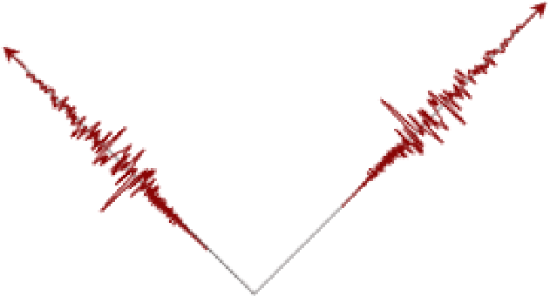

X
Y
a
x
(
t
)
a
y
t
)
(

Figure 3. Schematic representation of ground motion orientation

4. ANALYSIS RESULTS

In this section, analyses result of 1386 NRHA conducted via OpenSees (2009) structural analysis program is presented. In the analyses, both orthogonal horizontal components of ground motions were subjected to structural models, simultaneously. Analyses results are presented so that the effect of hysteretic representation of LRB on maximum-direction of ground motions can be discussed. Selected response quantity is the maximum isolator displacement computed by taking square-root-of –sum-of-squares of displacements in both horizontal directions.

Variation of Maximum-Direction with Isolation Period

One of the important parameters that affect the design of seismically isolated structures is the isolation period. To get an optimum design by considering the balance between the isolator displacement and accelerations (or forces) transferred to the superstructure, engineers may need to consider a range of isolation periods rather than having one single value. Accordingly, results presented in this section corresponds to four distinct isolation periods of 2.25s, 2.50s, 2.75s and 3.0s. For each isolation period, NRHA were repeated for both deteriorating and non-deteriorating representations of LRBs. In order to focus solely on the effect of isolation period, Q/W ratio is kept constant and equals to 0.105. Variation of maximum-direction of ground motions due to change in seismic isolation period is demonstrated in Figure 4 for each record, individually. In Figure 4, maximum isolator displacements (MIDs) are presented for each ground motions. Grey bars represent MIDs obtained for deteriorating hysteretic behavior of LRBs while red lines stand for MIDs calculated for nondeteriorating hysteretic behavior of LRBs. Figure 4 also introduces the incidence angle at which MID is maximum among all the rotated versions of ground motion pairs for both deteriorating and non-deteriorating cases.
In Figure 4, it is clearly seen that a change in isolation period may lead to differentiation in maximum-direction of ground motion pairs. The original observation in Figure 4 is that maximum-directions of ground motions may not be identical for deteriorating and non-deteriorating cases. For instance, when isolation period, T_{iso}, is equal to 3.0s, for EQ#4 the maximum-direction is 50° for non-deteriorating case while it is 30° for deteriorating case. On the other hand, the maximum-directions for both deteriorating and non-deteriorating cases of EQ#11 are the same and equal to 60°. Data presented in Figure 4 reveals that maximum-direction of a ground motion may be sensitive to isolation period and hysteretic model used to represent isolator units depending on the ground motion characteristics.

Variation of Maximum-Direction with Characteristic Strength of LRB

Maximum isolator displacements and corresponding maximum-directions for ground motion pairs listed in Table 2 are given in Figure 5 as a function of Q/W ratio. To be able to highlight the significance of Q/W ratio on maximum-direction only, isolation period T_{iso} is kept constant and equals to 3.0s. Similar to Figure 4, the horizontal axis of the graph represents the ground motion number whereas the vertical axis is for maximum isolator displacement. Figure 5 indicates that Q/W ratio is also a noticeable effect on maximum-direction of ground motions for analyses of seismically isolated structures. Changing the Q/W ratio may lead to variation of maximum-direction. For instance, for EQ #10, in case deteriorating analyses the maximum-directions for Q/W ratios of 0.090, 0.105, 0.120 and 0.135 are 30°, 80°, 70° and 0° (as-recorded), respectively. However, there are also cases for deteriorating analyses where maximum-directions do not change with increasing Q/W ratio (i.e. EQ #11).
The comparison of maximum-directions obtained from analyses performed with different hysteretic representations of LRBs revealed that depending on the ground motion record under consideration, maximumdirections may be different for both cases. For instance, the maximum-directions of EQ #3 are 80°, 80°, 10° and 10° for non-deteriorating case while their counterparts for deteriorating case are 10°, 10°, 0°, 80°. Figure 5 shows that maximum-direction of a ground motion may be sensitive to Q/W ratio and hysteretic model used to idealize isolator units depending on the ground motion characteristics.

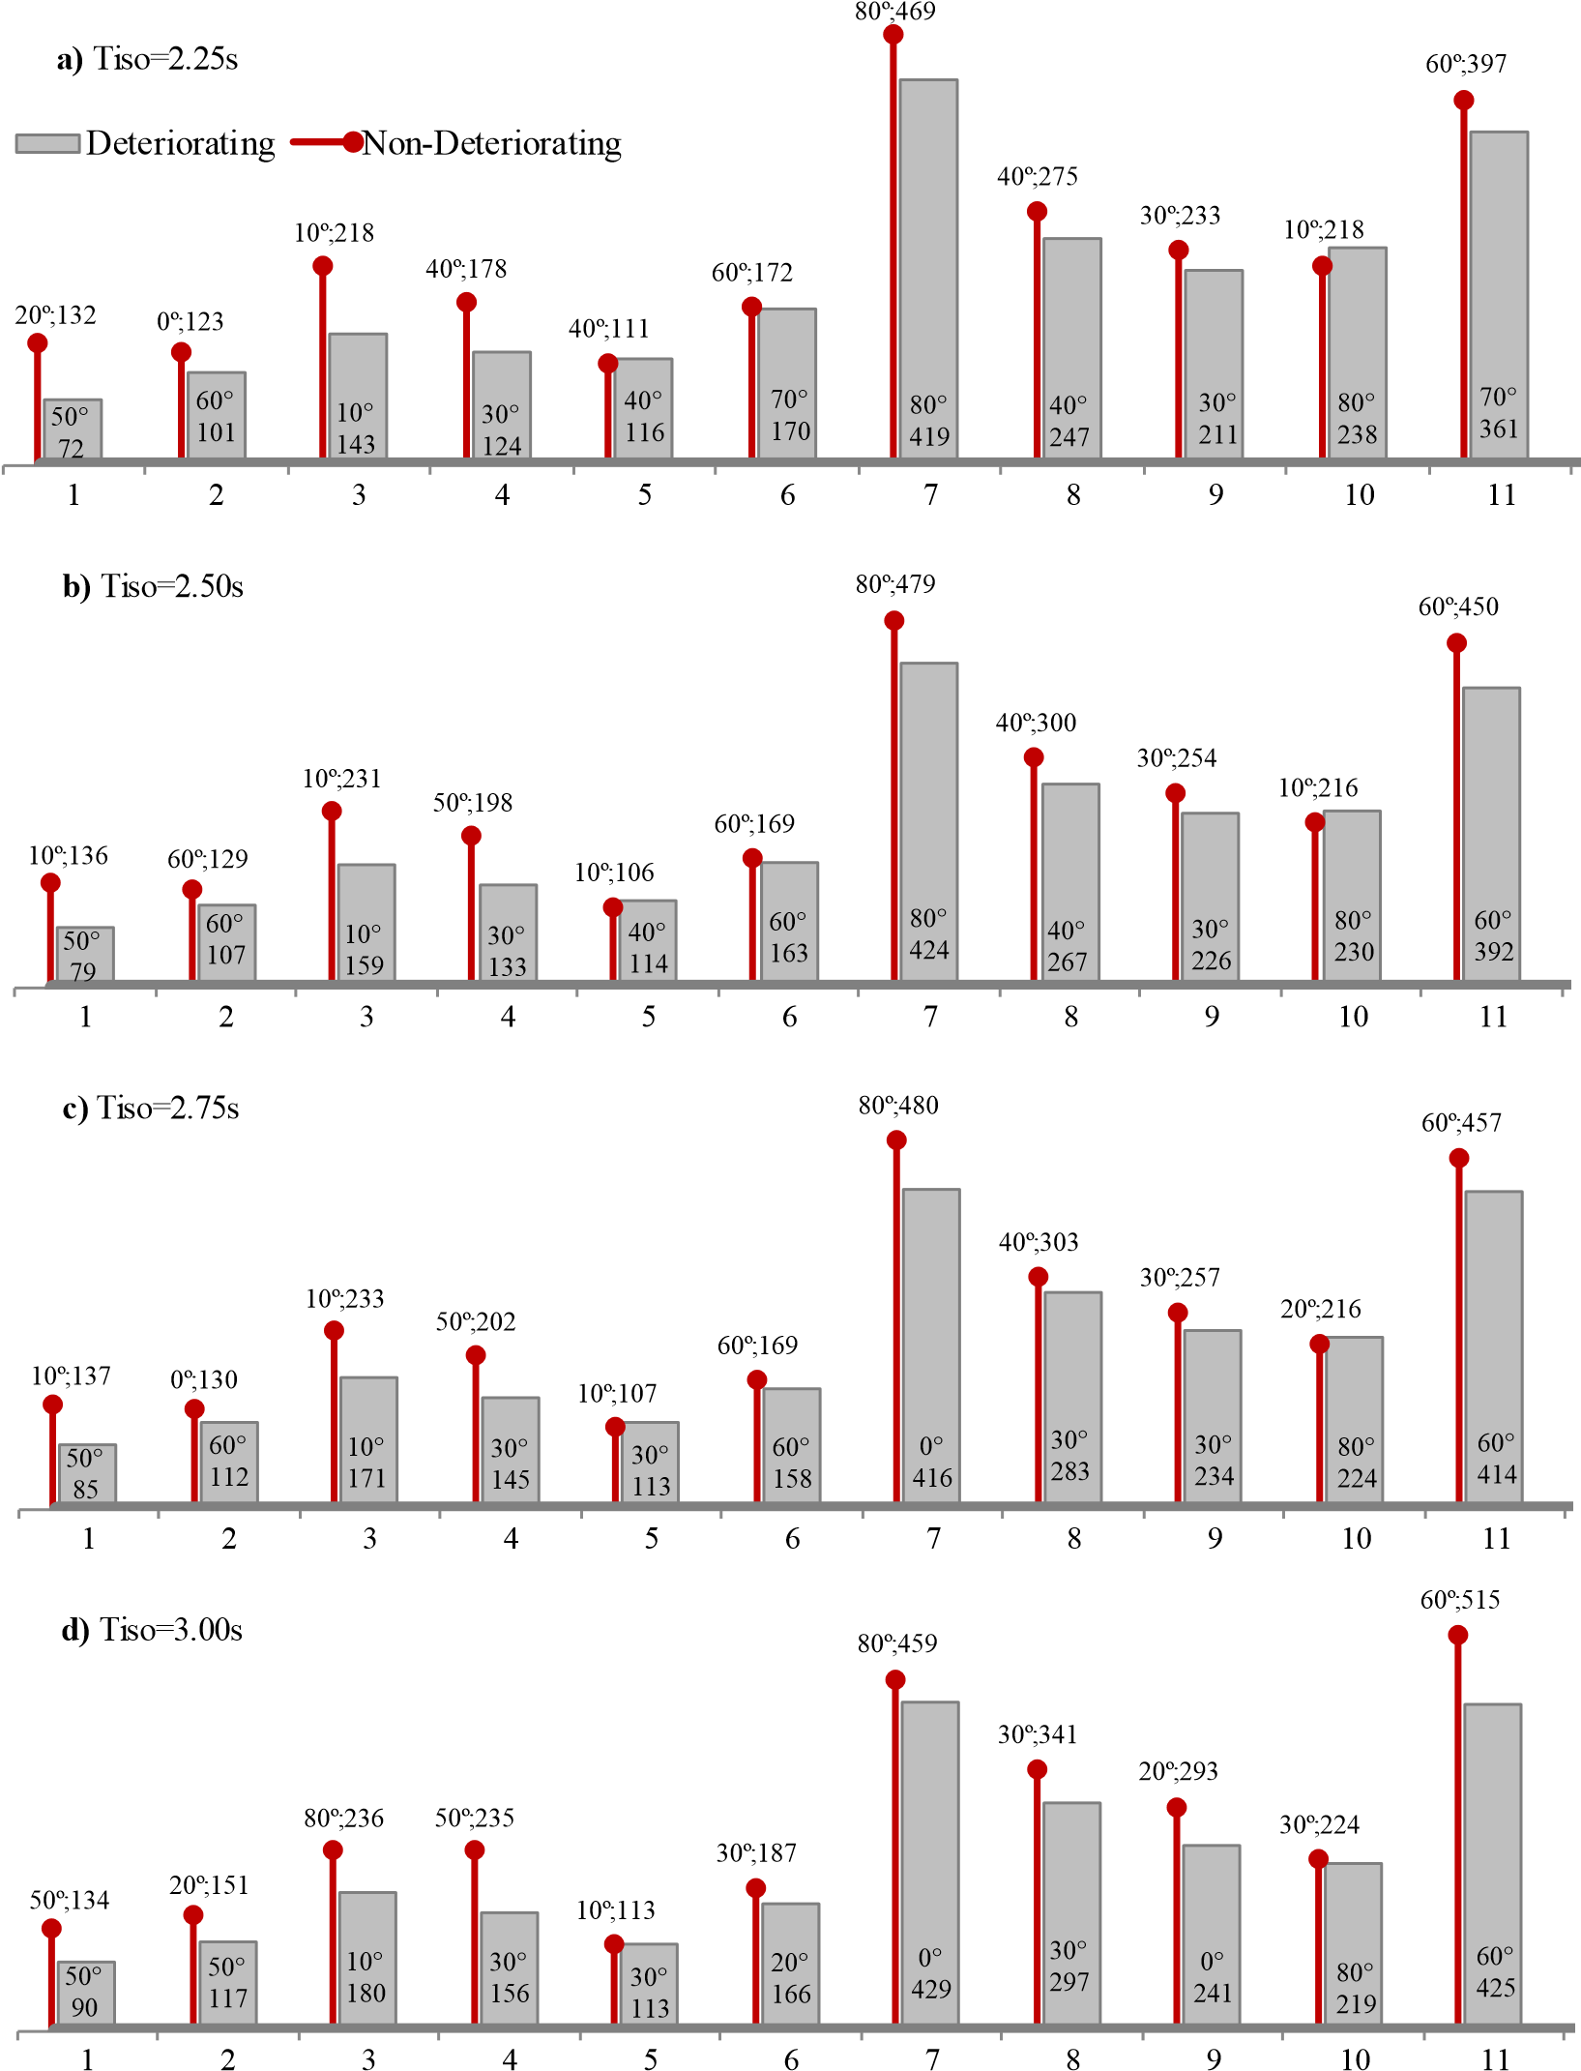
MID (mm)
MID (mm)
MID (mm)
MID (mm)
MID (mm)
MID (mm)

EQ #

Figure 4. Variation of maximum direction of ground motions according to the isolation system period and bilinear representation of LRBs. a) T_{iso}=2.25s, b) T_{iso}= 2.50s, c) T_{iso}=2.75s, d) T_{iso}=3.00s.

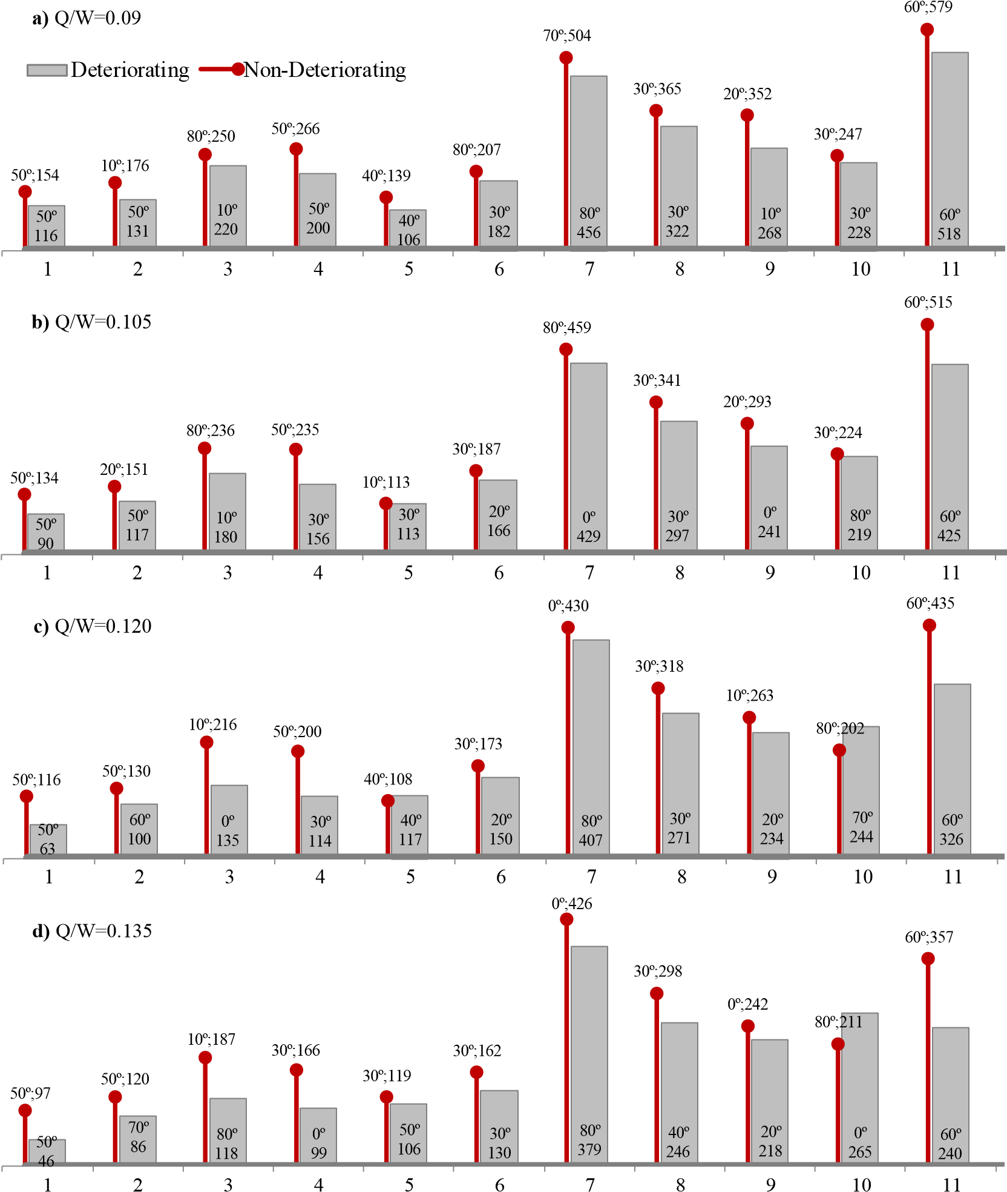
MID (mm)
MID (mm)
MID (mm)
MID (mm)

EQ #

Figure 5. Variation of maximum direction of ground motions according to the Q/W ratio and bilinear representation of LRBs. a) Q/W=0.09, b) Q/W=0.105, c) Q/W=0.120, d) Q/W=0.135.

5. CONCLUDING REMARKS

This study investigated the variation of maximum-direction of ground motions due to change in important characteristics of isolator units considered during the design of seismically isolated structures. For this purpose, Q/W ratio and isolation period are selected as parameters together with the hysteretic idealizations of LRBs used in the analyses. Results of nonlinear response history analyses revealed that maximum-direction of ground motions may change for different characteristics of isolator units. Furthermore, using deteriorating or nondeteriorating hysteretic representations for LRBs may also change the maximum-direction of ground motions.

6. REFERENCES

ASCE. (2010) Minimum design loads for buildings and other structures, ASCE/SEI 7-10, Reston, VA.
Athanatopoulou A. (2005) Critical orientation of three correlated seismic components. Engineering Structures, 27(2): 301-312.
Dicleli M. (2006) Performance of seismic-isolated bridges in relation to near-fault ground-motion and isolator characteristics. Earthquake Spectra, 22(4): 887-907.
FEMA 451. National earthquake hazard reduction program (NEHRP) (2006) recommended provisions: design examples, Building Seismic Safety Council, National Institute of Building Sciences, Washington.
Goda K., Taylor C.A. (2012). Effects of aftershocks on peak ductility demand due to strong ground motion records from shallow crustal earthquakes. Earthquake Engineering and Structural Dynamics, 41(15): 2311-2330.
Kalkan E., Kwong N.S. (2012) Evaluation of fault-normal/fault-parallel directions rotated ground motions for response history analysis of an instrumented six-story building. US Department of the Interior, US Geological Survey.
Kalkan E., Kwong N.S. (2014) Pros and cons of rotating ground motion records to fault-normal/parallel directions for response history analysis of buildings. Journal of Structural Engineering, 140(3): 04013062.
Kalpakidis I.V., Constantinou M.C. (2009) Effects of heating on the behavior of lead-rubber bearing. I:theory. Journal of Structural Engineering, 135: 1440-1449.
Kalpakidis I.V., Constantinou M.C. (2009) Effects of heating on the behavior of lead-rubber bearings. II: verification of theory. Journal of Structural Engineering, 135(12): 1450-1461.
Khoshnoudian F. and Poursha M. (2004). Responses of three dimensional buildings under bi-directional and unidirectional seismic excitations. In Proceedings of the 13th World Conference on Earthquake Engineering, 1-6.
Mavroeidis G.P., Papageorgiou A.S. (2003) A mathematical representation of near-fault ground motions. Bulletin of the Seismological Society of America, 93(3): 1099-1131.
Mavronicola E.A., Polycarpou P.C., Komodromos P. (2017) Spatial seismic modeling of base-isolated buildings pounding against moat walls: effects of ground motion directionality and mass eccentricity. Earthquake Engineering and Structural Dynamics, 46(7): 1161-1179.
OpenSees. (2009) Pacific earthquake engineering research center, University of California, Berkeley. http://opensees.berkeley.edu.
Ozdemir G., Erseker B., Avşar O. (2016) On the variation of maximum isolator displacements due to ground motion directionality. Interaction Between Theory and Practice in Civil Engineering and Construction, 229-234.
Rigato A.B., Medina R.A. (2007) Influence of angle of incidence on seismic demands for inelastic single-storey structures subjected to bi-directional ground motions. Engineering Structures, 29(10): 2593-2601.
Somerville P.G., Smith N.F., Graves R.W., Abrahamson N.A. (1997). Modification of empirical strong ground motion attenuation relations to include the amplitude and duration effects of rupture directivity. Seismological Research Letters, 68(1): 199-222.
Tezcan S.S., Alhan C. (2001). Parametric analysis of irregular structures under seismic loading according to the new Turkish Earthquake Code. Engineering Structures, 23(6): 600-609.

Master’s Degree Student, Eskisehir Technical University, Eskisehir, Turkey, esengul_cavdar@eskisehir.edu.tr
Assoc. Prof. Dr., Eskisehir Technical University, Eskisehir, Turkey, gokhan_ozdemir@eskisehir.edu.tr

