**DEVELOPMENT OF SEISMOISOLATION IN RUSSIA**

**DOI 10.37153/2686-7974-2019-16-82-97**

Belash T.A., Kostarev V.V. , Rutman Ju.L., Uzdin A.M.

**1. Introduction**

In the former USSR seismic isolation research began developing actively in the early 1970s. This development was based on the work of 5 groups of experts:

* A group of seismic isolation enthusiasts. The most famous among them were Eng. F.D.Zelenkov, Dr. V.V.Nazin, Prof. Yu.D.Cherepinsky and Prof. A.V.Kurzanov.
* Experts of Central Research Institute of Building Structures in Moscow. Representatives of this scientific school headed by Professor J.M. Eisenberg were Dr. L.Kilimnik, Dr. V.Smirnov, Prof. A.Abakharov.
* Representatives of Saint-Petersburg scientific school headed by Professor O.A.Savinov. There one could note Prof. T.A.Belash, Prof. I.U.Albert, Prof. A.M.Uzdin, Dr. I.O.Kuznetsova and Dr. A.A.Dolgaya
* Experts of the Defense Ministry, who successfully worked out seismoisolation systems for military objects. Among them there were a lot of famous experts such as Prof. K.N.Shkhinek, Prof. V.S.Beliaev. Now representative of military concept Prof. Yu.L.Rutman is the leading expert in the field of seismic isolation in Russia.
* Private firms that have arisen on the ruins of scientific institutions of the socialist construction industry. The process of establishing of such companies was extremely difficult, but now we can name the companyCKTI-Vibroseism (CVS) headed by Dr. Kostarev as a successful one.

**2. Seismic isolation enthusiasts**

At the end of the 50-s of the last century, due to the growth of construction in seismic prone areas, many engineers were carried away with the idea of seismic isolation but they had no scientific basis. They were sometimes wrong, but nevertheless their work led to creation of the seismic isolation theory. More than 500 seismic isolated buildings and structures were built in the former Soviet Union owing to their efforts. The most interesting results are described below.

**Seismoisolated buildings designed by F.D.Zelenkov in Ashgabat, 1959**

Two buildings with suspended foundations were constructed in Ashgabat in 1959 [1]. They have been in operation so far. But later seismoisolation was blocked due to extremely small damping in the seismoisolating system and because buildings swayed under the wind and some vehicle actions.

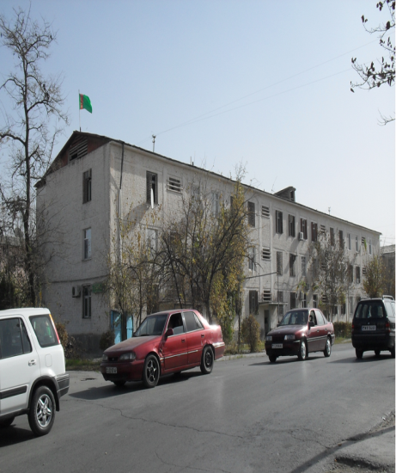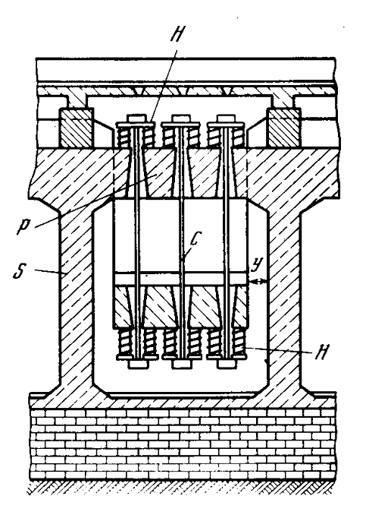

Figure 1.Seismoisoleded building with suspended foundation in Ashgabat and foundation scheme

y - clearance for freedom of a building seismic oscillations; H – springs; C - steel pendants;

P- reinforced concrete girders; S - reinforced concrete frame

Seismoisolation of Dr. V.V.Nazin 1970-1974

Knowing a well-known Chinese solution of a “house on balls” proposed 4000 years ago, Dr.Nazin decided to stiffen the Chinese foundation and built a house on concrete “eggs”[2,3]. The house was tested by a vibromachine and at the level of excitation corresponding to 7-degree earthquake it showed high seismic resistance. Unfortunately, the ”eggs” were too small. Due to great contact stresses, they crumbled after 2 years of operation.

Figure 2. Nazin's Egg Foundations

Later columns cut out of a large “egg” were used as supporting elements. Such houses were built in the Crimea (Simferopol) in the early 70s of the last century. Just like the house by F.D. Zelenkov, these houses were weakly damped.

In the mid-70s, two students of the Simferopol Institute of Resort Service, having studied the resonance theory, shook the house with an amplitude of more than 20 cm at two o’clock in the morning, causing panic. After that, the isolation was blocked out.

**Seismoisolation proposed by Prof. Yuri Cherepinsky**

Yuri Cherepinsky proposed an original construction of seismoisolating foundation (Figure 3, Figure 4) [4,5].

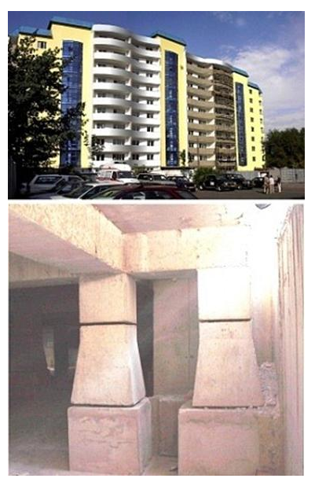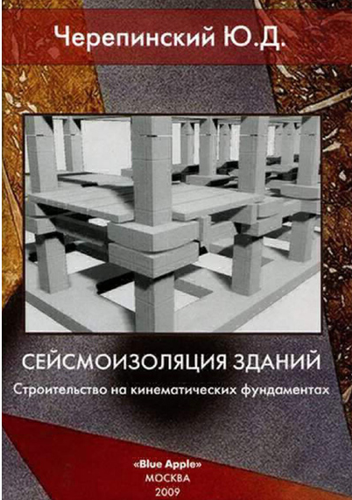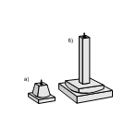

Figure 3. Seismoisolating foundation of Prof. Yu.D.Cherepinsky

Yuri Cherepinsky made great efforts to get dozens of seismically isolated buildings constructed in Kamchatka, Sakhalin and Siberia. He carried out field tests of several buildings, but he had never had any theory of their behavior.

He succeeded in making a unique experiment in Petropavlovsk-Kamchatsky. Two neighboring identical buildings, one with seismic isolation and the other without it, were exposed to vibrators installed in the basement of the buildings. In both cases accelerations of the base were 0.5-0.7 m/s2. To prove the advantages of his seismoisolation system, a table with food and drinks placed on the fifth floor of both buildings for gests. In the non-isolated building a banquet could not be held because utensils jumped on the table and glasses with vodka tipped over. In the seismically isolated building the banquet went successfully. However it is necessary to stress that under a 9-degree action these buildings can jump off the supports and turn into piles of construction waste.

**Seismoisolation by Prof. A.V.Kurzanov**

The supports by A.V.Kurzanov (Figure 4) are similar in principle to supports by Yu.D.Cherepinsky, but it is easier to manufacture them and to analyze their behavior [6,7]. Kurzanov got a number of residential buildings constructed on such support in some places including Sochi. Just like Cherepinsky, he conducted field tests of seismically isolated buildings, but he did not have any theory of mathematical analysis of their behavior. Such theory was worked out later, in particular, motion equation of buildings with Kurzanov and Cherepinsky foundations were obtained by A.Dolgaya and A.Uzdin [7,8]. They can be presented in the following form:

for Kurzanov foundations

 (1)

for Cherepinsky foundation

 (2)

Here .

All symbols are explained in Figure 4, which also presents force-displacement diagrams for the supports considered.

|  |  |
| --- | --- |
| b)  a) |  |
|  |  |
| Figure 4. Supports by Prof. Yu.D.Cherepinsky (a) and A.V.Kurzanov (b)  and their force-displacement diagrams | |

**3. Moscow school of seismoisolation. Central Research Institute of Building Structures**

The founders of the Moscow school of seismic isolation were Professor Jakobn Eisenberg and Dr. Leonid Kilimnik.

**Dr. L.Kilimnik** promoted the constructing of buildings with a seismic isolating sliding belt (Figure 5) [9,10]. Unfortunately, he died at the age of about 50 and his work on seismic isolation remained unfinished. However, more than 50 buildings with a sliding belt were built on Sakhalin and in Kyrgyzstan.

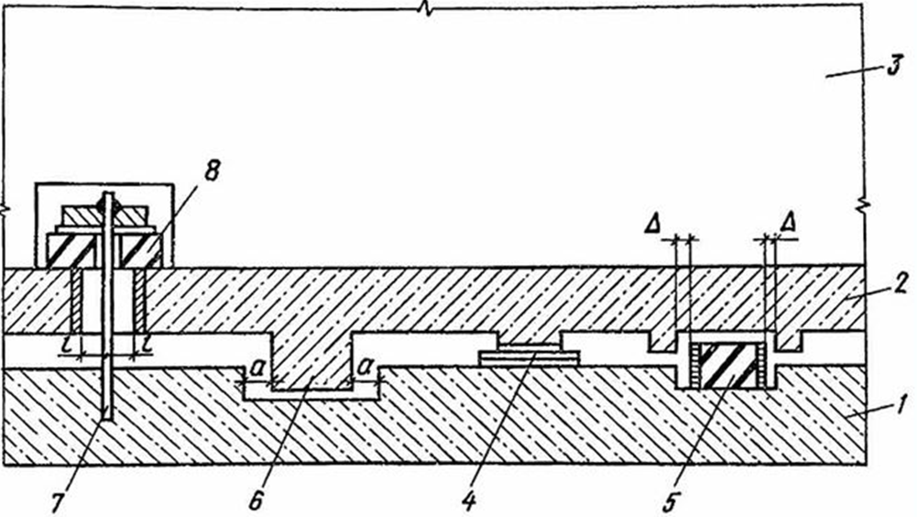

Figure 5. Seismic isolating sliding belt

1 - foundation piling; 2 – grid; 3 – building; 4 – sliding bearing; 5 – elastic restrictor; 6 – rigid restrictor; 7 – vertical brace; 8 – vertical shock absorber

The design provides for the possibility of structure vibration displacements, but in the designing process the corresponding calculations and setting friction parameters were not performed. Unfortunately buildings can “crawl” and in fact some of them crawled away by about 10 cm under operation loads.

**Prof. J.M. Eisenberg** is the Patriarch of domestic earthquake engineering. He developed adaptive seismic isolation systems [11,12], in particular, systems with switched off members (breaking links) (Figure 6, 7). His solutions were put into practice in the former Soviet Union and, in contrast to the previously considered structures, had a scientific basis and were supported by theoretical and experimental investigations. In the field of theory, Professor **J.M. Eisenberg** introduced the concept of the system state spectrum [13]. This is the dependence of the bearing capacity of the structure on its eigen period in the process of damage accumulation.

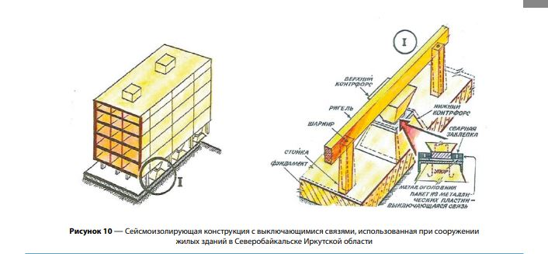

Figure 6. Isolating structure with switched-off links, used in the construction of residential buildings

in Severo-Baikalsk city in Irkutsk Region

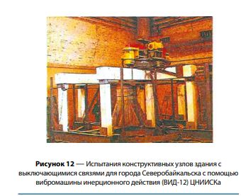

Figure 7. Tests of structural units of a building with switched-off links

T

S

1

2

3

4

Figure 8. Response spectrum and system state spectrum

1 –response spectrum; 2 –system state spectrum;

3 –initial system state; 4 –point of adaptability

J.M. Eizenberg and O. A. Savinov, were the first in the Soviet Union to point out the need of high damping of seismoisolating foundations in order to prevent large mutual displacements of the isolated parts of the structure.

In the 90s after the collapse of the Soviet Union, when the state funding of science practically ceased, J.M. Eizenberg and V. I. Smirnov actively assisted in the using foreign technologies in the practice of seismic isolation in Russia. They collaborated with German, Italy and Chinese firms. With their direct participation, dozens of buildings on rubber bearings were constructed, mainly in Sochi.

**4. Leningrad school of seismoisolation founded and headed by Prof.   
O.A. Savinov**

Oleg Savinov paid great attention to the theoretical foundations of the problem of structure seismic isolation [14].

The first theoretical problem was **that of setting the design seismic input**. In the early studies we were faced with excessively large displacements of seismoisolated buildings. Under long-period inputs mutual design displacements of the base plates came up to one meter or more. It turned out that the calculation results are extremely sensitive to the type of the design input. In the first calculations, the authors used the Seismic Scale in law [32,33] and normalized the design accelerations along the upper boundary of this Scale. In the research process the relationship between PGA and the prevailing action period was established: the longer the period, the smaller the acceleration. This result was obtained by A.A.Dolgaya on the base of analyzing about 240 earthquake records with intensity 8 on the MSK scale [15]. The dependence of the PGA on the prevailing input period is shown in figure 9. The same result was obtained later by Chinese and Russian experts [16] on the base of analyzing about 100 earthquake records with intensity 9 on the MSK scale (Figure 10).



Figure 9. Dependence of the PGA on the prevailing input period for earthquakes with intensity 8 on the MSC scale in accordance with [15].

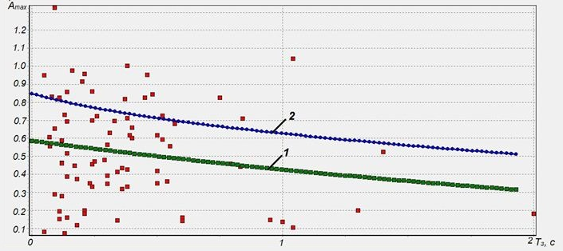

Figure 10. Dependence of the PGA on the prevailing input period for earthquakes with intensity 9 on the MSC scale in accordance with [16].

The results obtained are the basis for the fundamental conclusion that **the optimal seismoisolation damping does not depend on the input spectral composition**.

Another important result obtained under O. Savinovs’ leadership was the **substantiation of overdamping seismoisolation systems.**

This result for **systems with viscose damping** is explained in Figure 11 [17]. Here three gain-frequency characteristics for non-isolated (curve 1), for low-damped isolated (curve 2) and for high-damped isolated (curve 3) systems are shown.

|  |  |
| --- | --- |
|  |  |
| Figure 11. Gain-frequency characteristics for non-isolated (1) and isolated (2,3) systems  2- low-damped system, 3- high-damped system | |

Very often an earthquake has the predominant frequency in the range of 15-20 c-1 and the non-isolated system has the resonant peak at the point A. Seismoisolation decreases multiply system displacements from point A to point B, and the decreasing effect is noticeably worse for the high-damped system, which is clearly seen in the fragment of the gain-frequency characteristics in the right part of Figure 11. But expect this effect to take place, but real life can give one a surprise. We expect a high-frequency earthquake, but in fact but face with law-frequency. In this case instead of point B we can get point C and the structure collapse. In this case the high-damped seismoisolation can save the situation. Although high-damped isolation is less effective than law-damped one, it prevents dangerous resonant system displacements.

For results obtained [8] for **systems with dry friction damping** are illustrated in Figure 12.

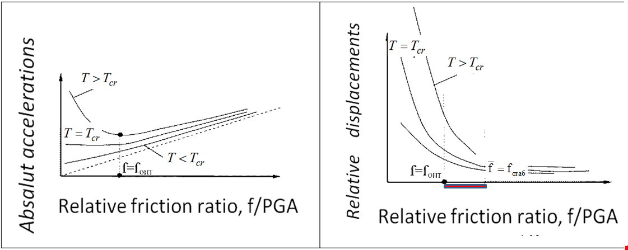

Figure 12. The dependences of absolute accelerations and relative displacements on the relative friction ratio

For system under consideration there is some critical period of seismoisolation Tcr. If T<Tcr , the dependence of peak structure acceleration does not have the minimum, i.e. the greater the dry friction coefficient “f” the greater structure accelerations. If T>Tcr, there is minimum of peak structure accelerations at f=fopt. The other important value of friction coefficient is a stabilizing one denoted by fst. At f>fst, the structure displacement stops changing. As a result, one can single out the area of f-value fopt<f<fst,in whichone should look for the seismoisolation damping. This area was called the “working area”[7,8]. In each case it is better to overdamp the system than to underdamp it [18]. This statement is illustrated in Figure 13. There are two dependences of acceleration on the friction ratio: for 8 degree (1) and for 9-degree (2) earthquakes. We expect to deal with an 8-degree earthquake and design acceleration of about 2 m/s2, but the God sends us a 9-degree one. One can see what happens with damped and overdamped systems. The damped system gets accelerations equal to 6.2 m/s2 and the overdamped one - only 4.2 m/s2.It can save the system from the collapse but one has to pay for everything and at the same time the structure accelerations increase from 2 to 3 m/s2 under 8-degree earthquake.

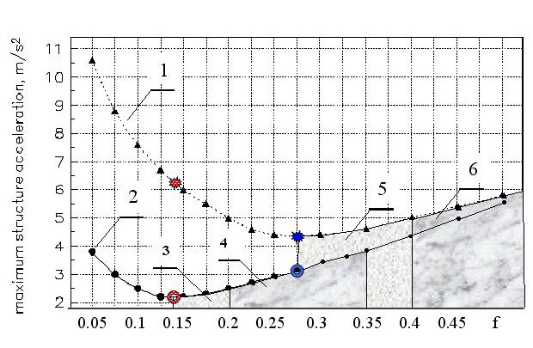

Figure 13. Dependences of structure acceleration on the friction ratio:

for 8 degree (1) and for 9-degree (2) earthquakes

3 – the working area for I=8; 4 – the overdamped area for I=8

5 – the working area for I=9; 6 – the overdamped area for I=9

**Isolating sliding belt** was also analyzed to find its reasonable damping [19]. These investigations are illustrated in Figure 14.

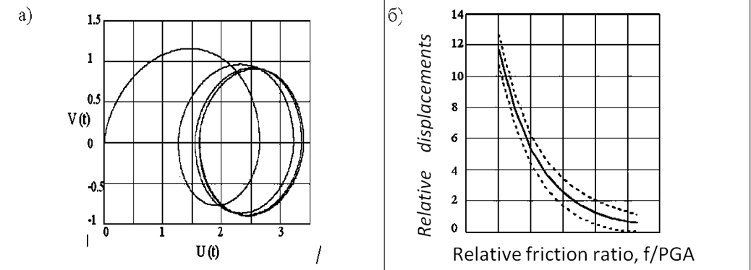

Figure 14. The trajectory of the building movement on the phase plane (a) and the dependence of the building displacement on the relative friction ratio (б)

The solid line is one is sided shift, the dotted lines are the oscillation amplitude

Under earthquakes buildings with sliding belts get on-side shift plus displacements caused by oscillations. Analyzing the damping influence on mentioned members of structure displacement made it possible to present the one dependence of structure movement on the friction damping in the belt, shown in Figure 14b.

In 1989-1991 Petersburg University worked out the problem of constructing buildings on the week water-saturated soils [20]. There were proposed to use together compacted soil pad and seismoisolated foundation. An example of calculating analysis of this system is shown in Figure 15.

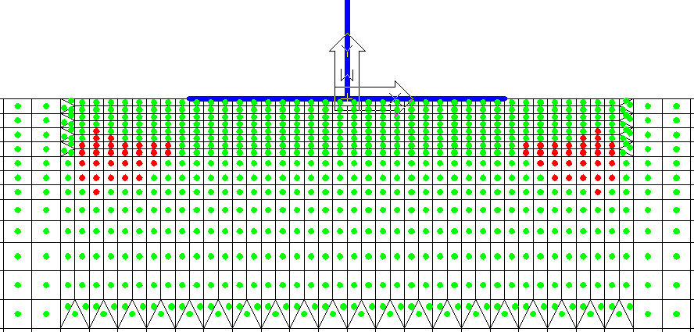

Figure 15. Areas of the limit state of the soil massif under seismic input with the intensity of 9-degree on the MSK scale for the isolated building on the 3-meter thick soil pad

**Original seismic protection systems** were worked out by the Leningrad school experts, in particular isolated hydroengineering and transport structures. Under the leadership of Professors O.Savinov and I.Sheinin pneumoprotection of dams and tanks [7, 21] was worked out/ Examples of such solutions are shown in Figure 16. In these cases the air is the elastic element of isolating system.

|  |  |
| --- | --- |
|  |  |
| Figure 16. Pneumoprotection  1 – reservoir; 2 – liquid; 3 – tank with air; 4 – support;  5,6 - pressure diagrams with the pneumoprotection and without it | |

The Leningrad school of seismoisolation worked out engineering principles of bridge seismoprotection. They were used in constructing the Sochi - Adler railway line. The idea of such protection is illustrated in Figure 17. The protected structures are described in papers [22].

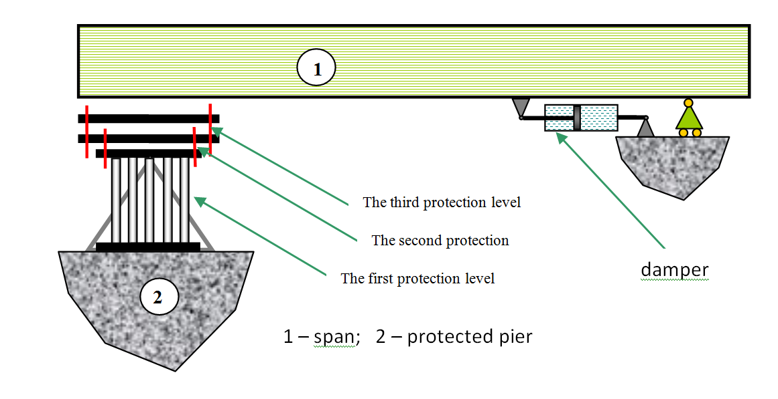

Figure 17. Principle diagram of bridges seismoisolation in Sochi

**5. Experts of the Defense Ministry**

Since the end of the 70s, the Ministry of Defense (DM) has done research on the problems of seismic isolation of various kinds of military facilities of various complexity and responsibility degrees. In addition to serious theoretical studies, the DM had unique experimental bases in which large-scale experimental studies were conducted (Figure 18). On the DM testing ground site a four-story house in actual size could be tested up-to destruction.

|  |  |
| --- | --- |
|  |  |
| Figure 18. Large-scale test shaketables  The DM experts have developed original supporting parts for the structure seismic isolation. In particular, in the Design Office of Special Engineering (KBSM) plastic seismic isolating supports have been developed, which were discussed in detail in [23,24,25]. Note, that similar supports have been independently developed in Japan. These supports are shown in Figure 19 | |
|  |  |
| Рисунок 19. Пластические демпферы КБСМ и фирмы “Sumitomo Metal Mining”  KBSM and “Sumitomo Metal Mining” plastic dampers | |

Original seismic isolation systems were developed for seismic protection of nuclear power plants. [26].

Based on the previous experience of creating systems for shock and vibration protection of defenses [27] new systems of seismic isolation were developed in KBSM in 2007-2011, under the leadership of V.D. Guskov and Yu, L.Rutman. The result of this work was the pendulum seismic isolation system (PSIS) shown in Figure 20, protected by patents [28-31] and, further, certified in Russia. Models of these pendulum supports were tested on the above-mentioned seismic shake-table near Vyborg [23] (Figure 21).

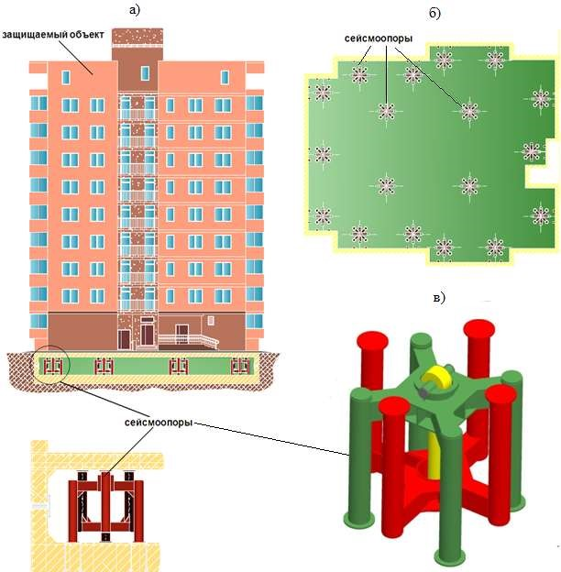

Figure 20. The seismic isolation system developed by the KBSM firm:

a - a building located at the PSIS; b - top view; c - 3D model of PSIS

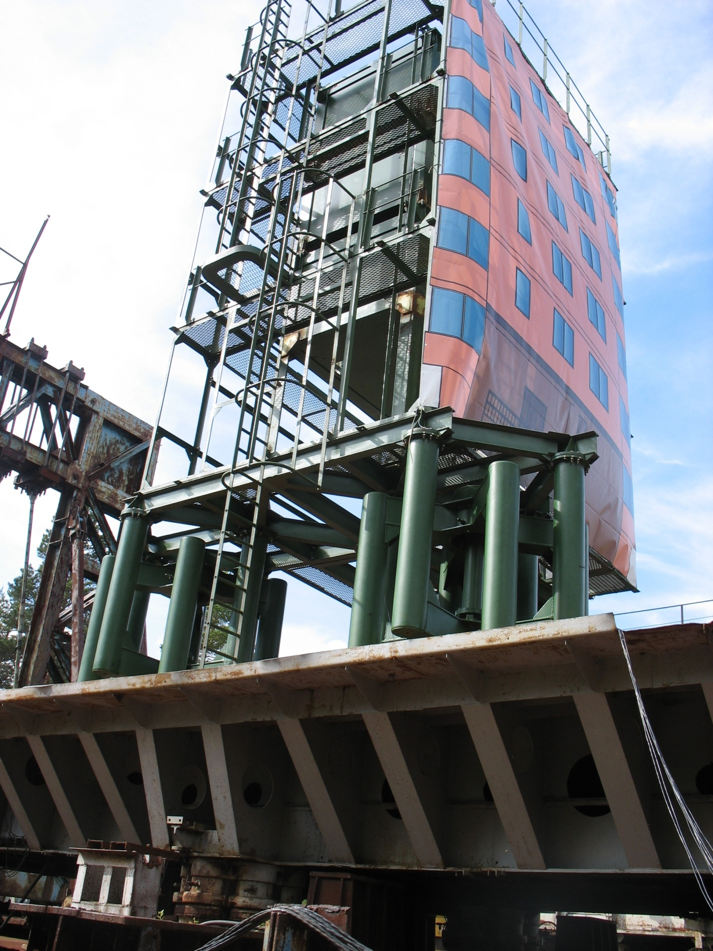

Figure 21. Testing the building model with the KBSM PSIS

**6. Private firms, developing seismoisolating systems**

Some private firms have arisen on the ruins of scientific institutions of the socialist construction industry. For example, Stroycomplex-5 worked out and manufactured earthquake protection devices for bridges in Sochi [22]. But the authors consider that there is only one firm in Russia, CKTI-Vibrosesm, which is able to carry out the whole work complex providing for the use seismoisolation in different projects. On the one hand, this firm has a base to calculate, design, test and manufacture complex seismoisolating systems. Testing center of CKTI-Vibroseism firm is shown in figure 22. In their tests the platform does not shake but the structure does at all natural frequencies providing the full scope of loads and deformations for all seismic isolated system elements.

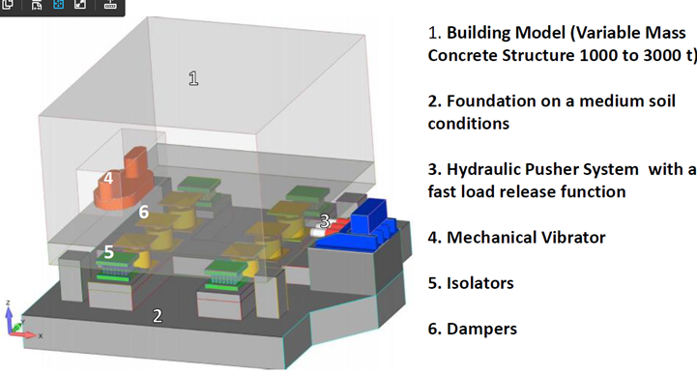

Figure 22. Testing center of CKTI-Vibroseism firm.

CKTI-Vibroseism firm promotes isolating devices consisting of Vibroseism damper and Herb-spring (Figure 23).

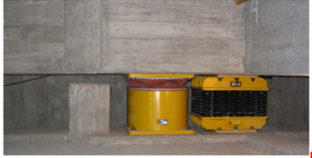

Figure 23. Arrangement of spring and damper devices

**7. Литература**

Зеленьков Ф.Д. Предохранение зданий и сооружений от разрушения с помощью сейсмоамортизатора.М.:Наука.-1979.-49 с.

Назин В.В. Индустриализация строительства сооружений сейсмостойкой конструкции. Киев, Будивельник, 1977.

Назин В.В. Фундамент сейсмостойкого здания: А.с. N344094,кл. Е04Н 9/02, Е04D 27/34, 1972.

Черепинский Ю.Д. Сейсмоизоляция жилых зданий. Алматы, 203, 157

Черепинский Ю.Д., Жунусов Т.Ж., Горвиц И.Г. Активная сейсмозащита зданий и сооружений. Алма-Ата: КазНИИНТИ.-1985.-32с.

Курзанов А.В., Ахмедов А.М. Натурные исследования трехэтажного фрагмента и пятиэтажного здания на сейсмоизолирующих опорах // Экспресс-информация ВНИИИС. Сер.14. Сейсмостойкое строительство, 1994, Вып.2-3, с.24-32.

Уздин А.М., Елизаров С.В., Белаш Т.А. Сейсмостойкие конструкции транспортных зданий и сооружений. Учебное пособие. ФГОУ «Учебно-методический центр по образованию на железнодорожном транспорте», 2012-500 с.

Уздин А.М., Долгая А.А. Расчет элементов и оптимизация параметров сейсмоизолирующих фундаментов. М., ВНИИНТПИ, 1997, 76 c

Килимник Л.Ш., Казина Г.А. Современные методы сейсмозащиты зданий и сооружений// Обзор/М.,ВНИИИС,1987,65 с.

Килимник Л.Ш., Солдатова Л.Л., Ляхина Л.И. Анализ работы зданий со скользящим поясом с использованием многомассовой расчетной модели. Строительная механика и расчет сооружению 1986, № 6. с.96-73.

Айзенберг Я.М. Исследования адаптивных систем сейсмозащиты и методов сейсмоизоляции (Координационное совещание, Алма-Ата, март, 1979) // Сейсмостойкое строительство, 1980, Вып.1, с.32-34.

Айзенберг Я.М. Сооружения с выключающимися связями для сейсмических районов. М.:Стройиздат.-1976.-229 с.

Айзенберг Я.М. Спектры состояния систем с деградирующей жесткостью и их применение для оценки сейсмической реакции сооружений.//Экспресс-информация ВНИИИС. Сер.14.Сейсмостойкое строительство.-1981.-Вып.6.- с.24-29.

Савинов О.А. Сейсмоизоляция сооружений (концепция, принципа устройства, особенности расчета).// Избранные статьи и доклады "Динамические проблемы строительной техники", С.-Петербург, 1993, с.155-178.

Долгая А.А. Моделирование сейсмического воздействия коротким временным процессом. // Э-И. ВНИИНТПИ. Сер. “Сейсмостойкое строительство”, Вып. 5-6., 1994, с.56-63

Уздин А.М., Нестерова О.П., Прокопович С.В., Долгая А.А., Чанг Юань, Гуань Юхай, Ван Хайбинь. Моделирование сейсмических воздействий для динамического расчета зданий и сооружений. Российско-китайский научный журнал «Содружество» Ежемесячный научный журнал научно-практической конференции, 2017 № 20 1 часть, с. 59-66

Уздин А.М., Давыдова Г.В. Фундаменты в сейсмически опасных районах. В сб. Труды юбилейной конференции, посвященной 50-летию РОМГГиФ, Том 2, М., РОМГГиФ, 2007, с. 190-196

Uzdin A.M., Davidova G.V. Why the overdamped isolation is better than the underdamped one. 10-th World Conference on Seismic Isolation, Energy Dissipation and Active Vibrations Control of Structures, Istanbul, Turkey, May 28-31, 2007, CD, paper №GA15

Давыдова Г.В., Ермошин А.А., Румянцев А.Ю., Уздин А.М. Оценка перемещений зданий с сейсмоизолирующим скользящим поясом. Сейсмостойкое строительство. Безопасность сооружений. 2007, №3, с. 34-36

Уздин А.М., Ильясов А.Б. О системном подходе к анализу динамического взаимодействия «сооружение-фундамент-основание» при расчете сейсмостойких сооружений. Основания, фундаменты и механика грунтов, 2014, №3, c. 10-16

Савинов О.А., Шейнина С.И. К анализу сейсмозащитных свойств воздушной завесы. Известия ВНИИГ, 1980, 1, 140, с.84-89

Kuznetsova I.O., Uzdin A.M., Zhgutova T.V., Shulman S.A. Seismic protection of railway bridges in Sochi. PROCEEDINGS OF WORKSHOP “Bridges seismic isolation and large-scale modeling” Saint-Petersburg 29.06 - 03.07.2010. - pp. 39 – 41.

Beliaev V.S. Support-Pendulum Seismic Isolation System for Large NPP Equipment // Trans. SMiRT-22. San-Francisco, California, USA. August 18-23, 2012

Пространственные пластические демпферы, методы их расчета и экспериментальные исследования Гуськов В.Д., Рутман Ю.Л. Труды международной конференции «Четвертые Окуневские Чтения», Санкт – Петербург, 2004.

Устройства для сейсмоизоляции зданий, промышленных объектов и их оборудования. Ю.Л.Рутман. Труды шестой Российской национальной конференции по сейсмостойкому строительству и сейсмическому районированию, Сочи, 2005.

Seismic Protection nuclear and non-nuclear plants: 3D elastic-plastic dampers. Рутман Ю.Л., Беляев В.С., Гуськов В.Д. Proceedings of the 10th World conference on Seismic Isolation, Energy Dissipation and Active Vibrations control structures, 28–31 May 2007, Istambul

«Системы сейсмоизоляции гражданских и промышленных зданий и устройства защиты оборудования этих объектов от экстремальных воздействий». Труды шестых Окуневских чтений, СПб, 2008, с.39-44, Рутман Ю.Л., А.М. Амелин, В.В. Грунин, В.Д. Гуськов, В.Г. Долбенков, К.Б. Ходасевич.

Патент №2367744, зарегистрирован 29.09.2009: «Устройство для защиты сооружения от сейсмического воздействия » Гуськов В.Д., Долбенков В.Г., Зайцев Б.И., Рутман Ю.Л., Смирнов В.И., Ходасевич К.Б.

Патент №2369693, зарегистрирован 10.10.2009: «Опора сейсмостойкого сооружения», Амелин А.М., Грунин В.В., Гуськов В.Д.,Зайцев Б.И., Рутман Ю.Л, Ходасевич К.Б..

Патент № 2427693, зарегистрирован 27.08. 2011: «Опора сейсмостойкого сооружения», Амелин А.М., Гуськов В.Д. Долбенков В.Г., В.Д.,Зайцев Б.И., Рутман Ю.Л, Сивков А.Н., Смирнов В.И., Ходасевич К.Б.

Патент № 2405096, зарегистрирован 27.11.2010: «Опора сейсмостойкого сооружения», Амелин А.М., Гуськов В.Д. Долбенков В.Г., В.Д. Зайцев Б.И., Рутман Ю.Л, Сивков А.Н., Ходасевич К.Б.

ГОСТ Р З 57546-2017. ЗЕМЛЕТРЯСЕНИЯ. Шкала сейсмической интенсивности. М., Стандартинформ, 2017, 28 с.

ГОСТ 6249-52 «Шкала для определения силы землетрясений в пределах от 6 до 9 баллов».