Experimental Investigation on transverse steel damper seismic system for cable-stayed bridges under earthquake sequences

DOI 10.37153/2686-7974-2019-16-50-60

Aijun Ye, Lianxu Zhou

ABSTRACT

The conventional transverse fixed system for cable-stayed bridges is often adopted in current engineering practices, which inevitably increases seismic demands at bents, towers and foundations. To address this issue and improve the seismic performance of cable-stayed bridges in transverse direction, a novel transverse steel damper seismic system (TSDSS) has been developed. Considering that multiple strong aftershocks may occur shortly after a destructive main shock, the reliability and seismic performance of TSDSS under ground motion sequences are experimentally studied herein. A series of experiments on a 1/35-scale model of Sutong Bridge with a main span of 1088m are conducted on a four-shake-table testing system, in which two synthetic ground motion sequences are adopted as input. Test results show that (1) TSDSS significantly reduces lateral horizontal force demands at the deck-bent/tower connections, and reduces curvature demands at bent bottoms and along tower shafts, meanwhile limiting the relative displacement at deck-bent/tower connections to an acceptable level for practice. (2) A gradual increase in residual deformations of TSD under ground motion sequences are recorded, but it has little impact on seismic performance of cable-stayed bridges. (3) In general, the TSDSS is experimentally validated to be a reliable and efficient seismic strategy for cable-stayed bridges.

Keywords: Shake table test; Cable-stayed bridges; Isolation system; Transverse steel damper; Earthquake sequences

1. INTRODUCTION

A considerable number of cable-stayed bridges have been built around the world in the past thirty years. Most of them act as key roles in national or local transportation networks. Due to the considerations of structural importance and the repair difficulty of earthquake-induced damages especially to bridge towers and foundations, these main components of cable-stayed bridges should remain elastic state under design-level earthquakes stipulated in Chinese specifications for seismic design of bridges(China 2011; MCPRC. 2008). In the longitudinal direction of cable stayed bridges, an excellent seismic performance has been achieved by using Fluid Viscous Dampers (FVD) to reduce the shear and bending demands at tower bottoms meanwhile to limit the displacement demands at deck (Martínez-Rodrigo and Filiatrault 2015; Soneji and Jangid 2007; Ye A, Hu S. 2004). In the transverse direction, however, the conventional transverse fixed system is often adopted in engineering practices. In this system, rigid constrains are applied at deck-bent (or pier) and deck-tower connections for providing enough stiffness to carry traffic and wind loads from normal service conditions, which inevitably increases seismic demands at bents, towers and foundations (Shen et al. 2015; Zhou et al. 2019). To cover the requirements stipulated in the specifications, these components are always designed with sufficient capacity for large seismic excitations, such as increasing section dimensions or reinforcement ratio. This uneconomic strategy renders the demands of transverse isolation systems for cable-stayed bridges.
In recent years, a few transverse seismic systems equipped with damping devices have been developed by the researchers to improve the transverse seismic performance of cable-stayed bridges. For example, a transversal seismic protection system, comprising FVDs and fuse restraints, was installed in Rion-Antirion Bridge in Greece to resist extreme earthquakes (Infanti et al. 2004). Ye et al. (Ye A, Hu S. 2004) investigated the effectiveness of FVDs placed at deck-piers connections for long span cable-stayed bridges. Ismail et al. (Ismail et al. 2013) developed a Roll-N-Cage (RNC) isolator, and investigated the mitigation efficiency of this type of damper for cable-stayed bridges under near-fault earthquakes. Shen et al (Shen et al. 2015, 2017) recently developed a Transverse Steel Damper (TSD) and proposed a new transversal seismic system for long span cable-stayed bridges. In this system, the TSDs were transversely placed at deck-bent connections in parallel with sliding bearings, while rigid constrains were still used in the deck-tower connections. The TSD not only possesses excellent energy dissipation capacity but also can freely accommodate the longitudinal movement of deck under the loads form normal service conditions.
Although several mitigation systems for cable-stayed bridges have been proposed using numerical analyses, their feasibility under real ground motions have not been well verified by experiments. In addition, multiple strong aftershocks may occur shortly after a destructive main shock (Rinaldin et al. 2017). For example, in the 2016 Kumamoto earthquake, three strong shakings (moment magnitude, M_{w} > 6) occurred in Kyushu Island within only three days (Kato et al. 2016; Uchide et al. 2016). Therefore, these dampers in a bridge located in a seismic-prone area may undergo multiple earthquakes in a short time. Note that the supplemental dampers in these isolation systems are usually used to dissipate the earthquake energy. Consequently, the earthquake-induced damages may mainly concentrate in these dampers. In general, those impaired dampers may not be replaced immediately in the gaps of such frequently sequential shakings. Therefore, the seismic performance of cable-stayed bridges under multiple earthquake excitations needs to be investigated; and the reliability of damper devices used as energy dissipation devices for cable-stayed bridges under ground motion sequences should be concerned as well.
This paper aims to experimentally verify the mitigation efficiency of TSDSS for cable-stayed bridges, and investigate the seismic performance and reliability of TSDSS under ground motion sequences. Shake table tests on a 1/35-scaled model of Sutong Bridge with/without TSDs were conducted on a four-shake-table system in the Multi-functional Shaking Table Lab at Tongji University, Shanghai, China.

2. Description for shake table tests

2.1 Scale model design

Sutong Bridge with a main span of 1088 m and two side spans of 500 m (300 +100 +100 m) was taken as a prototype, which is the longest span as-built cable-stayed bridge in China. The total length of this bridge is 2088 m, and the height of twin inverted Y-shaped RC towers is 300 m. FVDs were installed in the longitudinal direction to limit the displacement demands at deck under earthquakes with a return-period of 2500 years, while rigid constrains were adopted at the deck-bent and deck-tower connections. More detailed information can be found in references (Wang et al. 2013; Zhou et al. 2019).
According to the bearing capacity of shake tables at Tongji University, a scale factor of 1/35 for length was adopted, and then a 1/35-scaled model of Sutong Bridge was designed. Table 1 shows main scale factors used in the test model design. Figure 1 shows details of the scale model. The total length of the scale-model is 59.66 m, and the height of tower is 8.58 m. For the experimental feasibility, bents and towers of the scale model were directly mounted on four shake tables (A to D) while the soil-structure interaction was ignored herein. According to the similarity of first three-order dynamic characteristics of structure, the number of cables was reduced to 56 pairs from 272 pairs in the prototype bridge. Each cable in the test model was represented by the 7.7-mm-diameter steel wire rope. The dimensions and reinforcements for cross-section of towers and bents were designed according to the similarity of cross-sectional shear and bending capacities. Based on the similarity of cross-sectional bending stiffness along strong and weak axes, the orthotropic steel box girder in the prototype was represented by a steel box with thickness of 10mm. According to the density scale-factor of 10.5, additional masses are needed to achieve the equivalent dead load and inertial force. Table 2 lists the self-weight and the additional mass attached to the tower/bent shafts as well as deck. Figure 2(a) shows the full-view of the test model.
To monitor the seismic responses of the bridge model, as illustrated in Figure 1, eleven and seven horizontal string potentiometers were arranged along the deck and tower shaft, respectively. The relative displacements at all deck-bent and deck-tower connections were measured by string potentiometers, and the force sensors were used to measure forces transferred from deck to bents and towers as shown in Figure 2(b) and (c). In addition, the average section curvature along the tower column was monitored by a pair of linear potentiometers placed at two opposite faces of the tower column, which can be calculated by Equation (1).

(1)

where is deformation difference between the two linear potentiometers; l is the vertical length of the measured region; is the horizontal distance between the two potentiometers.

Table 1. Main scale factor for bridge model design.

Physical quantity | Length | mass | Time | Elastic models | Acceleration
Value | 1/35 | 0.000245 | 0.169 | 0.3 | 1.0

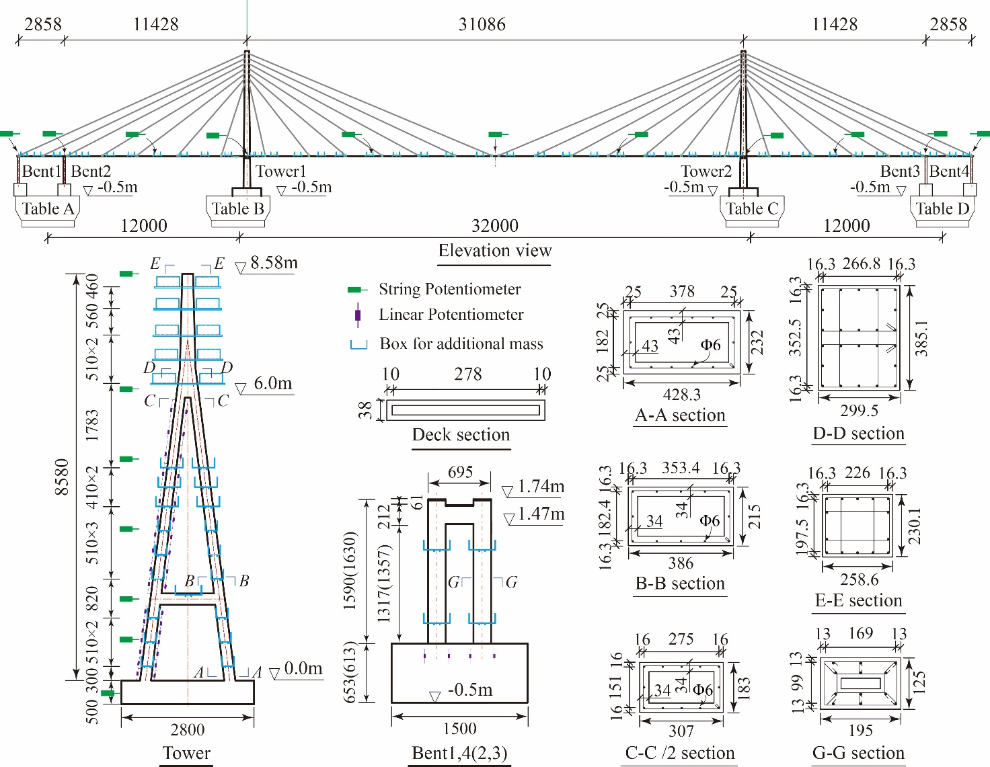

Figure 1. Details of the 1/35-scaled model (unit: millimeter).

Table 2. Self-weight and additional mass of the test model.

Components | Self-weight/kg | Additional mass/kg
Deck | 2970 | 12889
Tower #1 and 2 | 2131 | 13876
Bent #1, 2, 3 and 4 | 210 | 916

2.1 Description for the TSDSS and TFS

Two types of transverse structural systems for cable-stayed bridges were tested. As shown in Figure 2, one is TSDSS. In this system, one TSD was placed at all deck-bent connections in parallel with two sliding bearings, and two TSDs were placed at deck-tower connections. The other for comparison is the conventional transverse fixed system (TFS) with transversely fixed constraints at all deck-bent and –tower connections. The deck in two systems is freely moveable in the longitudinal direction. Note that the forces transferred from deck to bents and towers were measured by force sensors as shown in Figure 2(b) and (c).
Figure 3 presents the configuration of TSD used in the test, which consists of two triangular steel plates with a yield strength of 326 MPa. Each plate has a height of 11 cm, a width of 7 cm and a thickness of 0.3 cm. The yield strength, initial stiffness and post-yield stiffness of the TSD are 0.74 kN, 73 kN/m and 13.5 kN/m, respectively, which is determined by a quasi-static test.

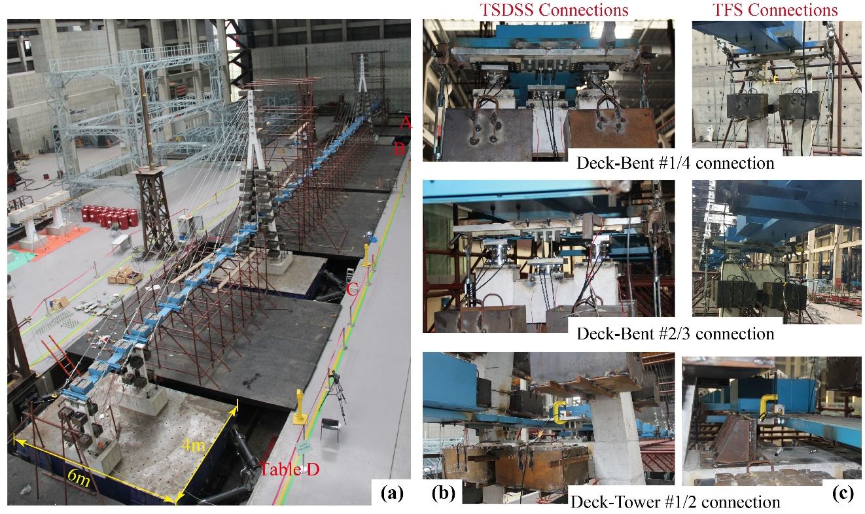

Figure 2. Photo for the shake table test: (a) full-view of bridge model, (b) deck-bent/tower connections in TSDSS and (c) deck-bent/tower connections in TFS.

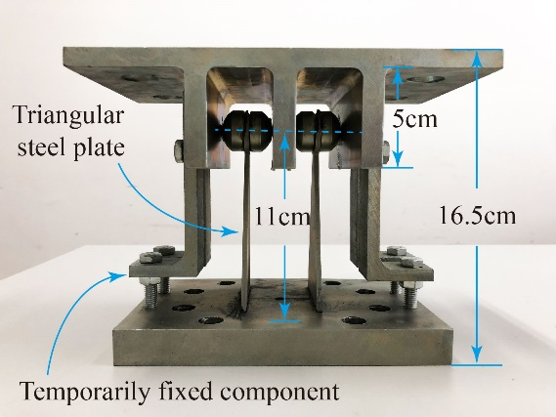

Figure 3. The configuration of TSD used in the test.

3. testing protocol

To investigate the seismic performance of TSDSS under ground motion sequences, three different ground motions with a PGA of 0.5g are selected as input. This intensity is adopted mainly based on two reasons: 1) to keep the towers and bents in elastic state for testing safety and reliability. 2) within the first requirement, to trigger a large seismic demand as far as possible for feasibility of measurement. The information of the adopted ground motions are: (1) Chi-Chi, recorded in 1999 Taiwan earthquake (TCU129 Station, Magnitude, M = 7.62, Source distance, R_{JB} = 1.83 km, Average shear wave velocity at top 30 meters of the site, V_{s30}= 511.18 m/s); (2) El Centro, recorded in 1940 Imperial Valley earthquake (El Centro Station, M = 6.95, R_{JB} = 6.09 km, V_{s30}= 213.44 m/s) and (3) E10, a far-field and soft-site artificial wave, obtained from the report of probabilistic seismic hazard analysis for the site of the Sutong Bridge.
Two synthetic ground motion sequences shown in Figure 4 are adopted as input of TSDSS, the S1consists of E10 in three times and sequence S2 consists of El Centro twice followed by ChiChi ground motion. The time axial of each ground motion in these two sequences is compressed according to the time-scale of 0.169. Figure 5 presents the acceleration spectra of time-compressed ground motions with 3% damping ratio. Table 3 lists the test case arrangements. After case 1, intact TSDs were used to replace the tested ones. The TFS was excited by El Centro, ChiChi and E10 sequentially. The seismic excitation was only limited in the transverse direction.

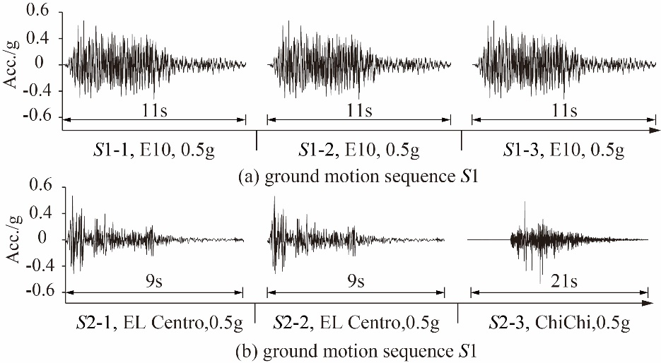

Figure 4. Ground motion sequences with compressed time-axial.

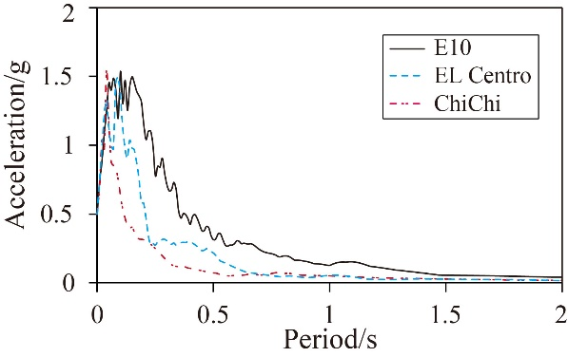

Figure 5. Acceleration spectra of time-compressed ground motions with 3% damping ratio.

Table 3. Test cases.

System | Case | Ground motions | PGA/g
TSDSS | Case 1 | Sequence S1 | 0.5
 | Case 2 | Sequence S2 | 0.5
TFS | Case 3 | EL Centro, in following with ChiChi and E10 | 0.5

4. experimental results and discussion

4.1 Seismic responses of TSDSS under ground motion sequences

Figure 6 presents the displacement responses of TSD at different locations under ground motion sequences S1 and S2. As can be seen from these figures, a gradual increase in the residual deformation of TSDs under sequence S1 is recorded, while no residual deformation is observed when the TSDSS experiences sequence S2 which indicates that TSDs still remain elastic. Figure 7 shows the hysteretic loops of TSD at deck-tower connection under different ground motions. It is clear that the TSD presents a plump hysteretic curve under E10, while almost maintains in the elastic state under El Centro and Chi-Chi ground motions. These results indicate that the TSD possesses an excellent energy dissipation capacity, but its hysteretic behavior is highly related to characteristics of ground motions.

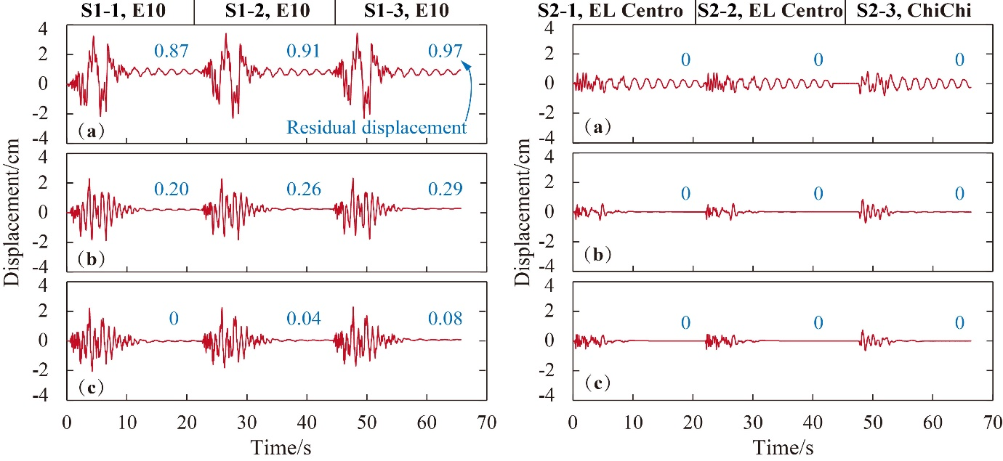

Figure 6. Displacement responses of TSD at different locations under sequences S1 and S2: (a), (b) and (c) TSD at deck-Tower 1, deck-Bent 2 and deck-Bent1 connections, respectively.

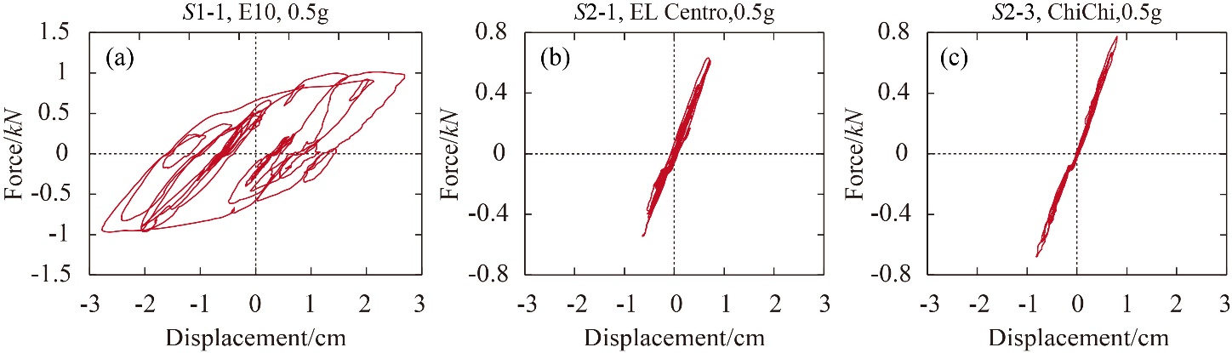

Figure 7. Hysteretic loops of TSD at deck-tower connection under different ground motions.

The impact of TSD residual deformation on the seismic responses of bridge is studied here. Since residual deformation occurs in TSDs under sequence S1 rather than S2, seismic responses of TSDSS under S1 are discussed here. Figure 8 shows comparisons of the forces transferred from deck to bents/towers under the first shaking (S1-1) and the third shaking (S1-3); Figure 9 presents the comparisons of displacement demands along tower shaft under each shaking (S1-1, S1-2 and S1-3) of sequence S1. As can be seen from these results, it can be claimed that although the residual deformation occurs in the TSD, it almost has no influence on the quantity of forces transferred from deck to bents/towers, and naturally has no influence on the curvature demands at bent bottoms (for the purpose of conciseness the results is not presented here). It also has no influence on the displacement demands along the tower shafts as expected. In addition, no other physical damages except residual deformation were observed in the tested TSDs, and the load paths from the deck to bents/towers were never interrupted during the tests.

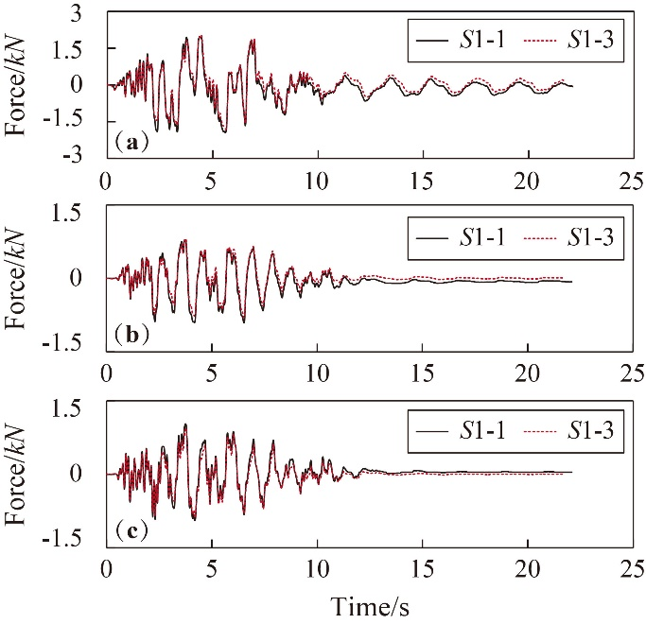

Figure 8.Comparisons of forces transferred from deck to (a) Tower 1, (b) Bent 2 and (c) Bent 1 under the first shaking (S1-1) and the third shaking (S1-2).

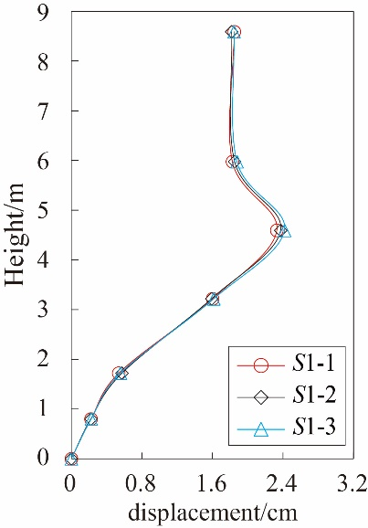

Figure 9. Comparisons of displacement demands along tower shaft under each shaking of sequence S1.

4.2 Mitigation efficiency of TSDSS

Another aim of this study is to investigate the mitigation efficiency of TSDSS. The seismic responses of TSDSS under E10 (S1-1), El Centro (S2-1) and ChiChi (S2-3) ground motions, including accelerate responses of deck, forces transferred from deck to bents and towers, and curvature demands at bent bottoms and along tower shafts, are compared with that of TFS.
Figure 10 presents the comparisons of peak transverse-accelerations along the deck between TSDSS and TFS. Due to the symmetry of structure, only left half of the whole-bridge results are presented. It is obvious that the peak transverse-acceleration of the TSDSS is significantly lower than that of the TFS, which results in the remarkable decrease of the horizontal forces transferred from the deck to bents and towers in the TSDSS, as listed in Table 4. More specifically, compared with TFS, the forces transferred for deck to Bent1, Bent2 and Tower 1 decrease averagely by 76%, 77% and 84%, respectively.

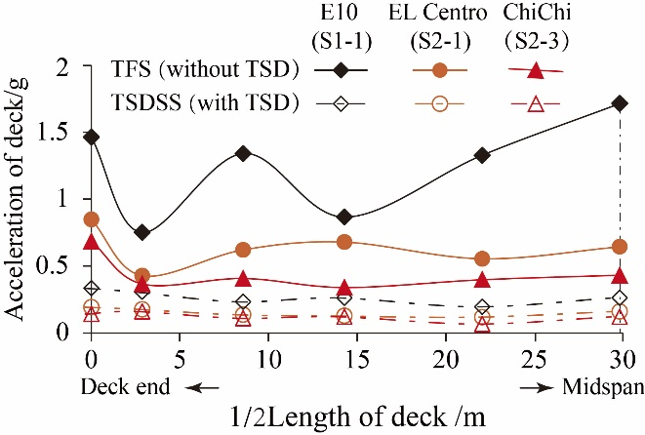

Figure 10. Comparisons of accleration responses along deck between TSDSS and TFS.

Table 4. Peak transverse forces at deck-bent/tower connections in TFS and TSDSS under different ground motions.

Connection | Ground motions | FF/kN | FS/kN | Mitigation ratio  R=(FS- FF)/FF | Average value of R
Deck-bent1 | Chichi | 1.88 | 0.68 | -64% | -76%
 | El Centro | 2.59 | 0.51 | -80%
 | Site E10 | 6.53 | 1.11 | -83%
Deck-bent2 | Chichi | 1.95 | 0.87 | -55% | -77%
 | El Centro | 3.70 | 0.58 | -84%
 | Site E10 | 11.95 | 0.95 | -92%
Deck-tower1 | Chichi | 6.18 | 1.53 | -75% | -84%
 | El Centro | 8.09 | 1.17 | -86%
 | Site E10 | 23.11 | 1.98 | -91%
Note: FF = peak transverse force for TFS; FS = peak transverse force for TSDSS.

Figure 11 presents the comparisons of curvature demands at bottom sections of Bent 1, Bent 2 and Tower1 between the TSDSS and TFS under E10. Compared with the TFS, significant drop of the curvature demands at the tower and bent bottom sections is found in TSDSS.

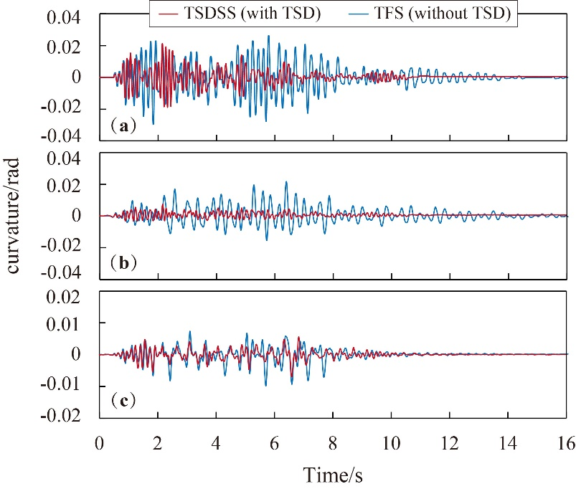

Figure 11. Section curvature time-histories of different systems under E10 (S1-1): (a), (b) and (c) the curvature at bottom sections of Bent 1, Bent 2 and Tower 1.

Figure 12 presents the curvature envelopes along the tower column of TSDSS and TFS under different ground motions. As can be seen from these results, the TSDSS can reduce section curvatures along the tower column under the three ground motions. Additionally, it is worth highlighting that the towers are more vulnerable when they experience earthquakes containing more low-frequency contents, such as the E10 ground motion in this study as shown in Figure 5.

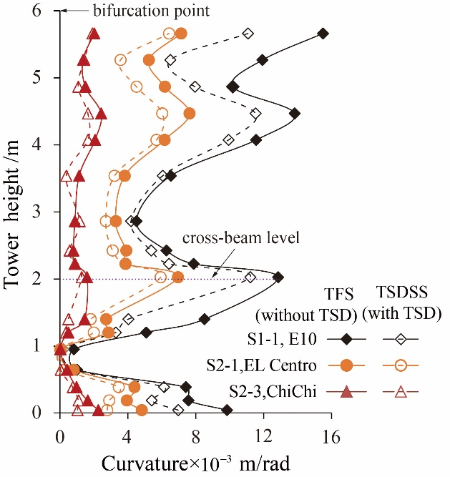

Figure 12. Comparisons of peak curvatures along tower shaft between the TSDSS and TFS under different ground motions with a PGA of 0.5g

5. Conclusions

This paper aims to experimentally verify the mitigation efficiency of TSDSS for cable-stayed bridges, and investigate the seismic performance and reliability of TSDSS under ground motion sequences. Shake table tests on a 1/35-scaled model of Sutong Bridge with/without TSDs were conducted on a four-shake-table system. The main remarkable findings are as follows:
- The TSD possesses an excellent energy dissipation capacity, but its hysteretic behavior is highly related to ground motions.
- Although a gradual increase in residual deformations of TSD under ground motion sequences are recorded, but it has little influence on seismic performance of cable-stayed bridges.
- The TSDs seismic system is experimentally validated to be a reliable and efficient seismic strategy for cable-stayed bridges.

6. Acknowledgments

This study was supported by the National Basic Research Program of China (No.2013CB036302).

7. References

China, M. of H. and U.-R. D. of P. R. (2011). code for seismic design of urban bridges. China Architecture & Building Press, Beijing,China.
Infanti, S., Papanikolas, P., Benzoni, G., and Castellano, M. G. (2004). “Rion-Antirion Bridge: Design and Full-Scale Testing of the Seismic Protection Devices.” Proceedings of the 13th World Conference on Earthquake Engineering.
Ismail, M., Casas, J. R., and Rodellar, J. (2013). “Near-fault isolation of cable-stayed bridges using RNC isolator.” Engineering Structures, Elsevier Ltd, 56, 327–342.
Kato, A., Nakamura, K., and Hiyama, Y. (2016). “The 2016 Kumamoto earthquake sequence.” Proceedings of the Japan Academy, Series B, 92(8), 358–371.
Martínez-Rodrigo, M. D., and Filiatrault, A. (2015). “A case study on the application of passive control and seismic isolation techniques to cable-stayed bridges: A comparative investigation through non-linear dynamic analyses.” Engineering Structures, 99, 232–252.
MCPRC (Ministry of Communications of the People’s Republic of China). (2008). Guidelines for seismic design of highway bridges, Beijing.
Rinaldin, G., Amadio, C., and Fragiacomo, M. (2017). “Effects of seismic sequences on structures with hysteretic or damped dissipative behaviour.” Soil Dynamics and Earthquake Engineering, 97, 205–215.
Shen, X., Camara, A., and Ye, A. (2015). “Effects of seismic devices on transverse responses of piers in the Sutong Bridge.” Earthquake Engineering and Engineering Vibration, 14(4), 611–623.
Shen, X., Wang, X., Ye, Q., and Ye, A. (2017). “Seismic performance of Transverse Steel Damper seismic system for long span bridges.” Engineering Structures, 141, 14–28.
Soneji, B. B., and Jangid, R. S. (2007). “Passive hybrid systems for earthquake protection of cable-stayed bridge.” Engineering Structures, 29(1), 57–70.
Uchide, T., Horikawa, H., Nakai, M., Matsushita, R., Shigematsu, N., Ando, R., and Imanishi, K. (2016). “The 2016 Kumamoto–Oita earthquake sequence: aftershock seismicity gap and dynamic triggering in volcanic areas.” Earth, Planets and Space, Springer Berlin Heidelberg, 68(1), 180.
Wang, H., Hu, R., Xie, J., Tong, T., and Li, A. (2013). “Comparative study on buffeting performance of Sutong Bridge based on design and measured spectrum.” Journal of Bridge Engineering, 18(7), 587–600.
Ye A, Hu S., F. L. (2004). “Seismic displacement control for super-long-span cable-stayed bridges.” China Civil Engineering Journal, 12(37), 38–43.
Zhou, L., Wang, X., and Ye, A. (2019). “Shake table test on transverse steel damper seismic system for long span cable-stayed bridges.” Engineering Structures.

Professor, State Key Laboratory of Disaster Reduction in Civil Engineering, Tongji University, Shanghai, China, yeaijun@tongji.edu.cn
Ph.D. Candidate, Department of Civil Engineering, Tongji University, Shanghai, China, csuzlx@ tongji.edu.cn

