PERFORMANCE BASED DESIGN OF SEISMIC ISOLATED BRIDGES

IN COLD CLIMATES USING MULTI DIRECTIONAL TORSIONAL

HYSTERETIC DAMPER AND LUBRICATED FLAT SLIDING

SPHERICAL BEARINGS

DOI 10.37153/2686-7974-2019-16-228-239

Murat DICLELI, Ali SALEM MILANI

ABSTRACT

The seismic and in-service performance of seismic isolation bearings is significantly affected by cold climates. The stiffness of rubber isolators and dry surface friction coefficient of curved surface sliding isolators increases considerably at extreme cold temperatures. An alternative design approach is presented in this paper where a special type of hysteretic damper with re-centering capability in combination with spherical sliding bearings with lubricated sliding surface are used together to minimize cold temperature effects. In this specific design arrangement, the dampers are attached to the deck using elongated holes (gaps), which are sized to accommodate the thermal displacements and hence to keep the dampers from being activated during thermal displacements. The gaps are sized based on the expected maximum thermal displacement in each pier. The gap length will thus be different for different piers. With this arrangement, the number of dampers engaged during an earthquake depends on the magnitude of the displacements. The distinct feature in this design is: (i) preventing the engagement of dampers under thermal displacements during service life without using shock transmitters and (ii) sequential engagement of dampers as a function of the magnitude of the seismically induced displacements. This paper presents a sample application of this methodology in the design of a major viaduct. The performance goals of the bridge require no damage at 475-year return period earthquake and repairable damage at 2475-year return period earthquake. The cold temperature test results of the isolation system, the design features of this seismically isolated bridge and the results of nonlinear time-history analyses are presented in this paper.

Keywords: Seismic isolation; Bridge; Damper

INTRODUCTION

Special seismic protection, usually in the form of isolation or energy dissipation devices or combination of both, is often required for seismic protection of important structures located in areas of high risk of seismic activity to satisfy design objectives of controlled structural response and minimal or no damage. For structures subjected to earthquakes with intense long duration acceleration pulses, although seismic isolation technology may be used to reduce and control the magnitude of the forces, such a system alone may not be adequate to reduce the displacement demand to practical ranges of application (Dicleli 2008). In such cases, a combination of seismic isolation and energy dissipation devices or dampers is used to reduce and control both forces and displacements. Use of seismic isolation combined with energy dissipaters in bridges is as widespread. This paper is meant to be a demonstration of application of modern seismic isolation techniques to achieve a performance-based design of a bridge.

DESCRIPTION OF THE BRIDGE AND THE CONSTRUCTION SITE

Figure 1 shows the satellite view and a perspective view of the Bitlis River Viaduct. The viaduct spans the Bitlis River in eastern Turkey with a total length of 1390 meters. Part of this bridge with a length of 801 meters containing 17 spans is designed as a post-tensioned box girder bridge, 19.6 meter width and girder depth of 3.0 meters, which is to be constructed using the incremental launching method. The height of the piers in this part of the bridge vary between 14 to 37 meters. Longitudinal view and a typical cross section of the bridge and the deck are shown in Figure 2.

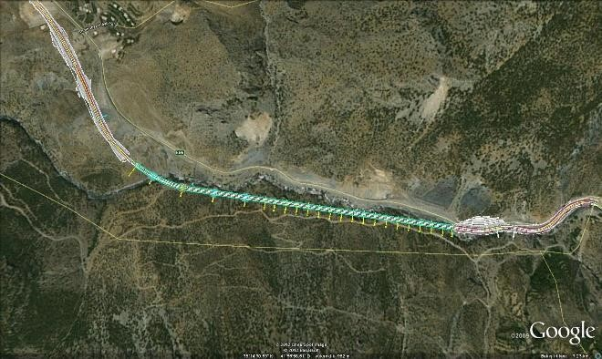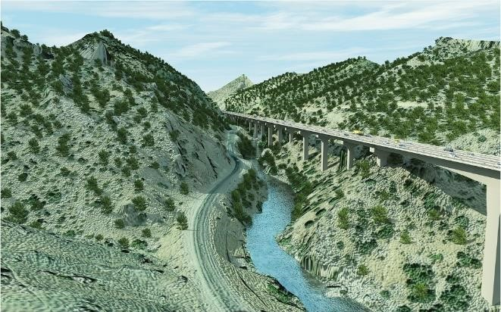

Figure 1. Satellite and perspective views of the viaduct.

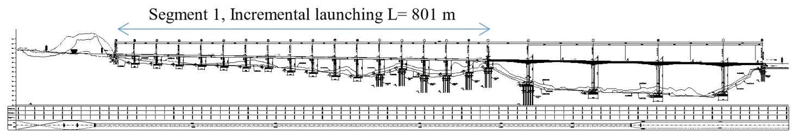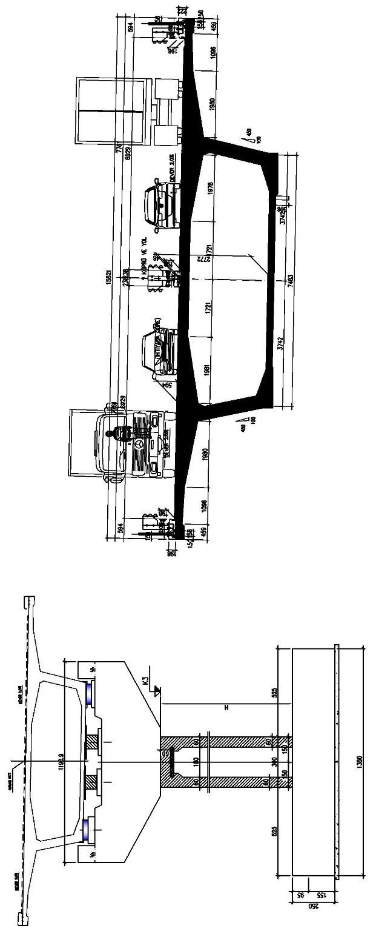

Figure 2. Longitudinal and cross-section views of the bridge and the deck.

SEISMICITY OF THE SITE AND SEISMIC PERFORMANCE GOALS

Figure 3 shows the site seismicity and the site-specific design spectrum, as obtained from a probabilistic seismic hazard analysis (Çetin 2010). The site is located in a seismically active zone where seven potential sources of seismic activity were identified, two of which are capable of producing earthquakes with maximum magnitude of 7.6. The performance goals set for this viaduct are defined as follows:
- For 72-year return period earthquake (i.e., during construction): No damage
- For 475-year return period earthquake (design-basis earthquake): No damage
- For 2475-year return period earthquake (maximum considered earthquake): Repairable damage.

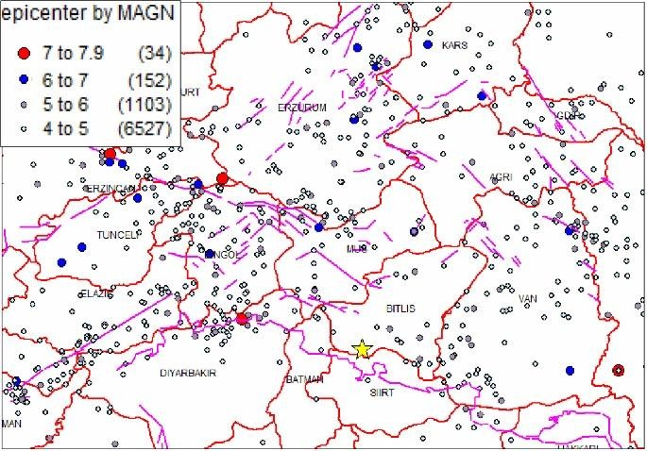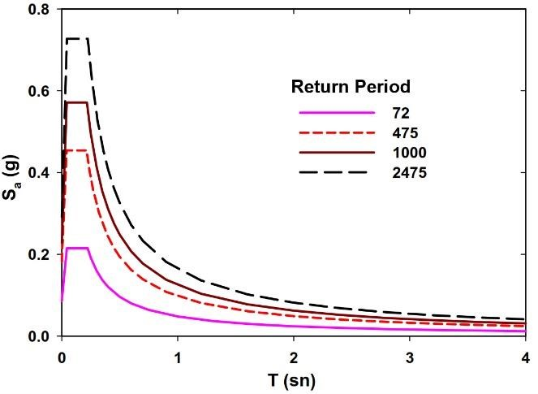
(a) (b)

Figure 3. (a) Site seismicity (the site is shown by a yellow star); (b) Site-specific design spectrum.

SEISMIC ISOLATION SYSTEM SELECTED FOR DESIGN

The viaduct is located in a very cold area where the temperature can reach -22ºC, a seismic isolation system that performs reliably in cold temperatures is needed. Accordingly, spherical bearings coupled with steel hysteretic dampers with re-centering capability; MTHD (Multidirectional Re-centering Steel Damper) are chosen. A brief description of the newly-developed MTHD damper is given in the following. MTHD (Multidirectional Torsional Hysteretic Damper) is designed to dissipate energy through yielding and plasticization of cylindrical energy dissipaters under torsion. Eight of these identical energy dissipaters each attached to a torsion arm are arranged in a symmetric configuration to create the MTHD. Fig 4(a) and (b) show perspective and side views of MTHD, respectively. Figure 4(c) shows a section view of MTHD with a typical energy dissipation unit of MTHD. All of the parts which compose the damper are named in Fig 4(a) and Fig 4(c). However, for the sake of brevity, detailed description of the device is not given here and the interested reader is referred to reference (Salem Milani and Dicleli (2016)ª). To convert translational motion of the structure to twisting in the cylindrical energy dissipaters, each arm is coupled with a guiding rail which through a low-friction slider block guides the motion of the arm. Schematic top-views of MTHD at undisplaced and displaced positions are shown in Figure 4(d).
A distinguishing feature in force-displacement response of MTHD is the geometric hardening behavior which is the outcome of translation-to-rotation motion conversion mechanism in the energy dissipation units of MTHD, as schematized in Figure 5(a). This mechanism, magnifies the reaction force required to balance the torque in energy dissipaters. Figure 5(a) shows a typical energy dissipation unit with arm length L, subjected to displacements d₁ and d₂, where d₂>d₁. Let the rotation angle of the arm, the reaction force and the torque are denoted by θ, f and T, respectively and let the numerical index indicate the corresponding state of displacement. Given that T=f.L.cosθ, and since increasing displacement leads to reduction in cosθ without any reduction in T, it can be easily shown the f₂>f₁, that is:

$\frac{T_{2}}{L\cos{{\text{θ}}_{\text{2}}}}>\frac{T_{1}}{L\cos{{\text{θ}}_{\text{1}}}}{ f}_{2}>f_{1}$ (1)

Note that the reaction force of the device is the sum of projections of all eight forces coming from eight energy dissipation units. Thus, the hardening behavior at eight energy dissipation units directly leads to similar behavior in global response of the device. The described mechanism also offers the possibility of controlling the desired level of hardening in force-displacement response, through adjustment of the arm length to maximum displacement ratio. Varying levels of hardening obtained as such, leads to hysteresis loops of different shapes as shown in Figure 5(b). As indicated on these graphs, the parameter used to characterize hardening in the MTHD is named ‘Hardening Index’, defined as;

$HI=\frac{F_{max}}{F_{Y}}$ (2)

where F_{max} and F_{Y} stand for maximum force capacity (force at D_{max}) and effective yield force of MTHD. A 200kN, 120mm-capacity version of the device was built and tested in UniBw/Munich and also at METU/Ankara, as shown in Figure 6. Force-displacement response loops of MTHD, as obtained from tests are given in Figs. 7(a),(b), which depict a very stable cyclic response with little variation in force levels not exceeding %4.0 the mean value. MTHD is capable of reaching high force and displacement capacities, shows high levels of damping, controllable post-elastic stiffness and very stable cyclic response. A design methodology for the device has also been completed. Further details on this device can be found in (Salem Milani and Dicleli (2016)^{a,b}.

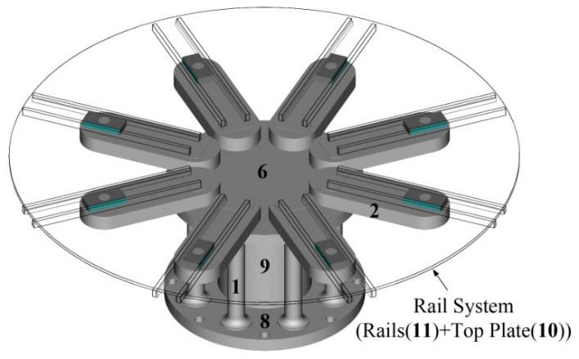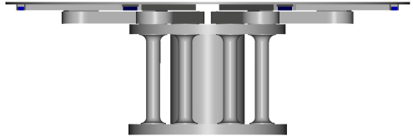
(a) (b)
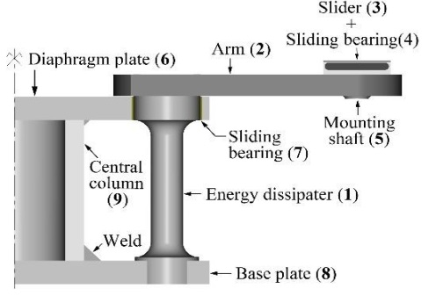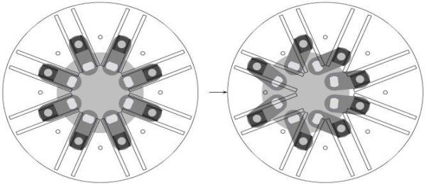
(c) (d)

Figure 4. Multidirectional Re-centering Steel Damper (MTHD): (a) Isometric view showing the rail system and base device underneath; (b) side view; (c) Section view showing a single energy dissipation unit of MTHD; (d) Schematic top-view of MTHD at un-displaced and displaced positions.

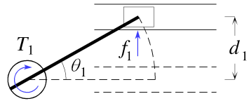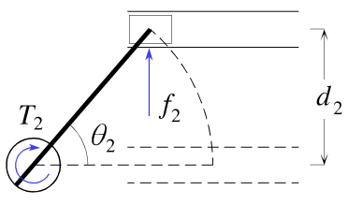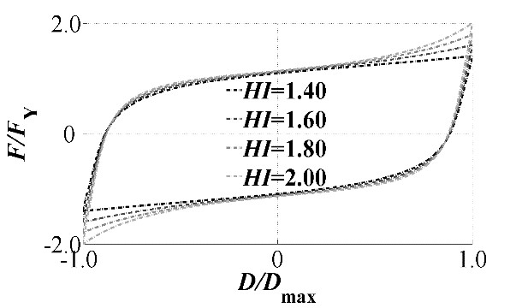

(a) (b) (с)

Figure 5. (a) Working mechanism of MTHD responsible for geometric hardening; (b) MTHD response for different design hardening indices.

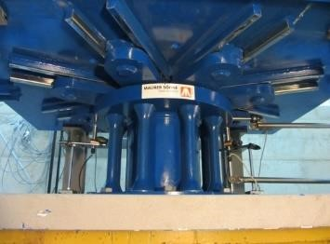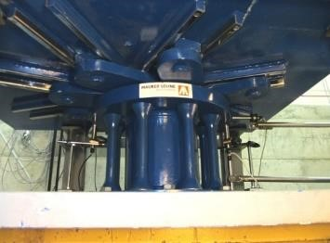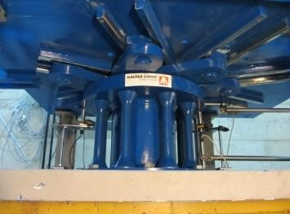
(a) (b) (c)

Figure 6. 200kN, 120mm-capacity prototype MTHD at: (a) un-displaced position, (b),(c) two extreme strokes of ±120mm.

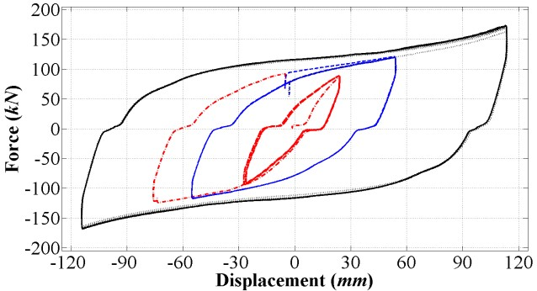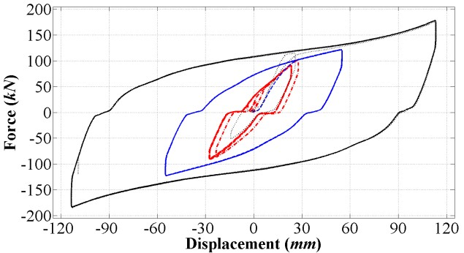
(a) (b)

Figure 7. Cyclic response of prototype MTHD, obtained from tests of MTHD with energy dissipaters made of: (a) S355J2+N, (b) C45 steel grades.

TESTS ON SPECIMENS SIMILAR TO THE ENERGY DISSIPATERS OF MTHD COOLED DOWN TO LOW TEMPERATURES

Following the development of the new steel damper, with the aim of gaining insight into the phenomenon of torsional fatigue in solid cylindrical steel specimens and to acquire data for the design of the new damper, a series of torsional low-cycle fatigue tests on cylindrical specimens of S355J2+AR and C45E steels are performed using a specially-designed test setup, capable of twisting the specimens up to ±50°. The specimens are tested under different levels of torsional shear strain (engineering shear strain at most-strained fibers) ranging between 0.044 to 0.130 (about 13 to 40 times the yield strain) and the data was used to calibrate the Coffin-Manson model for the prediction of the low-cycle fatigue life of the steel specimens for use as energy dissipaters of MTHD. Also, The impact of various other relevant factors on low-cycle fatigue behavior of specimens are looked into, including low temperature. A total of 67 specimens were produced out of C45E and S355J2+AR steels. The specimens are basically cylinders with enlarged ends, with both ends machined into a semi-rectangular-shaped section to provide a plug-type attachment.
To assess the prospects of using the new hysteretic damper (MTHD) in very cold environments, a number of specimens made of S355J2+AR and C45E, were cooled down to -80°C using an ultra-low temperature freezer, as shown in Figure 8. The tests started when the surface temperature in the middle of the specimen was in the range of -45°C, as measured using a thermocouple, as shown in Figure 8(b). The ideal way to perform these tests would require the specimens to be immersed in a cooling agent (e.g. dry ice), if the cooling agent has a sublimation (boiling) temperature close to the desired temperature. This way, a constant temperature is maintained all over the specimen and the outside thermal condition is correctly replicated. The tests started in about 2~5 minutes after taking the specimens out of the freezer.
The results are summarized in Table 1. In the case of S355J2+AR steel, the torsional low-cycle fatigue life of cooled-down specimens are 41, 46.5, 43, as indicated in the table, with an average of 43.5. In comparison to the average of 40 cycles obtained from specimens tested at room temperature and under identical strain levels, it may be confirmed that low temperature conditions has no negative effect on the fatigue life. Although it is expected that cold temperatures would have an adverse effect on the low cycle fatigue life as the tensile toughness of steel decreases and the material becomes more brittle, this effect is not observed since the cold temperature in the specimen diminishes after a few initial cycle that result in heat generation due to material yielding. Furthermore, the difference between the low and room temperature test results may be attributed to scatter inherent in fatigue tests. Similar conclusion can be made in the case of C45E steel, where the average low-cycle fatigue life of cooled-down specimens is 20.5 cycles. This can be compared to a similar specimen tested at room temperature and under identical strain giving number of cycles to failure equal to 20, and also compared to the outcome of Coffin-Manson model fitted to the entire data, giving a value of 18 cycles. The observations are also depicted in Figure 9(a),(b), which show the data points from the cooled-down specimens, along with the Coffin-Manson curve fitted to similar specimens tested at room temperature. This result is not unexpected for a specimen which passes through the first cycle, since the specimen heats up instantly, and for the rest of the duration of the test, the temperature stays at normal levels.

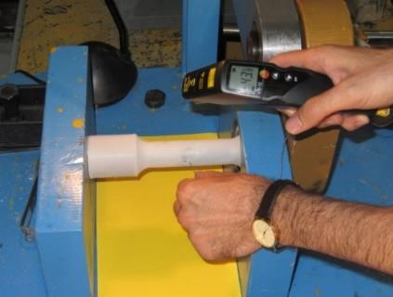

(a) (b) (c)

Figure 8. Pre-test freezing of specimens to -80°C: (a) The ultra-low-temperature freezer; (b) Surface temperature measurement on the specimen after being placed in the test setup: notice white-colored frosting on the specimen.

Table 1. Low-cycle fatigue life of specimens froze and tested while having at a surface temperature of about -45°C at the start of the test.

S355J2+AR |  | C45E specimens
Specimen No. | No. of cycles to failure (2*N_{f}) | Specimen No. | No. of cycles to failure (2*N_{f})
20 | 41 | 23 | 19
22 | 46.5 | 24 | 21
26 | 43 | 25 | 21.5
Average*: | 43.5 | Average*: | 20.5

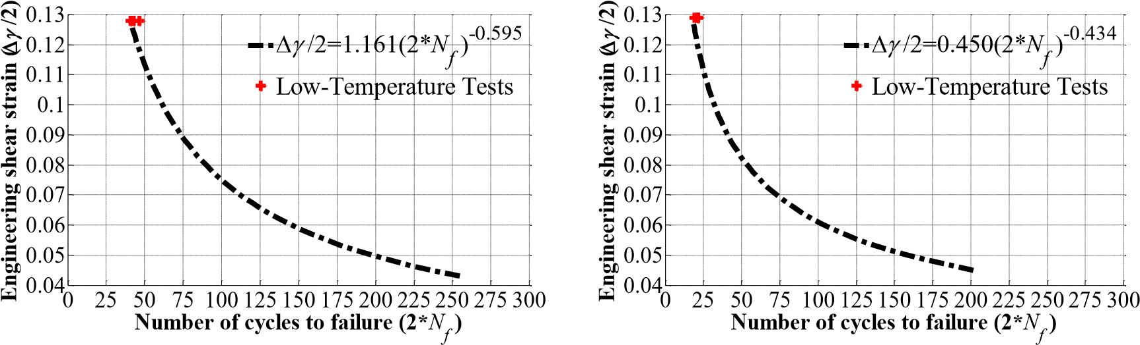
(a) (b)

Figure 9. Data points from specimens froze and tested while having at a surface temperature of about -45°C at the start of the test, along with the Coffin-Manson curve fitted to data from similar specimens tested at room temperature: (a) S355J2+AR steel; (b) C45E steel.

THE ISOLATION SCHEME OF THE BRIDGE

Figure 10 shows a schematics of the isolation of the part of the bridge located between the abutment A1 and pier P17. The part of the bridge between P17 and the abutment A2 is built using balanced cantilever method where the piers are built monolithically with the deck. The expansion joints are located on two abutments and pier P17. The focus in this study is the part of the bridge between the abutment A1 and pier P17. As shown in Figure 10, the spherical bearing on the abutment A1, pier P17 and three additional piers on each side are unidirectional to resist wind loads. That is, at these points the bridge is fixed to the abutment/pier in the transverse direction. On the 10 piers in between, the spherical bearings are multidirectional and the bridge is free to move both laterally and longitudinally during an earthquake. Under wind loads, the dampers provide the required resistance in the transverse direction within their elastic limit. The MTHDs are placed on these 10 piers, two on each pier, as shown in the cross-section view in Figure 11(a). An issue to be tackled with the use of the hysteretic dampers is the presence of thermal movements in certain piers. The bridge is designed to eliminate the thermal movements at its two abutments where the expansion joints are located. That is, thermal action expands or contracts the deck from the middle. Therefore, the dampers on piers away from the middle pier(s) will be subjected to thermal displacements, the intensity of which depends on the pier’s distance from the middle point of the deck. To prevent the low-cycle fatigue in dampers as a results of repeated thermal displacements, the attachment of the dampers to the deck is designed to be via elongated holes (slots), as shown in Figure 11(b). This way, a gap is left between the anchorage and the upper plate of the MTHD, in the longitudinal direction of the bridge. The gap is sized to accommodate the maximum probable thermal displacement per each pier. The amount of gap provided for MTHDs on each pier is indicated in Figure 10. An alternative solution would be to use shock transmission units (luck-up devices) to connect the dampers to the deck. However, this solution entails increased cost and reduced reliability since shock transmission units are both expensive and require maintenance. The design of the MTHDs with gaps, as described above, was also meant to serve a second objective. Presence of gaps in connections of certain MTHDs means that the engagement of these dampers during an earthquake depends on whether the intensity of the displacements are large enough for the gaps to close. That is, at very low-intensity events, only dampers on middle piers (P8 and P9) are engaged; thus, preventing both the unnecessary increase in base shear on the other piers and also damage to the MTHDs on those piers. With increasing intensity of the ground motion more number of MTHDs on piers come into action. This sequential engagement of the dampers is the performance-based oriented feature in this design. In addition the dampers, which are connected without slots on Piers 8 and 9 provide the required resistance within their elastic range against breaking forces.

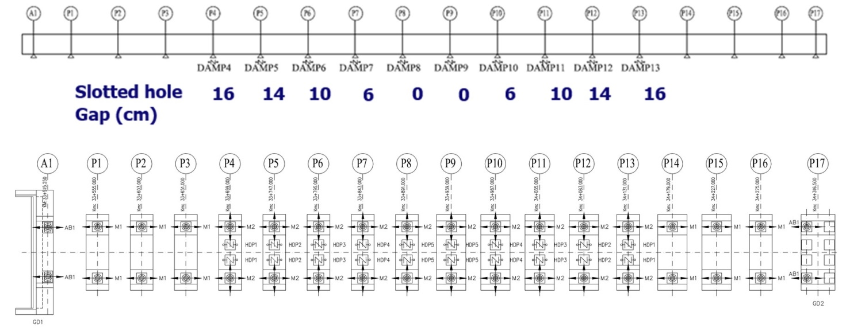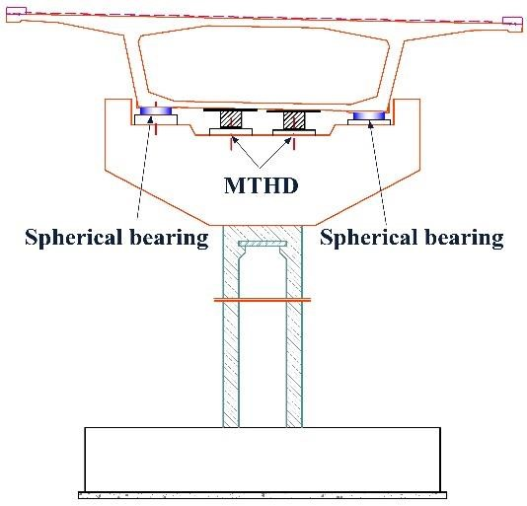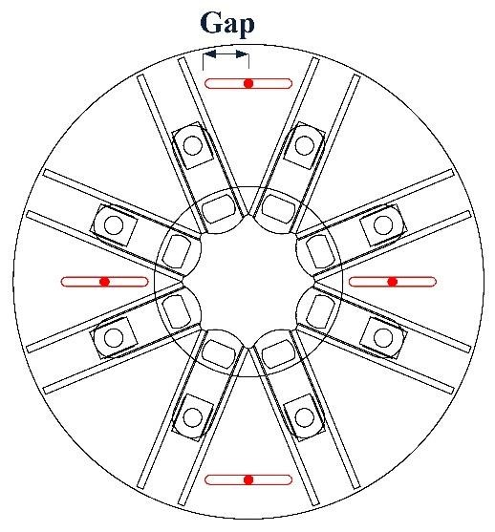
Figure 10
.
Schematics of the isolation system.

(a) (b)

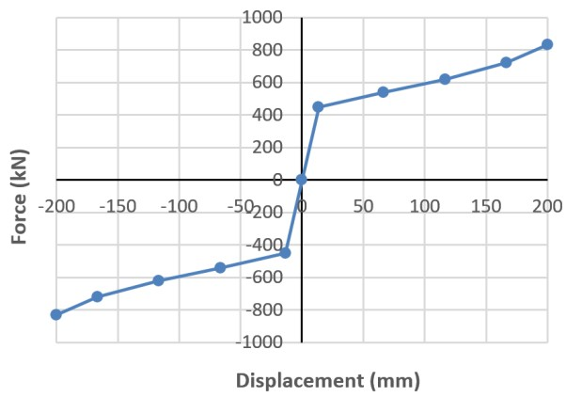
(c)

Figure 11. (a) Installation of two MTHDs on a typical pier; (b) The provided gaps (longitudinal direction) on the upper plate of the MTHDs where the device is mounted to the deck; (c) Force-displacement response of MTHD.

SEISMIC PERFORMANCE CRITERIA FOR THE MTHD-EQUIPPED VIADUCT

Based on the arrangement of the MTHDs, as laid out in previous section, the seismic performance goals of no damage at DBE and repairable damage in MCE are redefined as follows: at DBE (475 years return period), limited number of dampers (those with zero and 6 cm slot gaps) will be engaged during the earthquake in the longitudinal direction. No damage will be inflicted in the substructure members. If needed, energy dissipaters of few dampers could be replaced after the earthquake. At MCE (2475 years return period), dampers with larger slot gaps will also be engaged sequentially as the intensity of the ground shaking increases. The central piers may yield after the damper reach a certain force level. In the preliminary design stage, equivalent linear analysis method was used to determine the required surface coefficient of the spherical bearings and force/displacement capacity of the MTHDs. Following the initial design, a series of time-history response analyses are performed to assess whether the proposed design meets the performance objectives. The results are presented in the following section.

TIME-HISTORY RESPONSE ANALYSES

To assess the performance of the bridge in DBE and MCE-level earthquakes, a 3D model of the bridge was built in SAP2000, as shown in Figure 12. Spherical bearings are modelled using rigid plastic model (using nonlinear link element with Wen plasticity model where the elastic stiffness is taken very high) and the MTHD dampers are modelled using nonlinear links with multi-linear kinematic hardening behaviour. The effect of soil-structure interaction was found to be negligible due to the stiff soil condition under the foundations. The model is subjected to seven bi-directional design spectrum-compatible ground motions, as specified in Table 2. Displacement response histories of the MTHD dampers in the longitudinal direction for Kocaeli and Landers records (two records with the largest magnitude) for both MCE and DBE events are presented in Figure 13. Sample hysteresis loops of damper on piers No. 6 and 9 in the longitudinal direction for Kocaeli record are given in Figure 14. The maximum displacement of the MTHDs in the longitudinal directional was found to be 330mm. The dampers were thus designed for a displacement capacity of 350mm. The displacement in the transverse direction of the bridge was found to be small and did not govern the design displacement of the damper.

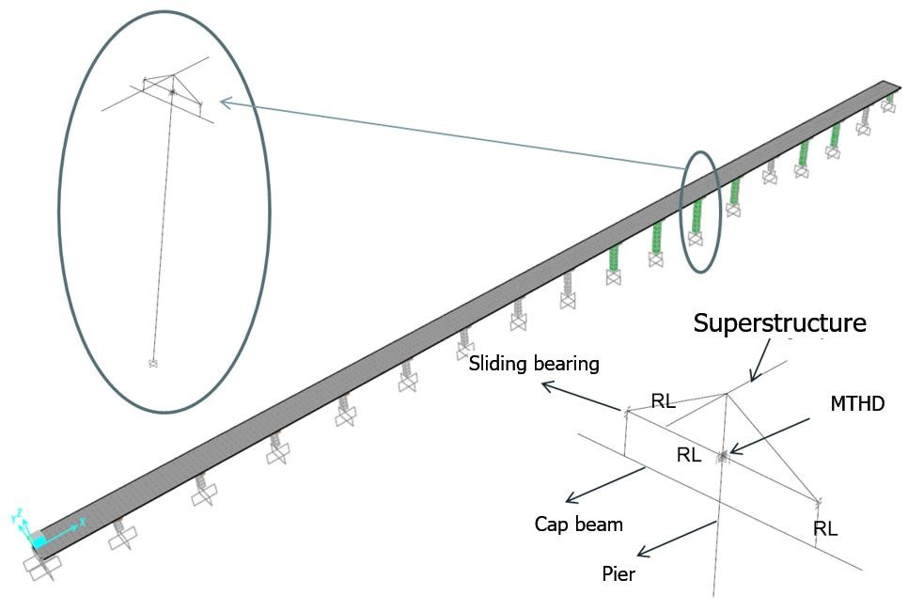

Figure 12. Structural model of the bridge.

Table 2. Specification of the design spectrum-compatible ground motions.

No. | Event | M_{w} | Fault Type | Station | Scale Factor
 |  |  |  |  | %10/50yr %5/50yr %2/50yr
1 | Imperial Valley, 1979 | 6.5 | Strike Slip | 6604 Cerro Prieto | 1.00 | 1.25 | 1.40
2 | Landers, 1992 | 7.3 | Strike Slip | 21081 Amboy | 0.75 | 0.85 | 0.90
3 | Kocaeli, 1999 | 7.4 | Strike Slip | Gebze | 0.75 | 0.90 | 1.00
4 | Duzce, 1999 | 7.1 | Strike Slip | 531 Lamont | 1.40 | 1.70 | 1.90
5 | Nahanni, 19856 | 6.8 | Reverse Oblique | 6099 Site 3 | 0.75 | 0.95 | 1.10
6 | Spitak, 1988 | 6.8 | Reverse  Oblique | 12 Gukasian | 0.90 | 1.20 | 1.40
7 | Loma Prieta, 1989 | 6.9 | Reverse Oblique | 58378 APEEL 7 | 1.00 | 1.15 | 1.25

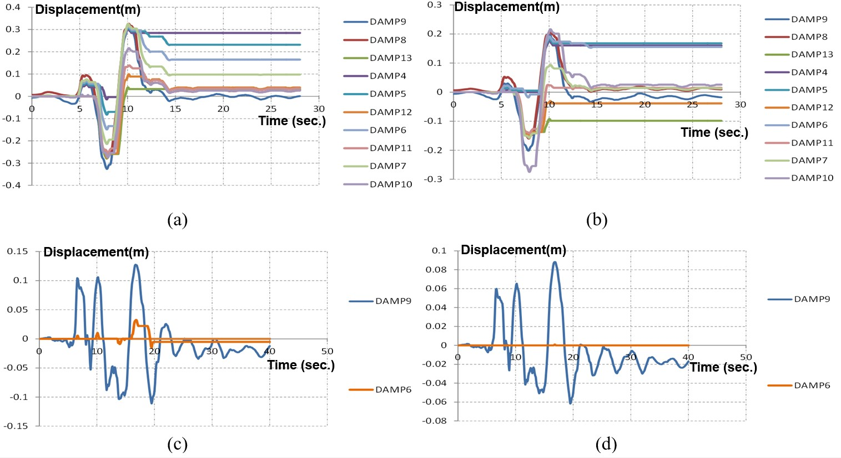
Figure 13. Displacement response time history of the dampers in the longitudinal direction for (a) Kocaeli MCE; (b) Kocaeli DBE; (c) Landers MCE and (d) Landers DBE, earthquake records.

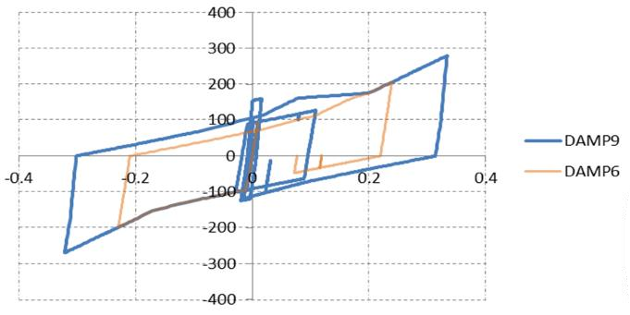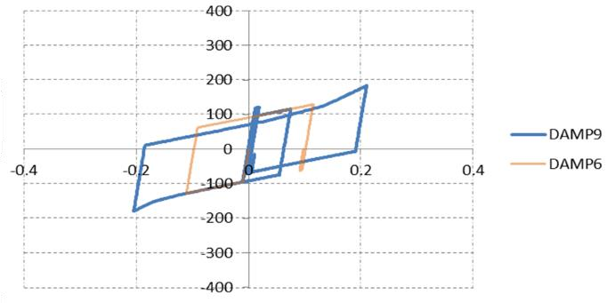
Displacement(m)

Force(kN)

Displacement(m)

Force(kN)

(a) (b)

Figure 14. Sample hysteresis loops of damper on piers No. 6 and 9 in the longitudinal direction for (a) Kocaeli, MCE and (b) Kocaeli, DBE records.

DAMAGE ANALYSIS

To evaluate the performance of the bridge, the state of damage in the piers should be assessed. The damage Model of Hindi and Sexsmith (2001) is used for this purpose. The damage model takes as a reference the monotonic energy dissipation capacity of a structure in the undamaged virgin state, which is defined as the area, Ao, under the static pushover curve up to the point of failure (Figure 15(a)). With the actual “n” cycles of load-displacement history applied on the structure due to a potential earthquake, the remaining monotonic energy dissipation capacity of the structure, compared to that in its virgin state, defines the extent of damage. The remaining monotonic energy dissipation capacity of the structure is defined as the area, An, under the static pushover curve obtained from the end of the last cycle, n, to the failure point (Figure 15(b)). Accordingly, the damage index is the ratio:

$DI=\frac{A_{o}-A_{n}}{A_{o}}$ (3)

A damage index of 0.0 (A_{n}=A_{o}) is indicative of no damage, whereas a damage index of 1.0 (A_{n}=0) is indicative of complete damage or collapse. The damage index is correlated with the physical state of damage, according to the following scale:
- DI<0.2: Minor damage–light cracking–very easy to repair.
- 0.2≤DI<0.4: Moderate damage–severe cracking, cover spalling–repairable.
- 0.4≤DI<0.6: Severe damage-extensive cracking, reinforcement exposed–repairable with difficulties.
- 0.6≤DI<1.0: Severe damage–concrete crushing, reinforcement buckling–irreparable.
- DI=1.0: Complete collapse.
The calculated damage indices are given in Table 3. For DBE-level earthquakes, the DI values are all below 0.2, indicating that the objective of no damage at DBE is met. Likewise, in case of MCE-level earthquakes, all DI values fall below 0.4 indicating that the objective of repairable damage at MCE is met.

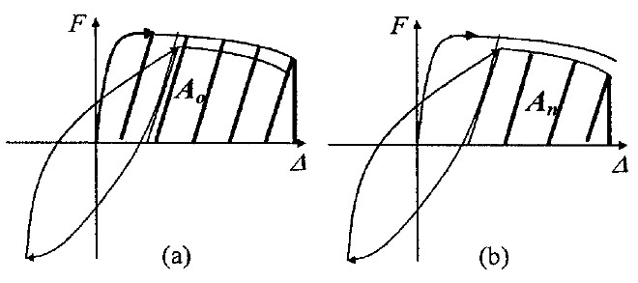

Figure 15. Definition of damage equation parameters of the model by Hindi and Seximith (200): (a) monotonic energy in the virgin state; (b) monotonic energy after the application of load-displacement cycles.

Table 3. Calculated damage indices.

Earthquake | Imperial  Valley, 1979 | Landers, 1992 | Kocaeli, 1999 | Duzce, 1999 | Nahanni, 1985 | Spitak, 1988 | Loma Prieta, 1989 | Average
DBE | 0.06 | 0.09 | 0.12 | 0.10 | 0.03 | 0.05 | 0.08 | 0.076
MCE | 0.11 | 0.19 | 0.27 | 0.21 | 0.07 | 0.13 | 0.22 | 0.171

CONCLUSIONS

The paper presents a practical application of seismic isolation technique following a performance-based design approach for a bridge. The bridge is designed with a seismic isolation system composed of spherical bearings and Multidirectional Torsional Hysteretic Damper (MTHD). The MTHD is a recently-developed hysteretic damper with a controllable post-elastic stiffness. To keep the dampers from being activated during the thermal displacements, the attachment of the dampers to the deck is made through elongated holes oriented in the longitudinal direction of the bridge. The size of these gaps depend on the amount of expected maximum thermal displacement in each pier and is thus different for different piers. This means that the number of the dampers to be engaged during an earthquake will depend on the intensity of the displacements. The slotted connections of MTHD ensures a progressive energy dissipation that is a function of the intensity of the earthquake in the longitudinal direction where the piers are weaker. The progressive design solution ensures minimal or no damage of substructure at small intensity, more frequent earthquakes while damage progressively increases in response to less frequent, larger earthquakes. The progressive / adaptive solution used in the design balanced the damage and risk producing an economical design solution.

REFERENCES

Çetin, K. Ö. (2010). Probabilistic seismic hazard analysis of Bitlis River Viaduct, Technical Report, Middle East Technical University, METU Revolving funds Project No. 2010.03.03.01.03.24, Ankara, Turkey.
Dicleli, M. (2008). Performance of seismic-isolated bridges with and without elastic-gap devices in near-fault zones, Earthquake Engineering and Structural Dynamics, vol. 37, Issue 6, pp. 935-954.
Hindi R. A. and Sexsmith R. G. (2001). A proposed damage for RC bridge columns under cyclic loading, Earthquake Spectra, 17(2): 261–289.
Salem Milani, A., and Dicleli, M. (2016)ª. Systematic development of a new hysteretic damper based on torsional yielding: part I—design and development, Earthquake Engineering and Structural Dynamics, 45(6): 845–867.
Salem Milani, A., and Dicleli, M. (2016)^{b}. Systematic development of a new hysteretic damper based on torsional yielding: part II—experimental phase, Earthquake Engineering and Structural Dynamics, 45(5): 779–796.

Middle East Technical University, Ankara, Turkey, mdicleli@metu.edu.tr
Ditto

