SEISMIC RESPONSE EVALUATION OF EXISTING OLD BRIDGE CONSIDERING THE AGEING EFFECT OF ELASTOMERIC AND LEAD-RUBBER BEARINGS

DOI 10.37153/2686-7974-2019-16-343-354

Yeonhui JEONG, Jong-Keol SONG, Ji-Yeong HONG

ABSTRACT

The last two earthquakes that occurred Gyeongju and Pohang city areas in south Korea have left the necessity for the seismic design and rehabilitation not only buildings but infrastructures. In order to retrofit the aseismic capacity of existing old bridges, the most commonly used retrofit method was a seismic isolation system. Damages in the bridges by the last two earthquakes usually occurred in the bearings, anchor, and concrete mortar on pier. The purpose of this study is to evaluate the seismic responses of PSC box girder bridge considering the ageing effect of rubber bearing(RB) and lead-rubber bearing(LRB). The modification factor is used to take into account the ageing effect in the bearings. Existing old bridges are 3D modeled and analyzed with OpenSEES program provided by Pacific Earthquake Engineering Research Center (PEER). The 14 earthquake records which are used the analysis are based on the ATC-63 Near Fault without Pulse (NFNP). From the results in this study, it can be observed how the maximum displacements and forces are changed after the ageing effect consideration

Keywords: PSC box girder bridge, rubber bearing, lead-rubber bearing, nonlinear response history analysis, ageing effect

1. Historic seismicity and previous studies about deterioration of Bridge Bearing

The bridges in South Korea have constructed since 1880. From that era, the total number of bridges are 33,572 depending on the paper which was published from Ministry of Land, Infrastructure and Transport (MOLIT) in 2018. The secure of the bridge bearing capacity is important to the aspect in the transport system. Due to the design factors or the deterioration of the bearing system, it may cause serious structural damages to not only the entire bridge but the total transport system. For that reason, it is necessary to investigate the condition of the bridge bearings including the deterioration, damage and structural fatigue at regular intervals. According to the documents published by MOLIT, the seismic design of the bridges on the national roads has adjusted only 86% which is much less than those on the highway.

1.1 Bridge Bearings

The bridge bearings have designed to transfer some of forces and to prevent to transmit of others. In bridges, the superstructure affects to seismic forces, temperature effects, vehicles moving, concrete shrinkage and creep and so on. Without bearing, the seismic forces directly affect to girder. As the follow the force, it will strictly transfer to the piers. There are several types of bearing developed and adjusted which are sliding, rolling device and elastomeric bearing(EB). Especially, the plan shapes of elastomeric bearings are usually circular and rectangular. Furthermore, the pads have plain or laminated with steel. The two types of bearing are selected to identify the ageing effect and the effect of the piers. The selected bearing types are rubber bearing(RB) and lead rubber bearing(LRB).

1.2 Deterioration of Bridge Bearings

The factors for deterioration are various such as ageing, temperature, the low material quality when it is constructed and so on. The study about the ageing effects of seismic isolation devices has been in various countries. To know exact ageing trend of the seismic isolation bearing, it is necessary to remove the bearings from the bridge then check the material properties how it getting changed. In England, the twenty-year old natural rubber bearings were removed. The condition is good and the lateral stiffness was 1.8 kN/mm which means that the lateral stiffness has increased by 32 percent or may decreased by about 12-percent of the bounding design values when the designed lateral stiffness is between 1.36 and 2.04 kN/m (Stevenson and Price 1986). In Japan, the accelerated test was conducted with 4 different rubber types which are natural rubber, chloroprene rubber, ethylene-propylene rubber and high damping rubber and the factors which are thermal oxidation, ozone, low-temperature ozone, ultraviolet radiation, slat water spray and acid rain spray. The general results are the tendency of four kinds of rubber almost same and the most significant degradation factor is discovered under the thermal oxidation test (Itoh et al. 2006). Analytically, using the modification factor has been used. The American Association of State Highway and Transportation Officials (AASHTO) Guide Specification mentions that the minimum and maximum effective stiffness of the isolation system shall be calculated using the minimum and maximum values of K_{d} and Q_{d} and it is suggested that the maximum modification factor values based on the ageing effect with four different elastomeric bearings Table 1 (Thompson et al. 2000).

Table 1. AASHTO values of λ for ageing effect

 | λ_{max, ageing}
Elastomeric Bearing type | K_{d} | Q_{d}
Low-Damping Natural rubber | 1.1 | 1.1
High-Damping Rubber-A | 1.2 | 1.2
High-Damping Runner-B | 1.3 | 1.3
Lead-Rubber | - | 1.0

  - Objective

The aim of the study is focusing on the ageing effects of the seismic isolation through the modification factors suggested by AASHTO guideline. After consideration the ageing effect, the absolute maximum displacement data can be suggested to the main parameter to decide the retrofit or replacement of seismic isolation bearing in the bridges.

2. bridge modelling

2.1 Modelling of PSC-Box Girder Bridge

2.1.1 Superstructure

Among a variety types of bridge superstructures, the most common superstructure types are Pre-Stressed Concrete(PSC) Beam, Pre-stressed Concrete Box, Steel Beam and Steel Box based on the FMS information. The maximum span lengths are 30m 50m, 40m and 50m in PSC beam, PSC box, Steel beam and Steel box, respectively. The PSC box girder used in this study has 4 spans with 50m length. The deck is modeled as elastic beam-column elements in the analysis program. The beam-column element makes the superstructure like elastic condition under the seismic excitation. In the mass consideration aspect, the lumped mass is applied to the top of the pier.

2.1.2 Pier

The girder is supported by irregular height of piers which are 14m, 21m and 14m as shown in Figure 1. The pier is modeled as circular fiber elements with unique constitutive models which is confined, unconfined and steel reinforcement. Furthermore, the end of pier is considered as fixed. The cap beam and pier is modeled by rigid element and fiber element, respectively in the OpenSees. Usually, the nonlinear failure usually occurs in the pier then the superstructure.

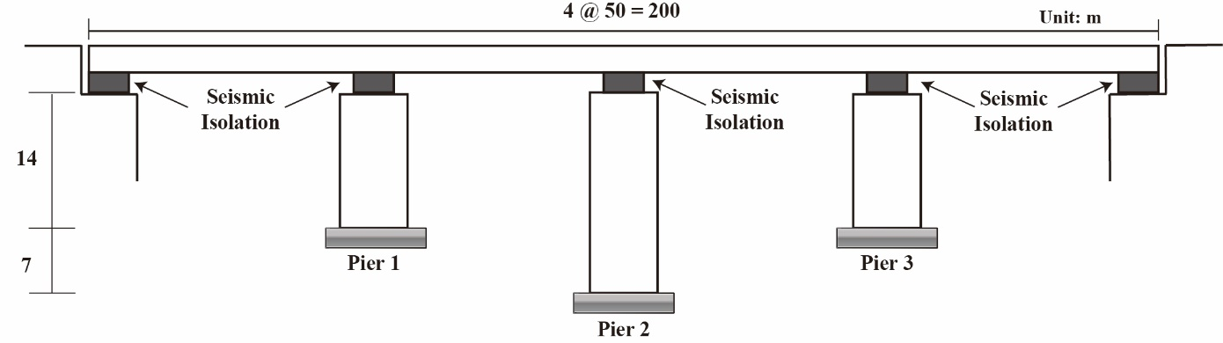

Figure 1. Example bridge used in the model analysis

2.2 Selected Seismic Isolation

For the analysis, the elastomeric bearing which is composed with rubber and steel layer and lead rubber bearing are selected. Figure 2 (a) and Figure 3 (a) show the example of those of seismic isolation bearings. In the late 1980s, AASHTO had conducted a variety research on rubber bearings.
The basic material properties such as compression loading, temperature effect, rotation, shear and combined loading were evaluated. Normally, the elastomeric bearing behavior is linear with the stiffness parameter K as shown in Figure 2 (b). In this study, the material properties of rubber bearing are based on the report published by ESCO-RTS (http://enrtech.co.kr/en/) which is one of the bearing producers in South Korea. The details of the rubber bearing in abutment and pier show in Table 2 and Table 3 respectively. Furthermore, the details of LRB in abutment and pier show in Table 4 and Table 5.

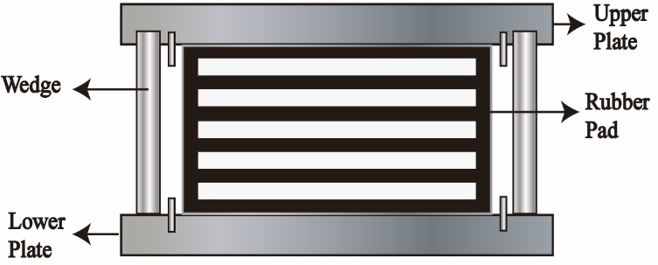 | 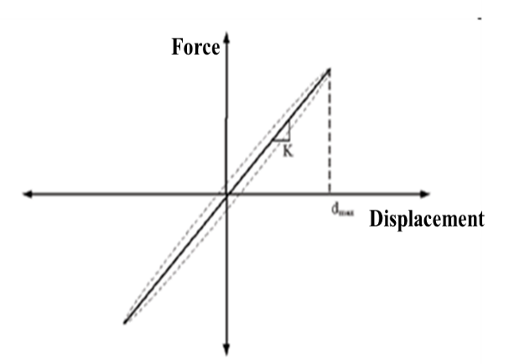
(a) | (b)

Figure 2. (a) Example of rubber bearing with steel plates (b) theoretical hysteretic curve
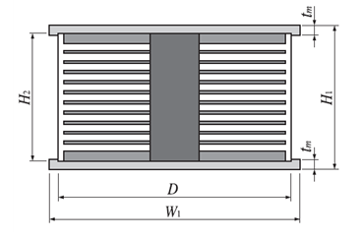 | 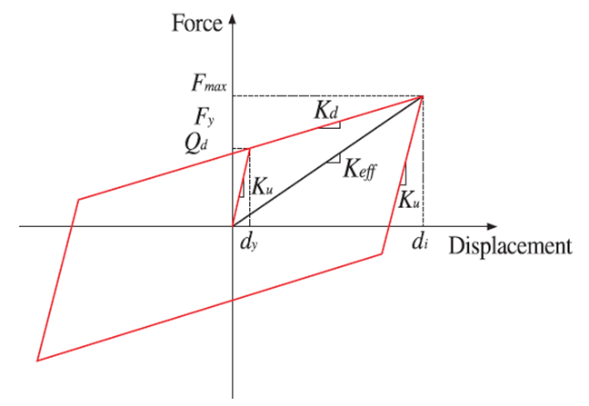
(a) | (b)

Figure 3. (a) Example of lead rubber bearing (b) Force-displacement relation curve of lead rubber bearing

Table 2. Material properties of Rubber bearing with steel plates in abutment

Applied weight  (kN) | Size of bearing |  |  | G=1.15MPa
 | Height, H  (mm) | Number of layer, n | Effective rubber thickness  (mm) | Horizontal Force |  |  | Shear Spring coefficient, K_{h}  (kN/m)
 |  |  |  | Always | Earthquake
 |  |  |  | 70%  (kN) | 150%  (kN)
2,800 | 100 | 4 | 18 | 193 |  | 414 | 5,750

Table 3. Material properties of Rubber bearing with steel plates in pier

Applied weight  (kN) | Size of bearing |  |  | G=1.15MPa
 | Height, H  (mm) | Number of layer, n | Effective rubber thickness  (mm) | Horizontal Force |  |  | Shear Spring coefficient, K_{h}  (kN/m)
 |  |  |  | Always | Earthquake
 |  |  |  | 70%  (kN) | 150%  (kN)
6,000 | 119 | 4 | 64 | 394.5 |  | 845.3 | 8,805

Table 4. Material properties of Lead Rubber Bearing in abutment

Force  (tonf) | LRB Diameter, D  (mm) | Steel Width, W₁  (mm) | Steel Thickness,  (mm) | LRB Height, H  (mm) |  | Post-Yield Stiffness, K_{d}  (kgf/cm) | Compress Stiffness, K_{v}  (tonf/cm) | Effective Stiffness, K_{h}  (kgf/cm)
300 | 650 | 730 | 40 | 367 | 297 | 1,328 | 7,769 | 3,117

Table 5. Material properties of Lead Rubber Bearing in pier

Force  (tonf) | LRB Diameter, D  (mm) | Steel Width, W₁  (mm) | Steel Thickness,  (mm) | LRB Height, H  (mm) |  | Post-Yield Stiffness, K_{d}  (kgf/cm) | Compress Stiffness, K_{v}  (tonf/cm) | Effective Stiffness, K_{h}  (kgf/cm)
600 | 900 | 980 | 40 | 372 | 302 | 2,643 | 21,309 | 6,073

2.3 Input Earthquake Records

The input earthquake records used in this study are same to the earthquake set of the ATC-63 report. The earthquake set of ATC-63 are distinguished to 3 groups such as Far Field(FF), Near Fault without Pulse(NFNP), Near Fault with Pulse(NFP). The ATC-63 is a down-selection of PEER-NGA database was made below criteria:

- Magnitude : M > 6.5
- Fault Mechanisms : strike slip and reverse thrust faults
- Recording site soil condition : rock or stiff soil, Vs > 180 m/s
- Distances for “Near fault Records” : R <= 10 km
- Records per fault rupture event : no more than 2 records per event
- Peak ground acceleration : PGA > 0.2 g

One set of records, termed “Near Fault without Pulse(NFNP)” record set is selected for the dynamic analysis which includes fourteen ground motion pairs recorded at site located less than 10 km of the faults. Figure 4 and Table 6 show the time-history records and the main criteria of the NFNP records set, respectively.

(a) | (b)

Figure 4. ATC-63 Near Fault Earthquake Ground Motion Records without a pulses; (a) NGA0165 (b) NGA0160

Table 6. The list of ATC-63 Near Fault Earthquake Ground Motion Records without a pulses

Earthquake  ID | PEER NGA  Record Sequence Number (RSN) | PGA  SRSS  (g) | PGD  SRSS  (cm)
1 | 126 | 0.785 | 35.6
2 | 160 | 1.094 | 24.7
3 | 165 | 0.694 | 31.5
4 | 495 | 1.871 | 25.5
5 | 496 | 1.138 | 21.1
6 | 741 | 0.888 | 17.7
7 | 753 | 0.883 | 19.2
8 | 825 | 1.039 | 23.7
9 | 1004 | 0.916 | 18.2
10 | 1048 | 0.584 | 26.8
11 | 1176 | 0.399 | 64.6
12 | 1504 | 0.446 | 75.4
13 | 1517 | 0.736 | 22.9
14 | 2114 | 0.183 | 66.3

2.4 Limitation

The sampled bridge used in this study cannot represent the all types of constructed bridges in South Korea. It is necessary to consider more sampled bridges with some standards such as the superstructure types (PSC beam, PSC box, Steel box and so on.), types of piers (round or rectangular). South Korea is not severe seismic area.

3. result of seismic response

3.1 Rubber Bearing

The behavior of elastomeric bearing is linear. To consider the ageing effect, the maximum modification factor (λ_{max, ageing}) shown in Table 1 is used in the horizontal stiffness of bearings. Figure 5 shows the behavior of the rubber bearings on the abutment and two different lengths of piers. As a result, the horizontal stiffness of RB are increased and the maximum displacements of RB for each ground motion record are changed by depending on the records.

(a) | (b)
(c)

Figure 5. Comparison of force-displacement relationships of RB considering ageing effect; (a) RB on abutment (b) RB on 14 m pier (c) RB 21 m pier

3.2 Lead-Rubber Bearing

The hysteresis loops of lead-rubber bearing depending on the records represent are shown in Figure 6. To consider the ageing effect, the maximum modification factor (λ_{max, ageing}) shown in Table 1 is used in the post-yield stiffness(K_{d}). The maximum displacements of LRB considering ageing effect are slightly increased than those of the original isolation bearing. However, maximum shear forces of LRB considering ageing effect are slightly decreased than those of the original isolation bearing.

(a) | (b)
(c)

Figure 6. Comparison of force-displacement relationships of LRB considering ageing effect; (a) LRB on abutment (b) LRB on 14 m pier (c) LRB 21 m pier

3.3 Seismic Hysteresis of Piers

It is expected that the change of material properties due to the deterioration such as ageing effect of the bridge supports as RB and LRB will affect the behavior of the piers in case of earthquake. In order to investigate the effect of the seismic behavior of the RB and LRB considering ageing effect to the seismic behavior of the bridge piers, the force-displacement relations of the bridge piers were compared. During the strong earthquake, the behavior of the box girder of bridge is elastic, but the behavior of piers and bearings is inelastic. Figure 7 and Figure 8 represent the behavior of the pier installed with RB and LRB. In this study, two different pier lengths are considered. The maximum displacements and shear forces of piers with RB and LRB considering ageing effect are slightly increased than those with the original isolation bearing.

(a) | (b)

Figure 7. Comparison of seismic hysteresis loops of pier with RB; (a) 14 m pier (b) 21 m pier

(a) | (b)

Figure 8. Comparison of seismic hysteresis loops of pier with LRB; (a) 14 m pier (b) 21 m pier

3.4 Comparison of force and displacement ratios for RB, LRB, and Piers

The force ratio (F_{ageing}/F_{original}) and the displacement ratio (D_{ageing}/D_{original}) are defined as the ratio of the maximum force and the maximum displacement considering the ageing effect to the maximum force and the maximum displacement without considering the ageing effect. From the Figure 9-12, it can be observed that the mean values of the displacement ratio (D_{ageing}/D_{original}) is less than 1, on the contrary, the mean values of the force ratio (F_{ageing}/F_{original}) is larger than 1. In other words, the maximum displacements of RB and LRB considering ageing effect are increased than those of the original isolation bearing. However, maximum shear forces of RB and LRB considering ageing effect are decreased than those of the original isolation bearing. The mean values of the displacement ratio (D_{ageing}/D_{original}) of RB and LRB on pier is less than those of the abutment, and the mean values of the force ratio (F_{ageing}/F_{original}) of RB and LRB on pier is larger than those of the abutment.
The Figure 13 to Figure 16 indicate the displacement ratio (D_{ageing}/D_{original}) and force ratio (F_{ageing}/F_{original}) of the pier affected by the isolation system. The mean value of the both of ratios are larger than 1. It means that by the effect of the isolation system, the piers reflect larger displacement and force after the ageing effect.

(a) | (b)
(c)

Figure 9. Comparison of displacement ratio(D_{ageing}/D_{original}) of RB; (a) RB on abutment (b) RB on 14 m pier (c) RB on 21 m pier

(a) | (b)
(c)

Figure 10. Comparison of displacement ratio(Dageing/Doriginal) of LRB; (a) RB on abutment (b) RB on 14 m pier (c) RB on 21 m pier
(a) | (b)
(c)

Figure 11. Comparison of force ratio (F_{ageing}/F_{original}) of RB; (a) RB on abutment (b) RB on 14 m pier (c) RB on 21 m pier

(a) | (b)
(c)

Figure 12. Comparison of force ratio(F_{ageing}/F_{original}) of LRB; (a) LRB on abutment (b) LRB on 14 m pier (c) LRB on 21 m pier
(a) | (b)

Figure 13. Comparison of displacement ratio(D_{ageing}/D_{original}) of Piers installed RB; (a) 14 m pier (b) 21 m pier

(a) | (b)

Figure 14. Comparison of displacement ratio(D_{ageing}/D_{original}) of piers installed LRB; (a) 14 m pier (b) 21 m pier

(a) | (b)

Figure 15. Comparison of force ratio(F_{ageing}/F_{original}) of piers installed RB; (a) 14 m pier (b) 21 m pier

(a) | (b)
Figure 16. Comparison of force ratio(F_{ageing}/F_{original}) of piers installed LRB; (a) 14 m pier (b) 21 m pier

4. Conclusions

Since 1992, the seismic design procedure has applied to the bridges in South Korea. It is almost 30 years over the use isolation system in the bridges. For that reason, it is necessary to consider the deterioration of the bridge components. This study focuses on the isolation bearings. With the results, the engineer can be predicted the time to retrofit the bridge isolation. The isolation usually well affect rely on a variety of factors such as temperature, ozone, wear, and so on. The ageing effect can consider using the modification factors which have suggested by AASHTO.
The rubber bearing has a linear behavior under the earthquake excitation. The modification factor is adjusted to the horizontal stiffness of the bearing. The lead rubber bearing has a hysteretic loop under the seismic happened and the modification factor is used to the post-yield stiffness to consider the ageing effect. The maximum displacements of RB and LRB considering ageing effect increase than those of the original isolation bearing. However, maximum shear forces of RB and LRB considering ageing effect decrease than those of the original isolation bearing. In the pier aspect, the mean values of maximum displacement and force ratio affected by RB and LRB movements increase. As the ageing effect is acting on the bearing system, the piers have more displacement and force than the original condition. For that reason, the ageing effect can be more damaged to the bridge.

5. Acknowledgments

This work is financially supported by Ministry of the Interior and Safety as Earthquake Disaster Prevention Human resource development Project. Also, this research was supported by Basic Science Research Program through the National Research Foundation of Korea(NRF) funded by the Ministry of Education(NRF-2018R1D1A3A03000767).

6. References

Stevenson, A., & Price, R. (1986). Case Study of Elastomeric Bridge Bearings After 20 Years of Service. Special Publication, 94, 113-136.
Itoh, Y., Gu, H., SATOH, K., & KUTSUNA, Y. (2006). Experimental investigation on ageing behaviors of rubbers used for bridge bearings. Doboku Gakkai Ronbunshuu A, 62(1), 176-190.
Subcommittee on Bridges, Structures Staff, & Transportation Officials. Subcommittee on Bridges. (2010). Guide specifications for seismic isolation design. AASHTO.
Thompson, A. C., Whittaker, A. S., Fenves, G. L., & Mahin, S. A. (2000). Property modification factors for elastomeric seismic isolation bearings. In Proceedings of the 12th World Conference on Earthquake Engineering. Upper Hutt, NZ: New Zealand Society for Earthquake Engineering.

MSc, Kangwon National University, Chunheon-si, Republic of Korea, yeonhui.j@kangwon.ac.kr
Corresponding author: Professor, Civil Engineering Department, Kangwon National University, Chunheon-si, Republic of Korea, songj@kangwon.ac.kr
MSc, Kangwon National University, Chunheon-si, Republic of Korea, hongjy@kangwon.ac.kr

