STATE OF THE ART ON APPLICATION, R&D AND DESIGN RULES FOR SEISMIC ISOLATION AND ENERGY DISSIPATION IN TURKEY

DOI 10.37153/2686-7974-2019-16-267-277

Mustafa ERDIK

ABSTRACT

This paper provides a brief survey of the structures in Turkey with passive structural control. The utilization of the technique of seismic isolation for new structures and retrofit of existing structures is developing at a high rate in the country. As of 2019 there exist about 120 structures with seismic isolation. The list includes buildings, airport terminals, LNG storage tanks, highway and railway viaducts, stadium, hospitals and schools. Most of the recent activity seems to have focused on viaducts and hospital buildings as the Ministry of Health made it mandatory to use seismic isolation for public hospitals in the high earthquake hazard zones of Turkey. As of 2018, 23 health projects are complete or under construction with total investment of more than USD 23 billion. The Basibuyuk Training and Research Hospital in Istanbul, retrofitted with seismic isolation, encompasses 750 beds in 113.000 square meter floor area and is the largest hospital in the world retrofitted with a seismic isolation system consisting of 688 lead rubber and 154 sliding bearings. The newly built Adana Integrated Health Campus (City Hospital) has 430,000 square meter floor area and houses 1500 beds. With an isolation system composed of 1552 triple curved surface friction sliders, the hospital is currently the largest base isolated hospital in the world. A new seismic isolation design code for buildings is prepared along the lines of relevant ASCE and EC codes.

Keywords: Turkey; Earthquake; Isolation; Codes

1. INTRODUCTION

Earthquake is a threat to human lives and assets. Population growth and increasing urbanization in earthquake-prone areas suggest that earthquake impacts on human populations will continue in the coming decades. Although, seismic design codes have been very successful in reducing collapse of structures, and have saved the lives of people, the same level of success is not seen in non-structural and business losses. In fact, in developed countries, over the past 20 years, most of the economic losses caused by earthquakes have resulted from non-structural damage and loss of facility use.
Modern buildings contain sensitive and costly equipment that are vital in business, commerce, education and health care. The contents of these buildings are generally more costly and valuable than the buildings themselves. Furthermore, hospitals, communication and emergency centers, and police and fire stations must be operational immediately after an earthquake, when the need is greatest. Based on performance based seismic design approach, the expected performance objective for such critical facilities should be "fully operational" under exposure to the design basis earthquake (DBE).
Conventional construction techniques may result in very high floor accelerations in stiff buildings and large inter-story drifts in flexible structures, causing difficulties in ensuring the safety of the non-structural components and contents. In order to achieve a "fully operational" performance, the most promising design approach is to use seismic isolation technique. Turkey is located in an earthquake prone region and suffered high amount of casualties and loss of property due to earthquakes over many centuries. Potential impacts of large earthquakes on urban societies need to be mitigated through multi-disciplinary approaches. In Turkey, passive control technology has been applied at an accelerated pace to new or retrofitted buildings and infrastructures for earthquake protection essentially after the 1999 Kocaeli Earthquake. A code on seismic isolation of buildings is prepared and being enforced as of January 2019. To date, the numbers of structures constructed with seismic isolation devices approach 120. Most applications of seismic isolation involve large scale medical facilities and important bridges/viaducts. The use of passive control technologies remained highly limited for residential buildings and industrial structures. Three of the largest (measured by total floor area) ten base isolated buildings in the world selected the survey “The 10 Largest Base-Isolated Buildings in the World” study in 2017 conducted by Engineering News Record (ENR) (https://www.enr.com/articles/42366-the-10-largest-base-isolated-buildings-in-the-world) are located in Turkey.

2. NEW DESIGN CODE FOR seismic isolation of BUILDINGS

In Turkey, since 2000, academicians, design professionals and regulators have accepted passive control technologies as a viable means by which to limit the earthquake-induced damage. Due to the lack of the official seismic isolation design code have led professional engineers to the use the US (ASCE, AASHTO) and European (EC8) codes for the seismic isolation design for buildings and bridges. The different approaches and procedures in these codes, especially in the design ground motion definitions, have led to non-uniform applications. The testing of the bearings also followed these codes (and even mixtures of them) caused incompatible test results with the design parameters used.
Turkey, has embarked on a program to build numerous large hospitals complexes with seismic isolation for hospital buildings over 100 bed capacity, located in medium to high seismic hazard (475 year peak ground acceleration exceeding 0.3g) zones. (Erdik et al, 2015). For these applications applications, the Turkish Ministry of Health has also prepared a set of technical specifications for the seismic isolation design.
In response to the advent of seismic isolation technology and increased number of seismic isolation applications in Turkey, the newly prepared Seismic Isolation Design Code for Buildings is being enforced since the beginning of 2019.
The Turkish seismic isolation code is essentially based on the principles of ASCE 7-10 (2010) and ASCE 7-16 (2016) with some influences from the EC8 (2005). In addition ASCE 41-13 (2014), Constantinou et al. (2011) and McWitty and Constantionou (2015) are considered. The materials used in the manufacturing process of elastomeric isolation units are to conform to the requirements of the Chapter 8.2.2 of the European Standard (prEN 15129, 2007) and, unless otherwise stated in the code, the design of the isolation units will be based on European Standard EN 1337-3 (2005).
New Turkish Earthquake Resistant Design Code (TERDC, 2018) considers 475-year (DBE-Design Basis Earthquake) and 2475-year (MCE-Maximum Credible Earthquake) ground motion levels for the seismic isolation design. Table 1 provides the minimum performance levels and the permitted design procedure to be considered in seismic isolation design. SBD and DBD abbreviations stand, respectively, for Strength Based Design and Displacement Based Design.
Important points of the Turkish seismic isolation code are provided below:
• Every stage of seismic isolation design conducted under of this Code shall be controlled and approved by the peer review board.
• For the design seismically isolated buildings the importance factor shall be taken as 1
• For all load combinations, the factor of safety against global overturning at the isolation interface shall be greater than 1.0.
• Minimum Response Modification Coefficients of 1.2 and 1.5 are stipulated respectively for the “continued functionality” (CF) and “limited damage / immediate occupancy” (LD) performance levels.
• In the design of the isolation system, avoiding tension forces in the isolation devices is essential. In specific cases, special devices that can accommodate tension can be used. The functionality of such devices should be ensured by laboratory tests.
• The isolation system shall be configured to produce a lateral restoring force at any displacement up to its maximum design displacement. To ensure re-centering, the restoring force of the isolation system at the MCE level displacement shall be greater than the restoring force respectively at half of this displacement by not less than 2.5% of the seismic weight of the superstructure.
• The analysis methods listed below shall be used depending on the properties of the building and isolation system: (a) Equivalent Lateral Force (ELF) Method, (b) Mode Superposition Method and, (c) Nonlinear Time History Analysis.

Table 1. Performance Levels and the Permitted Design Procedure

New Buildings with Seismic Isolation (Super-structure)
Earthquake  Level | Seismic Design Category: 1-4, 3a, 4a |  | Seismic Design Category: 1a, 2a
Earthquake  Level | Normal Performance | Permitted Design Procedure | High  Performance | Permitted Design Procedure
DBE | LD | SBD | CF | SBD
MCE | - | - | - | -
Existing Buildings Retrofitted with Seismic Isolation (Super-structure)
Earthquake  Level | Seismic Design Category: 1-4, 3a, 4a |  | Seismic Design Category: 1a, 2a
Earthquake  Level | Normal Performance | Permitted Design Procedure | High  Performance | Permitted Design Procedure
DBE | DC – LD⁽¹⁾ | SBD | LD – CF⁽¹⁾ | SBD
MCE | - | - | - | -
New and Retrofitted Buildings with Seismic Isolation (Isolation System and Sub-Structure)
Earthquake  Level | Seismic Design Category: 1-4, 3a, 4a |  | Seismic Design Category: 1a, 2a
Earthquake  Level | Normal Performance | Permitted Design Procedure | High  Performance | Permitted Design Procedure
DBE | - | - | - | -
MCE | CF | DBD⁽²⁾ – SBD⁽³⁾ | CF | DBD⁽¹⁾ – SBD⁽²⁾
⁽¹⁾For Risk Category “I” Buildings ⁽²⁾ For isolation system ⁽³⁾ For sub-structure

• The equivalent lateral force (ELF) method is the basic analysis method and will be used for the initial design of the isolated building and, sizing of the isolator units and to provide reference design values. ELF method uses the maximum direction response spectra that requires the modification of the geometric mean (GeoMean) response spectra used in the general earthquake resistant design. As such, the displacement at the center of rigidity of the isolation system at DBE and MCE design level earthquakes is computed with spectral acceleration values multiplied by the factor 1.3.
• For each isolator unit type, the maximum and the minimum property modification factors are obtained in terms of the property modification factors for “aging and environmental effects”, “testing conditions” and “manufacturing variations”.
• For the application of nonlinear time history method, a minimum eleven sets of earthquake ground motions (acceleration records with two orthogonal horizontal and one vertical component) with the following properties shall be selected for the analysis to be performed in the time domain.
• If the uncoupled vertical vibration period of the isolated building is than 0.1s, the vertical degree of freedoms shall be considered in the sub- and super-structure models and both the vertical and horizontal component of the ground motion shall be taken in to account in the design process
• For cases where the soil class is weaker that ZD (NEHRP soil class D) the design process should incorporate 3D soil-structure interaction analysis.
• Prototype Tests involve: Long duration compression test; Vertical stiffness test; 20 cycle service test; Series of combined compression and shear cyclic tests to establish effective stiffness and damping at DBE and MCE level displacements; Cyclic load test to check durability; Ramp test to verify isolator stability and; Uplift / tension test (if needed).
• Production Tests involve: Long duration compression test and combined compression and shear cyclic test at DBE level.
• For all tests the specimen shall remain stable and slope of the force-deformation curve shall always remain positive. Detailed acceptance rules are stipulated that compares: the results over the cycles of tests and difference of the upper and lower bound values of the isolator properties with the range obtained from the test results.

3. SEISMIC ISOLATION APPLICATIONS

Number of seismic isolation applications in Turkey have significantly increased and became prevalent after the 1999 Kocaeli (Mw 7.4) and Düzce (Mw 7.2) earthquakes. The 2011 Van earthquake reminded the importance of functionality of critical structures like hospitals and directed decision maker’s attention to seismic isolation techniques to ensure functionality after major earthquakes. Most of these seismic isolation applications are for big structures and the isolation systems encompass in the order of 1000 isolator units. These structures include wide range of large terminal buildings, hospitals, data centers, sports arenas, storage tanks and bridges. Following is a brief description of the characteristics of some of the significant applications.

3.1 Hospitals

It is vital to preserve the functionality of hospitals and protection of costly medical equipment immediately after major earthquakes. To enable the post-earthquake functionality of hospitals, the Ministry of Health public private partnership program foresees to build health campuses with seismic isolation. As of 2017, 21 health projects are complete or under construction with total investment of more than USD 23 billion.
Three of the largest ten base isolated buildings (measured by total floor area) in the world selected the survey “The 10 Largest Base-Isolated Buildings in the World” study in 2017 conducted by Engineering News Record (ENR) (https://www.enr.com/articles/42366-the-10-largest-base-isolated-buildings-in-the-world) are located in Turkey. Adana Integrated Health Campus, Adana, Turkey of 430,000 square meters, 1512 isolator units was the second in line after the Apple Park, Cupertino, California building of 445,005 square meters, sitting on 700 isolator units. The fourth and the ninth ones are the: Isparta City Hospital, Isparta, Turkey (221,000 square meters, 903 isolator units) and Erzurum Regional Research and Training Hospital, Erzurum, Turkey (180,000 square meters, 386 isolator units).
Kocaeli University hospital is the first seismically isolated hospital building in Turkey. Construction completed in 2001 with 256 curved friction sliders used in the isolation system. Erzurum Regional Research and Training Hospital is an 180,000-meter square complex with 400-bed capacity. 386 lead rubber bearings were used as the isolator units (Figure1). Isparta City Hospital having a patient bed capacity of 755 was designed and constructed as with a seismic isolation system that 903 double friction pendulum type isolator units (Figure 2). Erzurum Medical Campus, constructed in 2011, consists of 5 isolated hospital blocks with 190,000 meter square area housing 575 beds. The total number of curved surface friction slider type isolators is 1150. Van Gynecology, Obstetrics and CVC Hospital complex with 500 bed capacity was constructed in 2013. It has a covered area of 125,000 square meter and 512 curved surface friction slider type isolators are used in seismic the isolation system.

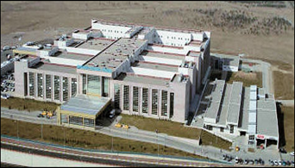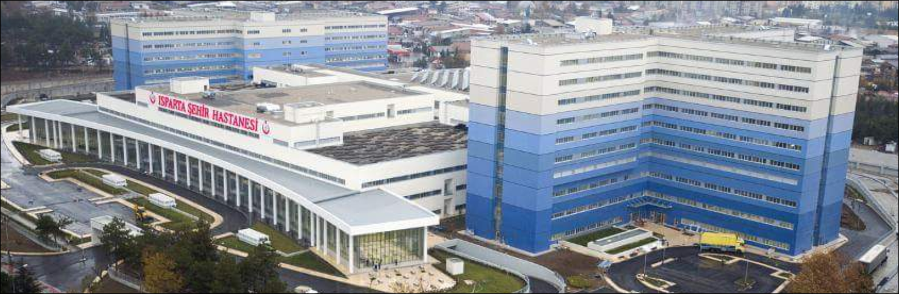

Figures 1 and 2. Erzurum Regional Research and Training Hospital and Isparta City Hospital.

The construction of three base isolated new hospitals (Okmeydanı, Göztepe and Kartal City Hospitals) and the retrofit of Başıbüyük Hospital with seismic isolation were realized in İstanbul under the ISMEP project of the Governorate of Istanbul. The identical Okmeydanı and Göztepe City Hospitals are 250,000 square meter in size accommodating 1150 beds and each hospital is isolated with 506 triple friction pendulum type bearings (Figure 3). Kartal City Hospital, 280,000 square meters in size with 1200 bed capacity, is being isolated with 855 triple friction pendulum type bearings (Figure 4).
Maltepe Başıbüyük Training and Research Hospital in İstanbul was retrofitted with seismic isolation (Figure 5). It represents the largest hospital in the world, retrofitted with seismic isolation. The hospital complex is composed of sixteen 2-13 story blocks with a total area of 113.000 meter square and 750-bed capacity. The retrofit design has aimed to limit the base shear to 12.5% of the seismic weight of the superstructure at DBE (475-year) earthquake level and to keep the story-drifts under 0.5% and 1.0% respectively for DBE and MCE (2475-year) earthquake levels. Considering the architectural limitations and construction practice the isolation layer has been selected as the top of the first basement floor, as indicated in Figure 6. The columns below isolation layer were retrofitted through RC jacketing. The isolation system used for the retrofit was determined as a combination (687 units) of lead rubber (LRB) and sliding (NTM) bearings manufactured by Freyssinet Inc. Furthermore, 154 Pot type supports were installed under the stairwells and elevator cores (Figure 7). For the installation of isolator units the columns were supported by a post tension mechanism in order to cut the column for the placement of the isolator units

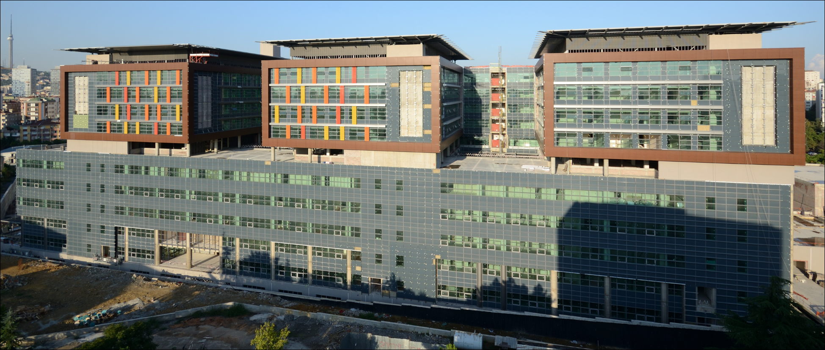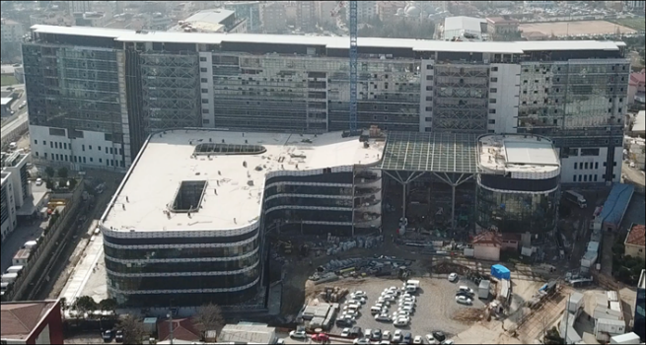

Figures 3 and 4. Okmeydanı-Göztepe Hospitals and Kartal City Hospital.

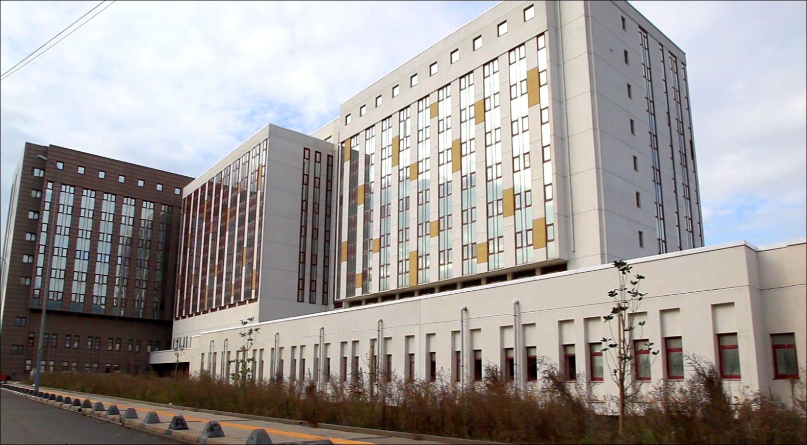

Figure 5. Maltepe Başıbüyük Training and Research Hospital.

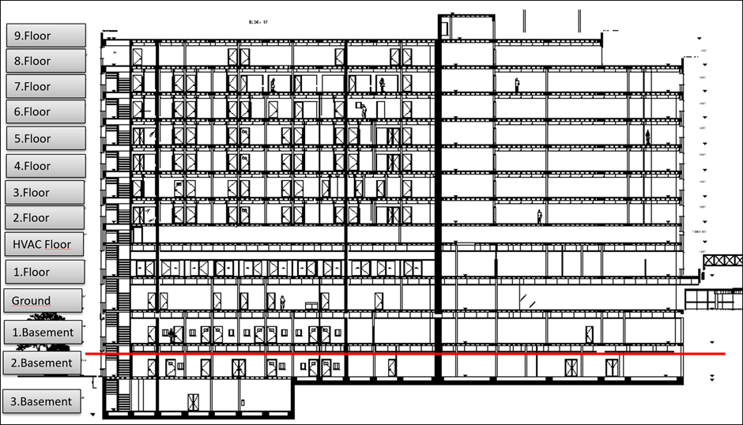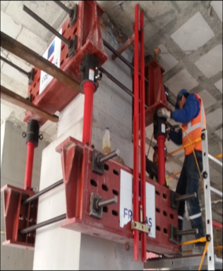

Figures 6 and 7. Structural Sectıon Indicating the Isolation Level and the Installation of Isolator Units

Adana Integrated Health Campus (Adana City Hospital), encompassing 430,000 square meter floor space, was identified as the second largest base isolated building (measured by total floor area) in the world. The hospital has a total capacity of 1,550 beds housed in three hospital units. The hospital structure, located on a high seismic zone, is supported by 1513 triple friction pendulum seismic isolators and targets “operational” performance level under the Design Basis Earthquake (DBE). The architectural design of the complex was done by HWP Planungsgesellschaft mbH, Stuttgart, Germany. The structural engineer was Ülker Engineering Ltd., Istanbul, Turkey. It was built by Rönesans Sağlık Yatırım Inc. The complex is located on an octagonal base and 4 towers with 11 storey stand at each corner in a symmetric fashion. A general picture of the hospital and an isometric view of the structural model used in the design are provided respectively in Figures 8 and 9.

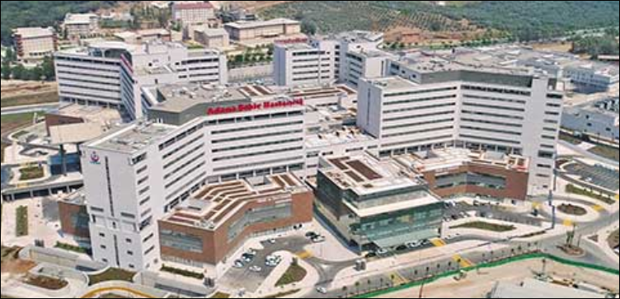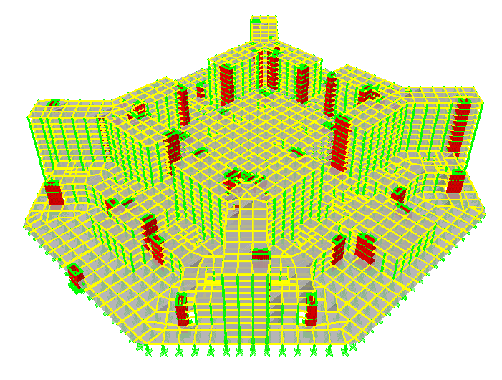

Figures 8 and 9. A General Picture of the Adana City Hospital and an Isometric View of the Structural Model

Bursa City Hospital, located in Bursa City in Marmara Region in Turkey, is built within the scope of Public Private Partnership (PPP) of the Ministry of Health by Rönesans Sağlık Yatırım Inc. The structural engineer was OBS Ltd., Istanbul, Turkey. The hospital has 1355 bed capacity and encompass a closed area of approximately 325.000m2. The hospital has 3 basement floors, ground floor and 7 floors. The isolation interface is at the top of the 2nd basement floor columns below the 1st basement floor slab and at the foundation level below the elevator and staircase walls. 859 LRB type isolation units were used in the seismic isolation system. The largest isolation units has a diameter of 127cm, total rubber thickness of 28cm with a lead core of 22cm diameter. Nominal MCE design parameters are: system displacement = 48cm, system damping = 0.20, effective period = 3.24s and base shear coefficient =0.18. A general picture of the hospital and an isometric view of the structural model used in the design are provided respectively in Figures 10 and 11.

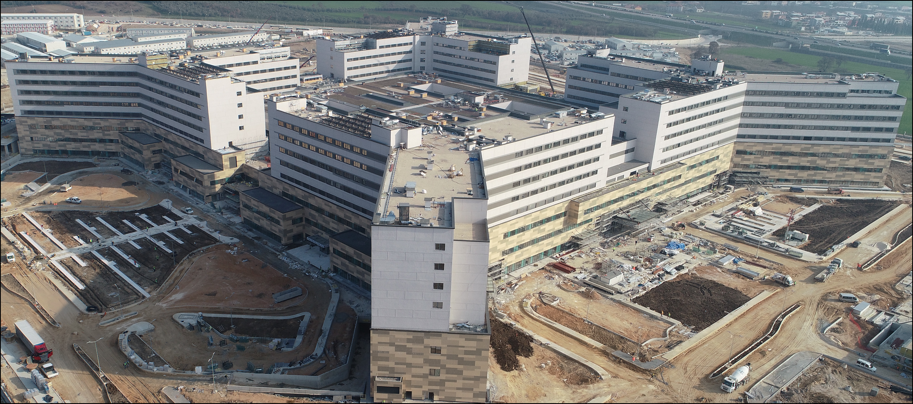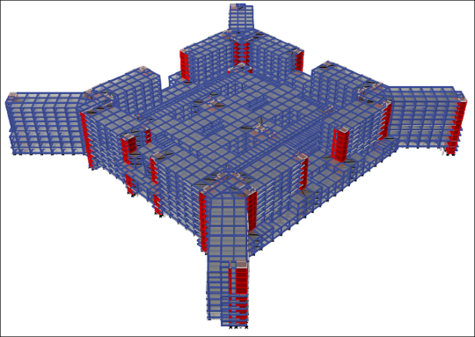

Figures 10 and 11. A General Picture of the Bursa City Hospital and an Isometric View of the Structural Model

An important hospital project under construction in Turkey is the Başakşehir (Ikitelli) Health Campus in Istanbul. The 790,000 square meter, 2,354-bed hospital complex sitting on 2040 isolator units, is expected to be the largest base-isolated building in the world when completed in late 2019 (Figure 12). The hospital is built by Rönesans Holding and the structural engineer is ARUP Los Angeles. ASCE 7-10, 41-13 as well as TERDC (2018) design codes were used for Performance Based Seismic Design. The non-uniformity of the soil layers underlying the hospital and the fact that the hospital is supported on isolators makes the relative settlement of the shallow foundations 1m diameter bored piles with variable lengths depending on the soil type are used (Figure 13). The largest triple friction pendulum isolator type used has an outer dimension of 157cm and a height of 52cm with three stage nominal friction coefficients of 0.03, 0.055 and 0.065. It has a displacement capacity of 86cm, vertical elastic load capacity of 67MN. The structure has a total seismic weight of 1.3 x 10⁹ kg, a fixed base period of 1.6s and1.9s. The isolated system periods are 3.7s (DBE) and 4.5s (MCE). The seismic load coefficients are 0.08g (DBE) and 0.12g (MCE). Figures 14 and 15 illustrate the structural models used for linear and nonlinear analysis. A current view of the construction is provided in Figure 16.

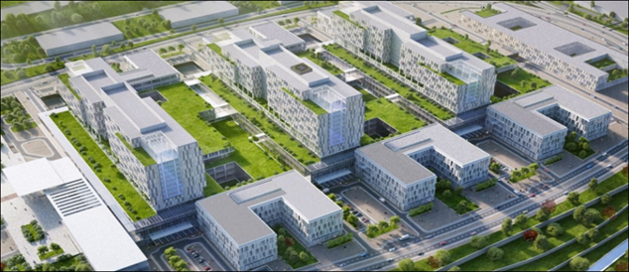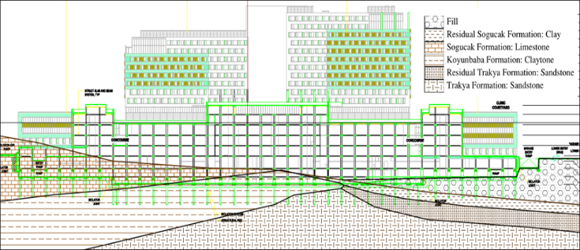

Figures 12 and 13. A Rendered View of the Başakşehir Hospital and Structural and Geotechnical Section

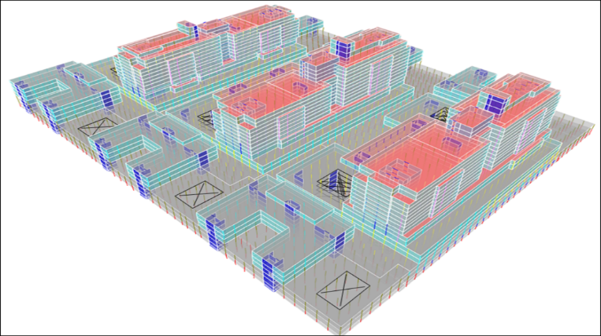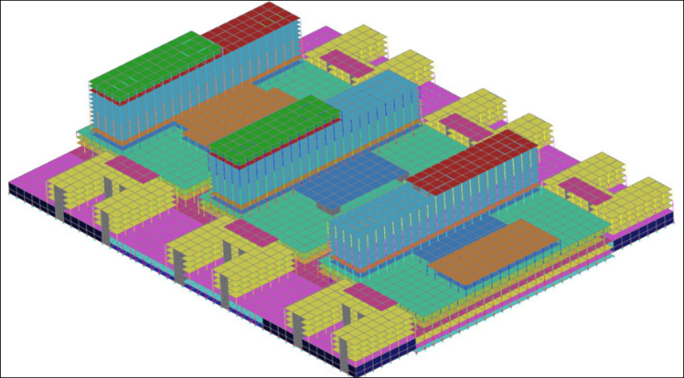

Figures 14 and 15. ETABS Model for Linear Analysis and LS-Dyna Model for Non-Linear Analysis

Figure 16. A View of the Başakşehir Hospital Construction (February, 2019)

Other hospitals constructed with seismic isolation include, but not limited to, the following. Elazığ hospital, with a total area of 350,000 square meter encompassing 1050 bed capacity, has a seismic isolation system with 878 triple friction pendulum isolator units. Çorum hospital, encompassing 800 beds within 102,000 square meter area, is seismically isolated with 741 lead rubber bearings. Information on: Manisa (150,000m2, 560 beds, 734 LRB units), Eskişehir (291,000m2, 1081 beds, 973 curved surface friction slider units), Antalya Muratpaşa (52,000m2, 300 beds, 443 LRB units), Kahramanmaraş Elbistan (49,000m2, 300 beds, 455 curved surface friction slider units), Manisa Merkez Efendi (68,000m2, 458 beds, 501 curved surface friction slider units), Balıkesir Burhaniye (30,000m2, 100 beds, 158 LRB units), Bursa Gemlik (35,000m2, 150 beds, 236 LRB + 24 slider units), Edirne Keşan (26,000m2, 150 beds, 180 LRB + 12 slider units), Bursa Şevket Yılmaz (40,000m2, 150 beds,188 curves surface friction slider units), Bursa Kestel (27,000m2, 125 beds,192 curved surface friction slider units), Çanakkale Biga (23,000m2, 150 beds, 280 LRB units), İstanbul Çekmeköy (49,000m2, 150 beds and 173 curves surface friction slider units) and İstanbul Yedikule (29,000m2, 200 beds, 102 LRB units) City Hospitals are provided in Erdik (2017).

3.2 Other Structures

The seismic isolation applications for data centers, schools, sports stadia, industrial facilities, bridges and viaducts as of 2017 were covered in Erdik (2017).
The number of applications on other structures since 2017 were limited to small scale bridges.

4. DAMPERS, BUCKLING RESTRAINED BRACES AND TUNED MASS DAMPERS

Renaissance Tower in Istanbul, Istanbul Technical University-Technopark Building in İstanbul and Folkart Twin Towers in İzmir has employed unbounded braces in their earthquake resistant design. The earthquake retrofit of the Turkcell Maltepe Plaza building in Istanbul encompasses 36 viscous dampers as diagonal bracing elements. Earthquake retrofit of the Bosporus Suspension Bridge included the use of four viscous dampers as buffers between the deck and the towers. Hysteretic dampers were used in connection with the earthquake retrofits of the Old and New Golden Horn Bridges and the Ortaköy approach viaduct of the Bosporus Suspension Bridge. The use of tuned mass dampers in Turkey has been so far limited to tall industrial stacks (Erdik, 2017).
A novel application of Tuned Mass Damper to one of the stacks in Tüpraş Rafinery in Izmir will be presented in this conference.
The Yavuz Sultan Selim Bridge, is the third bridge built in Istanbul across the Bosphorus Straits wıth eight traffic lanes and two railway tracks. The hybrid cable-stayed / suspension bridge, has main span of 1408m, 322m-tall towers and 58m-wide deck – three world records for this bridge type. The entire system is supported by two A-shaped concrete towers. To control the vibration of the back span and stay high angle stay cables external viscous dampers were used (Figure 17). The low angle long stay cables in the main span were cross linked to each other to introduce damping (Figure 18).

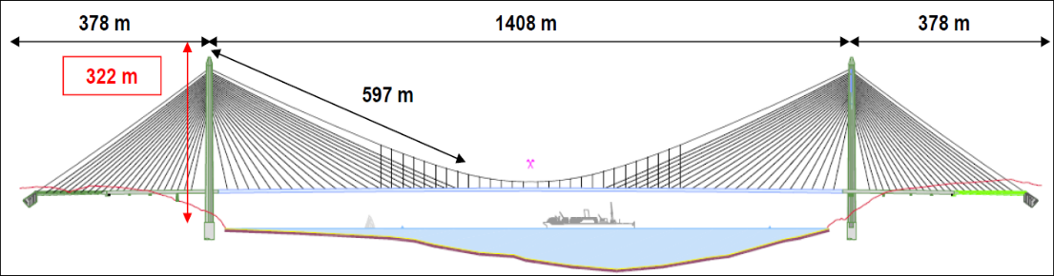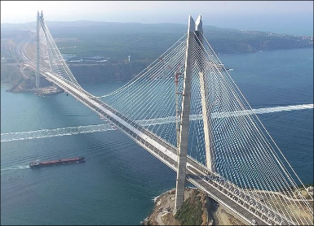

Figure17. General outline and view of the Yavuz Sultan Selim Bridge

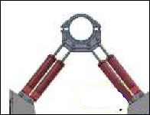

Figure 18. Viscous dampers and the cross-links used on the Yavuz Sultan Selim Bridge Stay Cables

The Osmangazi Suspension Bridge (Izmit Bay Bridge), is a suspension bridge with 1550m long main span and two 566 m long side spans, and is the fourth longest suspension bridges in the world. The bridge, that carrıes six lanes of highway across the İzmit bay, consists of a steel box with stiffened steel plate deck (total bridge length 3020m), sustained by cables and towers made of stiffened steel plate (up to 252m height).
Figure 19 provides a view of the bridge with north and south approach viaducts. The bridge is located in an area of high seismic activity, and crosses the North Anatolian Fault. The earthquake performance of the bridge was enhanced by building its pylons on a concrete foundation that rests on a large gravel bed. Since the foundation can slide on in the event of a major earthquake, the bridge will be partly isolated from the earthquake through foundation-soil interaction.
To further control its earthquake response: sliding spherical bearings (with uplift protection), to carry the vertical loads, and lateral elastomeric bearings to provide the transversal restraint were used. Four viscous dampers with lock-up devices control the thermal motion of the suspended deck (Figure 20).

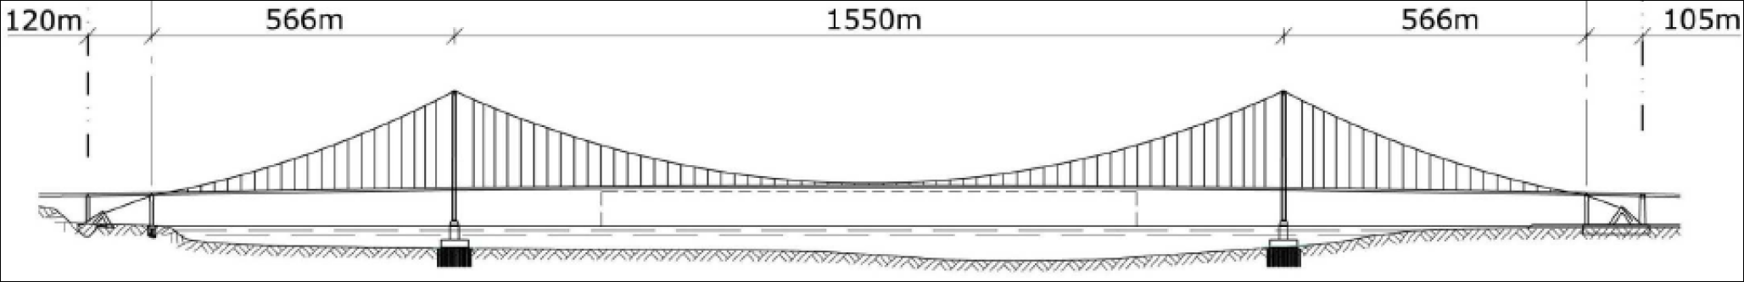
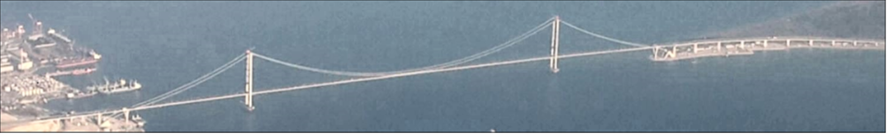

Figure 19. General layout of Osmangazi Suspension Bridge (North to south = left to right)

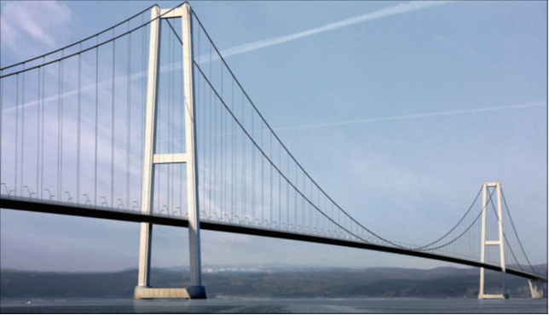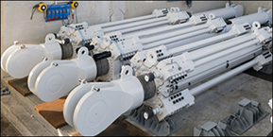

Figure 20. South Approach of the Osmangazi Suspension Bridge and a picture of the dampers used.

5. Conclusions

Seismic isolation technology is being implemented in Turkey at an accelerated rate, especially after the 1999 Kocaeli earthquake. The enforcement of Ministry of Health for the use of seismic isolation for hospitals in medium-to-high seismic hazard regions is an important and rational decision.
Considering the amount of investment in health sector and high level of seismicity in Turkey, seismic isolation appear to the only solution to achieve the performance objective of being “operational / functional” for the protection of human lives as well as the investment.
In this connection, the seismic safety level of both the structure and non-structural content of the existing hospitals should also be upgraded so that they could serve after a big earthquake.
Even though the design and construction of structures with seismic isolation involve quite complicated procedures that require advanced engineering input, it has been effectively implemented in important world-class projects in Turkey.
The new official code prepared for the seismic isolation design for buildings will certainly regulate as well as encourage the new applications.
As is the case with new engineering applications, it is inevitable that some problems occur during the design and construction process. These problems can mainly divided into two groups as “technical” and “logistics”.
The technical problems can be listed as;
• Number of experienced engineers for the analysis and design of the seismically isolated structures is quite limited in Turkey
• Similarly, number of architects who has experience in providing solutions in seismically isolated buildings is also quite limited in Turkey
• The official national code is only very recently available in Turkey to regulate the analysis and design of seismically isolated structures
• In the application process, the number of contractors who has the experience of constructing seismically isolated structures are quite limited in Turkey
The logistical problems can be listed as;
• The isolator productions in emerging. However, currently, most of the isolator manufacturers are located outside Turkey
• The number of testing facilities, with capability to provide real time testing to large scale isolators, are in few in number and located outside the country. Testing process of the isolation units is a vital issue that requires the preparation of an official regulation concerning the selection and licencing of testing facilitıes.
• Lack of knowledge, in investors, contractors and engineers, about the selection, procurement, testing and installation stages of the seismic isolation process results in delays in construction schedule.
As required by the new code, the peer review process needs to be structured and become an integral part of the hazard assessment, design and implementation of the seismic isolation applications. Furthermore, the training of engineers for the proper and correct utilization of seismic isolation techniques, as well as licensing, needs to be considered for the healthy development of applications.
In general, it should be kept in mind that the appropriate use seismic isolation technology requires the adherence to the following points. Otherwise, the seismic safety of the isolated structure may possibly be lower than that of the conventional one.
• A rational and functional architectural design, especially for hospitals.
• A reliable definition of the seismic input (Rational incorporation of near fault ground motion effects, long period and long duration ground motions characteristics in the design basis ground motion is of importance).
• A dependable, robust and resilient design using recent design codes, in conformity with the rational performance objectives and with appropriate peer review.
• A careful selection, design, manufacturing, testing, installation, protection and maintenance of the seismic isolation units,
• A good construction implementation, with quality assurance and control and with particular attention to be paid to seismic joints, and lifelines crossing the isolation interface.
• A minimum strong motion instrumentation installed in the base isolated structure to understand the earthquake response of seismic isolation systems.

6. Acknowledgments

I would like to thank Serdar Binzet, Head of Engineering Group, Renaissance Holding Inc., Ali Atac, CEO, TIMA Engineering Inc. and Danyal Kubin, CEO, Prota Inc. for their generous support. I am also grateful to Director Gökhan Elgin, Director, IPCU for his trust and support.
The members of the board of Turkish Society of Seismic Isolation, Dr.Cüneyt Tüzün, Dr.Bahadır Şadan, Dipl.Ing.Ömer Ülker and Dipl.Ing.Mehmet Özcanlı greatly assisted in the preparation of this paper, for which, I am grateful.

7. References

AASHTO (2010), Guide Specifications for Seismic Isolation Design, American Association of State Highway and Transportation Officials (AASHTO), 3rd edition. Washington, DC. Washington, D.C.
ASCE 41-13 (2014), Seismic Evaluation and Retrofit of Existing Buildings, American Society of Civil Engineers, Reston, VA.
ASCE 7-16 (2016), Minimum design loads for buildings and other structures, Standard, American Society of Civil Engineers, Reston, VA.
Constantinou M.C., I. Kalpakidis, A.Filiatrault and R.A. Ecker (2011), LRFD-Based Analysis and Design Procedures for Bridge Bearings and Seismic Isolation, MCEER 11-0004
EC-8 (2005), Eurocode 8, Design of Structures for Earthquake Resistance Part 1: General Rules, Seismic Actions and Rules for Buildings, EN 1998-1:2005. Comitee Europeen de Normalisation, Brussels.
EN 15129 (2009),Antiseismic Devices. Brussels: Comité Européen de Normalisation, 2009.
Erdik, M., C.Tüzün and Ö.Ülker (2015), Evaluation of Seismic Isolation Applications of Health Care Facilities in Turkey, Proc. 14WCSI
Erdik, M. (2017), State of the Art on Application, R&D and Design Rules for Seismic Isolation and Energy Dissipation for Buildings, Bridges and Viaducts, Cultural Heritage and Chemical Plants in Turkey, Invited Paper, Proc. 15th WCSI and NZSEE 2017, Wellington, NZ.
Erdik, M. (2015), State of the Art on Application, R&D and Design Rules for Seismic Isolation and Energy Dissipation for Buildings, Bridges and Viaducts, Cultural Heritage and Chemical Plants in Turkey, Proc. 14th WCSI San Diego, CA.
Erdik M, Ülker Ö, Şadan B, Tüzün C (2018), Seismic isolation code developments and significant applications in Turkey, Soil Dynamics and Earthquake Engineering (2018) 115
Eurocode-8 (2005), EN 1998-1: Design of structures for earthquake resistance - Part 1: General rules, seismic actions and rules for buildings, European Committee for Standardization, Brussels Belgium.
TERDC (2018), Specification for Buildings to be Built in Seismic Zones, Government of Republic of Turkey, Ankara, Turkey

Prof, Emeritus, Department of Earthquake Engineering, Bogazici University, Istanbul, Turkey, erdikm@gmail.com

