TECHNIQUES FOR SEISMIC STRENGTHENING OF HISTORICAL MONUMENTS

DOI 10.37153/2686-7974-2019-16-426-437

Mircan KAYA

ABSTRACT

Due to the complexity of their geometry, the variable and unpredictable characteristics of original materials used in their creation, heritage structures are peculiar and a multi-disciplinary approach is required in any intervention project for historical monuments with a proper assessment to determine their specific needs, a correct diagnoses to decide on the techniques of intervention. Apart from the traditional techniques like bed joint reinforcement, the intervention to historical buildings may benefit from several other modern methods which may be described as innovative techniques to improve their performance under existing and additional loads like seismic loads. Among them are pre-stressing & post-tensioning, use of shape memory alloy devices and shock transmition units, shoring, drilling, and the use of stainless steel or titanium.There are several examples of seismic strengthening with traditional and innovative techniques around the world, which will be discussed in this paper.

Keywords: Bed Joint Reinforcement, Historical monuments, post-tensioning, pre-stressing, seismic strengthening, shape memory alloy devices, shock transmitters, tie rods

1. INTRODUCTION

An historic monument is an awe inspiring building that creates a sense of curiosity and makes us want to know more about the people, and culture produced it. With its architectural, aesthetic, historic, documentary, archeological, economic, social and even political and spiritual or symbolical values; the first impact is always emotional being a symbol of the cultural identity and a part of heritage. Surviving the hazards of 100 years of usefulness, it has a good claim of being called historic” [1].
The conservation of historical monuments with different intervention techniques requires an interdisciplinary approach that involves the coordination of many aspects such as architectural, structural, aesthetic, historic, scientific, and technical methods A team formed of experts from different fields should work in harmony by respecting each other's efforts. Therefore, a successful outcome depends on following a methodology which includes proper assessments, a safety evaluation, and the selection of the appropriate intervention techniques meeting best the strengthening needs of the specific building.
Various intervention techniques for structural strengthening or consolidation of historic monuments can be used. However, recent approach recommends that they should fulfill the criteria of reversibility, durability, compatibility, and minimal intervention. Bearing always in mind that no decision or technique is error-free, the intervention should not avoid the possibility of considering new intervention techniques in the future.

2. INTERVENTION THEORY

General conceptions to be considered during an intervention project for an historic structure are:
1) Damage suffered by the object.
2) Insecurity of the object.
3) Disfigurement suffered by the object

The standards of ethics that must be followed rigorously during all kinds of conservation interventions for historical buildings are:
1) Condition of the object, the methods adapted as well as the materials used for the intervention should be documented properly.
2) Historical evidence must not be destroyed, falsified, or removed and should be recorded promptly.
3) Any intervention must be the necessary minimum.
4) Any intervention must be carried out with an unswerving respect for the aesthetic, historical, and physical integrity of the heritage structure [1]

Considerations listed below are essential during an Intervention project:
1) It has to be reversible, if there are no technical limitations.
2) It should not imperil future possible interventions .
3) Not hinder the possibility of future access to all evidence incorporated in the project.
4) Allow the maximum amount of existing material to be preserved.
5) Be harmonious in texture, form, scale, color, but, be less eye-catching than the original material, yet identifiable at the same time.
6) Not be undertaken by unqualified persons without sufficient training, and experience.

2.1 Materials Used in Historic Structures

The two main structural materials of historic buildings are masonry and timber. Masonry is one of the oldest construction materials which is as old as the history of civilization. It can be made of brick, stone, concrete, and tile that are manufactured as units, and bonded usually by using mortar in the job site. Historic masonry buildings are generally very stable, and durable.
Masonry is a brittle composite material which is weak in tension but strong in compression. It will normally crack when subjected to tensile stress. Visible patterns of cracking, particularly in vaulted masonry buildings indicate the nature of internal action. The directions of the principal compressions are parallel to the cracks because in masonry structures, cracks occur mainly close to the right angles of the principle tensile stresses. Cracking in masonry does not necessarily point to important structural problems. If there is a resisting scheme (as an embedded arch or system of arches) involving only compression forces, masonry structures may stand safely despite cracks.

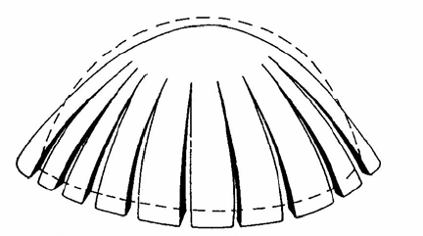

Figure 1. Cracking in masonry does not necessarily point to a structural problem

Members of timber systems can resist tensile as well as compression. The joints can resist tension. However, the strength of the total system is limited by the strength of the joints, and the span is limited by the length of the timber available.
In the case of stone, it's strength, quarrying facilities, lifting, and transportation were dominant considerations. The longest stone beams known are in Fujian, China. They are 23 m long granite beams, and they were used to for the construction of a multi span bridge [1].
The behavior of a masonry structure can be examined in the light of three simplified assumptions:
1) masonry has no tensile strength.
2) masonry has an infinite compressive strength. Although a local crushing of masonry can be observed, overall collapse due to masonry crushing is not realistic, because the stresses are usually low in comparison to the compressive strength of the materials.
3) Sliding failure cannot occur. Although it is possible to find occasional evidence of slippage in a masonry structures, it is assumed that the friction between the voussoirs are high enough, or stones are effectively interlocked so that they cannot slide on one another.

3. Causes of damages

All unintended gaps in masonry are called “cracks”, which can be categorized as:
1) Cracks through units.
2) Opening of be joints and butt joints.
3) Sliding along bed joints.

Causes of damage may be categorized as:
1) Imposed deformations.
2) Excessive lateral forces.
3) Eccentric loading.
4) Embedded iron work.
5) Defects in brickwork cladding and reinforced concrete-framed buildings.
6) Problems with cavity ties.

3.1 Damage and Collapse Caused by Dynamic Actions

Earthquakes, winds, vibrations, explosions are all dynamic actions causing large dynamic amplitude oscillations and acceleration causing severe damage, and even collapse.
The intensity of the forces imposed on a structure is related to the intensity of the acceleration, natural frequencies, and the energy dissipating capacity of the structures. Seismic action is often the main cause of damage and collapse of historical buildings. The effect of earthquakes is often amplified by earlier structural damage and by soil settlement in particular. Damage and collapse happen successively during earthquakes; the building becomes more and more disconnected and cracked as numerous shocks hit the building, although only a few are of high magnitude. Fortunately this usually reduces the overall stiffness of the structure so that its natural period increases, and thereby lower forces are induced. In many cases, the safety margin is therefore not reduced and is very different to that which occurs in very rigid buildings [5].
It’s not possible to avoid earthquakes or to modify the intensities or frequencies of earthquakes. The knowledge of the hazard which is determined by seismic classification is useful in order to calibrate the interventions. It is also possible to quantify the reference seismicity in every area through hazard studies.

4. STRUCTURAL ASSESSMENT AND APPRAISAL

In an appraisal process of an existing structure, structural analysis form only one part of the equation. An iterative process is required between phases of data acquisition, structural behavior, diagnosis, and safety. Diagnosis and safety evaluation of the structure, in particular, are two consecutive stages related to each other. If these stages are performed incorrectly, it cannot be possible to determine the efficient measures of treatment for the structure, leading to inadequate safety levels due to poor judgment.

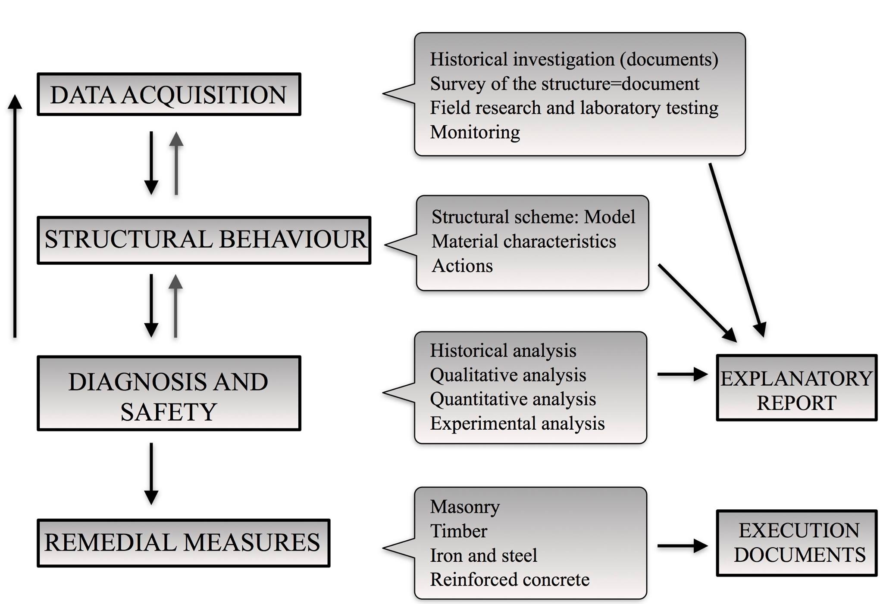

Figure 2. Recommended methodology for a successful structural assessment and appraisal

The International Scientific Committee on the Analysis and Restoration of Structures of Architectural Heritage (ISCARSAH) has prepared recommendations for those who are involved in conservation and restoration problems. The recommended methodology for a successful project is shown in Figure 3.
In terms of the risk for human life, historic buildings can be categorized as:
1) Isolated buildings.
2) Buildings belonging to urban areas.
3) Buildings open to the public
4) Buildings open to mass groups of people (cathedrals, theatres, etc.) [7].
The building categories present different typologies and their response to seismic actions are different. Depending on the complexity of the structure, the method for the structural analysis to be applied should be decided accordingly. For a complex structure, it is often difficult to perform a non-linear analysis whereas linear elastic models provide practical solutions. Figure 3 shows the paths for improved appraisal for existing structures [3].

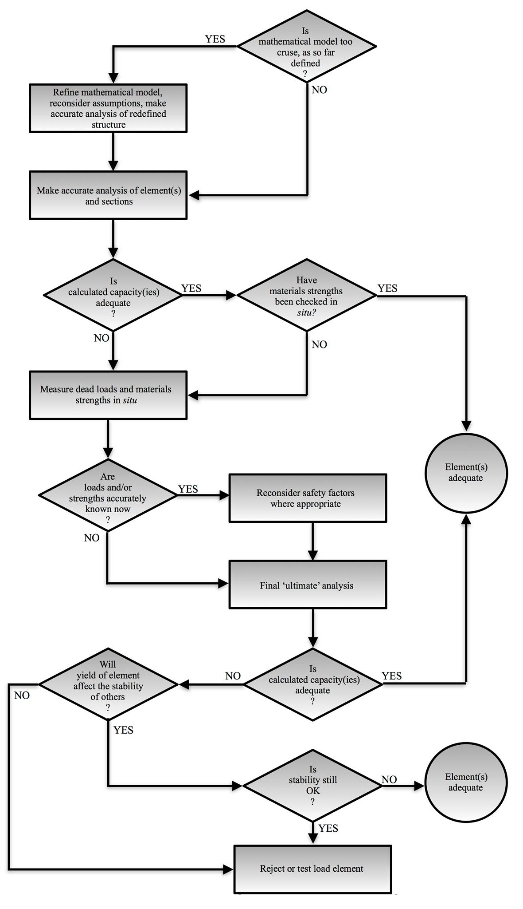

Figure 3. Paths of improved appraisal [3].

The methodology of investigation which is within the EU Contract “ONSITEFORMASONRY” developed between 2001 and 2004, and within GNDT and RELUIS contracts, is briefly described in Figure 4 [7].

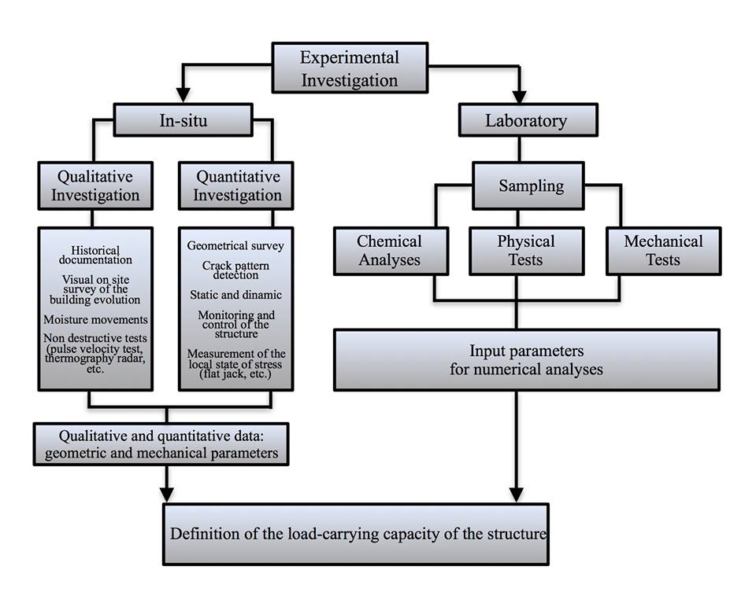

Figure 4. Finalization of the experimental survey for the structural analysis.

4.1 Tests for Material Characterization

Laboratory tests which are aimed at determining the material characteristics to be implemented in the structural analysis are performed in two ways:

1) Laboratory Tests
These tests are aimed at determination of the characteristics of the materials in terms of chemical, physical and mechanical point of view, to detect their origins, to know its composition and content. The resulting data is useful to decide on the appropriate materials for repair and strengthening works, which must be compatible with the original ones. It also helps to measure the decay and durability of the material with aggressive agents. Tests performed on damaged and new mortar as well as damaged and new bricks and stones are given in this category [7].

2) On-site Investigation Tests
These tests are carried out by using non-destructive or minor destructive techniques:
a) Minor Destructive Tests
Among the several minor destructive tests (the ponder drilling test, the penetration test, the Schmidt Hammer test, the flat jack test) for mortars, the flat jack test is the only technique which gives the most reliable mechanical results up to now. The flat jack test was originally applied to determine the in-situ stress level under compression of the masonry. The state of the stress is determined by the stress relaxation caused by a cut which is perpendicular to the surface of the wall. The stress release is determined by a partial closing of the cutting. [7]
b) Non Destructive Tests
Non-destructive tests (thermovision, sonic pulse velocity tests, radar and sonic tomography) can be used for the detection of hidden structural elements such as floors, arches, pillars, qualification of masonry and of masonry materials, for the mapping of the non-homogeneity of the materials used in the walls (the use of different bricks in the history of the building), for the evaluation of the extent of mechanical damage in cracked structures, for the detection of voids and flaws, for the evaluation of moisture content and capillary rise, for the detection of surface decay, and for the mechanical and physical properties of mortar, brick or stone [7].

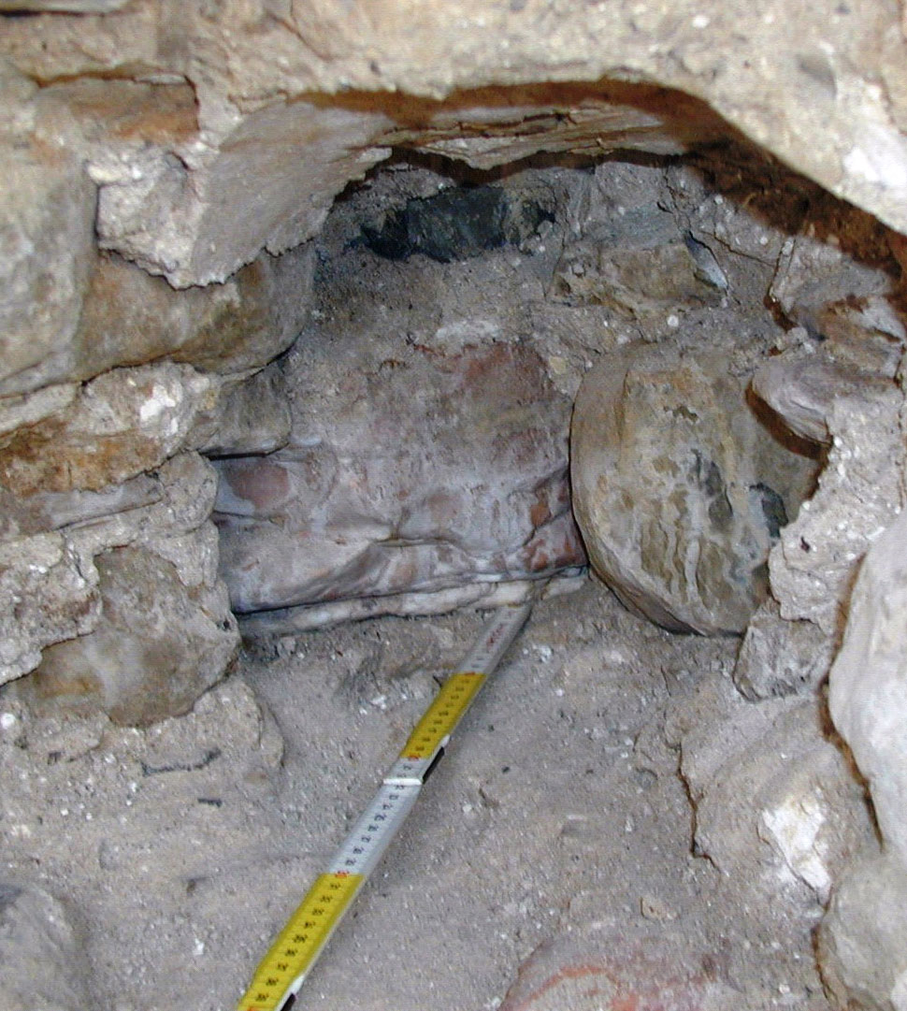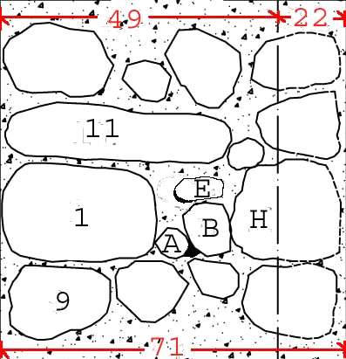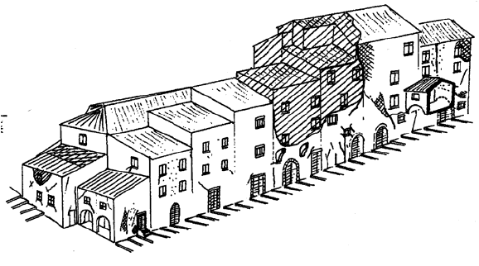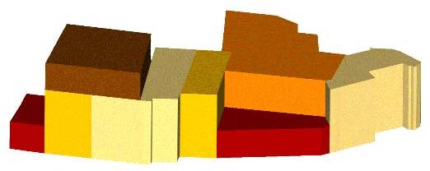

Figure 5. Left: Minor destructive test. (a, b) removal of few stones, (c) survey of the wall section [6] , [7].Right: Failure of raw builgings in Umbria, Italy (Penazzi, 2000), [8] and constructive evolution phases of a complex of buildings

4.2 Different Levels of Investigations

Investigations may be carried out at the urban level to examine the evolution of historic centers under different actions like earthquakes in the past as well as for maintenance purpose because the lack of maintenance for a long time can be as destructive as earthquakes.

5. SEISMIC STRENGTHENING

In any structural strengthening projects, compatibility must be the main criteria while choosing the repair materials. The new repair material must be compatible with the existing original material of the building. There has been many problems in the past due to interventions with incompatible materials [3].
Due to the lack of knowledge and of appropriate analytical models, masonry has been treated, until recently, as a homogeneous material as concrete, steel, or wood.
With an assumption such that masonry structures in seismic areas should demonstrate a box behavior, stiff floors and connections between the walls and floors were considered to be effective regardless of their geometry and material composition. The same intervention techniques applied in seismic areas which entails the substitution of timber-floors and roofs with concrete ones, wall injection by grouts, use of concrete tie beams inserted in the existing walls.

5.1. Principles of Seismic Strengthening

The provisions should be ensured for seismic strengthening of historic buildings with masonry walls:
1) All the walls should be tied laterally to the floors which will enable the floors to act as rigid diaphragms. By doing this, the walls will be prevented to bend in plan freely or move laterally, hence the plan shape will be undisturbed.T-junctions will not be detached [3].
2) To create rigid diaphragm floors, timber floors are substituted by reinforced concrete floors. However, owing to the fact that the introduction of concrete floors will increase the mass of the building which will lead to an increase of the inertia forces, more appropriate means should be used. Increased mass and conclusive increased inertia forces imposed on the vertical structure during an earthquake is undesirable.
3) What is essential is the tying of walls to the floors by appropriate methods. Inspections of damages after various earthquakes show that entire walls parallel to the floor beams had fallen away, whereas the walls on which the floor joists were supported were still standing.
The earthquake that struck Umbria and Marche in 1997 demonstrated the limits of some of the traditional strengthening techniques. Significant damage was observed during inspections, even on the buildings that were previously consolidated after the 1979 earthquake. Wrong choices of intervention techniques proved to be disastrous rather than protective.

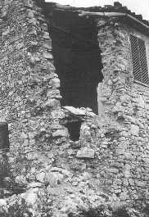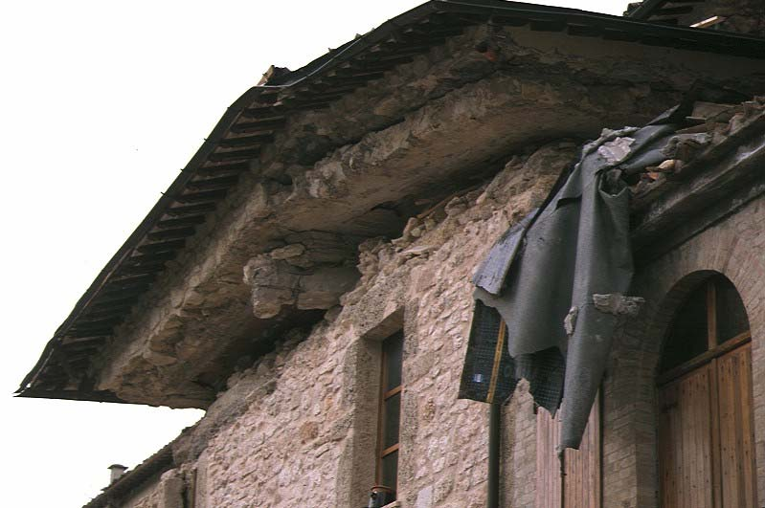

Figure 6. Inadequate consolidation of masonry

It is evident that the strengthening of historic cultural properties against earthquakes cannot be separated from an overall consolidation project. A monument that is suffering from any problem from settlement to material deterioration should be fixed with an inclusive vision. Therefore, it is worth mentioning once again the criteria that must be taken into consideration when seismic strengthening is necessary:
1) Masonry quality should be improved by means of proper consolidation techniques.
2) Structural configuration should be improved by additional new resistant elements.
3) A monolithic three-dimensional behavior of the structure, against the horizontal seismic loads should be achieved, by means of wall-to-wall and floor-to-wall connections: Metallic or different material tie rods, external circumferential tie rods, local connections, ring beams.
4) If the intervention will be executed partially, the effects in terms of variation of the distribution of the stiffness should be evaluated and calculated properly.
5) Bad execution of the intervention may cause worsening the masonry quality which will affect the global behavior of the building negatively.

5.2. European Seismic Codes for Existing Buildings

Table 1. European Codes For Exisiting Buildings

EUROCODE 8 - Design of structures for earthquake resistance.
Part 3: Assessment and retrofitting of buildings
(prEN 1998-3; November 2004)
Developed from 1996
ORDINANCE P.C.M. 3274 20/03/03: First elements about the general criteria for the seismic classification of national territory and about technical regulations for constructions in seismic areas.
Developed from 2003 until 2005
ORDINANCE P.C.M. 3431 03/05/05: Further changes
and upgrades to the Ordinance PCM n. 3274.
Officially termed by the NATIONAL CODE FOR CONSTRUCTION
ANNEX 2: Technical rules for the design, the assessment and the seismic upgrade of buildings.
GUIDELINES FOR THE APPLICATION OF THE SEISMIC ORDINANCE TO THE CULTURAL HERITAGE

5.3. Eurocode 8/ Opcm 3431: Main Principles

1) The new rules of design and assessment of buildings are performance based.
2) The performance of the structure is linked to the limit states: The ultimate limit state ULS and the damage limit states DLS.
3) Only limit state design is allowed. Allowable stresses method is no longer accepted.
4) A design approach is described which proposes to assign a different resistance to different structural elements (Hierarchy of resistance).
5) The new seismic classification is based on the definition of 4 zones that are characterized by different values of a_{g} . National territories are classified.
6) The ductility of structural elements is expressed and participates in the definition of the design action.

5.4. Bed Joint Reinforcement Technique

The bed joint reinforcement technique is based on the insertion of steel bars in the mortar bed joints previously excavated by a few centimeters and then refilled by a repointing material. It is particularly applicable to facing masonry having regular courses (brick or stone masonry rather than rubble stone walls), where it can be appropriate for several structural conditions.

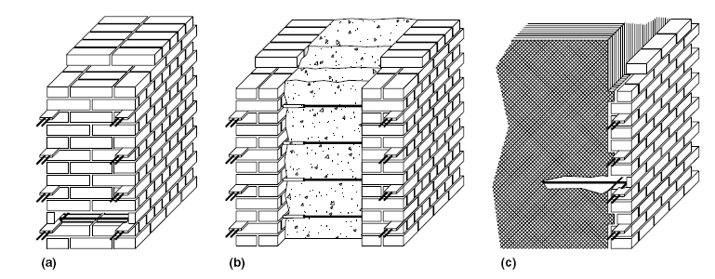
Figure 7. Application of Bed Joint Reinforcement technique on different types of brick masonry walls: (a) solid bearing wall; (b) multi-leaf wall; (c) multi-leaf wall with external veneer wythe.

The main operative steps for a correct execution of the intervention with the Bed Joint Reinforcement Technique [10]:
1) Removal of the plaster or the finishing from the surface, to investigate the condition of the masonry.
(2) Accurate inspection of the masonry; it should be appropriate to inject some large voids or replace some bricks.
(3) Cutting of the bed mortar joints by using suitable tools; the recesses should be at least 10 mm high and 50-80 mm deep, so that the reinforcement can be inserted and the remaining mortar in the masonry can bear the applied loads.
(4) Removal of powder or rubble by air or water. This depends on both the existing and the repointing materials. Water can be appropriate to avoid the excessive absorption from the new mortar to the old one. The groove should be kept dry if special polymeric materials are used.
(5) Placing of a first layer of embedding material, which should be accurately compacted. Compatible mortars are usually made of hydraulic lime and can contain special additives, having expansive properties to compensate for the shrinkage during the hydration phase.
(6) Placing of the reinforcing material: steel bars or plates (stainless, in general) or FRP laminates can be used. To increase the friction between reinforcement and the existing mortar, rough surfaces should be preferred. When using steel bars, their contact area should be cleaned with sandblasting, the use of more bars with smaller diameters should be preferred. However, due to the slight thickness of the bed joints which are usually around 10–15 mm, only reinforcements that are reduced in size (4–6 mm in diameter) can be inserted. The reinforcement should be separated from the surface of the brick by using spacers.
(7) A second layer of mortar has to be applied over the first bar to cover it sufficiently. Another bar is inserted if necessary, and then another layer of mortar should be laid to cover it.
(8) To seal the horizontal joints and for a homogeneous appearance, a final layer of repointing material should be placed in the last available slot of 15–20 mm
The proposed technique does not show a particularly high difficulty of application. However, operative phases should be executed carefully, especially in the historic buildings (cutting of the bed joint, cleaning, repointing). Bed Joint Reinforcement is a surface intervention but the combination of this technique with minor reconstruction (where bricks are particularly damaged) and/or injections (especially for multi-wythe masonry walls with internal core having a high percentage of voids), can improve significantly the global strength of the structure.

6. STATE-OF-THE-ART METHODS FOR SEISMIC STRENGTHENIN OF HISTORIC BUILDINGS

6.1. Pre-stressing and Post-Tensioning

Masonry is strong in compression and has a low tensile strength. This is the main reason why masonry has been used primarily as a construction material for vertical members subjected essentially to gravity loads so far. The weight of the wall may resist to the small lateral loads and deformations. On the other hand, walls with low axial loads demonstrate a poor cracking behavior and a low strength. These drawbacks may be eliminated by post-tensioning the masonry which introduces the desired level of axial load in a wall, thus enhancing the strength, performance, and durability. The prestressing steel prevents brittle tensile failure modes of masonry walls [18].
Pre-stressing of concrete or masonary means that the steel is being tensioned and the concrete or masonry is being compressed. Masonry is very strong in compression and weak in tension and due to the lack of tensile strength, heterogeneity of its components (brick or stone and mortar) and anisotropic behavior, masonry structures are vulnerable to earthquake motions. On the other hand, steel is very strong in tension. By putting the masonry into compression and the steel into tension it gives the strongest quality to both materials before any substantial service loads are applied on them.. The introduction of active compression will provide capacity to resist tensile forces [18].
A tendon is the basic element of post-tensioning which is consisted of pre-stressing steel wires, coated with a protective coating, and housed inside of a duct or sheathing. The forces are transmitted to the structure by means of anchors which are on each end of the tendon [18].

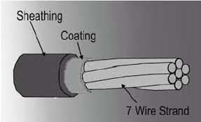

Figure 8. Post-Tensioning tendon [18].

The post-tensioning of masonry structures entails the combination of a relatively new technique with an old material for strengthening purposes. The successful application of post-tensioning relies on the proper execution of the relevant works:
1) Determination & assessment of the real properties of the masonry and the building.
2) Apropriate design according to the relevant codes in force.
3) Proper application of post-tensioning.
By using horizontal tendons, a horizontal compression state can be induced. This will increase the shear strength of walls as well as improving considerably the connections of orthogonal walls. The easiest way of affecting the pre-compression is to place two steel rods on the two sides of the wall and strengthening them by turnbuckles. Prestressing is also useful to strengthen spandrel beam between two rows of openings when there is no rigid slab.

6.2. Shape Memory Alloy Devices and Shock Transmitters

The traditional strengthening intervention techniques described in the previous sections are mostly based on reinforcements which increase significantly the overall capacity of the structures. Historic masonry buildings are highly vulnerable due to cumulative damages from the past earthquakes and due to aging which progressively reduces the strength of the materials. On the other hand, they are also vulnerable to ambient vibrations caused by traffic, wind, bells, etc. Therefore, in many cases, these conventional intervention techniques are not sufficient to prevent collapse. Seismic resistance has sometimes been decreased by wrong restoration interventions as well. Some historic monuments are at risk of collapsing under static lads. Considering the current situation of Santa Sofia, for instance which had to be strengthened to protect the building from collapse under static loads, it may be worth to consider innovative intervention techniques which proved to be very effective to protect the structures under both static and dynamic loads.
The use of devices based on super elastic shape memory alloy devices has proved very effective in improving the seismic resistance of masonry structures. The performance of such types of devices were investigated for different structural aspects. Shape Memory Alloy Devices (SMADS) can be used to pre-stress the masonry while at the same time avoiding the overstressing due to the force limitation offered by the super elastic plateau of the alloys. Other types of SMADS become active only during dynamic actions and they do not imply any load transmission to the masonry structure. These types of SMADS can be used as horizontal restraints to enhance the out-of-plane seismic strength of outside masonry walls like the facades of churches. One important characteristic of SMADS is that they are custom designed, taking into account the specific characteristics of the monuments [9, 20].
The results of EC funded ISTECH Project which aimed at developing innovative techniques for the restoration of cultural heritage structures shows through numerical models and intensive tests that SMADS can substantially increase the stability of masonry structures. The out-of-plane shaking table tests on masonry mock-up displays that structure equipped with SMADs remains unharmed exposed to an earthquake of at least 50% higher intensity compared to the one reinforced with conventional steel ties. Pseudo-dynamic tests on other masonry mock-ups subjected to in-plane seismic excitations also show significant increase in the seismic resistance of the mock-ups equipped with SMADs.

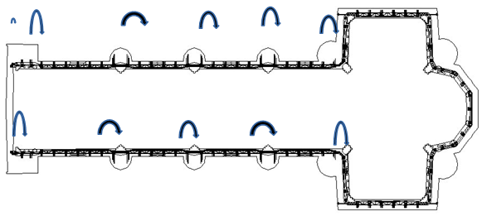

Figure 9. Shock transmission units installed on the upper basilicata of San Francesco in Assisi. Arrows show the locations of the STUs.

Two restoration applications have been realized by utilizing this innovative technique thanks to these successful results: The Bell Tower of the S. Giorgio of Trignano Church in S. Martino in Rio which is damaged during the October 1996 earthquake, and the transept tympana of the Basilica of St. Francesco in Assisi, which was damaged during the September 1997 earthquake.
Shape memory alloy devices are axial devices exploiting the super elastic properties of shape memory alloys which are used in the form of small diameter wires and they have been developed specifically for safeguarding of exisiting historic buildings. [11, 20] SMADs can be substituted with conventional steel ties to connect different structural elements (façades to floors or to roofs). The force limitation capacity of SMAD devices provides the advantage over the use of steel ties. For example, when used as horizontal ties to connect façade walls to roof, SMADs permit controlled displacements and can limit transmitted forces, according to the constitutive law of the device.
Shock transmission units (STU) are generally used as dynamic or temporary restraints. They are based on piston / cylinder system utilizing the fluid to flow through orifices to create a reaction that is the result of a pressure. This pressure is differential across the piston head. They have been extensively used in new structures like bridges, viaducts and prefabricated buildingsin recent yaears [11], [12, 20]. STU devices are designed to work in a way that when a dynamic movement like earthquake occures exceeding the so called activation velocity they react as a very stiff temporary restraint, whereas for very slow movements of service conditions, such as those imposed by thermal expansion, they accommodate to the movements. Recently, STU devices have also been applied in the restoration of some historical masonry buildings. The first of these applications was implemented in the church of San Giovanni Battista in Carife, Italy, which was heavily damaged by the Irpinia earthquake of 1980 during which the old timber roof completely collapsed. A new steel truss roof was built and shock transmission units were used to connect the new roof to the masonry walls. This was done to keep the thermal elongations of the roof from inducing high stresses on the walls and, at the same time, guarantee a situation where the roof can share the seismic actions with all the walls during a seismic attack (owing to the roof high in-plane stiffness and temporary stiff connections to the walls provided the STUs). The most recent application of shock transmission units in monuments was implemented at the Basilica of San Francesco in Assisi, Italy (Figure 10, Figure 11).

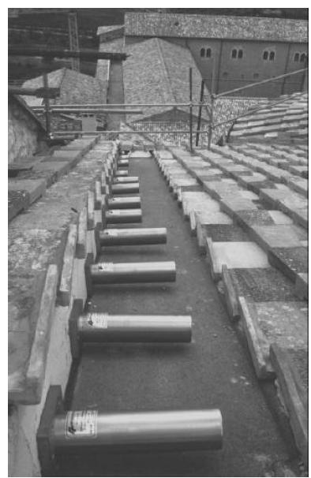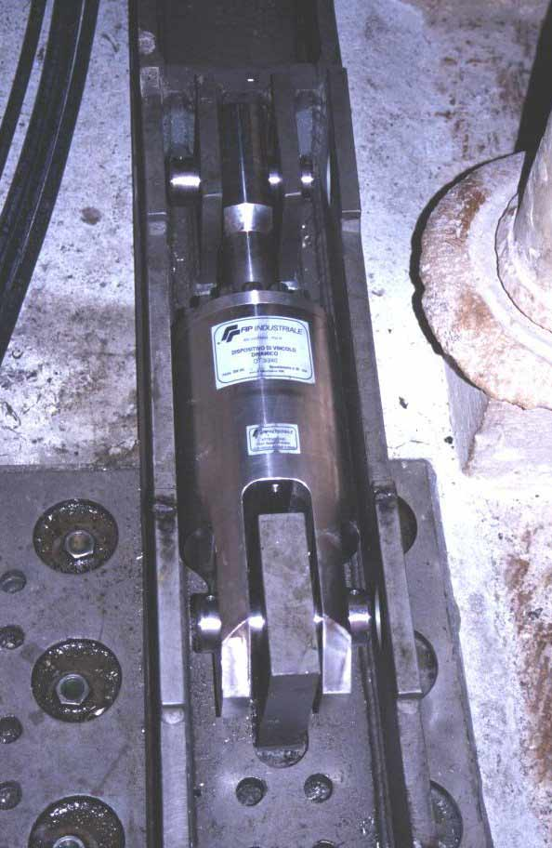

Figure 10. Shock transmission units applied on the Basilica of San Francesco in Assisi.

6.3. Seismic Isolation

The philosophy of the seismic base isolation is to decouple the structure from the ground by means of various types of devices with very low horizontal stiffness and with sufficient damping capacity which change the dynamic characteristics of the structure by increasing its natural period. Decoupling the structure from the ground, thus reducing the earthquake energy transmitted to the upper structure which will consequently reduce the accelerations, put forward seismic isolation as a very effective method for protecting not only the structure itself but also the content of the structure against earthquake. Therefore, the technique comes to prominence when the structure is invaluable in terms of historic value or its contents.
Recent awareness for protecting important buildings against earthquake lead the use of seismic isolation to be used extensively on many types of buildings from bridges to hospitals in high seismic zones. When installed between the foundation and the upper structure, the tecnhique is called as “base isolation”. However, it is also possible to apply seismic isolation partially on a building at different levels.
The first historical building retrofitted by using seismic isolation is the he Salt Lake City and County Building is in the USA. The project was realized in 1987-1988 and the massive five-storey, un-reinforced masonry and stone structure of 76 m high clock tower, located only 3 k m from a fault, was isolated by using 443 rubber isolators. About one half of the isolators were with a lead core to increase damping [11, 20].

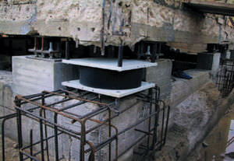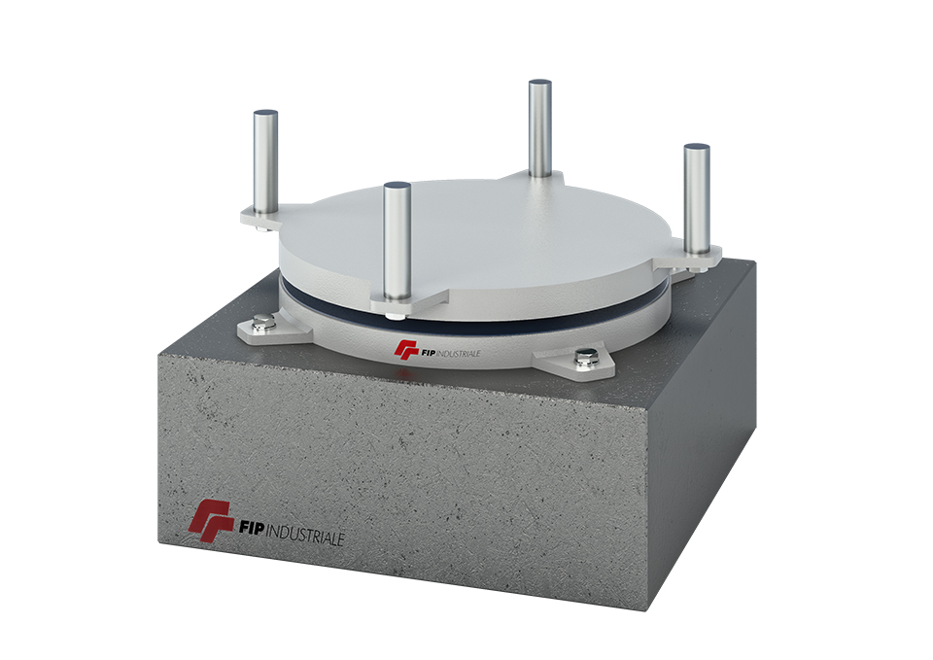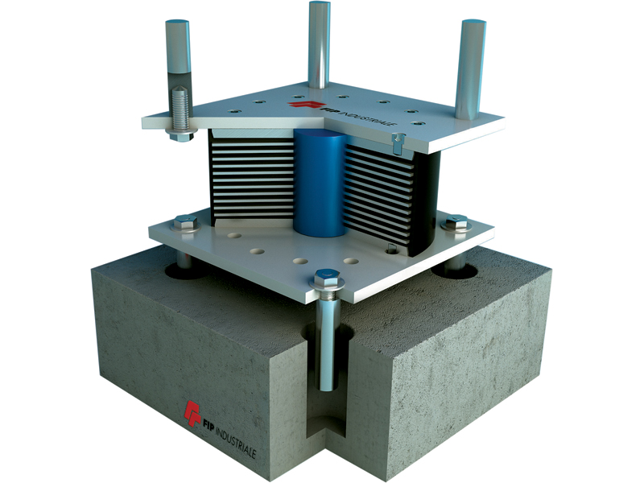

Figure 11. Application of seismic isolation on an existing building and types of isolation devices

7. conclusıons

The clear definition given by Viollet-le-Duc of his understanding of restoration in his Dictionnaire raisonné de l'architecture states that: “Restoration: both the word and the activity itself are modern. To restore a building is not to repair or rebuild it, but to re-establish its original state which must, at a certain moment in time, have existed.”
For successful restoration intervention projects that are necessary to improve the seismic performance of cultural heritage buildings located in seismic areas the understanding of Viollet-le-Duc should never be overlooked. It is a fact that in most cases, interventions are planned only after earthquakes hit the historic monuments. Whereas protective measures should be taken before the heriyage buildings of historic importance have been damaged. This can be achieved by considering a proper combination of traditional and state-of-the-art modern techniques that would meet the needs of the specific building.

8. REFERENCES

Bernard M. Feilden, Conservation of Historic Buildings. 3rd ed., Architectural Press, Oxford, 2003, pp.1-13
Jacques Heyman, The Stone Skeleton. Cambridge University Press, Cambridge, 1995, pp. 1–163.
Poul Beckman and Robert Bowles, Structural Aspects of Building Conservation, 2nd edition, Elsevier Butterman Heineman, Oxford, 2004.
C. Edson Armi, Design and Construction in Romanesque Architectıre, Cambridge University Press, published in the United States of America by Cambridge University Press, New York, 2004.
Giorgio Croci, “Strengthening of monuments under the effect of static loads, soil settlements and seismic actions”, Historical Constructions, P.B. Lourenço, P. Roca (Eds.), Guimarães, 2001, pp. 1167-1190 L. Binda, “Insitu General Purpose NDT anf MDT”, Department of Structural Engineering, Politecnico di Milano.
Luigia Binda, Antonella Saisi, “Knowledge of the Building, On Site Investigations and Connected Problems”, E. Cosenza (ed), Eurocode 8 Perspectives from the Italian Standpoint Workshop, 213-224, © 2009 Doppiavoce, Napoli, Italy, pp. 213-224. v.
Luigida Binda, A. Sasi, “State of the Art of Research on Historic Structures in Italy”, ResarchGate, January, 2001, pp.10-27
Claudio Modena, Filippo Casarin, Francesca da Porto, Enrico Garbin, Nicola Mazzon, Marco Munari, Matteo Panizza, Maria Rosa Valluzzi “Structural Intervention on Historic Masonary Buildings: Review of Eurocode 8 Provisions in the Light of the Italian Experience”, E. Cosenza (ed), Eurocode 8 Perspectives from the Italian Standpoint Workshop, 225-236, © 2009 Doppiavoce, Napoli, Italy
Mircan Kaya, “Inventory of of Repair and Strengthening Methods with Iron and Steel”, Msc Dissertation, Technical University of Catalonia, 2009.
M.G.Castellano, Gianpaolo Colato, Samuele Infanti, “Use of viscous dampers and shock transmition units in the seismic protection of buildings”, 13th World Conference of Earthquake Engineering, Vancouver, B.C., Canada, August 2004, Paper No: 2172, pp. 7-13.
M.G.Castellano, “Innovative technologies for earthquake protection of architetural heriatge” International Icomos Congress, Bethlehem, Palestine, Conference Proceedings, pp.212-234, October 2000.
Binda L., Modena C., Baronio G., Abbaneo S., 1997. Repair and investigation techniques for stone masonry walls, in construction and building materials, Vol. 11, N.3, pp. 133-142, 1997.
L. Binda, C. Modena, G. Baronio, A. Gelmi, “Experimental qualification of injection admixtures used for repair and strengthening of stone masonry walls”, 10th Int. Brick/Block Masonry Conf., Calgary, 1994 Vol.2, pp. 539-548.
"Reinforced and prestressed masonry", Proceedings of a conference organized by the Institution of Civil Engineers, London,1982. ThomasTelford Ltd., London, 1982, pp. 155-163.
A. Saisi, M. R. Valuzzi, L. Binda, C. Modena, “Creep behavior of brick masonry panels strengthened by the bed joints reinforcement technique using CFRP thin strips”, Proceedings of SAHC2004: IV International Seminar on Structural Analysis of Historical Constructions, Possibilities of Experimental and Numerical techniques. Padova, Italy, 2004, pp 837–846.
L. Binda, C. Modena, G. Baronio, S. Abbaneo, (1997), “Repair and investigation tecniques for stone masonry walls”, Construction and Building Materials, 1997, vol. 11, n. 3, pp. 133-142.
“What is Prestressing”, Evaluation and Certification Service, LLC, Phoenix, AZ, 2006
Adolfo Preciado, Gianni Bartoli, y Harald Budelmann, “The Use of Prestressing Through Time as Seismic Retrofitting of Historical Masonry Constructions: Past, Present and Future Perspective”, CIENCIA ergo-sum, ISSN 1405-0269, V o l . 22-3, noviembre 2015-febrero 2016. Universidad Autónoma del Estado de México, Toluca, México. Pp. 242-252.
A De Luca , E Mele, J Molina , G Vergezetti, And A V Pinto, “The Retorfit of Historic Buildings Through Seismic Isolaton: Results of Pseudo Dynamic Tests on a Full Scale Specimen” , 12 WCEE Conference proceedings,Auckland, New Zeland ,2000.
Mircan Kaya, Techniques for Seismic Strengthening of Historical Monuments, Proceedings of the 19th World Academy of Science Engineering and Technology Conference,18-19 April 2018, Paris,France.

Exclusive Agent of FIP in Turkey , Istanbul, Turkey mircan.kaia@fip-group.it1

