PERFORMANCE OF STEEL FRAMED BUILDINGS EQUIPPED WITH

VISCOUS FLUID DAMPERS UNDER NEAR-FAULT GROUND MOTIONS WITH DIRECTIVITY

DOI 10.37153/2686-7974-2019-16-418-425

Memduh KARALAR, Murat DİCLELİ

ABSTRACT

This study is aimed at comparing the seismic performance of steel chevron braced frames (CBFs) with and without fluid viscous dampers (FVDs) as a function of the characteristics of the near-fault (NF) ground motion and FVD parameters. For this purpose, comparative nonlinear time history (NLTH) analyses of single and multiple story CBFs with and without FVDs are conducted using NF ground motions with various velocity pulse periods scaled to have small, moderate and large intensities. Additionally, NLTH analyses of single and four-story CBFs with FVDs are conducted to study the effect of the damping ratio and velocity exponent of the FVD on the seismic performance of the frames. The analyses results revealed that the seismic performance of the CBFs without FVDs is very poor and sensitive to the velocity pulse period and intensity of the NF ground motion due to brace buckling effects. Installing FVDs into the CBFs significantly improved their seismic performance by maintaining their elastic behavior. Furthermore, FVDs with smaller velocity exponents and larger damping ratio are observed to be more effective in improving the seismic performance of the CBFs subjected to NF earthquakes. However, FVDs with damping ratios larger than 50% do not produce significant additional improvement in the seismic performance of the CBFs.

Keywords: steel, frame, bracing, damper, seismic, near-fault

1. INTRODUCTION

In steel building construction, chevron braced frame (CBF) is frequently used since its brace configuration provides an open space for architectural arrangements. Seismic energy dissipation in a CBF solely depends on the inelastic cyclic behavior of the braces. Cyclic axial force-deformation behavior of a brace is unsymmetric in tension and compression and typically exhibits substantial strength and stiffness deterioration due to buckling effects (Sabelli et al. 2003). Thus, when subjected to a strong ground motion, inelastic buckling of the braces in a CBF results in loss of lateral stiffness and strength of the frame (Khatib et al.1998). Furthermore, it is difficult to achieve well-distributed ductility demands along the height of the CBF due to the premature buckling of the braces at certain floor levels (Perotti et al. 1991), which results in soft-story formations, dynamic instability (Tremblay and Robert, 2001) and hence substantial damage to the frame members. Because of the above-mentioned poor performance characteristics, a large number of CBFs suffered considerable damage in past earthquakes (Osteraas, and Krawinkler, 1989, Kim and Goel, 1992, Hisatoku, T., R, 1995, Tremblay et al. 1995, Tremblay et al. 1996, Krawinkler et al. 1996).
Near-fault (NF) ground motions affected by directivity contain distinct pulses in their acceleration and velocity histories. For the same peak ground acceleration (A_{p}) and duration of shaking, NF ground motions with forward rupture directivity effect can generate much higher base shears and inter-storey drifts in buildings compared to those produced by far-fault ground motions (Malhotra, P.K, 1999). Thus, such ground motions are anticipated to be even more detrimental to CBFs, which have already been observed to suffer substantial damage in past earthquakes.
Numerous research studies have been initiated in recent years to improve the performance of CBFs through the introduction of new structural configurations, the use of high performance materials, buckling restrained braces as well as passive energy dissipation devices such as hysteretic, friction and fluid viscous dampers (FVDs). Among all these seismic performance improvement techniques, using FVDs in a structure has the unique advantage of reducing the structure base shear force and deflections at the same time since the velocity-dependent maximum FVD force is out of phase with the maximum deflection of the structure. In addition, installing FVDs into a structure does not alter its force-displacement relationship and hence its dynamic modal characteristics. Furthermore, since NF ground motions with forward rupture directivity effect are generally composed of one or more, high amplitude, long period velocity pulses, it is anticipated that, when installed in CBFs, the velocity dependent FVDs may mitigate the effect of such high velocity jolts efficiently. Consequently, FVDs seem to be viable tools for improving the seismic performance of CBFs located within NF zones.
Many research studies concerning the effect of FVDs on the seismic performance of building structures subjected to far-fault and NF ground motions have been conducted in the past However, a comparative research study on the seismic performance of CBFs with and without FVDs as a function of NF ground motion and damper parameters is scarce. Furthermore, it is important to evaluate the efficiency and feasibility of nonlinear FVDs, which are particularly used to obtain smaller damper forces in retrofitting applications, for mitigating the detrimental effects of NF ground motions. It is also important to evaluate the efficiency and feasibility of using FVDs with higher damping constants to mitigate the effects of intense velocity pulses associated with NF ground motions. Thus, this study focuses on comparing the seismic performance of CBFs with and without FVDs as a function of the intensity and frequency characteristics of the NF ground motion as well as the damping ratio and velocity exponent of the FVD. The results from such a research study may then be used to measure the efficiency of FVDs for improving the seismic performance of CBFs as a function of the NF ground motion characteristics and FVD parameters and arrive to important conclusions and recommendations related to the seismic retrofitting and design of CBFs located near active faults using FVDs.

2. RESEARCH OBJECTIVE AND METHODOLOGY

In this research, first, a numerical brace-buckling model is developed to simulate the inelastic cyclic behavior of the braces in CBFs using the finite element based program ADINA [26]. Next, 84 comparative nonlinear time history (NLTH) analyses of single, two, four and eight story CBFs with and without FVDs are conducted using seven NF ground motions with various velocity pulse periods scaled to represent small, moderate and large intensity earthquakes. These comparative analyses are performed mainly to study the effect of the NF ground motion properties and the number of stories on the seismic performance of CBFs with and without FVDs. Subsequently, 224 additional NLTH analyses of single and four story CBFs with FVDs are conducted to study the effect of the damping ratio and velocity exponent of the FVD on the seismic performance of the frames as a function of the NF ground motion parameters. In the last phase of the research, practical implications of using FVDs in CBFs are outlined and important conclusions and recommendations collected from the NLTH analyses results are summarized.

3. DETAILS OF THE FRAMES CONSIDERED FOR ANALYSES

The details of the one, two, four and eight story frames considered for NLTH analyses are demonstrated in Figure 1. The frame members are numbered from 1 to 11 and their sizes are tabulated across each number in the same figure. First, the eight-story frame is configured such that each two-story levels have the same member sizes, the lateral strength of the frame gradually decreases at the higher story levels and the frame exhibits nonlinear behavior under moderate to high intensity ground motions per current state of practice. The one, two and four-story frames are then assumed to form the bottom one, two and four stories of the eight-story frame respectively. This was done to solely study the performance of the CBFs with and without FVDs as a function of the number of stories. The fundamental periods of the one, two, four and eight story CBFs are 0.23, 0.28, 0.39 and 0.67 s. respectively. For the CBFs with FVDs, the dampers are assumed to be mounted along the existing chevron braces. A typical FVD arrangement is illustrated on the single story frame in Figure 1.

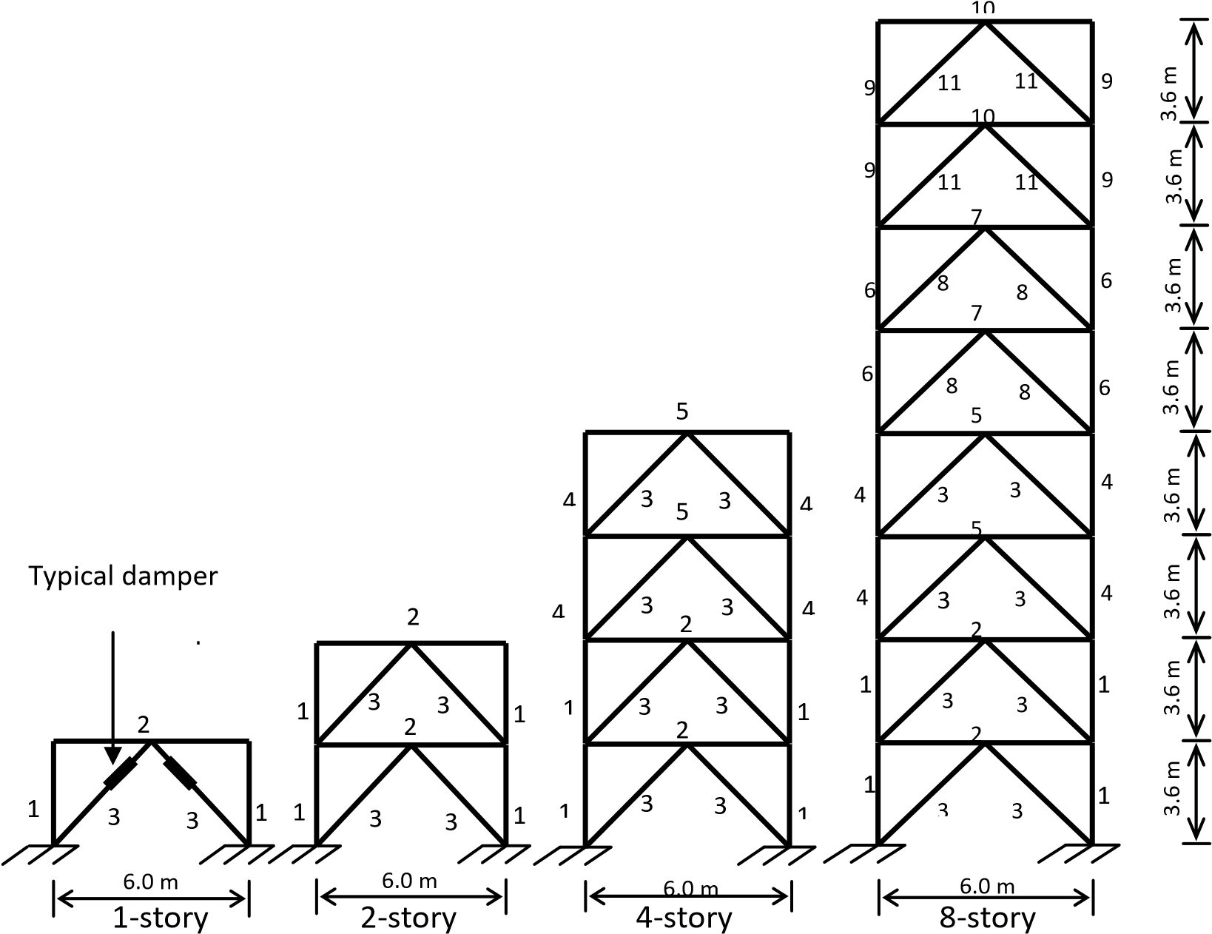

Figure 1. Frame models

4. GROUND MOTIONS CONSIDERED FOR ANALYSES

NF ground motions are generally characterized by their peak ground velocity, Vp (or acceleration, Ap) and velocity pulse period, Tp, representing their dominant period and energy content. Consequently, NF ground motions with various velocity pulse periods and intensities are considered to assess the performance of the CBFs with and without FVDs for a wide range of NF ground motion characteristics. For this purpose, a set of seven NF ground motions with velocity pulse periods ranging between 1.1 and 5.0 s are considered (Table 1). Recent research on measuring the intensity of NF ground motions revealed that the peak ground acceleration is a more representative intensity measure than the peak ground velocity. Accordingly, the peak accelerations of the NF ground motions are scaled to have Ap=0.20g, 0.35g and 0.50g representing respectively,small, moderate and large intensity earthquakes.

Table 1 Properties of near-fault ground motions used in the analyses

Earthquake | Station | Distance | Ap | Vp | Tp
 |  | (km) | (g) | (cm/s) | (s)
Morgan Hill, 1984 | Gilroy 6 | 11.8 | 0.29 | 36.4 | 1.10
Northridge, 1994 | Rinaldi | 7.1 | 0.84 | 166.1 | 1.25
Loma Prieta, 1989 | Gilroy 2090 | 12.7 | 0.34 | 39.1 | 1.40
Northridge, 1994 | Sylmar Olive view | 6.1 | 0.35 | 116.3 | 2.60
Imperial Valley, 1940 | Impvall/H-ECC092 | 7.6 | 0.37 | 69.0 | 3.30
Imperial Valley, 1940 | Impvall/H-E05230 | 1.0 | 0.24 | 90.5 | 3.90
Landers, 1992 | Lucerne | 1.1 | 0.72 | 97.6 | 5.00

5. MODELING OF THE CBF FOR NLTH ANALYSES

A direct integration NLTH analysis procedure is adopted to perform the seismic analyses of the frames using the nonlinear finite element based program ADINA. An implicit time integration procedure employing Newmark’s method with δ=1/2 and α=1/4 was used in the solution. The inelastic behavior of steel braces is generally expressed in terms of an axial load, P, an axial displacement, δ, and a transverse displacement, Δ, at the mid-point of the brace as shown in Figure 3 (a). A typical buckling curve of a brace member under cyclic axial load is illustrated in Figure 3 (b). At a critical value of the transverse displacement of the brace, the second order moment in the brace will be equal to its plastic moment capacity under the applied axial load. At this point, the buckling load (point 1) is reached. Additional increases in the axial displacement result in larger transverse displacement, Δ, because of the plastic hinge rotations at the mid-point of the brace. Consequently, the second order moment at the mid-point of the brace increases. This results in a drop in the axial force resistance of the brace along segment 1-2 due to the moment-axial force interaction effects. Upon unloading from point 2 to a level where the axial load is zero (point 3), the brace retains residual axial (δ) and transverse (Δ) deformations. When the brace is loaded in tension from point 3 to point 4, the behavior is elastic. At point 4, the product of the axial load and transverse displacement again equals the plastic moment capacity of the brace under the applied axial load. Thus, a plastic hinge at the mid-point of the brace is produced for the second time. However, along segment 4-5, the plastic hinge rotations act in the reverse direction of that along segment 1-2 and reduce the magnitude of the transverse deflection until the yield point (5) in tension is reached.

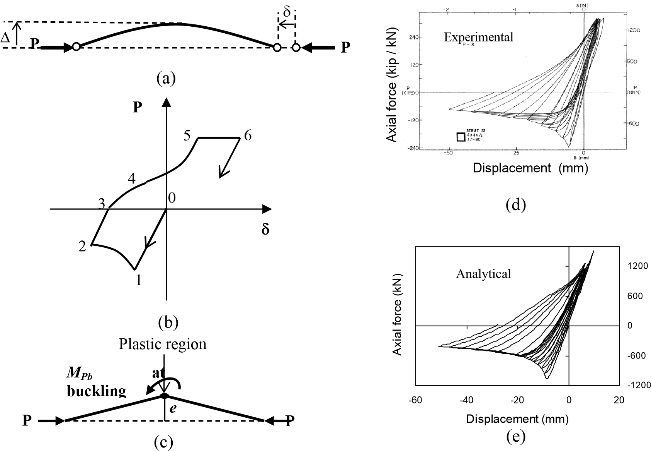

Figure 3 (a) Buckling brace (b) Typical brace axial force-deformation behavior. (c) Nonlinear brace model. (d) Experimental hysteresis loop [33] (e) Numerical hysteresis loop from ADINA.

6. COMPARATIVE SEISMIC ANALYSES OF CBFs WITH AND WITHOUT FVDs

To study the effect of FVDs on the seismic performance of CBFs, a damping ratio of 50% of critical damping in the first mode of vibration is considered for the calculation of the damping constants of the FVDs in the structural model. Although a 50% damping ratio may be considered large in some practical applications, it was chosen to clearly observe the difference between the seismic behavior of CBFs with and without FVDs considering the high velocity pulses of NF ground motions. Damping values smaller than 50% of critical (10% and 30%) are considered in the parametric studies presented in the subsequent sections. performances of the CBFs with and without FVDs are compared and studied in relation to the intensity of the NF ground motions. The analyses results are presented in Figures 4(a)-(c). Figure 4(a) compares the average of the maximum inter-story drifts from the seven NF earthquakes for one, two, four and eight story CBFs with and without FVDs as a function of the intensity of the ground motions. For all the ground motion intensities and CBFs considered, the presence of FVDs produces significant improvements in the seismic response of the frames. The energy dissipated by the FVDs causes the frame members and the braces to remain within their elastic limits. It is noteworthy that the maximum damper forces shown in Figure 5(a) for four and eight story frames are smaller than the buckling capacity of the braces in the CBFs without FVDs. This results in considerably smaller inter-story drifts of the CBFs with FVDs than those without FVDs. Furthermore, it is observed from Figure 4(b) that the ratios of the average maximum inter-story drifts of the
CBFs without FVDs to those with FVDs range between 1.65 and 9.85. In most structures equipped with FVDs, the reduction in the seismic drift response is in the order of 1.5-2.5 times. The larger reduction in the seismic drift response of CBFs (1.65-9.85) is partly due to (i) the buckling of the braces in CBFs without FVDs yielding unusually large inter-story drifts compared to other types of structures and (ii) the relatively more efficient dissipation of the earthquake energy, which is transmitted by high amplitude velocity pulses, by velocity dependent FVDs. Thus, FVDs are observed to be very efficient devices for mitigating the effect of seismic forces particularly for CBFs located in NF zones. Moreover, it is observed from Figure 4(b) that the ratio of the average maximum drift of the CBF without FVD to that with FVD (drift ratio) is a function of the intensity of the NF ground motion and the number of stories. The dependency of this drift ratio on the intensity of the NF ground motion and the number of stories is found to result from the buckling of the braces. Buckling of the braces in CBFs without FVDs is generally more predominant for frames with larger number of stories subjected to NF ground motions with larger intensities. In such frames, the buckling of the braces at certain floor levels results in soft story formations. This, in turn, produces considerable plastic penetrations into the essential structural components of the CBFs that lead to large inter-story drifts and hence large drift ratios.
In summary, it is found that using FVDs forms an effective design and retrofit strategy for CBFs and it is generally more useful for frames with larger number of stories located in NF zones with a high risk of intense earthquakes. Moreover, in retrofitting applications, the presence of the braces in CBFs is anticipated to facilitate the installation of the FVDs at relatively lesser cost compared to other types of structures such as moment resisting frames.

0
50
100
150
200
0.2
0.35
0.50
Ap (g)
Avg. story drift (mm)
STORY
8-
0
10
20
30
40
50
0.2
0.35
0.50
Ap (g)
Avg. story drift (mm)
STORY
4-
0
10
20
30
0.2
0.35
0.50
Ap (g)
Avg. story drift (mm)
2-
STORY
0
10
20
30
0.2
0.35
0.50
Ap (g)
Avg. story drift (mm)
No damper
With damper
1-
STORY
( a)

1-STORY
0
2
4
6
8
10
Story drift ratio
8-
STORY
0
2
4
6
Story drift ratio
4-
STORY
0
2
4
6
Story drift ratio
STORY
2-
0
2
4
6
Story drift ratio
0.2 0.35 0.50 0.2 0.35 0.50 0.2 0.35 0.50 0.2 0.35 0.50
Ap (g) Ap (g) (b) Ap (g) Ap (g)

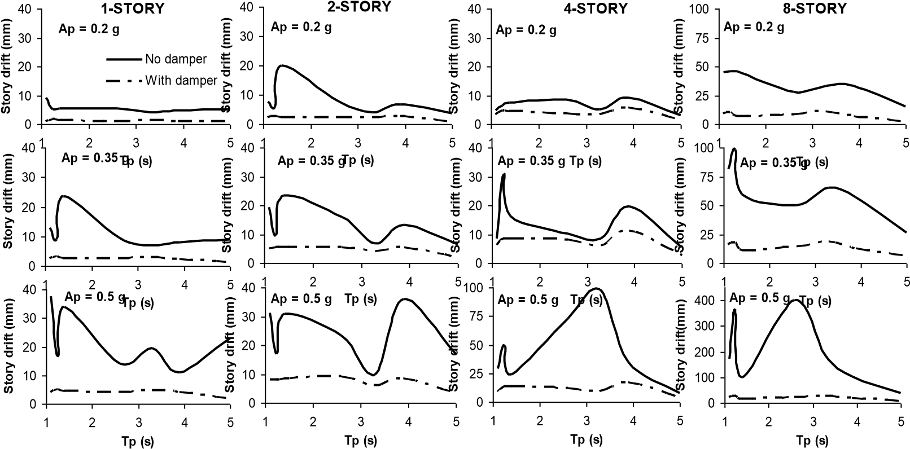
(c)

Figure 4. (a) Average of the maximum inter-story drifts of CBFs with and without FVDs from the seven earthquakes as a function of Ap for one, two, four and eight story frames, (b) Ratio of the average maximum inter-story drifts of CBFs without FVDs to those with FVDs for one, two, four and eight story frames (c) Maximum inter-story drifts of one, two, four and eight story CBFs with and without FVDs as a function of Tp for Ap=0.20g, 0.35g and 0.50g.

7. PERFORMANCE OF THE CBF WITH AND WITHOUT FVDS IN RELATION TO THE VELOCITY PULSE PERIOD OF THE NF GROUND MOTION

In this section, performances of the CBFs with and without FVDs are compared and studied in relation to the velocity pulse period, Tp, of the NF ground motion. Figure 4(c) compares the maximum inter-story drifts of one, two, four and eight story CBFs with and without FVDs as a function of Tp for various ground motion intensities. It is observed that CBFs without FVDs generally display a good response over the range of Tp values considered for low to moderate intensity NF ground motions and for lower number of stories. Nonetheless, for high intensity NF ground motions and for larger number of stories, a sudden deterioration in the lateral strength and stiffness and an ensuing increase in the maximum drift response of the frames are observed due to the effect of brace buckling and the behavior of the CBF becomes much more sensitive to the Tp of the ground motion. For high intensity NF ground motions (Ap=0.5g), it is observed from Figure 4(c) that the largest seismic drift responses of the frames with smaller number of stories are generally produced by NF ground motions with lower Tp while those of the frames with larger number of stories are produced by NF-ground motions with relatively higher Tp. This may be mainly due to the fundamental inelastic vibration period of the CBFs falling within the range of the dominant period of the NF ground motion.

8. EFFECT OF FVD PARAMETERS ON THE SEISMIC PERFORMANCE OF CBFζζ

In this section, a parametric study involving a total of 224 NLTH analyses is conducted to investigate the effect of FVD parameters on the seismic performance of the frames using one and four story CBFs. For this purpose, the damping ratio, ζ, of the frames corresponding to their first vibration mode is varied between 10% and 150% of critical while keeping the value of the velocity exponent, α of the FVDs at 0.5 to solely study the effect of the damping ratio, ζ, on the seismic response of the frames. Although, values of ζ larger than 50% are not practical, they are considered in the parametric study to measure the benefits of higher percentage of damping on the performance of the frames subjected to NF ground motions. Similarly, keeping the value of the damping ratio, ζ at 50%, the value of the velocity exponent, α, is varied between 0.3 and 1.0 to study the effect of α on the seismic response of the frames. It is observed that generally, the maximum inter-story drift of the CBFs with FVDs decreases as the Tp of the ground motion increases for the range of ζ values and ground motion intensities considered. This is mainly due to the much smaller fundamental periods of the one (0.23 s) and four story (0.39 s) frames in relation to the dominant periods of the NF ground motions producing off-resonant, smaller structural responses and hence smaller FVD forces at larger values of Tp. In CBFs without FVDs however, brace buckling effects and associated lateral stiffness degradation produce inelastic fundamental periods within the range of the period of the NF ground motion leading to large frame responses due to resonance effects. Thus, it becomes clear that one of the main advantages of using FVDs for seismic design and retrofitting of CBFs located in NF zones is to keep the frame within the elastic range and hence produce frame fundamental periods much smaller than the dominant period of the NF ground motions to produce off-resonant, smaller responses.
The average of the maximum inter-story drifts of the one and four story CBFs from the seven NF earthquakes is plotted in Figure 8(a) as a function of the damping ratio for Ap= 0.35g and 0.50g. It is observed that the relationship between the maximum inter-story drift and the damping ratio is nonlinear and similar regardless of the value of the peak ground acceleration. As expected, the maximum inter-story drift decreases as the damping ratio increases. However, the reduction in the maximum inter-story drift as a function of the damping ratio is significant only for damping ratios smaller than or equal to 50%.

9. CONCLUSIONS AND RECOMMENDATIONS

The effect of FVDs on the seismic performance of CBFs as a function of the intensity and velocity pulse period of the NF ground motion and FVD parameters is investigated. It is observed that CBFs without FVDs generally display a good response over the range of Tp values considered for low to moderate intensity NF ground motions and for lower number of stories. Nonetheless, for high intensity NF ground motions and for larger number of stories, a sudden deterioration in the lateral strength and stiffness and an ensuing increase in the maximum drift response of the frames are observed due to the effect of brace buckling and the behavior of the CBF becomes highly sensitive to the Tp of the NF ground motion. The buckling of the braces in CBFs results in soft story formations and concentration of the energy dissipation at the intermediate story levels. Nevertheless, the CBFs with FVDs exhibit a more uniform lateral displacement profile and distribution of energy demand compared to the CBFs without FVDs. Moreover, for CBFs with FVDs, the seismic response of the frames is found to be significantly less sensitive to the Tp of the NF ground motion. Thus, installing FVDs makes the seismic response of the CBF relatively less sensitive to the number of stories and frequency characteristics of the NF ground motion and hence the design and performance of such frames with FVDs becomes more reliable in NF zones.
The parametric studies concerning the effect of damping ratio on the seismic response of the CBFs with FVDs revealed that the relationship between the maximum inter-story drift and the damping ratio is nonlinear and similar regardless of the value of the peak ground acceleration. As expected, the maximum inter-story drift decreases as the damping ratio increases. However, the reduction in the maximum inter-story drift as a function of the damping ratio is significant only for damping ratios smaller than or equal to 50%. For damping ratios larger than 50%, the relatively smaller reduction in the maximum inter-story drift of the frame is accompanied by a relatively large increase in the damper force. Thus, using FVDs, which will produce damping ratios larger than 50%, does not seem to be practical in NF zones. In fact, damping ratios ranging between 10 and 30% seem to produce the largest reduction in the seismic force while having reasonable damper forces. In summary it is recommended that using FVDs with damping ratios in the range of 10%-30% is very effective for the seismic design and retrofitting of CBFs with large number of stories. Furthermore, for CBF’s subjected to intense NF earthquakes where damper velocities larger than 1 m/s is expected, using FVDs with large α values is very effective for the seismic design and retrofitting of CBFs . However, if the expected damper velocities are smaller than 1 m/s, using FVDs with smaller α values becomes more effective.

10. REFERENCES

Sabelli, R., Mahin, S. and Chang, C. Seismic demands on steel braced frame buildings with bucklingrestrained braces. Engineering Structures 2003; 25(5): 655-666.
Khatib, I.F., Mahin, S.A., Pister, K.S. Seismic behavior of concentrically braced steel frames. Report No. UCB/EERC-88/01, Earthquake Engineering Research Centre, 1988.
Perotti, F., Scarlassara, G.P. Concentrically braced frames under seismic actions: nonlinear behavior and design coefficients. Earthquake Engineering and Structural Dynamics 1991; 20(5): 409-427.
Tremblay, R. and Robert, N. Seismic performance of low- and medium-rise chevron braced steel frames. Canadian Journal of Civil Engineering 2001; 28(4): 699-714.
Osteraas, J. and Krawinkler, H. The Mexico earthquake of September 19, 1985: behavior of steel buildings. Earthquake Spectra 1989; 5(1): 51-88.
Kim, H. and Goel, S. Seismic evaluation and upgrading of braced frame structures for potential local failures. Report No. UMCEE 92-24, Dept. of Civil and Environmental Engineering, Univ. of Michigan, Ann Arbor, 1992.
Hisatoku, T., R. Analysis and repair of a high-rise steel building damaged by the 1995 Hyogoken-Nanbu earthquake. Proceedings of the 64th Annual Convention, Structural Engineers Association of California, Sacramento, 1995; 21-40.
Tremblay, R., Timler, P., Bruneau, M., and Filiatrault, A. Performance of steel structures during the 1994 Northridge earthquake. Canadian Journal of Civil Engineering 1995; 22(2): 338-360.
Tremblay, R. Bruneau, M., Nakashima, M., Prion, H.G.L. Filiatrault, A., DeVall, R. Seismic design of steel buildings: lessons from the 1995 Hyogo-ken Nanbu earthquake. Canadian Journal of Civil Engineering 1996; 23(3): 727-756.
Krawinkler, H., Anderson, C. J., Bertero, V. V., Holmes W. and Theil, C. Northridge earthquake of January 17, 1994: reconnaissance report, Vol. 2 - steel buildings. Earthquake Spectra 1996; 12(S1): 25-47.
Malhotra, P.K. Response of buildings to near-field pulse-like ground motions. Earthquake Engineering and Structural Dynamics 1999; 28(11): 1309-1326.

Assistant Professor, Zonguldak Bülent Ecevit University, Zonguldak, TURKEY, memduhkaralar@beun.edu.tr
Professor, Middle East Technical University,Ankara, TURKEY, mdicleli@metu.edu.tr

