COMPARATIVE ASSESSMENT OF THE EFFICIENCY OF SEISMIC
İSOLATION FOR SEISMIC RETROFITTING OF HIGHWAY BRIDGES IN REGIONS OF LOW-TO-MODERATE SEISMICITY

DOI 10.37153/2686-7974-2019-16-411-417

Memduh KARALAR, Murat DİCLELİ

ABSTRACT

The economical and structural efficiency of friction pendulum bearings (FPB) for retrofitting typical seismically vulnerable bridges is studied. For this purpose, a bridge was selected to represent typical seismically vulnerable bridges. A comprehensive structural model of the bridge was first constructed for seismic analysis. An iterative multi-mode response spectrum analysis of the bridge was then conducted to account for the non-linear behavior of the bridge components and soil-bridge interaction. The calculated seismic demands were compared with the estimated capacities of the bridge components. It was found that the bearings, wingwalls and pier foundations of the considered typical bridge need to be retrofitted. A conventional retrofitting strategy was developed for the bridge and the cost of retrofit was estimated. Next, the bridge was further studied to develop appropriate techniques for upgrading its seismic capacity using FPB. It was observed that the use of FPB mitigated the seismic forces and eliminated the need for retrofitting of the substructure components of the bridge. An average retrofitting cost using FPB was calculated and found to be less than the cost of conventional retrofitting considered in this study. Thus, FPB may successfully be used for economical seismic retrofitting of typical bridge.

Keywords: seismic isolation, bridge, soil-structure interaction, nonlinear analysis

1. INTRODUCTION

According to United States Geological Survey [1], the Central United States is a region of moderate to high risk of seismic activity and it is anticipated that the probability of a Richter magnitude 6–7 earthquake occurring in Central United States within the next 50 years is higher than 90%. Recognizing the threat of seismic activity, in the early 1990s, Illinois Department of Transportation (IDOT) made a statewide assessment of the seismic vulnerabilities of its over 6000 highway bridges. Many of these bridges were found to be vulnerable as they were built in the late 1960s and early 1970s during a rapid expansion of the highway system and before there were any seismic design regulations in American Association of State Highway Transportation Officials (AASHTO) [2] bridge design specifications. The assessment of the vulnerability of these bridges identified deficiencies [3] that are; brittle fixed steel bearings, rocker bearings with stability problem, short seat widths, columns with insufficient transverse reinforcement and lap splices and foundations with inadequate lateral and bearing resistance.
Conventional seismic retrofitting methods [4–9] may be used to mitigate the risk that currently exists for seismically vulnerable bridges in Illinois. Some of these methods are; replacing old steel bearings with modern conventional bearings such as elastomeric, pot or spherical bearings, widening the pier cap and abutment seat to accommodate seismic lateral movements of the super-structure, strengthening and enhancing the ductility capacity of the columns using concrete and steel jackets, advanced composite fiber reinforced polymer or pre-stressed wire wrapping and increasing the size of the footings, the number of piles and providing dead man anchors to improve the lateral resistance of the footings. However, most of these retrofitting methods are expensive and difficult to implement. Furthermore, retrofitting a component of the bridge may overstress some other components and result in additional retrofitting cost. Mobilization and traffic control during substructure retrofitting over an extended period of time constitutes an additional hidden cost that need to be considered. Thus, an economical and innovative method for mitigating the seismic forces on the bridges in Illinois by response modification may provide an efficient solution to the above problems. This may be achieved by replacing the already vulnerable existing bearings by friction pendulum bearing (FPB) to reduce the seismic forces in the bridge substructures and eliminate the need for their costly retrofitting.

2. RESEARCH OBJECTIVE AND METHODOLOGY

In this paper, the economical and structural efficiency of FPB for retrofitting typical seismically vulnerable bridges in the State of Illinois is studied. For this purpose, a bridge was carefully selected by IDOT to represent typical seismically vulnerable bridges in the State of Illinois. Iterative multi-mode response spectrum (MMRS) analysis of the bridge is conducted considering the nonlinear behavior of the bridge components and soil–bridge interaction effects to assess its seismic vulnerability. A conventional retrofitting strategy is then developed for the seismically vulnerable components of the bridge and the cost of retrofit is estimated. Next, the bridge is further studied to develop appropriate techniques for upgrading its seismic capacity using FPB to eliminate the need for retrofitting of its vulnerable components. Finally an average retrofitting cost using FPB is calculated and compared with the cost of conventional retrofitting to assess the economical efficiency of FPB.

3. DESCRIPTION OF THE BRIDGE

The bridge is located on route 24 in Johnson County, in Illinois and was constructed in 1970 to carry the westbound lane traffic over a roadway. The bridge has three spans carrying two traffic lanes and a slab-onpre-stressed-concrete-girder deck as shown in Figure 1. The bridge deck is continuous from one abutment to the other and is supported by two multi-column piers in between. The expansion joint widths at the north and south abutments are 38.1 and 25.4 mm, respectively. The strength of concrete used in the prestressed concrete girders is 34.5 MPa. The strengths of concrete and the steel reinforcement used for the rest of the bridge are 24 and 275 MPa, respectively. The site soil is composed of layers of stiff silty clay extending down to the hard sandstone. The base of the north abutment is placed approximately at the natural ground level. The south abutment is placed approxi-mately 1.7 m above the natural ground level. The fill material above the ground level is medium moist silty clay. The footings of piers 1 and 2 are placed respectively at 4.7 and 3.4 m below the natural ground surface. The standard penetration and unconfined compressive strength test results at each substructure location were provided by IDOT and are presented elsewhere.

4. STRUCTURAL MODEL

A 3D structural model of the bridge is built and ana-lyzed using the program sap2000 [15]. The structural model is capable of simulating the nonlinear behavior of the structural components and soil–bridge interaction effects when used in combination with iterative MMRS analyzes. In the model, equivalent elastic stiffness properties are used for the components exhibiting non-linear behavior. These stiffness properties are updated at each iteration step to simulate the nonlinear behavior of the components.The bridge superstructure is modeled using 3D beam elements. Full composite action between the slab and the girders is assumed in the model [16,17]. The superstructure is divided into a number of segments and its mass (13.40 ton/m) is lumped at each nodal point connecting the segments. Each mass is assigned four dynamic degrees of freedom (DOF); translations in the X and Y directions and rotations about the X and Z axes as shown in Figure 2. The importance of including the flexibility and strength of supports at abutments and piers in seismic analysis of highway bridges is well recognized by various researchers [22–26] and transportation agencies [2,27–29]. Thus, the effect of soil–bridge interaction is included in the analysis of the bridge considered in. this study using boundary springs at the interface nodes between the bridge and the soil.

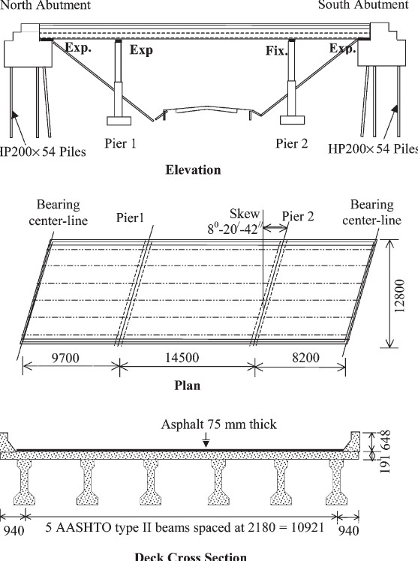

Figure 1. Bridge elevation, plan and deck cross-section (all dimensions are in mm).

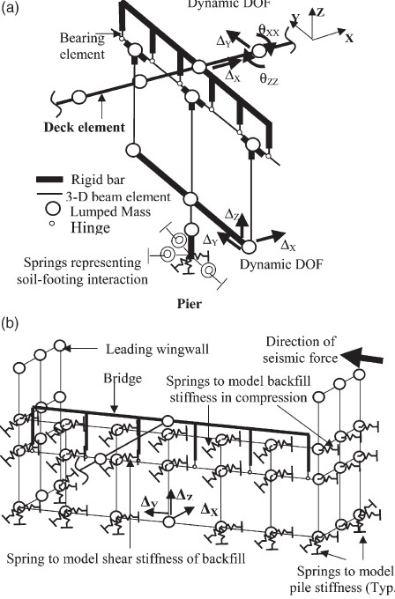

Figure 2. Structural model of the bridge at the piers and abutments.

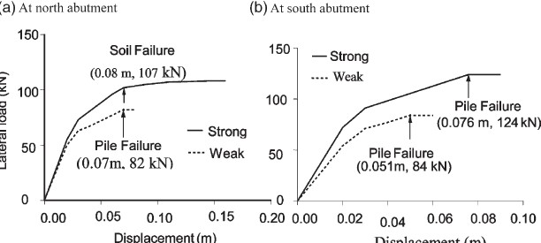

Figure 3. Static pushover analysis results for the piles at north and south abutments.

5. ANALYSIS RESULTS

A total of 100 modes of vibration are considered in the seismic analysis of the bridge to accomplish full participation of the structure mass including the mass of the substructures. Figure 4(a) and (b) display the shapes of the first two vibration modes of the bridge. The fundamental period of the bridge is 0.584 s and corresponds to its modal vibration in the longitudinal direction. The second, third and fourth modal periods of the bridge are 0.541, 0.395 and 0.308 s, respectively. The periods for the first 20 modes vary between
0.584 and 0.049 s. The cumulative percentages of modal mass participation for the first 20 modes in the longitudinal and transverse directions are 84.13 and 80.54%, respectively. As noted from Figure 4(b), the transverse direction mode is coupled with the torsional mode of the bridge. The torsional rotation occurs about pier 2 due to the larger stiffness of the bearings. Consequently, larger seismically induced forces are anticipated at the north abutment due to the effect of the torsion.

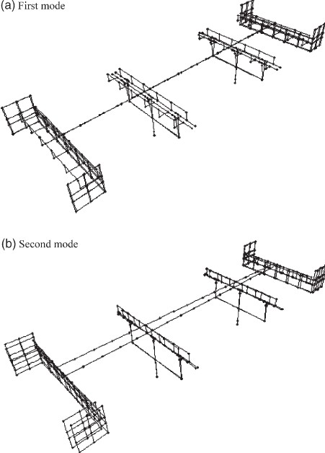

Figure 4. Bridge first and second modes of vibrations.

Table1presents the sub-structure reactions for the abutment piles and base of the pier foundations. The total seismic force acting on the structure is 1594 kN in the longitudinal and 1776 kN in the transverse direction. The seismic force in the trans-verse direction includes the contribution of friction and passive resistance of the backfill and the embankment soil and in the longitudinal direction includes the effect of static and dynamic backfill pressures. The piers carry 67% of the total seismic force. At the abutments, the maximum longitudinal direction lateral force is 99 kN for the battered piles and 28 kN for the vertical piles.

Table 1. Seismic substructure reactions (at foundation base for piers)

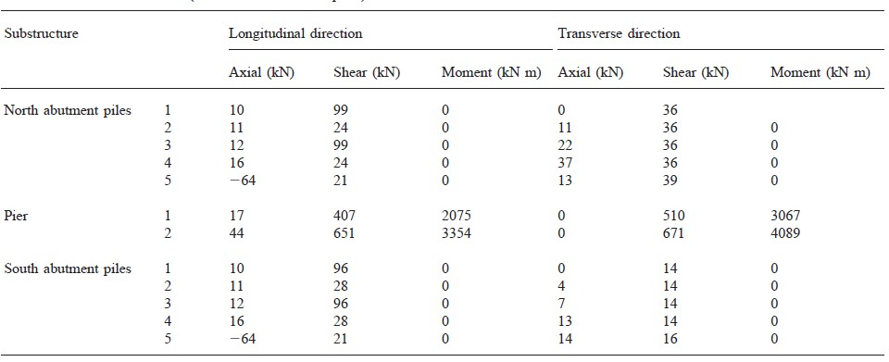

6. SEISMIC RETRFITTING OF THE BRIDGE USING FPB

The structural model used for the detailed seismic analysis of the bridge is slightly modified to incorporate the FPB instead of the elastomeric bearings – the FPB are also modeled using 3D vertical beam elements. The equivalent linear stiffness of the FPB is used to estimate the stiffness properties of the beam elements. However, an iterative analysis procedure is performed as the equivalent bearing stiffness and hysteretic damping is function of the bearing displacement. The iterative analysis procedure is described in detail below.
An iterative MMRS analysis technique is used to obtain the isolation bearing displacements and other structural responses. First, a maximum displacement, D_{d}, is assumed for the FPB. The assumed displacement, the bearing reactions due to the self-weight of the bridge, the friction coefficient (4%) and the radius, R (1020 mm), of the bearings are substituted to calculate the equivalent stiffness for each bearing. The calculated equivalent stiffness is then used to obtain the stiffness of the beam elements used in the model. The equivalent viscous damping ratio is also calculated by substituting the bearing properties and the assumed displacement. A total of 100 modes of vibration are considered in the seismic analysis of the bridge with FPB. The first two modes of vibrations are those mainly involving the isolation system. The rest are the nonisolated modes of vibration with 53% mass contribution, which is the total mass of the substructure elements. The fundamental period of the bridge is 1.423 s and corresponds to the modal vibration of the structure in the longitudinal direction, while the second period of vibration is 1.395 s and corresponds to the modal vibration of the structure in the transverse direction.

Table 2. FPB seismic lateral displacements and forces

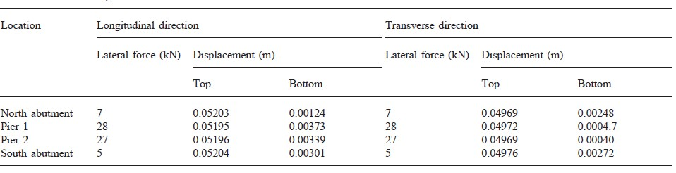

Table 3. Seismic substructure reactions of the bridge with FPB (at foundation base for piers)

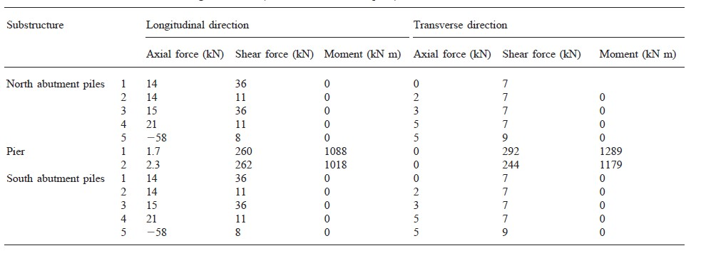
Table 4. Seismic forces in abutment and wingwalls of the bridge with FPB

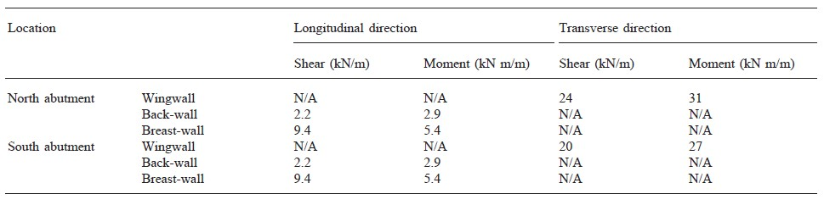

7. CONCLUSIONS

The economical and structural efficiency of FPB for retrofitting typical seismically vulnerable bridges in the State of Illinois is investigated by studying a bridge, which was carefully selected by IDOT to represent typical seismically vulnerable bridges commonly used in the State of Illinois. The following observations are made:
1. FPB eliminated the in-plane torsional rotation of the bridge and resulted in a more uniform distribution of seismic forces among substructures.
2. A three to four times reduction in the seismically induced forces in the structure components is achieved with the FPB. This is a result of: (i) energy dissipation and (ii) lower equivalent linear stiffness of FPB compared to that of the elastomeric bearings and even other rubber-based seismic isolation bearings for this particular application. The lower equivalent linear stiffness mainly results from the relatively smaller weight of the only 32.4 m long bridge superstructure transferred to the FPB.
3. Thus, FPB effectively mitigated the seismic forces and eliminated the need for costly retrofitting of the bridge substructure components. Furthermore, the low profile of FPB required only minor modifications to adjust the bearing seat elevations. However, FPB resulted in large superstructure displacements in excess of the expansion joint widths. This required either providing knock-off devices at the abutments or increasing the widths of the expansion joints to eliminate the possibility of the superstructure impact-ing the abutment back-wall and a potential damage to the abutment piles.

8. REFERENCES

USGS. Reducing earthquake losses throughout United States;(1998), Available from: http://quake.wr.usgs.gov/prepare/factsheets/NewMadrid/.
AASHTO, (1998) LRFD bridge design specifications., 2nd ed. Washington, DC: AASHTO.
Capron MR. (1996) Seismic isolation of bridges in Midwest. In: Pro-ceedings of the Structures Congress, Part I. Chicago, Illinois: ASCE; p. 48–55.
Tseng WS, Penzien J. (1973) Analytical investigations of the seismic response of long multiple span highway bridges. Report no. UCB/EERC 73/12. Berkeley, California: Earthquake Engineering Research Center, University of California.
Penzien J, Chen M. (1975) Seismic response of highway bridges. In: Proceeding of US National Conference on Earthquake Engineer-ing. Ann Arbor, Michigan: Earthquake Engineering Research Institute; p. 66-1.
Mitchell D, Sexsmith R, Tinawi R. (1994) Seismic retrofitting techniques for bridges—a state-of-the-art report. Canadian Journal of Civil Engineering;21(5):823–35.
FHWA. (1995) Seismic retrofitting manual for highway bridges. Wash-ington, DC: Federal Highway Administration, US Department of Transportation, [Publication no. FHWA-RD-86-102].
Saunders TD, Cahill JA, McLean DI, (1995) Marsh ML, Ho C. Seismic retrofitting of bridge substructures.
Transportation research record no. 1476. Washington, DC: Transportation Research Board; p. 37–47.

Assistant Professor, Zonguldak Bülent Ecevit University, Zonguldak, TURKEY, memduhkaralar@beun.edu.tr
Professor, Middle East Technical University,Ankara, TURKEY, mdicleli@metu.edu.tr

