**PERFORMANCE-BASED SEISMIC DESIGN OF BUILDING STRUCTURES USING A PASSIVE ENERGY DISSIPATION DEVICE**

**DOI 10.37153/2686-7974-2019-16-399-410**

Omar Kammouh[1], Stefano Silvestri[2], Michele Palermo[3], Gian Paolo Cimellaro[4]

**ABSTRACT**

The primary objective of the *Performance-Based Seismic Design* (PBSD) is to provide stipulated seismic performances for building structures. However, a certain degree of design freedom is needed for matching a specific seismic response. This design freedom is not obtainable by the conventional lateral resisting systems because their stiffness and strength are coupled. Here, we put emphasis on the role of the unconventional lateral resisting systems in adding more flexibility to the design. In this paper, we seek to explore the seismic design of moment resisting frame structures equipped with an innovative hysteretic device, known as *Crescent-Shaped Brace* (CSB). The paper presents an exhaustive procedure for the seismic design of the CSB devices within the Performance-Based Seismic Design (PBSD) framework. The seismic behavior of an existing three-storey reinforced concrete structure equipped with the CSB devices is studied and verified by means of static pushover and dynamic time-history analyses. The results obtained confirm the validity of the proposed design method and the efficiency of the new hysteretic device. The actual behavior of the controlled structure matches the predefined behavior, thus fulfilling of the prescribed multi-seismic performances.

*Keywords*: *Crescent Shaped Brace, Seismic analysis, Dynamic analysis, Performance Based Seismic Design.*

**1. INTRODUCTION**

Recently, several attempts in the earthquake engineering field could find their ways into numerous innovative systems that provide the structure with a specific performance under a given earthquake level. Among others, the most known systems are: (a) seismic isolation systems, which uncouple the superstructure from its substructure leading to a “conceptual separation between the horizontal and vertical resisting systems” (Palermo et al. 2014b); (b) tuned mass damping systems, which are used to minimize the excitation of a structure caused by high lateral vibrations (Hoang et al. 2016); (c) active and semi-active systems, which adjust the mechanical properties of a structure in accordance with the measured response (Datta 2010b); (d) dissipative systems, which are inserted in the superstructure in order to minimize the seismic effects in the structure through their energy dissipation capacity (Chopra and Anil 2001). Although the listed systems have been well integrated into literature and practice, none of them could entirely fulfil the seismic performance objectives of the structure.

In this paper, we focus on a novel lateral resisting device, namely the Crescent-Shaped brace (CSB). CSB is a hysteretic device that falls in the passive energy dissipation category, allowing the structure to have prescribed multiple seismic performances (Palermo et al. 2014a). The presented work proposes an exhaustive procedure for the seismic design of a multi-storey shear-type frame structure equipped with the CSB devices. The proposed method can be applied to both single and multi-degree-of-freedom shear-type structures. To describe the procedure in all the details, a three-storey reinforced concrete case study structure is considered. The equipped structure is designed in such a way to meet the “Essential Objectives” indicated in Figure 1 (Bertero et al. 2002). After the design, the performances of the equipped building under different seismic design levels are numerically obtained through non-linear time-history and pushover analyses. The results obtained in this paper confirm the validity of the proposed design method and the effectiveness of the new hysteretic device.

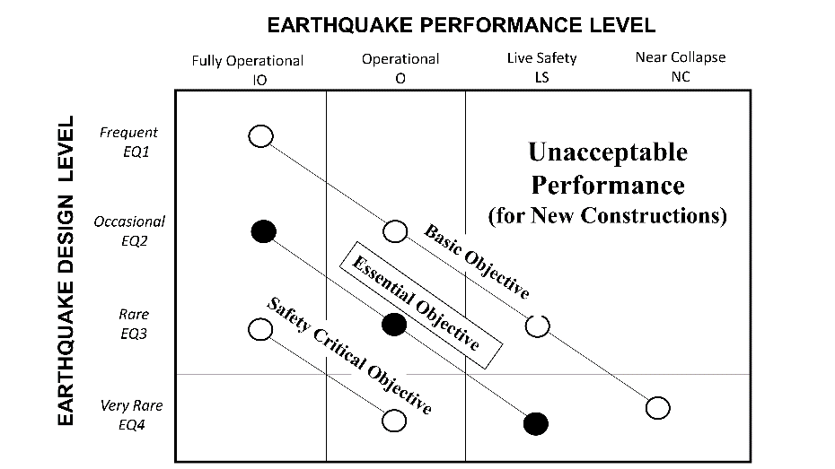

Figure 1.Performance-based seismic design objectives, adopted from (Kammouh et al. 2018)

**2. The Crescent-Shaped Braces**

***2.1 Overview***

Crescent-Shaped brace (CSB) is a special lateral resisting device that is capable of providing additional design freedom to frame structures. Its geometrical configuration, as shown in Figure 2, allows the structure to have prescribed multiple seismic performances within the performance-based design scheme (Palermo et al., 2014b). The Crescent-Shaped Braces enable the designer to have control over the design because their strength at yielding is not coupled with their lateral stiffness.

***2.2 Analytical model of the CSB***

In their previous work on the Crescent-Shaped Braces, Palermo et al. have derived analytical formulas that allow sizing the device given its target stiffness and target yield strength. Equations (1) and (2) are simplified versions of the equations presented in (Palermo et al. 2014b). Stiffness and strength are initially imposed by the predefined performance objectives of the specific structure considering the structural and non-structural responses. Equation (1) allows obtaining the arm ratio of the device, which is the ratio between the arm of the device “” and the diagonal length “”. The arm ratio is then substituted in Equation (2) to obtain the moment of inertia of the CSB device. Full detail on the derivation of these equations can be found in (Palermo et al., 2014a).

 (1)

where =*d/L* is the arm ratio of the device (can be assumed 0.1 for preliminary design), *d*  is the arm of the device, ** is the plastic bending resisting moment of the cross section,  is the plastic section modulus, is the yield strength, **is the target yield strength,  is the diagonal length.

 (2)

where  is the moment of inertia of the cross-section,  is the target initial lateral stiffness,  is the elastic modulus of the steel cross-section,  is the angle between the force and the diagonal when the device is installed in a frame structure (in Figure 2 ).

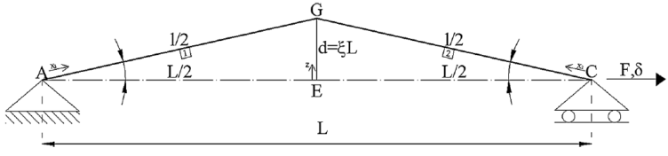

Figure 2. The geometric configuration of the studied device (Palermo et al., 2014a)

***2.3 Mechanical behaviour of the CSB***

The post-yielding behaviour of the bracing device is numerically studied using the fibre-based program ‘SeismoStruct V.7.0.6’ (SeismoStruct). A specimen of the bracing device (HEB200 European profile) is firstly subjected to a monotonic increasing tension loading, and the result is reported in Figure 3(a). The force-displacement behaviour of the device looks quite complex. In the first part of the curve, the CSB responds mainly in flexure and behaves linearly until it reaches the yielding at the knee section. Afterwards, the device experiences a softening behaviour at the plasticization of the knee section (pseudo-horizontal part), followed by a significant hardening behaviour as the device gets more and more elongated and thus responding mainly through its axial stiffness capacity, like a conventional brace or a truss in a tensile configuration.

Likewise, the same sample is subjected to monotonically increasing compressive loading, considering the geometrical and the mechanical nonlinearity of the device. The constitutive law of the hysteretic device in compression is given in Figure 3(b). It is worth to note that unlike a conventional brace, the CSB device does not suffer from in-plane buckling or a sudden capacity drop because of its special geometrical configuration. Out-of-plane buckling should (and can easily (Palermo et al. 2014b)) be prevented by means of a proper choice/design of the cross section (e.g. balanced inertias along strong and weak axes, or addition of longitudinal ribs in correspondence to the neutral axis fibre).



Figure 3. (a) Monotonic behavior of a single CSB in tension; (b) Monotonic behavior of a single CSB in compression

**3. Performance-based design of A MULTI-STOREY SHEAR-TYPE FRAME EQUIPPED WITH csb devices**

In this section, we propose an exhaustive procedure for the seismic design of a multi-storey shear-type frame equipped with Crescent-Shaped Braces (CSB) based on the modal analysis. The proposed method may be used to design or strengthen structural systems that do not satisfy particular pre-defined performance objectives. The design procedure is illustrated in Figure 4. The purpose of this design procedure is to obtain a target lateral stiffness for the single CSB device. The stiffness term is then used in the previously-delivered design formulas (Equations (1) and (2)) to get the inertia demand of the brace. Once securing the moment of inertia, the cross section profile of the device can be chosen accordingly. It is worth to note that the cross section choice controls the post yielding behaviour of the bracing device, which in turn affects the post yielding behaviour of the whole structure (Palermo et al. 2014a). Without loss of generality, in the following, a three-DOF system schematization is used to describe in details the steps of the design procedure.

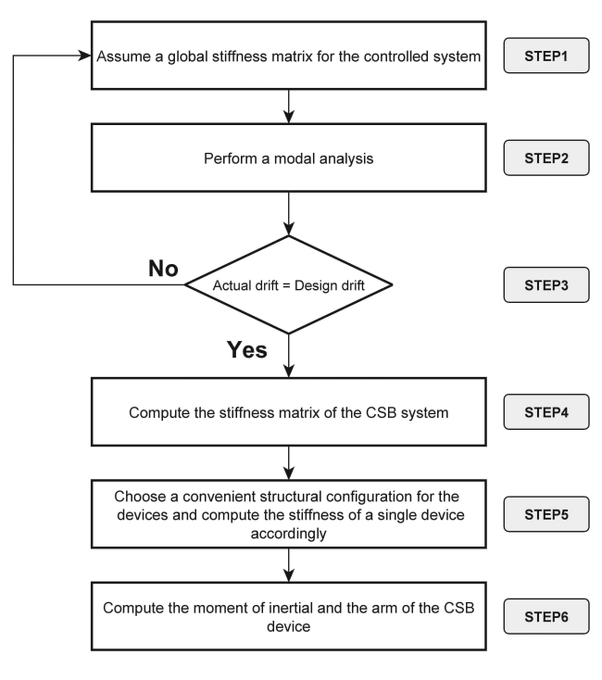

Figure 4. Flowchart of the CSB design scheme

***3.1 Step 1: Global stiffness matrix***

The global stiffness matrix describes the stiffness of the controlled system (i.e. bare structure + CSB devices). This matrix can be derived by combining (as they act in parallel) the stiffness matrices of both the uncontrolled system and the bracing system.

*3.1.1 Stiffness matrix of the uncontrolled system:*

 (3)

where  is the stiffness matrix of the uncontrolled system, , , and  are the stiffness terms of the uncontrolled system at the first, second, and third storeys respectively. All matrix’s components are known and can be derived by applying the direct stiffness method.

*3.1.2 Stiffness matrix of the CSB system*

 (4)

where  is an unknown stiffness matrix belonging the bracing system, , , and  are the stiffness terms of the braring system at the first, second, and third storeys respectively.

*3.1.3 Global stiffness matrix of the controlled system (uncontrolled structure + CSB)*

 (5)

where is the stiffness matrix of the controlled system, , , and  are the stiffness terms of the controlled system at the first, second, and third storeys respectively, and they are given as follows:

 (6)

For the first iteration, the stiffness matrix of the controlled system  is set equal to the stiffness matrix of the uncontrolled system . Alternatively, we can keep the stiffness matrix of the controlled system  as unknown, which makes the method non-iterative; however, the modal analysis would be very complicated when dealing with more than 3-DOFs, and yet having an unknown stiffness matrix.

***3.2 Step 2: Modal analysis***

A modal analysis of the controlled system is performed using the initial global stiffness and the mass matrices of the system. The modal analysis allows obtaining the elastic displacements at each storey and for the different modes The modes are then combined using the SRSS rule given in Equation (7). Afterwards, the inter-storey drifts at different storey levels are computed using Equation (8).

 (7)

 (8)

where  and  are the displacements at storeys andrespectively,  is the actual inter-storey drift between two successive storey levels and,  is the mode’s number, *N* is the number of modes.

***3.3 Step 3: Matching the design drifts***

To achieve the predefined design objective, the actual and the design inter-storey drifts should match. If the two drifts show a difference, the global stiffness matrix of the system is adjusted by adding an increment, as shown in Equation (9), and the modal analysis is run again. This increment is given in Equation (10). It should be noted that the design drift of the structure must be equal or lower than its yielding drift because we are performing a linear analysis, and therefore we are assuming a pure linear behaviour for the structure.

 (9)

 (10)

where *i* is the storey number, *r* is the iteration number, is the modification coefficient,  is the actual drift (obtained from the modal analysis ), is the design drift (obtained from the predefined performance objectives).

***3.4 Step 4: Stiffness of the CSB system***

The target stiffness matrix of the bracing system is obtained by subtracting the stiffness matrix of the uncontrolled structure from the global stiffness matrix that we reach in the final iteration of step 3. The equation is given as follows:

 (11)

***3.5 Step 5: Stiffness of the single CSB device:***

At each storey level, the target stiffness of each CSB device is obtained by dividing the target stiffness components of the CSB system (,  or ) over the number of devices at that storey level, as in Equation (12). The number of devices may be assigned by the professional designer in accordance with the architectural constraints in the building structure.

. (12)

where *KCSB,i* is the stiffness of the single CSB device at the *ith* storey, *NCSB,i* is the number of devices at the *ith* storey.

***3.6 Step 6: Moment of inertia and cross section profile***

The moment of inertia of each device is computed using the formulas introduced in Equations (1) and (2), where  is set equal to *KCSB,i*, and  is the target yield strength at which we want the device to go inelastic. Once the moment of inertia is secured, the cross section profile can be picked from a broad range of cross sections. It is worth to note that the cross-section profile choice may control the post yielding behaviour of the bracing device, which in turn affects the post yielding behaviour of the whole structure. Therefore, different cross-section profiles should be tested so the inelastic performance objectives (i.e. PO corresponds to very rare EQ level) can be met.

**4. Numerical example**

***4.1 Case study structure***

The case study structure is an existing building built in 1983. The building is an elementary school located in Bisignano city, Italy (a relatively high seismic zone). As shown in Figure 5, the planar geometry of the building structure is rectangular with dimensions equal to 21.39m x 15.00m. It is made up of three strorey levels with a roof pavilion on the top. The backbone forming the structure consists of four bays in the y-direction (Elevation 1) and three bays in the x-direction (Elevation 2). The structure is composed of beams supported on columns, forming a moment-resisting frame system. All columns have a unique cross section of 40cm x 50cm, with the long side in the direction of the main frame. The beams that form the main frames (x-direction) have rectangular cross sections of 40cm width and 60cm depth, while the edge beams (y-direction) have cross sections of 40 cm width and 50cm depth (CND, 2004) and (CND, 2005).

The mechanical properties of the concrete were determined by the presidency of the council of ministers and the department of civil protection in Italy, who performed ultrasonic and rebound hammer tests on a set of columns and beams. It was found that beams and columns were built adopting concrete C20/25 (average cubic strength Rck equal to 24.6 MPa) and a modulus of elasticity E=25140 MPa, which was reduced by half to take into account the inertia reduction due to crack formation, according to suggestions made by FEMA (FEMA 2000) and Italian Building Code (NTC 2008). As for the reinforcement bars, steel FeB38K (yield strength is equal to 375 MPa) was adopted.

***4.2 The seismic input***

In this work, two types of non-linear analysis are performed; static pushover analysis, which delivers the capacity curve of the structure starting from rest until the failure point (Datta 2010a), and dynamic time-history analysis, which was conducted by scaling a set of seven accelerograms to the four design values of PGA, as indicated in Table 1, where *Ty* is the return period of the design earthquake, *PGA* is the peak ground acceleration,*F0* is the maximum spectral dynamic amplification, *Tc\** is the characteristic period at the beginning of the constant velocity branch of the design spectrum. The ground motions are obtained using the software *SIMQKE_GR* (Vanmarcke et al. 1990) in such a way to be compatible with the design spectra at the fundamental period of the structure indicated by the Italian Building Code (NTC 2008).

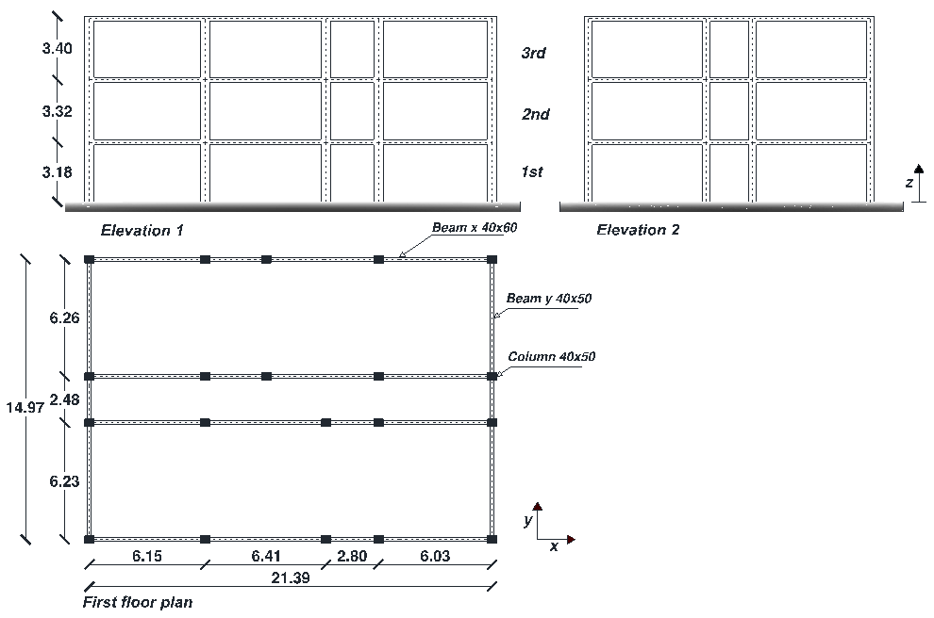

Figure 5. Elevations and plan of the studied building

Table 1. Earthquake design levels with corresponding response spectra parameters

|  |  |  |  |  |  |
| --- | --- | --- | --- | --- | --- |
| **Earthquake**  **design level** | **Earthquake**  **performance level** |  |  |  |  |
| **EQ1: frequent** | Fully operational-SLO | 45 | 0.089 | 2.277 | 0.293 |
| **EQ2: occasional** | Damage-SLD | 75 | 0.116 | 2.286 | 0.321 |
| **EQ3: rare** | Life safety-SLV | 712 | 0.323 | 2.459 | 0.385 |
| **EQ4: very rare** | Near collapse-SLC | 1462 | 0.426 | 2.498 | 0.417 |

***4.3 CSB bracing system***

*4.3.1 Performance objectives*

Performance objectives are usually set depending on the client’s requirements, building’ destination, building’s importance, and building’s typology (Ricci et al. 2012). Bertero et al. (2002) have proposed applicable performance limits based on structural and non-structural damage criteria, such as structural damage indexes (DM), storey drift indexes (IDI), and rate of deformations (floor velocity, acceleration). Those performance objectives, however, correspond to the basic objectives (Figure 1); thus, they cannot be used in our design because our desire is to meet higher requirements. Table 2 shows the basic objectives corresponding to each of the four earthquake levels, as proposed by Bertero et al. (2002), and another set of performance limits belonging to the essential performance objectives, proposed by the authors. First, the inter-storey drift index (IDI) that corresponds to EQ-3 (PO-3) is set to be 0.0045, which limits the damage of the non-structural components and prevents the yielding of the structural ones. Other objectives (PO-1, PO-2, and PO-4) were selected proportionally to the ground motions at the fundamental period of the structure.

Table 2. Quantification of the basic and the essential performance objectives

|  |  |  |  |
| --- | --- | --- | --- |
| **Limit state** | **IDI** (Bertero et al. 2002)  **(Basic objectives)** | **Limit state** | **IDI**  **(Essential objectives)** |
| EQ1: Fully operational | 0.003 | EQ1: Fully operational | PO-1 = 0.0013 |
| EQ2: Damage | 0.006 | EQ2: Fully operational | PO-2 = 0.0018 |
| EQ3: Life safety | 0.015 | EQ3: Damage | PO-3 = 0.0045 |
| EQ4: Near collapse | 0.020 | EQ4: Life safety | PO-4 = 0.0055 |

*4.3.2 Design of the CSB devices (x-direction)*

Step 1: Global stiffness matrix

Mass matrix:

 (13)

Initial stiffness matrix:

 (14)

Step 2: Modal analysis (SLV response spectrum)

Inter-storey drifts:

 (15)

Step 3: Matching the design drifts

Design drifts:

 (16)

Global stiffness matrix at the final iteration:

 (17)

Step 4: Stiffness of the CSB system

 (18)

 (19)

Step 5: Stiffness of the single CSB device

Structural configuration

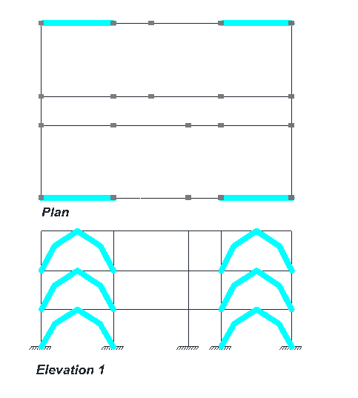

Figure 6. Structural configuration of the CBSs in the analyzed building structure

 (20)

 (21)

Step 6: Moment of inertia and cross section profile

Arm ratio: 

Moments of inertia:

 (22)

Cross sections:

 (23)

***4.4 Numerical verification***

In this section, the achievement of the pre-defined seismic performance objectives is verified through a numerical simulation of the seismic behaviour of the case study structure. For this purpose, a finite element model has been developed using the commercial software SAP2000 (Computers and Structures 2015). The constitutive law of the CSB bracing elements was obtained using the fibre-based software ‘SeismoStruct V.7.0.6’ (SeismoStruct), and then inserted in SAP2000 as non-linear links (NL).

Pushover analysis is first conducted using two displacement shapes (linear and uniform), whose average is considered. The base shear and the roof (top) displacement have been used to represent the force and displacement, respectively. Figure 7(a)shows the capacity spectra of the controlled and uncontrolled buildings and the essential performance objectives in *Sad*format. Investigation of the graph shows that the capacity curve of the controlled structure matches exactly the predefined target curve. On the other hand, the capacity spectrum of the uncontrolled structure was unable to fulfil the predefined seismic performances.

Non-linear time-history (TH) analysis has also been performed to evaluate the seismic performance of the structure. Four groups of spectrum-compatible accelerograms have been considered in agreement with the EQ levels reported in Table 1. Each group consists of seven ground motion records and is scaled to the PGA of the corresponding EQ level at the fundamental period of the structure. The results of the TH analyses are plotted in Figure 7(b), where each point represents the maximum base shear and ultimate displacement of the corresponding time-history analysis. Investigation of the graph allows observing that the seismic response of the uncontrolled structure fails to achieve the predefined performances, unlike the controlled structure whose time-history analyses results show a large agreement with the prescribed objectives.



Figure 7. (a) Acceleration-displacement capacity spectra of the controlled and uncontrolled structures with the performance objectives. (b) Time-history response of the controlled and uncontrolled structures with the performance objectives

**5. conclusions**

In this paper, an application of an energy dissipation Crescent Shaped Brace (CSB) device in existing structures was presented. CSBs have a special geometry that allows controlling the performance of structures under different seismic levels. A comprehensive procedure for the seismic design of multi-storey frame structures equipped with Crescent Shaped Brace (CSB) devices was proposed. The procedure falls within the performance-based seismic design (PBSD). The procedure was presented with full details with reference to a three-storey existing reinforced concrete case study structure. The design procedure allowed obtaining a target stiffness and a target moment of inertia for each of the bracing devices in such a way to achieve the predefined design objectives. Once the braces were designed, the global behavior of the case study structure equipped with CSB devices was carried out by means of nonlinear static and dynamic analyses.

The findings show that the CSB braces can be a great structural retrofitting system for existing buildings to ensure they are compatible with the desired seismic objectives. The results of the analyses demonstrate a large agreement between the actual and the target behavior of the controlled system. All pre-selected seismic performances corresponding to different seismic levels have been perfectly met, unlike the uncontrolled structure (without CSB) that failed to achieve the predefined performances.

The present method can be applied only to shear-type frame structures. Future work will be geared towards testing other types of structures. In addition, more investigation will be carried out to study the behavior of the device in the nonlinear range. This will allow us to better control the behavior of the structure in the inelastic range.

**6. ACKNOWLEDGEMENTS**

The research leading to these results has received funding from the European Research Council under the Grant Agreement n° ERC_IDEal reSCUE_637842 of the project IDEAL RESCUE— Integrated DEsign and control of Sustainable CommUnities during Emergencies.

Financial supports of Department of Civil Protection (DPC-RELUIS 2014-2018 Grant –Research line 6 "Seismic isolation and dissipation", WP2: "Energy dissipation", Task 2.6: "Definizione di metodi di progetto, procedure e software dedicati ai sistemi di dissipazione di energia e proposte di normativa sviluppate nell’ambito del presente progetto") is gratefully acknowledged.

**. References**

Bertero, Raul, D. B., and Vitelmo, V. (2002). "Performance-based seismic engineering: the need for a reliable conceptual comprehensive approach." *Earthquake Engineering & Structural Dynamics*, 31(3), 627-652. 10.1002/eqe.146.

Chopra, and Anil, K. (2001). *Dynamics of structures : theory and applications to earthquake engineering*, Prentice-Hall, Upper Saddle River, N.J.

Computers and Structures, I. 2015. SAP2000, version 18.1.

Datta, T. K. (2010a). "Inelastic Seismic Response of Structures." *Seismic Analysis of Structures*, John Wiley & Sons, Ltd, 237-274.

Datta, T. K. (2010b). "Seismic Control of Structures." *Seismic Analysis of Structures*, John Wiley & Sons, Ltd, 369-449.

Seismic Rehabilitation Guidelines (2000). FEMA, F. E. M. A.

Hoang, T., Ducharme, K. T., Kim, Y., and Okumus, P. (2016). "Structural impact mitigation of bridge piers using tuned mass damper." *Engineering Structures*, 112, 287-294. <http://dx.doi.org/10.1016/j.engstruct.2015.12.041>.

Kammouh, O., Silvestri, S., Palermo, M., and Cimellaro, G. P. (2018). "Performance‐based seismic design of multistory frame structures equipped with crescent‐shaped brace." *Structural Control and Health Monitoring*, 25(2), e2079. doi:10.1002/stc.2079.

NTC (2008). "Norme Tecniche per le Costruzioni, Italian building code, adopted with D.M. 14/01/2008, published on S.O. no. 30 G.U. no. 29 04/02/2008."

Palermo, M., Ricci, I., Gagliardi, S., Silvestri, S., Trombetti, T., and Gasparini, G. (2014a). "Multi-performance seismic design through an enhanced first-storey isolation system." *Engineering Structures*, 59, 495-506. <http://dx.doi.org/10.1016/j.engstruct.2013.11.002>.

Palermo, M., Silvestri, S., Gasparini, G., and Trombetti, T. (2014b). "Crescent shaped braces for the seismic design of building structures." *Materials and Structures*, 48(5), 1485-1502. 10.1617/s11527-014-0249-z.

Ricci, I., Gagliardi, S., Gasparini, G., Silvestri, S., Trombetti, T., and Palermo, M. "First-Storey Isolation Concept for Multi-Performance Seismic Design of Steel Buildings." *Proc., 15 WCEE*.

Vanmarcke, E. H., Cornell, C. A., Gasparini, D. A., and Hou, S.-n. 1990. SIMQKE_GR

1. Research assistant, Department of Structural, Geotechnical and Building Engineering (DISEG), Politecnico di Torino, Turin, Italy, omar.kammouh@polito.it
2. Associate Professor, Department of Civil Engineering, University of Bologna, Bologna, stefano.silvestri@unibo.it
3. Research assistant, Department of Civil Engineering, University of Bologna, Bologna, michele.palermo7@.unibo.it
4. Associate Professor, Department of Structural, Geotechnical and Building Engineering (DISEG), Politecnico di Torino, Turin, Italy, gianpaolo.cimellaro@polito.it