3-D BASE CONTROL SYSTEMS FOR THE SEISMIC PROTECTION OF STRUCTURES

DOI 10.13753/2686-7974-2019-16-591-599

Peter NAWROTZKI, Victor KOSTAREV, Daniel SIEPE, Dmitry MOROZOV

ABSTRACT

Earthquakes not only cause severe damage for structures, but also lead to outage of operation of important lifeline structures, as hospitals and power plants. Thus, seismic protection needs to be considered for civil structures as well as for important equipment and machinery within these structures. The arrangement of vibration isolation systems for buildings and machinery is state of the art. Elements consisting of helical steel springs are corresponding devices, used worldwide. Optimizing the parameters of these elements and arranging viscous dampers additionally, lead to a seismic control system, entitled as Base Control System (BCS). The horizontal and vertical flexibility of the springs and damping forces in all spatial directions yield a 3-dimensional seismic protection system.
The present contribution explains the corresponding advantages in terms of significant reductions of acceleration levels, internal forces and in-structural response spectra due to seismic loading. Basics and optimization criteria for the layout of Base Control Systems are offered and several examples of machinery and buildings are presented showing the advantages and improved seismic behavior of these structures. Selected pictures and numerical details document the effectiveness of the presented seismic mitigation strategies and are used to illustrate the general applicability of the 3-D Base Control Systems.

Keywords: Base Control System; Damping; 3-D

1. INTRODUCTION

The majority of seismic protection strategies still pay only attention to the horizontal effect of earthquakes respectively the horizontal isolation by devices that provide horizontal low frequencies in combination with a vertically very stiff support of the structure. The corresponding elements (e.g. lead rubber bearings, friction pendulum bearings) are well-known as Base Isolation System (BIS). Since structures will experience simultaneous horizontal and vertical excitations due to seismic ground motion, the 3-dimensional effects should be considered. Mitigation systems with helical steel springs and viscous dampers yield flexibility in all three spatial directions, and are entitled as Base Control Systems (BCS) to distinguish them from the previously mentioned systems.
Using spring elements for seismic protection purposes originated from the strategy of vibration isolation of machinery and buildings that has become “state of the art”. If a structure is placed on such an elastic support system an oscillatory system is created. If the supporting springs are much more flexible than the structure the structure could be considered as a rigid mass. Then the elastic devices allow the supported structure to react like a rigid body and all deformations and stresses are typically restricted to remain within the elastic range. Thus, the possibility of damages to any structural or non-structural element is reduced. Nowadays, the 3-dimensional support systems are frequently used to reduce seismic accelerations of machine parts, equipment and buildings – often in combination with providing vibration isolation efficiency.
This paper starts with a section about the basics of 3-D Base Control Systems. Their main characteristics, applicable optimization procedures and corresponding experimental investigations are discussed. The following chapters focus then on the practical application of these systems for machinery in power plants and for building structures under seismic excitation.

2. BASE CONTROL SYSTEMS

Systems with helical steel springs and viscous dampers provide flexibility and damping in both horizontal and vertical directions. These systems are entitled as Base Control Systems to distinguish them from wellknown base isolation systems, typically consisting of horizontally very flexible and vertically very stiff devices. The present chapter starts with a section about the basics, main characteristics and advantages of the 3-dimensional earthquake protection systems. This is followed by the presentation of some general optimization criteria and details about experimental investigations on a common shaking table and one a new type of test rig.

2.1 Basics

Base Control Systems (BCS) consist of spring elements and viscous dampers. Each spring unit consists of a top and bottom housing and - depending on the required load capacity - a number of individual helical steel springs that are arranged in several rows. The spring elements are arranged below the base of the structure to carry its weight and are designed to have sufficient safety margin to bear also additional loads (in both horizontal and vertical directions) from seismic excitation and other load cases. The springs possess vertical as well as horizontal linear-elastic behavior. There is nearly no dependency between the horizontal and the vertical stiffness of the spring devices. The horizontal stiffness is equal for both horizontal directions. Thus, the numerical description of these elements is comparatively simple and the behavior of the structure on these devices can easily be assessed. Highly efficient viscous dampers are arranged in parallel to the spring elements. These dampers supply absorption forces in all spatial directions. The properties of these dampers can be described by the damping resistance values in all three directions. Figure 1 shows an example of a BCS below a reinforced concrete structure.

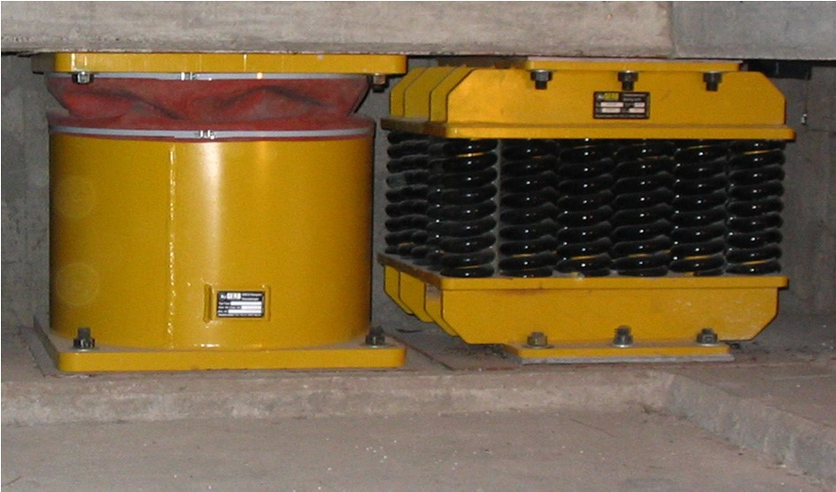

Figure 1. Typical Base Control System below apartment building

The arrangement of elastic spring devices leads to a change of the mode shape of the supported structure and to a reduction of the predominant frequency of the system; in other words: an increase of the fundamental period of vibration. The mentioned decrease of frequency could reduce the seismic demands by more than 60 %, depending on the details of the design spectrum. Regarding the low frequency of the system it is very important to consider the corresponding seismic displacements.
Between supported structure and adjacent structures too large displacements must be avoided. Furthermore, the occurring relative displacements have to be handled by the devices also. As a corresponding example a simplified single degree of freedom system with a damping ratio of 5 % is investigated. The randomly chosen design spectrum is shown on the left side of Figure 2. The calculated relationship between seismic displacements and absolute accelerations can be taken from the right side of Figure 2.

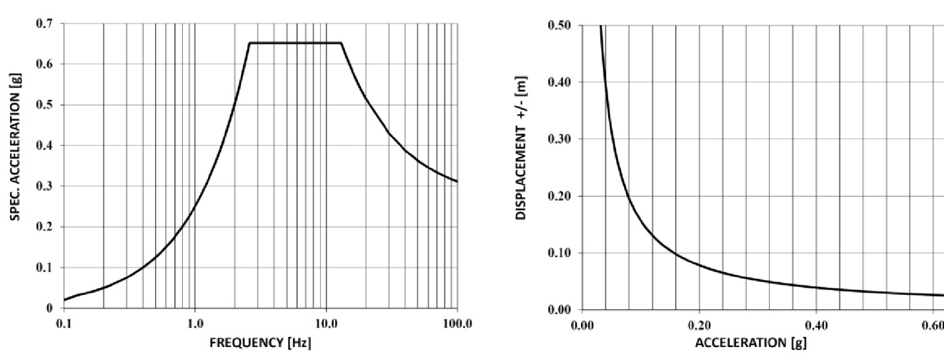

Figure 2. Seismic 5 % damped spectrum (left) and relation between displacement and acceleration (right)

Having a look at the previous figure it becomes obvious that it is required to find an optimum between the reduction of accelerations and occurring relative displacements. It is not recommended in general to yield extremely low accelerations with enormous huge displacements. It would be much better to use a different support strategy – taking into account a little bit higher acceleration values but in combination with an increase of damping to control the displacements also. The chosen strategy should always focus on the project specific requirements; e.g. in terms of discrete acceleration limits.
The mentioned dampers, installed beside the spring devices, have the task to absorb the kinetic energy. Their arrangement leads to an increase of structural damping and they serve as displacement limitation of the supported structure and of the devices themselves. The possible reduction of the induced structural demands due to the increase of damping can be taken from different national and international standards. An increase of structural damping from 5 % to 15 % causes a reduction of stresses, strain, displacements, etc. in a range of about 25 % according to ASCE/SEI 7-16 (2017). The mentioned mitigation measure is combined with the frequency reduction in an optimum case.
In summary, a Base Control System allows the tuning of rigid body mode shapes into the low frequency range in combination with an increase of structural damping. This support strategy results in significantly reduced seismic acceleration levels of the supported structure.

2.2 Main Characteristics

The application of Base Control Systems significantly improves the seismic performance of the supported structure. As described above, the chosen designation is used to distinguish this 3-dimensional protection system (BCS) from well-known base isolation systems (BIS), where horizontally very flexible and vertically very stiff devices (e.g. rubber bearings) are applied. Table 1 shows several important differences between the described protection systems.

Table 1. Brief characteristics of Base Isolation Systems (BIS) and Base Control Systems (BCS).

BIS |  | BCS
Extremely low | Horizontal stiffness | Low
Very high | Vertical stiffness | Medium
Very low | Horiz. acceleration | Low
Very low | Stress / Strain level | Very low
No / amplification | Vertical efficiency | High
Very large | Displacement | Medium
Large | Vert. soil reaction | Medium
Problematic | Higher modes | Nearly no effect
Difficult | Exchange of devices | Easily possible
High | Bearing capacity | Medium – high
No | Vibration isolation / protection  against structure borne noise | Integrated
Problematic | Aging / design life | No problem
Difficult | Adjustment / leveling of  structure | Standard procedure
No | Control / leveling of vertical forces | Easily possible

Both systems, BCS and BIS, are suitable for the reduction of seismic demands, depending on the frequency content of the earthquake. In general, the BIS could be described as a very efficient horizontal seismic protection system, quite in contrast to the Base Control System, that provides a 3-dimensional protection effect, in combination with several additional advantages. Vertical subsoil reactions are smaller, exchange of devices and control respectively leveling of height and vertical forces are easily possible, if a BCS is used. Furthermore, important targets in terms of relative displacements could be kept. Due to the vertically and horizontally flexible steel springs the supported structure is also protected against shock loading as described in Siepe and Nawrotzki (2015).

2.3 Optimization

The devices of a Base Control System vary especially in the bearing capacity, in the horizontal and vertical stiffness properties, in the ratio between vertical and horizontal stiffness (Kv/Kh) and in the damping resistance. Concerning the type of spring and damper a wide variety is available. New developments are always possible. Generally there are no universal optimum properties of the support devices for all structures. The stiffness ratio is one of the most important optimization criteria for a 3-dimensional support system. If a low value for Kv/Kh is used, the occurring mode shape will include a horizontal movement with a large rocking part. The increase of the stiffness ratio yields a mode shape with less rocking. Values in a range between 5 and 8 for this ratio are typical results of successfully used optimization steps. Thus, the stiffness ratio could be used to control the mode shape of the supported structure. As described in a previous section, the flexible springs also reduce the system frequency and as a consequence the induced seismic accelerations. Results of a simplified calculation, as shown in Figure 2, can be used to find the optimum between acceleration and relative displacement to keep the project specific requirements.
During the optimization of the support properties it is important to consider the possible increase of structural damping. The increase will help to further reduce the seismic demands as well as to reduce the relative displacements. Depending on the details of the supported structure (mass, dimensions, material damping) the properties of the support system will be chosen to achieve a system damping of around 10 % to 20 % of critical damping for the vertical direction and about 20 % to 40 % of critical damping for the horizontal directions.
The above mentioned general optimization criteria are backed up by a more detailed study for a large building structure described in Kostarev et al. (2017). Here, the peak accelerations and relative displacements at the isolator unit are the important parameters that are used as basis for the goal function. Very good results were found for a combination of vertical natural frequency of 3.0 Hz and first horizontal frequencies of 0.9 Hz, both with a damping ratio of about 20 %.

2.4 Experimental Investigations

In addition to the theoretical investigations several practical tests have been performed at IZIIS (Institute of Earthquake Engineering and Engineering Seismology) in Skopje, Macedonia. Their biaxial shaking table is able to generate an acceleration input up to 3.0 g for the horizontal direction, as well as a vertical acceleration input up to 1.5 g. These values are applicable for zero pay load. The 5.0 x 5.0 m table possesses a maximum pay load of about 40 metric tons. A five story, three bay steel frame model with a total mass of about 24 metric tons has been tested with and without Base Control System on the described shaking table. Figure 3 shows the test-setup with BCS.

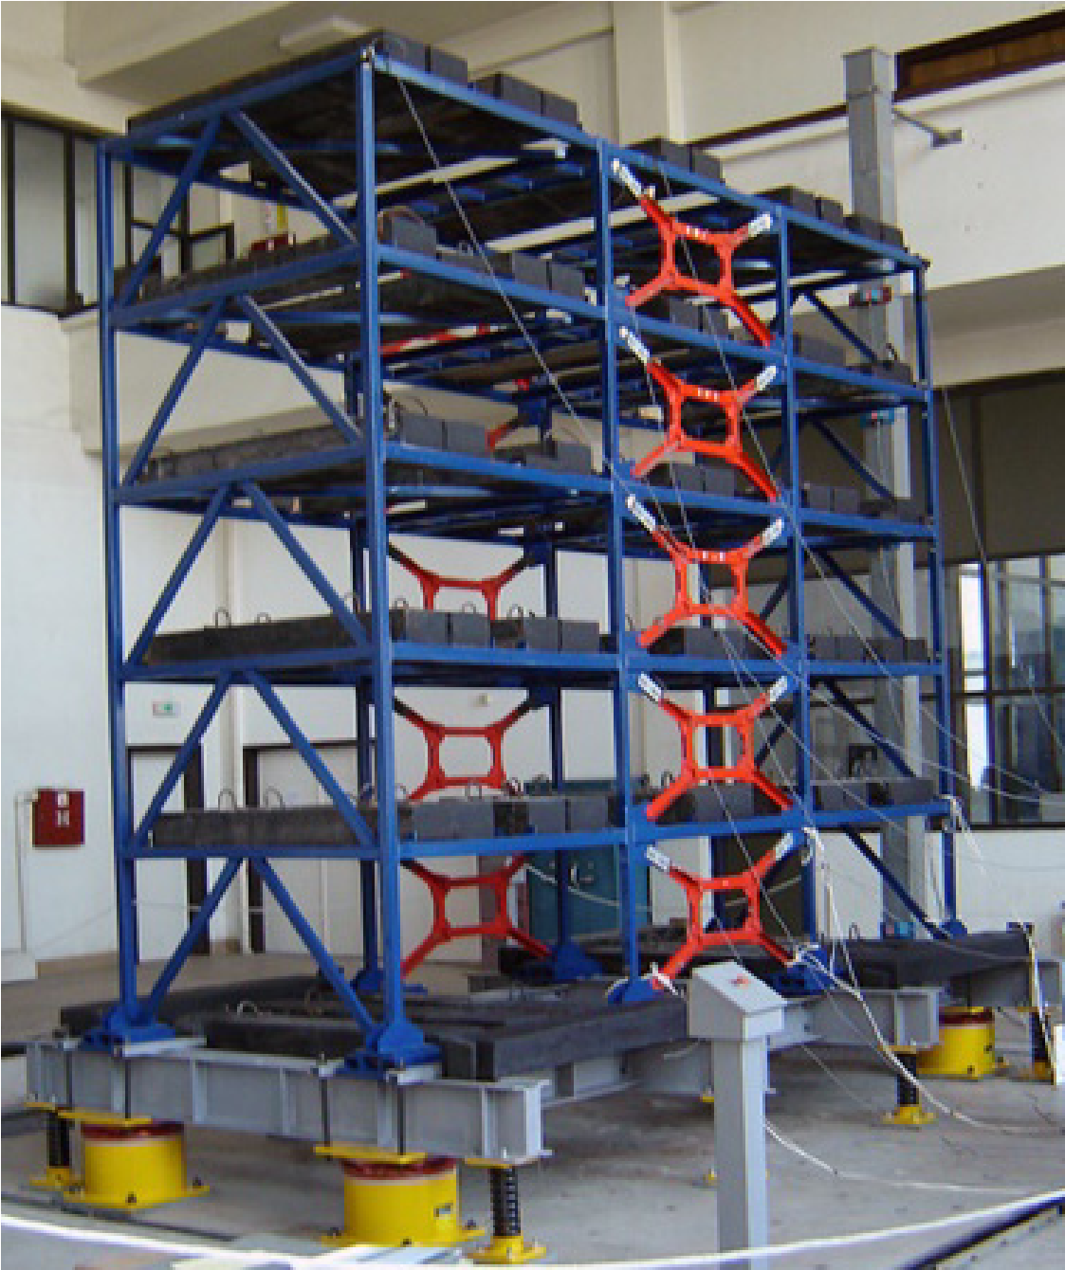

Figure 3. Tested model (with BCS) on the shaking table at IZIIS

The efficiency of the BCS as seismic mitigation system has been studied by simulating a set of ten different earthquake records for both test-setups. Evaluating the large number of recorded time history responses in terms of absolute accelerations, axial and bending strain at various locations of the structure it can be concluded that the BCS reduces the structural responses by more than 50 % compared to the unprotected structure. More detailed information can be found in Rakicevic et al. (2006).
Beside the tests on well-known shaking tables it is nowadays also possible to test elements of a BCS and/or other seismic isolation devices at a new test stand, erected in St. Petersburg, Russia. Here, a special inverse test rig (SIST) was developed in order to perform testing of real structures with seismic isolation systems in natural scale. In contrast to typical shaking tables, the inverse approach implies that the substructure is not shaking but the superstructure is shaking at its natural frequencies with amplitudes due to full gravity and full seismic loading. The general test-setup is shown in Figure 4.
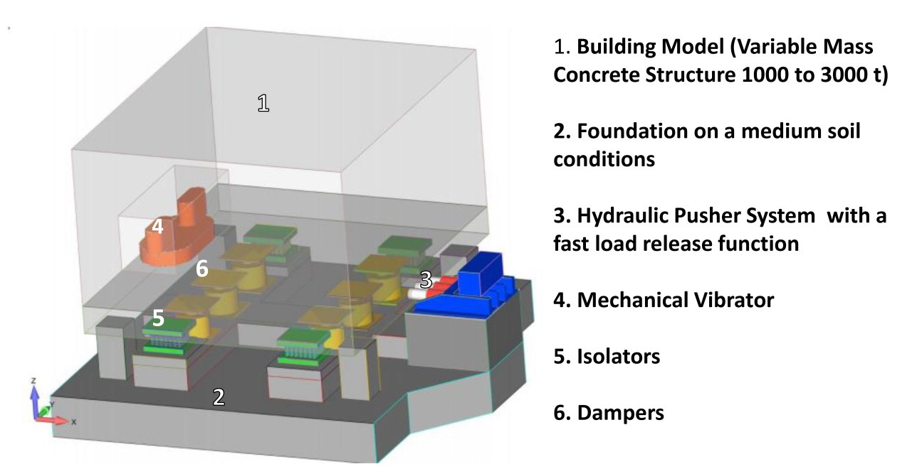

Figure 4. Configuration of the SIST (Seismic Isolation Systems Test)

The system could consists of a superstructure with a mass between 1000 and 3000 metric tons and a hydraulic system that is able to push the structure to the desired maximum displacement and ensures a fast release of the pushing mechanism to allow a free movement of the supported structure. The superstructure is placed on 4 isolators and a variable number of damping devices. Figure 5 shows the setup at the site in St. Petersburg before the first tests were performed in December 2017.

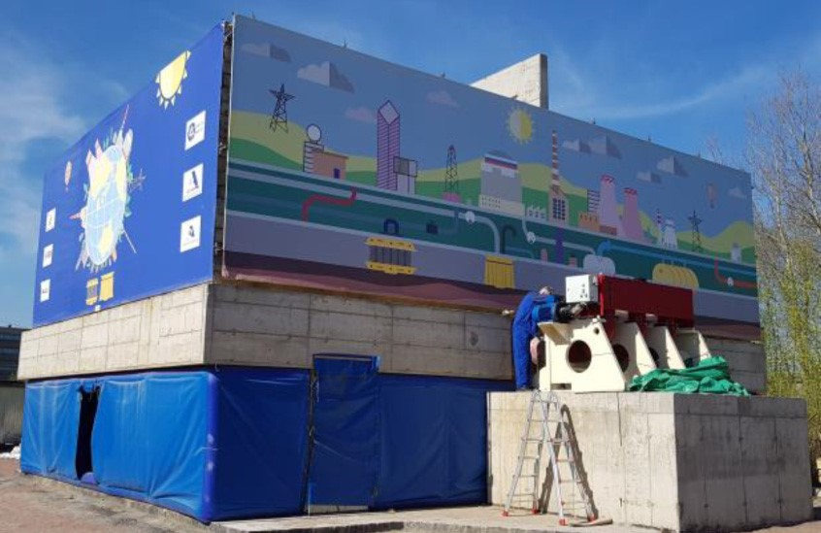

Figure 5. General view of SIST at St. Petersburg, Russia

The initial tests verified the general functionality and operability of the test rig. Afterwards extensive tests of a 3-D Base Control System were performed. The results show that the spring elements and viscous dampers provide previously defined optimal parameters to the superstructure, as presented in Kostarev et al. (2018).

3. PROJECT EXAMPLE: MACHINERY

Turbo-generator sets, emergency diesel generators, feed water pumps, fans or coal mills are typical examples of elastically supported power plant machinery. Helical steel spring elements and viscous dampers are used here for yielding vibration isolation. The mentioned devices could also be used to protect the machinery against seismic demands and other extraordinary load cases. A typical view of spring elements below a turbine deck is shown in Figure 6.

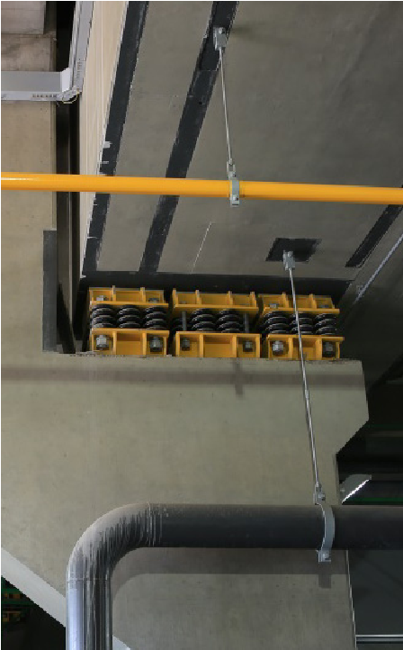

Figure 6. Vibration isolation system below turbine foundation

As a corresponding project example the investigations for two new 500 MW turbine units for the extension of the Anpara Thermal Power Station in Uttar Pradesh, India are presented in the following section. These turbines from BHEL (Bharat Heavy Electricals Ltd.) will be located in a high seismic zone with a peak ground acceleration of 0.22 g. During the initial design stage of the turbine deck the seismic behavior of a conventional, rigidly supported turbine deck was compared with the behavior of a turbine deck supported by springs and dampers. Figure 7 shows the 3-dimensional finite element model that was used for the analyses. The model consists of the reinforced concrete turbine deck and substructure, machine masses and spring devices.

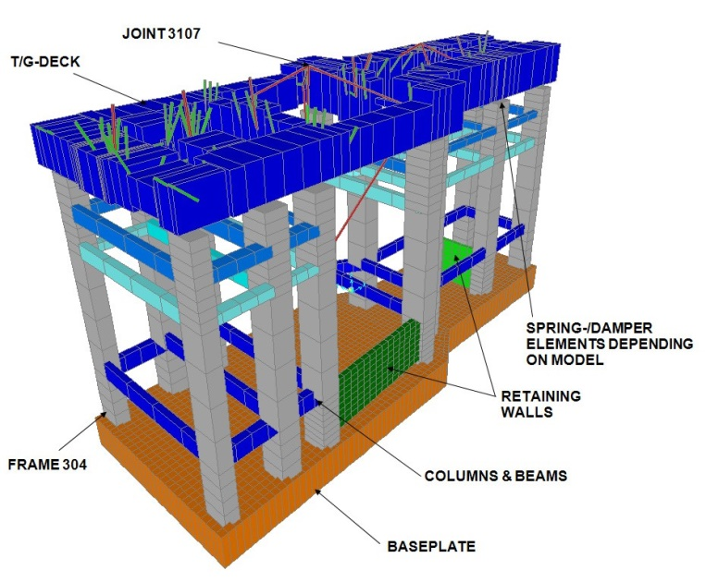

Figure 7. Finite element model

The first model, without vibration isolation system, shows a first horizontal mode shape in transversal direction with a frequency of about 2.0 Hz. During an optimization procedure the parameters of the spring devices are chosen. Using a quite high ratio between vertical and horizontal stiffness in combination with an increase of damping yield a horizontal frequency of about 1.0 Hz with corresponding damping ratio of 15 %. This layout leads to a significant reduction of seismic results. Response spectrum analyses are performed to directly compare the structural responses of the two finite element models. The absolute acceleration at level of the shaft could be reduced from about 0.6 g down to about 0.2 g in transverse direction. The results of the model without elastic devices are used as reference values (“100 %”). Some important results are presented in Table 2.

Table 2. Comparison of response spectrum analyses in transversal direction.

Arrangement of seismic protection system | No | Yes
Absolute acceleration at shaft level (Node 3107) | 100 % | 41 %
Bending moment at column (Frame 304) | 100 % | 48 %
Shear force at column (Frame 304) | 100 % | 34 %

Similar results could be found for the longitudinal direction. The absolute acceleration values as well as internal forces are significantly reduced if springs and dampers are used. Thus, it was decided to arrange the vibration isolation and seismic protection system for both turbine generator decks.

4. SEISMIC PROTECTION OF BUILDINGS

Buildings are usually quite complex in regard to their dynamic behavior, and they required a very high standard in safety questions. Nawrotzki (2007) presented that worldwide there are more than 100 buildings that are supported on helical steel spring elements. Here, the elastic support is required in most of these cases to achieve vibration isolation, e.g. if there is a train passing very closely. The quite high frequency excitation in vertical direction, which may disturb or endanger the building, is filtered out by low frequency support systems. For projects in seismically prone areas this support strategy is modified to consider the effects of earthquakes also. Viscous dampers are arranged additionally to increase the structural damping and the stiffness parameters, above all the ratio between vertical and horizontal stiffness, are optimized, as described in a previous section.
Concerning seismically protected buildings a special project has to be mentioned. Two identical apartment buildings are built in 2004 in a high seismic zone at the University of Mendoza, Argentina. One building consists of a “rigid” foundation; the adjacent identical building is supported by a Base Control System. Both structures, presented in Figure 8, consist of three floors of reinforced concrete and masonry infill and were equipped with seismic accelerometers by the National Technological University of Mendoza. The total weight of one building amounts to approximately 260 metric tons. The dimensions are about 8.2 x 8.7 m in plan with a height of 9 m.

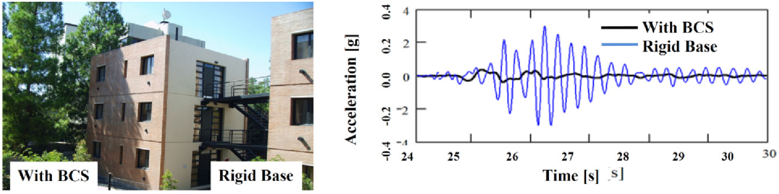

Figure 8. Non-isolated rigid based building and based controlled building (left) and measured seismic accelerations
at roof of both buildings (right)

The general feasibility and the efficiency of the BCS have been confirmed by its behavior under a real earthquake with a peak ground acceleration of 0.12 g in 2005. The comparison of the measured results is presented in Figure 8. At the building with Base Control System the acceleration values are reduced by more than 70 %. It has to be noted that theses excellent results are reached with small (only about 3 mm) relative displacements within the devices. Due to the change of the mode shape the base controlled building experience a constant acceleration distribution along its height.
After slightly adjusting the characteristics of the initial analysis model due to the measured results it could be shown that corresponding reduction factors can be found in regard to internal stress and strain values as well as to subsoil reaction loads. The axial forces were reduced by more than 60 %, the shear forces by more than 75 %, and important bending moments were decreased by about 90 % according to Stuardi et al. (2008). Thus, the Base Control System has successfully demonstrated its outstanding seismic protection capability for a building under real earthquake conditions.

5. CONCLUSIONS

An approach for the seismic protection of structures was investigated and has shown its effectiveness and potential application. After a short introduction into the fundamentals of 3-dimensional Base Control Systems, some corresponding project examples were discussed. It is shown that the proposed control system leads to a significant reduction of accelerations, base reactions and internal forces. The use of these systems should be further investigated for practical application in buildings and important machinery.

6. REFERENCES

American Society of Civil Engineers (2017) ASCE/SEI 7-16 Minimum design loads and associated criteria for buildings and other structures. American Society of Civil Engineers, ISBN: 978-0-7844-1424-8.
Kostarev V.V., Vasilyev P.S., Nawrotzki P. A new approach in seismic base isolation and dynamic control of structures Proceedings of the 2017 NZSEE Conference, 27-29 April 2017, Wellington, New Zealand.
Kostarev V., Nawrotzki P., Vasilyev, P. Vaindrakh M. Seismic dynamic analysis, optimization, testing and probabilistic safety assessment of an innovative 3D seismic base isolation system for important structures Proceedings of the TINCE 2018 – Technological Innovations in Nuclear Civil Engineering, 29-31 August 2018, Paris-Saclay, France.
Nawrotzki P. Elastic support systems for the preservation of cultural heritage Proceedings of the International Symposium on Studies on Historical Heritage, 17-21 September 2007, Antalya, Turkey.
Rakicevic Z., Jurukovski D., Nawrotzki P. Analytical modeling of dynamic behavior of a frame structure with and without Base Control System Proceedings of the 4th World Conference on Structural Control and Monitoring, 11-13 July 2006, San Diego, USA.
Siepe D., Nawrotzki P. Horizontal and vertical isolation of seismic and aircraft impact Proceedings of the 14th World Conference on Seismic Isolation, Energy Dissipation and Active Vibration Control of Structures, 9-11 September 2015, San Diego, USA.
Stuardi J. E., Nawrotzki P., Suarez L. E. Comparative seismic performance of a base control system based on measured and calculated responses Proceedings of the 14th World Conference on Earthquake Engineering, 12-17 October 2008, Beijing, China.

Managing Director, GERB Schwingungsisolierungen GmbH & Co.KG, Berlin, Germany, peter.nawrotzki@gerb.de
President, CKTI-Vibroseism Ltd., St. Petersburg, Russia, victor.kostarev@gmail.com
Seismic Group Manager, GERB Schwingungsisolierungen GmbH & Co.KG, Essen, Germany, daniel.siepe@gerb.de
General Director, OOO GERB, St. Petersburg, Russia, gerb.morozov@gmail.com

