**DEVELOPMENT AND REVISION OF THE EUROPEAN STANDARD   
EN 15129 ON ANTI-SEISMIC DEVICES**

**DOI 10.37153/2686-7974-2019-16-558-569**

Renzo Medeot[1]

**ABSTRACT**

CEN officially created the TC 340: Anti-seismic Devices in 1993 with the task to proceed with the standardization of the seismic hardware for use in structures erected in seismic areas and designed in accordance with EUROCODE 8: Design of Structures for Earthquake Resistance, with the aim of modifying their response to seismic action.

This European Standard specifies functional requirements and general design rules thereof, material characteristics, manufacturing and testing requirements, as well as acceptance, installation and maintenance criteria.

This Standard covers all types of Seismic Hardware in existence and leaves a door open to future progress. This derives principally from the fact that the Standard is highly performance-oriented and this feature also constitutes *per se* a guarantee of equity between the various systems that may be used as alternatives. .

Also, the paper elucidates the criteria adopted for the pending revision of the EN 15129 that began in December 2015.

In conclusion, this document summarizes the experience gained in Europe over the past 40 years in the field of Anti-seismic devices, which is dealt with through the application of very advanced criteria.

This favours progress inasmuch as it promotes loyal competition through clear and fair rules that protect the interests of the community.

*Keywords: Seismic Norms, seismic devices, seismic hardware*

**1. INTRODUCTION**

An increasing number of Congresses and Symposia - as well as other professional meetings - give testimony to the significant strides made by Earthquake Engineering during the last forty years.

Progress has been the result of a better understanding of the seismic behaviour of structures as well as improved knowledge of the characteristics of seismic actions.

In relation to these two aspects [Dolce (1991)], newly developed design strategies have been devised and implemented entailing the use of special mechanical devices to be included in the structural system in order to substantially:

**-** change its overall behaviour (e.g. seismic isolators) and/or

- dissipate most of any input energy (e.g. energy dissipating braces, hydraulic dampers), or

- provide a different behaviour under service and seismic actions (e.g. shock transmission units).

Thousands of applications have been implemented all over the world to many types of structures of varying size [Martelli (2003]. However, such a large number could still be inadequate, when one considers the fact that structural safety can be easily improved by one order of magnitude using passive control systems.

Newly conceived design strategies could not have found useful application without a parallel development of the hardware needed to implement them.

Thus, many research laboratories and certain pioneering industries have decided to invest important resources in this field, inventing and improving a series of devices that exploit well known physical phenomena for the seismic protection of structures.

As it is often the case when technological growth in a given field reaches important levels of development as well as a reasonable degree of maturity, a need spontaneously arises to establish ground rules that define principles of general validity.

Said rules ultimately come to nest in documents of increasing importance like

* *recommendations,*
* *guidelines* and
* *standards*.

Within the spirit of the above, in March, 1992, the Italian Standardization Institute (UNI) forwarded to the European Committee on Standardization (CEN) a formal request calling for the creation of a Technical Committee charged with drafting a norm to cover anti-seismic hardware.

Within the framework of existing procedures, CEN launched an inquiry amongst the member nations with a July, 1992 deadline. Fourteen of them responded to the inquiry with 11 votes in favour and 3 against.

In September 1992, the Bureau Technique Secteur 1 (BTS1) as the competent body in construction within CEN, responded favourably to the UNI request upon examination of the inquiry results.

After due bureaucratic tribute was paid, the first meeting of the officially nominated Technical Committee finally convened in Vienna in October, 1993. [Medeot (2003)]

This occasion saw the creation of a Work Programme with fixed target dates, the election of a Chairman (this author) and the installation of four Working Groups, each with an appointed "Convener“.

**2. GENERAL CRITERIA ADOPTED**

A Standard, given its nature, is in principle a document that limits user's freedom (i.e., manufacturers, design engineers, etc.).

However, in order to be a good Standard, it cannot impair technological progress within its area of applicability by favouring what is in existence over what might be developed in the future.

So as to avoid such an eventuality, CEN established few rules. The three most important of these rules are:

a) requirements should be expressed in terms of performance as much as possible;

b) only those characteristics which can be verified by a given method shall be included in the Standard;

c) the Standard must represent an objective state-of-the-art and thus must not exclude any systems whose validity has been proven through successful applications.

Point (a) above regards a long held controversy as to whether it might be possible to draft a Standard that can be purely performance oriented. Unfortunately, the answer has to be negative. Nonetheless, it is always possible to find an equitable compromise between "product oriented" and "performance oriented" requirements that can result in full observance of criteria (b) and (c).

The application of the above cited criteria favours progress inasmuch as it promotes loyal competition through clear and fair rules that protect the interest of the community.

An important observation about general criteria regards the fact that the European Standard on Anti-seismic Devices should be harmonized with the Eurocodes (hereinafter referred to as ECs), particularly in what relates to EC8 – Design of Structures for Earthquake Resistance dealing with buildings and bridges endowed with seismic isolation systems, whose logical implementation it represents.

Unfortunately, coordination between the activities of the two Technical Committees did not meet with the success that was expected inasmuch there exists some “overstepping of borders” amongst the respective areas of responsibility and competence. However recently two Liaison Officers have been appointed by TC250/SC8 and TC340 and it is believed that they should resolve the controverses in the next future.

**3. STRUCTURE OF THE STANDARD**

The structure of the European Standard on Anti-seismic Devices has been modified several times. Its definitive version includes the following:

Scope

Part 1:. Terms and definitions, symbols and abbreviations - General Design Rules

Part 2: Rigid Connection Devices

Part 3: Displacement Dependent Devices

Part 4: Velocity Dependent Devices

Part 5. Elastomeric Isolators

Part 6: Curved and Flat Sliding Isolators

Informative Annexes accompany the various Parts of the Standard, in order to give useful comments and explanations to the reader.

Much attention has been focused on the definition of the various types of devices. In effect, the CEN rules require that "*the definitions shall be unambiguous and as concise as possible*".

As an example, let’s examine the case of clause “Scope”. “*This European standard covers the design of devices that are provided in structures with the aim of modifying their response to the seismic action. It specifies functional requirements and general design rules in the seismic situation, material characteristics, manufacturing and testing requirements, as well as acceptance, installation and maintenance criteria*”.

***3.1 General Design Rules***

General design rules are set forth in Part 1 of the Standard and are consistent and strictly related to those stated in the EN 1998, Part 1: Buildings, and Part 2: Bridges, particularly for devices used in seismic isolated structures, which are dealt with in specific sections.

According to the two limit states referred to in EC8, EN 15129 considers as fundamental the following

types of requirements:

* *No failure requirement*
* *Damage limitation requirement*

Both are referred to the relevant seismic intensities defined in EN 1998-Part 1 for the:

- ear Collapse Limit State and for the

- Damage Limitation State respectively.

The first one requires that devices retain their functional integrity and residual mechanical resistance, including, when applicable, residual load bearing capacity after the seismic event.

The second requires that devices withstand the corresponding seismic action without the occurrence of damage and associated limitations of use, whose costs would be disproportionately high in comparison to the cost of the structure itself.

Reliability differentiation is required for different types of buildings or civil engineering works and is implemented by classifying structures into different importance categories. To each category, an importance factor γI is assigned and applied to the seismic action.

The values of the factor γI are recommended in the corresponding parts of EN 1998. Increased reliability is required of the devices, in terms of the crucial role they play within the structural system. This requirement is already stipulated in EN 1998-Part 1 (2004), and EN 1998-Part 2 (2005), for seismic isolation devices. However, in EN15129, it is extended to devices used in applications other than seismic isolation.

In order to comply with this requirement, according to EN 1998-1 (edifices) a magnification coefficient γx=1,2 shall be applied to the design seismic action effects on the devices and their connections to the structure.

The mechanical and physical properties of devices, of their components and of their connections to the structure shall be assessed by laboratory tests through appropriate procedures.

Amongst functional requirements, specific emphasis is placed upon the need that devices and their connections to structures shall be designed, constructed and installed in such a way that their routine inspection and replacement are possible during the service lifetime of the construction.

Moreover, replacement of a device after it has sustained damage shall be possible without resorting to major interventions. Devices used for replacement shall comply with the Norm EN15129 and with additional requirements originally defined by the owner, unless otherwise requested by him at the time of the replacement.

In order to account for the inevitable variability in device characteristics due to the dependence of the mechanical behaviour of their materials on several factors, such as temperature and other environmental

conditions (age, strain rate, etc.,) the upper and lower limits of the mechanical parameters of the core materials and of the devices shall be checked through experimental tests.

It is of interest to also remind the innovative criterion developed by this Author (Medeot, 2004) and adopted in the Norm to evaluate the re-centring capability of an isolation system, which is based on energy concepts.

In the case of an equivalent linear analysis, to ensure adequate re-centring capability of a seismically isolated structure, it shall be verified that, for a deformation from 0 to the design displacement dEd :

 (1)

where: ES is the elastically (reversibly) stored energy

EH is the hysteretically (irreversible) dissipated energy.

The above requirement has been recently adopted in the Eurocode 8 and thus removed from EN 15129.

At the *10th World Conference* (Istanbul, Turkey, May 2007) this author presented a paper titled “Comparison Between US and European Norms on Seismic Hardware” (Medeot, 2004)

The reference Norms were the *prEN15129* (in its provisional status) and the “*AASHTO Guide Specification for Seismic Isolation Design*” (in its 1999 version).

About re-centring capability of isolation systems, the latter specifies the following:

“…*the restoring force at dt shall be greater than the restoring force at 0,5 dt  by not less than W/80* ”, where *dt* is the design displacement and *W* is the weight of the supported isolated mass.

This requirement, which still exists in the latest version (AASHTO, 2014, “Guide Specification”), can be better illustrated through a graphical representation of Figure 1.

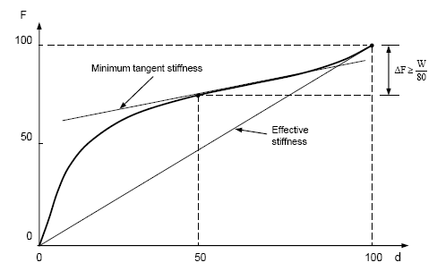

Figure 1. Graphical representation of Re-centring Capability Evaluation according   
to *Guide Specifications for Seismic Isolation Design*

Let’s consider the case of the curved surface sliding isolator (i.e. the Friction Pendulum® ).The stiffness for this type of isolator is constant and equal to k = W/R. Thus, the above requirement is satisfied when:

 that is to say:  (2)

We conclude that according to the Guide Specifications the re-centring capability of a Friction Pendulum® device is independent from the value of its dynamic coefficient of friction μdyn. This is obviously a paradox [Medeot (2011)].

Conversely, the energy-based approach in the EN15129, leads to the following expression:

 (3)

As we can see, in the case of energy-based approach the re-centring capability of the Friction Pendulum® depends also on the dynamic coefficient of friction μdyn, as it is obvious.

Finally, in the Clause “General Design Rules” of EN 15129 specific concern is given to Validation of Anti-seismic Devices (after the revision:Assessment and Verification of Constancy of Performance - AVCP).

Any type of device shall be subjected to a technical validation procedure, which shall include elements proving that the device conforms to its functional requirements. It shall comprise at least the following:

* a description of the ranges of parameters relevant for the type of device under consideration;
* a method to estimate the expected service life;
* proof of the device’s ability to function in a reliable and stable way during its service life;
* values of the mechanical properties of the device,

Type tests shall be required for the validation of new systems, or of existing systems when materials are changed, as well as of existing systems in ranges of use outside those previously validated.

The mechanical properties of the devices needed in the design for the anticipated service lifetime of the system, together with their ranges of variation, shall be determined by the type tests. Full-scale devices shall be required for these tests, unless otherwise specified in the relevant clauses of this standard.

A given percentage of the devices to be installed in a structure shall be subjected to acceptance tests, before putting them into place, to confirm that their properties conform to the design values.

***3.2* *The Anti-*Seismic *Devices***

Before defining the structure of the Standard, and similar to what happened in other scientific fields (e.g., Biology) there was an attempt to create a "systematics" of present seismic hardware, that is to say, to group existing devices on the basis of the functions they perform or the common principles governing their functioning.

Thus, the starting point was the creation of divisions of a general character and then moving toward increasingly detailed subdivisions.

After several reconsiderations and changes of mind, the existing seismic hardware has been subdivided into the following four groups according to the functions they perform:

* Rigid Connection Devices
* Displacement Dependent Devices
* Velocity Dependent Devices
* Isolators

It is worth summarizing the essential features of these fundamental groups of devices.

*Rigid Connection Devices*: are devices that link two structural elements without transmitting bending moments and vertical loads.

To the family of Rigid Connection Devices belong three distinct groups of devices.

* Permanent Connection Devices
* Fuse Restraints provide a rigid connection between two structural elements in service conditions only, while they break away at the occurrence of an earthquake, thus permitting the movements between the adjacent structural elements
* Temporary Connection Devices perform the opposite function of Fuse Restraints.

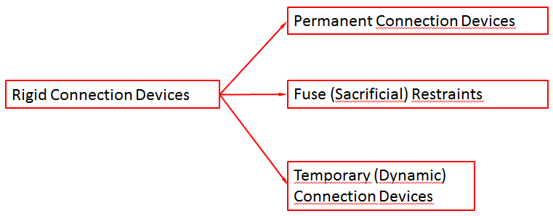

Figure 2. Subdivision of Rigid Connection Devices

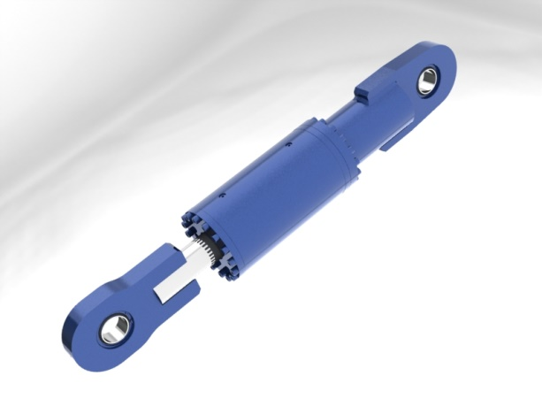

Figure 3. Shock Transmitter, an example of temporary Rigid Connection Device

*Displacement Dependent Devices*: are devices that do not carry vertical loads, whose behaviour is mainly displacement-dependent rather than velocity-dependent (see Figure 4 here below).

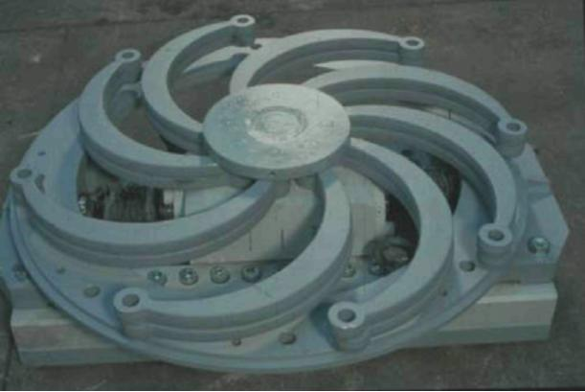

Figure 4.Arrangement of Steel Hysteretic Elements, an example of Displacement Dependent Device

Displacement Dependent Devices have been subdivided as shown in Figure 5 below.

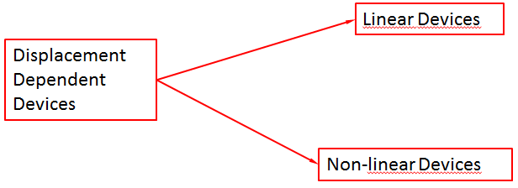

Figure 5. Subdivision of Displacement Dependent Devices

*Velocity Dependent Devices*: devices which do not carry vertical loads and whose behaviour is mainly velocity-dependent rather than displacement-dependent (see Figure 6 on next page).

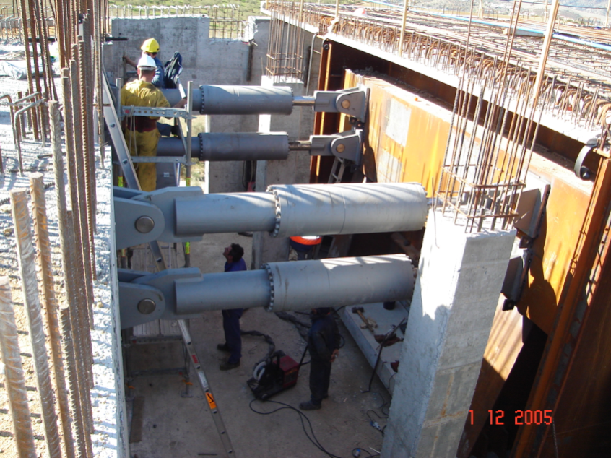

Figure 6**.** Hydraulic Viscous Dampers, an example of Velocity Dependent Devices

*Seismic Isolators****:*** devices that support the gravity load of a structure [10] and accommodate the large horizontal displacements produced by seismic actions whilst still safely supporting the gravity load of the structure and resisting the vertical forces produced by the seismic actions (see Figure 7 here below).

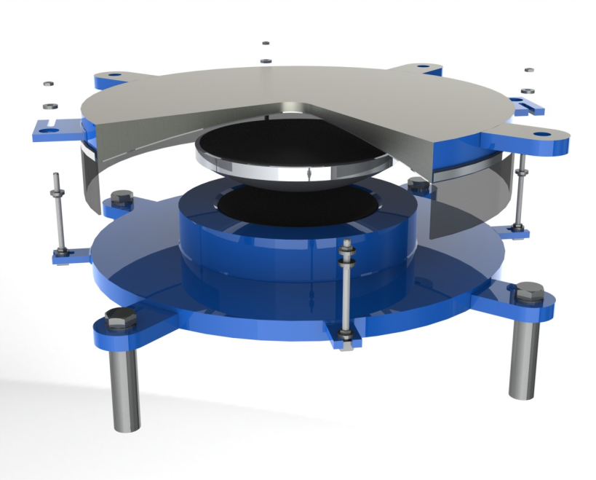

Figure 7**.** Exploded view of aSliding Isolation Pendulum, an example of Seismic Isolator

The Seismic Isolators have been subdivided as shown in Figure 8 here below.

.

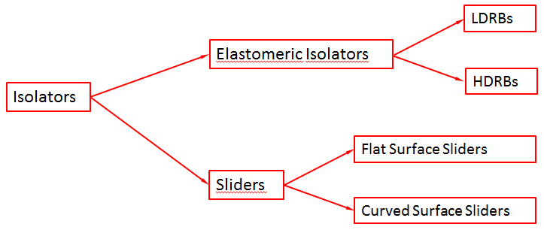

Figure 8. Subdivision of Seismic Isolators

Due to their extension, the sections dedicated to all the types of devices would need a dedicated lecture.

It is important to keep in mind the fact that the Norm takes into consideration all the types of devices presently in existence on the European market – even those developed outside Europe, e.g. Lead Rubber Bearings and Friction Pendula®.

However, it should be emphasized that in Europe the lack of inclusion of a type of device within a Norm’s stipulations does not necessarily imply its being excluded from the European market.

It only means that a need arises for a European Technical Assessment (ETA), now replaced by the European Assessment Document (EAD).

***3.3 Combination of Anti-Seismic Devices***

Combining pre-existing devices generates "hybrids" that, may show interesting new characteristics. However, something quite to the contrary could also occur.

Thus, general rules are furnished to avoid any such eventuality.

Flat Surface Sliders (i.e. free bearings) often form part of a combined device. It may consist of the combination of a structural bearing allowing sliding movement in one or two directions and one or more anti-seismic devices in accordance with the relevant Clauses of the EN 15129. Also a combination with more than one type of anti-seismic device is possible.



Steel

Hysteretic

Device

LRB

Figure 9. Lead Rubber Bearing (LRB) coupled with a crescent moon shaped steel hysteretic device

**4. ATTESTATION OF CONFORMITY (now AVCP)**

A few months before the EN15129 came into force (August 1st, 2011), a revolution occurred in Europe on the market of Construction Products, i.e. the approval of the Regulation No. 305/2011 (Construction Products Regulation, or CPR), which replaces the Construction Products Directive (89/106/EEC) and lays down harmonised rules for the marketing of construction products.

The CPR defines clear rules for the Assessment and Verification of Constancy of Performance (AVCP) system applicable to construction products and replaces the former Attestation of Conformity.

The latter shall not be confused with Evaluation of Conformity, which is seen as a purely technical matter closely linked with a specific product and the way it is produced which can be standardized for the benefit of comparability.

Conversely, the AVCP is an administrative process that is carried out by Notified Bodies, which are the recognised third party carrying out the assessment of performance of construction products.

The Assessment and Verification of Constancy of Performance (AVCP) is a harmonised system defining how to assess products before they are placed on the market and control the constancy of the assessment results throughout the production.

Depending on the tasks assigned in the process of Assessment and Verification of Constancy of Performance, there are three organisms involved in the CE marking procedure, namely:

• The Notified Testing Laboratory

• The Inspection Body

• The Certification Body

The Norm clearly distinguishes between

• Type Testing (TT), which shall be performed by the Notified Testing Laboratory prior to commencing manufacture and repeated if change in the construction product or manufacturing processes occurs.

• Factory Production Control (FPC), where extent and frequency of factory production control procedures are given. The FPC system shall be regularly inspected by the Inspection Body to ensure the regular implementation and effectiveness of the system.

Whenever a change occurs in the design of the anti-seismic device, the raw material, or the production process, which would change the tolerances or requirements for one or more of the characteristics of a device, the Type Tests shall be repeated for the appropriate characteristic(s).

In conclusion, type tests shall be required:

• for the assessment of the performance of new devices;

• for the assessment of the performance of existing devices in ranges of use outside those covered by the previous assessment;

The FPC system shall consist of procedures, regular inspections and tests and/or assessments and the use of the results for example to control raw and other incoming materials or components, equipment, the production process and the product, with the aim of ensuring the constancy of the performance throughout the production.

Tasks and responsibilities in the production control organisation shall be documented and thisdocumentation shall be kept up-to-date.

The manufacturer shall have available the installations, equipment and personnel which enable him to carry out the necessary verifications and tests.

He may, as may his agent, meet this requirement by concluding a sub-contracting agreement with one or more organizations or persons having the necessary skills and equipment.

**5. NORM APPROVAL PROCEDURES**

Eighteen years have transpired from the beginning on the drafting work of the EN 15129 (Sept. 1993) and its coming into force (Aug. 2011).

The preliminary document in English language (prEN 15129) was completed in June, 2004 and, after having been translated into the two additional official EU languages (French - German) it was submitted to Public Inquiry (now referred to as “CEN Enquiry”) in the time lapse January – June 2005.

CEN Inquiry represents an important stage in the drafting process of an European Standard and entails the right of any one person to submit observations, comments and suggestions in writing for a 6-month period subsequent to the prEN's official publication.

All such information must be examined by the Technical Committee and there are two possible outcomes:

a) the individual observations may be accepted as valid and thus lead to prEN modifications,

b) comments may be rejected, in which case the reason for rejection is forwarded writing to the proponent, on a case by case basis.

When the results of a Public Inquiry demonstrate insufficient agreement on the prEN (i.e., an excessive number of comments, their relative importance, etc.) a second Public Inquiry on the revised prEN, normally lasting 2-months but up to a maximum of 4 months, may be decided by the Technical Committee. This is precisely the case with that occurred with this Norm - because the TC 340 deliberated to include new types of isolators at year’s end in 2005 (specifically, the Lead Rubber Bearing and the Sliding Pendulum) which were under a patent coverage in the past.

Approval of the final version of a Norm is carried out through a formal vote by CEN member nations. Each of them is entitled to a number of votes which is proportional to its population (i.e., a weighed voting procedure). All votes are unconditional but editorial comments may nonetheless be made.

All negative votes must be accompanied by a justification.

If the outcome of the voting is positive, the CEN Technical Board notes the approval of the EN and establishes a target availability date.

If the outcome is negative, the Technical Board decides what further action is to be taken.

The EN 15129 was approved by Formal Vote in November 2009 and entered into the one-year “coexistence” period with national Norms (if any) on August 1st, 2010.

Thus, the Norm has become effective and mandatory in all the CEN Member States on August 1st, 2011.

As it may be appreciated from the above, in addition to bureaucratic "red-tape", "technological democracy" also exacts its "pound-of-flesh" but, in exchange, it affords fair treatment and equal opportunity to all.

**6. APPLICATIONS OF EN15129 IN THE WORLD**

As already stated, this norm became effective in all member states of the European Union in 2011, and therefore from that year all anti-seismic devices installed must bear within the EU the CE marking, which certifies their conformity with EN 15129.

Nonetheless this Norm was also adopted in countries outside the EU. Its adoption in individual projects is spreading in the Ex-Soviet countries, Mediterranean countries (including Turkey), as well as in Central and South America, with important demanding applications.



Figure 10. Isparta Hospital (Turkey) – Courtesy of Maurer SE (Germany



Figure 11. Djamaâ El Djazïr Mosque (Algiers) – Courtesy of Maurer SE (Germany)



Figure 12. Izmit Bay Suspension Bridge (Turkey) – Courtesy of FIP Industriale (Italy)



Figure 14. Cable-stayed Russkij Bridge in Vladivostok (Russian Federation) - Courtesy of Maurer SE (Germany)



Figure 15. Cable-stayed Golden Horn Bridge in Vladivostock (Russian Federation - Courtesy of FIP Industriale (Italy)

**7. CONCLUSIONS**

• The European Standard on Anti-seismic Devices represents the most complete and up-to-date document presently available to Seismic design Engineers and Seismic Hardware Manufacturers. In effect, the Standard aims to cover all types of Seismic Hardware in existence and leaves a door open to future progress.

• This principally derives from the fact that the Standard is highly performance-oriented and this feature also constitutes a guarantee of equity between the various systems that may be used as alternatives.

• The long period of time allocated by the Work Program for the completion of the European Standard on Anti-seismic Devices is justified not only by the observance of procedures and regulations established by CEN, but also by the vast entity of the material treated as well as the fact that important processes of development are presently in progress.

• CEN has established very stringent rules regarding the structure and contents of a Standard as well how it is presented. However, this set of rules is far from being a handicap. In fact, it actually constitutes a most useful tool that facilitates the work of those who endeavour to draft a Standard.

* An inducement to revise the EN 15129 derived from several factors like the surging seismic engineering market, the expiration of international industrial patents on important types of devices, the development of new technologies and the need for new high-performance, durable and reliable materials
* Gaining profit from the experience accrued from the revision of the parallel Norm 1337: *Structural Bearings,* which is presently close to its completion, there is a reasonable expectation to complete the revision works of EN 15129: *Anti-seismic* *Devices* in about three years.

**8. ACKNOWLEDGEMENTS**

In his capacity as past Chairman of CEN – TC 340, this author wishes to express his appreciation to all the expert members for the work performed. In particular, this author is grateful to the Conveners of the Working Groups, namely: Prof. Mauro Dolce, Prof. Philippe Bisch, Dr. Keith Fuller and Dr. Eng. Samuele Infanti. Special thanks to Prof. Virginio Quaglini for his valuable suggestions in drafting Section 4.

**8. REFERENCES**

AASHTO, (2014), “Guide Specification for Seismic Isolation Design”, Fourth Edition, 2014 - Washington D.C. USA

Braun, Ch and Medeot,R. (2007), “The Sliding Isolation Pendulum*” 6th World Congress on Joints, Bearings and Seismic Systems for Concrete Structures”*  Halifax – Canada, September 2007

CEN (2004) EN 1998-1: Design of structures for earthquake resistance - Part 1: General rules, seismic actions and rules for buildings, *European Committee for Standardization,* Brussels – Belgium*.*

CEN (2005) EN 1998-2 : Design of structures for earthquake resistance - Part 2: Bridges, *European Committee for Standardization,* Brussels – Belgium

Dolce, M., Ducci, G., (1991). “Seismic Protection Guide-Lines for Highway Bridges in Italy*”*. *Proc. of 3rd World Congress on Joints and Bearings* , Toronto.

Martelli, A. (2003) “Design rules and guidelines for structures provided with passive control systems of seismic vibrations applied or proposed in Armenia, Chile, France, Italy, Japan, Mexico, P.R. China, Russian Federation*,* USA*.* “*Technical Report A/03-01, ENEA ed. ASSISi*, Bologna

Medeot R., (2003), “Development of the European Standard on Anti-Seismic Devices” - *8th World Seminar on Seismic Isolation, Energy Dissipation and Active Vibration Control of Structures -* Yerevan, Armenia

Medeot R.,(2004) “Re-Centering Capability Evaluation of Seismic Isolation Systems Based on Energy Concepts”, *13th World Conference on Earthquake Engineering,* - Vancouver, B.C., Canada

Medeot, R. (2007) : “Comparison Between US and European Norms on Seismic Hardware” . *Proc. of 10th World Conference on Seismic Isolation, Energy Dissipation and Active Vibrations Control of Structures,* Istanbul, Turkey.

Medeot, R. (2011), “Lesson Learned from Shake Table Tests on Flat and Curved Surface Sliders” *proc. of Seventh IJBRC World Congress ,* Las Vegas, Nevada - October 2-6, 2011

1. Past Chairman of CEN TC 340 , COMITÉ EUROPÉEN DE NORMALISATION, medeot@medeot.eu