Parameter Sensitivity Analysis of Isolated Bearings of Continuous Girder Bridge under Far-field Long Period Ground Motion

DOI 10.37153/2686-7974-2019-16-489-499

Xuehong LI, Xiuli XU, Zhijun LI, Weiguo HUANG, Mengmeng CHENG

ABSTRACT

With the rising in the number of isolated bridge and the adverse effects under the far-field long-period ground motion appearing, the seismic response of isolated bridge under the far-field long-period ground motion has attracted more and more attention. In this paper, some parameters related to the seismic response characteristics of the isolated bridge, such as bearing shear, bearing deformation, displacement at pier top and pier bottom shear, are taken to control the behavior of the isolated bridge. Parameter sensitivity analysis of different isolation devices of continuous girder bridges under far-field long-period ground motion are carried out. Conclusions are as follows: as the increasing of the yield force of bearing, the longitudinal seismic response of bridge increases and tends to be stable, while the transverse seismic response of bridge decreases first and then increases; as the increasing of the initial shear stiffness and hardening ratio of isolated bearings, the seismic response of bridge increases; as the increasing of the effective horizontal stiffness of bearings, bridge seismic response increases first and then decreases. According to the study of bridges that are like the bridges in supported project, the optimal parameters of isolated bearings in bearing design are provided as the initial shear stiffness is 1.37E+04 KN/m, yield force is between 100 KN and 300 KN, and the hardening ratio is between 0.08 and 0.15.

Keywords: Far-field Long-period Ground Motion; Isolated Bridge; Bearing Parameters; Sensitivity Analysis; Seismic Response

1. INTRODUCTION

For the gradual increase of isolated bridge, the adverse effects could appear under the far-field long-period ground motion. The ability to resist earthquakes of seismic isolation bridge attracted more and more attention under the far-field long-period ground motion. Under the long-period earthquakes, for example, near field pulse-type ground motion and far-field long-period ground motion, the isolated structure may be adversely affected (Liu X. 2018). The isolated structure has a long-period of natural period and is susceptible to the long-period ground motion. Therefore, its seismic performance under long- period ground motion is worth studying. Wang Yanan, et al., took a base- isolated structure as an example based on the code for seismic design, compared the seismic response of the structure under the seismic code ground motion and far-field long-period earthquakes, and the influences of long-period ground motion to the seismic response of structures was studied. The results show that the probability of isolated structure damaging under long-period ground motion is much greater than that of ordinary ground motion with the same peak ground acceleration (PGA). The ratio of peak ground velocity (PGV) and peak ground acceleration, PGV/PGA, under far-field long-period ground motion is greater than that under ordinary ground motion, and these PGAs and PGVs show irregularity. For the isolated continuous beam bridge, the isolation performance degrades under long-period ground motion (Wang Y, Du Y, Hu G et al. 2018, Sun Y, Chen T, Zhuo W et al. 2016, Wang S. 2017). At present, many researches confirm that the isolated structure will be damaged by near-field pulse-type ground motion, but there are few studies focused on the adverse effects of long-field long-range ground motion on the isolated structure. It is particularly important to carry out relevant research in the case that the destructiveness of far-field long-period earthquake damage is confirmed.
A long-field long-period ground motion is the ground motion with the long-period as the main component, which is longer than the ordinary ground motion. From the analysis of earthquake record, the characteristics of far-field ground motion mainly include relatively low intensity, long duration, large displacement and long-period components of ground motion (Xu L, Yu H, Cao W et al. 2010). In recent years, several great earthquakes, such as the 1989 Loma Prieta earthquake in the United States, caused severe damage to the viaduct in the northwestern of San Francisco, which was nearly 100 km from the epicenter. In 2008, the Wenchuan earthquake affected the whole China to different degree. The earthquake in northeastern Japan in 2011 caused a certain degree of bending at the top of the Tokyo Tower at 380 km from the centrum (Beck J. L., Hall J. F. 1986, Celebi M, Prince J, Dietal C et al. 1987, Boore D. M. 2001, Koketsu K, Hatayama K et al. 2005, Maeda T, Sasatani T. 2008, Zhou F, Cui H, Shigetaka ABE et al. 2012). The destructive effect of far-field earthquake on structures has also attracted more and more attention (Fukuwa N. 2008). The continuous beam bridge has the outstanding advantages of high structural rigidity, small deformation of the bridge deck, good dynamic performance, and smooth deformation curve and is god for high speed driving, and its mechanical performance is superior to other bridges. With the increase of road grades and the promulgation of China’s new bridge design codes, the engineering circles have higher and higher requirements for seismic performance of bridges, many in-service bridges have been unable to meet seismic requirements. Most of these bridges use seismic isolation devices and the superstructure and bearings are separated from the seismic ground motion which reduces the seismic force and energy greatly. Therefore, the seismic isolations are widely used in continuous beam bridges. As LRBs are used more and more in continuous beam bridges, proper parameters of LRB need to be selected to maximize its isolation performance, especially in the long-field long-period ground motion. In the bridge seismic design process, how to effectively avoid damage to the isolated bridges is an important issue to be solved.
The dynamic performance of the lead rubber bearing (LRB) under earthquakes can be mainly described by the following parameters, yield force F_{y}, initial stiffness K_{u}, post-yield stiffness K_{d} and the hardening ratio α (the ratio of the post-yield stiffness to the initial stiffness, i.e. α=K_{d}/K_{u}). This paper mainly analyzes the sensitivity of the ground motion response of the bridge structure to the main parameters of the LRB, based on it, a reasonable seismic isolation system and control measures and design suggestions are proposed for the concrete continuous beam bridge.

2. Construction of engineering and finite element model

A three-span concrete continuous girder bridge of a certain expressway is studied, which span is 30m. Three different links are considered for analysis. The main girder is a composite box girder, and the cover girder is 12m long, 1.6m wide and 1.5m high. Double column piers are adopted with a diameter of 1.4m and a height of 10m. The concrete strength of the beam and the pier are C40 and C30, respectively. The longitudinal reinforcement is HRB335. The schematic diagram of bridge piers and foundation is shown in Figure 1. The influence of piles is not considered in this study. A type of bearing of LRB600-120-160 was used in the bridge. The yield shearing force of the bearing is 90.2 KN. The initial stiffness and the post-yield stiffness are 9.061 KN/m and 0.697 KN/m, respectively. The main girder and pier of the continuous beam bridge are simulated with 3D beam element, and the support is simulated by LINK element in the software ANSYS. The finite element model is shown in Figure 2.

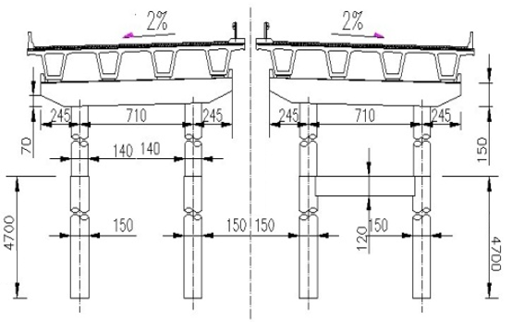

Figure 1. Schematic diagram of bridge pier and foundation

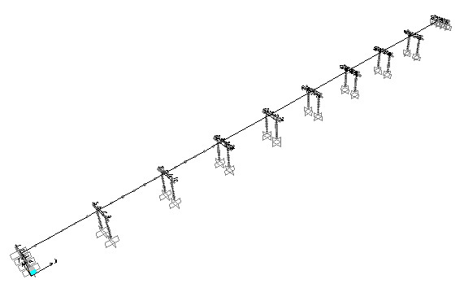

Figure 2. Finite element model

3. Ground motion

In order to clearly analyze the sensitivity of seismic response to bearing parameters, the following three typical far-field long-period ground motions are selected as the excitation ground motions in this paper. The basic information of the excitation is shown in table 1. The ground motions are input along the longitudinal bridge and the transverse bridge, respectively. In addition, the constant load effect is also taken into consideration.

Table 1. Time domain information for three ground motions

Ground motion | Predominant period | Distance | PGA
ILA048 | 2.169 | 100.53 | 0.090
ILA056 | 5.291 | 103.69 | 0.078
ILA004 | 4.808 | 110.68 | 0.078

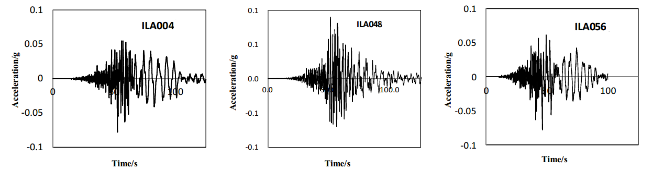

Figure 3. Acceleration time history curve of three ground motion (g)

4. Sensitivity analysis of bridge seismic response to bearing parameters

The bearing shear deformation, the shearing force at column bottom and the displacement of pier top have a high relation with the ground excitation, which are considered as the control parameters of seismic response of the bridge. Sensitivity analysis of bridge seismic response to bearing parameters, including F_{y} K_{u}, K_{d} and alpha, were conducted according to the highway bridges lead isolation rubber bearing (JT/T 822-2011) regulation. The value ranges of F_{y}, K_{u} and α are listed in Table 2.

Table 2. The value of parameter

parameters | Value
Yield point F_{y} (×10⁵N) | 0.5 | 1.0 | 1.5 | 2.0 | 2.5 | 3.0
Initial stiffness K_{u} (×10⁷N/m) | 0.9 | 1.3 | 1.8 | 2.15 | 2.5 | 3.0
Hardening ratio α | 0.08 | 0.15 | 0.25 | 0.32 | 0.4 | 0.5

The horizontal equivalent stiffness of the lead-core rubber bearing can be calculated by Equation 1:

(1)

Where F_{y} is the yield force, T_{r} is the total thickness of internal rubber, γ is the shear strain, and K_{d} is the post-yield stiffness. Table 3 lists the horizontal equivalent stiffness of bearings with different values of parameters.

Table 3. Parameter cases of effective horizontal stiffness

Parameter cases | ① | ② | ③ | ④ | ⑤ | ⑥ | ⑦ | ⑧
Yield point F_{y} (×10⁵N) | 1.0 | 1.5 | 2.0 | 1.5 | 1.5 | 1.5 | 1.5 | 0.5
Initial stiffness K_{u} (×10⁷ N/m) | 1.3 | 1.3 | 1.3 | 0.9 | 2.15 | 1.3 | 1.3 | 1.3
Hardening ratio α | 0.15 | 0.15 | 0.15 | 0.15 | 0.15 | 0.08 | 0.32 | 0.15
Effective horizontal Stiffness(×10⁶ N/m) | 2.62 | 2.95 | 3.28 | 2.35 | 4.23 | 2.04 | 5.16 | 2.28
Parameter cases | ⑨ | ⑩ | ⑪ | ⑫ | ⑬ | ⑭ | ⑮ | ⑯
Yield point F_{y} (×10⁵N) | 2.5 | 3 | 1.5 | 1.5 | 1.5 | 1.5 | 1.5 | 1.5
Initial stiffness K_{u} (×10⁷ N/m) | 1.3 | 1.3 | 1.8 | 2.5 | 3 | 1.3 | 1.3 | 1.3
Hardening ratio α | 0.15 | 0.15 | 0.15 | 0.15 | 0.15 | 0.25 | 0.4 | 0.5
Effective horizontal Stiffness(×10⁶ N/m) | 3.62 | 3.95 | 3.70 | 4.75 | 1.45 | 4.25 | 6.20 | 7.50

4.1. Sensitivity of seismic response of bridge to bearing yield force F_{y}

Figure 4 and Figure 5 present the seismic response of bridge with different F_{y}. It can be seen from Figure 4, as the value of F_{y} increases gradually, the longitudinal seismic response decreased sharply first and then stabilized. And the degree of the influence of input ground motion is more and more small. An appropriate yield strength value about 2.0E+05 N is provided, which can give small seismic response.

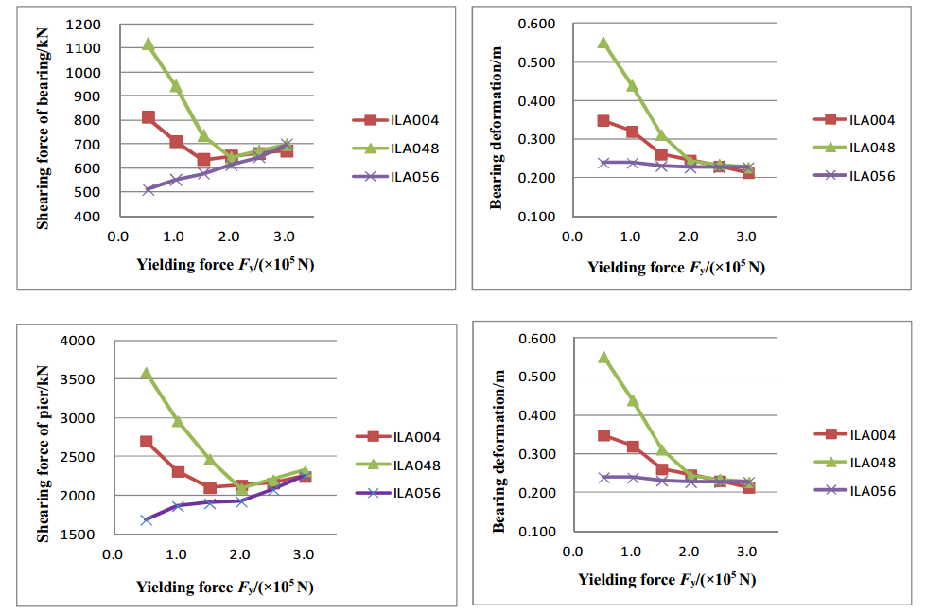

Figure 4. The sensibility of the bridge responses to yield under the longitudinal excitation

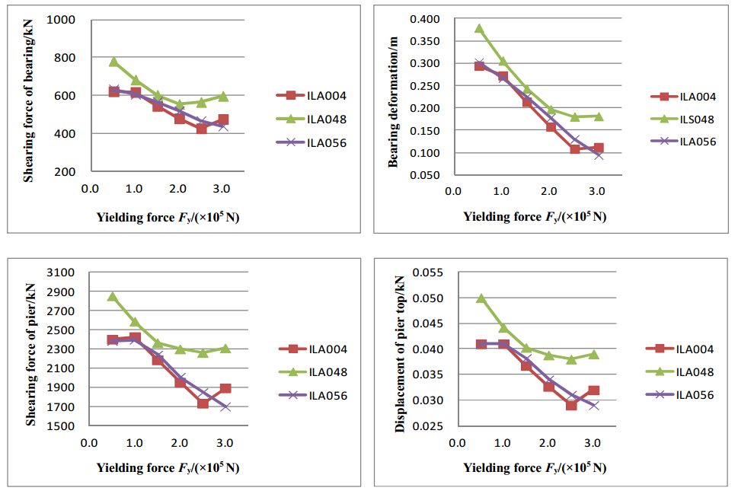
Figure 5. The sensibility of the bridge responses to yield under the transverse excitation
As can be seen from Figure 5, as the gradual increase of F_{y}, the transverse seismic response first decreases and then increases. Moreover, when F_{y} is greater than 2.5E+05 N, the variation degree of the ground motion response is very small.

4.2. Sensitivity of seismic response of Bridges to Ku stiffness before buckling

Figure 6 and Figure 7 present the curve of seismic response with K_{u} under the action of longitudinal bridge and transverse bridge, respectively.

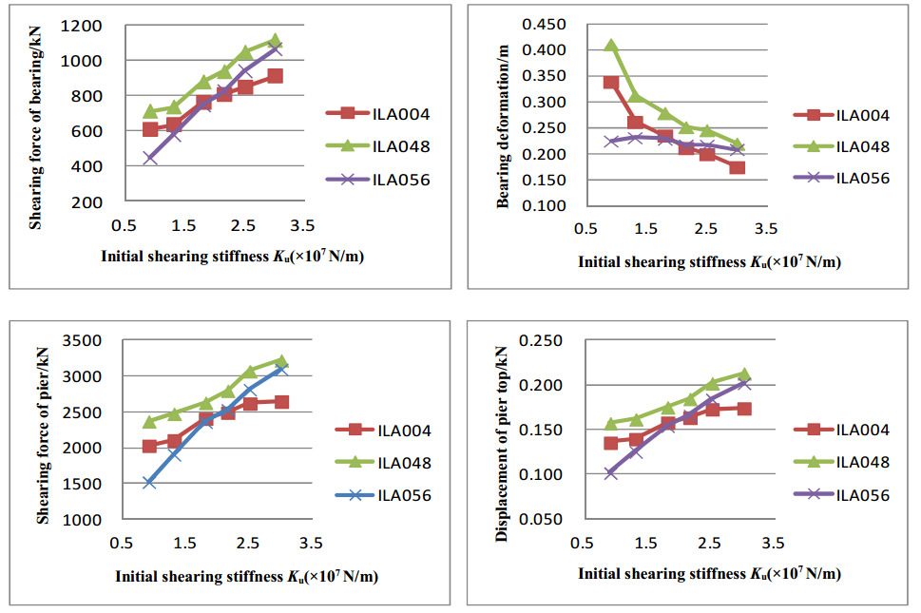

Figure 6. The sensibility of the bridge responses to front stiffness under the longitudinal excitation

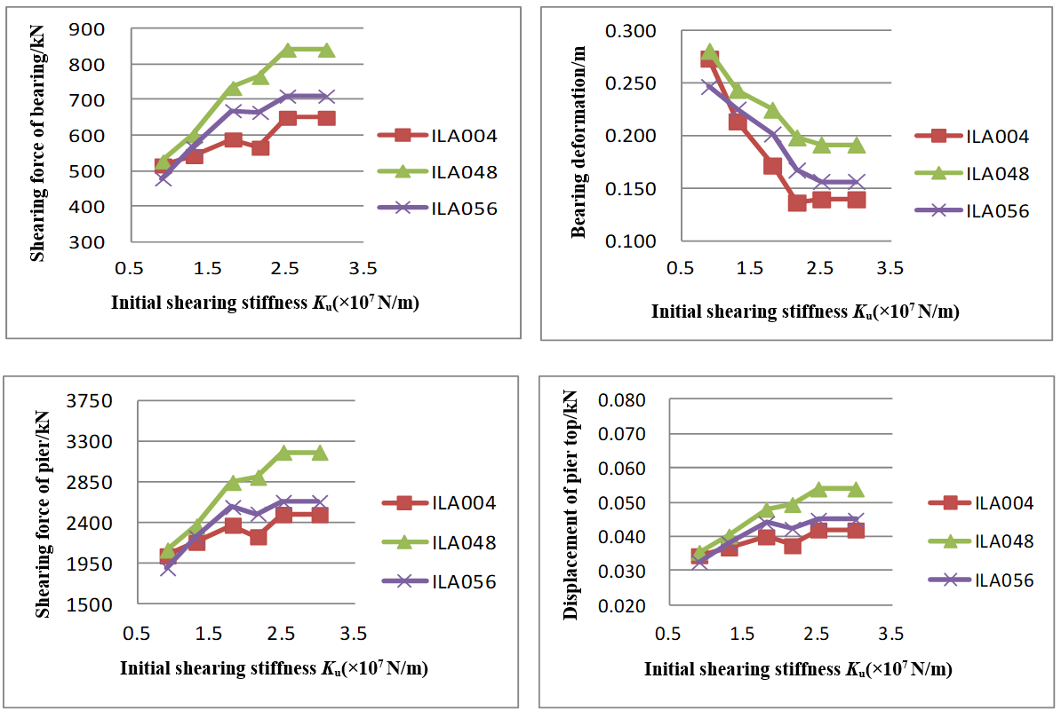

Figure 7. The sensibility of the bridge responses to front stiffness under the transverse excitation

It can be seen from Figure 6 and Figure 7, as the increase of K_{u}, the shear force at the bottom of the pier and the displacement at the top of the pier both increase gradually. The deformation of the abutment gradually decreases, and the energy consumption of the abutment decreases. Therefore, under the premise of meeting the stiffness requirements of the bridge in normal operation, a smaller the K_{u} value can give a smaller seismic response.

4.3. Sensitivity of seismic response of Bridges to bearing hardening ratio α

Figure 8 and Figure 9 show the variation curves of the seismic response with hardening ratio under the longitudinal and transverse earthquakes respectively.

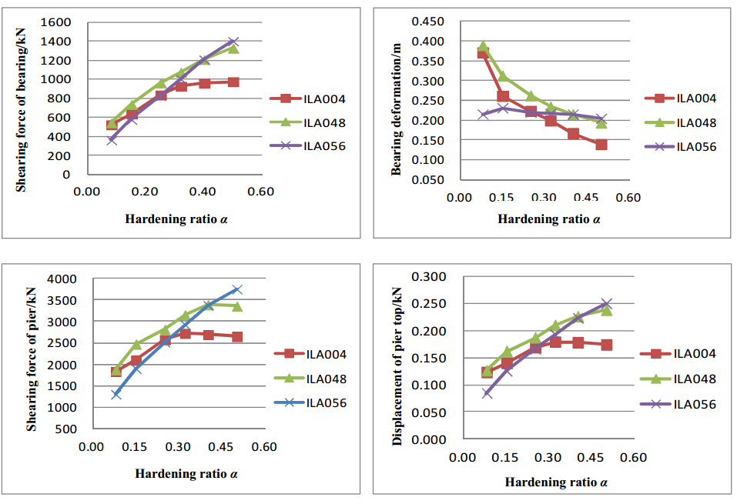

Figure 8. The sensibility of the bridge responses to hardening ratio under the longitudinal excitation

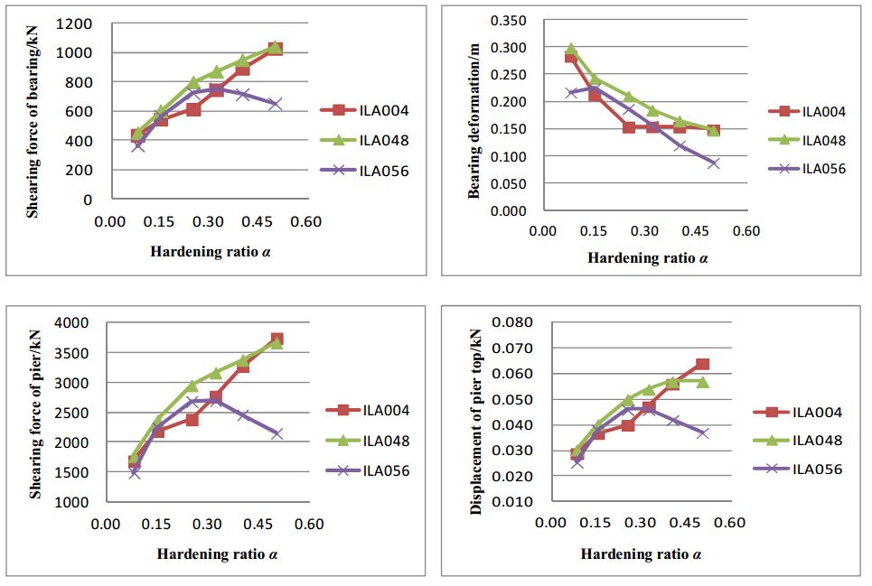

Figure 9. The sensibility of the bridge responses to hardening ratio under the transverse excitation

As can be seen from Figure 8 and Figure 9, the change of hardening ratio significantly changes the seismic response of the bridge. As the hardening ratio increases, the shear force at the bottom of the pier and the displacement at the top of the pier increase gradually, while the deformation of the abutment decreases gradually and the energy consumption of the abutment decreases.

4.4. Sensitivity of seismic response of Bridges to effective horizontal stiffness of supports

Effective stiffness of the bearing is also a main indicator reflecting the bearing performance. The relationship between the effective stiffness and seismic response were plotted in Figure .10 and Figure .11. The bearing effective stiffness in 2.0E+06 N/m ~ 4.0E+06 N/m gives a smaller seismic response. The relation between levels of equivalent stiffness within the scope of bearing parameters was shown in table 4. A suggested value was provided in the following, effective stiffness between 2.0E+06 N/m ~ 4.0E+06 N/m value, before bending stiffness K_{u} with 1.3E+07 N/m, yield F_{y} with 1.0 ~ 3.0E+05 N, hardening ratio α 0.15.

Table 4. Three kinds of effective stiffness parameter cases

Parameter cases | ① | ③ | ⑩
Yield point F_{y} (×10⁵ N) | 1.0 | 2.0 | 3
Bending stiffness K_{u} (×10⁷ N/m) | 1.3 | 1.3 | 1.3
Hardening ratio α | 0.15 | 0.15 | 0.15
Horizontal effective stiffness(×10⁶ N/m) | 2.62 | 3.28 | 3.95

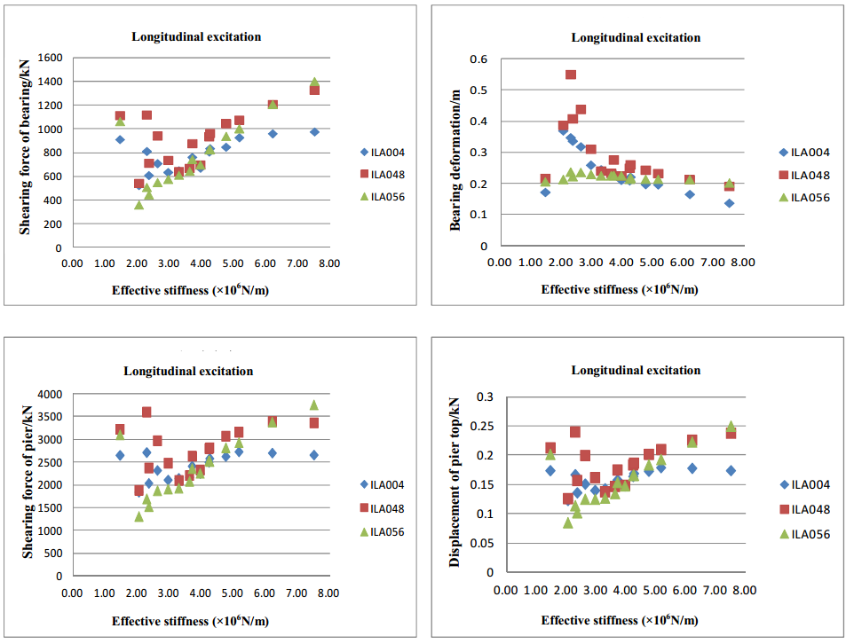

Figure 10. The sensibility of the longitudinal bridge responses to effective stiffness
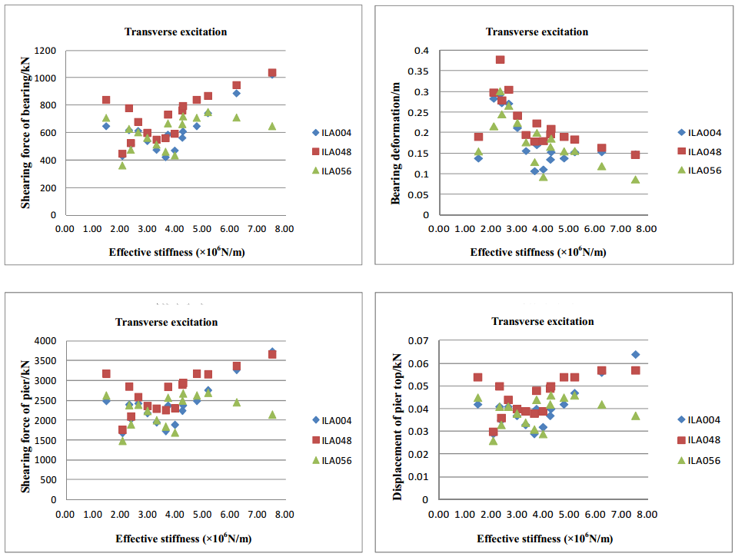

Figure 11. The sensibility of the transverse bridge responses to effective stiffness

5. Conclusions

(1) With the increase of the yielding force of the bearing, the longitudinal seismic response of the bridge is gradually reduced, tending to be stable, and the influence of the input ground motion is getting smaller and smaller, and finally tends to be consistent; The seismic response decreases first and then increases, and with small change under the ground motion response when the yield force is greater than 2.5E+05 N. The yield force is preferably from 2.0E+05 N to 2.5E+05 N.
(2) With the increase of pre-yield stiffness and hardening ratio, the seismic response of the bridge increases, the deformation of the bearing decreases, the energy consumption of the bearing decreases, and the overall seismic isolation effect decreases. Furthermore, the seismic response of the bridge is sensitive to the change of hardening ratio. These two parameters are recommended to take small values as far as possible under normal conditions.
(3) The shearing force of the LRB, the shearing force of the pier bottom and the displacement of the pier top are firstly decreased and then increased with the increase of the horizontal effective stiffness of LRB. The deformation of the LRB decreases with the increase of the horizontal effective stiffness. The energy consumption is reduced, and the seismic response is small when the horizontal effective stiffness is set from 2.0E+06 N/m to 4.0E+06 N/m.
(4) For bridges in similar structural form in the supporting project, when the pre-yield stiffness K_{u} is 1.3E+07 N/m, the yielding force F_{y} is between 1.0E+05 N and 3.0E+05 N, and the hardening ratio is between 0.08 and 0.15, LRB will have a good performance and the seismic response of the bridge is small. These values can be selected as the optimal LRB parameters.

6. AcKNowledgments

The authors are grateful for the support by the National Natural Science Foundation of China (Grant No. 51108234), the Natural Science Foundation of Jiangsu Province (Grant No. BK2011803) and the National Natural Science Foundation of China (Grant No. 51178258).

7. References

Beck J. L., Hall J. F. (1986) Factors contributing to the catastrophe in Mexico City during the earthquake of September. Geophys Res Lett, (13): 593-596.
Boore D. M. (2001) Comparisons of ground motions from the 1999 Chi-Chi earthquake with empirical predictions largely based on data from California. Bull Seism Soc Amer, (91): 1212-1217.
Cai Y, Xing Y, Hu D. (2008) On sensitivity analysis. Journal of Beijing Normal University (Natural Science), (44): 9-16. (in Chinese)
Celebi M, Prince J, Dietal C et al. (1987) The culprit in Mexico City-amplification of motions. Earthquake Spectra, (3): 315-328.
Fukuwa N. (2008) Key parameters governing the dynamic response of long-period structures. J Seism, (12): 295-306．
Koketsu K, Hatayama K et al. (2005) Damaging long-period ground motions from the 2003 MW8.3 Tokachi-oki Japan earthquake. Seism Res Lett, (76): 67-73.
Liu X. (2018) Study on unfavorable seismic behavior of the isolated structure under long-period earthquake and controlling research. Ph. D Dissertation of Xi’an Technological University. (in Chinese)
Maeda T, Sasatani T. (2008) Long-period ground motions from the 2003 Tokachioki earthquake. J Seismol, (12): 243-253.
Sun Y, Chen T, Zhuo W et al. (2016) Study on seismic response characteristics of isolated continuous bridges under long-period ground motion. Engineering Mechanics, (33): 244-250. (in Chinese)
Wang S. (2017) Parameter characteristics and correlation of typical far-field long-period ground motions. Journal of Henan University of Urban construction, (26): 30-37. (in Chinese)
Wang Y, Du Y, Hu G et al. (2018) Seismic performance of base-isolated structures under far-field long-period ground motion based on seismic codes. China Earthquake Engineering Journal, (40): 219-224. (in Chinese)
Xu L, Yu H, Cao W et al. (2010) Evaluation of site dependence and methods for site analysis based on far-field ground motions from the Wenchuan earthquake. ACTA SEISMOLOGICAL SINICA, (32): 175-183. (in Chinese)
Zhou F, Cui H, Shigetaka ABE et al. (2012) Inspection report of the disaster of the east Japan earthquake by Sino-Japanese joint mission. Building Structure, (42): 1-20. (in Chinese)

Professor, College of Civil Engineering, Nanjing Tech University, Nanjing, China, lixuehongnj@163.com
Professor, College of Civil Engineering, Nanjing Tech University, Nanjing, China. njxuxiuli@163.com
Associate Professor, College of Civil Engineering, Nanjing Tech University, Nanjing, China. lizhijun@njtech.edu.cn
Ph. D student, College of Civil Engineering, Nanjing Tech University, Nanjing, China. colinering@126.com
Graduate student, College of Civil Engineering, Nanjing Tech University, Nanjing, China. 1305311349@qq.com

