A Multi-Directional Isolation System for Multi-Storey Buildings under Coupled Horizontal and Vertical Seismic Excitations

DOI 10.37153/2686-7974-2019-16-633-645

Mohammad Masoud POURMASOUD, James B.P LIM,
Iman HAJIRASOULIHA, Daniel MCCRUM, Alan R.L PARK

ABSTRACT

Seismic isolation systems have been widely used to protect the structural and nun-structural elements under severe earthquakes. While the efficiency of conventional seismic isolation systems in decoupling the superstructure from the horizontal ground motions has already been demonstrated, there is no practical methodology to decouple the vertical components of the ground motions, which are especially important in near-fault earthquakes. This study aims to develop the concept of a new Multi-Directional Seismic Isolation (MDSI) system to enhance the seismic performance of structures under coupled horizontal and vertical earthquake excitations. The efficiency of the proposed system is demonstrated by improving the seismic performance of a 5 and 12-storey buildings under vertical and horizontal strong earthquake excitations. It is shown that MDSI can reduce the maximum vertical and horizontal accelerations in the multi-storey buildings by up to 40% and 20%, respectively, by reducing the vertical stiffness of the isolation system. This can result in a significant reduction of damage to non-structural elements and contents.

Keywords: Seismic Isolation, Multi-Directional Seismic Isolation, Vertical Stiffness, Response Accelerations

1. Introduction

Seismic isolation has appeared as an efficient system that has become pervasive across the world through its desirable performance during the earthquake. This system has saved many buildings of being sustained per structural and non-structural damages during the major earthquakes (Warn et al. 2012). Observations from real ground motions enabled real world understanding of the behaviour and performance of different kinds of base isolation systems. It is estimated that until late 2013 more than 15,000 structures include of buildings, bridges, viaducts and industrial structures have been designed and built with seismic isolations (Martelli et al. 2014). An ideal base isolation separates the building from the ground shaking and afford a gentle lateral movement for superstructure without inducing to ductile behaviour (Miranda et al. 2012). The relatively low horizontal stiffness of base isolation entails large period of superstructure that alongside with the substantial damping of the system mitigates the responses acceleration throughout the structure (William H Robinson; G. H McVerr, n.d.) (2001). Although exhaustive investigations have been completed on the performance of seismic base isolation and the isolation system can meet the majority of performance objectives, there is still no robust consensus on how to address vertical acceleration (Guzman Pujols and Ryan 2018). Seismic isolation systems, including elastomeric and frictional systems, have to comply with the stability requirements. Among them some clauses like control of stability under maximum axial load and concurrently maximum lateral displacement or control of maximum shear strain would be govern (ASCE 7-16 2016). This process will lead to a considerable size of base isolators that have a several thousand times larger vertical stiffness compared to their horizontal stiffness (Sasaki et al. 2012) (Furukawa et al. 2013). Shake table tests have shown that the vertical accelerations response under a tri-directional excitations can reach up to 5g and significantly affect the functionality of non-structural elements (Ryan et al. 2016) (Soroushian et al. 2016). In a conventional base isolated structures, horizontal accelerations are typically not greater than 0.25 to 0.35g, hence the vital factor that determines the functionality of building is the vertical acceleration component. In reality, once the vertical acceleration of floors exceeds 1g, building contents start to overturn (Furukawa et al. 2013). To date, a variety of concepts have been employed to equip different types of structures with three dimensional base isolation (Ersoy et al. 2001). Recent 3D excitation tests, on base isolated structures investigated the effect of vertical acceleration on the horizontal response of the multi-story buildings (Ryan Keri L. and Dao Nhan D. 2016). Floors acceleration spectra evaluation has demonstrated that while the horizontal input is constant, the horizontal response is magnified by increasing the vertical acceleration intensity, in particular for higher modes. Also, synchronization of vertical and horizontal accelerations entails substantial vibration in the floors of building structures (Guzman Pujols and Ryan 2018). The vertical vibration propagates along the height and depending on the dynamic properties of the slabs, the vibration can magnify several times. Hence, the vertical accelerations must be taken into account in the calculation of structures, in particular when the structure is placed in high-frequency zones.
Extensive attempts have been employed to mitigate the destructive consequences of horizontal-vertical coupling for base isolated structures (Unal and Warn 2014). (Warn Gordon P. and Vu Bach n.d.) Attempted to understand the vertical stiffness sensitivity of elastomeric seismic isolations to the Shape Factor of the bearing. They Analysed a 3 and 9 story tow dimensional isolated frames and realized that Low Shape Factor (LSF) is quite influential on vertical acceleration attenuation. Their results show that a shape factor (S) less than 5 and vertical damping greater than 10% mitigate the vertical acceleration escalation from the base to the roof. However, elastomeric seismic isolations that are used in multi-story structures typically have a shape factor higher than 15 as they are accompanied with large lateral displacement leading to a considerable diameter of rubber layers and consequently big shape factors.
The Vertical Distributed Flexibility (VDF), proposed by (Unal and Warn 2014) to implementation of laterally restrained column bearings at distinct levels of the seismic isolated structure to degrade the vertical accelerations along the height. Indeed the VDF idea is based on increasing and discretization of structural flexibility up the seismic isolation level. Although VDF entails to degraded vertical acceleration along the height, the employed restrained column bearings can jeopardize the idea because of economic issues.
Therefore, it is necessary to provide a base isolation system for multi-story building structural systems that can separate the vertical and horizontal isolation so that the maximum degradation of vertical stiffness can be achievable without affecting the horizontal characteristics of isolator. This paper develops the concept of a new Multi-Directional Seismic Isolation (MDSI) system to enhance the seismic performance of multi-story structures under coupled horizontal and vertical earthquake excitations by separating the vertical and horizontal specifications of the isolators in the way that the appropriate mechanical properties be achievable in each direction independently.

2. MDSI Conceptual Model

The Multi-Directional Seismic Isolation (MDSI) concept develops a seismic isolation system that despite having all features of a conventional base isolators in the horizontal direction, is able to damp and degrade the excitations in the vertical direction also.
The principle of MDSI is based on separating of vertical and horizontal behaviours. Conventional seismic isolators (elastomeric, lead rubber bearings, friction pendulums, cross linear bearings) accommodate lateral displacements of hundreds of millimetres during seismic events. When designing conventional seismic isolators, increasing the size of the isolator, increases the shape factor and subsequently magnifies the vertical stiffness. Indeed the vertical stiffness is directly relevant to effective compressive modulus of the rubber (E_{c}) and the reduced rubber area (A_{r}) and both of these parameters are relevant to the dimension of isolator. Shape factor and vertical stiffness define with following equations (EN 15129 2009), where B_{b} = bonded plan dimension of bearing, t_{i =} Rubber layer thickness, A_{b} and A_{pl} are the bonded area of rubber and the area of the lead core respectively. Also, E and k are the elastic modulus and the material constant of rubber.

$S_{i}=\frac{A_{b}-A_{pl}}{πB_{b}t_{i}}$ For lead rubber bearings (1)

$K_{vi}=\frac{E_{c}A_{r}}{t_{i}}$ (2)

The MDSI is designed to provide the vertical performance of the system in reducing ground accelerations being transferred into the isolated structure. The basic principle of the MDSI can be modelled as a vertical – damped spring.
In this system, a super high damp rubber layer is added to the seismic isolator and is designed in a way that causes low vertical stiffness along with high damping. The total vertical stiffness of the system under the lateral displacement comes from the vertical stiffness of high damp rubber layer which is invariably constant plus the vertical stiffness conventional isolator.

3. Mechanical Characteristics of MDSI

The vertical specification of a conventional lead rubber bearing which is for an existing 12 story steel structure (is explained in next section) is compared with the MDSI version of that isolator. The conventional bearing was constituting of 32 rubber layers with 950mm bonded diameter which are covered by 10mm side rubber layer. A 150mm diameter lead core has employed to provide the damping of the system in horizontal direction. The utilized rubber is from low damping natural rubbers with shear and elastic modulus equal to G=0.45 MPa and E=1.47 MPa respectively which leads to a rubber ultimate elongation about 600% and the rubber material constant k=0.84. Material properties are obtained from the Robinson Seismic Company (Skinner, Robinson, and McVerry 1993).
Table 1 shows the amounts of applied loads under gravity and seismic combination. Table 2 present the specification of the rubbers for the conventional isolator and the MDSI, respectively.

Table 1. Applied loads

P _{DL+0.5LL} (kN) | P _{1.2DL+LL} (kN) | P _{DL+LL+EQ} (kN)
3000 | 6000 | 12000

Table 2. LRB size and materials specifications

LRB Diameter (mm) | Number of rubber layers | Rubber layers thickness (mm) | G (MPa) | E (MPa) | E_{C} (MPa)  =E(1+2KS²) | Lateral displacement (mm)
970 | 32 | 10 | 0.45 | 1.47 | 1326 | 350

Table 3. Vertical specifications of a conventional and a MDSI system

 | K_{v0} (kN/mm) | K_{v-displace} (kN/mm) | Ɛ_{C,E} | P_{cr} (kN)
Conventional system | 1916 | 1039 | 2.9 | 25200
MDSI system | 443 | 371 | 6.9 | 29500

In this case as is shown in Table 3 the vertical stiffness under zero displacement and maximum displacement (350mm) results in a significant reduction from 1916 kN/mm to 443 kN/mm and from 1039 kN/mm to 370 kN/mm, respectively. Table 3, demonstrates that the vertical stiffness degraded dramatically by about 80%. Furthermore, the buckling load at zero displacement is almost same for both scenario means the MDSI system doesn’t affect the axial load capacity of seismic isolation. Indeed according to Eurocode (EN 15129 2009), the P_{cr} has a direct relationship with shear modulus, rubber diameter, and shape factor and inversely with rubber height. P_{cr} is the maximum vertical load at the displacement Δ. The following equation describes the P_{cr} where ƛ is equal 1.3 for square bearings and is equal 1.1 for circular bearings, A_{r} is reduced rubber area and T_{r} is total rubber thickness

$P_{cr}=\frac{ƛGA_{r}B_{b}S}{T_{r}}$ (3)

4. Numerical Study

4.1 2D and 3D excitation comparison

In order to investigate the effects of vertical excitations on the structural responses, a 3D frame model of a 12 story conventional base isolated structure was developed in SAP2000. SAP2000 has been used in several analyses of seismic isolated structures. (Cancellara and De Angelis 2016) (Gesualdi, Cardone, and Rosa 2018) (Cardone, Palermo, and Dolce 2010). In this case, the superstructure is incorporated of a 3D frame of a dual system with intermediate steel moment and steel concentrically braced frame which is derived on 16 lead rubber bearing, as shown in Figure 4. The 4m high typical floor plans are symmetric with 23m in longitudinal and 21m in latitudinal direction which are divided to 3 spans (Figure 1). The floors are constrained by the rigid diaphragm to consider the in-plane stiffness of the concrete slabs.
The building is located in a high seismic zone and is already designed and detailed based on the requirements of seismic codes (ASCE 7-16 2016). The columns were defined as hollow box sections varying from 540 mm × 540 mm to 430 mm × 430 mm along the height. While, the beams were made of built-up I-sections, mostly with 450mm depth, all of the beam-column connections are fixed. The concentric braces with 250mm width are employed to provide enough lateral stiffness and drift restriction. The 200 mm solid slab were designed to carry 2.7 kN/m² super dead load and 2.6 kN/m² live load, while the corresponding variable loads for roof level were considered 3.3 kN/m² and 5 kN/m² respectively. Also about 2 kN/m linear load were applied to the perimeter beams as the weight of the external walls. P-Delta effects were taken into account and the Rayleigh damping model with a constant damping ratio of 0.05 was assigned to the first mode and to the mode at with the cumulative mass participation exceeds 95%.
Figure 1 represents the plan, elevation and isolation level of structures.

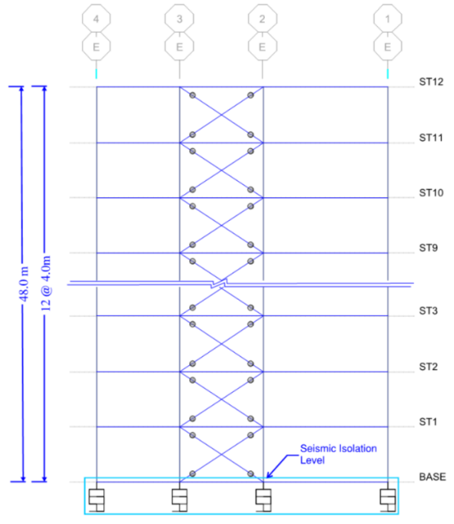 | 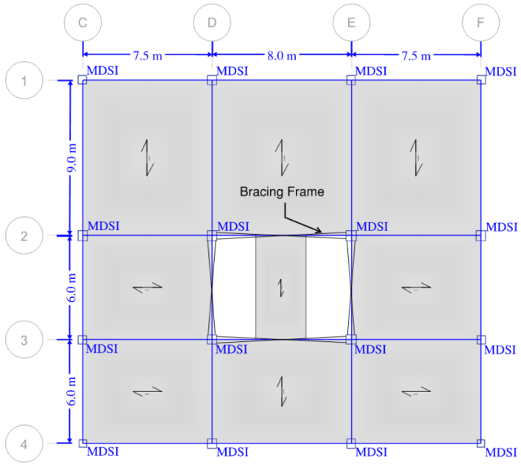
Figure 1. Plan and section of 12 story structure.

4.1.1 Base isolation system:

The base isolation system was composed of 16 conventional lead rubber bearings (LRB), one beneath each column. The isolator’s diameter is B=970mm with 32 single rubber layers (ti=10mm) encompassing a 150mm diameter lead core. The properties of the isolators were calculated to accommodate the maximum axial load with required lateral displacement. The preliminary design of 12 story structure revealed that the maximum axial load under the seismic load combination is approximately P=12,000kN. The 150mm diameter lead core provides the characteristic yield strength, Q_{d} = 152 kN at the yield displacement D_{y} = 20mm and entails more than 20% effective damping of base isolation system under maximum displacement. The rubber layers are chosen from the soft rubbers, G=0.45 MPa and cause the post-yield stiffness, K_{d} = 0.89 kN/mm. The base isolation system is designed to mobilize and reach the superstructure up to 350mm lateral displacement which is calculated to Maximum Considerable Earthquake (MCE). The measured seismic weight, W=48,000 kN, therefore the effective period of superstructure is T=3.0s. In the vertical direction the combination of rubber layers and shim plates entail the vertical stiffness K_{v} = 1916 kN/mm. The lateral displacement affects the vertical stiffness of conventional elastomeric bearings, increasing the horizontal movement and decreasing the vertical stiffness.

4.1.2 Isolation system modelling

The cyclic nonlinear behaviour of different kinds of base isolation systems are definable by the NLink elements of SAP2000_Nonlinear (Scheller and Constantinou 1999)(Scheller and Constantinou 1999). The linear properties include of initial effective stiffness (K1) and damping as well as the nonlinear properties include of secondary stiffness (K2), lead core yield strength (F_{y}) and the post-yield stiffness ration (r = K2/K1) are adjustable with the “Rubber Isolator Links”. Also the Force-Displacement diagram of isolators can be introduced to the software by “MultiLinear Plastic Links”. Figure 2 shows the bilinear behaviour of the employed lead rubber bearings.

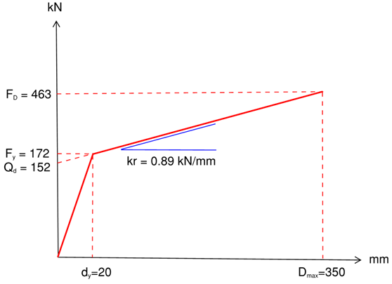

Figure 2. Nonlinear behaviour of seismic isolation devices.

4.1.3. Superstructure analysis

The desired response of a seismically isolated structure is to minimizing the distributed acceleration in the superstructure floors. The acceleration of stories is an indication of damage rate to the non-structural elements and appliances of stories (Ryan et al. 2016) (FEMA 2003).
A nonlinear time history analysis of the structure subject to bi-directional and tri-directional ground excitations was carried out in order to investigate the escalating effects of vertical accelerations on the dynamic behaviour of the structure. The structural elements were modelled with linear elastic frame elements while the base isolation system behave nonlinearly. Generally speaking, seismic isolation structures are designed so that the superstructure remains elastic (Zhang and Shu 2018).
In order to investigate the trend of acceleration responses, ten near field earthquake records (PEER reference) with large horizontal and vertical accelerations were selected (see Table 4) and applied to a 5 and 12 story structures. As shown in Table 4 half of the selected ground motions have peak vertical acceleration greater than 0.8g, 3 of them are between 0.8g and 0.5g and the rest are less than 0.5g.
Table 4. Specification of earthquake records

No. | Records | Station | Peak acceleration in H-direction (g) | Peak acceleration in V-direction (g) | Pulse period (s) | Magnitude
Eq.1 | Bam 2003 | Bam | 0.8 | 0.97 | 19 | 6.6
Eq.2 | Christchurch 2011 | Cashmere High school | 0.4 | 0.97 | 6.3 | 6.2
Eq.3 | Christchurch 2011 | Cathedral | 0.38 | 0.8 | 5.6 | 6.2
Eq.4 | Christchurch 2011 | Hospital | 0.35 | 0.6 | 7 | 6.2
Eq.5 | Chichi 1999 | TCU 065 | 0.82 | 0.27 | 5.7 | 7.6
Eq.6 | Kobe 1995 | JMA | 0.83 | 0.34 | 7.8 | 6.9
Eq.7 | Landers 1992 | Lucerne | 0.79 | 0.82 | 5.1 | 7.3
Eq.8 | Lomaprieta 1989 | Saratoga | 0.52 | 0.38 | 4.5 | 6.9
Eq.9 | Northridge 1994 | Rinaldi | 0.87 | 0.96 | 3 | 6.7
Eq.10 | Northridge 1994 | Sylmar | 0.84 | 0.53 | 3.1 | 6.7

In this study, an attempt was made to investigate the influence of the vertical component of excitation on the amplification of horizontal and vertical responses. Ground excitations were applied in the analysis in the two horizontal directions (2D excitation) and then separately in both horizontal and vertical directions (3D excitation). As seen in Table 4, half of the excitations have a peak ground acceleration (pga) greater than 0.8g in vertical direction, So their coupling with horizontal motions are vital to be considered. The excitations in all directions are unscaled. The floors acceleration responses in the horizontal and vertical directions for 2D and 3D excitations are drawn in Figure 3 for the 12-story structure. As expected, the 3D excitation magnifies the vertical accelerations significantly in comparison with the 2D excitation. The maximum amplification was observed on the Landers earthquake, the vertical acceleration is amplified by about 5 times. But what is notable is that considering the vertical component of the earthquake, influences the horizontal responses severely as well, as it can be magnified more than twice. In Bam earthquake, accompany of horizontal and vertical excitations were led to a magnification range from 1.5 to 2.1 in horizontal direction. The distributed accelerations clearly represent that ignoring the vertical acceleration can terminate to underestimated assumptions and unsafe structural design in particulate for the near field zones.

Horizontal Accelerations | Vertical Accelerations
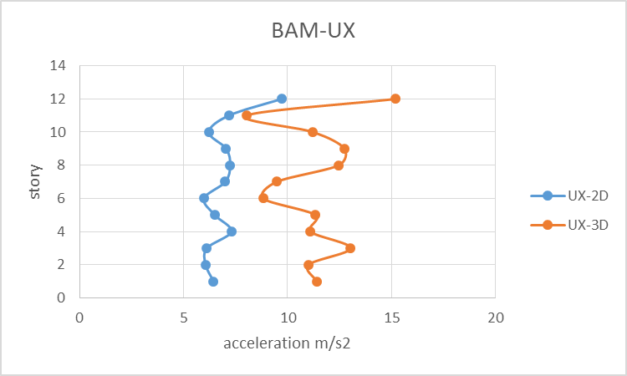 | 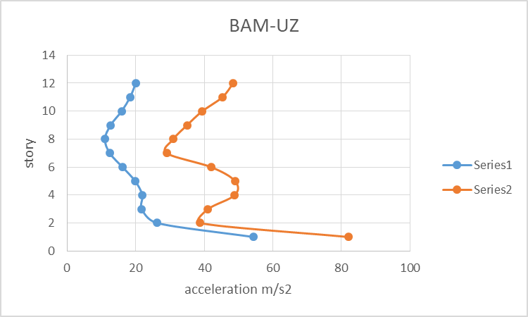
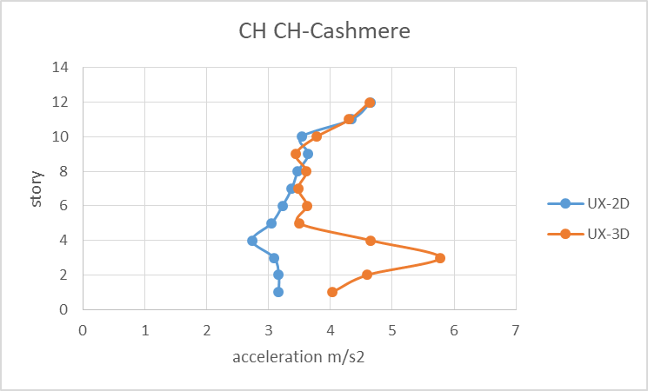 | 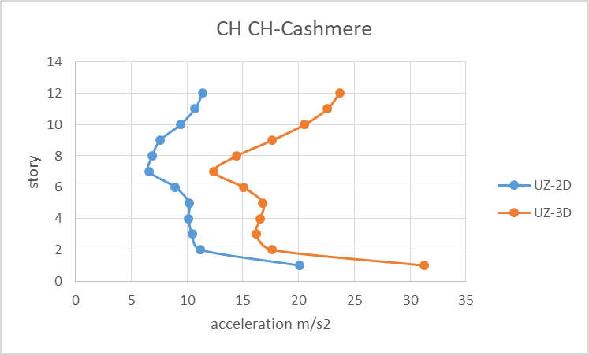
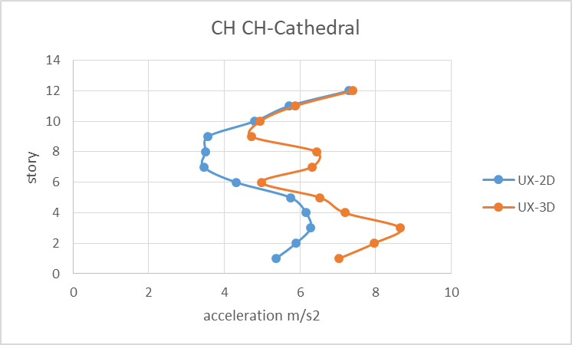 | 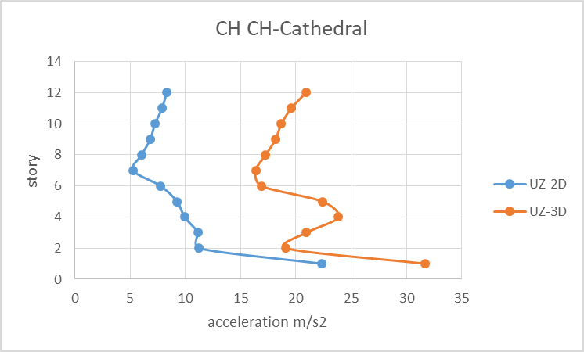
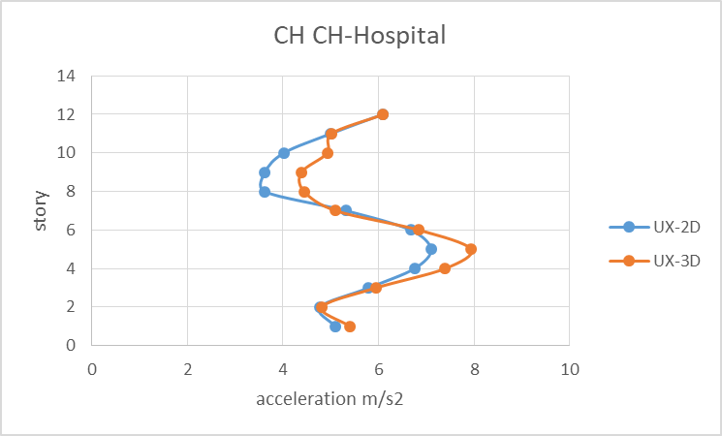 | 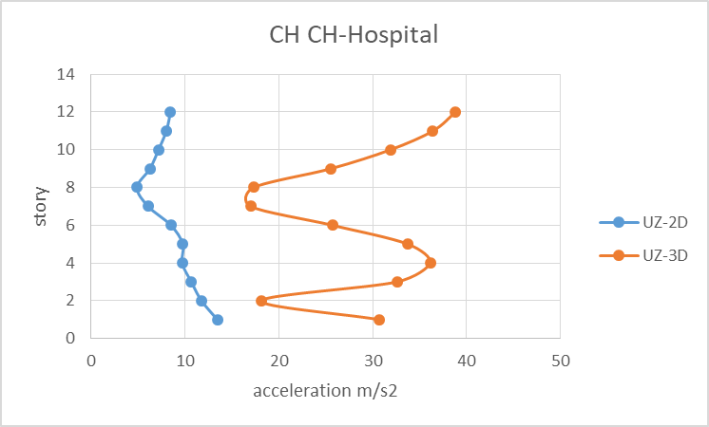

Figure 3. Comparison between 2D and 3D excitation – Left side, horizontal direction – Right side,
vertical direction-12 story structure.

4.2. Variation of vertical stiffness

In this section, the sensitivity of acceleration responses in horizontal and vertical directions to changes in base isolation vertical stiffness is investigated. To this end, a 5 story structure along with the 12 story structure explained in previous section developed. It is aimed to investigate the effect of vertical stiffness degradation on the vertical acceleration distributed along the height of each super-structures.
For each structure, without changing the horizontal properties of isolators, the vertical stiffness of isolator’s link is varied from 1.0Kv (which is hereafter referred to as initial state) to (0.75, 0.50, 0.25 and 1.25)*K_{v}. A value of 1.0*Kv is an unchanged vertical stiffness from the designed conventional base isolation. The values of (0.75, 0.50, 0.25)*K_{v} present the reduction factors in vertical stiffness of isolator. The value of 1.25Kv is also considered to compare the effect of stiffness increasing by the way.
Figure Figure 4 represents the trend of changes in vertical stiffness on the vertical acceleration distribution along the height of 5 story structure. The Figure demonstrates the general response of structure to vertical stiffness change of isolators. As it’s shown, the gradual degradation of vertical stiffness has improved the isolator’s behaviour along the height. The depicted distribution of accelerations for 12 story structure shown similar tendency likewise, although are not included in this paper.

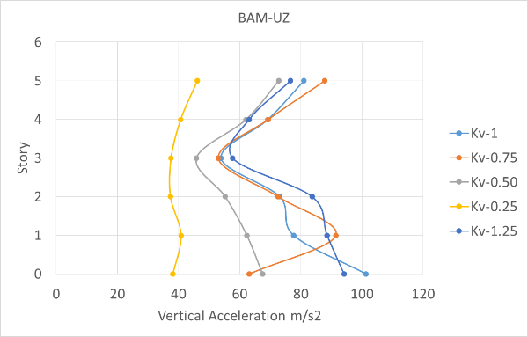 | 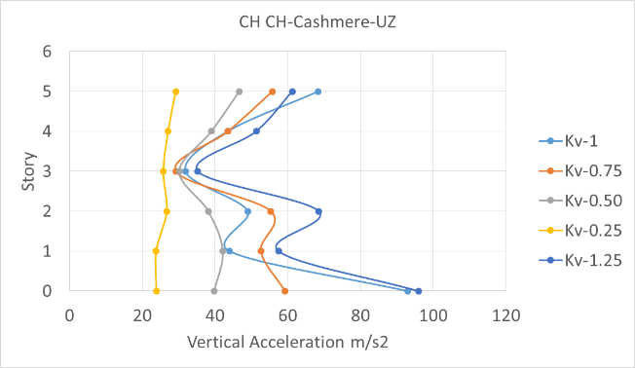
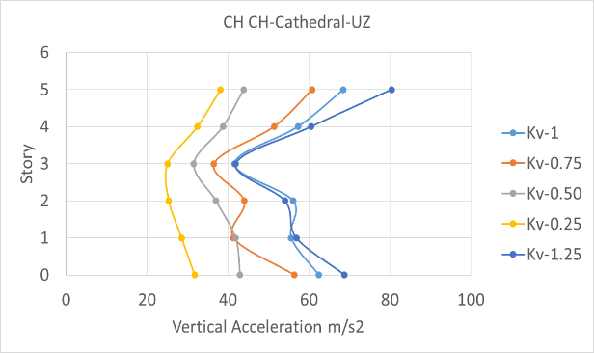 | 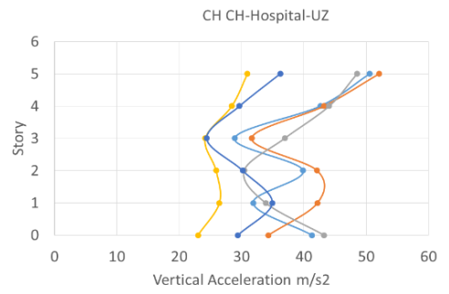
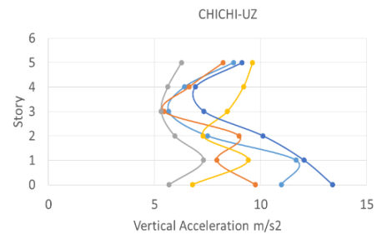 | 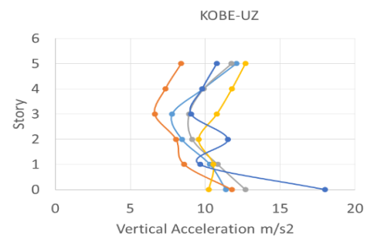
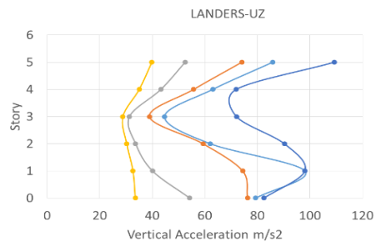 | 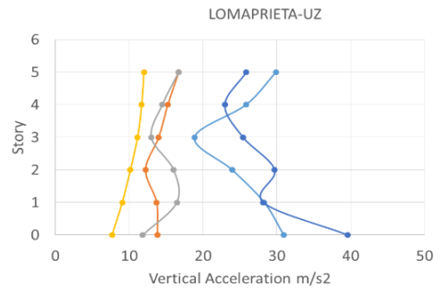
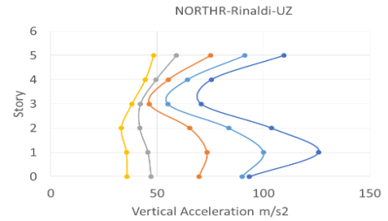 | 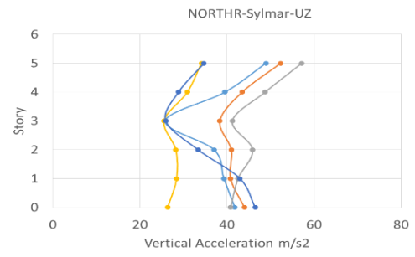
Kv-1 Kv-0.75 Kv-0.50 Kv-0.25 Kv-1.25

Figure 4. The effect of vertical stiffness degradation on vertical acceleration responses for 5 story structure.

Figure 4 demonstrates that the vertical stiffness degradation is quite effective in attenuating of acceleration in superstructure stories. For further insight, the maximum story acceleration of each vertical stiffness (Kv-0.25 to Kv-1.25) is separately divided to the maximum story acceleration of initial state. This procedure was repeated for all 3 directions. The output ratio demonstrates how the H-V coupling behaviour, responses to the vertical stiffness degradation and in each stage of vertical stiffness degradation, how many percentage the maximum acceleration of the structures are attenuated.
Table 5 and Table 6, represent the maximum acceleration reduction ratio for 5 story structure in vertical and horizontal directions. According to the tables the maximum acceleration ratios for both structure is dropped to 60% and less than 80% in vertical and horizontal directions respectively. Indeed by degradation of vertical stiffness of isolators, about 40% and 20% of accelerations in vertical and horizontal directions are attenuated.

Table 5. The ratio of maximum vertical accelerations of variable vertical stiffness’s (Kv-0.25 to Kv-1) over initial vertical stiffness (Kv-1) for 5 story structure.

 | Vertical Direction - 5 story
 | BAM | CH CH Cashmere | CH CH Cathedral | CH CH Hospital | Chi Chi | Kobe | Landers | Lomaprieta | Northridge Rinaldi | Northridge Sylmar | average
Kv-1.25 | 102% | 105% | 128% | 104% | 87% | 87% | 122% | 130% | 120% | 103% | 109%
Kv-1.0 | 100% | 100% | 100% | 100% | 100% | 100% | 100% | 100% | 100% | 100% | 100%
Kv-0.75 | 97% | 86% | 91% | 86% | 80% | 84% | 77% | 69% | 77% | 101% | 85%
Kv-0.50 | 105% | 61% | 78% | 85% | 68% | 73% | 66% | 51% | 78% | 91% | 76%
Kv-0.25 | 57% | 46% | 60% | 78% | 81% | 79% | 47% | 40% | 68% | 45% | 60%

Table 6. The ratio of maximum horizontal accelerations of variable vertical stiffness’s (Kv-0.25 to Kv-1) over initial vertical stiffness (Kv-1) for 5 story structure.

 | Horizontal Direction - 5 story
 | BAM | CH CH Cashmere | CH CH Cathedral | CH CH Hospital | Chi Chi | Kobe | Landers | Lomaprieta | Northridge Rinaldi | Northridge Sylmar | average
Kv-1.25 | 109% | 93% | 103% | 88% | 103% | 107% | 108% | 105% | 95% | 116% | 103%
Kv-1.0 | 100% | 100% | 100% | 100% | 100% | 100% | 100% | 100% | 100% | 100% | 100%
Kv-0.75 | 94% | 82% | 103% | 92% | 99% | 105% | 64% | 92% | 101% | 98% | 93%
Kv-0.50 | 87% | 85% | 85% | 89% | 103% | 102% | 44% | 84% | 102% | 95% | 88%
Kv-0.25 | 79% | 75% | 66% | 65% | 93% | 96% | 32% | 71% | 81% | 75% | 73%

It is notable that the major reduction ratios occur for the records like Bam, Christchurch, Landers and Northridge which are suffered from significant peak vertical accelerations. The average of accelerations on the last column of the tables demonstrate the general trend of responding the distributed acceleration to vertical stiffness degradations, as the vertical stiffness decreases the acceleration responses do, too.
Also in order to wrap up a general conclusion, the average of maximum ratios originated from all ten records are reflected in Figure 5. These Figures generally stipulate that averagely for 5 story building up to 40% and more 20% acceleration attenuation in vertical and horizontal respectively are achievable.
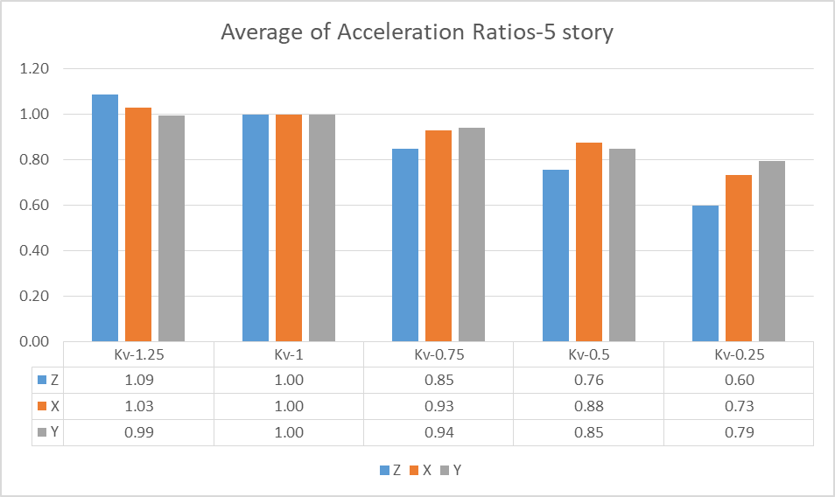

Figure 5. Average of maximum acceleration ratios-5 story building.

For the 12 story structure, similar to what already observed, for the records with high vertical peak acceleration like Bam, Christchurch Landers and Northridge the maximum degradation ratio was obtained.
Table 7 and Table 8, represent the maximum story acceleration of each ensemble of vertical stiffness (Kv-0.25 to Kv-1.25) divided to the maximum story acceleration of the initial state. This ratio describes by degrading the vertical stiffness of base isolation system, how many percentage discount can be achievable for the maximum acceleration of superstructure in each direction. The first row of the tables show that the stiffening of isolators vertically will escalate the vertical acceleration and have negligible effect on the horizontal accelerations. The second row is invariably 100%, as the initial state (Kv-1) was assumed the basis of comparison. The lower rows prove that except some rare cases the lowest vertical stiffnesses caused the maximum attenuation for all ground motions.

Table 7. The ratio of maximum vertical accelerations of variable vertical stiffness’s (Kv-0.25 to Kv-1) over initial vertical stiffness (Kv-1) for 12 story structure.

 | Vertical Direction - 12 story
 | BAM | CH CH Cashmere | CH CH Cathedral | CH CH Hospital | Chi Chi | Kobe | Landers | Lomaprieta | Northridge Rinaldi | Northridge Sylmar | Average
Kv-1.25 | 131% | 105% | 113% | 64% | 91% | 117% | 126% | 104% | 108% | 71% | 103%
Kv-1.0 | 100% | 100% | 100% | 100% | 100% | 100% | 100% | 100% | 100% | 100% | 100%
Kv-0.75 | 84% | 110% | 87% | 67% | 80% | 113% | 72% | 126% | 114% | 89% | 94%
Kv-0.50 | 83% | 88% | 77% | 62% | 91% | 93% | 65% | 83% | 83% | 58% | 78%
Kv-0.25 | 68% | 90% | 54% | 30% | 56% | 86% | 43% | 47% | 82% | 55% | 61%

Table 8. The ratio of maximum horizontal accelerations of variable vertical stiffness’s (Kv-0.25 to Kv-1) over initial vertical stiffness (Kv-1) for 12 story structure.

 | Horizontal Direction - 12 story
 | BAM | CH CH Cashmere | CH CH Cathedral | CH CH Hospital | Chi Chi | Kobe | Landers | Lomaprieta | Northridge Rinaldi | Northridge Sylmar | Average
Kv-1.25 | 102% | 102% | 113% | 103% | 101% | 106% | 99% | 106% | 100% | 103% | 104%
Kv-1.0 | 100% | 100% | 100% | 100% | 100% | 100% | 100% | 100% | 100% | 100% | 100%
Kv-0.75 | 93% | 104% | 96% | 102% | 106% | 101% | 99% | 98% | 94% | 94% | 99%
Kv-0.50 | 72% | 94% | 89% | 102% | 107% | 101% | 106% | 94% | 86% | 87% | 94%
Kv-0.25 | 48% | 77% | 75% | 94% | 101% | 104% | 127% | 97% | 78% | 97% | 90%
Figure 6 presents the general results from vertical stiffness degradation of the 12 story structure. The Figures exposes the average of maximum response accelerations over the initial state for each ensemble of vertical stiffnesses. The intent of this diagram is to find out the overall acceleration attenuation by decreasing or increasing of vertical stiffness. Among all ensembles, the maximum stiffness degradation (Kv-0.25) is demonstrating that the vertical and horizontal accelerations are attenuated to 60% and 90% of initial state respectively. On the contrary, 25% vertical stiffening, intensifies the maximum vertical acceleration more than 15%.

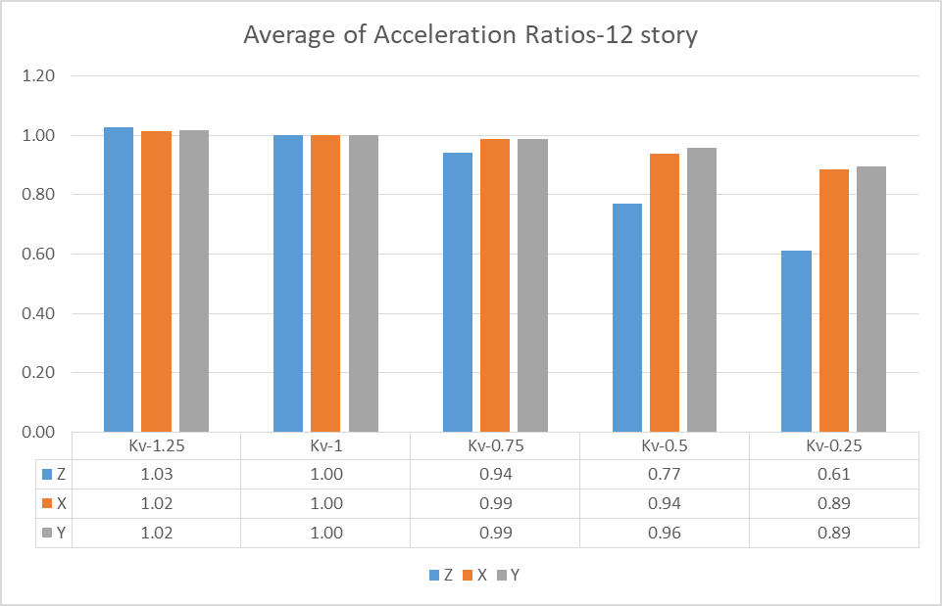

Figure 6. Average of maximum acceleration ratios-12 story building.

5. Conclusion

This paper presents a numerical development of a Multi-Directional Seismic Isolation (MDSI) system that attenuates the vertical accelerations response as well as horizontal responses. Analytical investigations with ten near field records were employed for a 5 and 12 story structure. The acceleration responses of horizontal excitation were compared with H-V coupling results. Also, the vertical stiffness gradually decreased and the effects on lateral and vertical responses were investigated. The major results obtained from this paper are as follow:
1. The MDSI concept can carry high levels of seismic axial loads as well as conventional seismic isolation, but unlike the conventional isolators, the horizontal requirements don’t affect the vertical specifications in MDSI system.
2. The 3D excitation magnified the vertical acceleration responses up to 5 times rather than 2D excitation. Also the effect of H-V coupling significantly intensified the lateral responses up to 2. So disregarding of vertical component of the earthquake might be ended to an underestimated and unsafe design, in particulate in near fields.
3. The parametric investigation demonstrates the vertical stiffness under zero displacement was degraded from 1916 kN/mm to 443 kN/mm which is about 80% attenuation in vertical stiffness. Also, however, MDSI has much less vertical stiffness in comparison with conventional isolators, but their buckling load capacity (Pcr) is almost same.
4. For both structures, the vertical stiffness degradation were led to about 40% vertical acceleration attenuation. Also the horizontal accelerations experience about 20% and 10% reduction in 5 and 12 story structures respectively.

6. Acknowledgements

Special thanks to those have assisted to this research, in particular the technical support from Low Damage Design Co.

7. References

ASCE 7-16. 2016. Minimum Design Loads and Associated Criteria for Buildings and Other Structures. LCCN 20170182751. American Society of Civil Engineers.
Cancellara, Donato, and Fabio De Angelis. 2016. “Nonlinear Dynamic Analysis for Multi-Storey RC Structures with Hybrid Base Isolation Systems in Presence of Bi-Directional Ground Motions.” Composite Structures 154 (October): 464–92. https://doi.org/10.1016/j.compstruct.2016.07.030.
Cardone, D., G. Palermo, and M. Dolce. 2010. “Direct Displacement-Based Design of Buildings with Different Seismic Isolation Systems.” Journal of Earthquake Engineering 14 (2): 163–91. https://doi.org/10.1080/13632460903086036.
EN 15129. 2009. European Standard on Anti-Seismic Devicies.
Ersoy, Selahattin, M. Ala Saadeghvaziri, Gee-Yu Liu, and S. T. Mau. 2001. “Analytical and Experimental Seismic Studies of Transformers Isolated with Friction Pendulum System and Design Aspects.” Earthquake Spectra 17 (4): 569–95. https://doi.org/10.1193/1.1423653.
FEMA. 2003. “Multi-Hazard Loss Estimation Methodology - Earthquake Model. HAZUS-MH MR4 Technicl Manual, Federal Emergency Management Agency, Washangton.” In .
Furukawa, Sachi, Eiji Sato, Yundong Shi, Tracy Becker, and Masayoshi Nakashima. 2013. “Full-Scale Shaking Table Test of a Base-Isolated Medical Facility Subjected to Vertical Motions.” Earthquake Engineering & Structural Dynamics 42 (13): 1931–49. https://doi.org/10.1002/eqe.2305.
Gesualdi, Giuseppe, Donatello Cardone, and Giuseppe Rosa. 2018. “Finite Element Model Updating of Base-Isolated Buildings Using Experimental Results of in-Situ Tests.” Soil Dynamics and Earthquake Engineering, February. https://doi.org/10.1016/j.soildyn.2018.02.003.
Guzman Pujols, Jean C., and Keri L. Ryan. 2018. “Computational Simulation of Slab Vibration and Horizontal-Vertical Coupling in a Full-Scale Test Bed Subjected to 3D Shaking at E-Defense.” Earthquake Engineering & Structural Dynamics 47 (2): 438–59. https://doi.org/10.1002/eqe.2973.
Martelli, Alessandro, Paolo Clemente, Alessandro De Stefano, Massimo Forni, and Antonello Salvatori. 2014. “Recent Development and Application of Seismic Isolation and Energy Dissipation and Conditions for Their Correct Use.” In Perspectives on European Earthquake Engineering and Seismology, 449–88. Geotechnical, Geological and Earthquake Engineering. Springer, Cham. https://doi.org/10.1007/978-3-319-07118-3_14.
Miranda, Eduardo, Gilberto Mosqueda, Rodrigo Retamales, and Gokhan Pekcan. 2012. “Performance of Nonstructural Components during the 27 February 2010 Chile Earthquake.” Earthquake Spectra 28 (S1): S453–71. https://doi.org/10.1193/1.4000032.
Ryan Keri L., and Dao Nhan D. 2016. “Influence of Vertical Ground Shaking on Horizontal Response of Seismically Isolated Buildings with Friction Bearings.” Journal of Structural Engineering 142 (1): 04015089. https://doi.org/10.1061/(ASCE)ST.1943-541X.0001352.
Ryan, Keri L., Siavash Soroushian, E. “Manos” Maragakis, Eiji Sato, Tomohiro Sasaki, and Taichiro Okazaki. 2016. “Seismic Simulation of an Integrated Ceiling-Partition Wall-Piping System at E-Defense. I: Three-Dimensional Structural Response and Base Isolation.” Journal of Structural Engineering 142 (2): 04015130. https://doi.org/10.1061/(ASCE)ST.1943-541X.0001384.
Sasaki, Tomohiro, Eiji Sato, Keri L. Ryan, and Taichiro Okazaki. 2012. “NEES/E-Defense Base Isolation Tests: Effectiveness of Friction Pendulum and Lead-Rubber Bearings Systems.” In . Libson-Portugal.
Scheller, J, and M C Constantinou. 1999. “Response History Analysis of Structures with Seismic Isolation and Energy Dissipation Systems: Verification Examples for Program SAP2000,” 112.
Skinner, Robert Ivan, William H. Robinson, and G. H. McVerry. 1993. An Introduction to Seismic Isolation. Wiley.
Soroushian, Siavash, E. “Manos” Maragakis, Keri L. Ryan, Eiji Sato, Tomohiro Sasaki, Taichiro Okazaki, and Gilberto Mosqueda. 2016. “Seismic Simulation of an Integrated Ceiling-Partition Wall-Piping System at E-Defense. II: Evaluation of Nonstructural Damage and Fragilities.” Journal of Structural Engineering 142 (2): 04015131. https://doi.org/10.1061/(ASCE)ST.1943-541X.0001385.
Trevor E Kelly, S.E. 2001. Base Isolation of Structures Design Guidelines. Holmes Consulting Group ltd.
Unal, Mehmet, and Gordon P. Warn. 2014. “Optimal Cost-Effective Topology of Column Bearings for Reducing Vertical Acceleration Demands in Multistory Base-Isolated Buildings.” Earthquake Engineering & Structural Dynamics 43 (8): 1107–27. https://doi.org/10.1002/eqe.2388.
Warn, Gordon P., Keri L. Ryan, Gordon P. Warn, and Keri L. Ryan. 2012. “A Review of Seismic Isolation for Buildings: Historical Development and Research Needs.” Buildings 2 (3): 300–325. https://doi.org/10.3390/buildings2030300.
Warn Gordon P., and Vu Bach. n.d. “Exploring the Low Shape Factor Concept to Achieve Three-Dimensional Seismic Isolation.” 20th Analysis and Computation Specialty Conference, Proceedings, . Accessed March 6, 2018. https://doi.org/10.1061/9780784412374.001.
William H Robinson; G. H McVerr, R. Ivan Skinner (Robert Ivan). n.d. An Introduction to Seismic Isolation. Chichester ; New York : Wiley c1993.
Zhang, Jian, and Zhan Shu. 2018. “Optimal Design of Isolation Devices for Mid-Rise Steel Moment Frames Using Performance Based Methodology.” Bulletin of Earthquake Engineering 16 (9): 4315–38. https://doi.org/10.1007/s10518-018-0321-0.

Department of Civil and Environmental Engineering, University of Auckland, New Zealand, mpou570@aucklanduni.ac.nz
Department of Civil and Environmental Engineering, University of Auckland, New Zealand, james.lim@auckland.ac.nz
Department of Civil and Structural Engineering, University of Sheffield, UK, i.hajirasouliha@sheffield.ac.uk
School of Civil Engineering, University College Dublin, Ireland, daniel.mccrum@ucd.ie
Director, Robinson Seismic ltd, New Zealand, Alan.Park@robinsonseismic.com

