**seismic RESPONSE CONTROL OF CABLE-STAYED BRIDGE INCORPORATING ENERGY DISSIPATION SYSTEMS**

**DOI 10.37153/2686-7974-2019-16-622-632**

Galvarino PINTO[1], Jean-Paul QUISPE[2]

**ABSTRACT**

In this paper, the objective is to study the characteristics of different devices to improve the seismic performance in cable-stayed bridges; so that the seismic response of a cable-stayed bridge can be evaluated and compared, considering different connection configurations between the deck and piers. It was analyzed first considering (i) Strong deck-to-pier connection (SDPC), (ii) No connection (NC) and (iii) Limited transfer force with isolators plus viscous dampers (LTF-I + VD). For this, the three-dimensional model of a cable-stayed bridge was analyzed by means of a nonlinear dynamic analysis or nonlinear Time-History analysis. The results show that for the SDPC case the period of the system is reduced, while the acceleration and forces increase; to NC show a very large relative displacement between the deck and piers, finally for the case LTF-I + VD we can control the response to an adequate level, being the best alternative for cable-stayed bridges in zones highly seismic.

*Keywords: Cable-Stayed Bridge; Seismic Response Control; Energy Dissipation Systems; Time-History Analysis.*

**1. INTRODUCTION**

Cable stayed bridges are very important engineering structures due to their high costs and logistical importance. The failure of the bridge during an earthquake results in significant consequences. Hence, it being strengthened against an earthquake is an importance issue (Atmaca et al. 2014). An important decision in the concept design of a cable-stayed bridge will be whether to connect the bridge deck to the piers, because the demands that arise in the piers will depend on this. If the connection between the deck and the piers is essentially rigid, the period of the system reduces and both the acceleration and force demands increase dramatically. On the other hand, if no connection is provided between the deck and the piers, the deck will exhibit a pendulum-type response with little lateral stiffness; this response mode will be characterized by a very long period of vibration. The third alternative is to provide an intermediate solution for the deck-to-piers connection, which could be achieved through the use of dampers and isolators. It is likely that an intermediate solution will offer the best option for cable-stayed bridge in seismic regions (Calvi et al. 2010).

In recent years, research has been carried out incorporating energy dissipation systems in cable-stayed bridges (Chang et al., 2006), (Casciati et al., 2008), (Atmaca et al., 2014), (Calvi et al., 2010), (Han et al., 2018), in order to control the response in the structural system; because the seismic isolation strategy is widely used in seismic active regions to protect the structures from earthquake damage for nearly three decades (Han et al., 2018).

The seismic response control of cable-stayed bridge incorporating energy dissipation systems is the most effective solution in the seismic performance of cable-stayed bridge. In order to illustrate the benefit of the energy dissipation systems, two types of analysis were developed, the first is the elastic dynamic analysis (Response Spectrum Analysis (RS)) which is then compared and revised with and nonlinear dynamic analysis (Time-History Analysis (TH)).

**2. prototype of cable-stayed bridge**

The prototype of the bridge model is an alternative solution for the project of the highway Arequipa - La Joya, Peru. The bridge is a semi-harp type cable-stayed bridge with spans 82.96 m, 185.26 m and 82.96 m, as shown in Figure 1(a). The reinforced concrete (RC) piers are approximately 40.45 m above the deck and sustains the superstructure with 14 pairs of steel stay cables. The superstructure has a width of 24 m and a depth of 2.5 m. The bridge hollow piers has a rectangular section of 4.4 m by 2.1 m, with thickness of 0.91 m and 0.6 m in longitudinal and transversal direction, respectively. The deck of the cable-stayed bridge consists of four-cell pre-stressed concrete box girder. In the LTF-I + VD model, the energy dissipations system consisted of a simple friction pendulum system (FPS), considered as isolators, which were considered to be installed between beam cap and the deck, and linear viscous dampers (LVD), were considered to be installed between the piers and the deck, as shown in Figure 2(b).

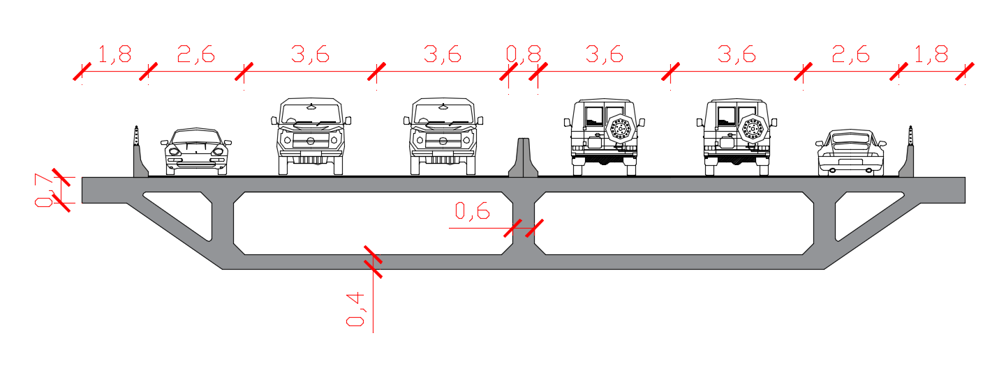

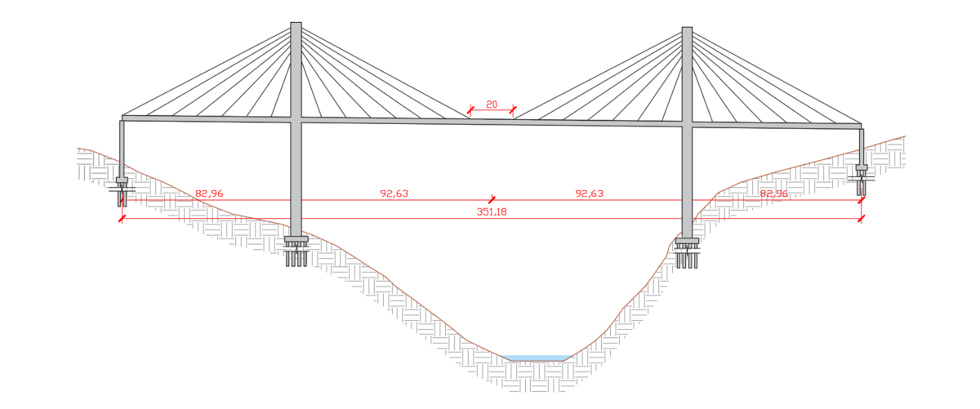

(a)

(b)

Figure 1. (a) Side view of cable-stayed bridge (b) Cross-section of cable-stayed bridge.

|  |  |
| --- | --- |
| |  | | --- | |  | |
|  |

1. (b)

Figure 2. (a) Pier elevation of the cable-stayed bridge. (b) Position of the linear viscous dampers.

***2.1 Numerical model of cable-stayed bridge***

Three dimensional finite element models (3D FEM) of the cable-stayed bridge were developed in the software CSiBridge for the three cases of study (SDPC, NC, LTF-I + VD) and for the two types of the analysis (RS and TH). The FE model consist of 1282 points, 1226 elements type shells, 88 elements type frame, and 110 elements type link. Damping ratio was specified as 5%, and 3 FPS isolators were placed in each joint between the beam cap and the piers, 6 linear viscous dampers (LVD) were placed in each piers (3 each side) for the LTF-I + VD model, as shown in Figure 3. The effective radius of curvature Reff =1.00 m, frictional coefficients µ=0.05, and displacement capacities d = 0.30 m, are taken into account in the FPS properties for numerical analysis.

|  |  |
| --- | --- |
|  | |
| (a) | (b) |
| Figure 3. (a) Pier elevation of the cable-stayed bridge and Position of FPS (b) Simple friction pendulum system (FPS). | |

***2.2 Characteristic of input ground motion***

The bridge is located in Arequipa, Peru in a zone of high seismicity (Lat. 16° 24’ 56” and Long. 71° 42’ 28.05”); where no strong motion records from similar historical earthquake exists. Hence, synthetic accelerogram are used. The synthetic accelerogram, was generated (Figure 4 (a) y (b)), by the program SismoSignal and Sismomatch, SeismoSoft (2018), from Design Spectrum (DE) and Maximum Credible Earthquake (MCE) according to the Manual of Transport and Communications Ministry of Peru, MTC (2016).

To generate the synthetic accelerograms, the Arequipa earthquake of June 23, 2001 was used as a base; it is worth mentioning that the main event was not registered. In Figure 5, a comparison between the DE and the MCE spectrum with the synthetic spectra generated from the systematic accelerograms is shown.

|  |
| --- |
|  |
| (a) |
|  |
| (b) |
| Figure 4. (a) Synthetic accelerogram for DE level and (b)  Synthetic accelerogram for MCE level, from MTC (2016). |

|  |
| --- |
|  |
| Figure 5. Comparison among response spectra of synthetic accelerogram and response spectrum of the Manual of Transport and Communications Ministry of Peru, MTC (2016). |

***2.3 Characteristics of the energy dissipation system***

For the study of the cable-stayed bridge, a set of isolators (3 per each piers) of the type FPS and VP was suggested, with the aim of improving the responses of both forces and displacements in the structural system.

The FPS is based on the properties of a pendulum motion. The structure to be insulated is supported on an articulated teflon-coated load element sliding on the inside of a spherical surface.

For a pendulum with weight W and radius of curvature Rc it is well know that the period of vibration Tp and the associated stiffness Kp are:

$T_{p}=2π\sqrt{\frac{R_{c}}{g}}$ (1)

$K_{p}=\frac{W}{R_{c}}$ (2)

Where g is the acceleration of gravity.

The resisting friction force can be expressed as a function of vertical load and friction coefficient µf, as:

$V_{f}=μ_{f}W$ (3)

The maximum force Vm is equal to:

$V_{m}=W\left(μ_{f}+\frac{∆_{m}}{R_{c}}\right)$ (4)

and hysteretic damping is:

$ξ_{hyst}=\frac{2μ_{f}}{π\left(μ_{f}+\frac{∆_{m}}{R_{c}}\right)}$ (5)

**3. NUMERICAL RESULTS OF THE cable-stayed bridge**

In this project, three types of analysis were developed, the TH (dynamic nonlinear) of DE and MCE, each of them evaluated with a different connection (SDPC, NC, LTF-I + VD). Moreover, it was possible to obtain displacements, shears and moments. In addition, a comparison between the three mentioned analyzes will be obtained.

The bridges have an initial displacement; this is because the bridges present permanent loads and eccentric gravitational loads as shown in Figure 6.

|  |
| --- |
|  |
| (a) |
|  |
| (b) |
| Figure 6. Eccentric gravity loading effects on (a) internal forces and (b) deformed shape.  (From: Calvi et al. 2010). |

It should be noted that the analysis was carried out without permanent loads only the presence of an earthquake.

The following graphics allow us to analyze the results of the analysis TH-DE with their respective connections.

|  |  |  |
| --- | --- | --- |
| **(a)** |  | **(a)** |
| **(b)** | (b) |
| **(c)** | (c) |



1. (b) (c)

Figure 8. Displacements on the deck for the analysis TH-DE in longitudinal direction, with (a) SDPC (b) LTF-I + VD (c) NC.

|  |  |  |
| --- | --- | --- |
| **(a)** | **(b)** | **(c)** |

In this figure, the accelerations in the deck for the different connections are shown, it is also important to note the amplification of the demand of accelerations in the deck in SDPC connection (1.11 g) approximately 8 times more with respect to initial accelerations (0.14g).

|  |  |  |
| --- | --- | --- |
| **(a)** |  | **(a)** |
| **(b)** | (b) |
| **(c)** | (c) |

Figure 9. Acceleration on the deck for the analysis TH-DE in longitudinal direction, with (a) SDPC (b) LTF-I + VD (c) NC.

|  |  |
| --- | --- |
| P1T…    P1M  P1B | **(a)** |
| (b) |
| |  (c) |
| (a) |
| (b) |
| (c) |
| (a) |
| (b) |
| (c) |

Figure 10. Shear force in longitudinal direction, for the analysis TH-DE on the pier with

(a) SDPC (b) NC (c) LTF-I + VD.

|  |
| --- |
| Table 1. Comparison of displacements in the deck for the analysis TH-DE y TH-MCE. |
| |  |  |  |  |  |  |  | | --- | --- | --- | --- | --- | --- | --- | | **Displacements (mm)** | | | | | | | |  | Connection  Type | | TH (dynamic nonlinear) | | | | | DE | | MCE | | | Longitudinal (mm) | Transverse (mm) | Longitudinal (mm) | Transverse (mm) | | SDPC | DP1C | 18.03 | 118.88 | 27.05 | 178.30 | | DCC | 22.49 | 210.20 | 33.73 | 315.30 | | DP2C | 18.03 | 126.60 | 27.04 | 174.90 | | LTF-I+VD | DP1C | 145.29 | 123.45 | 219.40 | 186.70 | | DCC | 147.05 | 231.29 | 222.10 | 310.20 | | DP2C | 146.18 | 204.57 | 220.70 | 308.40 | | NC | DP1C | 290.30 | 361.34 | 436.90 | 543.20 | | DCC | 290.26 | 366.77 | 436.90 | 551.30 | | DP2C | 289.93 | 339.10 | 436.40 | 509.80 | |

According to Table 1, the LTF-I + VD model reaches 87% more displacement than the SDPC model, and 50% less than the model NC. With these results, the intermediate option is the connection with which we can control the response to adequate level, being the best alternative for cable-stayed bridges in zones highly seismic.

|  |
| --- |
| Table 2. Shears forces for the analysis RS of DE and MCE. |
| |  |  |  |  |  |  |  | | --- | --- | --- | --- | --- | --- | --- | | **Shear (MN)** | | | | | | | |  | Connection type | | TH (dynamic nonlinear) | | | | | DE | | MCE | | | Longitudinal (MN) | Transverse (MN) | Longitudinal (MN) | Transverse (MN) | | SDPC | P1T | 0.200 | 0.148 | 0.301 | 0.221 | | P1M | 8.951 | 4.167 | 13.440 | 6.241 | | P1B | 13.711 | 10.900 | 20.570 | 16.350 | | LTF-I+VD | P1T | 0.027 | 0.022 | 0.041 | 0.034 | | P1M | 1.658 | 1.909 | 2.487 | 2.864 | | P1B | 1.960 | 2.746 | 2.264 | 4.100 | | NC | P1T | 0.161 | 0.054 | 0.242 | 0.082 | | P1M | 4.896 | 2.513 | 7.338 | 3.774 | | P1B | 4.588 | 4.491 | 6.884 | 6.768 | |

For the three different connection typologies a non-linear time history analysis was developed. It is observed in the previous figures that the connection LTF-I + VD with respect to the other connections limits the displacements, thus obtaining intermediate displacements, also registering the design forces lower in the towers (lower than the free solution due to the dissipation of additional energy from viscous damping devices and isolators).

**4. CONCLUSION**

The results show that for the case SDPC the period of the system reduces, while the acceleration and forces increase; NC show a very large relative displacement between the deck and piers, finally for the case LTF-I + VD we can control the response to adequate level, this being the best alternative for cable-stayed bridges in highly seismic zones.

It has been argued that the use of connections LTF-I + VD is likely to provide the best control of seismic response, as they can limit the actions imposed onto the bridge towers which should be stiff in order to limit deck displacements under seismic loads.

**5. References**

AASHTO LRFD Bridge Design Specifications, 8th Edition.

AASHTO, Guide Specifications for Seismic Isolation Design, 4th Edition.

Atmaca B., Yurdakul M., Ates. (2014) Nonlinear dynamic analysis of base isolated cable-stayed bridge under earthquake excitations. Soil Dynamic and Earthquake Engineering, 66 (2014) 314-318.

Calvi M., Sullivan T., Villani A. (2010) Conceptual seismic design of cable-stayed bridge. Journal of Earthquake Engineering, 14:8, 1139-1171.

Casciati F., Cimellaro G.P., Domaneschi M. (2008) Seismic reliability of a cable-stayed bridge retrofitted with hysteretic devices. Computers and Structures, 86 (2008), 1769-1781.

Computer and Structures Inc., CsiBridge. Berkeley, CA, USA 2018.

Chang C. M., Loh C. H. (2016) Seismic response control of cable-stayed bridge using different control strategies. Journal of Earthquake Engineering, 10 (8), 481-508.

Han Q., Wen J., Du X., Zhong Z., Hao H. (2018), Nonlinear seismic response of a base isolated single pylon cable-stayed. Engineering Structures, 175(2018), 806-821.

SeismoSoft: Earthquake engineering software solutions, [www.seismosoft.com](http://www.seismosoft.com).

1. Director of School of Civil Engineering, Catholic University of Saint Pablo, Arequipa, Peru, gpinto@ucsp.edu.pe
2. Student of School of Civil Engineering, Catholic University of Saint Pablo, Arequipa, Peru, oscar.quispe@ucsp.edu.pe