INFLUENCE OF EARTHQUAKE CHARACTERISTICS ON THE PEAK

SEISMIC RESPONSE OF A BASE ISOLATED STEEL BUILDING

DOI 10.37153/2686-7974-2019-16-609-621

Constantina PAVLIDOU, Petros KOMODROMOS

ABSTRACT

Since the peak seismic response of a base-isolated building strongly depends on the characteristics of the imposed seismic ground motion, the behavior of a base-isolated building under different seismic ground motions is studied, in order to better assess its expected peak seismic response. Specifically, the behavior of a typical three-dimensional (3D) steel building is examined as base-isolated with elastomeric bearings, using the SAP2000 software, while the effect of nearfault ground motions is studied by imposing 7 pairs of near- and 7 pairs of far-fault seismic records to the building. The results indicate that near-fault seismic components are more likely to increase the peak seismic response of the building than the corresponding far-fault components. The direction of the imposed earthquake excitations is also varied by rotating the imposed pairs of seismic records from 0◦ to 360◦, with respect to the major construction axes. It is observed that the peak seismic response may occur in incidence angles other than the horizontal construction axes of the building. The influence of 5% and 10% accidental mass eccentricities is also studied, indicating that when accidental mass eccentricities are taken into account the peak relative displacements of the base isolated structure are sustainably increased.

Keywords: base isolation; seismic isolation; peak seismic response; near vs. far fault; incidence angle

1. INTRODUCTION

The concept of seismic isolation has become a reality within the last decades by the development of seismic isolation systems. The main characteristic of seismic isolation is the inserted flexibility in the horizontal directions, usually at the base of a seismically isolated building in order to shift its fundamental period outside the dangerous for resonance with the seismic ground excitations range. Significant reductions of the interstorey drifts, peak floor accelerations and base shear forces can be achieved by installing seismic isolation bearings, usually at a level between the ground and the superstructure.

2. DESIGN AND MODELING ASSUMPTIONS

2.1 Superstructure

The spatial (3D) model of a steel building examined was initially designed and studied by Varnava (2013). The structure is a two-story building with plan dimensions 24m x 20m and floor heights of 3.30m. The frame in the X direction has three equal spans of 8m each, while the frame in the Y direction has 4 equal spans of 5m each. A moment resisting frame is designed in the X direction, with rigidly connected beams to the columns, while in the Y direction the frames act like trusses: the beam–column connection is pin-joined, while the edge sides of the outer frames are concentrically braced. A 3D view of the base-isolated building is shown in Figure 1 and the sections are presented in Table 1. Each floor is simulated as a rigid diaphragm and the masses are lumped at the floor levels.

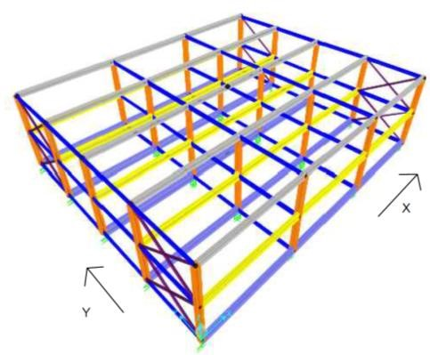

Figure 1. A 3D view of the base-isolated building, with respect to the construction horizontal axes, X and Y.

Table 1. Sections used in the building.

Floor |  | Section Type
Base-isolated ground level | Primary beams | IPE 600
 | Secondary beams | IPE 200
 | Columns | HEA 300
1st floor level | Primary beams | IPE 500
 | Secondary beams | IPE 200
 | Columns | HEA 300
2nd floor level | Primary beams | IPE 400
 | Secondary beams | IPE 200
 | Columns | HEA 300

2.2 Design and modeling of the NRBs and LRBs

The design of the base isolation system was conducted by Varnava (2012) by selecting a target eigenperiod
T_{dtar}=1.2sec. The corresponding acceleration of the design spectrum S_{d}(1.2) equals 0.3125g. Both NRBs and
LRBs are defined as "Rubber Isolator" type link elements in the SAP2000 structural analysis software. The NRBs have been modeled assuming equivalent linear properties, while nonlinear inelastic properties have been used for the LRBs. The mechanical characteristics of the isolators are given in Table 2.

Table 2. Mechanical characteristics of NRBs and LRBs.

 | NRB | LRB
Mass (kg) | 111.60 | 117.30
Weight (kN) | 1.0000 | 1.1507
Design displacement (mm) | 94.90 | 94.90
Effective stiffness (kN/m) | 722460 | 509730
Translational Effective stiffness (kN/m) | 664.8 | 1319.5
Elastic stiffness (kN/m) | 664.8 | 20383.5
Rotational Effective stiffness (kNm) | 12.4330 | 12.4201
Yield strength (kN) | - | 55.1985
Post yield stiffness ratio | - | 0.031565

3. NEAR–FAULT GROUND MOTIONS

The necessity of using seismic isolation on buildings obviously depends on the seismic activity of the respective region. It has been observed that the recorded seismic ground motions from stations located near the fault, have significant differences from the ground motions recorded from stations at long distances. A near-fault ground motion is defined by the distance between the rupture and the recordings.
Mavroeidis et al. (2004) have implemented simple mathematical models for the characterization of the nearfault strong ground motions. It is highlighted that the duration of the near-fault ground motion pulse is the most determining parameter in the elastic and inelastic performance of a SDOF system. The pulse duration is proportionate with the earthquake magnitude. Furthermore, the impulsive character of the near-fault velocity pulse affects significantly the elastic response spectra of the SDOF system. Moreover, Zhang and Wang (2013) have performed seismic damage analyses, which show that accumulated damage of concrete gravity dams is significantly affected by near-fault ground motions. Particularly, they have observed that the nonlinear response obtained from near-fault ground motions has a considerably different and greater displacement history than those obtained from far-fault ground motions.

3.1 Selected earthquake records

In order to assess the effect of near-fault ground motions, 7 sets of near- and far-fault accelerograms obtained from the PEER Center Database are used. The near- and far-fault seismic excitations had been recorded during the same seismic events at different stations. As already stated in previous studies (Somerville 2005), in order to achieve more accuracy, two acceleration records are considered simultaneously in the two horizontal directions, the Fault-Normal (FN) and Fault-Parallel (FP) for each ground motion.
The selection of the near-fault ground motions is based on specific criteria (Mavronicola 2017), specifically: (i) an earthquake magnitude of 𝑀_{𝑤} ≥ 6.0 and (ii) a distance to the fault rupture of 𝑅_{𝑟𝑢𝑝} < 15 𝑘𝑚. The farfault accelerograms are selected from the same seismic event, but at a further distance from the fault 𝑅_{𝑟𝑢𝑝} > 40 𝑘𝑚 (Tables 4 and 5). The near- and far-fault ground motion records are normalized to have their peak ground accelerations (PGA) equal to 0.3𝑔. This value is selected according to the requirements of EC8, which is the design ground acceleration, 𝑎_{𝑔} = 0.25𝑔, multiplied by the soil factor, 𝑆 = 1.2.

Table 3. Characteristics of selected horizontal near-fault records.

EQ  No. | NGA seq. no. | Event | Year | Station | M_{w} | FN | FP | Rjb  (km) | Rrup (km) | Vs30 (m/sec)
 |  |  |  |  |  | PGA  (g) | PGA  (g)
1 | 292 | Irpinia-  Italy-01 | 1980 | Sturno | 6.9 | 0.23 | 0.31 | 6.80 | 10.80 | 1000.00
2 | 802 | Loma  Prieta | 1989 | Saratoga -  Aloha Ave | 6.9 3 | 0.36 | 0.38 | 7.60 | 8.50 | 370.80
3 | 1045 | Northridge -01 | 1994 | Newhall - W  Pico Canyon Rd. | 6.6 9 | 0.43 | 0.28 | 2.1 | 5.5 | 285.9
4 | 1176 | Kocaeli- Turkey | 1999 | Yarimca | 7.5 1 | 0.28 | 0.31 | 1.40 | 4.80 | 297.00
5 | 1489 | Chi-Chi- Taiwan | 1999 | TCU049 | 7.6 2 | 0.28 | 0.25 | 3.80 | 3.80 | 487.30
6 | 3746 | Cape  Mendocin  o | 1999 | Centerville  Beach_ Naval Fac | 7.0 1 | 0.32 | 0.48 | 16.44 | 18.31 | 459.04
7 | 764 | Loma  Prieta | 1989 | Gilroy -  Historic Bldg | 6.9 3 | 0.29 | 0.24 | 10.27 | 10.97 | 308.55
𝑀_{𝑤} magnitude, 𝑅_{𝑗𝑏}: Restrict range of Joyner-Boore distance, 𝑅_{𝑟𝑢𝑝}: Restrict range of closest distance to rupture plane, 𝑉_{𝑠30}: Average shear wave velocity of top 30 meters of the site

Table 4. Characteristics of properties of selected horizontal far-fault records.

EQ  No. | NGA seq. no. | Event | Year | Station | M_{w} | FN | FP | Rjb  (km) | Rrup (km) | Vs30 (m/sec)
 |  |  |  |  |  | PGA  (g) | PGA  (g)
1 | 283 | Irpinia Italy-01 | 1980 | Arienzo | 6.9 | 0.03 | 0.05 | 52.93 | 52.94 | 612.78
2 | 799 | Loma  Prieta | 1989 | SF Intern. Airport | 6.93 | 0.24 | 0.33 | 58.52 | 58.65 | 190.14
3 | 946 | Northridge -01 | 1994 | Antelope Buttes | 6.69 | 0.05 | 0.07 | 46.65 | 46.91 | 572.57
4 | 1154 | Kocaeli Turkey | 1999 | Cekmece | 7.51 | 0.05 | 0.05 | 64.95 | 66.69 | 346.0
5 | 2479 | Chi-Chi Taiwan-04 | 1999 | CHY057 | 6.2 | 0.08 | 0.08 | 78.16 | 78.45 | 411.46
6 | 826 | Cape  Mendocin  o | 1992 | Eureka -  Myrtle and West | 7.01 | 0.15 | 0.18 | 40.23 | 41.97 | 337.46
7 | 751 | Loma  Prieta | 1989 | Calaveras Reservoir | 6.93 | 0.08 | 0.05 | 78.32 | 78.41 | 512.27

3.2 Seismic combinations and codes provisions

The seismic response of buildings strongly depends on the direction of the imposed seismic excitations. In order to simplify analyses, regulations have developed some simple combination rules in order to take into account the arbitrary direction of the imposed seismic excitation in the analysis. In this research work, analyses with 100% of both components of ground motion are conducted.

4. EFFECT OF INCIDENCE ANGLE

Although it is common practice to apply a pair of seismic ground motions along the two principal horizontal directions of the building, the earthquake excitations, which can be recorded as fault-normal (FN) and faultparallel (FP), can occur at any orthogonal horizontal axes, rotated randomly around the vertical axis.
Several studies have shown that, the peak seismic response strongly depends on the seismic incidence angle, which is the angle between the imposed ground motions and the principal construction axes of the building. Specifically, Athanatopoulou (2005) performed linear time-history analyses under several earthquake records and different incident angles, showing that the critical value of a response quantity could be up to 80% larger than the corresponding values when the seismic components are applied along the major construction axes. Lagaros (2010a), while conducting parametric studies regarding the influence of the incidence angle on the structural response, found out that the critical incidence angle varies significantly, taking also into account the intensity level. He proposed a new procedure for performing multi-component incremental dynamic analysis, which takes into account the randomness of both record and incident angle.
Rigato and Medina (2007), demonstrated that the peak inelastic deformation demands are underestimated because they often occur when the ground motion is applied at orientations other than the principal construction axes of the building, regardless of whether there is a torsional irregularity in the building or not. The results demonstrated that the incidence angle should be taken into account in earthquake design, although this has not yet been included in the building codes.
It should be noted that research studies in which nonlinear time-history analysis is performed, show that it is difficult to define the critical incidence angle (Magliulo et al., 2014). Furthermore, studies have shown that the critical incidence angle of a seismic excitation is influenced more by the characteristics of the excitation, rather than by the properties of the building.
Kalkan et al. (2014) mentioned that it is common in the USA to rotate the pair of seismic records to the faultnormal and fault-parallel (FN/FP) directions in order to define the envelope of all responses over all possible excitation angles, before they are used as input for three dimensional (3D) analysis of buildings within 5 km of active faults. It was shown that the critical angle of incidence that corresponds to the peak response over all possible angles, strongly depends on the characteristics of the seismic ground motion. Therefore, it would be difficult to determine an optimal building orientation that maximizes the demands of a building before time history analyses are performed.
Moreover, Polycarpou et al (2015) highlighted the importance of considering the arbitrary direction of the ground motion with respect to the major construction axes of the building, especially during pounding. On the other hand, Mavronicola (2017) pointed out that the critical angles significantly differ in the X and Y directions, which leads to the conclusion that the effect of the excitation characteristics in the interstorey drifts is considerably influenced by the dynamic characteristics of the building. Moreover, it is observed that the amplification of the peak seismic responses strongly depends on the excitation angles, leading to petal-like shape peak responses diagrams.
The excitation angle θ can be defined as the angle between the principal directions of the excitation’s orthogonal components, with respect to the global axes of the system X and Y, as it is mentioned by Mavronicola (2017). In order to study the effects of the ground motion incidence angle, the seismic record pairs are rotated from 0◦ to 360◦, with a 15◦ interval with respect to the major construction axes, and the major peak seismic response quantities are noted in the next paragraphs.

4.1 Maximum relative displacements

The first examined response quantity is the maximum relative displacements, which determines the minimum required dimension of the seismic gap that should be ensured as a clearance around the base-isolated building. Thus, Figure 2 displays the maximum relative displacements in the X and Y directions under both NF and FF ground motions. The graphs generally show higher peak relative displacements under the NF ground motions, in both X and Y directions. On the other hand, how much is the difference between the values due to the NF and FF ground motions, strongly depends on the excitation angle. It should also be noted that, under some excitation angles, a greater value occurs due to the FF ground motions.

0
80
160
0
60
120
180
Rel.Displ. (mm)
Inc. Angle (deg)
Italy
0
80
160
0
60
120
180
Rel.Displ. (mm)
Inc. Angle (deg)
Loma1
0
80
160
0
60
120
180
Rel.Displ. (mm)
Inc. Angle (deg)
Northr
0
80
160
0
60
120
180
Rel.Displ. (mm)
Inc. Angle (deg)
Kocaeli
0
80
160
0
60
120
180
Rel.Displ. (mm)
Inc. Angle (deg)
Chi
-
Chi
0
80
160
0
60
120
180
Rel.Displ. (mm)
Inc. Angle (deg)
Cape
0
80
160
0
60
120
180
Rel.Displ. (mm)
Inc. Angle (deg)
Loma2

Figure 2. Maximum relative displacements (mm) in X and Y directions of the base-isolated building in terms of the excitation angle, under the NF and FF ground motions.

4.2 Peak interstorey drifts

Similarly, Figure 3 presents the first-floor interstorey drifts in both X and Y directions of the base-isolated building, in terms of the excitation angle, under both NF and FF ground motions. In particular, the envelopes of the peak interstorey drifts at the corner columns are provided, for various angles of the seismic incidence. It is observed that smaller peak interstorey drifts occur in the Y direction, due to the x-braces placed in that direction, which provide more stiffness to the frames, limiting the horizontal deformations of the superstructure in that direction. The graphs present a completely different seismic response, with a different critical incidence angle under NF and FF ground motions at each seismic event. The only relation between the results in X and Y directions is their phase difference of 90° between the critical incidence angles. It is shown that, the seismic response of the building strongly depends on the characteristics of the seismic ground motion. Therefore, it is important to examine the seismic response of a building by imposing pairs of seismic ground motions among several excitation angles at the design stage, and not only along the building’s major horizontal construction axes.

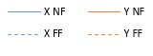

0.0
10.0
0
60
120
180
Int. Drift (mm)
Inc. Angle (deg)
Italy
0.0
10.0
0
60
120
180
Int. Drift (mm)
Inc. Angle (deg)
Loma1
0.0
10.0
0
60
120
180
Int. Drift (mm)
Inc. Angle (deg)
Northr
0.0
10.0
0
60
120
180
Int. Drift (mm)
Inc. Angle (deg)
Kocaeli
0.0
10.0
0
60
120
180
Int. Drift (mm)
Inc. Angle (deg)
Chi
-
Chi
0.0
10.0
0
60
120
180
Int. Drift (mm)
Inc. Angle (deg)
Cape
0.0
10.0
0
60
120
180
Int. Drift (mm)
Inc. Angle (deg)
Loma2

Figure 3. Peak first-floor interstorey drifts (mm) in X and Y directions of the base-isolated building in terms of the excitation angle, under NF and FF ground motions.

4.3 Peak floor accelerations

In addition to the peak interstorey drifts, another important parameter in the seismic design is the superstructure’s peak floor accelerations. Thus, the peak floor accelerations in X and Y directions of the baseisolated building in terms of the excitation angle, under NF and FF ground motions are presented in Figure 4.

0.0
5.0
0
60
120
180
Accel (m/s²)
deg
Italy
0.0
5.0
0
60
120
180
Accel (m/s²)
deg
Loma1
0.0
5.0
0
60
120
180
Accel (m/s²)
deg
Northr
0.0
5.0
0
60
120
180
Accel (m/s²)
deg
Kocaeli
0.0
5.0
0
60
120
180
Accel (m/s²)
deg
Chi
-
Chi
0.0
5.0
0
60
120
180
InAccel (m/s²)
deg
Cape
0.0
5.0
0
60
120
180
Accel (m/s²)
deg
Loma2

Figure 4. Peak floor accelerations (m/s2) in X and Y directions of the base-isolated building in terms of the excitation angle, under NF and FF ground motions.

According to the above graphs, no consistency is shown in the results. Therefore, the a priori determination of the critical incidence angle is practically impossible. Regarding the two different types of seismic ground motions, it is observed that in most cases examined, greater results occur when NF ground motions are imposed to the building. It should be noted that, under some other seismic events, minor differences between the NF and FF ground motions are observed.
In conclusion, regarding the rotating of the ground motions to FN/FP directions; it is revealed that, maximum responses not always occur when the excitations are imposed along the major horizontal construction axes. Consequently, different incidence angles should always be taken into account for the seismic design of a baseisolated building.

5. EFFECT OF ACCIDENTAL MASS ECCENTRICITIES

Eccentricities, e_{s}, are obtained by shifting the centers of mass of the superstructure (CMs) from the center of stiffness (CRs), which are located in the geometric center of the plan, or vice versa, i.e. by shifting the CRs from the CMs of the superstructure.
EC8 and the International Building Code (IBC) specify 5% eccentricities of the maximum floor dimension in each horizontal direction, while the New Zealand and Canadian codes suggest a value of 10%. The above codes require the relocation of the mass center in each floor along the X and Y construction axes, in both positive and negative directions (Anagnostopoulos et al., 2015a).
Previous research works have shown that the accidental mass eccentricities may cause higher torsional amplification. Specifically, Tena-Colunga and Escamilla-Cruz (2006), performed nonlinear dynamic analyses in order to study the peak seismic responses for different ratios of the static eccentricities between the CMs and CRs in the superstructure due to asymmetries. They observed that a higher torsional amplification exists in base-isolated buildings with mass eccentricities in the superstructure than in base-isolated buildings with stiffness eccentricities in the superstructure.
Moreover, according to Lee (1980), base isolation reduces the structural torques significantly, even if the building has large eccentricities. It is clear though, that this reduction of the structural torques is greatest when the isolation system’s center of stiffness coincides with the building’s center of mass.
Anagnostopoulos et al. (2015b) summarized the modeling approaches of earthquake-induced torsion in buildings, pointing out that, although building codes allow simplified assumptions and idealizations of onestory models, this may lead to erroneous conclusions, and needs to be further investigated.

5.1 Maximum relative displacements

In order to examine the effect of accidental mass eccentricities at the superstructure on the peak seismic response of the base-isolation system, the envelopes of the peak relative displacements at the base isolation level extracted from the four corner columns are presented in this paragraph, for the symmetric base-isolated building versus the two buildings with bidirectional accidental mass eccentricities of 5% and 10%. Specifically, Figures 5 and 6 illustrate the peak relative displacements at the base isolation level for the three different cases, which are the buildings without any eccentricities, with 5% eccentricities and with 10% eccentricities, in X and Y directions under NF and FF ground motions, respectively, among all excitation angles.

Italy  0  27090  180 |  | Loma1  0  90  180  270 |  | Northr  0  27090  180 |  | Kocaeli  0  90  180  270
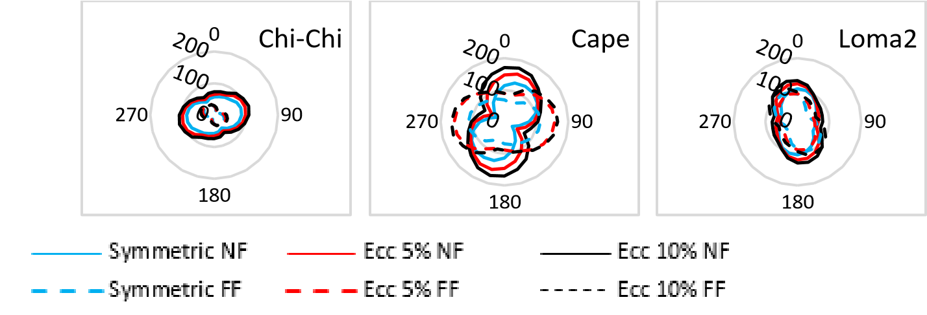

Figure 5. Peak relative displacements (mm) in X direction under NF and FF ground motions, in terms of the excitation angle for symmetric and non-symmetric (5% and 10%) base isolated buildings.

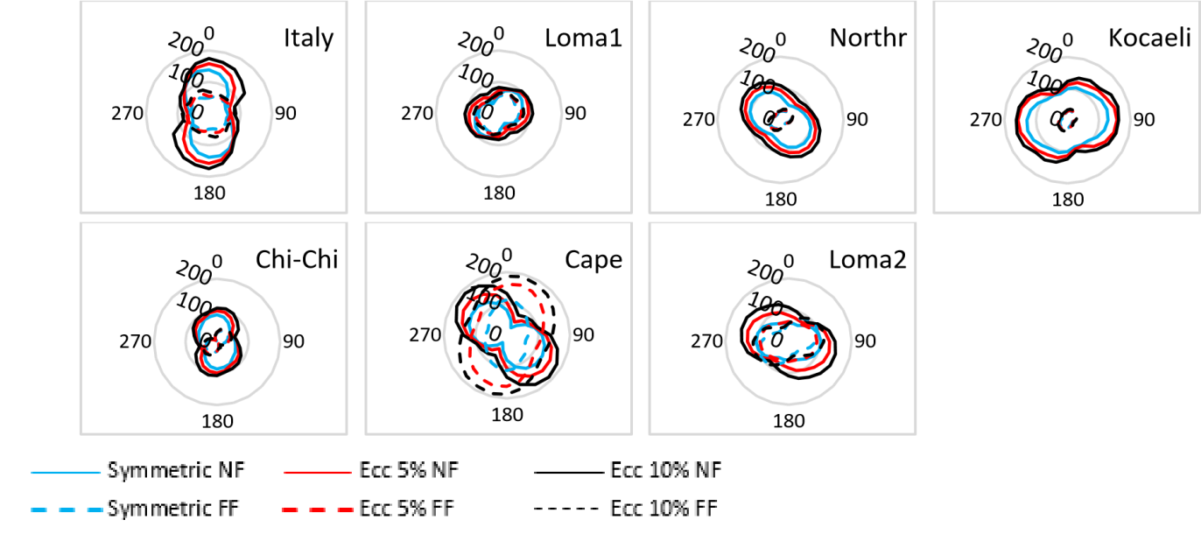

Figure 6. Peak relative displacements (mm) in Y direction under NF and FF ground motions, in terms of the excitation angle for symmetric and non-symmetric (5% and 10%) base isolated buildings.

The computed results indicate that the peak relative displacements in both X and Y directions are significantly increased due to the accidental mass eccentricities and, as expected, the building with 10% accidental mass eccentricities presents greater relative displacements at the base isolation level.
Under almost all seismic events, the maximum relative displacements due to the NF ground motions are considerably larger than the corresponding values due to the FF ground motions, in both X and Y directions, and among all excitation angles. The only exception is the seismic event in Cape Mendocino, where the maximum relative displacements are equally large under both NF and FF ground motions. It should also be noted that, under each seismic ground motion a different critical incidence angle occurs.
Regarding the incidence angle, generally the behavior of the superstructure remains the same for all three different cases that are considered (specifically, without any eccentricities, with 5% eccentricities and with 10% eccentricities), with slightly increased structural response, when taking into account accidental mass eccentricities.

5.2 Peak interstorey drifts

The overall comparison between the peak interstorey drifts computed at the symmetric base-isolated building and the buildings with 5% and 10% accidental mass eccentricities is presented in the Figures 7 and 8, for the X and Y directions, respectively.
According to the computed peak response, it is generally observed that, regarding the maximum of the peak interstorey drifts, the seismic performance of the building is generally greater when subjected to NF ground motions, in both X and Y directions, but on the contrary, this increase is strongly related to the angle of incidence.
In almost all cases, the occurred interstorey drifts of the building with 10% accidental mass eccentricities due to NF ground motions are up to 50% increased. This is an important observation, since it is effective for most of the incidence angles. On the other hand, it is worth noting that, for some specific excitation angles the peak interstorey drifts due to the FF ground motions are greater than the corresponding values due to the NF ground motions.
When comparing the symmetric building and the buildings with 5% and 10% accidental mass eccentricities, minor differences of the peak interstorey drifts are observed. Therefore, it can be concluded that, at least for the interstorey drifts, the accidental mass eccentricities do not influence significantly the peak response of the superstructure of the base-isolated building.
Finally, it is again observed that the building presents different critical incidence angle under each seismic event, which confirms the difficulty of determining a priori the critical incidence angle of a building.

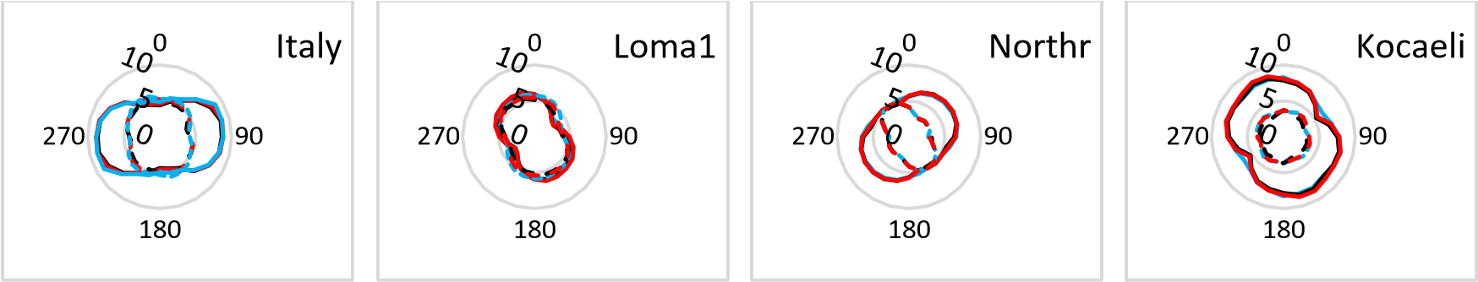
0 Chi-Chi  27090  180 |  | 0 Cape  27090  180 |  | 0 Loma2  27090  180

Figure 7. Maximum interstorey drifts (mm) in the X direction under NF and FF ground motions, in terms of the excitation angle, for symmetric and non-symmetric (5% and 10%) base isolated buildings.

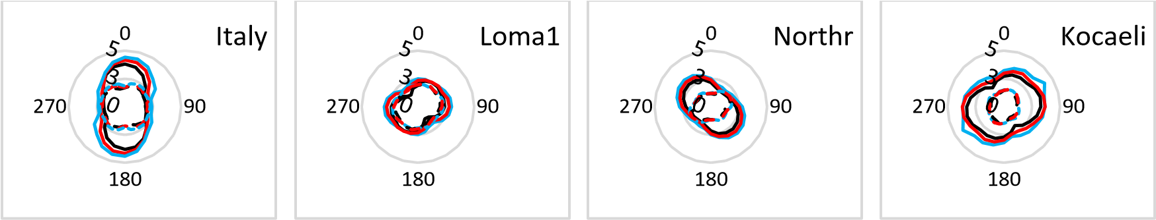
0 Chi-Chi  27090  180 |  | 0 Cape  27090  180 |  | 0 Loma2  27090  180

Figure 8. Maximum interstorey drifts (mm) in the Y direction under NF and FF ground motions, in terms of the excitation angle, for symmetric and non-symmetric (5% and 10%) base isolated buildings.

5.3 Peak floor accelerations

Similarly, a comparison between the peak floor accelerations of the base-isolated buildings is presented, with
(5% and 10% eccentricities) and without any eccentricities is presented in X and Y directions, in Figures 9 and 10 respectively.
In both X and Y directions, significant variations for the different excitation angles are observed, but at the same time, regarding the three different cases of the base-isolated building, a uniformity is observed. The results do not present important differences under most excitation angles, which leads to the conclusion that in those cases the accidental mass eccentricities do not significantly affect the peak seismic response of the base-isolated building, as already stated by Anagnostopoulos et al (2015a). This observation applies under all ground motions, both NF and FF.
Regarding the two types of ground motions, although the peak values of the top-floor accelerations do not significantly differ, in most cases a slightly increased seismic response is observed under the NF ground motions. To sum up, for most seismic records, the “worst case scenario” in terms of the peak floor accelerations in both
X and Y directions, is the case of 10% bidirectional eccentricities of the base-isolated building. It is shown that the accidental mass eccentricities mainly increase the peak seismic response, but occasionally they may even decrease it. Which one happens and to what extent, strongly depends on specific earthquake characteristics.
The maximum floor accelerations clearly depend on the excitation angle. In addition, under each pair of seismic records, the maximum floor acceleration occurs along a different incidence angle, which leads to the conclusion that it is not possible to predict the critical incidence angle of a building without performing dynamic analyses with varying incidence angles. Therefore, it could be concluded that the determining factor for the peak response of the seismic isolated system is the angle of incidence.

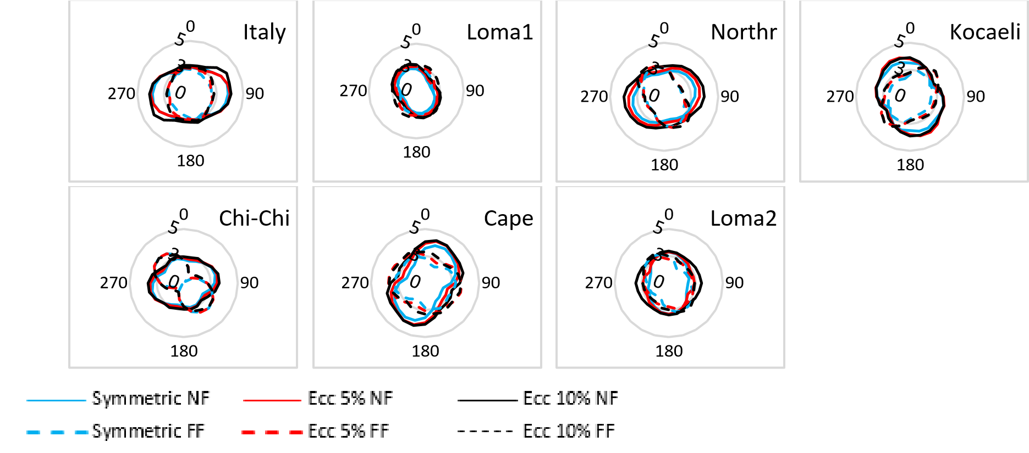
Figure 9. Maximum floor accelerations (m/s2) in the X direction under NF and FF ground motions, in terms of the excitation angle for symmetric and non-symmetric (5% and 10%) base isolated buildings.

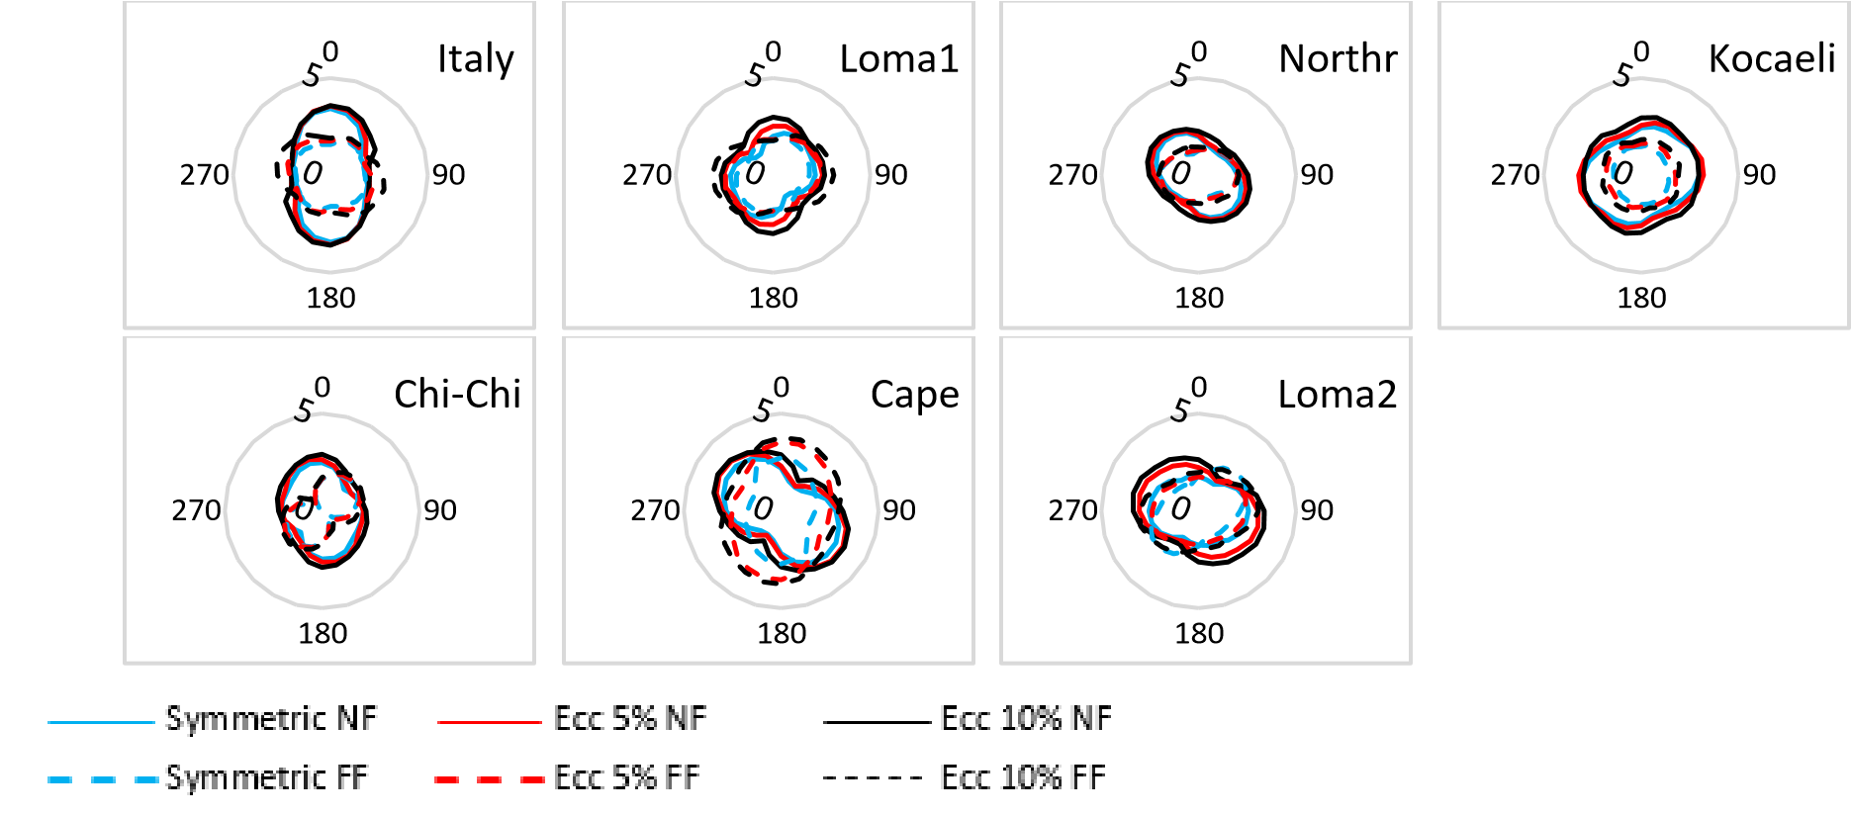
Figure 10. Maximum floor accelerations (m/s2) in the Y direction under NF and FF ground motions, in terms of the excitation angle for symmetric and non-symmetric (5% and 10%) base isolated buildings.

The effect of accidental mass eccentricities in terms of maximum floor accelerations is examined, by taking into account 5% and 10% bidirectional mass eccentricities for the analyses of the base-isolated building, among various incidence angles and under both NF and FF ground motions.
It is shown that, the maximum floor accelerations at the superstructure have minor differences between the symmetric building and the two buildings with accidental mass eccentricities, which leads to the conclusion that the superstructure of a base-isolated building may not be significantly affected by the accidental mass eccentricities.
Moreover, it is observed that, under each seismic event a different incidence angle is the critical one. The determination of the critical incidence angle is hence complicated, and different dynamic simulations should be performed for each building, especially if it is a high-importance building, in order to obtain a more reliable assessment of the peak seismic response under the worst-case scenario regarding the incidence angle.

6. CONCLUSIONS

The effectiveness of seismic isolation seems to strongly depend on the proximity to active faults, as well as the angle of the seismic incidence with respect to the principal construction axes. In this work the effect of near- and far-fault ground motions imposed on the base-isolated building has been investigated, considering various angles of seismic excitation.
The peak seismic response of the base-isolated building is examined through nonlinear time-history analyses under 7-set of near-fault seismic records and 7-set of the same earthquake events of far-fault seismic records. The performed parametric analyses indicate that the peak seismic response due to the imposed FF ground motions is significantly smaller than the corresponding seismic response due to the NF ground motions, under all seismic records and for all loading combinations.
Subsequently the effect of the seismic incidence angle is investigated under both near- and far-fault earthquakes. Parametric analyses have been performed by varying the excitation angle and the results indicate that the critical angle of excitation is not always at the principal horizontal axes- 0 or 90 degrees. Inversely, the maximum response occurs at different excitation angle for each pair of seismic records. This leads to the conclusion that when taking into account the seismic lateral forces only at the principle horizontal directions for the seismic design of a building, may lead to a significant underestimation of its actual response. The overall conclusion is that, under each seismic event a different incidence angle is the critical one. The determination of the critical incidence angle is hence complicated or even impossible, and different simulations should be performed for each base-isolated building, in order to obtain a more reliable evaluation of the peak seismic response.
Moreover, the effect of accidental mass eccentricities on the seismic response of the base-isolated building has been investigated under both near- and far-fault seismic excitations, at arbitrary directions of the seismic incidence. The base-isolated building is examined in two cases: by taking into account 5% and 10% bidirectional accidental mass eccentricities. The results indicate that mass eccentricities generally increase the response of the base-isolated buildings, due to the increase of the torsional effects, which causes rotations of the diaphragms. However, the rotation of the diaphragms are due to the essentially rigid-body rotation of the base-isolated building at the isolation level rather than the deformation of the superstructure. Specifically, the maximum relative displacements at the base isolation level are significantly increased due to the existence of mass eccentricities, either of 5% or of 10%. On contrary, regarding the deformations of the superstructure, minor differences are observed for both peak interstorey drifts and absolute floor accelerations due to the mass eccentricities, which leads to the conclusion that the superstructure of a base-isolated building is practically not affected by the accidental mass eccentricities. Moreover, by comparing the results of near- and far-fault ground motions, no significant difference in the increase of the response is observed.
Overall, the results of this research work agree with the conclusions of other research works, as the behavior of all examined buildings, show that the near-fault seismic pairs may cause more intense movement, than the far-fault seismic pairs, but this observation is not absolute and therefore, cannot be generalized.
In conclusion, it is shown that the response of the base-isolated building strongly depends on the angle of the seismic incidence, which can also amplify or alleviate the effects of near-fault ground motions and mass eccentricities. The response induced at excitation angles other than the construction horizontal directions (0◦ and 90◦), which are usually the only directions used in the analysis according to most design seismic codes, could be highly increased. This observation should be taken into account for the seismic building design, contrary to the provisions of some seismic codes, where no such provision is included.
The computed results indicate that the earthquake characteristics in combination with the characteristics of the seismic isolation system seem to have a significant role in the seismic response of the base-isolated building. This can be critical in the estimation of the required distance around a seismically isolated building.

7. REFERENCES

Anagnostopoulos S., Kyrkos M., Papalymperi, A., and Plevri, E. (2015a). Should accidental eccentricities be eliminated from Eurocode 8?. Earthquakes Struct. 8 (2015), p.463–484. DOI:10.12989
Anagnostopoulos S., Kyrkos M., and Stathopoulos K. (2015b). Earthquake induced torsion in buildings: critical review and state of the art. Earthquakes Struct. 8 (2015), p.305–377. DOI:10.12989.
Athanatopoulou A. (2005). Critical orientation of three correlated seismic components. Eng. Struct. 27, p.301–312. DOI:10.1016.
Kalkan E., Kwong N. (2014). Pros and Cons of Rotating Ground Motion Records to Fault-Normal/Parallel Directions for Response History Analysis of Buildings. J. Struct. Eng., 140(3) (2014).
Lagaros N. (2010). Multicomponent incremental dynamic analysis considering variable incident angle. Building and Infrabuilding Engineering 6, Nos. 1–2, p.77–94.
Mavroeidis G., Dong G., Papageorgiou A. (2004). Near-fault ground motions, and the response of elastic and inelastic single-degree-of-freedom (SDOF) systems. Earthquake Eng Struct. Dyn. 33 (2004), p.1023–1049. DOI:10.1002.
Mavronicola E., Polycarpou P., Komodromos P. (2017). Spatial seismic modeling of base-isolated buildings pounding against moat walls: effects of ground motion directionality and mass eccentricities. Earthquake Eng Struct. Dyn. 46 (2017) p.1161–1179.
PEER Pacific Earthquake Engineering Research Center (2011). Ground motion database. Available at:
http://peer.berkeley.edu/peer_ground_motion_database
Polycarpou P., Papaloizou L., Komodromos P., Charmpis D. (2015). Effect of the seismic excitation angle on the dynamic response of adjacent buildings during pounding. Earthquakes and Buildings 8 (2015) p.1127-1146.
Rigato A., Medina R. (2007). Influence of angle of incidence on seismic demands for inelastic single-storey structures subjected to bi-directional ground motions. Engineering Buildings 29 (2007) p.2593–2601.
Somerville P. (2005). Engineering characterization of near fault ground motions, 2005 NZSEE Conference.
Tena-Colunga A., Escamilla-Cruz J. (2007). Torsional amplifications in asymmetric base-isolated buildings. Eng Struct 29 (2007) p.237–247.
Varnava, V., Komodromos, P. (2013). Assessing the effect of inherent nonlinearities in the analysis and design of a lowrise base-isolated steel building. Earthquakes Struct. 5 (2013) p.499–526.
Zhang S., Wang G. (2013). Effects of near-fault and far-fault ground motions on nonlinear dynamic response and seismic damage of concrete gravity dams. Soil Dynamics and Earthquake Engineering 53 (2013) p.217–229.

University of Cyprus
Associate Professor, Civil & Env. Eng. Dept., University of Cyprus, Nicosia, Cyprus, komodromos@ucy.ac.cy

