**A comparatıve study on methods of analyses for seısmıcally ısolated structures**

**DOI 10.37153/2686-7974-2019-16-601-608**

Seda OZDEMIR[1], Ahmet YAKUT[2], Bekir Ozer AY[3]

**ABSTRACT**

The main objective of this study is to investigate the accuracy of response spectrum analysis (RSA) procedure for seismically isolated buildings. For this purpose, a typical hospital building from a real project in Turkey with 15 floors having a dual structural system is employed. The building was analyzed using RSA and Fast nonlinear analysis (FNA) procedures. The inter-story drift ratios and peak floor accelerations, that are known to affect both structural and non-structural components, were obtained from both analyses procedures and were then compared. The results revealed that RSA may underestimate both floor accelerations and inter-story drift ratios. It has also been observed that FNA procedure may be preferred as a time efficient alternative to obtain response of seismically isolated buildings since the only nonlinearity is generally assigned to isolators that are located in the isolation level.

*Keywords: Seismic Isolation; Fast Nonlinear Analysis; Response Spectrum Analysis*

**1. INTRODUCTION**

Seismic activities resulting in strong ground motion may have catastrophic consequences like loss of life and property: The outcome of a major or moderate earthquake may often be economic loss as well. In traditional seismic design approach, some predefined and controllable damage to the structure is allowed with regard to the expected seismic performance of the structure for a defined earthquake level. In controlled damage approach, ductility of the system has to be ensured. Since inelastic design approach means some controlled damage to both structural and non-structural elements, cost of the damage allowed has to be evaluated considering also the probability of that level of damage to occur. After evaluating costs and probability of damage, design force levels are to be decided on and the structure is designed accordingly. In some cases, cost evaluation of the damage is not acceptable depending on the type of the structure. If the consequences of the damage level are not acceptable, earthquake demand can be decreased by seismic isolation and energy dissipation devices by modifying building response characteristics.

***1.1 Motivation to This Work***

In Turkey, seismic isolation became very popular after the 2013 Technical Memorandum of Ministry of Health, which obliges design of hospitals located in first or second seismic zone and having 100 or more inpatient bed availability as seismically isolated. In recent years, numerous hospital buildings have been planned, designed and constructed as seismically isolated buildings in Turkey. According to the Memorandum, there is no project specific or site-specific technical criteria when deciding on the seismic isolation application to the intended hospital buildings. In fact, most of the hospitals and buildings have been designed based on Turkish Earthquake Code 2007 (TEC 2007) which is nullified upon the release of new Turkish seismic code in 2018, and does not cover the design considerations of seismically isolated buildings. Therefore, the designers had used TEC 2007 for the structure above the isolation level and performed conventional structural design and detailing, and used international codes and guidelines referencing miscellaneous seismic isolation aspects for the seismic isolation units. For these reasons, there seems to be a mixed approach, which is a confounding factor in overall structural design. During structural design stages including design of seismic isolation units, multiple criteria from several codes and specifications, even conflicting one another, may confuse the designer, the manufacturer of the isolation units, the owner and the administrative staff included in the project. While some designers have linear elastic response spectrum analysis as basis and proceed the overall design accordingly, some other may perform nonlinear time history analysis and another one may prefer fast nonlinear analysis. In the absence of a national seismic isolation specification till the release of new Turkish Earthquake Code 2018 (TEC 2018), as well as due to lack of experience of structural engineers, owners and the administrators, design of the system as a whole may be unsatisfying regarding several aspects. So, the study outlined here aims to compare the two most popular analysis procedures through interstory-drift ratios and peak floor accelerations obtained for a Hospital Building designed in Turkey.

***1.2 Scope of This Work***

In this study, one of the structural blocks of a real hospital project designed as seismically isolated from Turkey is investigated. The evaluation of seismic isolation design is assessed by linear elastic response spectrum analysis procedures under a design spectrum obtained from site specific analysis. To explore the accuracy of the linear elastic response spectrum analysis method, Fast Nonlinear Analysis (FNA) is also performed for the seismically isolated system as well as to include nonlinear characteristics of the seismic isolation units. The main parameters to be investigated are interstorey drift ratio and floor acceleration values.

* 1. ***Structural System Definition***

Architectural design of the structural system is taken from one of the buildings of a real hospital project to be designed as seismically isolated in Turkey. Key plan of the hospital blocks is demonstrated in Figure 1. The block analyzed is marked on the key plan as a shaded region and demonstrated separately on the right of Figure 1. In the original design, architectural plan dimensions and storey heights are not identical and each floor has been designed for different purposes like surgery rooms, mechanical rooms, bedrooms, common use areas, offices, parking areas... etc.



Figure 1. Key plan of hospital blocks (on the left) and typical architectural plan of the hospital block (on the right)

For the architectural design of the structural systems specified in Table 1, an ideal architectural floor is selected such that it represents each kind of functionality in the hospital, rather than being specific regarding purpose of utilization. This approach is required since the analyses to be performed in this work need to be independent from the architectural design especially in terms of floor masses. In consideration of this study, all the floor mass and floor geometries were selected to be identical.

Table 1. Architectural details

|  |  |  |
| --- | --- | --- |
| **Arcitectural Geometry** | | |
| Plan dimensions | 60.3 m x 79.2 m |  |
| Span length (in general) | 8.5 m |  |
| Storey height | 4.6 m |  |
| Number of stories | 15 |  |
| Total building height | 69 m |  |

Structural system is a dual system, which is consisted of moment frame together with shear walls arranged based mainly on architectural considerations.

* 1. ***Seismicity***

The seismic demand is adapted from a first degree seismic zone in Turkey. For linear response spectrum analyses, site-specific response spectra curve for Design Basis Earthquake (DBE) is obtained for Izmir region. In both linear and nonlinear analyses procedures, DBE level earthquake is used to evaluate the seismic effects on the superstructure. Site specific DBE level of response spectrum curve had been previously obtained from Probabilistic Seismic Hazard Assessment (PSHA). The site-specific response spectra for the selected location in İzmir is given in Figure 2.

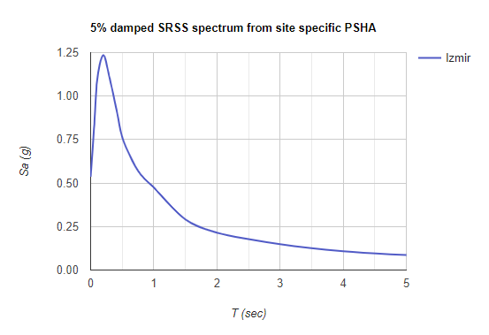

Figure 2. 5% damped SRSS spectral acceleration values from site specific PSHA

For fast nonlinear analysis, a number of appropriate 7 ground motion records are selected and scaled based on the site-specific target spectrum. Based on the fault mechanism at the site, earthquake magnitude, shear wave velocity (Vs30) tectonic regime and fault distance properties, appropriate real ground motion histories are selected. For Izmir site, majority of the focal mechanism is formed by normal faults and strike-slip faults. During ground motion selection procedure, candidate accelerograms are sought to meet the soil type and fault mechanism criteria. However, in the presence of fewness in available real ground motions, fault mechanism criteria is relaxed as in the work of Ay and Akkar (2012). Note also that no records containing pulse are selected as eligible. Selected ground motions are demonstrated in Table 2. The selected ground motion records are scaled such that they meet the scaling criteria given in ASCE (2010). The scale factors are shown in Table 2.

Table 2. Selected ground motion records for time history analysis procedure

|  |  |  |  |  |  |  |
| --- | --- | --- | --- | --- | --- | --- |
| **Record name** | **Earthquake name** | **Magnitude** | **Joyner-Boore Distance (km)** | **Vs30 (m/s)** | **Style of faulting** | **Scale factor** |
| **0015** | Kern Country | 7.36 | 38.42 | 385 | Reverse | 1.93 |
| **0762** | Loma Prieta | 6.93 | 39.32 | 368 | Reverse | 2.70 |
| **0807** | Loma Prieta | 6.93 | 47.41 | 401 | Reverse | 3.96 |
| **1015** | Northridge-01 | 6.69 | 47.79 | 405 | Reverse | 4.32 |
| **1633** | Manjil, Iran | 7.37 | 12.56 | 724 | Strike-Slip | 0.61 |
| **2714** | Chi-Chi, Taiwan-04 | 6.2 | 38.11 | 442 | Strike-Slip | 2.71 |
| **3503** | Chi-Chi, Taiwan-06 | 6.3 | 29.64 | 475 | Reverse | 2.40 |

In Figure 3, the mean spectrum of the scaled ground motions is presented.

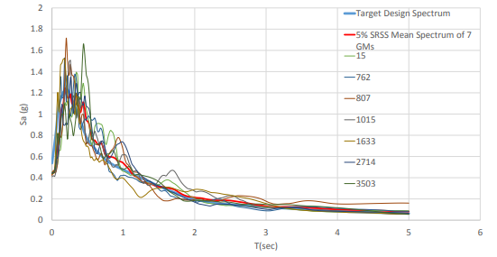

Figure 3. SRSS target spectrum versus 5% damped SRSS spectrum of 7 ground motions

**2. Design AND ANALYSIS of THE BUILDING**

***2.1 Design of Isolation Units***

The building investigated is isolated at the foundation level. A total of 114 friction pendulum type isolators are used. In linear response spectrum analysis procedures, effective values of the design parameters of the isolation units are used. Basic effective values considered are upper bound (UB) effective stiffness and effective damping values of the targeted seismic isolation design. Although the effective damping is theoretically calculated as 40.43%, effective damping of each system is limited to 30% to exclude higher mode effects in single degree of freedom analysis. For this purpose, maximum allowable effective damping is specified as 30% in ASCE 7-10. Nonlinear behavior of seismic isolation units are also taken into consideration through Fast Nonlinear Analysis (FNA) procedure. Seismic isolator characteristics are specified in Table 3.

Table 3. Linear isolator parameters

|  |  |  |  |  |  |  |
| --- | --- | --- | --- | --- | --- | --- |
| **Isolator type** | **Maximum vertical load (kN)** | **Effective stiffness (Keff) (kN/m)** | **Effective damping (D) (%)** | **Damping coefficient (BD)** | **Isolated period (Tiso) (sec)** | **Isolator UB displacement (diso) (cm)** |
| **1** | 8000 | 3578 | 40.43 | 1.7 | 3.00 | 18.9 |
| **2** | 9000 | 4024 | 40.43 | 1.7 | 3.00 | 18.9 |
| **3** | 10000 | 4471 | 40.43 | 1.7 | 3.00 | 18.9 |

***2.2 Methods of Analysis***

Fast Nonlinear Analysis (FNA) is selected rather than Nonlinear Time History Analysis (NTHA) due to prolonged computing time resulted in NTHA. In the study of Wilson (2000) the author states that the computational speed of FNA method as compared to the traditional "brute force" method of nonlinear time history analysis is found as several magnitudes faster in many nonlinearity cases. Interested readers may refer to the fundamental equilibrium equations which provide efficiency in computing time specified. As it is also mentioned in the study of Wilson (2000) certain types of large strains, as in the case of the seismic isolation modeled by link members, can be assumed as a lumped nonlinear element in the system by applying FNA method. Note that in seismically isolated systems, all the nonlinearity is limited and restraint to the link members such that the superstructure remains elastic, which is the main goal. Therefore, FNA can be an efficient way to assess the superstructure by the only nonlinearity in link members representing isolation units in modal space. For this reason, the analysis can also be named as a nonlinear modal time history analysis. Based on the study of Siller (2004) the analysis performed in modal space based on modal parameters, which mainly are eigenvectors and eigenvalues, requires a relatively small number of modes to regenerate the response of the system. In addition, the orthogonality of the eigenvectors allows a given degree of freedom to be fully described by its own eigenvector, which reduces even more algebraic burden. According to Siller (2004), one disadvantage of making use of modal coordinates may be that "the modal responses have little physical meaning in case of an issue during an updating or identification analysis, in which the differences between an experimental model and its theoretical counterpart must be conciliated".

Aside from FNA, response spectrum analysis is also carried out in order to make comparions and to evaluate its efficiency as compared to FNA.

**3. Analysıs results**

Interstorey drift ratio (IDR (%)) and peak floor accelerations (PFA (g)) in two horizontal directions x and y, respectively, obtained from both RSA and FNA method are presented in this part. Interstorey drift ratio is considered as the drift in percent between two adjacent floors divided by the storey height. Both interstorey drift ratio and floor accelerations are obtained from each floor at the center of rigidity of the corresponding floor for RSA. For FNA procedure, the time instant when the maximum interstorey drift ratio or floor acceleration occurred is taken as the time instant when the corresponding maximum value occurred in the top floor.

***3.1 IDR (%) Results from RSA and FNA***

In Table 4, maximum IDR (%) in x and y directions obtained from RSA are presented. The maximum IDR in x-direction is approximately 0.08 percent that is less than the one in y-direction. These values are much less than the value of 0.4 percent that is allowed approximate value in the Turkish earthquake code (TEC 2018) for superstructure.

Table 4. Maximum interstorey drift ratios (%) obtained from RSA

|  |  |
| --- | --- |
| **x-direction** | **y-direction** |
| **0.077** | 0.104 |

In Table 5 and Table 6, mean of maximum IDR (%) in x and y directions calculated from FNA corresponding to each scaled ground motion record are demonstrated, respectively. In x-direction, the smallest computed value is around 0.07 percent and the largest one is approximately 0.13 percent, the mean of all being nearly 0.1 percent. As observed in RSA, the values in y-direction are a bit larger. The mean of all ground motion records resulted in IDR of 0.15 percent. It is observed that RSA results can be significantly lower than the FNA results which leads to unconservative results.

Table 5. Mean of maximum interstorey drift ratios (%) obtained from FNA by 7 ground motion records in x-direction

|  |  |  |  |  |  |  |  |
| --- | --- | --- | --- | --- | --- | --- | --- |
|  | **In x direction** | | | | | | |
| **GM Record No.** | **0015** | **0762** | **0807** | **1015** | **1633** | **2714** | **3503** |
| **Maximum IDR (%)** | 0.088 | 0.125 | 0.103 | 0.069 | 0.095 | 0.072 | 0.131 |
| **Mean IDR (%)** |  | 0.098 | | | | | |

Table 6. Mean of maximum interstorey drift ratios (%) obtained from FNA by 7 ground motion records in y-direction

|  |  |  |  |  |  |  |  |
| --- | --- | --- | --- | --- | --- | --- | --- |
|  | **In y direction** | | | | | | |
| **GM Record No.** | **0015** | **0762** | **0807** | **1015** | **1633** | **2714** | **3503** |
| **Maximum IDR (%)** | 0.203 | 0.122 | 0.122 | 0.160 | 0.147 | 0.154 | 0.123 |
| **Mean IDR (%)** |  | 0.148 | | | | | |

***3.2 PFA (g) Results from RSA and FNA***

Table 7. summarizes PFA (g) values in x and y directions as the result of the performed RSA. Maximum floor accelerations seem to be close in both directions which is computed as nearly 0.12 g.

Table 7. Peak floor acceleration (g) obtained from RSA

|  |  |
| --- | --- |
| **x-direction** | **y-direction** |
| **0.117** | 0.125 |

In Figure 4 and 5, floor acceleration distributions through each floor obtained from the FNA of 7 ground motion for x and y directions are presented. It is worth mentioning that performing nonlinear modal history analysis provided the detection of sign of acceleration response direction.

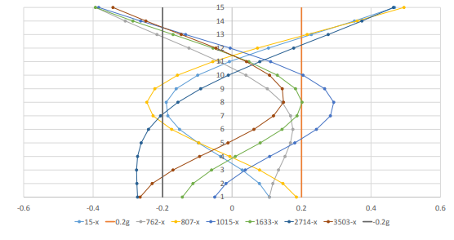

Figure 4. PFA (g) in x-direction through floors from FNA

Maximum and mean of the PFA (g) of 7 ground motion are stated in Table 8 and Table 9. The mean values of PFA obtained from FNA are much larger than the ones obtained in RSA.

Table 8. Mean of peak floor acceleration (g) obtained from FNA by 7 ground motion records in x-direction

|  |  |  |  |  |  |  |  |
| --- | --- | --- | --- | --- | --- | --- | --- |
|  | **In x direction** | | | | | | |
| **GM Record No.** | **0015** | **0762** | **0807** | **1015** | **1633** | **2714** | **3503** |
| **Maximum PFA (g)** | 0.468 | -0.393 | 0.495 | -0.384 | -0.393 | 0.465 | -0.343 |
| **Mean PFA (g)** |  | 0.420 | | | | | |

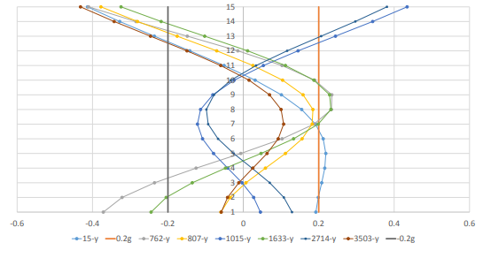

Figure 5. PFA (g) in y-direction through floors from FNA

Table 9. Mean of peak floor acceleration (g) obtained from FNA by 7 ground motion records in y-direction

|  |  |  |  |  |  |  |  |
| --- | --- | --- | --- | --- | --- | --- | --- |
|  | **In y direction** | | | | | | |
| **GM Record No.** | **0015** | **0762** | **0807** | **1015** | **1633** | **2714** | **3503** |
| **Maximum PFA (g)** | -0.413 | -0.410 | -0.378 | 0.434 | -0.324 | 0.381 | -0.432 |
| **Mean PFA (g)** |  | 0.396 | | | | | |

**4. Conclusions**

Based on this study, following concluding remarks can be deduced:

* FNA resulted in an average acceleration value of 0.420g in x direction and RSA in a maximum acceleration value of 0.117g; meaning that FNA resulted in an acceleration value of 3.59 times higher than the value obtained from RSA. In y direction, it is 3.17 times higher than the acceleration value obtained from RSA.
* Although the difference in IDR (%) values obtained from RSA and FNA is not significant, RSA method seems to be underestimating the drift values as well.
* In a seismically isolated system, linear elastic response spectrum analysis may be used as a tool to preliminarily assess the reduction in forces and design the isolator characteristics. However, since it may underestimate the exact response, especially floor accelerations, making use of the acceleration responses obtained from linear elastic procedures for nonstructural damage sensitivity assessment may be unfavorable.
* Appropriate seismic isolation design, structural geometry arrangement and floor mass distribution in the system design ends up with satisfying modal mass participation from the fundamental mode of vibration, which ensures almost a rigid body motion in the system where interstorey drift values are significantly minimized. For the same reason, Fast Nonlinear Analysis (FNA) may be an efficient tool for analyzing the systems as mentioned.

**5. References**

ASCE (2010). Minimum Design Loads for Buildings and Other Structures (ASCE 7- 10).

B. O. Ay and S. Akkar. (2012) A procedure on ground motion selection and scaling for nonlinear response of simple structural systems. Published online in Wiley Online Library.

E. L. Wilson. (2000) Three Dimensional Static and Dynamic Analysis of Structures.

H. R. E. Siller. (2004) Non-linear Modal Analysis Methods for Engineering Structures. A thesis submitted for the degree of Doctor of Philosophy in Mechanical Engineering, University of London.

TEC (2007). Ministry of Public Works and Settlement Government of Republic of Turkey. Regulations for Buildings to be Built in Earthquake Areas. 2007.

TEC (2018). Turkish Building Earthquake Code. Ministry of Interior. Presidency of Disaster and Emergency Management. 2019.

1. PhD Student of Engineering Sciences, Middle East Technical University, Ankara, Turkey, [seda.ozdemir@metu.edu.tr](mailto:seda.ozdemir@metu.edu.tr)
2. Prof. Dr., Civil Engineering Dept., Middle East Technical University, Ankara, Turkey, [ayakut@](mailto:ayakut@)metu.edu.tr
3. Assist. Prof. Dr., Architecture Dept., Middle East Technical University, Ankara, Turkey, [ozer@metu.edu.tr](mailto:ozer@metu.edu.tr)