Friction Damper System for Reducing Seismic Demand

DOI 10.37153/2686-7974-2019-16-730-733

Manish SHRIKHANDE

ABSTRACT

A new system for enhancing energy dissipation capacity through supplemental friction dampers has been developed. The proposed system does not obstruct the access to open spaces and can be readily deployed for retrofitting works with the help of handy clamping devices. Under the test conditions, a reduction of 30% in the seismic demand was observed. Further reduction is possible by suitable changes in the system parameters and material for friction interface.

Keywords: Energy Dissipation; Earthquake Resistant Design; Friction Damper; Performance Based Design; Supplemental Damping; Seismic Retrofit

1. INTRODUCTION

The coventional paradigm in earthquake resistant design is to design for serviceability limit state for a more frequent moderate earthquake, known as the design basis earthquake (DBE), while the ultimate limit state condition is presumed to prevail to the rare extreme event, referred to as the maximum considered earthquake (MCE) – provided that certain prescriptive guidelines for enhancing ductility are followed. While this dual level approach towards earthquake resistant design has been adequate in preventing the loss of lives, mounting economic losses due to strong earthquakes has led to a newer paradigm of performance based seismic design.
The design of structures to withstand earthquakes has been proposed as a problem of energy budgeting (Akiyama 1988):

E_{k} + E_{d} + E_{s} + E_{h} ≥ E_{i} (1)

where E_{k} is the kinetic energy stored in the system, E_{d} represents the energy lost through dissipation mechanisms, E_{s} is the elastic strain energy stored in structural members, E_{h} is the hysteretic energy corresponding to inelastic deformations, and E_{i} is the earthquake input energy. The seismic performance of a building can be improved by either reducing the energy input from earthquake (e.g., by using base isolation), and/or by enhancing the energy storage and dissipation capacity by addition of new structural elements and energy dissipation devices. Seismic response control through energy dissipation is increasingly being considered as a cost-effective way to mitigate the effects of strong earthquakes (Aiken et al. 1993). The use of friction to dissipate energy for controlling the seismic response has been extensively explored and several systems have been developed.
The idea of improving seismic behaviour by increasing energy disspation capacity has developed from the testing of devices for force and deformation capacities (Kelly et al. 1972) to studying the earthquake response of full-scale models augmented with energy dissipation devices (Grigorian et al. 1993). Dissipation of energy through metallic-yield has been found to be promising by incorporation of added damping and stiffness (ADAS) devices on top of chevron brace in building frames (Whittaker et al. 1991). With the help of ADAS elements, the stiffness increased by more than 150% while significantly increasing the hysteretic damping and strength of the structure. Similar reduction in seismic response has been observed with the use of viscous and viscoelastic dampers in structural systems. The maximum damper force depends on the maximum relative velocity and displacement for viscous and viscoelastic damper whereas it is constant for friction and metallic-yield dampers (Hanson 1993). The use of supplemental damping is one of the most cost-effective strategies for enhancing seismic capacities of structural systems.
For effective energy dissipation, dampers need to harness the structural deformations to the maximum extent possible, and therefore, are often placed in diagonal or Chevron brace configurations. This arrangement often interferes with the functional requirements by obstructing the access. Open ground floor (or, soft storey) is a common feature in urban settlements despite its known vulnerability during earthquakes. These open spaces in the ground floor are often used for parking and other community activities and can’t be wished away. An arrangement of links for deploying viscous damper to get a large clear space while amplifying the relative motion has been examined recently (Polat and Constantinou 2017). In this study, we propose a friction damper system which can be readily deployed in structural systems without obstructing the access to the open spaces.

2. OPEN FRICTION DAMPER SYSTEM

An open configuration for friction damper has been designed and tested for controlling the seismic response of a frame. The damper consists of a middle insert plate connecting the two top ends of adjacent columns in a bay with the help of clamping devices. This middle plate is sandwitched between two exterior plates which are connected to the bottom end of the columns through two vertical members with moment free connections at both ends. The three plates have horizontal slots through which a nut-bolt assembly can apply pressure against the sliding interfaces for controlling friction force. The arrangement ensures that the middle insert plate moves with the top ends of the columns while the end plates move with the bottom end of the columns thereby harnessing the full story drift for energy dissipation through friction. We used an aluminium plate as the middle insert plate which is sandwitched between steel plates providing two sliding interfaces for energy dissipation through friction. Total friction force during the relative slip between plates will be F = 2μN , where N is the normal force across the plates and μ is the kinetic coefficient of friction. The coefficient of friction between aluminium-steel interface is in the range [0.45, 0.6] (Engineering Toolbox 2004). Other materials can be used in place of steel and aluminium depending on the availability and durability considerations. The normal force across the plates is maintained by the nut-bolt assembly. For a bolt of diameter d, a tightening torque of T is related to the force N as:

T = k · d · N (2)

where, k is the nut factor which ranges from 0.03 to 0.35 depending on geometry, thread friction and underhead friction, d is the nominal diameter (in m) of the bolt, N is the clamping force (in N) in the bolt, and T is the applied torque (in N · m) (Shoberg). For a given set of sliding interfaces, the friction force can be controlled by changing the torque, and/or by changing the diameter of bolt(s). For the same tightening torque, a larger diameter bolt results in a smaller normal force across the plates. Setting clamping force is crucial for the damper performance. Too small force will hardly produce any friction and hence negligible energy dissipation, whereas a very high clamping force will cause the plates to stick together and there will not be any relative slip across the interfaces for energy dissipation through friction. Somewhere in between these two extremes is the desired clamping force which will allow slipping at some fraction of the maximum lateral force for facilitating energy dissipation. Assuming maximum lateral force at the level of damper to be F_{max}, the required clamping force may be estimated as:

N = α F_{max} / (2μ n) (3)

where, α is the fraction of maximum lateral force as the slip force, n is the number of frames sharing the lateral force assuming rigid floor diaphragm action, and μ denotes the coefficient of friction between sliding interfaces. The damper assembly participates only in the energy dissipation during vibrations and has no role to play in the gravity load support system. Therefore, these plates are not required to be very heavy.

2.1 Experimental Investigation

A steel frame 2.0 m × 1.7 m in plan and 2.0 m tall as shown in Figure 1 is used as a specimen for shake table testing. The natural frequency of the frame is estimated through free vibration test as 7.0 Hz and the damping ratio as 0.9%. The friction force is controlled by the torque for tightening the nut-bolt assembly pressing the slotted plates together. We used a single nut-bolt assembly of 10 mm nominal diameter for each damper in two bays. A calibrated clamping force was applied by using torque wrench for tightening torque of 3.0 Nm

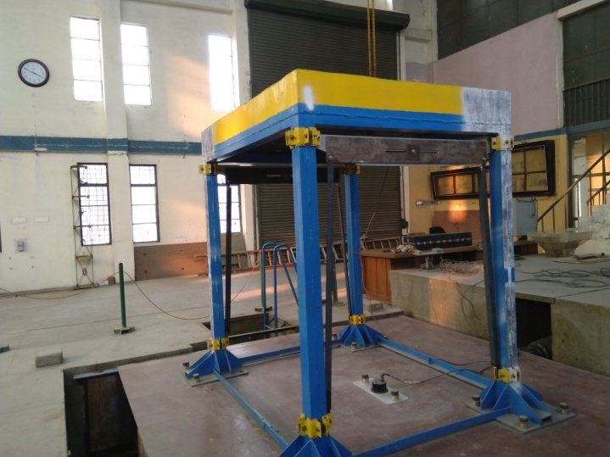 | 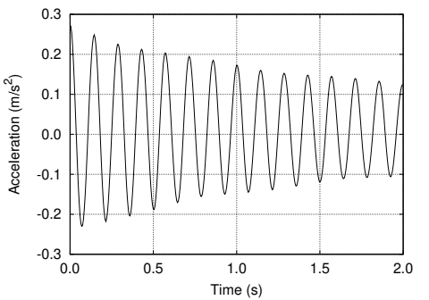
(a) Portal frame with damper | (b) Free vibration response of bare frame
Figure 1. Frame specimen with damper

which corresponds to clamping force of 1.2 kN (assuming the nut factor to be 0.25 for dry conditions). The clamping force can be further reduced, if needed, by using a nut of larger nominal diameter. The specimen was tested for artificial earthquake time history compatible with the MCE level motion in seismic zone V — the most severe one of the Indian standard IS-1893.

3. RESULTS AND DISCUSSIONS

The specimen frame with and without damper was tested on the shake table for a spectrum compatible MCE level motion corresponding to the seismic zone V of IS-1893. Accelerations were measured at the base and at the roof level of the specimen. The acceleration response amplification is quantified by the ratio of absolute maximum of roof and base accelerations. Alternatively, the ratio of root mean square (rms) values of roof and base accelerations can also be used to quantify the response amplification. These amplification factors are tabulated in Table 1.

Table 1. Damper performance for different clamping force

Excitation Type | Clamping Force Acceleration Amplification
MCE | 0.0 (Bare Frame) | 2.95 (3.81 rms)
(Zone-V) | 1.2 kN (3.0 Nm) | 1.92 (2.67 rms)

Figures in parentheses correspond to the rms ratios. The response amplification is reduced by about 30% due to dissipation in the damper. The approximate clamping torque of 3 Nm roughly corresponds to about 1.5 kN of limiting friction force for slippage which is approximately 25% of the maximum lateral force on one column bay. The 5% damped spectra of the motions at the base and roof (with and without damper) are shown in Figure 2. The friction damper is effective in reducing the maximum acceleration at the roof as well as the floor spectrum by 30% as compared to the bare frame. Further reduction can possibly be achieved by reducing the clamping force to initiate the slip at a lower force levels, however, 3.0 Nm is the minimum torque that could be applied with the calibrated wrench.

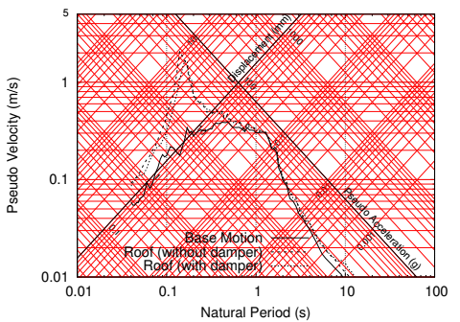 | 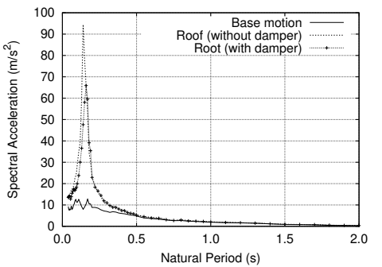
(a) Tripartite plot | (b) Spectral acceleration (linear scale)
Figure 2. 5% damped response spectra of base and roof acceleration

4. Conclusions

A friction damper suitable for deployment in an open configuration has been developed and tested under earthquake conditions. A simple clamping device allows for easy installation of this damper system in existing structures. For the test conditions, the damper was found to reduce the maximum acceleration at the roof of a single storey frame specimen by 30%. Further reduction can be achieved by reducing the limiting friction force for slippage by either reducing the clamping force, or by reducing the friction between plates by choosing suitable interface materials.

5. References

Aiken I., Nims D., Whittaker A., Kelly J. (1993) Testing of passive energy dissipation systems. Earthquake Spectra , 9(3):335–370.
Akiyama H. (1988) Earthquake resistant design based on the energy concept. Proceedings of Ninth World Conference on Earthquake Engineering, August 2–9, Tokyo-Kyoto, Japan, vol. V; V–905–V–910.
Cherry S., Filiatrault A. (1993) Seismic response control of buildings using friction dampers. Earthquake Spectra, 9(3):447–466.
Engineering Toolbox (2004) Friction and friction coefficients. [Online] https://www.engineeringtoolbox.com/friction-coefficients-d_778.html. Accessed on April 01, 2019.
Grigorian C., Yang T., Popov E. (1993) Slotted bolted connection energy dissipators. Earthquake Spectra, 9(3):491–504.
Hanson R. (1993) Supplemental damping for improved seismic performance. Earthquake Spectra, 9(3):319–334.
Pall A., Marsh C. (1982) Response of friction damped braced frames. Journal of the Structural Division, ASCE , 108(ST6):1313–1323.
Polat E., Constantinou M. (2017) Open-space damping system description, theory and verification. Journal of Structural Engineering 2017, 147(4):04017 082.
Shoberg R. Engineering fundamentals of threaded fastener design and analysis, RS Technologies, PCB Load and Torque, Inc. [Online] http://www.hexagon.de/rs/engineering fundamentals.pdf. Accessed on April 01, 2019.
Whittaker A., Bertero V., Thompson C., Alonso L. (1991) Seismic testing of steel plate energy dissipation devices. Earthquake Spectra, 7(4):563–604.

Professor, Department of Earthquake Engineering, Indian Institute of Technology Roorkee, Roorkee – 247667, India, mshrifeq@iitr.ac.in

