**SEISMIC ENERGY DISSIPATION IN SEMI-RIGID CONNECTED STEEL FRAMES**

**DOI 10.37153/2686-7974-2019-16-705-717**

Vijay SHARMA[[1]](#footnote-1), M K SHRIMALI[[2]](#footnote-2), S D BHARTI[[3]](#footnote-3), T K DATTA[[4]](#footnote-4)

**ABSTRACT**

A comparison between the losses of seismic energy between the semi-rigidly connected building frames modeled in two different ways and the corresponding rigidly connected frame is presented. For this purpose, three different types of earthquakesare considered, namely, the far-field, and the near-field with directivity and fling-step effects. Each type of earthquakeis scaled to a PGA level that ranges from 0.2g to 0.6g. The loss of seismic energy is investigatedwith respect toa number of seismic demand parameters such as the maximum inter-story drift ratio, the maximum roof displacement, the total number of plastic hinges, the SRSS of maximum plastic hinge rotations and the energy dissipation. A ten-story steel building frame designed according to the Indian standard code is taken as the illustrative example. A nonlinear time history analysis is performed using SAP 2000 to find the responses. The results of the study indicate that (i) the seismic energy dissipation in the multilinear plastic link modeling of the semi-rigid joints is considerably more as compared to the multilinear elastic link modeling of the same; the difference between the two energy dissipations decreases for reduced PGA level; (ii) the energy dissipation in rigid frames is more as compared to the semi-rigid frame modelled with multilinear elastic link model; multilinear plastic link model provides comparable seismic energy loss to the rigid frames; and (iii) the nature of energy dissipationgreatly differs with the nature of earthquake, PGA level, type of modeling of the semi-rigidity and the type of connection.

*Keywords: Semi-rigid; Near-Field; Far-field; Energy Dissipation*

**1. INTRODUCTION**

The steel moment resisting frames (SMRF) are generally preferred in major earthquake-prone areas due to their high ductility and strength as compared to other construction practices. The most crucial component of SMRF is the beam-column connections, especially in seismic events. The conventional practices to design the connections, consider it as rigid with the infinite stiffness in order to fulfill the safety considerations of high stiffness and adequate over-strength regardless of the cost of construction. These conventional practices generally design these frames to remain almost in theelastic range. During 1994 Northridge and 1995 Kobe earthquakes, it was observed that the rigid SMRF were significantly affected and damaged at the beam-column joints. These events diverted the attention of seismic analysts towards the rigid to semi-rigid (SR) connections. During a seismicevent, the significant amount of energy stored in the structure is dissipated in the formation of plastic hinges in the flexural members. Depending upon the seismic energy stored, the number and rotations of the plastic hinges could be significant resulting in a high level of damages. The use of SR connections considerably reduces the number of formation of plastic hinges and improves the performance levels of plastic hinges (brings down collapse prevention ‘CP’ level to life safety ‘LS’ or immediate occupancy ‘IO’ levels as defined in ASCE 41-13([ASCE 2014](#_ENREF_4))).

As a consequence, presently, most of the code provisions such as Indian, European and American standards, allow three types of beam-column connections, namely, rigid or fully restrained connections, semi-rigid or partially restrained connections and flexible or pinned connections ([ANSI/AISC 2016](#_ENREF_3), [Eurocode 2005](#_ENREF_10), [IS-800 2007](#_ENREF_12)).[Díaz et al. (2011)](#_ENREF_8) presented an extensivestate-of-the-art review paper on the growth of the semi-rigid connections during the 19th century. They considered the moment-rotation (M-θ) behavior of all available SR connection models such as mechanical, experimental, analytical, and informational. Enhancing the global hysteretic energy can be attained either by improving the hysteretic path of structural components (member and connection) as provided in FEMA 355D([2000](#_ENREF_11)) or actuating the enhanced number of locations for plastification before the structural collapse. The second measure is implied in the current practices in AISC 341-16 ([2016](#_ENREF_7)) and Eurocode 8 ([2005](#_ENREF_6)).

The seismic performance of steel SMRF with SR connections were critically examined analytically and experimentally by various researchers in the past ([Elnashai et al. 1994](#_ENREF_9), [Nader et al. 1991](#_ENREF_17)).[Aksoylar et al. (2011)](#_ENREF_2) investigated the hysteretic moment-rotation behavior of low-rise semi-rigid frames.[Abolmaali et al. (2005)](#_ENREF_1) experimentally investigated the energy dissipation characteristics of welded/ bolted connections. [Sekulovic et al. (2008)](#_ENREF_18) studied the dynamic performance of the multi-story SR frames subjected to ground motions with three PGA levels and found that the seismic energy is significantly dissipated in connection springs and plastic hinges. [Lemonis (2018)](#_ENREF_16)examinedthe seismic performance of SMRF analytically in the context of energy dissipation in joints and beams.

The above studies considered only the far-field ground motions for evaluating the seismic performances. For the near field earthquakes, studies were limited to rigid frames only ( [Kunnath et al. (2004)](#_ENREF_15). The response behavior of SR frames and seismic energy dissipation in them are not studied thoroughly for the near field earthquakes. This paper investigates the seismic performance of a 10-story steel SR frame and compares it with that of the corresponding rigid frame. The comparison is made for two types modeling of the semi-rigid connection, namely, the multi-linear elastic link element model and the multi-linear plastic link element model. The responses and the energy dissipations are obtained by a nonlinear time history analysis (NTHA) for three different types of earthquakes, namely, the far field and the near field with directivity and fling step effects. For each earthquake, three PGA levels (low, medium and high) are considered. The response parameters of interest include the maximum base shear, the maximum roof displacement, the maximum inter-story drift ratio, the number of plastic hinges, the SRSS of maximum plastic hinge rotations, and energy dissipation in the form of a link (connection) hysteretic energy and modal damping energy.

**2.THEORY**

For the nonlinear time history analysis and the push over analysis (carried out to compare the capacity curves of rigid and semi-rigid frames), the standard software SAP 2000 is used. The modeling of the frames in SAP2000 requires some careful considerations. They are described below.

***2.1 Modeling of different types of Semi-rigid connection inSAP2000***

The beam-column semi-rigid connections implemented in this study have two types of hysteresis behavior. The zero-length two jointed multi-linear elastic (MLE) link elements have isotropic hysteresis behavior, whereas the zero-length two jointed multi-linear plastic (MLP) link elements exhibit the kinematic hysteresis behavior as shown in Figure 1(a and b). The significant amount of energy is dissipated in cyclic loading in MLP link element. The MLP link exhibits the kinematic hardening behavior,and it is appropriate for ductile connections.

**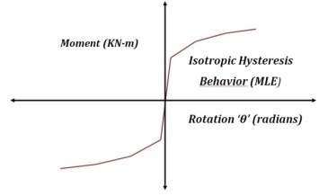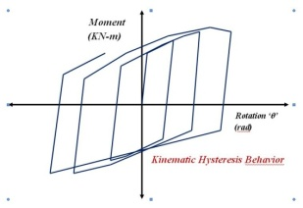**

(a) (b)

Figure 1. Comparison Of Semi-Rigid Connection Hysteresis Behavior (a) Isotropic Hysteresis Behavior OfMLE Link; (b) Kinematic Hysteresis Behavior OfMLP Link Element

Figure 2 (a) describes the typical generic moment-rotation (M-θ) curve adopted for SR connections. The M-θ values of the curveare dependent on three parameters, namely, stiffness, flexural strength,andductility. These parameters are based on the AISC 341-16 criterion for seismic strengthening of beam-column connections for a special moment resisting frames. The flexural strength ofconnectionsis taken in such a way that the ratio of the yield moment capacity (Myc) of connection to the plastic moment capacity of the connection (Mpc) is maintained at 2/3. The flexural strength of connection at the column face should be 0.8 times the plastic moment capacity of the connected beam (Mpb)to fulfill the story drift limit ( >0.04 rad), prescribed by ASCE 341-16 guidelines. The degree of semi-rigidity of SR connections is defined by two parameters;thestiffness parameter α and the strength parameter β. [Chan et al. (2000)](#_ENREF_5)limit the ductility of connectionstoa minimum of 0.04 rad for SR or partially restrained connections. The connection parameters are defined as follows:

$α={S_{ki}}/{\left(\frac{EI_{b}}{L_{b}}\right)}$ and $β=\frac{Mpc}{{Mpb}_{}}$ (1)

whereSki is the initial connection stiffness; EIb/Lbis the adjoiningbeamflexural stiffness

In SAP2000, the rotational nonlinearity is considered in R3 direction for both types of link elements. The material nonlinearity for the flexural plastification is considered as concentrated default plastic hinges as per ASCE 41-13 as explained in Figure 2(b). The second order P-Δ effects are considered for accounting geometric nonlinearity. The panel zone behavior of joints is excludedfrom the study.

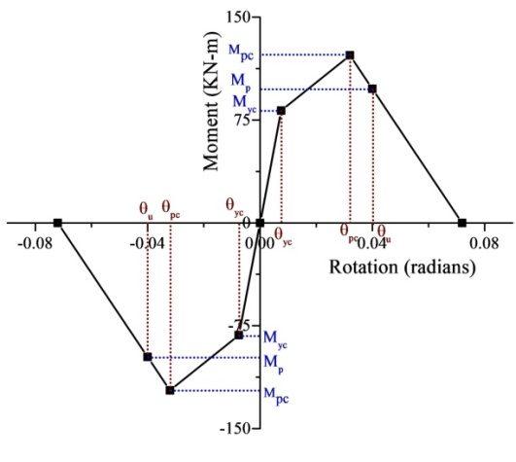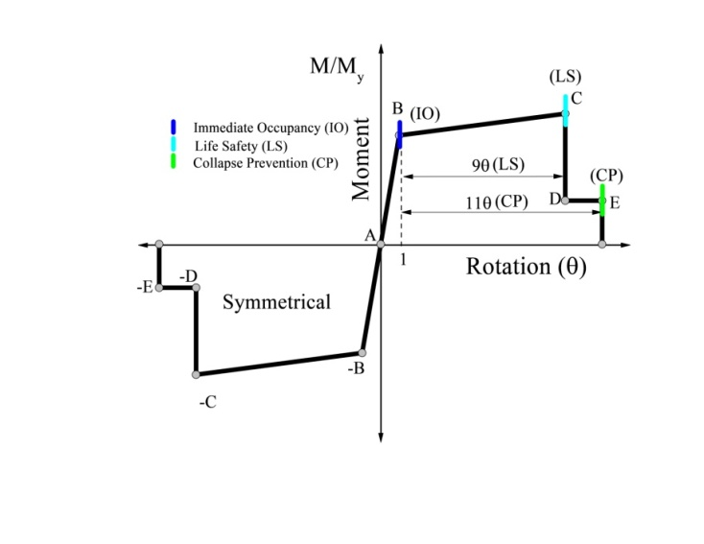

(a) (b)

Figure 2. (a) Typical Moment-Rotation Curve for Semi-Rigid Connection (b) Hysteresis Curve for Default Plastic Hinges as per ASCE-41-13

***2.2 Analysis***

*2.2.1 Nonlinear Static Procedure- Pushover Analysis (POA)*

The nonlinear static pushover analysis of rigid and semi-rigid framesare performed at 4% of the total height of monitored displacement up to the collapse level. The fundamental mode shape lateral load pattern is selected for the lateral push. The capacity curves of considered frames are obtained from the pushover analysis.

*2.2.2 Nonlinear Time History Analysis (NTHA)*

The standard NTHA using Hilber-Hughes-Taylor time integration approach with default parameters (gamma=0.5 and beta=0.25) are selected for an analytical simulation purpose. The 5% proportional Rayleigh damping for first and second vibration modes are considered. The second order P-Δ effect is also considered in the analysis. In all, 63 NTHA simulations were executed for the10-story rigid and semi-rigid frames.

**3. NUMERICAL STUDY**

For the numerical study, a 10-story frame with rigid and semi-rigid frames with MLE and MLP link elements are considered. The 10-story frame has an identical height of 3.2 m each with three bays of 5 m each in both directions. The building comprises of special moment resisting frames with rigid beam to column connections. The sections are selected to assure the capacity design concept, i.e., the stiffness of columns are 1.2 times the connected beam stiffness (strong column-weak beam; SCWB) as shown inFigure3(a). The frames are loaded by150 mm thick concrete slab along with floor finish and 225 mm thick partition wall load. The effective gravity load consists of 20KN/m as dead load, 15 KN/m as roof load and 4 KN/m as live load, uniformly distributed over beams. The special moment resisting frames are designed for seismic strengthening as per Indian standards [IS-800 (2007)](#_ENREF_12), IS 1893-Part-1([2016](#_ENREF_14)) and IS 875([1987](#_ENREF_13)). The seismic design parameters considered for design are zone factor (Z=0.36, Zone V), soil type (medium soil), importance factor (I=1 for high rise commercial building), and response reduction factor for frame type (for SMRF, R=5). The three different varieties of ground motions as shown in Figure 3(b) considered for seismic simulations are far-field (FF), Landers; near-field with directivity effects (NFD), Imperial Valley; and near-field with fling step effect (NFF), Chi-Chi TCU072. The time histories of acceleration of the ground motions are shown in Figure 3(b).

D:\Vijay Sharma\SAP DIRECTORY\Conference 2_SEC 2018_Jadavpur University\10S Building Model\10S- Building Frame.emf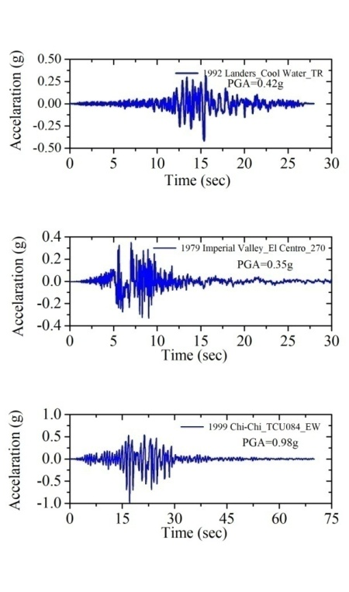

(a) (b)

Figure 3. (a) 10-Story Frame with Gravity Loading, And (b) Earthquake Records for Far-Field (Landers), Near-Field With Directivity (Imperial Valley) And Near-Field With Fling Step (TCU084)

A typical internal frame is selected for the numerical study. Two types of beam-column connection are used, namely, rigid and two sets of semi-rigid (SR) connections for seismic performance evaluation. The semi-rigidity in the beam-column connections is defined by the two dimensionless parameters, i.e., stiffness (α) and strength (β) parameters. The semi-rigid frames are designated as (i) A1-MLE and A1-MLP with parameters α=7; β=0.75; (ii) A2-MLE and A2-MLP with α=12; β=1.0; and (iii) A3-MLE and A3-MLP with α=20; β=1.5. The MLE and MLP are considered to categorize SR frames with multilinear elastic link connection and multilinear plastic link connection. The responses obtained from SR frames are comparedwith those of the rigid frame (A0-Rigid). The two-dimensional POA and NTHA are executed for the frames in SAP2000. The material nonlinearity in all frames modeled as concentrated plasticity in the form of default plastic hinges as per ASCE-41-13 at the beam and column ends.

***3.1 Capacity Curve or Pushover Curve***

The capacity curves for the 10-story rigid and semi-rigid frames are obtained from POA as shown in Figure 4. The capacity curve estimates the overall capacity of the structureobtained from nonlinear static analysis or pushover analysis. The capacity curve is a plot of capacity of the structure against the roof displacement. It is used to assess the behavior of structure in the inelastic range. Figure 4 shows that there is a considerable reduction in the maximum base shear in the semi-rigid frames as compared to the rigid frames. The elastic-plastic (curved portion) and theplastic portion (flat portion) of the curveare significantly increased in the case of the semi-rigid frames. Before the NTHA responses were obtained, this comparison was made in order to assess the ductility behavior of the semi-rigid frame in comparison to the rigid frame.

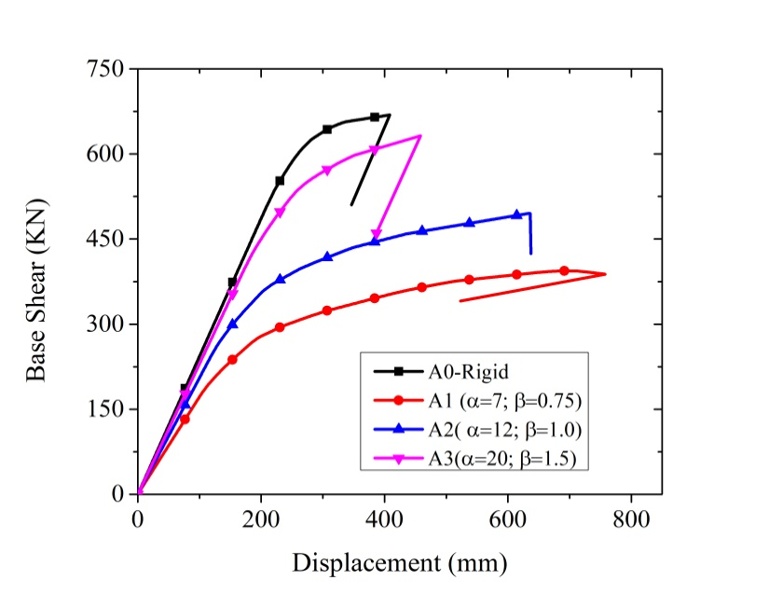

Figure4. Capacity Curve for Rigid And Semi-Rigid Frames

**4. RESULTS AND DISCUSSIONS**

The seismic energy dissipation in SR frames with a multi-linear elastic link (MLE) and multi-linear plastic link (MLP) are evaluated for the 10-storyframe at three PGA levels under the far-field and near-field ground motions. Further, the responses obtained from the semi-rigid (SR) MLE and MLP frames are compared to the rigid frame. The response quantities for comparison are the roof displacement (Droof), the maximum base shear (Vmax), the maximum inter-story drift ratio (% MIDR), the formation of total number of plastic hinges (TH), the SRSS values of maximum plastic hinge rotation (HRSRSS) and the energy dissipation in the form of modal damping (ED) and link hysteretic energy (EC). Further, the comparisons are carried out for different types of earthquakes.

***4.1 Energy dissipations in the semi-rigid and the rigid frames***

Figure 5 shows the link hysteretic energy and the modal damping energy in the SR frames for the three types of the earthquake for the PGA level of 0.6g. It is seen from the figure that the link hysteretic energy is less than the modal damping energy for all the three types of the earthquake. Further, both energies are more for the near field earthquake; they are maximum for the near field earthquake with the fling step effect. From the figure, it is also observed that the link hysteretic energy is more for the multilinear plastic link models as compared to the multi-linear elastic models. The reverse trend is observed for the modal energy. Figure 6 shows the distribution of different types of energy in the two types of modeling of semi-rigid joints, namely, multilinear elastic and plastic for the near field earthquake with the fling step effect for the PGA level of 0.6g. It is seen from the figure that, for the multilinear elastic link model, the modal energy consumes most of the input energy; very less amount of the input energy is dissipated in the form of other energies. As a consequence, the energy dissipation by way of the formation of plastic hinges is small leading to the formation of very less number of plastic hinges in the semi-rigid frame modeled with multilinear elastic connections as shown in Table 1. The same figure shows that for the multilinear plastic link model, the link hysteretic energy and the modal damping energy together consume most of the input energy; not much energy is left to be dissipated by way of the formation of plastic hinges. As a consequence, the number of plastic hinges formed in the semi-rigid frame modeled with multilinear plastic link connection is also found to be very less as shown in Table 1.

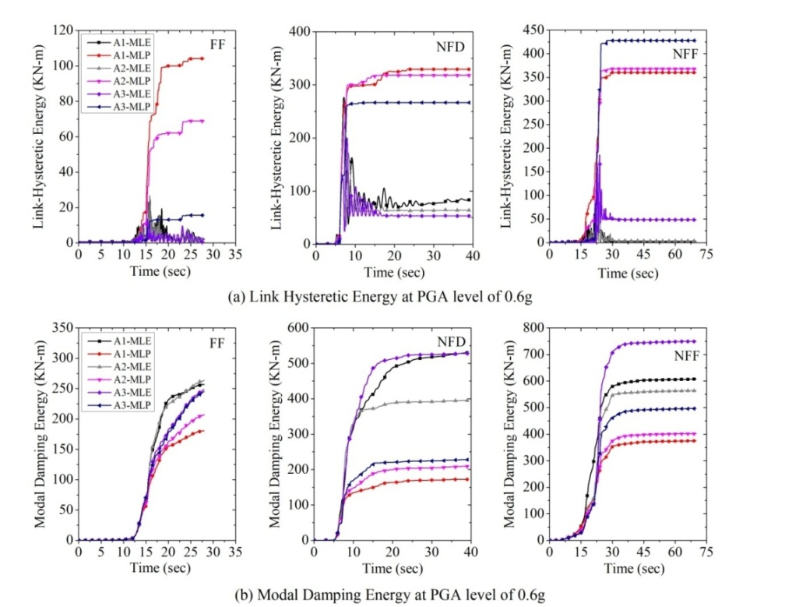

Figure 5. Comparison of (a) Link Hysteretic Energy, and (b) Modal Damping Energy Under FF, NFD and NFF Ground Motion At PGA Level Of 0.6g

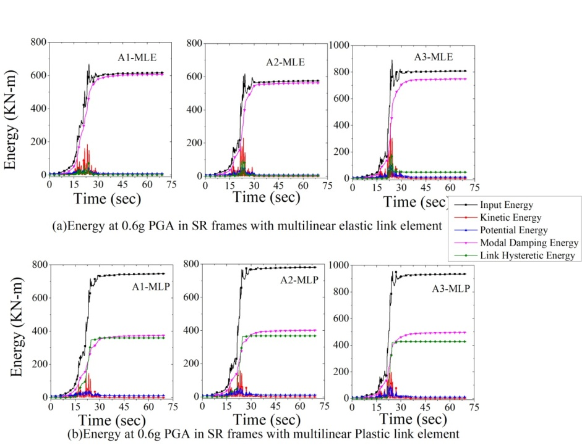

Figure 6. Energy in SR Frames with (a) Multilinear Elastic Link Element, and (b) Multilinear Plastic Link Element Under Chi-Chi TCU084 (NFF) Ground Motion At PGA Level Of 0.6g

Figure 7 shows the distribution of energy in the rigid frame for the far field and the near field earthquakes. It is seen from the figure that the modal energy together with other energies consumes only a part of the total input energy; much energy is left which gets dissipated in the formation of plastic hinges. Because of this reason, a large number of plastic hinges are formed in the rigid frame as shown in Table 1.

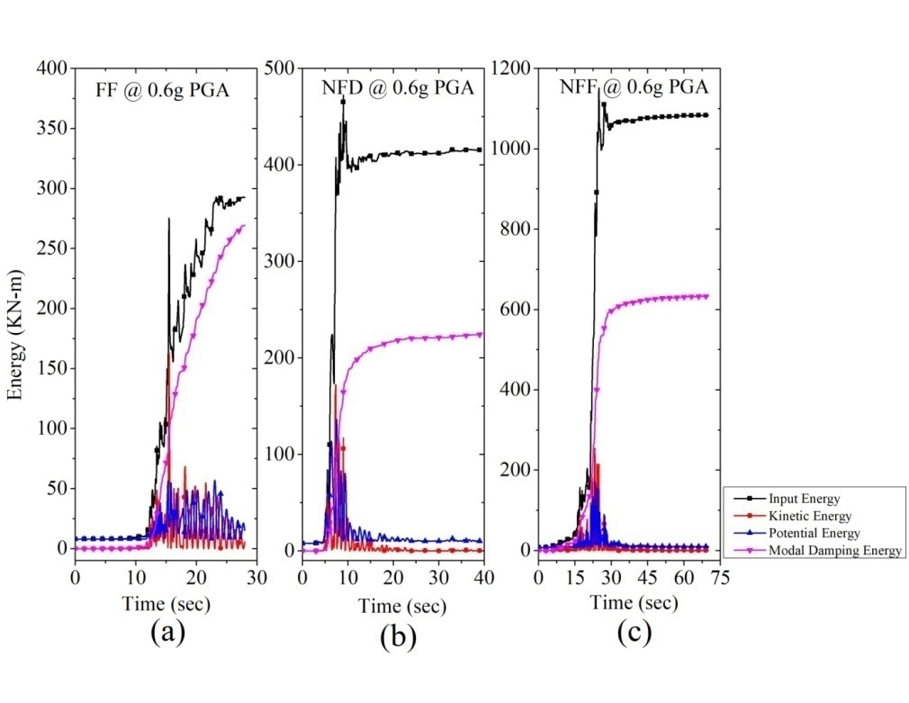

Figure 7. Energy in Rigid At 0.6g PGA For (a) FF, (b) NFD, and (c) NFF

Table1. Comparison of Formation of Total Number of Plastic Hinges

|  |  |  |  |  |  |  |  |  |
| --- | --- | --- | --- | --- | --- | --- | --- | --- |
| **Building Model** | **Total Number of Plastic Hinges (TH)** | | | | | | | |
| **FF** | |  | **NFD** | |  | **NFF** | |
| **0.4g** | **0.6g** |  | **0.4g** | **0.6g** |  | **0.4g** | **0.6g** |
| A1-MLE | 0 | 2 |  | 6 | 12 |  | 0 | 2 |
| A1-MLP | 0 | 2 |  | 4 | 7 |  | 0 | 0 |
| A2-MLE | 0 | 2 |  | 6 | 6 |  | 3 | 5 |
| A2-MLP | 0 | 0 |  | 4 | 6 |  | 2 | 3 |
| A3-MLE | 0 | 2 |  | 6 | 9 |  | 4 | 8 |
| A3-MLP | 0 | 1 |  | 4 | 6 |  | 4 | 6 |
| A0\_Rigid | 0 | 18 |  | 40 | 51 |  | 49 | 62 |

Tables 3 and 4 show the distributions of the link hysteretic energy and the modal energy for different cases of study. The tables confirm the observations made from Figures 5 and 6 for PGA levels other than the PGA level of 0.6g. It is to be noted that the modal energy in the case of the rigid frame is less than that of the semi-rigid frame with the multilinear elastic link model (A3) having ‘α’=20 and ‘β’=1.5.

Table 2. Comparison of SRSS of Maximum Plastic Hinge Rotations in radians

|  |  |  |  |  |  |  |  |  |
| --- | --- | --- | --- | --- | --- | --- | --- | --- |
| **Building Model** | **SRSS (radians)** | | | | | | | |
| **FF** | |  | **NFD** | |  | **NFF** | |
| **0.4g** | **0.6g** |  | **0.4g** | **0.6g** |  | **0.4g** | **0.6g** |
| A1-MLE | 0.0000 | 0.0007 |  | 0.0071 | 0.0408 |  | 0.0000 | 0.0005 |
| A1-MLP | 0.0000 | 0.0003 |  | 0.0057 | 0.0243 |  | 0.0000 | 0.0005 |
| A2-MLE | 0.0000 | 0.0000 |  | 0.0050 | 0.0389 |  | 0.0005 | 0.0027 |
| A2-MLP | 0.0000 | 0.0000 |  | 0.0044 | 0.0273 |  | 0.0001 | 0.0025 |
| A3-MLE | 0.0000 | 0.0002 |  | 0.0044 | 0.0268 |  | 0.0078 | 0.0191 |
| A3-MLP | 0.0000 | 0.0000 |  | 0.0015 | 0.0232 |  | 0.0040 | 0.0062 |
| A0\_Rigid | 0.0000 | 0.0028 |  | 0.0133 | 0.0535 |  | 0.0371 | 0.0596 |

Table 3. Absolute Link Hysteretic Energy in the Semi-rigid MLE and MLP Connections

|  |  |  |  |  |  |  |  |  |  |  |  |
| --- | --- | --- | --- | --- | --- | --- | --- | --- | --- | --- | --- |
| **Building Model ID** | **Link Hysteretic Energy (KN/m)** | | | | | | | | | | |
| **FF** | | |  | **NFD** | | |  | **NFF** | | |
| **0.2g** | **0.4g** | **0.6g** |  | **0.2g** | **0.4g** | **0.6g** |  | **0.2g** | **0.4g** | **0.6g** |
| A1-MLE | 3.94 | 15.10 | 24.96 |  | 29.54 | 110.42 | 276.60 |  | 19.89 | 36.96 | 74.64 |
| A1-MLP | 0.82 | 30.39 | 104.14 |  | 31.00 | 150.51 | 329.97 |  | 27.43 | 147.18 | 359.97 |
| A2-MLE | 2.04 | 10.29 | 26.83 |  | 17.32 | 97.76 | 236.86 |  | 27.75 | 70.15 | 100.35 |
| A2-MLP | 0.00 | 11.03 | 68.83 |  | 15.09 | 138.00 | 318.35 |  | 42.94 | 177.07 | 368.01 |
| A3-MLE | 1.30 | 4.11 | 13.62 |  | 5.64 | 70.12 | 200.14 |  | 34.71 | 110.51 | 185.92 |
| A3-MLP | 0.00 | 0.04 | 15.62 |  | 0.09 | 82.64 | 266.69 |  | 32.71 | 213.29 | 427.71 |

Table 4. Absolute Modal Damping Energy in the rigid and the Semi-rigid MLE and MLP Connections

|  |  |  |  |  |  |  |  |  |  |  |  |
| --- | --- | --- | --- | --- | --- | --- | --- | --- | --- | --- | --- |
| **Building Model ID** | **Modal Damping Energy (KN/m)** | | | | | | | | | | |
| **FF** | | |  | **NFD** | | |  | **NFF** | | |
| **0.2g** | **0.4g** | **0.6g** |  | **0.2g** | **0.4g** | **0.6g** |  | **0.2g** | **0.4g** | **0.6g** |
| A1-MLE | 33.66 | 132.64 | 256.66 |  | 77.48 | 174.49 | 529.63 |  | 81.91 | 247.27 | 607.22 |
| A1-MLP | 32.97 | 105.27 | 180.38 |  | 49.32 | 105.32 | 171.83 |  | 67.77 | 189.84 | 375.08 |
| A2-MLE | 25.78 | 106.64 | 263.73 |  | 66.44 | 244.27 | 395.21 |  | 120.02 | 304.59 | 563.71 |
| A2-MLP | 25.78 | 100.77 | 207.16 |  | 47.92 | 115.08 | 209.15 |  | 86.55 | 212.33 | 401.88 |
| A3-MLE | 27.44 | 109.78 | 248.04 |  | 44.58 | 224.96 | 527.78 |  | 160.46 | 460.50 | 749.28 |
| A3-MLP | 27.44 | 109.79 | 244.72 |  | 44.51 | 116.25 | 227.92 |  | 127.95 | 281.96 | 496.30 |
| A0-Rigid | 29.97 | 119.89 | 269.41 |  | 37.35 | 220.10 | **224.22** |  | 152.40 | 361.73 | 633.04 |

***4.2 Inelastic excursions and plastic hinge formation in the semi-rigid and the rigid frames***

As explained in the above section**,** very less number of plastic hinges are formed inthe semi-rigid frames as compared to the rigid frames. Thus, damages in the form of plastic hinges developed at member ends are much less in the semi-rigid frames. However, considerable inelastic excursion takes place in the plastic link connections dissipating energy through hysteresis loops in the semi-rigid frames as discussed in the above section. Table 1 shows the number of plastic hinges formed for different cases of the study. It is seen from the table that for the far field earthquakes, no plastic hingeis formed at the PGA level of 0.2g. At higher PGA levels, plastic hinges are formed both in the semi-rigid and the rigid frames. In the rigid frames, the large number of the plastic hinges are formed showing that much of the input energy is dissipated in the plastic hinges formed in the rigid frame, as opposed to the semi-rigid frames. Further, it is noticed that the number of plastic hinges in the rigid frame is maximum for the near field earthquake with the fling step effect, which is not so for the semi-rigid frame.

Table 2 shows the SRSS of plastic hinge rotations in the semi-rigid and the rigid frames. It is seen from Table 2 that the plastic hinge rotations are significantly higher in the rigid frames as compared to the semi-rigid frames. It again demonstrates that large amount of the seismic energy is dissipated in the plastic hinges for the rigid frames. Very less values of the SRSS of plastic hinge rotations is exhibited in the semi-rigid frames, as it would be expected.

***4.3 Comparison of the maximum roof displacements between the semi-rigid and the rigid frames***

Table 5 shows the maximum roof displacements in the semi-rigid and the rigid frames. It is seen from the table that the type of modeling of the semi-rigid frame has a distinct effect on the maximum roof displacement for the near field earthquakes. For the MLE model, the maximum roof displacements are more as compared to the MLP model for the near field earthquakes; this difference is more for the NFF at higher PGA level, i.e., 0.6g. The maximum roof displacements of the rigid frame are found to be less than the semi-rigid frame with A3-MLE (α=20 and β=1.5) model at higher PGA levels. For the PGA of 0.2g, when the frames remain in the elastic state, the maximum roof displacements of both the rigid and the semi-rigid frames remain nearly the same.

Table 5. Comparison of Roof Displacements Between Semi-Rigid and Rigid Frames

|  |  |  |  |  |  |  |  |  |  |  |
| --- | --- | --- | --- | --- | --- | --- | --- | --- | --- | --- |
| **Building Model** | **Roof displacement (mm)** | | | | | | | | | |
| **FF** | |  | **NFD** | | |  | **NFF** | | |
| **0.4g** | **0.6g** |  | **0.2g** | **0.4g** | **0.6g** |  | **0.2g** | **0.4g** | **0.6g** |
| A1-MLE | 141.05 | 191.47 |  | 271.10 | 570.18 | 1084.28 |  | 202.58 | 296.60 | 473.78 |
| A1-MLP | 143.74 | 204.74 |  | 210.22 | 536.18 | 937.13 |  | 180.40 | 304.60 | 398.14 |
|  |  |  |  |  |  |  |  |  |  |  |
| A3-MLE | 143.94 | 216.00 |  | 187.41 | 395.66 | 583.82 |  | 319.40 | 465.77 | 563.57 |
| A3-MLP | 143.94 | 215.37 |  | 187.41 | 311.06 | 502.67 |  | 275.38 | 336.83 | 429.35 |
|  |  |  |  |  |  |  |  |  |  |  |
| A0 | 149.77 | 223.02 |  | 170.07 | 322.17 | 434.63 |  | 299.78 | 388.20 | 458.54 |

Figure 8 compares the typical time histories of roof displacements at 0.6 PGA level for the three types of earthquakes between the rigid and the semi-rigid frames.

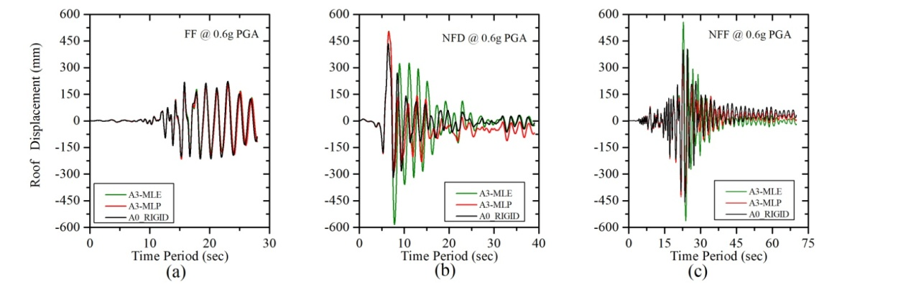

Figure 8. Comparison of the Time Histories of Roof Displacement at the PGA Level of 0.6g for Different Types of Ground Motions Between the Semi-Rigid and Rigid Frames

***4.4 Comparison of the maximum base shears between the semi-rigid and the rigid frames***

Table 6 shows the maximum base shears in the semi-rigid and the rigid frames for different earthquakes. It is seen from the table that the base shears in the rigid frames are significantly higher than those of the semi-rigid frames. The difference increases with the increase in the PGA level. Further, it is observed that in the semi-rigid frame, the MLP model provides less base shear as compared to the MLE model. With the increase in the degree of the semi-rigidity, this difference is reduced,and the base shears become nearly the same for the two models.

Table 6. Comparison of Maximum Base Shear at different PGA level

|  |  |  |  |  |  |  |  |  |  |  |  |  |  |  |  |  |  |  |
| --- | --- | --- | --- | --- | --- | --- | --- | --- | --- | --- | --- | --- | --- | --- | --- | --- | --- | --- |
| **Building Model ID** | **Base Shear (KN)** | | | | | | | | | | | | | | | | | |
|  | **FF** | |  | | **NFD** | | | | |  | | **NFF** | | | | |
| **0.4g** | | **0.6g** | |  | | | **0.2g** | **0.4g** | **0.6g** | |  | **0.2g** | | | **0.4g** | **0.6g** | |
| A1-MLE | 401.71 | | 522.66 | |  | | 359.27 | | 496.14 | 623.76 | |  | | 340.82 | 443.97 | | 516.97 | |
| A1-MLP | 397.40 | | 512.23 | |  | | 348.81 | | 491.57 | 591.37 | |  | | 318.14 | 359.84 | | 421.63 | |
|  |  | |  | |  | |  | |  |  | |  | |  |  | |  | |
| A2-MLE | 477.38 | | 548.12 | |  | | 410.25 | | 578.08 | 714.21 | |  | | 434.23 | 538.23 | | 596.49 | |
| A2-MLP | 438.57 | | 523.90 | |  | | 367.19 | | 577.59 | 709.26 | |  | | 413.85 | 491.87 | | 560.35 | |
|  |  | |  | |  | |  | |  |  | |  | |  |  | |  | |
| A3-MLE | 455.45 | | 683.49 | |  | | 447.40 | | 698.58 | 888.12 | |  | | 562.87 | 712.52 | | 743.75 | |
| A3-MLP | 455.10 | | 635.26 | |  | | 447.16 | | 698.58 | 886.58 | |  | | 545.15 | 704.76 | | 790.90 | |
|  |  | |  | |  | |  | |  |  | |  | |  |  | |  | |
| A0\_RIGID | 448.85 | | 665.03 | |  | | 419.42 | | 749.67 | 1015.09 | |  | | 643.40 | 869.05 | | 968.85 | |

***4.5 Comparison of the maximum inter-story drift ratios between the semi-rigid and the rigid frames***

The variations of the maximum inter-story drift ratios (MIDR) along the story height are shown inFigure9 at the PGA level of 0.4g and 0.6g for the three different earthquakes. It is observed from the figure that the maximum MIDR for the near field earthquakes occurs at the third story level, while for the far field earthquake it is found to occur at the second story level. The MIDR is more in the semi-rigid frame as compared to the rigid frame as it would be expected. However, in the semi-rigid frame the maximum MIDR is influenced by the type of the modeling of the semi-rigid frame and the earthquake. For the NFD earthquake, A1-MLE model provides the peak MIDR. For NFF earthquake, A3-MLE model provides the peak MIDR.

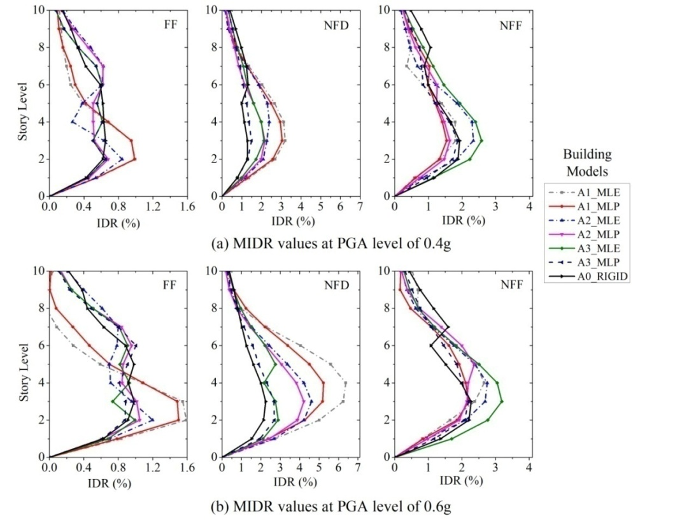

Figure 9. Variations of % maximum inter-story drift ratio (a) at 0.4g, and (b) at 0.6g PGA level

**5. CONCLUSIONS**

The seismic energy dissipations and the responses of 10-story semi-rigid and rigid steel frames are investigated at three PGA levels under three different types of earthquakes, namely, the far-field and the near-field (with directivity and fling step effects). The three scaled PGA levels are typically described as the low, medium or design level, and high or severe level of earthquakes. A nonlinear time history analysis is performed to obtain the energy dissipations and the responses. The semi-rigid frame is modeled in two ways, namely, the beam-column joints modeled as the multilinear elastic and plastic connections. The degree of semi-rigidity is considered as an important variable parameter. The results of the numerical study lead to the following conclusions:

1. The modes of the dissipation of the input seismic energy are different in the semi-rigid and the rigid frames; in the rigid frame, the modal energy together with the hysteretic energy in the plastic hinges dissipates nearly most of the input energy; on the other hand, in the semi-rigid frames, most of the seismic energy is dissipated by the modal energy and the link hysteretic energy.
2. In the semi-rigid frame, the link hysteretic energy is less than the modal energy; for the MLE model, the modal energy consumes most of the input energy and a little hysteretic energy,and other energies consume the rest of the input energy; for the MLP model, most of the input energy is dissipated by combination of comparable amount of link hysteretic and modal damping energy.
3. The number of plastic hinges formed in the semi-rigid frames are far less than that formed in the rigid frame; the type of the modeling of the semi-rigid frame does not have a significant effect on the number of the plastichinge formed.
4. The roof displacements are more for the semi-rigid frames as compared to the rigid frame at higher PGA levels; however, the roof displacements are nearly the same for both semi-rigid and rigid frames at the PGA level of 0.2g: the roof displacement is more for the NFF earthquake.
5. The base shear is less in the semi-rigid frames as compared to the rigid frame; in the semi-rigid frames, the MLP model provides less base shear than the MLE model and this difference decreases with the increase in the degree of semi-rigidity.
6. The maximum inter-story drifts in the semi-rigid frames occur at the third floor level for the near field earthquake; the type of the joint modeling and the nature of earthquake influence the peak MIDR; for the NFD earthquake, the A1-MLE model provides the peak MIDR, while for the NFF earthquake, A3-MLE provides the peak MIDR.

**6. References**

Abolmaali, A., J. H. Matthys, M. Farooqi and Y. Choi (2005). Development of moment–rotation model equations for flush end-plate connections.Journal of Constructional Steel Research 61(12): 1595-1612.

Aksoylar, N. D., A. S. Elnashai and H. Mahmoud (2011). The design and seismic performance of low-rise long-span frames with semi-rigid connections. Journal of Constructional Steel Research 67(1): 114-126.

ANSI/AISC (2016). ANSI/AISC 360-16: Specification for Structural Steel Buildings .American Institute of Steel Construction, Chicago.

ASCE 41-13 (2014): Seismic Evaluation and Retrofit of Existing Buildings. American Society of Civil Engineers, Reston, Virginia 20191

Chan, S.-L. and P.-T. Chui (2000). Non-linear static and cyclic analysis of steel frames with semi-rigid connections, Elsevier.

Eurocode 8 (2005) Design of structures for earthquake resistance-part 1: general rules, seismic actions and rules for buildings.European Committee for Standardization, Brussels.

ANSI/AISC 341-16 (2016). Seismic Provision for Structural Steel Buildings, American Institute of Steel Construction, Chicago.

Díaz, C., P. Martí, M. Victoria and O. M. Querin (2011). Review on the modelling of joint behaviour in steel frames.Journal of constructional steel research 67(5): 741-758.

Elnashai, A. and A. Elghazouli (1994). Seismic behaviour of semi-rigid steel frames. Journal of Constructional Steel Research 29(1-3): 149-174.

Eurocode (2005). Eurocode 3: Design of Steel Structures (Part 1-8: Design of Joints).European Committee for Standardization, Brussels.

FEMA (2000). FEMA‐355D:State of the art report on connection performance FEMA Washington, DC.

IS-800 (2007). General Construction in Steel-Code of Practice 3rd Revision Bureau of Indian Standards, New Delhi

IS 875-Part 1(1987) Code Of Practice For Design Loads (Other Than Earthquake) For Buildings And Structures. Beureau of Indian Standards, New Delhi

IS 1893 (2016) Criteria for earthquake resistant design of structures.Part 1 General Provisions and Buildings (Sixth Revision) Bureau of Indian Standards, New Delhi

Kunnath, S. K. and E. Kalkan (2004). Evaluation of seismic deformation demands using nonlinear procedures in multistory steel and concrete moment frames. ISET Journal of Earthquake Technology 41(1): 159-181.

Lemonis, M. (2018). Steel moment resisting frames with both joint and beam dissipation zones. Journal of Constructional Steel Research 147: 224-235.

Nader, M. and A. Astaneh (1991). Dynamic behavior of flexible, semirigid and rigid steel frames. Journal of Constructional Steel Research 18(3): 179-192.

Sekulovic, M. and M. Nefovska-Danilovic (2008). Contribution to transient analysis of inelastic steel frames with semi-rigid connections. Engineering Structures 30(4): 976-989.

1. Research Scholar, Malaviya National Institute Of Technology, Jaipur, INDIA, [2017rce9016@mnit.ac.in](mailto:2017rce9016@mnit.ac.in) [↑](#footnote-ref-1)
2. Professor, National Center for Disaster Mitigation and Management, Malaviya National Institute Of Technology, Jaipur, INDIA, [shrimali](mailto:emailaddress@canterbury.ac.nz)mk@gmail.com [↑](#footnote-ref-2)
3. Professor, National Center for Disaster Mitigation and Management, Malaviya National Institute Of Technology, Jaipur, INDIA, [sdbharti@gmail.com](mailto:sdbharti@gmail.com) [↑](#footnote-ref-3)
4. Adjunct Professor, National Center for Disaster Mitigation and Management, Malaviya National Institute Of Technology, Jaipur, INDIA, [tushar\_k\_datta@yahoo.com](mailto:tushar_k_datta@yahoo.com) [↑](#footnote-ref-4)