**Design Method for Base-isolation structure combined with Active Control Based on the Limitation Conditions of the Responses and Control Force**

**DOI 10.37153/2686-7974-2019-16-928-939**

Yinli CHEN[1], Daiki SATO[2], Kou MIYAMOTO[3] and Jinhua SHE[4]

**ABSTRACT**

The linear quadratic regulator (LQR) is widely used in active structural controls (ASCs). However, at the present stage, the influence of the design parameters (LQR weighing matrices) on the vibration characteristics of the control system has not been explicitly expressed. In particular, the estimation of the required control force has not been conducted. Therefore, the LQR weighting matrices are mainly selected by trial and error approach, making it very difficult to design a control system that achieves the desired performance. To solve this problem, an equivalent model of the single-degree-of-freedom active model (structure with active control) is constructed, using which, a calculation method for the weighing matrices that does not require a trial and error approach to satisfy the desired control performance is proposed. Thereafter, the concept of the transitional response spectrum, which is widely used in structural design, is promoted as a control force spectrum that can be used to estimate the maximum control force. Finally, the design of a passive base isolation (PBI) reactor is discussed as an example, and the performance-oriented design method for the PBI structure combined with ASC is proposed that simultaneously satisfies the limitation conditions of the responses and control force.

*Keywords: Active structure control; Base-isolation structure; Linear-quadratic regulator (LQR), Equivalent model*

**1. INTRODUCTION**

To minimize damages to superstructures due to violent earthquakes and to resume operation immediately after earthquakes, in Japan, the use of passive base isolation (PBI) structures increased sharply after the great Hanshin earthquake (Y. Tanaka *et al*., 2011). At present, the PBI structure is widely used globally, not only in public buildings and high-rise apartments, but also in major constructions (G. P. Warn *et al*., 2012). Applying the PBI structure to nuclear power stations is a topic of worldwide research (S. Ryu *et al*., 2013, N. Takemi *et al*., 2013, A. S. Whittaker *et al*., 2014, H. Asano *et al*., 2014 and M. Kumar *et al*., 2017). However, by the end of 2017, there were no instances of nuclear power stations using the PBI structure in Japan (T. Hiraki *et al*., 2017). A possible reason for this is that though the PBI structure can decrease the absolute acceleration response on superstructures, it is difficult to control the displacement response within the allowable range, because the natural period of the PBI layer is relatively long (M. Kumar *et al*., 2017). To solve this problem, the authors conducted research on the PBI structure combined with active structural control (ASC) (Y. Chen *et al*., 2018 and K. Miyamoto *et al*., 2018). The linear quadratic regulator (LQR) is a widely used method in ASC controller design. The controller designed by LQR ensures asymptotic stability and minimizes control energy (A. Preumont *et al*., 2008). Thus, LQR is suitable for vibration control, and is widely used in ASCs (F. Casciati *et al*., 2012 and S. Korkmaz *et al*., 2011).

In conventional structural design, by using the response spectra of earthquake waves, it is possible to estimate the maximum responses of the model, without the need of numerical simulations. If the equivalent natural period and equivalent damping ratio of the ASC model can be described theoretically, the response spectrum can be used at the controller design stage, and the controller design can be simplified. However, at the present stage, using the LQR weighing matrices as parameters of LQR design, the effects on the equivalent natural period and the equivalent damping ratio of the control system are ambiguous. Hence the LQR weighing matrices are chosen using a trial and error approach, to achieve the desired control performance (A. Preumont *et al*., 2008). To solve this problem, T. Fujii *et al*. considered the single degree of freedom (SDOF) semi-active structural control system as a research topic, and theoretically clarified the influence of the LQR weighing matrices on the vibration characteristics of the control system (T. Fujii *et al*., 2013). However, the model used in T. Fujii *et al*. did not consider the structural internal damping, thus limiting its fields of application, making it incompatible with the model of the PBI structure combined with ASC. On the other hand, V. K. Elumalai *et al*. considered the SDOF magnetic levitation system as a research topic, and the paper proposed an algebraic method for calculating the LQR weighing matrices, which achieves the equivalent natural angular frequency and equivalent damping ratio (V. K. Elumalai *et al*., 2017). However, V. K. Elumalai *et al*. did not investigate the impact of specific factors on control system vibration characteristics, making it difficult to use the proposed method in ASC design. Moreover, when ASC is applied in construction, the required control input can be significantly large, as expected. It is therefore necessary to deduce the theoretical equation that can be used to theoretically estimate the maximum control force.

In this paper, the performance-oriented design method is proposed that simultaneously satisfies the limitation conditions of the responses and control force. Moreover, it requires neither trial and error nor numerical simulations, which simplifies the controller design.



Figure 1. SDOF model with active control

The equivalent model [Figure 1(b)] of the active model [Figure 1(a)], considering structural internal damping, is constructed. The influence of the design parameters (weighing matrices) on the structural characteristics (stiffness coefficient and damping coefficient) and vibration characteristics (natural period and damping ratio) is theoretically clarified. A calculation method for the LQR weighing matrices is proposed by using the constructed equivalent model to achieve the desired equivalent natural period and equivalent damping ratio. Furthermore, a new spectrum of a specific earthquake wave called the control force spectrum is proposed, which can be used to estimate the necessary maximum control force at the controller design stage. This makes it possible to calculate the weighing matrices for the design of the controller, which simultaneously satisfy the limitation conditions of responses and control force. Moreover, it requires neither trial and error nor numerical simulations. The remainder of the paper is organized as follows.

The mathematical modeling of the SDOF active model is presented in Section 2. Section 3 presents the construction of the equivalent model of the active model, considers the influence of the weighing matrices on the structural characteristics of the equivalent model, and details the calculation method for the weighing matrices. A control force spectrum is proposed in Section 4. In Section 5, a controller design method for the PBI structure with ASC that simultaneously satisfies the limitation conditions of responses and control force is proposed. Section 5 also presents a discussion of the design of the PBI type reactor as an example, to confirm the validity of the proposed design method.

**2. Design of control system**

Given that it is necessary to solve the algebraic Riccati equation (ARE), the structure is assumed to be an SDOF model. The dynamics of an SDOF control system are described by the following equation:

 (1)

where *m* is the mass; *c*0 is the damping coefficient; *k*0 is the stiffness coefficient of the structure, which is defined by (2) and (3); *x*(*t*), *d*(*t*), and *u*(*t*) are the response displacement, disturbance force, and control force, respectively.

 (2)

 (3)

where *T*0 is the natural period of the structure, and **0 is the damping ratio.

The state-space representation of (1) is

 (4)

where *z*(*t*) is a state vector, *A* is a system matrix, *Bu* is input matrices for *u*(*t*), *Bd* is input matrices for *d*(*t*), which is defined by (5).

 (5a)

 (5b)

 (5c)



Figure 2. Block diagram of control system

Figure 2 presents the block diagram of the control system used in this study.

The feedback control law

 (6)

is used, where *KP* is the state-feedback gain that is designed using the LQR method, which determines the state-feedback gain by minimizing the following performance index:

 (7)

where *R* (> 0) is the weighing matrix for the control force, and *Q* is the weighing matrix (semi-positive) defined by

 (8)

Thus, *KP* is defined as

 (9)

where *P* is a semi-positive symmetrical solution of the following ARE:

 (10)

**3. EQUIVALENT MODEL**

***3.1 Solution of the ARE***

Given that the solution of the ARE is a symmetrical matrix, it is written as

 (11)

Substituting (5), (8), and (11) into (10) yields

 (12)

Rewriting (12) yields

 (13)

Expanding (13) yields

 (14a)

 (14b)

 (14c)

The elements of the *P* matrix, such as *p*11, *p*12, and *p*22 are obtained using the ARE in (10):

 (15)

 (16)

 (17)

Moreover, given that *P* is a semi-positive matrix, it yields

 (18)

Finally, *p*12 and *p*22 are defined as

 (19a)

 (19b)

From (17) and (19), the analytical solution of the ARE can be obtained using the SDOF model.

***3.2 Construction of the equivalent mode***

Substituting (5c) and (11) into (9) , *KP* is

 (20)

where *KP*1 and *KP*2 are

 (21a)

 (21b)

Substituting (20) and (5a) into (6) yields the control force:

 (22)

Substituting (22) into (1) gives the vibration equation of the equivalent model:

 (23)

where *k*eq and *c*eq represent the stiffness coefficient and damping coefficient of the equivalent model and are defined by the following equation.

 (24a)

 (24b)

From (24a), it can be seen that *k*eq is dependent on *k*0, *q*1, and *R*. When *q*1=0, the value of *k*eq is equal to *k*0. When *q*1 is increased, the value of *k*eq increases. When the value of *R* is sufficiently large, the value of *k*eq approaches *k*0.

From (24b), it can be seen that *c*eq is dependent on *c*0, *k*0, *m*, *q*1, *q*2, and *R*. When *q*1=*q*2=0, the value of *c*eq is equal to *c*0. When *q*1 or *q*2 is increased, the value of *c*eq increases. However, the influence of *q*1 on *c*eq is smaller than that of *q*2, given that *q*1 is in the double route. When the value of *R* is sufficiently large, the value of *c*eq approaches *c*0.

As is commonly known, the natural angular frequency , natural period *T*eq, and damping ratio  of the equivalent model are

 (25a)

 (25b)

 (25c)

In addition, the control force of the equivalent model can be obtained by the difference between (1) and (23).

 (26)

From (26), the control force of the equivalent model can be calculated using the responses of the equivalent model and *k*0, *k*eq, *c*0 and *c*eq.

Solving (24a) and (24b), the elements of *Q*, such as *q*1 and *q*2, can be determined by

 (27a)

 (27b)

Furthermore, if the control system is represented in a controllable canonical form, (27) is identical to that proposed by V. K. Elumalai *et al*.

The calculation procedure of the LQR weight selection method is summarized below.

1. Specify the natural period and damping ratio of the structure (*T*0 and ), and calculate the value of *k*0 and *c*0 using (2) and (3).
2. Specify the desired natural period and damping ratio of the control system (*T*eq,tar and *ζ*eq,tar), and calculate the value of *k*eq,tar and *c*eq,tar using (2) and (3).
3. Arbitrarily assign a value to *R*. Even if the value of *R* is arbitrary, it does not affect the control system in this design procedure.
4. Substitute *k*eq,tar, *k*0, and *R* into (27a), and calculate *q*1 in the weighing matrix *Q*.
5. Substitute *c*eq,tar, *m*, *k*0, *c*0, *R*, and *q*1 calculated in Step 4 into (27b), and calculate *q*2 in the weighing matrix *Q*. If *q*2 ≥ 0, use the calculated values of *q*1 and *q*2 to design the control system. If *q*2<0 because the semi-positive limitation of *Q* cannot be satisfied, go back to Step 2 and review *T*eq,tar or *ζ*eq,tar.

Figure 3 presents the flowchart for the calculation method of the weighing matrices.

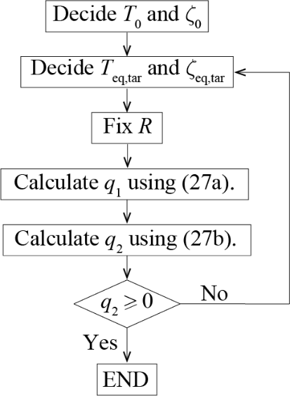

Figure 3. Flowchart of caculate procedure

**4. CONTROL FORCE SPECTRUM**

This section presents the calculation of the theoretical formula for the maximum necessary control force, and the proposal of the control force spectrum.

From (24a) and (24b), when *q*1=0, the equivalent stiffness coefficient *k*eq and equivalent damping coefficient *c*eq are expressed by the following equations:

 (28a)

 (28b)

Therefore, at *q*1=0, the equivalent natural angular frequency *ω*eq, the equivalent natural period *T*eq, and the equivalent damping ratio *ζ*eq are given by the following equations, respectively:

 (29a)

 (29b)

 (29c)

From (28), it can be seen that by setting *q*1 = 0, the equivalent damping ratio *ζ*eq can be adjusted without changing the equivalent natural period *T*eq from initial natural period *T*0 . By substituting (28a) into (26), the following equation can be obtained:

 (30)

Furthermore, by dividing (30) by the weight of the model m, the shear force coefficient of the control force *Cu* can be obtained.

 (31)

where *g* is the gravitational acceleration. Therefore, the shear force coefficient of the maximum necessary control force *Cu*,peak can be calculated using the following equation:

 (32)

where *SV* (*T*0 ,*ζ*eq) is the value of the response velocity spectrum when the equivalent natural period is *T*0 and the equivalent damping ratio is *ζ*eq . Moreover, by substituting *c*0=2*ζ*0*ω*0*m* and *c*eq=2*ζ*eq*ω*0*m* into (32), the shear force coefficient spectrum of the control force (control force spectrum) is

 (33)

From (33), by setting *q*1=0, the control force spectrum *SC* is calculated without using a time domain numerical simulation. By the velocity response spectrum of the earthquake wave *SV*, it is possible to evaluate the magnitude of the control force. Moreover, if the initial natural period *T*0 and the equivalent damping ratio *ζ*eq are fixed, the maximum control force is proportional to the initial damping ratio *ζ*0.

**5. DESIGN METHOD FOR PBI STRUCTURE WITH ASC**

In this section, a controller design method for the PBI structure with ASC, which can satisfy response limitations and control force limitations simultaneously, is proposed using the weighing matrices calculation formulas (27) and the control force spectrum (33). Moreover, the design of the PBI type reactor with ASC is considered as an example, to confirm the validity of the design method.

* 1. ***Publication Quality and Uniformity***

1. Specify the following:

mass of structure *m*

earthquake used in design procedure

limitation of response displacement *x*lim

limitation of response velocity 

limitation of response absolute acceleration 

limitation of initial damping ratio (passive damper) *ζ*0,lim

limitation of shear force coefficient of control force *Cu*,lim

1. Select the equivalent model (equivalent natural period *T*eq and equivalent damping ratio *ζ*eq) that satisfies the limitation conditions of the responses (displacement, velocity, and acceleration) in Step 0, From the response spectrum.
2. Using the control force spectrum (33) of the earthquake wave used in the design procedure, select the model that satisfies the limitation of the shear force coefficient of the control force *Cu*,lim and the limitation of the initial damping ratio *ζ*0,lim , from the equivalent models selected in Step 1. Specify the initial damping ratio *ζ*0 of the equivalent model.
3. Arbitrarily assign a value to *R*, set *q*1=0, and calculate *q*2 using (27b) for the selected models.
4. Calculate the state feedback gain *KP* by (9), using the weighing matrices *Q* and *R* determined in Step 3.
5. Confirm if the designed controller satisfies the limitation conditions, using a time domain numerical simulation.

***5.2 Required Registration***

An artificial earthquake wave is used, specifically, Art Hachinohe (phase characteristic: Hachinohe 1968 EW), which has a pseudo velocity response spectrum *pSV* of 200 cm/s (*ζ*=0.05) in the region after the corner period 0.64 s (Figure 4). In addition, the disturbance force *d*(*t*) is calculated by the following equation:

 (34)

The structure is a PBI reactor building, and the mass of the structure is approximately 3.7×108 kg (S. Ryu *et al*., 2013).



Figure 4 Art Hachinohe wave

(b) Pseudo velocity response spectrum

(a) Accelerogram

1. Limitation conditions:

*x*lim = 40 cm





*ζ*0,lim = 0.1

*Cu*,lim = 0.1

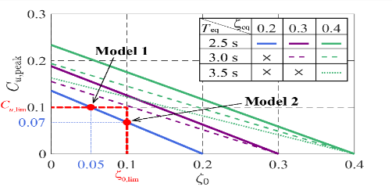

Figure 7 Relationship between *ζ*0 and

*Cu*



Figure 6 Velocity response spectrum

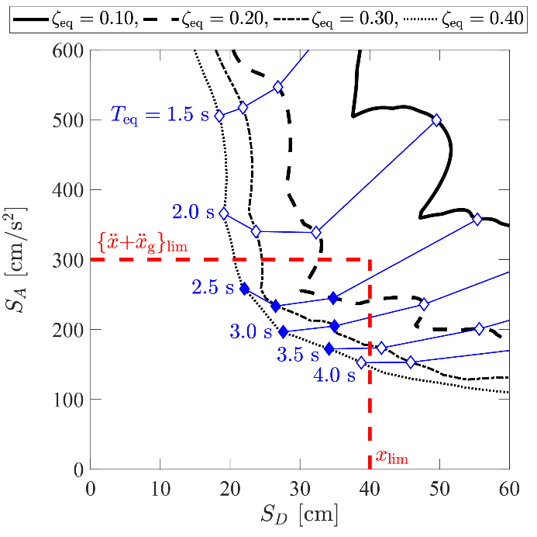

Figure 5 Relationship between *SD* and *SA*

1. Figure 5 presents the relationship between *SD* and *SA* of Art Hachinohe, and Figure 6 presents the *SV* of Art Hachinohe. Given that the reduction in responses is not expected even if the equivalent attenuation factor is set to 0.4 or more, the equivalent attenuation factor was examined up to 0.4. Table 1 presents the six models satisfying the response limitation conditions of Step 0.

Table 1. Peak responses of selectable models

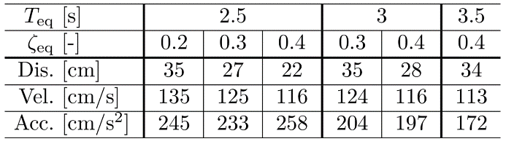

1. Using (33), Figure 7 presents the relationship between the initial damping ratios *ζ*0 and peak shear force coefficient of control force *Cu*,peak of the six models selected in Step 1 and the maximum shear force coefficients of the control force *Cu*,peak. From Figure 7, only the model with the equivalent natural period *T*eq=2.5 s and equivalent damping ratio *ζ*eq=0.2 satisfies the limitation condition of the initial damping ratio of *ζ*0,lim and shear force coefficient of the control force *Cu*,lim. Moreover, the model with the initial damping ratio *ζ*0=0.05 has a relatively less passive damper, and is therefore a passive-damper sensitive model (Model 1). The model with the initial damping ratio of *ζ*0=0.1 has a relatively low control force, and is therefore a control-force sensitive model (Model 2). In addition, to realize the equivalent model with the equivalent damping ratios of 0.3 and 0.4, it is necessary to increase *Cu*,lim or *ζ*0,lim.
2. Fixing *R*=1 and *q*1=0, calculate *q*2 using (27b). Table 2 presents *q*2 calculated using (27b).

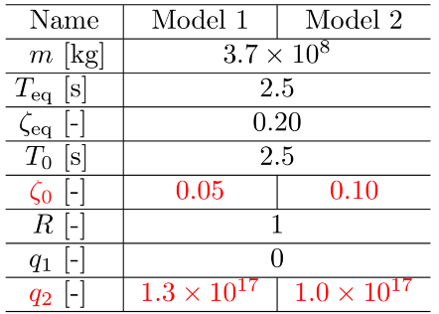

Table 2 Parameters of models

1. Table 3 presents the state feedback gain *KP* of Models 1 and 2, calculated using (21).

Table 3 Parameters of models

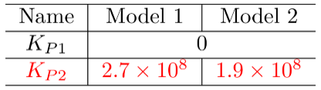

1. Figure 8 presents the responses (displacement *x*, velocity , and absolute acceleration ) and the shear force coefficient of the control force *Cu* of Models 1 and 2.

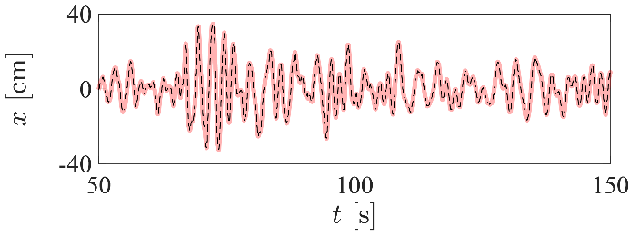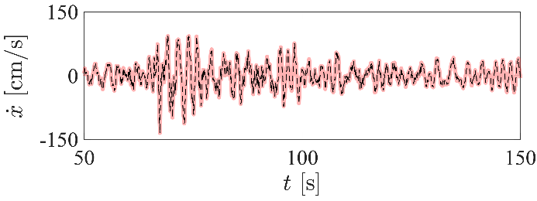

(a) Response displacement

(b) Response velocity

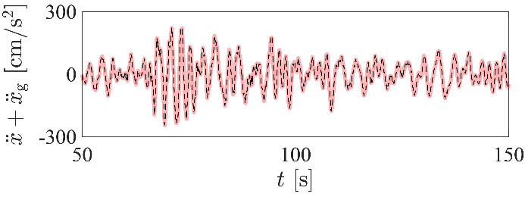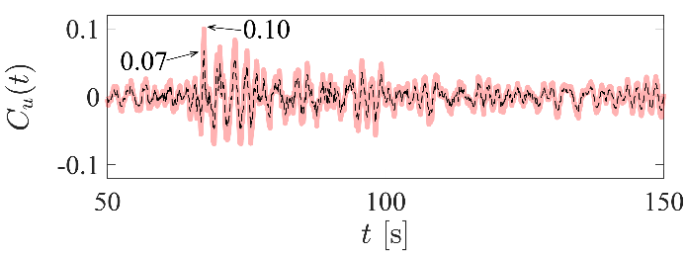

(d) Shear force coefficient of control force

(c) Response absolute acceleration

Figure 8 Numerical simulation results of models

From the design example, the following results were obtained:

1. From Figures 8(a)-(c), it can be seen that Models 1 and 2 satisfy all the limitation conditions of Step 0. The validity of the proposed design method can therefore be confirmed.
2. From Figures 8(a)-(c), it can be seen that the responses of Models 1 and 2 are identical. It can therefore be confirmed that the equivalent natural period *T*eq and equivalent damping ratio *ζ*eq are the same for Models 1 and 2.
3. From Figure 8(d), it can be seen that the maximum shear force coefficient of the control force of Model 1 is larger than that of Model 2. This is because the initial damping ratio of Model 1 (*ζ*0=0.05) is smaller than that of Model 2 (*ζ*0=0.10).

**6. CONCLUSIONS**

In this study, an equivalent model of an active model with a controller designed using an LQR was constructed for an SDOF model. This paper also presents the calculation method for determining the weighing matrices to satisfy the desired equivalent natural period *T*eq and equivalent damping ratio *ζ*eq, using the constructed equivalent model. Furthermore, in this paper, the control force spectrum is proposed, which can be used estimate the maximum necessary control force. This makes it possible to design a controller that satisfies the limitation conditions of the responses and maximum control force without trial and error, by using the conventional response spectrum of an earthquake. In the numerical design example of the PBI type reactor building with ASC, the validity of the proposed design method is verified. This study clarified the following points:

1. The analytic solution of the ARE used in the LQR can be obtained for SDOF model with damping coefficient, and the influence of the weighing matrices on vibration characteristics can be theoretically demonstrated.
2. By constructing an equivalent model, which has the same natural period and damping ratio as the active model, it is possible to evaluate the peak responses of the active model without the need of numerical simulations, by using the response spectrum of an earthquake wave. It is therefore possible to calculate the weighing matrices that satisfy the desired responses.

In this paper, a control force spectrum that can be used to estimate the required maximum control force for a specific earthquake wave was proposed. By using the proposed control force spectrum, the required maximum control power can be estimated at the controller design stage, without the need of numerical simulations.

**7. References**

Yuji T., Nobuo F., Jun T. and Masafumi M., (2011) Development and analysis of database for base-isolated buildings in japan. *AIJ Journal of Technology and Design*, (17): 79-84 [in Japanese].

Warn G. P. and Ryan K. L., (2018) A Review of Seismic Isolation for Buildings: Historical Development and Research Needs. *Soil Dynamics and Earthquake Engineering*.

Shimamoto R., Umeki Y. and Umeki Y., (2013) A study on seismic behavior of isolated reactor building in large input region. Part 1: Overall outline. *Summaries of technical papers of annual meeting, Architectural Institute of Japan*: 1285-1286 [in Japanese].

Takafumi H., Kenji K. and Haruyuki K., (2017) Mechanical energy evaluation method for seismic isolation systems with rubber bearings under large deflection. *AIJ Journal of Structural and Construction Engineering*, (82): 75-85 [in Japanese].

Vinodh K. E. and Raaja G. S., (2017) A new algebraic LQR weight selection algorithm for tracking control of 2 {DoF} torsion system. *Archives of Electrical Engineering*, (66): 55-75 [in Japanese].

Yinli C., Daiki S., Kou M. and Jinhua S., (2018) Mechanical energy evaluation method for seismic isolation systems with rubber bearings under large deflection. *AIJ Journal of Structural Engineering*, (64B): 199-206 [in Japanese].

Andre P. and Kazuto S., (2008) Active control of structures. *John Wiley & Sons, Inc.*

Fabio C., Jose R. and Umut Y., (2018) Active and semi-active control of structures – theory and applications: A review of recent advances. *Journal of Intelligent Material Systems and Structures*, (23): 1181-1195.

A. S. Whittaker, M. Kumar and M. Kumar. (2014). Seismic Isolation of Nuclear Power Plants, Nuclear Engineering and Technology, 46 (5), 569 – 580.

H. Asano, T. Hirotani, T. Nakayama, T. Norimono, Y. Aikawa, K. Sato, S. Asakura, M. Jimbo and Y. Umeki. (2014). Development of an Evaluation Method for Seismic Isolation Systems of Nuclear Power Facilities: Part 10 — Evaluation of Seismic Isolator Design, in: Proceedings of ASME 2014 Pressure Vessels & Piping Conference, Vol. 8, California, USA, p. V008T08A017.

K. Miyamoto, D. Sato and J. She. (2018). A New Performance Index of LQR for Combination of Passive Base Isolation and Active Structural Control, Engineering Structures, 157, 280 – 299.

A. Preumont and A. Seto. (2008). Active Control of Structures, John Wiley & Sons, Inc.

F. Casciati, J. Rodellar and U. Yildirim. (2012). Active and Semi-Active Control of Structures – Theory and Applications: A Review of Recent Advances, Journal of Intelligent Material Systems and Structures, 23 (11), 1181–1195.

1. Graduate student, Department of Architecture and Building Engineering, Tokyo Institute of Technology, Yokohama, Japan, chen.y.at@m.titech.ac.jp
2. Associate professor, Laboratory for Future Interdisciplinary Research of Science and Technology (FIRST), Tokyo Institute of Technology, Yokohama, Japan, sato.d.aa@m.titech.ac.jp
3. Doctor student, Department of Architecture and Building Engineering, Tokyo Institute of Technology, Yokohama, Japan, miyamoto.k.ag@m.titech.ac.jp
4. Professor, Department of Mechanical Engineering, Tokyo University of Technology, Hachioji, Japan, she@stf.teu.ac.jp