

Slow-cyclic test of steel plate shear wall with floor slab

**DOI 10.37153/2686-7974-2019-16-812-821**

Abhishek VERMA[1], Dipti Ranjan SAHOO[2]

ABSTRACT

This study presents a large-scale slow-cyclic experimental study of a single-story steel plate shear wall (SPSW) with a composite slab casted over the top horizontal boundary element (HBE). The bottom-HBE had no slab casted over it. The objectives of the study were to investigate the effect of the floor slab on the forces developed in the HBEs, and to check the efficacy of the proposed connection detailing in shifting the location of the plastic hinge away from the beam-column joints. The comparison of the response of the two HBEs is utilized to achieve this objective. The main emphases of the study were the yielding behaviour of the infill plate and the boundary elements, the behaviour of the plastic hinges, the crack propagation in the slab, and the failure modes of the SPSW components. Due to the presence of the slab, the top HBE exhibited a reduction in the axial forces but an increase in the vertical tension forces in the web region. The proposed connection detailing facilitated the axial-flexural plastic hinges in the HBEs to be formed away from the connections, which enhanced the ductility of the system in comparison to the past experimental studies. The specimen demonstrated a stable hysteretic response up to 6% story drift.

*Keywords: Steel plate shear wall; Slow cyclic experiment; Connection ductile detailing; Effect of slab; Lateral loading*

**1. INTRODUCTION**

Steel plate shear wall (SPSW) has been proven to be an excellent passive energy dissipating system for protecting buildings against seismic hazards. A typical SPSW consist of steel plates (webs) surrounded by boundary elements in both horizontal and vertical directions. Lateral resistance and hysteretic energy dissipation potential of an SPSW is achieved through the tensile yielding of web plates and the formation of plastic hinges at the ends of horizontal boundary elements (HBEs) [1]. For a good number of buildings that utilize this system, a floor slab rests on the horizontal boundary elements (HBEs) of the system. The presence of a slab may affect the distribution of internal forces in the HBEs, which may, in turn, affect the plastic hinge formation at the HBE ends. A number of experimental studies have been conducted to investigate the hysteretic behaviour of an SPSW, but limited studies (e.g., [2]) have included a slab over the HBEs.

To take into account this effect, an experimental study was conducted over a large-scale single-story single-bay specimen, in the Heavy Structures Laboratory, Indian Institute of Technology Delhi, to evaluate the cyclic performance of SPSW in the presence of a floor slab. The specimen was vertically loaded using two actuators, to include the effect of gravity loads. It was then subjected to slow-cyclic lateral forces, and its behaviour was observed and recorded. The main emphases of the study were the yielding behaviour of the infill plate and the boundary elements, the crack propagation in the slab, and the failure modes of the SPSW components.

**2. Experimental program**

The SPSW specimen used in the study represents a prototype of the top story of a 6-story SPSW system, scaled by a factor of 0.4. ISMB200 and ISMB250 were used as horizontal boundary elements (HBEs) and vertical boundary elements (VBEs), respectively. A steel sheet of thickness 0.6 mm was used as the infill plate of the SPSW. The geometric properties of the test specimen satisfied the required design parameters in accordance with ANSI/AISC 341-16 [3] provisions.

Figure 1 shows the schematic and photographic image of the specimen along with the slab and the infill plate. The infill plate was connected to the boundary elements through 5 mm fish plates. The infill plate was bolted over the fish plate using M16 bolts, staggered in two lines. The pitch of the bolts was 40 mm and the center lines of the two rows of bolts were 30 mm and 70 mm away from the face the boundary elements. Bolted connections were used to connect the infill plate to the fish plate. A composite floor slab of depth 100 mm, utilizing a trapezoidal corrugated steel deck sheet, was cast on the top of the SPSW system. Reinforcement bars of diameter 8 mm spaced at a center-to-center distance of 250 mm were provided as top reinforcement. The floor slab was connected to the top beam through four C-shaped shear studs.

To ensure high deformability of a frame, the ductility of the beam-column connection plays an essential role. Thus, a welded ductile connection was adopted to connect the HBEs and the VBEs. In addition to the fully welded webs and flanges of the HBEs, two stiffeners at the top and two at the bottom flanges of the HBEs were welded with the column. These stiffeners were triangular in shape and 10mm thick. Such a connection was tested as an alternative for the reduced-beam-section (RBS) connection adopted for an SPSW by the past researchers [4,5]. The connection detailing adopted in this study aims to achieve high rotational ductility without cutting the flanges of the beams. In addition to this, to prevent any local buckling in the web of the VBEs at the HBE-VBE connection, horizontal web stiffeners were also used on both the sides of the VBE webs in continuation of the flanges of the HBEs. The panel zones of the connections were strengthened against the shear deformations by providing a diagonal stiffener. Both the web and the diagonal stiffeners were 12 mm in thickness. The specimen was supported through pinned connections at the base of the VBEs.

The grade of the steel used for the boundary elements was E-300 [6]. The average value of the upper yield limit was calculated to be 345 MPa and that of the lower yield limit was 312 MPa. The material, on an average, exhibited a maximum tensile stress of 459 MPa. A deep drawn [7] cold rolled steel sheet, manufactured by SAIL, was utilized for the infill plate. The material exhibited the yield stress and the ultimate tensile stress of 220 MPa and 350 MPa, respectively. The concrete mix used for casting the slab was designed for a nominal grade of M20. It was casted in two batches. The compressive strengths of the concrete for the two batches after 7 days of casting were obtained as 18.5 and 12.7 MPa, which increased to 23.7 and 20.6 after 28 days, respectively.

Specimen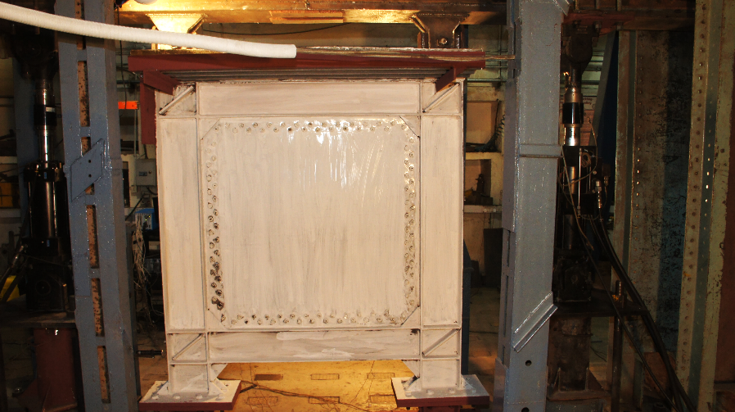

(a) (b)

Figure 1. (a) Schematic and (b) Photographic image of the SPSW specimen

Figure 2 shows the plan and the elevation views of the experimental set-up used to test the specimen. The specimen in oriented along the vertical plane in the east-west direction. The actuator which applies the lateral load is fitted towards the west end of the setup. The specimen was loaded vertically and laterally through a 5 m long and 620 mm deep rigid beam. The motivation behind the use of the loading beam was to facilitate the simultaneous loading from the 3 actuators.



Figure 2. Elevation of the test set-up

|  |
| --- |
| D:\phd\Experiment\New shortlisted photos\Before test\DSC01036.JPG  250kN actuator  Loading Beam  500kN Actuator  Specimen |

Figure 3. Complete views of the test setup

The specimen was connected to the rigid beam at the top of the VBEs through single bolt pinned connections. The vertical distance from the center of the pin at the top and the pin at the bottom of the specimen was 2270 mm. Two actuators, having a maximum capacity of 250 kN, were placed vertically to pull the rigid beam with a constant downward force of 60 kN each throughout the experiment. Including the weight of the loading beam and the concrete slab, each column was preloaded with a compressive force equal to 10% of its axial compressive capacity. The lateral load was applied using a single actuator connected to the west end of the loading beam. The actuator could apply a maximum lateral load of 500 kN. To prevent the out-of-plane movement of the setup, side supports were provided to the loading beam through rollers. No additional side supports were provided to the specimen directly.

The two vertical actuators of capacity 250 kN were set to the force-controlled mode. In this mode, the force that the actuator is required to apply is provided as the input to the actuator control system, as a function of time. A constant value of downward pull of 60 kN was applied throughout the experiment through each of these actuators. The lateral cyclic loading was applied to the system using the 500 kN capacity actuator attached to the west end of the loading beam. Figure 4 shows the lateral loading protocol applied using this horizontally positioned actuator.

Loading protocol

Figure 4. Imposed loading history

**3. Behaviour of the Specimen**

The specimen was whitewashed before the experiment began. When the specimen experienced high strain at any location, the whitewash flaked-off in that region. Thus, the flaking-off of the whitewash from the surface of the specimen was considered as a probable marker of yielding. Nevertheless, for an accurate estimation of yielding, direct measurement of either stress or strain at the location can be deemed more appropriate. But the technique used in this study is significantly easy to adopt, is cost effective and has much greater coverage of the surface of the specimen.

***3.1 Load-Displacement Response of Specimen***

The loads applied to the specimen and the corresponding displacements were recorded to evaluate the cyclic behaviour of the specimen. The load values were obtained directly from the actuator sensors. The corresponding values of the drifts were obtained using two methods. For the first method, displacement data directly obtained from the actuator sensors is utilized. This is divided by the center-to-center distance of the top and the bottom pinned supports to obtain the drift of the specimen. The second method considers the difference in the lateral displacements at the mid-height levels of the top- and bottom-HBEs. It was measured using two linear variable differential transformers (LVDTs). The distance between the two monitored points was measured to be 1455 mm. The drift calculated by dividing the difference of the readings of the two LVDTs by 1455 mm is referred to as the ‘story drift’ of the specimen in the present study. These LVDT sensors were removed before the start of the cycles of 8% drift, as the corresponding displacements were more than the maximum value which these sensors could measure.

The load-displacement response of the specimen is plotted for both the drift values obtained using the above described methods. The results are shown in Figure 5. Figure 5(a) shows the lateral load resisted by the specimen against the displacement observed at the actuator height. Figure 5(b) shows the variation of the lateral strength of the test specimen with the story drift. The SPSW specimen showed a stable hysteretic response up to a story drift of 5.5%. A peak load of 408kN was reached. The specimen exhibited a linear increment in the lateral load resisting capacity upto 1.3% drift, beyond which nonlinearity was observed. Thus, this value can reasonably be considered as the yield drift of the specimen. The reduction in the lateral load capacity of the specimen was first observed during the load cycles corresponding to 6% drift. A significant loss of strength was observed in the next two cycles corresponding to 8% drift. The test was terminated when the specimen had lost more than 60% of its capacity. Some significant events are highlighted and labelled as ‘A’ to ‘G’ in Figure 5(a). These labels mark the occurrence of the failures of the various components of the specimen. These are explained later in section 3.3.

Base shear vs actuator dispBase shear vs story drift

(a) (b)

Figure 5. Hysteretic response of SPSW (a) Story shear *vs*. specimen drift (b) Story shear *vs.* story drift

***3.2 Behaviour of HBEs***

The HBEs of the specimen did not show observable signs of high deformations upto 1% drift cycles. Figure 6 and Figure 7 show the whitewash flaking marks on the bottom- and top-HBEs f. At 2% drift, apart from the increased intensity of the axial-shear marks, marks were observed at the upper portion of the webs near the end. These were possibly caused due to the upward pull exerted on the web of the section by the steel infill plate. As the infill tension field forces in the infill plates are potentially higher near the corners, these marks also initiated at the ends of the HBE. As the drift increased and the entire steel infill plate reached its near-to-full capacity, the marks spread to the full length of the web during 3% and 4% drift cycles. Additional marks, due to this stretching of the section web in the vertical direction, were observed at the bottom portion of the web at 6% drift.

The marks due to the axial-shear yielding of the web progressively spread to the entire length of the HBE with increasing drift values. However, the contribution of the shear and the intensity of the marks lowered towards the mid-span of the member. Whitewash flaking in the flange of the bottom-HBE, representing flexural deformation were also observed at 2% drift. The flaking was observed beyond the region where triangular stiffeners were provided at the supports. This shows that one of the desired objectives to facilitate the formation of flexural hinges away from the HBE-VBE connections, was achieved successfully. The region strengthened by the triangular stiffeners also remained less affected by the axial forces in the web of the HBEs.

The top HBE first showed signs of deformation in the web during the load cycles corresponding to 1.5% drift. The pattern of marks at 1.5% drift demonstrated shear dominated deformation at the extreme ends and deformation due to the combined action of axial and shear forces in the region beyond the triangular stiffeners at the connections. At 2% drift, the top HBE also experienced stretch marks near the end, caused by the stretching of the HBE web due to tension field forces of the infill steel plate. However, unlike the bottom HBE, the marks in the top HBE initiated from both the upper and the lower portion of the web. As the drift increased to 3%, these marks extended toward the mid-span region. The marks in the lower part of the web spread to the entire HBE length. At 4% and 6% drift, these stretch marks extended to the entire height of the web. A higher magnitude of the vertical tensile deformation of the web of the top HBE can be attributed to the resistance provided by the slab against the downward movement of the web through the shear connectors. Such deformations are also expected to be high in the cases where plates are connected to the HBE at both the top and the bottom flanges. Nevertheless, these forces probably did not significantly affect the cyclic lateral response of the SPSW. No effect of these forces was observed in the region where triangular stiffeners were provided at the connections. The top-HBE did not show any signs of rupture or loss of strength until 8% drift cycles. The failures in the HBEs are discussed later in section 3.3 along with the failure of other components of the SPSW system.

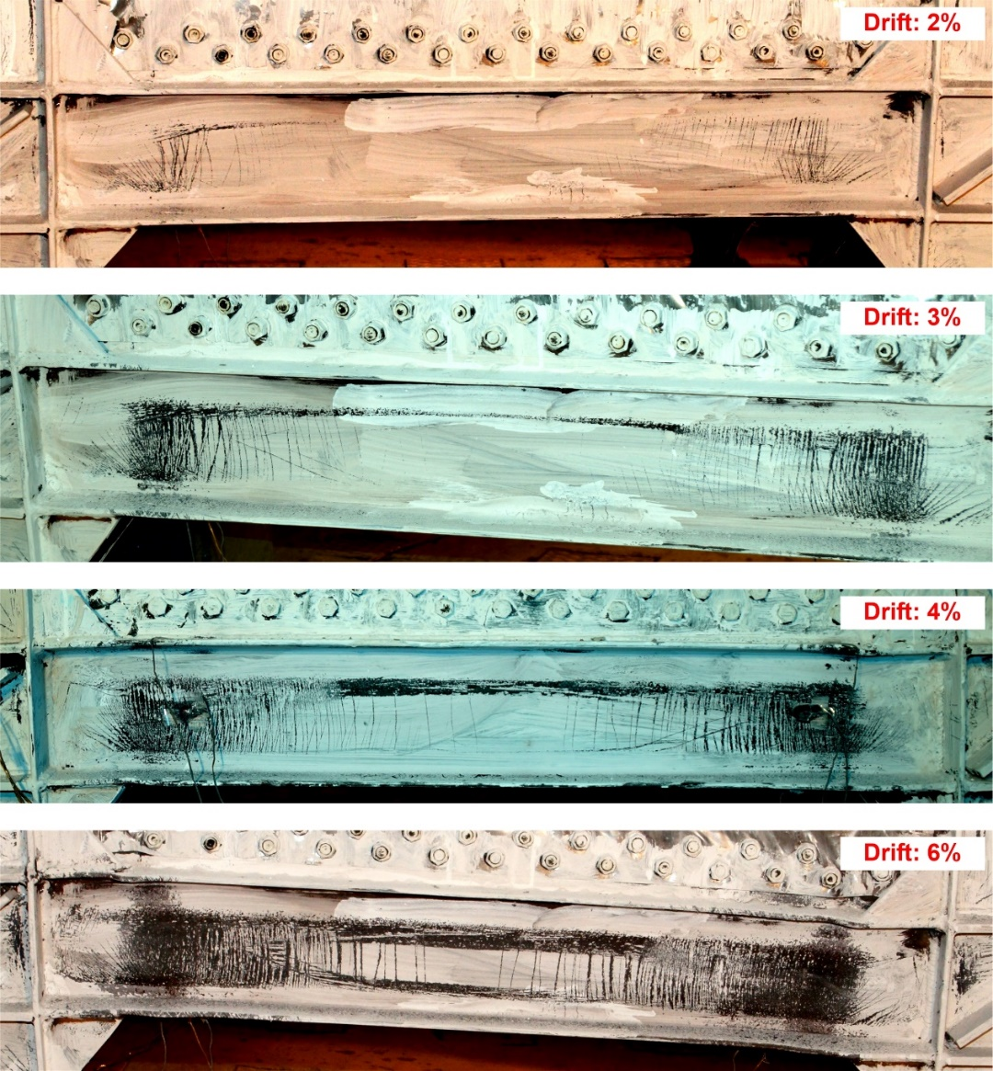

New stretch marks due to vertical stretching of web

Axial-flexural hinge

Marks due to axial yielding

Stretch marks due to vertical stretching of web

Marks in flange

Figure 6. Whitewash flaking marks on bottom HBE for 2% to 6% drift

***3.3 Failure of SPSW Components***

This section describes the failure of various components of the specimen at different drift levels during the experiment. The specimen demonstrated satisfactory failure mechanisms at high drift levels. The data recorded and the observation made during the experiment can help develop a better understanding of the collapse behaviour of a well-designed SPSW system. Most of the failure events that occurred during the experiment are marked on the load-displacement response of the specimen, shown in Figure 5(a). Each event is denoted by an uppercase alphabet as ‘A’ to ‘G’. These image of each of these events are shown and discussed in this section. The images are also marked with the corresponding alphabet to correlate the response and the events.

The first failure observed during the experiment was the bearing failure of the infill plate at the corner bolts. Such failures occurred at all the four corners of the plate. These failures did not have any impact on the load carrying capacity of the specimen.

|  |
| --- |
| D:\phd\Experiment\Edited photos\Yield pattern topHBE.jpg  Axial-flexural hinge  Shear marks  Axial-shear marks  Axial-shear marks  Stretch marks due to vertical stretching of web |

Figure 7. Whitewash flaking marks on top HBE

Events ‘A’ and ‘B’ mark the beginning of the tearing failure of the plate at the corners. In the positive direction, during the first cycle, the bearing failure at the corners enlarged at the corner bolts. Along with this, few tear marks were also observed at these bolts. Despite the tearing of the plate in the first cycle, no reduction in strength was observed. The tearing of the plate increased in the second cycle. By the end of the two cycles the plate had been torn significantly at the corner. During these cycles, significant local buckling in the flanges of the HBEs at the plastic hinge locations were also observed.

Figure 8 show the spread of the tearing of the infill steel plate across its entire width. A significant amount of tearing of the infill plate occurred when the specimen was first pushed to the 8% drift level. Discontinuous tearing of the plate at the bolt locations occurred both at the top and the bottom of the plate. These were spread uniformly all along the width of the plate. Such a failure indicates a uniformly spread tension field in the infill plate. When the plate was pushed to 8% drift, the remaining portions of the plate also ruptured. At this stage, the plate had been ruptured completely along the bolts at its top and the bottom. The rupture of the plate during the positive direction of the first cycle of 8% drift is marked as ‘D’ and during the negative direction is marked as ‘E’. The buckling of the flanges occurred at the points where the triangular connection stiffeners ended. The local buckling of the HBE flanges did not affect the capacity of the specimen. The reduction in the lateral strength of the SPSW was observed when a weld fracture occurred at the connection of the top flange of the south-west end of the bottom HBE. These two failure events resulted in a small reduction in the load resisting capacity of the specimen.

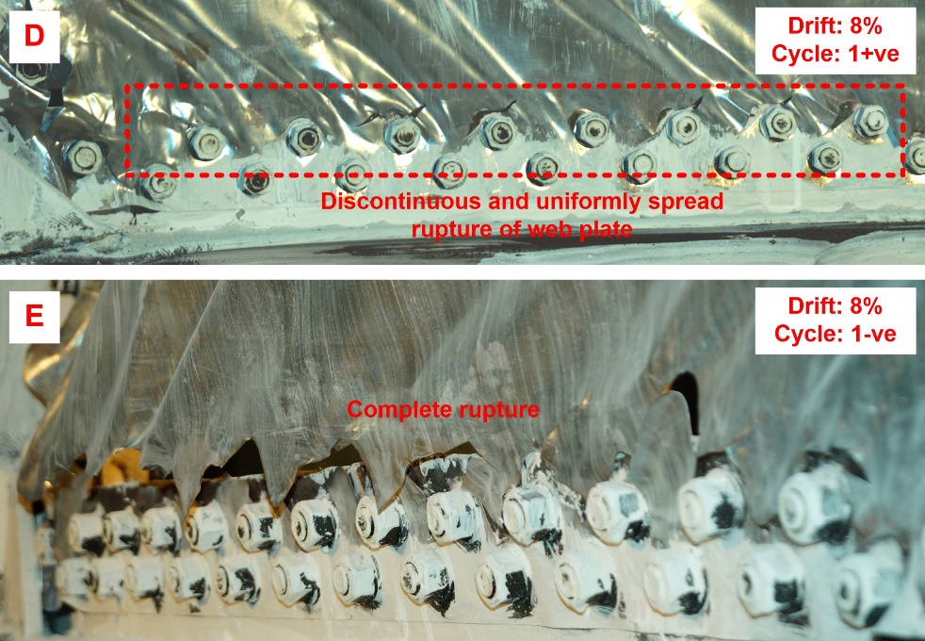

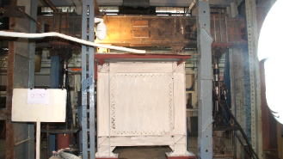

Figure 8. Tearing of infill plate along the bolts at the bottom at 8% drift

***3.4 State of Strain***

Strain gauges were placed at various locations to obtain the state of strain. For HBEs, the strain gauges were provided at the four expected plastic hinge locations, at a distance of 200 mm from the ends of the beam. To monitor the strain at these four sections, three strain gauges were put at each location. Two of these were provided in the flanges and one in the web, oriented to measure strain in the longitudinal direction of the HBEs. For the VBEs, these were provided at a height of 225 mm from the top flange of the bottom HBE. The strain gauges on the flanges were provided to obtain strain state in the longitudinal direction of the member, whereas the ones in the web measured strain in the horizontal direction.

For comparing the strain in the different components of the SPSW, the maximum and the minimum values of the strain corresponding to each drift level for various components of SPSW are shown in Figure 9. As there were multiple cycles applied at each drift level, the averages of the maximum and the minimum are considered here. In the case of the HBEs, beyond 2% drift level, the top flanges experienced higher strain. For this reason, failure initiated at the top flanges for both the top- and bottom-HBEs. It can also be observed from the figure that the flanges of the top-HBE predominantly experienced compressive strain, whereas, in the case of the bottom-HBE, tensile strain values dominated. The strain in the web of the HBEs also indicates the same behaviour. The lower compressive forces in the top-HBE can be attributed to the presence of the slab over it.

Strain envolope bottom beam flangesStrain envolope top beam flanges

(a) (b)

Strain envolope Web

(c)

Figure 9: Maximum and minimum strain for cycles corresponding to each 2drift level at (a) flanges of top-HBE, (b) flanges of bottom-HBE, (c) web of HBEs, and (d) flanges of west-VBE

**4. Conclusions**

The major conclusions of the study are:

1. The specimen resisted a peak lateral load of 408 kN and showed a stable hysteretic response upto 5.5% story drift.
2. The vertical tensile stresses in the web of the top-HBE connected to the slab are higher than the stresses in the web of the bottom-HBE, which did not have a slab cast over it.
3. The strain gauge data showed the presence of high compressive forces in the bottom-HBE. Whereas, the top-HBE experienced significantly lower compressive forces due to the axial stiffness provided by the slab.
4. In the case of both the HBEs, beyond 2% drift level, the top flanges of the sections experienced higher strain than the bottom flanges. For this reason, failure initiated at the top flanges for both the top- and bottom-HBEs.
5. The failure modes of the two HBEs were also distinct. The bottom-HBE experienced failure of welds at the HBE-VBE connections, whereas the top-HBE, which had a slab cast over it, experienced a rupture away from the joints.
6. The HBE-VBE connection detailing was effective in keeping the plastic hinge zones away from the weld-heat affected region.

The Conclusions of the study are yet to be verified through detailed finite element modelling, which would allow for a better understanding of the effect of the slab on the HBE behaviour. The model will then be used to expand the research to a broader range of boundary conditions and system properties.

**5. References**

Verma, A., and Sahoo, D. R. (2017) Seismic behavior of steel plate shear wall systems with staggered web configurations. *Earthquake Engineering and Structural Dynamics*. 47(3):660-667.

Qu B., Bruneau M., Lin C.H., Tsai K.C. (2008) Testing of full-scale two-story steel plate shear wall with reduced beam section connections and composite floors. *Journal of Structural Engineering*. 134 (3): 364–373.

ANSI/AISC 341-16 (2016) Seismic provisions for structural steel buildings. *American Institute of Steel Construction*, Chicago.

Vian D., Bruneau M., Tsai K.C., Lin Y.C. (2009) Special perforated steel plate shear walls with reduced beam section anchor beams. I: experimental investigation. *Journal of Structural Engineering*. 135 (3): 211–220.

Hoseinzadeh M.A., Safarkhani M. (2017) Seismic behavior of steel plate shear wall with reduced boundary beam section. *Thin-Walled Structures*. 116: 169–179.

IS-2062 (2001) Hot rolled medium and high tensile structural steel specification. Bureau of Indian Standards, New Delhi.

IS-513 (2008) Cold reduced low carbon steel sheet and strips. Bureau of Indian Standards, New Delhi.

1. Ph.D. Research Scholar, Indian Institute of Technology, New Delhi, India, [abhiverma.civil@gmail.com](mailto:abhiverma.civil@gmail.com)
2. Associate Professor, Indian Institute of Technology, New Delhi, India, [drsahoo@civil.iitd.ac.in](mailto:drsahoo@civil.iitd.ac.in%20) 