**APPLICATION OF AN ENERGY-BASED PROCEDURE TO THE DESIGN OF FV DEVICES FOR SEISMIC RETROFIT INTERVENTIONS**

**DOI 10.37153/2686-7974-2019-16-790-802**

Gloria TERENZI[1], Iacopo COSTOLI[2], Stefano SORACE[3], Paolo SPINELLI[4]

**ABSTRACT**

Supplemental damping techniques are increasingly applied in the field of seismic retrofit of frame buildings. Among these techniques, “mainly dissipative” (MD) ones, i.e. capable of supplying a high damping action without significant stiffening effects of the structural system, are preferred when rather stiff structures are dealt with in current conditions. A typical example in this field, represented by a MD-based retrofit intervention designed for a school gym in Florence, built in 1971, is presented in this paper. The structure is regular, but with dynamic properties significantly different along the two main directions in plan. A careful reconstruction of the characteristics of the constituting members, based on the original design documentation and on-site testing campaigns, helped analyzing in detail the seismic response of the structure in current state, highlighting the most critical elements. The MD-type system adopted as retrofit solution consists in a set of dissipative braces incorporating fluid viscous dampers, sized by an energy-based design procedure recently proposed by the first author. A performance analysis carried out in retrofitted conditions assesses that the targeted performance assumed for the intervention, consisting in an elastic structural response up to the maximum considered earthquake, is reached, along with an optimal level of the damping capacity of the dissipaters.

*Keywords: Supplemental damping technologies; Seismic retrofit; Dissipative braces; Fluid viscous devices; Energy-based design.*

**1. INTRODUCTION**

Dissipative bracing systems are increasingly adopted in anti-seismic design of new frame structures, as well as to retrofit existing ones. Several types of technologies have been implemented, capable of supplying supplemental damping and horizontal stiffness in different proportions, depending on the mechanical characteristics of dissipaters and their installation layout. By way of example, metallic yielding devices, like ADAS (Added Damping and Stiffness) components (Aiken et al. 1993, Soong and Spencer 2002), typically provide significant contributions in terms of both properties. On the other hand, fluid viscous dissipaters, when mounted at the tip of supporting braces in parallel with the overlying beam axis (Sorace and Terenzi 2008), slightly increase the horizontal stiffness of the structural system, while supplying high additional damping.

A further spreading of dissipative bracing technologies in the professional community strongly depends on the availability of simple and intuitive design procedures, especially concerning the preliminary sizing of dissipaters. The first methods offered in literature start from setting the desired damping ratio (i.e. the ratio of the damping coefficient to the critical damping coefficient) in the fundamental mode of vibration of the structure, in the hypothesis that the relevant effective modal mass (EMM) is a predominant portion of the total seismic mass (Ramirez et al. 2003). In general, the practical application of these methods consists in examining the response spectra at various damping ratios and choosing the value that allows constraining the maximum “global” response parameters (base shear, top lateral displacements, etc) within targeted acceptable limits. When the devices are characterized by nonlinear viscous properties, the same objectives can be reached by transforming relevant damping coefficients into equivalent linear viscous coefficients. These studies have provided the basis for the design procedures of buildings incorporating passive energy dissipation systems included in ASCE 41-06 (American Society of Civil Engineers 2006) Standards. Along the same conceptual line, some procedures based on the use of normative response spectra scaled by reduction factors corresponding to the damping capacity of the devices have been proposed more recently, where reference is made to damping ratio values no greater than 0.3. Other approaches use equivalent linear or non-linear static analyses to evaluate the design actions and reduce their effects through added damping. All the above-mentioned procedures are conceived for substantially regular structures. Few solutions are found for problems characterized by significant irregularities in plan and/or in elevation. Among these, a method based on properly calibrated expressions of the damping ratio derived from the results of non-linear dynamic analyses is formulated in Mazza (2015).

An alternative approach is represented by an energy-based design criterion, first proposed for fluid viscous dissipaters (Sorace and Terenzi 2008), and later extended to ADAS elements (Sorace et al. 2016). This criterion consists in determining the minimum damping coefficients of the devices required to assign them the capability of dissipating a prefixed fraction, β, of the seismic input energy, *EI*, computed on each story (Sorace and Terenzi 2008) or the entire structure (Sorace et al. 2016). To facilitate the choice of β, preferable ranges were provided for several different structural types, and checked in relation to the assumed design targets (Sorace and Terenzi 2008, Sorace et al. 2016). However, as the method requires a preliminary evaluation of the seismic input energy demand on the original structure, a finite element time-history analysis must be carried out first, and *EI* post-calculated from the results. Although an energy calculation can be performed with the help of commercial finite element programs by means of simple input instructions, professional engineers are not always familiar with this design approach, and may be discouraged from using it.

In view of this, bypassing this initial step by directly estimating the minimum damping capacity to be assigned to the dissipaters, a new procedure was proposed in (Terenzi 2018, Terenzi et al. 2018), and is demonstratively applied in this paper to a reinforced concrete (RC) structure. A performance assessment analysis of the structure in original and retrofitted conditions, carried out to evaluate the enhancement of seismic response capacities produced by the incorporation of the dissipative bracing system, is presented in the next Sections.

**2. CHARACTERISTICS OF THE case study STRUCTURE**

The case study building is the gym in a school in Florence, built in 1971, two external views and an internal view of which are displayed in Figure 1.

**(a)**

**(b)**

**(c)**

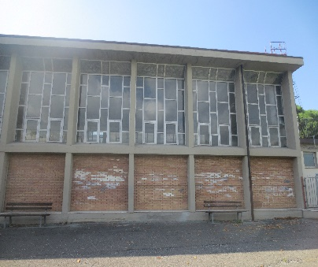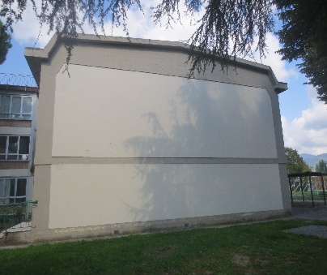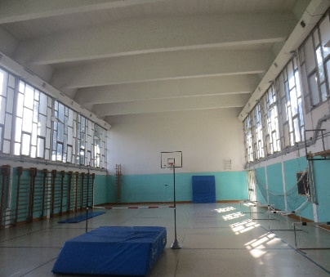

Figure 1. Lateral (a), front (b) and internal (c) views of the building

Figures 2 and 3 show the structural plan and the transversal cross section, respectively. The reference Cartesian coordinate system assumed in the analyses is indicated in Figures 2 and 3 too. As highlighted in Figure 2, the plan is rectangular, with sides of 14.4 m in transversal direction, parallel to *X*, and 24.25 m in longitudinal direction, parallel to *Y*. The height of the roof top is equal to 9.17 m, whereas the height of the façades, measured on top of the end section of the roof beams, is equal to 8.67 m. The structure is constituted by 9 identical RC frames of two columns each, numbered C1-C2 through C17-C18 in Figure 2, placed at a mutual distance of 3 m.

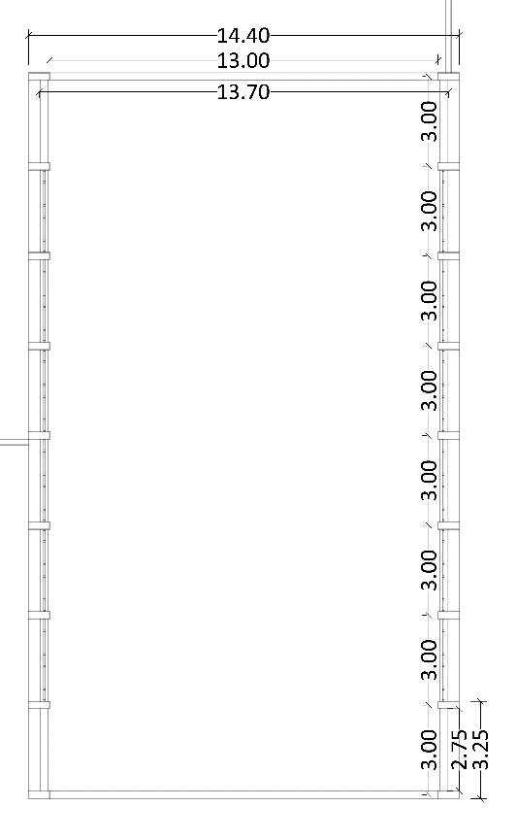

14400

13700

300

300

300

300

300

300

300

300

*C*6

*C*12

*C*2

*C*10

*C*8

*C*14

*C*16

*C*18

*C*4

*C*5

*C*11

*C*1

*C*9

*C*7

*C*13

*C*15

*C*17

*C*3

24250



*X*

*Y*

Figure 2. Structural plan of the building (dimensions in millimeters)



*X*

*Z*

*X*

Figure 3. Cross section of the building (dimensions in millimeters)

The cross sections of beams and columns and relevant reinforcement details, redrawn from the original structural design drawings, are illustrated in Figure 4. Columns have a mutual rectangular section with sides of 700 mm along *X* and 250 mm along *Y*. Roof beams have rectangular section with base of 250 mm and height varying from 1030 mm, at the ends, to 1540 mm, at half-span. In longitudinal direction the columns are connected on top by a rectangular beam, named TB in Figure 3, with dimensions 250×400 mm×mm; at a height of 3.17 m by an intermediate beam, named IB, having a polygonal section with base of 700 mm and maximum lateral side of 500 mm; and at the base by a rectangular beam constituting the lateral edge beam of the ground floor, named LEB, with dimensions 200×700 mm×mm. The IB beam, which supports the curtain wall-type glazed portions of the façades, subdivides all columns in two levels along the height.

300



1550

250

2 bars 18

stirrups 8/20

7 bars 18



250

1030

2 bars 18

4 bars 18



400

250

2 bars 14



400

250

stirrups 8/20

stirrups 8/10

stirrups 8/20

250



700

2 bars 18

3 bars 18

stirrups 8/20

**(b)**



700

200

bars 16

stirrups 8/20

200

500

**(a)**

**(c)**

**(d)**

3 bars 14

4 bars 14

Figure 4. Redrawn cross sections of: (a) roof beams – half-span and ends; (b) top longitudinal beams TB – half-span and ends; (c) intermediate longitudinal beams IB; and (d) columns (dimensions in millimeters)

The structure of the roof floor is 160 mm thick and made of 120 mm-high and 100 mm-wide partly prefabricated RC joists, parallel to *Y* and placed at a mutual distance of 400 mm; clay lug bricks; and a 40 mm thick upper RC slab. The ground floor only differs for the height of the joists, equal to 160 mm, which determines a total thickness of 200 mm. The foundation consists of a 400 mm-thick continuous slab, with 1400 mm-high (slab thickness included) and 250 mm-wide transversal rib beams, which connect the column base sections in *X* direction and support the ground floor.

A selective investigation campaign was carried out on materials and structural members, including on-site Son-Reb, pacometric and Vickers-type micro-durometer analyses, and laboratory tests on concrete and steel bar samples. Based on the prescriptions of Italian Standards (Italian Council of Public Works 2009, 2018), the tests met the basic knowledge level (named LC1) for the structural assessment analysis of public buildings in Italy. The corresponding value of the confidence factor, i.e. the additional knowledge level-related safety coefficient to be introduced in stress state checks, is equal to 1.35. The following main properties resulted from the characterization tests: mean cubic compressive strength of concrete equal to 19.6 N/mm2; yield stress and limit stress of steel equal to 417 MPa and 594 MPa, respectively.

**3. VERIFICATION ANALYSIS IN CURRENT CONDITIONS**

The verification enquiry in current conditions is articulated in a modal analysis, to calculate the vibration periods and associated modal masses, and a time-history analysis, to assess the seismic performance in terms of stress states and displacements.

The finite element model of the structure, a perspective view of which is displayed in Figure 5, was generated by SAP2000NL calculus program (CSI 2018) using frame type elements for all structural members. The modal analysis carried out by the model shows two first horizontal translational modes along *X* and *Y*, with vibration periods of 0.89 s (*Y*) and 0.35 s (*X*), respectively, and effective modal mass (EMM) equal to 79% along *Y* and 88.1% along *X*. The fourth and fifth mode are translational along *X* and *Y* too, with periods of 0.26 s (*Y*) and 0.11 s (*X*), and EMM equal to 20.9% (*Y*) and 11.8% (*X*), which provide summed modal masses with the corresponding first mode-related EMMs nearly equal to 100%, along both axes. The third and sixth mode are purely rotational around the vertical axis *Z*, with periods of 0.34 s and 0.04 s, and EMM equal to 84.4% and 12.4%, giving a summed modal mass of 96.8%.

The modal parameters quantitatively confirm a notably different translational behaviour of the structure along the two directions in plan, as a consequence of the markedly different sides of columns along *X* and *Y*, and the much higher flexural stiffness of the roof beams in comparison to the longitudinal beams.

The performance evaluation enquiry was carried out for the four reference seismic levels fixed in the Italian Standards (Italian Council of Public Works, 2018), that is, Frequent Design Earthquake (FDE, with 81% probability of being exceeded over the reference time period VR); Serviceability Design Earthquake (SDE, with 50%/VR probability); Basic Design Earthquake (BDE, with 10%/VR probability); and Maximum Considered Earthquake (MCE, with 5%/VR probability). The VR period is fixed at 75 years, which is obtained by multiplying the nominal structural life VN of 50 years by a coefficient of use Cu equal to 1.5, imposed to structures whose seismic resistance is of importance in view of the consequences associated with their possible collapse, like the case study school gym building. By referring to topographic category T1 (flat surface), and B-type soil, the resulting peak ground accelerations for the four seismic levels referred to the city of Florence are as follows: 0.065 g (FDE), 0.078 g (SDE), 0.181 g (BDE), and 0.227 g (MCE).

*C*17

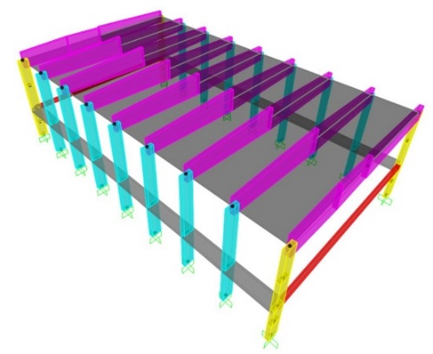

*X*

*Y*

*Z*

Figure 5. View and reference coordinate system of the finite element model

Time-history analyses were developed by assuming artificial ground motions as inputs, generated in families of seven by SIMQKE-II software (Vanmarcke 1999) from the spectra above. As required by the Italian Standards (Italian Council of Public Works 2018), as well as by several other international seismic Codes and Regulations (American Society of Civil Engineers 2006, European Committee 2003), in each time-history analysis the accelerograms were assumed in groups of two simultaneous horizontal components, with the first one selected from the first generated family of seven motions, and the second one selected from the second family.

The results of the analyses carried out at the FDE and the SDE are evaluated in terms of inter-level drift ratio (i.e. the ratio of inter-level drift to inter-level height of columns), *ILDr*, which is equivalent to the inter-storey drift ratio in the presence of a system of continuous intermediate beams, although without a floor. The maximum *ILDr* values induced by the most severe among the seven groups of input motions, *ILDr,max*, are as follows: 0.07% (FDE), 0.09% (SDE) in *X*, and 0.06% (FDE), 0.07% (SDE) in *Y*, on the first level; and 0.13% (FDE), 0.16% (SDE) in *X*, and 0.53% (FDE), 0.64% (SDE) in *Y*, on the second level. The drift ratios in *X* are far below the 0.33% limitation adopted by Italian Standards (2018) at the Operational (OP) performance level for frame structures interacting with drift-sensitive non-structural elements, like the masonry infills on the first level and the curtain wall-type windows on the second level, for the main façades of the building, and the infills situated on both levels, for the side façades. The *ILDr,max* values obtained at the second level in *Y* are 1.6 times (FDE) and about twice (SDE) the OP-related limit, and also greater than the drift threshold adopted by Italian Standards (2018) for the Immediate Occupancy (IO) performance level, equal to 0.5%.

The *ILDr,max* values computed for the second level in *Y* are equal to 1.36% at the BDE, and 1.69% at the MCE, assessing moderate (BDE) to high (MCE) potential plastic demands on columns — should an inelastic finite element analysis be carried out —, and severe (BDE) to very severe (MCE) damage of infills and curtain-wall windows. Consequently, the performance level attained in terms of displacement response is Life Safety (LS), both for the BDE and the MCE. At the same time, *ILDr,max* is no greater than 0.18% (BDE) and 0.22% (MCE) on the first level in *Y*, i.e. only 13% of the second level values. This identifies a cantilever-like response of the structure along *Y*, with structural and non-structural damage located on the second level. As discussed in the following Sections, this suggests to incorporate the dissipaters on the upper level only, in order to adequately exploit their damping capacity, and limit the cost of the retrofit intervention. In *X* direction *ILDr,max* is equal to 0.2% (BDE), 0.25% (MCE) on the first level, and 0.36% (BDE), 0.45% (MCE) on the second level. The inter-level drift profile depicts a frame-like layout along this axis, which approaches a shear-type shape on the second level, as a consequence of the high flexural stiffness of the roof beams in the *X*-*Z* vertical plan (which determines nearly a sliding-clamped constraint condition on the top section of columns).

The BDE and MCE-related response was assessed also in terms of stress levels. The shear-related checks are met in both directions and for both levels, up to the MCE. On the other hand, the combined axial force-biaxial bending moment stress state checks are met only for the internal columns (C3 through C16, according to the numbering in Figure 4) on the first level at the BDE. The response of corner columns (C1, C2, C17 and C18) at this level, as well as of all columns on the second level is unsafe starting from the BDE. By way of example, the *MX,*c–*MY,*c biaxial moment interaction curves (being *MX,c*, *MY*,c the bending moments around the *X* and *Y* axes) graphed by jointly plotting the two bending moment response histories obtained from the most demanding among the seven groups of MCE-scaled accelerograms, are plotted in Figure 6 for a corner column, namely C17.

**(c)**

**(b)**

**(a)**

**(d)**



*MX,c* [kNm]

*MY*,c[kNm]

***BDE – CS***

*C*17I



*MX,c* [kNm]

*MY,c* [kNm]

***BDE – CS***

*C*17II



*C*17II



*MX,c* [kNm]

*MY,c* [kNm]

*MX,c* [kNm]

*MY,c* [kNm]

*C*17I

***MCE – CS***

***MCE – CS***

*C*17II

Figure 6. Current state (CS). *MX,*c–*MY,*c biaxial moment interaction curves at the base section of column *C*17 on first level (a, c) and second level (b, d) obtained from the most demanding BDE-scaled (a, b) and MCE-scaled (c, d) group of accelerograms

The boundary of the *MX,*c–*MY,*c elastic interaction domain traced out for the value of the axial force referred to the basic combination of gravity loads, i.e. *Nc*=104 kN for the corner columns, is also shown in the two graphs. The response curves relevant to the first level highlight maximum *MX,*c–*MY,*c combined values slightly exceeding the safe domain boundary, at the BDE, and 1.77 times greater than the corresponding values situated on the boundary, with prevailing contribution of *MY,*c, at the MCE. The curves traced out for the second level show more marked unsafe conditions at the BDE, as compared to the first level ones, and exceed the boundary by a factor equal to 2.07, at the MCE, but with inverted role of the moments (i.e. with prevailing contribution of *MX,*c, for the second level).

**4. DISSIPATIVE BRACING RETROFIT INTERVENTION**

***4.1 Characteristics of the Protective System***

Fluid viscous devices are among the most widely used types of rate-dependent passive energy dampers installed in dissipative bracing technologies worldwide. This is owed to their high damping capacities, stable mechanical properties over time, simple installation procedures, limited architectural and visual impact, competitive costs and, in the case of pressurized elements, inherent self-centering qualities (Sorace and Terenzi 2001, Sorace and Terenzi 2014).

Within this class, a special type of pressurized FV devices has been studied for several years by the author and co-authors, focusing attention on their mechanical characterization, the implementation of analytical and numerical models to simulate their dynamic response, the formulation of sizing and design criteria, and the application to several different protective technologies and structural typologies. Concerning their analytical modelling, the time-dependent *FD* damping and *Fne* non-linear elastic reaction forces corresponding to the damper and spring functions are effectively simulated by the following expressions (Sorace and Terenzi 2001):

 (1)

 (2)

where *t*=time variable; *c*=damping coefficient; sgn(·)=signum function; =device velocity; |·|=absolute value; =fractional exponent, ranging from 0.1 to 0.2; *F*0=static pre-load force; *k*1, *k*2=stiffness of the response branches situated below and beyond *F*0; and *x*(*t*)=device displacement. For the development of the numerical analyses, the finite element model of a FV spring-damper is obtained by combining in parallel a non-linear dashpot and a non-linear spring with reaction forces given by expressions (1) and (2), respectively. Both types of elements are currently incorporated in commercial structural analysis programs, such as the SAP2000NL code used in this study. The installation layout of the spring-dampers in the dissipative bracing system is illustrated by the drawing in Figure 7, referred to the case study building, and corresponding to the basic configuration devised for RC frame buildings.

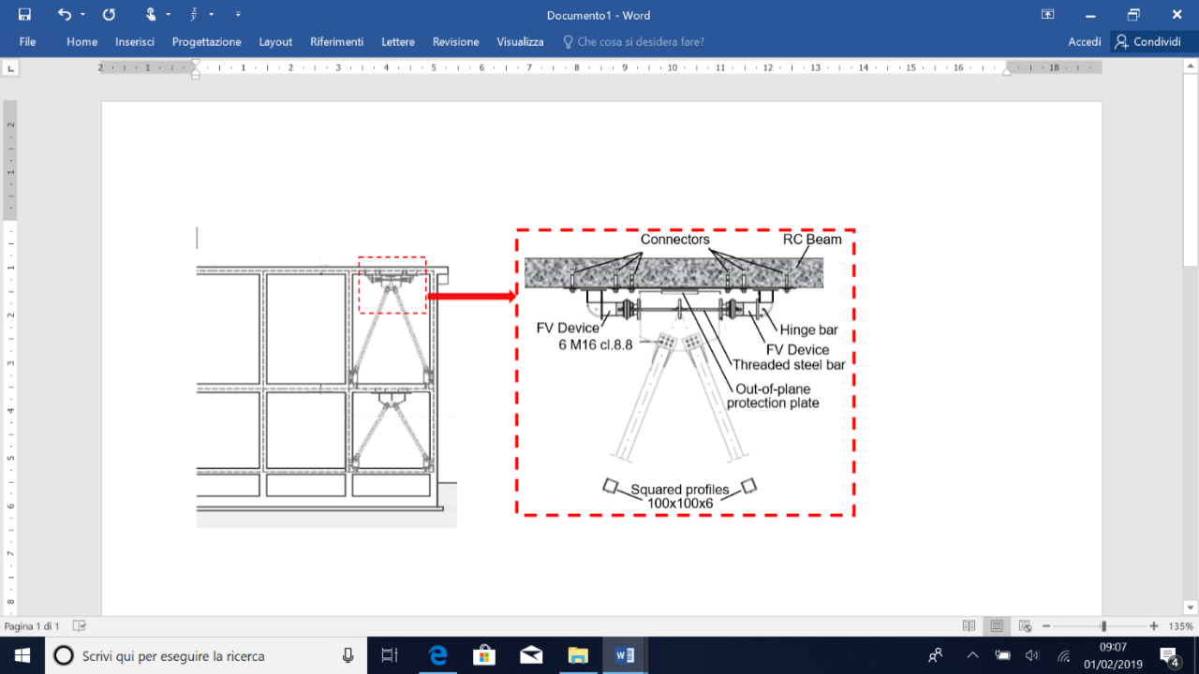

Figure 7. Installation details of the dissipative bracing system in the case study building

Therein, a pair of interfaced devices is placed in parallel with the connecting beam axis at the tip of each couple of supporting braces. A half-stroke initial position is imposed on site to the pistons of both spring-dampers, so as to obtain symmetrical tension-compression response cycles starting from a compressive-only response of the single devices. This position is obtained during the assembly operations by acting on a pair of threaded steel bars crossing the interfacing plate of each device, and connected to two other bored plates, screwed into the external casing of the spring-dampers.

***4.2 Design of the Protective System***

As shown in the building plan in Figure 8, the dissipative braces are placed in four alignments parallel to *X* (named *Al.* *X1* through *Al.* *X4*) and four alignments parallel to *Y* (*Al.* *Y1*–*Al.* *Y4*). The latter are constituted by pairs of adjacent columns (C1-C3 — *Al.* *Y1*, C15-C17 — *Al.* *Y2*, C2-C4 — *Al.* *Y3*, C16-C18 — *Al.* *Y4*). Concerning the *X*-parallel alignments, because the beam span is about 11 m long, four additional RC columns with mutual section 250×250 mm×mm, named AC1through AC4 in Figure 8, are built at a distance of 3 m from the corner columns prior to mounting the bracing members.

The design procedure applied for preliminarily sizing the FV devices is based on the assumption that, as observed above, for relatively stiff frame structures a substantial improvement of seismic performance can be reached by incorporating a supplemental damping system with limited stiffening capacity. For more deformable structures, a supplemental stiffness contribution helps control lateral displacements better, preventing over-dissipation demands to the protective technology adopted (Sorace et al. 2016, Terenzi 2018, Terenzi et al. 2018).

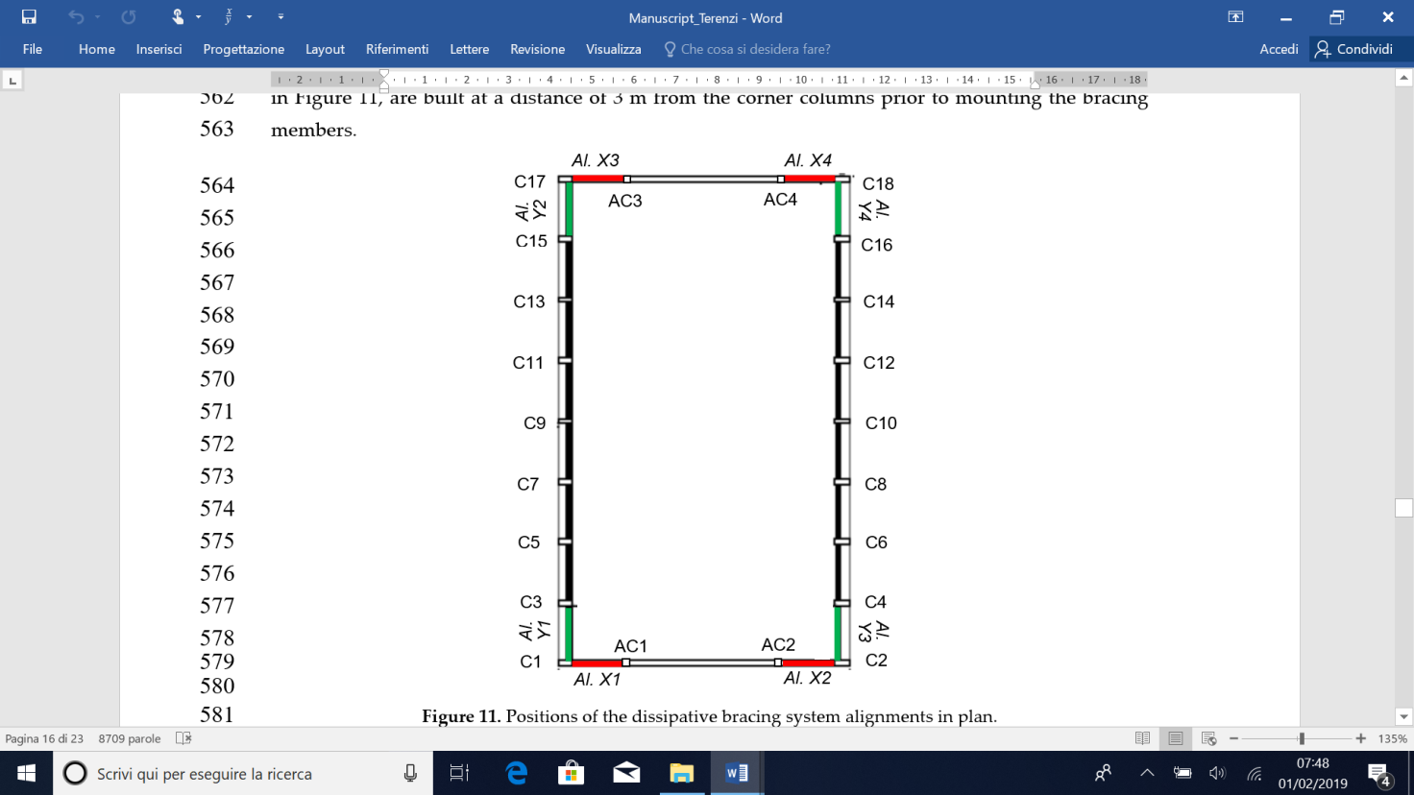

Figure 8. Positions of the dissipative bracing system alignments in plan

The FV dampers were designed based on the sizing procedure proposed in Terenzi (2018), by referring to its implementation for structures with poor shear and/or bending moment strength of constituting members. The procedure starts by assuming prefixed reduction factors, s, of the most critical response parameters in current conditions, which are evaluated by means of a conventional elastic finite element analysis. Simple formulas relating the reduction factors to the equivalent viscous damping ratio of the dampers, ξ*eq*, allow calculating the ξ*eq* values that guarantee the achievement of the target reduction factors. Finally, the energy dissipation capacity of the devices is deduced from ξ*eq*, finalizing their sizing process.

Based on the results of the assessment analysis reported in Section 3, the dissipaters are incorporated on the second level only, since the first level drifts computed in current conditions can produce only a marginal activation even of the smallest FV devices in standard manufacturing. Consequently, traditional non dissipative braces are installed on the first level in the same four plus four vertical alignments, so as to provide the necessary structural continuity with the dissipative bracing system placed on the second level, as illustrated in the elevation view of Figure 7, but without adding any further supplemental damping contribution. The application of the design procedure is summarized below for *X* and *Y* directions.

*X* direction – Lack of bending moment strength in columns

The verification analysisin current conditions highlights that the most critical response parameters in *X* direction are the bending moments around *Y* (i.e. *MY*) in the first level columns, with the highest unsafe conditions checked in the four corner columns. The maximum moment ****corresponding to the peak response point in Figure 6c, and associated with the concurrent axial force *Nc*=104 kN mentioned above, is equal to 398.7 kNm. The elastic limit moment  of the corner columns around the *Y* axis is equal to 224.8 kNm. Thus, the stress reduction factor  of the critical members, defined as ratio between the maximum moment and the corresponding elastic limit value, in *X* direction results as follows:

$α_{s}=α_{MY}=\frac{M_{Y,c}^{a}}{M_{Y,c}^{e}}$ (3)

Passing from the member to the frame structure level (equivalent to the frame structurestorey for this case study building), since all columns have the same cross section, *F* ratio coincides with *MY*:

 (4)

Based on this value, the equivalent viscous damping ratio of the set of spring-dampers to be installed on the second level is evaluated by means of the following relation (Terenzi 2018):

$ξ_{eq}\left(α_{F}\right)=\frac{2(α_{F}-1)}{α_{F}}$ (5)

obtaining a $ξ_{eq}\left(α_{F}\right)$ value of 0.277.

The *ED*energy dissipation capacity of the spring-dampers is therefore calculated by expression:

 (6)

The elastic limit values of the level shear *Fe* (i.e. the sum of the elastic limit shear forces of columns) and the first inter-level drift *ILDe* (replacing *IDe* in this case) computed in *X* direction, named *Fe,X* and *ILDe,1L,X*, are equal to 969 kN and 22 mm, respectively. Introducing these values, as well as *F* and ξ*eq*(*F*) values given by (3) and (5), in (6), the following *ED* estimate is derived:

 (7)

Dividing *ED* by the number of spring-dampers placed in *X*, the minimum energy dissipation capacity *ED,X*,*d* to be assigned to each of the 8 devices in order to reach the target performance at the MCE results as follows: *ED,X*,*d*=8.2 kJ. The spring-damper type with the nearest nominal energy dissipation capacity, *En*, to *ED,X*,*d* has the following mechanical properties, drawn from the manufacturer’s catalogue (Jarret 2018): *En*=9 kJ; stroke *smax*=±30 mm; damping coefficient *c*=9.9 kN(s/mm), with =0.15; *F*0=17 kN; and *k*2=1.74 kN/mm.

*Y* direction – Lack of bending moment strength in columns and excessive inter-level drift

The critical response parameters in *Y* direction are represented by the bending moments around *X* (*MX*) in the second level columns, with the highest unsafe conditions checked in the four corner columns too, and the second inter-level drifts. The maximum moment , corresponding in this case to the peak response point in Figure 6d, is equal to 174.2 kNm, whereas the elastic limit moment is equal to 84.2 kNm. Therefore, the stress reduction factor  of the critical members in *Y* direction is:

$α_{s}=α_{MX}=\frac{M_{X,c}^{a}}{M_{X,c}^{e}}$ (8)

and thus:

 (9)

The deformation-related reduction factor α*d* is calculated for *ILDmax* (replacing *IDmax*) and *ILDe* (replacing *IDe*) values computed on the second level in *Y* direction, named *ILDmax,2L,Y*, *ILDe,2L,Y* in the following:

$α_{d}=\frac{{ILD}_{max,2L,Y}}{{ILD}_{e,2L,Y}}$ (10)

As *ILDmax,2L,Y* corresponds to the *ILDr,max* value of 1.69% mentioned in Section 3.2, equal to 72.7 mm, and *ILDe,2L,Y* to 36.8 mm, *d* results to be equal to 1.98.

The equivalent viscous damping ratio is calculated in this case by referring both to F and d, using expressions (5) with reference to *F*, and the following:

$ξ_{eq}\left(α_{d}\right)=\frac{2(α_{d}-1)}{π}$ (11)

Referring to *d*, it results: $ξ_{eq}\left(α_{F}\right)$ = 0.33; $ξ_{eq}\left(α_{d}\right)$ = 0.624.

Named *Fe,Y* the elastic limit level shear in *Y* direction, by applying the *ED*energy dissipation capacity expression (7) and the relation below, referred to excessive inter-storey drift problems:

 (12)

the following *ED* estimates are obtained:

 (13)

 (14)

where *Fe,Y*=638 kN. By comparing ξ*eq*(*F*) with ξ*eq*(*d*), and *ED*(*F*) with *ED*(*d*), it can be observed that the relevant ratios are rather different. Indeed: ξ*eq*(*d*)/ξ*eq*(*F*)=1.89, *ED*(*F*)/*ED*(*d*)=1.1. This is due to the fact that, consistently with the general ξ*eq* expression (5), the damping coefficient depends on *Ee*, and thus on the elastic properties of the device, which are a function of the maximum displacement and force reached in the time-history response, in addition to the hysteretic response. On the other hand, the dissipated energy *ED* is only determined by the area covered by the response cycles, which identifies it as a more stable and reliable parameter for the design of the FV devices. ξ*eq* is only a useful synthetic measure of their limit damping capacity. The design process is completed by referring to the largest of the energy values, *ED*(*F*), *ED*(*d*), i.e. *ED*(*F*)=100.8 kJ. Similarly to *X* direction, the minimum energy dissipation capacity of each of the 8 devices placed in *Y*, *ED,Y*,*d*, in order to achieve the target performance at the MCE is obtained by dividing *ED*(*d*) by the number of spring-dampers: *ED,Y*,*d*=12.6 kJ. The device with the nearest nominal energy dissipation capacity to *ED,Y*,*d* has the following mechanical properties (Jarret 2018): *En*=14 kJ; stroke *smax*=±40 mm; damping coefficient *c*=14.16 kN(s/mm), with =0.15; *F*0=28 kN; and *k*2=2.1 kN/mm.

***4.3 Numerical Verification of the Retrofit Intervention***

A perspective view of the model including the dissipative bracing system is displayed in Figure 9.

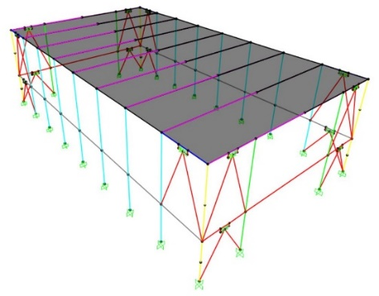

*C*17

*X*

*Z*

*Y*

Figure 9. View of the finite element model incorporating the dissipative bracing system

The modal analysis carried out in retrofitted conditions confirms the sequence of modes computed in current state, with differences on periods and EMMs lower than 10%, as a consequence of the small stiffening effect of this technology. Periods and EMMs of the two first horizontal translational modes along *X* and *Y* pass to 0.83 s (*Y*) and 0.32 s (*X*), and to 79.5% (*Y*) and 88.1% (*X*); periods and EMMs of the fourth and fifth mode, translational along *X* and *Y*, to 0.25 s (*Y*) and 0.105 s (*X*), and to 20.3% (*Y*) and 11.7% (*X*). Relevant summed

modal masses are nearly equal to 100% along both axes, in this case too. The third and sixth mode, rotational around *Z*, have periods of 0.33 s and 0.037 s, and EMM equal to 84.9% and 13.8%, giving a summed modal mass of 98.7%.

The results of the time-history verification analyses in rehabilitated configuration are synthesized in Figure 10, referred to the response induced by the most demanding of the seven groups of input ground motions scaled at the MCE level. In this Figure, the *MXc*–*MYc* interaction curves of the first and second level base sections of column C17, plotted in Figure 6c,d above for the original structure, are duplicated in retrofitted conditions. The two graphs show that the dissipative action of the protective system allows confining the interaction curves within the biaxial moment safe domain, reducing the maximum *MYc* (Figure 10a) and *MXc* (Figure 10b) moments nearly by the targeted *MY* and *MX* factors of 1.77 and 2.07 evaluated in the design phase.



*Mlc,*1[kNm]

*Mlc,*2[kNm]



*Mlc,*1[kNm]

*Mlc,*2[kNm]

***MCE – RS***

*MY,c* [kNm]

*C*17

*First Level*

**(a)**

**(b)**

*MY,c* [kNm]

*MY,c* [kNm]

*C*17

*Second Level*

***MCE – RS***

*MX,c* [kNm]

*MX,c* [kNm]

Figure 10. Retrofitted structure (RS). *MX,*c–*MY,*c biaxial moment interaction curves at the base section of column *C*17 on first level (a) and second level (b) obtained from the most demanding MCE-scaled group of accelerograms.

The response cycles of the pairs of spring-dampers exhibit peak displacements equal to 6.3 mm (alignments parallel to X) and 8.8 mm (alignments parallel to Y), far below the available stroke limits of 30 mm (in *X*) and ±40 mm (in *Y*) mentioned above. Furtheremore, the response of the devices situated along the diagonally opposite vertical alignments *Al.* *X1*, *Al.* *X3*, and *Al.* *Y2*, *Al.* *Y4* are nearly coincident, and the same occurs for the devices situated in *Al. Y2* and *Al. Y4*, highlighting that torsion effects in plan are virtually null.

**5. Conclusions**

The energy-based design criterion applied for the sizing of dampers utilized for the seismic retrofit of the gym frame building presented in this paper does not require any preliminary evaluation of the input energy demand on the original structure. At the same time, the most critical response parameters in current conditions — the reduction of which within the boundary of relevant safe domains (in case of lack of strength), or below limits preventing damage to structural and non-structural elements (in case of excessive lateral displacements) — are evaluated by a conventional elastic finite element analysis. Both aspects of the initializing step of the sizing procedure allow simplifying the design of supplemental damping-based retrofit solutions, which can be useful especially for professional engineers not familiar with seismic energy computation and the development of non-linear time-history analyses.

The demonstrative application to the considered case study structure allowed checking the quick sizing characteristics of the design criterion, even when stress state-related and drift-related deficiencies are both found in the original structure (as occurs in *Y* direction of the gym building). Furthermore, the values of the equivalent damping coefficient ratio calculated as a function of the reduction factors *F*, *d* relevant to stress states and drifts resulted to be notably different. On the other hand, a slight difference was found between the corresponding energy dissipation measures, *ED*(*F*) and *ED*(*d*). This identified *ED* as a more stable and reliable design parameter, as compared to ξ*eq*, consistently with the fact that *ED* is only determined by the area covered by the response cycles of the dissipaters. This was also confirmed by the fact that the *ED* values in *X* and *Y* computed from the time-history verification analysis were very similar to the *ED*(*F*) estimates.

As targeted in the retrofit design, the incorporation of the protective system in the gym building allows reaching an elastic and safe response of all members, as well as constraining the inter-level drifts below the Immediate Occupancy drift limit, up to the MCE, starting from a rather poor performance in original conditions.

**6. Acknowledgments**

The study reported in this paper was sponsored by the Italian Department of Civil Protection within the ReLUIS-DPC Project 2019-2021 – Work Package 15: Normative Contributions for Isolation and Dissipation. The author gratefully acknowledge this financial support.

**7. References**

Aiken I.D., Nims D.K., Whittaker A.S., Kelly J.M. (1993) Testing of passive energy dissipation systems. *Earthquake Spectra*, 9(3): 335-370.

ASCE/SEI 41-06 (2006) Seismic rehabilitation of existing buildings. *American Society of Civil Engineers – Structural Engineering Institute*, Reston, VA, 2006.

EN 1998-4 (2003) Eurocode 8: Design of structures for earthquake resistance - Part 1: general seismic rules. Seismic Actions and Rules for Buildings. European Committee for Standardisation, Brussels, Belgium.

Italian Council of Public Works (2018) Technical Standards on Constructions. *Italian Council of Public Works*, Rome, Italy [in Italian].

Italian Council of Public Works (2009) Commentary on the Technical Standards on Constructions. *Italian Council of Public Works*, Rome, Italy [in Italian].

Jarret SL (2018) Shock-control technologies. URL <http://www.introini.info>.

Mazza F. (2015) Comparative study of the seismic response of RC framed buildings retrofitted using modern techniques. *Earthquake and Structures*, 9(1): 29-48.

Ramirez O.M., Costantinou M.C., Kircher C.A., Johnson M.W., Chrysostomou C.Z. (2003) Validation of the 2000 NEHRP provisions' equivalent lateral force and modal analysis procedures for buildings with damping systems. *Earthquake Spectra*, 19(4): 981-999.

SAP2000NL (2018) Theoretical and users’ manual. Release 18.05. *Computers & Structures Inc*., Berkeley, USA.

Soong T.T., Spencer B.F. (2002) Supplemental energy dissipation: state-of-the-art and state-of-the-practice. *Engineering Structures*, 24(3): 243-259.

Sorace S., Terenzi, G. (2001) Non-linear dynamic modelling and design procedure of FV spring-dampers for base isolation. *Engineering Structures*, 23(12): 1556-1567.

Sorace S., Terenzi G. (2008) Seismic protection of frame structures by fluid viscous damped braces. *Journal of Structural Engineering, ASCE*, 134(1): 45-55.

Sorace S., Terenzi G. (2014) Motion control-based seismic retrofit solutions for a R/C school building designed with earlier Technical Standards. *Bulletin of Earthquake Engineering*, 12: 2723-2744.

Sorace S., Terenzi G., Mori C. (2016) Passive energy dissipation-based retrofit strategies for R/C frame water storage tanks. *Engineering Structures*, 106: 385-398.

Terenzi G. (2018) Energy-based design criterion of dissipative bracing systems for seismic retrofit of framed structures. *Applied Sciences*, 8, 268; DOI:10.3390/app8020268, [www.mdpi.com/journal/applsci](http://www.mdpi.com/journal/applsci); ID SCOPUS: 2-s2.0-85041834540

Terenzi G., Costoli I., Sorace S., Spinelli P. Verification of an energy-based design procedure for seismic retrofit of a school building, *Proceedings of the 14th International Conference on Building Pathology and Constructions Repair, CINPAR 2018*, 20-22 June 2018, Firenze, Italy.

Vanmarcke E.H., Fenton G.A., Heredia-Zavoni E. (1999) *SIMQKE-II – Conditioned earthquake ground motion simulator: User's manual, version 2.1*. Princeton University: Princeton, USA.

1. Department of Civil and Environmental Engineering, University of Florence, Italy, gloria.terenzi@unifi.it
2. Department of Civil and Environmental Engineering, University of Florence, Italy, iacopocostoli@gmail.com
3. Polytechnic Department of Engineering and Architecture, University of Udine, Italy, stefano.sorace@uniud.it
4. Department of Civil and Environmental Engineering, University of Florence, Italy, paolo.spinelli@unifi.it