**Shaking Table Test to Verify a New Seismic Response Control System Using Block & Tackle**

**DOI 10.37153/2686-7974-2019-16-771-781**

Taiki SAITO[1], Ryuto DOI[2], Kazuhiro HAYASHI[3]

**ABSTRACT**

This paper proposes a new seismic response control system using a block and tackle (hereinafter, referred to as a movable pulley damper system) developed especially for high-rise buildings. The proposed system has a configuration where a damper is installed on the track of the cable-stayed wire, amplifying the amount of movement of the wire by using a movable pulley that increases the damping effect to reduce the vibration of a building. Since the wire can be stretched across distant parts of a building, this system is able to exert an effect on a large relative displacement. To control the shear and bending deformation of a high-rise building during earthquake shaking, we examine a method to connect the core structure (parking tower) and the surrounding frame (housing part) of a high-rise building using the movable pulley damper system. This system aims to reduce the earthquake response of the building by the force of the damper attached to the core structure. By enlarging the relative displacement between the core structure and the surrounding frame by the moving pulley, it is possible to move the damper in considerable extent to dissipate large vibration energy. To verify the effectiveness of this response control system, a small shaking table test was conducted for a specimen simulating the core structure and the surrounding frame of a high-rise building.

*Keywords: Response control, High-rise building, Block and tackle, Earthquake, Damper*

**1. INTRODUCTION**

At the 2011 Great East Japan Earthquake, high-rise buildings in Tokyo, Nagoya and Osaka swayed significantly and caused damage to non-structural elements such as deformation of fire protection walls and the dropping of ceiling panels. In a 55-storey office building located in Osaka, which is more than 700 km away from the epicenter, all 32 elevators stopped and damage to non-structural elements happened. From the accelerometer installed on the 52nd floor, it is known that a large shaking with the maximum amplitude of 1,360 mm continued for more than 10 minutes. This is considered due to the resonance effect to the long-period earthquake ground motion generated in the deep sediments of the Osaka Plain.

In the recent seismic design of high-rise buildings in Japan, it is common to install damping devices such as oil dampers to reduce the earthquake response of the building. Also, there are many examples to install damping devices to the existing high-rise buildings as seismic retrofit measures. However, since the bending deformation components dominate in the upper part of the high-rise buildings, the response reduction effect of the damping device is limited. Analysis shows that the maximum response acceleration during earthquakes is reduced by about 10 to 20% by installing dampers.

The author proposed a new seismic response control system that is named as the movable pulley damper system, developed especially for high-rise buildings [1]. The idea to enhance the vibration reduction effect of a damping device using wire and pulleys has been already studied by Kawase et al. [2]. The basic configuration is to span the cable-stayed wire to building parts and install a damper connecting the wire. The structural system proposed in this study has a similar configuration; installing a damper on the track of the cable-stayed wire, except for amplifying the amount of movement of the wire by using a movable pulley and increasing the damping effect of the damper to reduce building vibration. The principle of this mechanism is shown in Figure 1. The wire is stretched to reciprocate between the pulley groups A and B, and one end of the wire is connected to the damper. Wires and pulleys are arranged on the other side of the damper under the same condition. When the building moves during an earthquake, the amount of displacement $D$ between A and B is enlarged by the number n of wires between them, and the damper can move by $×D$. At the same time, the damper force is expanded $n$ times and acts on the building.

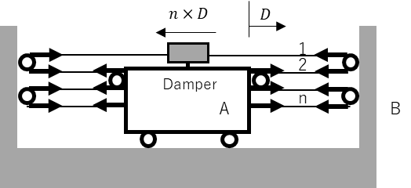

Figure 1. Mechanism of dynamic pully damper system

A series of experimental studies on this system have been conducted to confirm the damping effect and evaluate the effect of the wire elongation and the friction with the pulley. The features of this vibration control structure system are summarized as follows:

(1) It enables to increase the damping effect greatly by amplifying the movement of the wire with respect to the deformation of the building.

(2) Even the damper with small capacity can be used if the stroke of damper is large.

(3) Since the wire can be stretched between different spans or different stories, various arrangements are possible to install the system.

In this research, as shown in Figure 2, we consider applying the dynamic pulley damper system to a high-rise condominium building consisting of a surrounding frame (housing part) and a core part (parking tower). The surrounding frame and the core part are connected by a wire through pulleys and a damper device is installed at the top of the core. The relative displacement of two structures is amplified by the movable pulleys, and the damper moves largely to dissipate energy to reduce the vibration of the surrounding frame. We also derive the constitutive equation of the dynamic pulley damper system considering the elastic deformation of the wire rope and implement it into the frame analysis program.



Top view

Cross section view

Figure 2. Arrangement of a movable pulley damper system to a high-rise building with a core structure

**2. constitutive formula of dynamic pulley damper system**

A force-deformation relationship of the dynamic pulley damper system considering elongation of the wire is derived below. It is assumed that there is no friction between the wire and pulley and stretching due to temperature change and deflection due to the mass of the wire are ignored in the derivation.

The following conditions are established when implementing a dynamic pulley damper system into a frame. As shown in Figure 3, the wire is stretched between the pulleys installed at any four points in the frame in an X shape or an inverted V shape, and the wire of the diagonal part is reciprocated between the pulleys to increase the movement of the damper installed at the top or bottom of the system. The wire and the damper are on the same plane in the entire coordinate system, and the upper and lower sides of the wire are parallel to the horizontal plane.

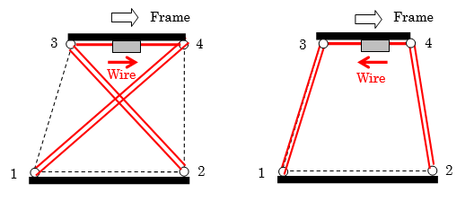

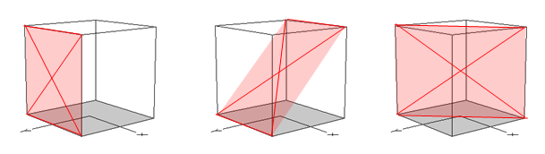

(a) X-shape (b) Inverse V shape (c) Plane to install system

Figure 3. Basic configuration of arrangement of a movable pulley damper system

The dynamic pulley system is replaced with the equivalent truss model as shown in Figure 4. The constitutive formula for truss replacement is derived below in case of the X-shape arrangement with the damper at the top.

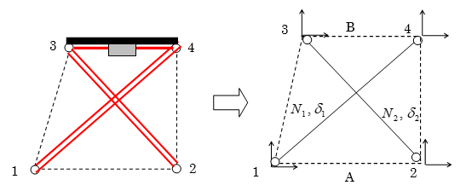

Figure 4. Replacement of the dynamic pulley system to the equivalent truss model

For the right side of the letter X shown in Figure 5, the force-deformation relationship of the wire in the oblique and horizontal parts is expressed as follows.



Figure 5. Equivalent truss model (right part of the model)

 (1)

 (2)

where,  are the wire elongation and the pulley distance of the oblique part,  is the number of reciprocations of the wire in the oblique part,  are the wire elongation and the pulley distant of the horizontal part between the pulley and the damper, and  are the Young's modulus and the cross section area of the wire. The relationship between wire tension  and damper force  is expressed as follows.

 (3)

The force and deformation of the equivalent truss are

 (4)

Similarly, for the left side of the letter X shown in Figure 6, the force-deformation relationship of the wire in the oblique and horizontal parts is expressed as follows.



Figure 6. Equivalent truss model (left part of the model)

 (5)

 (6)

The relationship between wire tension  and damper force  is as follows.

 (7)

The force and deformation of the equivalent truss are

 (8)



Figure 7. Equivalent truss model (left part of the model)

In the case of the letter X shown in Figure 7, the tension forces of the left and right wires act on the damper and the damper force is evaluated as . If one of the left and right wires stretches, the other wire shrinks by the same length, so the following relationship holds.

 (9)

where

 (10)

Therefore, the damper force is evaluated as

 (11)

The force of the truss can be obtained from the force of the damper by the following equation.

 (12)

The deformation of the damper is given by

 (13)

Therefore, it can be implemented into the frame analysis by the following procedure:

Step 1. Using the force  and displacement  of the truss, find the deformation of the damper from Equation (13).

Step 2. Determine the damper force  from the load deformation relationship of the damper.

Step 3. Update the truss axial forces  from Equation (12).

The dynamic pulley damper is implemented in the computer program, STERA_3D [3], developed by one of the authors for three-dimensional earthquake response analysis of buildings. Figure 8 shows the input window of the dynamic pulley damper. For the damper, you can choose a hysteresis damper or an oil damper.

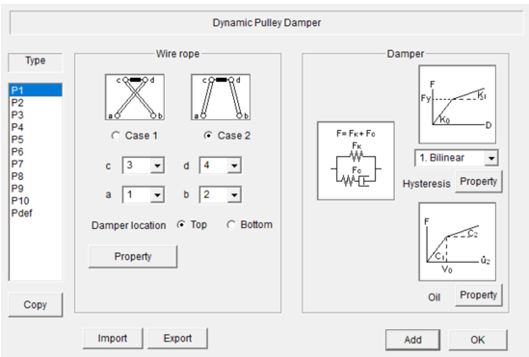

Figure 8. Input window of dynamic pulley damper in STERA_3D

**3. Shaking table test**

***3.1 Outline of the test specimen***

The outline of the test specimen for the shaking table test is shown in Figure 9. The specimen consists of two parts; a four-story frame part and a core part in the center. The floor of the specimen is made of steel plate and the column is made of ultra-duralumin plate. A steel plate with 150 mm length and 2 mm thickness is used as a hysteresis damper. The damper is placed at the ceiling of the 3rd floor, and wires are connected at the end. The yield strength of the damper is about 14N. The initial tension of the wire is 30 N. The left side of Figure 9 represents the stationary state, and the right side represents the deformed state. The view of the specimen is shown in Figure 10.



Figure 9. Outline of the test specimen of the shaking table (Unit: mm)

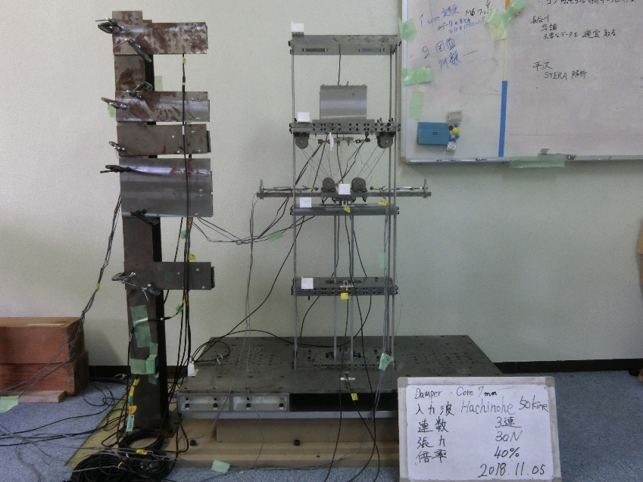

Figure 10. View of the test specimen

***3.2 Input wave and test cases***

The conditions of the experiment are shown in Table 1. A non-damping model in which the frame part and the core part are not connected is [Case F]. A model in which the frame part and the core part are connected only by wire and pulleys is [Case FW]. And a model in which a steel damper is introduced is [Case FWD]. In Case FWD model, the thickness of the core plate is changed as 12 mm (hard model) and 7 mm (soft model).

Table 1. Conditions of the experiment

|  |  |  |  |
| --- | --- | --- | --- |
| **Test case** | **Case F** | **Case FW** | **Case FWD** |
| Tension of wire (N) | --- | 30 | 30 |
| Size of steel damper (mm) | --- | --- | $$2×6$$ |
| Thickness of core plate (mm) | --- | 12 | 12 (hard model) |
| 7 (soft model) |

As input waves, we used three waves of 1940 El Centro wave, 1968 Hachinohe wave, and 1995 JMA Kobe wave, each with $1/\sqrt{10}$ times the time scale. The maximum velocity was gradually increased every 5 cm/s, and the experiment was terminated when the maximum inter-story drift angle of the frame exceeded 1/25. Figure 11 shows the input waves normalized to have the maximum velocity of 50 cm/s.



Figure 11. Input waves normalized to have the maximum velocity of 50 cm/s

***3.3 Test results***

Figures 12 to 14 show the relationships between the maximum input acceleration and the maximum displacement at each floor of the specimen under El Centro, Hachinohe and JMA Kobe waves. The maximum displacement of each floor is obtained from the difference between the displacement of each floor of the specimen and the displacement of the shaking table. In the case of El Centro wave in Figure 12, Case FW can suppress more building displacement than Case F. There is no difference in damping effect between Case FW and Case FWD up to an acceleration of about 100 cm/s2 in the 3rd and 4th floors, and up to an acceleration of 200 cm/s2 in the 1st and 2nd floors. However, when the input acceleration is higher than 200 cm/s2, the damping effect of Case FWD is prominent. In the case of Hachinohe wave in Figure 13, Case F and Case FW have similar damping effect. In Case FWD which introduced a damper, the deformation is suppressed both in the soft model and the hard model of the core part. In the case of JMA Kobe wave in Figure 14, the difference of the damping effect under each experimental condition did not appear in the 1st and the 2nd floors. Moreover, even in the 3rd and 4th floors, the difference of damping effect does not appear in each experimental condition up to an acceleration of 200 cm/s2, and the damping effect of other two waves cannot be seen even if the acceleration is increased.





Figure 12. Maximum Floor Displacement under El Centro Wave





Figure 13. Maximum Floor Displacement under Hachinohe Wave





Figure 14. Maximum Floor Displacement under JMA Kobe Wave

Figure 15 shows the maximum relative displacement of each story in El Centro, Hachinohe and JMA Kobe waves. In the case of El Centro wave, the introduction of the wire (Case FW) shows a remarkable damping effect. In the case of Hachinohe wave, although it is not apparent as El Centro wave, the maximum displacement is reduced by the dynamic pulley damper. In the case of JMA Kobe wave, smaller displacement of the third layer than the second layer is seen. Since the moving pulleys are placed close to the position of the node in the second vibration mode, it is considered that the response of the surrounding frame could not be effectively reduced in case of JMA Kobe wave



Figure 15. Maximum Floor Displacement under JMA Kobe Wave

Figures 16 and 17 show the comparison of the maximum displacement between analysis and test results under El Centro Wave for Case FW and Case FWD, respectively. In case of Case FW (Figure 15), the analysis and test results correspond relatively well. On the other hand, in case of Case FWD (Figure 16), the analysis results are generally smaller than the test results. It means that the model of the damper device must be improved for the future study.





Figure 16. Comparison between Analysis and Test Results under El Centro Wave for Case FW





Figure 17. Comparison between Analysis and Test Results under El Centro Wave for Case FWD

**4. Conclusions**

This paper proposed a new seismic response control system using a block and tackle, named as a movable pulley damper system. A shaking table test was conducted for a specimen simulating the core structure and the surrounding frame of a high-rise building. It was verified that the new system effectively reduced the building response. The constitutive formula was developed and implemented in the frame analysis program to simulate the test results.

**5. References**

[1] Taiki Saito, et al: New Seismic Response Control System using Block and Tackle, 16th World Conference on Earthquake Engineering, Santiago Chile, January 9th-13th 2017.

[2] Hiroshi Kawase, et al.: A New Approach for Structural Vibration Control : Damped Wire Sys-tem (Part 1. Fundamental Mechanism of Damped Wire System), Report of the Annual Meeting of the Architectural Institute of Japan , 975-976, 1990 (in Japanese)

[3] Taiki Saito: STERA_3D, <http://www.rc.ace.tut.ac.jp/saito/software-e.html>

1. Professor, Toyohashi University of Technology, Toyohashi, Japan, [tsaito@ace.tut.ac.jp](mailto:tsaito@ace.tut.ac.jp)
2. Graduate student, Toyohashi University of Technology, Toyohashi, Japan, [r163533@edu.tut.ac.jp](mailto:r163533@edu.tut.ac.jp)
3. Assistant Professor, Toyohashi University of Technology, Toyohashi, Japan, [hayashi@ace.tut.ac.jp](mailto:hayashi@ace.tut.ac.jp)