**The Characteristics of the Rubber Bearing with Tin Plug**

**DOI 10.37153/2686-7974-2019-16-910-918**

Masayuki YANAGI[1], Miyuki SHIMIZU[2], Ryoji SUZUKI[3], Akira YASUNAGA[4], Takeshi FURUHASHI[5]

**ABSTRACT**

Seismic isolation protects a structure from the destructive effects of an earthquake by decoupling it from the ground by seismic devices such as rubber bearings in the building basics. Rubber bearing with an energy dissipating lead has been used as one of seismic devices conventionally. However, while the rubber bearing with lead has the advantage of having a damping function, the use of lead in the damping material may cause environmental problems. Non-lead has already advanced in the field of each industry, and practical use of non-lead work is necessary.

We developed rubber bearing with tin plug (core) which we used tin for as damping materials from such a background.

In this paper, we report on the structure, characteristics, repeating durability of rubber bearing with tin plug.

As a result of the repeated test, although the yield load slightly decreased, the supporting capacity and the restoring capacity were sufficiently retained. After the cyclic loading tests, the specimen was cut and the state of the tin plug was confirmed, but damage such as cracks was not observed.

In conclusion, the repeating durability of the rubber bearing with tin plug under the cyclic loading tests was verified by the test results.

*Keywords: tin plug , rubber bearing , repeating durability*

**1. INTRODUCTION**

Non-lead has already advanced in the field of each industry, and practical use of non-lead work is necessary.

We developed rubber bearing with tin plug (core) which we used tin for as damping materials from such a background.

Tin plug is inserted in the center of isolator, and provides damping by deforming plastically when the isolator moves laterally in an earthquake. Tin is metal with the property that is approximately equal to lead, but yield load is high with 1.7 times of lead, and it means that energy absorption efficiency is high.

Rubber bearing with tin plug has lineup of diameter φ 700 mm ～ φ 1500 mm. As of the end of August 2018, there is a delivery record of a total of 2000 isolators in about 100 buildings.

In this paper, we report on the structure, characteristics, repeating durability of rubber bearing with tin plug.

**2. isolator structure**

The isolator structure and cross section of the rubber bearing with tin plug are shown in Figure 1. In the rubber bearing part where the rubber sheet and the inner plate are alternately laminated, there is abundant achievement with our natural rubber based laminated rubber and inner plate exposed structure excellent in vertical load supporting ability (diameter slightly larger than rubber sheet A structure using the inner plate) is adopted. Products are bolted to building foundations and superstructures via flanges fastened to connecting steel plates with connecting bolts. The tin plug disposed at the center of the rubber bearing part plastically deforms due to horizontal deformation of the rubber bearing part at the time of earthquake, thereby absorbing the earthquake energy and acting to suppress the shaking of the earthquake promptly.





Figure 1. Isolator structure and cross section of the rubber bearing with tin plug

**3. Plug material CHARACTERISTICS**

Characteristics of tin and lead were evaluated using a uniaxial tensile test specimen to study the plug material. The mechanical characteristics are shown in Table 1, the stress-strain characteristics are shown in Figure 2, and the stress change characteristics by repetition number are shown in Figure 3.

From this result, it was confirmed that tin has ductility and repeating performance equal to or higher than that of lead.

In addition, the cross-sectional structure of the specimen was observed before and after the uniaxial tensile test, and whether or not recrystallization occurred at 20℃ was confirmed. In the case where recrystallization does not occur, the crystal grains have a shape elongated in the axial direction, but when recrystallization occurs, the crystal grains are small and have a substantially circular shape. Figure 4 shows the cross-sectional structure of the tin material before the test, and Figure 5 shows the cross-sectional structure after 2 days of the test. Compared with the grain before the test, it can be confirmed that the crystal grain after the test has a smaller grain size and a shape close to a circle. Recrystallization of the plug means maintaining stable damping performance even when experiencing repeated earthquakes.

Table 1. Mechanical characteristics of tin and lead

|  |  |  |
| --- | --- | --- |
|  | **Tin** | **Lead** |
| Yield stress (MPa) | 19.2 | 12.9 |
| Rigidity (GPa) | 51.9 | 17.6 |
| Elastic limit strain (×10-4) | 3.70 | 7.33 |

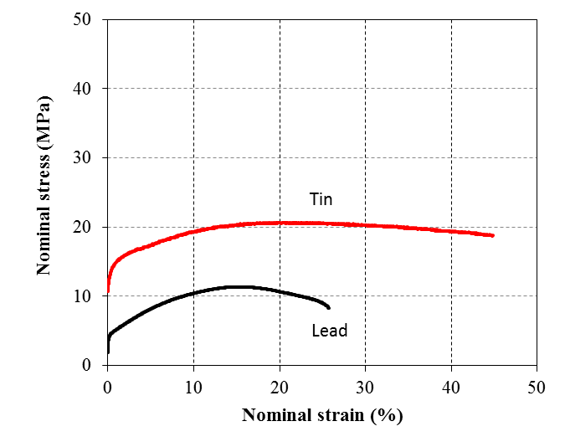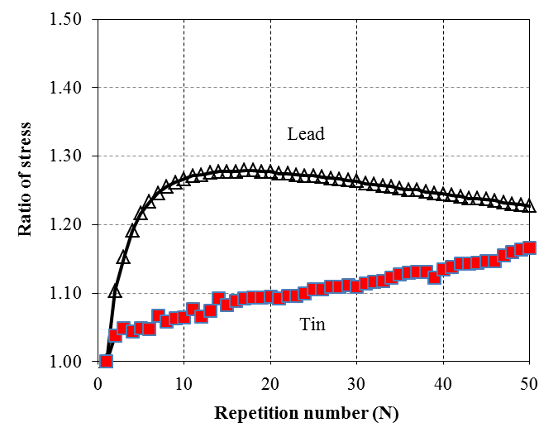

Figure 2. Stress-Strain characteristics Figure 3. Repetition number characteristics

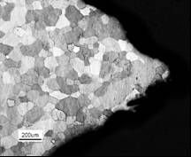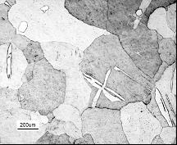

Figure 4. Cross-sectional structure before the test Figure 5. Cross-sectional structure after 2 days of the test

**4. isolator characteristics**

***4.1 Horizontal characteristics***

The second stiffness K2 of the rubber bearing with tin plug determines the natural period of the base isolation layer and the yield load Qd shows the damping ability. These characteristics are important characteristics for the seismic isolation building, and the shearing load-horizontal displacement relation at the time of horizontal displacement and each characteristic are in the relation shown in Figure 6. The horizontal displacement-shearing load basic characteristics of the rubber bearing with tin plug are shown in Figure 7 in comparison with rubber bearing with lead plug of the same structure. It was confirmed that the rubber bearing with tin plug had a damping capacity of about 1.7 times and yield load of conventional rubber bearing with lead plug.

Figure 8 shows the horizontal displacement-shearing load hysteresis characteristics of the shear strain of 25% to 400% of the specimen with a rubber diameter φ1000mm and a tin plug diameter φ200mm. It showed stable hysteresis characteristics up to horizontal displacement of 600 mm, and it was confirmed that even if deformation exceeding 600 mm was given, the restoring force was maintained.

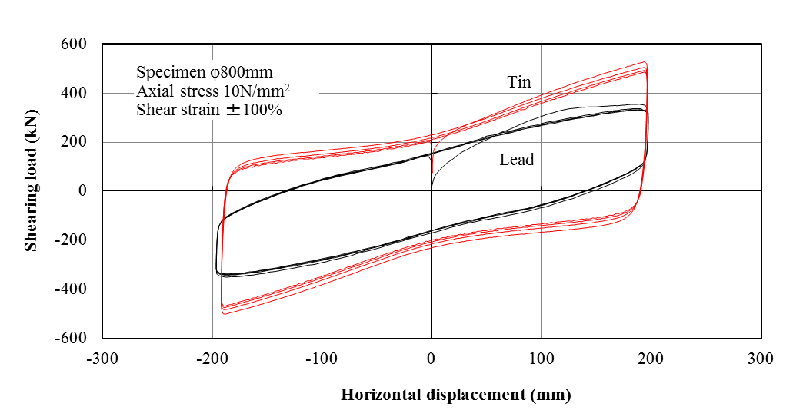



Figure 6. Horizontal characteristic (K2,Qd) Figure 7. Comparison of tin plug and lead plug

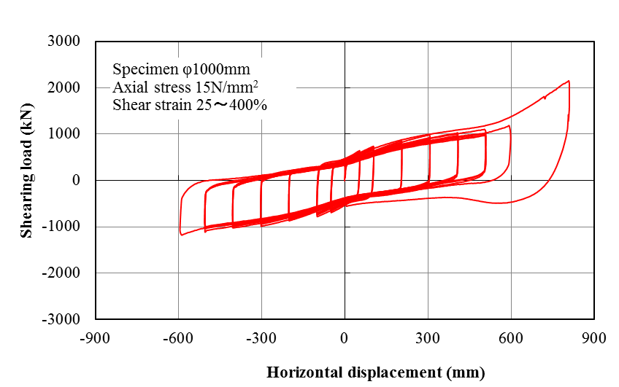

Figure 8. horizontal displacement-shearing load hysteresis characteristics

***4.2 Shear strain dependence***

The results of the shear strain dependence of second stiffness K2 and yield load Qd are shown in Figure 9 and Figure 10. The vertical axis shows the rate of change of K2 and Qd at each γ with respect to K2 and Qd at shear strain γ = ± 100%. As shown in Figure 9, K2 decreases as γ increases. On the other hand, as shown in Figure 10, Qd tends to decrease when γ is less than 100%, but becomes substantially constant when γ is 100% or more.

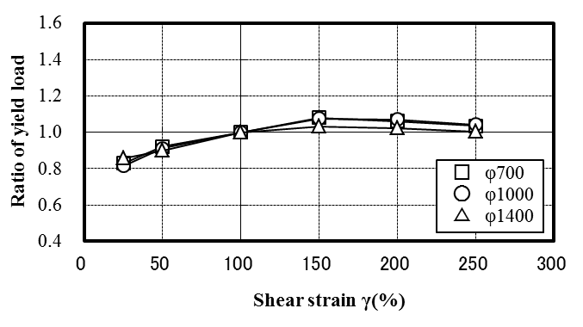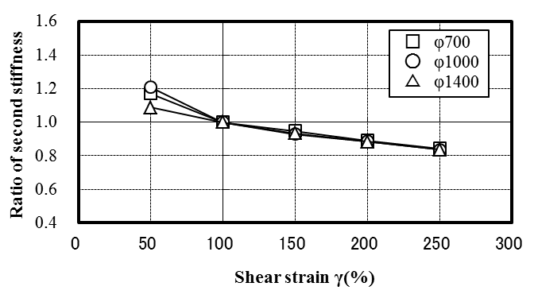





Figure 9. Shear strain dependence of second stiffness Figure 10. Shear strain dependence of yield load

***4.3 Compressive stress dependence***

The results of compressive stress dependence of second stiffness K2 and yield load Qd are shown in Figure 11 and Figure 12. The vertical axis shows the rate of change of K2 and Qd at each test compressive stress with respect to K2 and Qd at the standard compressive stress σ0. The horizontal axis shows the ratio of each test compressive stress to the standard compressive stress σ0. As shown in Figure 11, K2 decreases as the compressive stress increases. On the other hand, Qd increases as the compressive stress increases as shown in Figure 12.

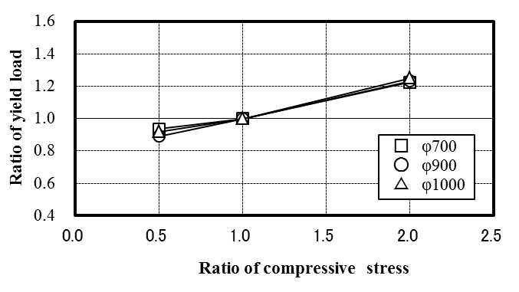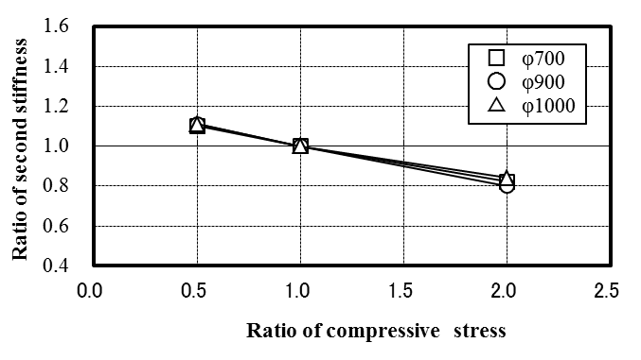

Figure 11. Compressive stress dependence of second stiffness Figure 12. Compressive stress dependence of yield load

***4.4 Temperature dependence***

The second stiffness K2 is correlated with the shearing stress of the rubber material and is thought to show the same tendency as the temperature dependency of the shearing stress. The yield load Qd is also correlated with the yield stress (0.2% yield stress) of tin, and it is considered that it shows the same tendency as the temperature dependency of the yield stress. The results of the temperature dependence test of the shear stress by the shear test piece are shown in Figure 13, and the temperature dependence test result of the yield stress (0.2% yield stress) by the reduced specimen is shown in Figure 14. The vertical axis shows the change rate of the measured value at each measurement temperature with respect to the characteristic value at 20℃. Both characteristics show a tendency to rise at low temperature and decrease at high temperature.

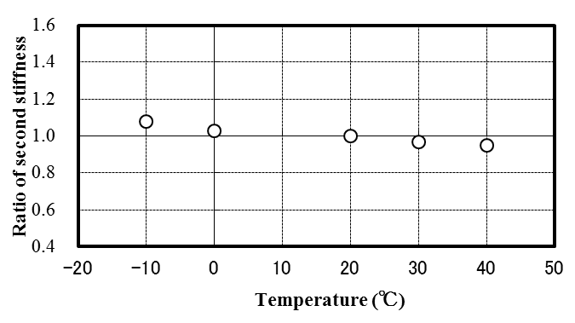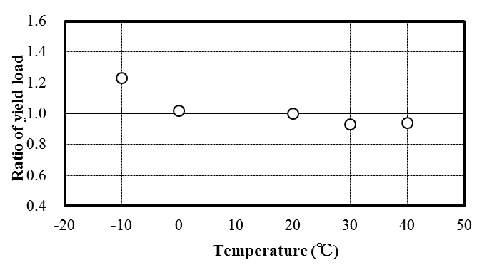

Figure 13. Temperature dependence of second stiffness Figure 14. Temperature dependence of yield load

***4.5 Velocity dependence***

The results of the velocity dependence of the yield load by the reduced test specimen φ 300 are shown in Figure 15. The yield load shows a tendency to increase with increasing velocity. On the other hand, it was confirmed that the second stiffness had almost no velocity dependence.

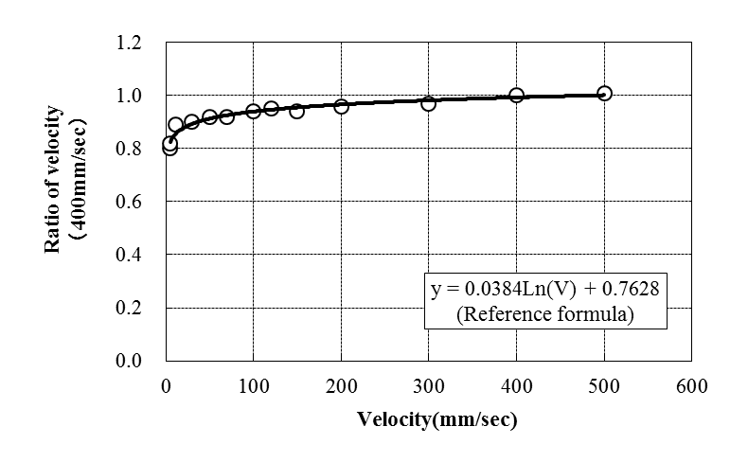Figure 15. Velocity dependence of yield load

**5. repeating durability**

The specimen for which the repeated repetition of the rubber bearing with tin plug was evaluated is shown in Table 2. All rubber materials are shear modulus G=0.39 N/mm2. The test conditions of each specimen are shown in Table 3. Table 3 also shows the displacement converted into φ1000 which is the assumed actual size. All excitation methods are constant amplitude excitation.

Table 2. Overview of Rubber Bearing with tin plug Specimen

|  |  |  |  |  |  |
| --- | --- | --- | --- | --- | --- |
|  | **assumed size**  **φ1000** | **φ500** | **φ700** | **φ800** | **φ1200** |
| Isolator diameter (mm) | φ1000 | φ500 | φ700 | φ800 | φ1200 |
| Tin Plug diameter (mm) | φ200 | φ100 | φ140 | φ160 | φ240 |
| Total rubber thickness (mm) | 7.5×26  =195.0 | 3.75×26  =97.5 | 5.3×26  =137.8 | 6.0×26  =156.0 | 9.0×22  =198.0 |
| S1:Primary shape factor | 32.0 | 32.0 | 31.7 | 32.0 | 32.0 |
| S2:Secondary shape factor | 5.1 | 5.1 | 5.1 | 5.1 | 6.1 |

Table 3. Repeated test conditions

|  |  |  |  |  |
| --- | --- | --- | --- | --- |
|  | **φ500** | **φ700** | **φ800** | **φ1200** |
| Axial stress (N/mm2)  (Axial load) (kN) | 15  (2827) | 15  (5542) | 15  (7238) | 15  (16286) |
| Test velocity (mm/s) | 12.6 | 173 | 5 | 5 |
| Shear strain γ (%)  (Horizontal displacement) (mm) | ±2  (±2) | ±100  (±137) | ±250  (±390) | ±300  (±594) |
| φ1000 conversion displacement (mm) | ±4 | ±195 | ±488 | ±585 |
| Cumulative horizontal displacement (m) | 3513 | 59 | 263 | 63 |
| Repetition number (N) | 439200 | 100 | 50 | 20 |

Figure 16 shows the shearing load-horizontal displacement relationship during continuous repetitive excitation. As the number of repetitions of each specimen increased, the yield load tended to decrease due to the influence of the temperature rise of the tin plug. However, it can be confirmed that the shape of the hysteresis loop is not disarranged until the end of the test and the vertical load supporting capacity is maintained.

Figure 17 shows the shearing load-horizontal displacement relationship obtained from the basic performance test results performed before and after continuous repetitive excitation. For φ500, φ700, φ800, no change was observed in the basic performance before and after excitation test. However, for φ1200, because of large deformation repetition with shear strain γ = ± 300%, a decrease in the yield load was observed compared to the other specimens, but after one day the yield load was repeated and compared with that before excitation It has confirmed that it has recovered to about 83%.

The cumulative displacement amount received by each specimen is shown in Figure 18. The partial amplitude on the vertical axis in Figure 18 is converted into φ1000 which is the assumed actual size.

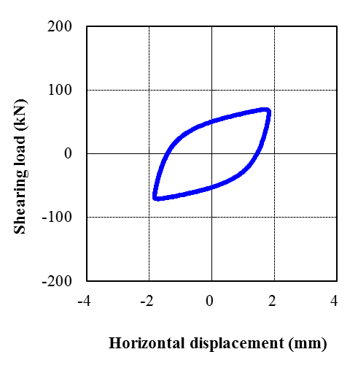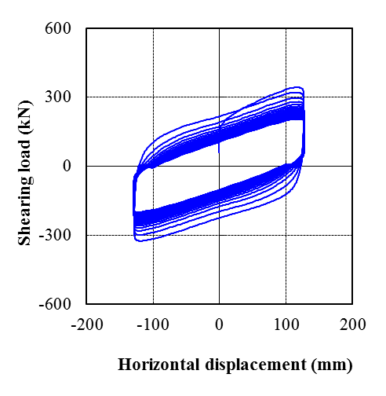

(a) φ500 γ=±2%,1cycle (b) φ700 γ=±100%,100cycle

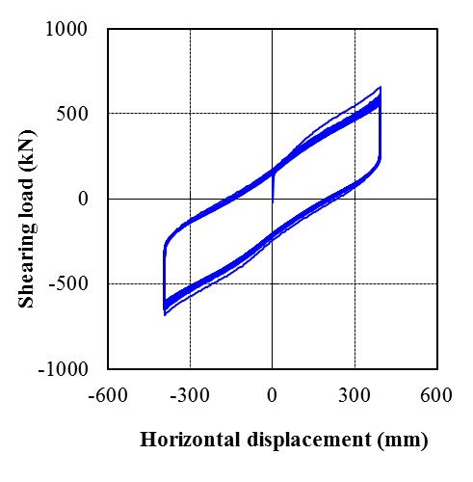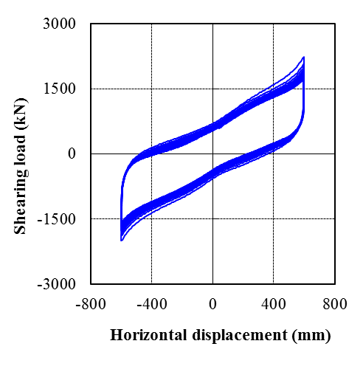

(c) φ800 γ=±250%,50cycle (d) φ1200 γ=±300%,20cycle

Figure 16. Horizontal characteristics of continuous repetition test

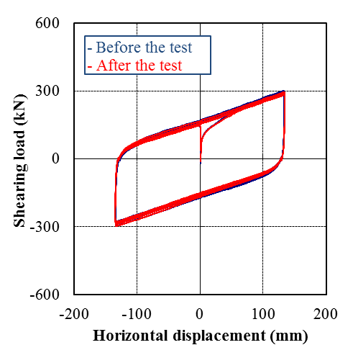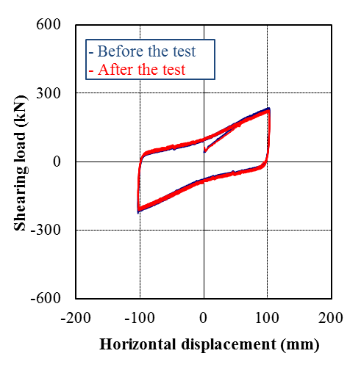

(a) φ500 γ=±100% (b) φ700 γ=±100%

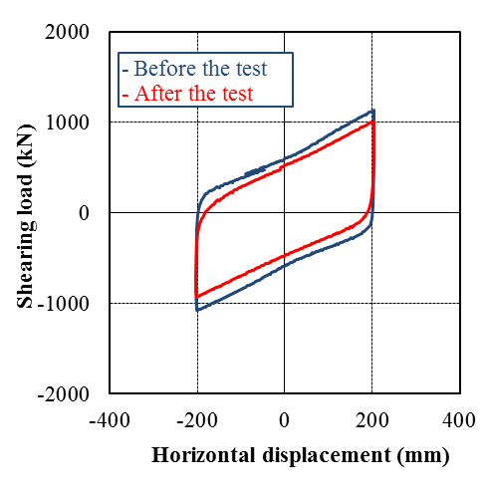

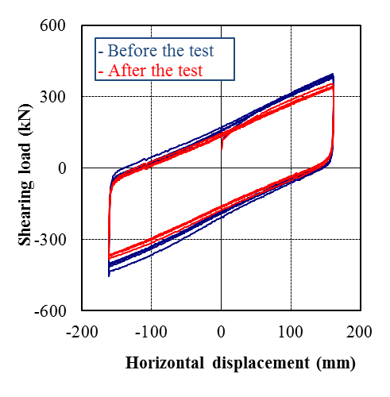

(c) φ800 γ=±100% (d) φ1200 γ=±100%

Figure 17. Horizontal characteristics before and after continuous repetition test

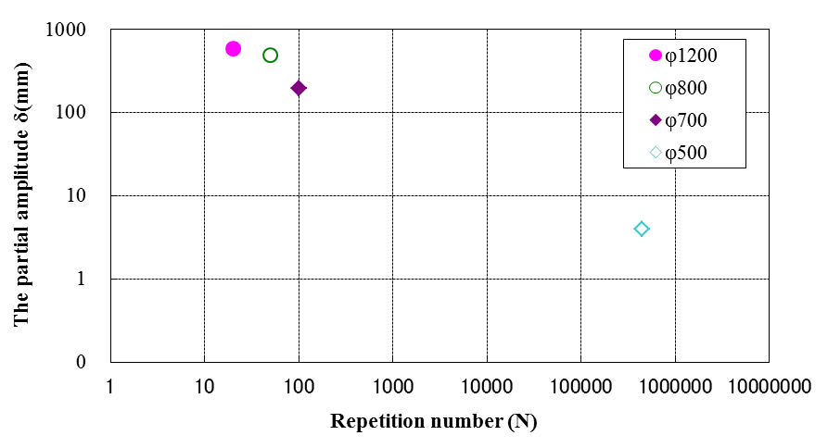

Figure 18. Equivalent amplitude and repetition number of each specimen

After completion of the test of φ500 and φ800, the test specimens were cut and the presence or absence of internal damages were confirmed. Figure 19 shows cut photographs. No damage such as cracks was observed in cross sections of the tin plugs for each specimen.

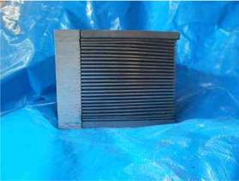

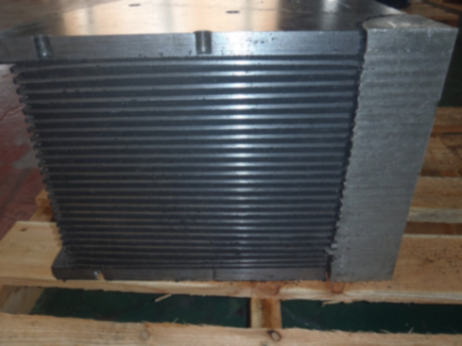

(a) φ500 (c) φ800

Figure 19. Cross-sectional photograph of test specimen after test

**6. Conclusions**

In development of environmentally friendly rubber bearing with tin plug that meets environmentally conscious societal needs, plug material characteristic test, characteristic test of actual product, and repeated durability were evaluated. We confirmed that rubber bearing with tin plug has damping capacity of about 1.7 times that of conventional rubber bearing with lead plug and various dependency.

Moreover, the durability by continuous repetitive excitation was verified, and although the yield load decreased, the results that the vertical supporting capacity and the restoring capacity were sufficiently retained were obtained. Furthermore, after completion of continuous repetitive excitation, the specimen was cut and the state of the tin plug was confirmed, but damage such as cracks was not observed.

In conclusion, the repeating durability of the rubber bearing with tin plug under the cyclic loading tests was verified by the test results.

**7. Acknowledgments**

The Rubber Bearing with Tin Plug were developed under a joint research project involving Aseismic Devices CO.,LTD. ,Sumitomo Metal Mining Siporex Co.,Ltd. ,SWCC SHOWA CABLE SYSTEMS CO.,LTD. The authors would like to express thanks to all developers.

**8. References**

Yamaguchi, N. et al. (2005) Development of Tin Rubber Bearing Isolator (Part1～Part5)

AIJ Journal of Technology and Design. , Architectural Institute of Japan:747-756

Kaihotsu, M. et al. (2008) Development of Tin Rubber Bearing Isolator (Part9)

AIJ Journal of Technology and Design. , Architectural Institute of Japan:381-382

Sudo, K. et al. (2013) Development of Tin Rubber Bearing Isolator (Part17)

AIJ Journal of Technology and Design. , Architectural Institute of Japan:725-726

Fukuda, S. et al. (2006) The development of the Rubber Bearing with Tin Plug , SWCC Review Vol.56:37-41

Fukuda, S. et al. (2007) The Characteristics of the Rubber Bearing with Tin Plug , SWCC Review Vol.57:40-44

Kaihotsu, M. et al. (2014) Soundness of Rubber Bearing with Tin Plug , SWCC Review Vol.60:58-62

1. SWCC SHOWA CABLE SYSTEMS CO.,LTD., Japan, Kanagawa, m.yanagi038@cs.swcc.co.jp
2. SWCC SHOWA CABLE SYSTEMS CO.,LTD., Japan, Kanagawa, m.kaihotsu019@cs.swcc.co.jp
3. Aseismic Devices CO.,LTD., Japan, Tokyo, ryouji@adc21.co.jp
4. Sumitomo Metal Mining Siporex Co., Ltd., Japan, Tokyo, Akira_Yasunaga@ni.smm.co.jp
5. Nihon University, Japan, Tokyo, furuhashi.takeshi@nihon-u.ac.jp