**Recent developments in New Zealand in seismic isolation, energy dissipation and vibration control of structures (2019)**

**DOI 10.37153/2686-7974-2019-16-882-890**

David WHITTAKER[1]

**ABSTRACT**

Recent activity in the implementation of seismic isolation, energy dissipation and vibration control of structures in New Zealand is summarised. Recent severely damaging earthquakes in New Zealand have left many buildings and infrastructure systems inoperable and not repairable, leading to their demolition. Owners and engineers are now seeking systems that will provide more resilient seismic behaviour. Resilient structures will be able to recover operation and function quickly after a major earthquake compared with conventional structural systems. Earthquake protection technologies now being developed and used to make more seismically resilient structures include seismic isolation and energy dissipation systems. These systems can provide better damage control and repairability of structures. The paper summarises recent projects in New Zealand that have incorporated seismic isolation and energy dissipation and other earthquake protection systems such as dissipative brace systems. A draft New Zealand Guideline for the design of seismic isolation systems for buildings was recently published. The Guideline makes recommendations for how engineers should design isolated buildings to meet performance requirements that will often be well in excess of the minimum requirements of the national building code. Details of the design Guideline are summarised and examples of the design displacement and acceleration demands in various main centres of New Zealand are also given.

*Keywords: New Zealand; Recent Developments; Isolation; energy dissipation*

**1. INTRODUCTION**

This paper summarises recent progress and developments in the application of seismic isolation, energy dissipation and vibration control for seismic protection of structures in New Zealand, as at 2019. It follows previous progress reports by the author to ASSISi conferences since 2007, primarily focussed on seismic isolation (Whittaker and Robinson 2007 and 2009, Whittaker 2013, 2015, 2017). Although New Zealand engineers were instrumental in inventing seismic isolation technology, implementation in New Zealand has been, until recently, predominantly only for significant public buildings and other special buildings or bridges. Following severe earthquakes in Christchurch in 2010/11 and Kaikoura in 2016, there has been a significant increase in the application of isolation and other energy dissipation technologies for earthquake protection of new and existing buildings, not just in critical high importance buildings. Recent examples of new and retrofit structures using isolation and energy dissipation technologies are summarized. A recently published guideline for design of isolation systems for buildings is summarized, including results of a limited parametric study of displacement and acceleration demands for typical isolation systems.

**2. recent damaging earthquakes in New zealand**

In 2010 and 2011 the city of Christchurch was severely impacted by a sequence of strong earthquakes. The sequence started with a Mw7.1 *Darfield Earthquake* with fault rupture within 20 km from the central business district (CBD) of Christchurch. Peak ground accelerations (PGA) in the CBD were in the order of 0.3g and there was widespread damage to buildings, but no loss of life in that event. The *Christchurch Earthquake* aftershock with magnitude Mw6.2 was centred within 2-3 km of the CBD and caused very strong ground shaking with peak ground accelerations in the order of 0.7g. This event caused widespread damage, collapse of several buildings and the loss of 185 lives. Several other moderate aftershocks had PGA shaking intensities of around 0.2g and caused further damage. The direct cost of damage was in the order of US$40B and around 1500 buildings in the CBD were demolished. A Royal Commission of Inquiry was set up by the New Zealand Government to report on the effects of the earthquakes (Royal Commission report). In the aftermath of these earthquakes many buildings have been rebuilt and some owners and engineers have chosen more earthquake resistant design systems such as base-isolation and other energy dissipative systems.

In 2016 the Mw7.8 Kaikoura earthquake caused strong and prolonged ground shaking across a substantial area of the northern part of the South Island. The earthquake caused extensive land-sliding and disruption to transportation infrastructure along the Kaikoura Coast. The main highway and railway infrastructure were severely disrupted and required major repair work to restore service. Significant damage was caused to a number of buildings in the Wellington area, particularly on reclaimed land around the Wellington City waterfront. Around ten buildings were demolished as a result of severe damage that was uneconomic to repair. Buildings in Wellington with seismic isolation or other protective systems generally performed well with little damage reported. The earthquake also caused extensive damage to wine silos in the Marlborough region, although those with protective anchor systems suffered little damage.

As a result of these recent damaging earthquakes, there is a heightened interest in developing more earthquake resilient (ie damage resistant and readily repairable) buildings in New Zealand.

**3. Recent new zealand projects with seismic isolation**

As at 2019 there are around 103 isolated structures in New Zealand. Figure 1 shows the approximate growth in numbers of isolated structures over time including the types of structures and isolation types. Most isolated structures are bridges and there is a steady increase in the number of isolated structures since 2010.

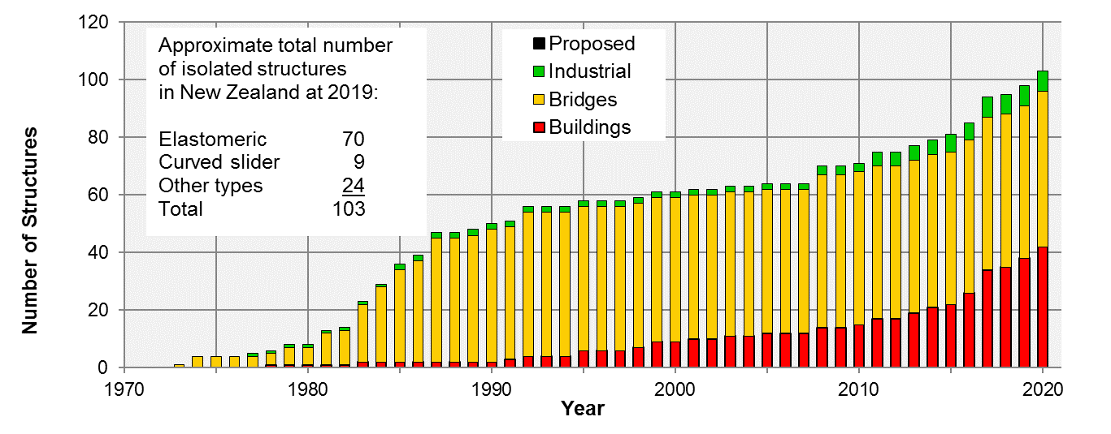

Figure 1. Growth in numbers of structures with seismic isolation in New Zealand

Table 1 summarises some recent projects New Zealand incorporating seismic isolation.

Table 1. Examples of recent seismic isolation projects in New Zealand

|  |  |  |
| --- | --- | --- |
| Project Name: | Wellington Airport Control Tower. | [Image result for nz wellington airport control tower isolated](http://www.google.com/url?sa=i&rct=j&q=&esrc=s&source=images&cd=&cad=rja&uact=8&ved=2ahUKEwij24WT19jhAhXTfH0KHco7CQMQjRx6BAgBEAQ&url=http://www.google.com/url?sa=i&rct=j&q=&esrc=s&source=images&cd=&ved=&url=http://db.nzsee.org.nz/2017/O4A.3_McKenzie.pdf&psig=AOvVaw0LJNx2jZdJ_ael_j-Bvnyf&ust=1555643837241075&psig=AOvVaw0LJNx2jZdJ_ael_j-Bvnyf&ust=1555643837241075) |
| Project Description: | 7 storey plus upper cab structure,  Importance Level 4, steel concentric braced frames, the building leans at 12.5 degrees from the vertical. |
| Engineer: | Holmes Consulting. |
| Isolation devices: | Lead Rubber (RSL). |
| Project Status: | Complete. |
| Project Name: | Spark Head Office Building, Christchurch. |  |
| Project Description: | 4 and 5 storey superstructures on common isolation plane, steel MRF. |
| Engineer: | Holmes Consulting. |
| Isolation devices: | LRB + Flat sliders (Robinson Seismic). |
| Project Status: | Under construction at 2019. |
| Project Name: | Wellington Town Hall retrofit. | C:\Users\dw\AppData\Local\Microsoft\Windows\Temporary Internet Files\Content.Outlook\6ZOH35TL\Wellington Town Hall.jpg |
| Project Description: | Seismic strengthening including seismic isolation of heritage town hall building. |
| Engineer: | Holmes Consulting. |
| Isolation devices: | Lead rubber and flat slider. (Robinson Seismic) |
| Project Status: | Construction started. |
| Project Name: | Wellington Children’s Hospital. |  |
| Project Description: | 7,000 m2 hospital, 3 storeys, regular plan, moment resisting steel frame. |
| Engineer: | New Zealand Consulting Engineers Ltd. |
| Isolation devices: | Triple pendulum (EPS). |
| Project Status: | Under Construction. |
| Project Name: | Morrison Kent House, Wellington. |  |
| Project Description: | Strengthening of mid-1960s  23-storey reinforced concrete encased structural steel frame including addition of mid-height isolation. |
| Engineer: | New Zealand Consulting Engineers Ltd. |
| Isolation devices: | Triple pendulum (EPS). |
| Project Status: | In design. |
| Project Name: | Ryman Healthcare Petone. |  |
| Project Description: | 4 new multi-level residential buildings. |
| Engineer: | Mitchell Vranjes Consulting Engineers and Simpson Gumpertz and Heger. |
| Isolation devices: | Lead rubber (DIS). |
| Project Status: | Completed. |

**4. Recent new zealand projects with other supplemental energy dissipation and damping systems**

Many new buildings recently constructed have incorporated dissipative brace systems such as buckling restrained braces (BRB). There are also a small number of buildings incorporating viscous damper braces, rocking frame and wall systems including post-tensioned cables to ensure re-centreing of the structure, and some containing additional damping devices such as lead extrusion or fluid viscous dampers - so-called “plug-and-play” replaceable devices. Table 2 gives examples of recent building projects including energy dissipative technologies.

Table 2. Examples of projects with other energy dissipation technologies

|  |  |  |  |
| --- | --- | --- | --- |
| Project Name: | | Christchurch Central Library “Turanga” |  |
| Project Description: | | 5 storey rocking concrete walls with vertical post-tensioning, U-shaped flexural yielding plates and lead damping devices. |
| Engineer: | | Lewis Bradford. |
| Technology: | | Rocking hybrid walls with dissipators. |
| Project Status: | | Completed 2019. |
| Project Name: | Outpatients Building, Christchurch. | |  |
| Project Description: | New 5-storey hospital with viscous damped (54 dampers) steel moment frame. | |
| Engineer: | WSP-Opus. | |
| Technology: | Viscous Dampers (Taylor Devices). | |
| Project Status: | Completed 2019. | |
| Project Name: | | Forte Health 1 and 2. |  |
| Project Description: | | 2 hospital buildings 3 storeys high. post-tensioned rocking steel frames with additional lead extrusion damping devices. |
| Engineer: | | Engenium. |
| Technology: | | Rocking and energy dissipation devices. |
| Project Status: | | Complete. |

**5. NZ guideline for design of seismic isolation systems for buildings**

***5.1 Oveview***

A Guideline for the design of seismic isolation systems for buildings in New Zealand has recently been completed for trial use by the industry (Whittaker and Parker 2019). This project was funded by government agencies MBIE and EQC, as well as professional technical societies NZSEE, SESOC and NZCS. The Guideline was prepared by specialist practitioners from the major New Zealand science agencies and engineering consultancies with experience in designing base-isolated buildings and it was reviewed by several international experts. The Guideline provides a means of compliance with the New Zealand Building Code and is based on NZS 1170.5 (the Structural Loading Standard) with suitable selection of design parameters, such as Structural Performance Factor Sp, and design ductility factor  (and k) for isolated buildings. The methodology recognizes the effects of period elongation and substantial effective damping available from seismic isolation systems.

***5.2 Isolated building types***

Four isolated building types are proposed, and designers must select, within specified criteria limits, which type they will design for and follow the requirements for that type.

Type 1 **Simple** - regular and low-rise superstructures. Equivalent static analysis is permitted, and structural elements are to be designed to remain elastic.

Type 2 **Normal** – more general isolated building layouts not meeting Type 1 requirements. Modal response spectrum analysis methods and structural design for nominally ductile behaviour are required as a minimum.

Type 3 **Complex** – isolated buildings where some inelastic deformation in the superstructure may be expected, or the isolation plane does not provide for the full displacement demand on the system. Numerical Integration (nonlinear) Time History Analysis and capacity design is required.

Type 4 **Brittle** – for brittle superstructures including existing structures. Numerical Integration Time History Analysis and design for elastic response is required.

The Guideline is intended for bilinear type hysteretic isolation systems using combinations of elastomeric, lead-rubber and flat slider isolators, or curved surface slider systems. Supplementary viscous damper devices may also be included.

***5.3 Performance-based design and limit states***

In addition to NZS 1170 Serviceability (SLS) and Ultimate (ULS) Limit States, the Guideline recommends that a Damage Control Limit State (DCLS) and a Collapse Avoidance Limit State (CALS) are considered for isolated buildings. The building, including isolation system, should be shown explicitly to be capable of surviving displacement demands for the rare earthquake event referred to in NZS 1170.5, without collapse.

The approach recommended in the Guideline is consistent with “low damage design” philosophies. The expected performance will generally exceed the minimum required by the national building code. An important principle is to communicate and agree the intended performance objectives with the building owner and to record these objectives in a Design Features Report.

***5.4 Design acceleration and displacement spectra for isolated buildings***

Design displacement spectra are directly provided, allowing designers to represent seismic demands in acceleration-displacement response spectra (ADRS) format. This format is convenient for designing isolated structures using simplified capacity-demand methods for determining base shear and displacement response demands on the isolation system. Design spectra are reduced for isolated structures compared with conventional building structures because of the increased effective system damping that that is available from the isolation system.

The Guideline includes changes to the long period portions of the NZS 1170 spectra, which typically govern the design of isolated buildings. The corner period TL, at which the constant displacement part of the spectrum starts, has been extended from 3 seconds to 5 or 10 seconds for most of the country. This has the effect of increasing displacement demands on isolation systems with periods greater than 3 seconds in most areas.

***5.5 Analysis and Design of isolated buildings***

Flow charts are provided in the Guideline for each isolated building type that address design of the isolated building overall including design of the substructure and superstructure, isolation system, adjacent stability structure, isolation plane and adjacent “rattle space” clearances. For most isolated structures the Structural Performance Factor Sp is recommended to be 1.0 and the superstructure should be designed to be elastic or perhaps nominally ductile. Guidance is provided for design parameters for materials standards for design of foundation, substructure and superstructure. A minimum level of ductile detailing and capacity design will generally be required in the superstructure to allow for possible inelastic demands under extreme earthquakes.

Preliminary analysis for all isolated building types would typically start with single degree of freedom analysis of an assumed rigid building on a flexible isolation layer, followed by more detailed analysis using equivalent static, modal response spectrum or numerical integration time history analysis, depending on the type and complexity of the building. Consideration of isolator property variability (upper and lower bound) is required in addition to target isolator system properties. Generally upper bound properties give maximum force demands on the structure, and lower bound properties give maximum displacement demands on the isolators.

***5.6 Specifications for procurement of isolators***

Guidance is provided for performance-based specification of the isolation system and isolator devices, based on US and European standards. A sample technical specification is also provided for procurement of isolation systems and isolator devices. Designers are recommended to select the type and number of isolators required and to prepare a performance-based specification giving the combinations of design forces and displacements that isolators are to withstand. It is strongly recommended that detailed design of the isolators is left to the supplier in accordance with an approved international standard. Qualification, prototype and production testing sequences and acceptance criteria are to be specified. Full-scale testing of isolators or similar prototypes is generally required, as is testing of production units. Load testing of 100% of production units is desirable, together with suitably qualified independent technical overview.

**6. Design Acceleration and Displacement spectra**

***6.1 Spectral shape functions***

The Guideline recommends acceleration and displacement spectra for design of isolated structures. The design spectra are based on NZS 1170.5 elastic hazard (acceleration) spectra and derived displacement spectra. The equations for base shear coefficient and displacements are given in Equations 1 and 2.

$C\left(T\right)=C_{h}\left(T\right) Z R N\left(T,D\right) B_{ξ}$ (1)

$∆\left(T\right)=∆_{h}\left(T\right) Z R N\left(T,D\right) B_{ξ}$ (2)

where *C(T)* is the design acceleration (base shear acceleration) in units of g; *Ch(T)* is the spectral shape factor (for acceleration); *(T)* is the elastic site displacement in mm; *h(T)* is the displacement spectral shape factor; *B* is the spectrum scaling factor to account for damping (less than or equal to 1.0); *Z* is the hazard factor; *R* is the return period factor and *N(T, D)* is the near-fault factor according to NZS 1170.5.

The acceleration *Ch(T)* versus displacement *h(T)* spectral shape for deep or soft ground (subsoil category D) is plotted in Figure 2. The effect of the variable corner period TL on the spectrum can be seen, where the solid red curve changes to dashed and dotted lines for periods exceeding 3 seconds or 5 seconds. In those cases, for long periods, spectral displacements increase beyond the normal constant displacement assumed in the standard NZS 1170.5 spectrum.

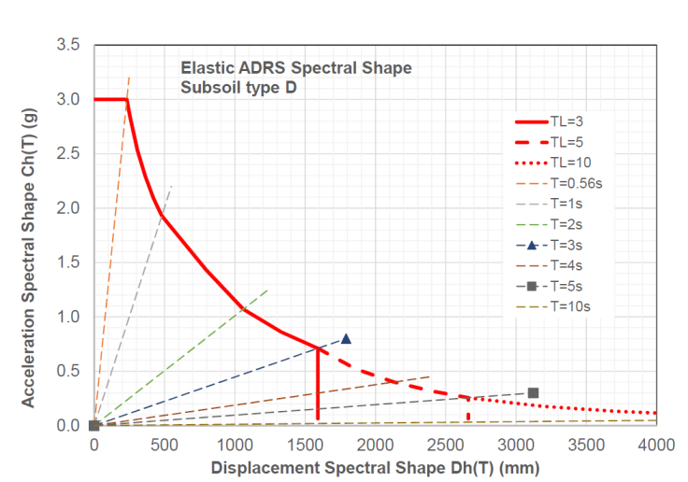

Figure 2. Acceleration versus displacement spectral shape for deep or soft ground conditions (subsoil category D)

The behaviour of the isolation system is assumed to be a yielding bilinear hysteretic system represented by the generalised expression for a curved surface slider system given in Equation 3.

$V_{b}=fW+∆/R$ (3)

where *Vb* is the base shear force and ** is the lateral displacement if the isolation system;

*f* is the friction coefficient, *W* is the isolated weight and *R* is the radius of curvature for a curved surface slider system.

The isolation system behaviour can be conveniently plotted on the acceleration versus displacement spectrum (ADRS) for the purposes of calculating capacity-demand diagrams and predicting acceleration and displacement response demands on the isolation system. An example is shown in Figure 3.

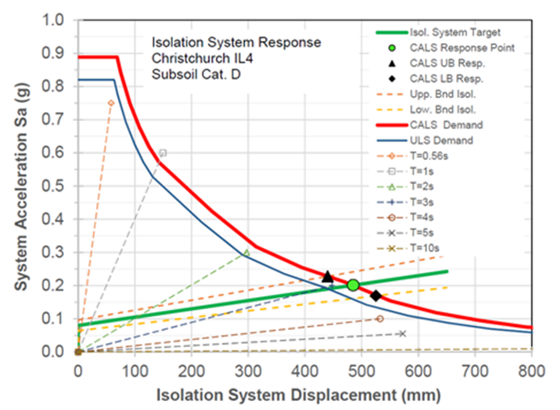

Figure 3. Sample capacity–demand diagram for a high importance (IL4) building in Christchurch on deep or soft ground and 1 in 2500 year (MCE) code demand for a curved surface slider isolator system with f=0.08 and R=4m

***6.2 Parametric study of acceleration and displacement demands***

A simple parametric study was carried out by the author to determine the acceleration and displacement spectra in the four main cities of New Zealand, Auckland, Wellington, Christchurch and Dunedin, according to the recommendations in the Guideline, using a limited range of isolation system parameters. These comparisons are a useful indication of demands for isolated buildings in each location.

The study considered a limited number of combinations of importance levels of buildings and ground conditions according to the New Zealand code, as well as equivalent curved surface slider isolation system properties, as follows:

Slider system friction coefficient f = 6%, 8%, 10% and 12%, or an equivalent yield level.

Slider system radius R = 2000, 4000 and 6000 mm, or equivalent elastomeric stiffness (these radii correspond to second-slope periods of 2.8s, 4.0s and 4.9s).

Some results of the study are shown in Figures 4, 5 and 6. The diagrams showing acceleration and displacement demands for various combinations of location, building importance, ground condition, slider radius and friction coefficient, calculated using the Guideline. The plotted points were each calculated using an iterative graphical procedure similar to that depicted in Figure 3. Lines have been drawn through various groups of points to show the effect of holding either curved surface slider yield level or radius constant while varying the other parameter. For the purposes of initial design, an additional displacement of up to 20% of these values could be assumed for isolators in the building corners, to allow for torsional response effects.

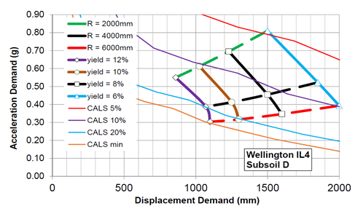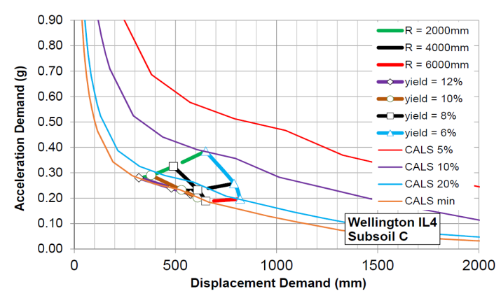

Figure 4. Acceleration-displacement demand plots for Wellington for post-disaster functional buildings on:   
(left) deep or soft subsoil D and (right) shallow soil ground conditions

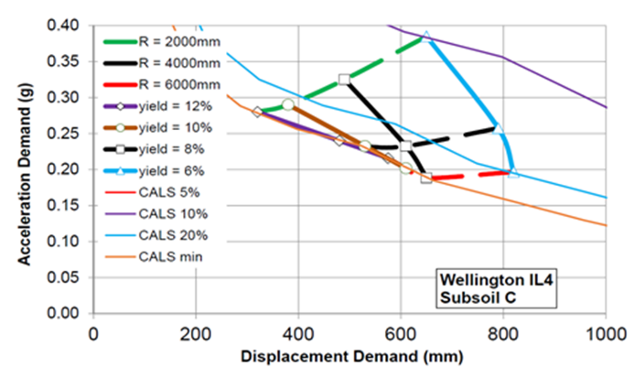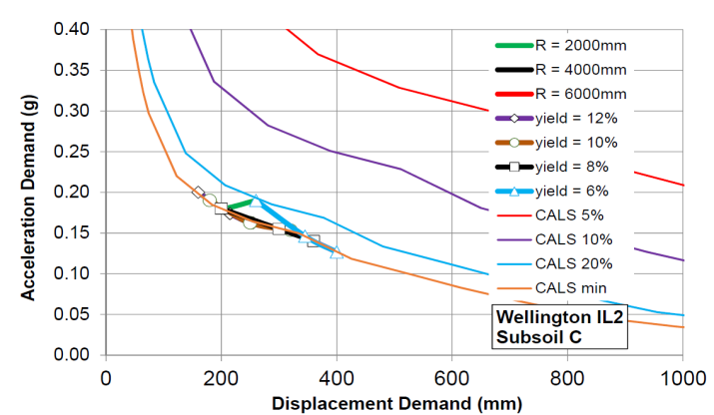

Figure 5. Acceleration-displacement demand plots for Wellington buildings on shallow soil ground conditions for:   
(left) post-disaster functional buildings and (right) normal importance buildings

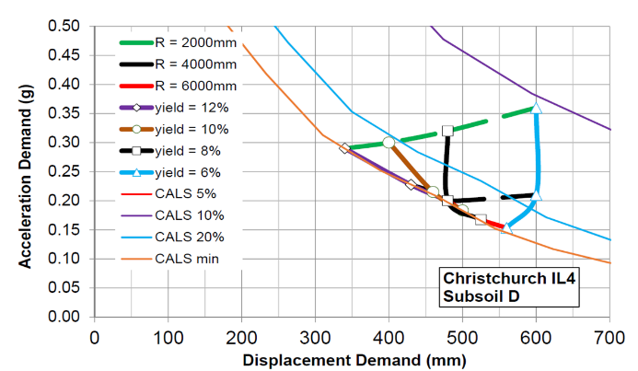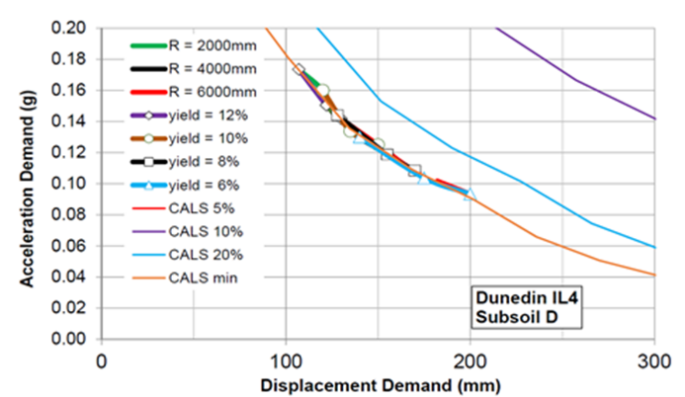

Figure 6. Acceleration-displacement demand plots for post-disaster functional buildings on deep or soft ground conditions located in: (left) Christchurch and (right) Dunedin

**7. Conclusions**

The rate of application of seismic isolation and other energy dissipation technologies has increased markedly in New Zealand following recent severe and damaging earthquakes. Owners and engineers are increasingly recognising the significant performance and life-cycle cost benefits that these technologies bring to earthquake protection and functional recovery of buildings and their contents. The benefits include increases in safety, as well as reductions in the frequency and severity of damage and downtime to repair any damage that does occur.

A recently published New Zealand guideline for design of buildings with seismic isolation will help ensure that design of isolated buildings is carried out in a consistent manner to meet the requirements of the national building code. Other energy dissipation and supplemental device technologies being routinely used in New Zealand include buckling restrained braces and increasing use of fluid viscous dampers. Seismic isolation and other energy dissipation earthquake protection systems are expected to be used much more frequently in New Zealand in the future.

**8. References**

Canterbury Earthquakes Royal Commission [2012], Volume 1, ISBN: 978-0-478-39559-4

Whittaker, D. and Robinson, W. R. [2007] “Progress of Application and Research & Development for Seismic Isolation and Passive Energy Dissipation for Civil and Industrial Structures in New Zealand”*, 10th World Conference on Seismic Isolation, Energy Dissipation and Active Vibrations Control of Structures*, Istanbul, Turkey.

Whittaker, D. and Robinson, W. R. [2009] “Progress of Application and Research & Development for Seismic Isolation and Passive Energy Dissipation for Civil and Industrial Structures in New Zealand”*, 11th World Conference on Seismic Isolation, Energy Dissipation and Active Vibrations Control of Structures*, Guangzhou, China.

Whittaker, D. [2013] “Recent Developments in Seismic Isolation in New Zealand”*, 13th World Conference on Seismic Isolation, Energy Dissipation and Active Vibrations Control of Structures*, Sendai, Japan.

Whittaker, D. [2015] “Recent Developments in Seismic Isolation in New Zealand (2015)”*, 14th World Conference on Seismic Isolation, Energy Dissipation and Active Vibrations Control of Structures*, San Diego, USA.

Whittaker, D. [2017] “Recent developments in New Zealand in seismic isolation, energy dissipation and vibration control of structures Developments in Seismic Isolation in New Zealand (2017)”*, 15th World Conference on Seismic Isolation, Energy Dissipation and Active Vibrations Control of Structures*, Wellington, New Zealand.

Whittaker D. and Parker W. [2019], “New Zealand Guideline for Design of Seismic Isolation Systems for Buildings”, Pacific Conference on Earthquake Engineering, Auckland.

1. Senior Technical Director, Beca Ltd, Christchurch, New Zealand, [david.whittaker@beca.com](mailto:david.whittaker@beca.com);

   President, NZSEE, Christchurch, New Zealand, president@nzsee.org.nz