THE NEW UNIFORM VF-ENERGY DISSIPATION DEVICE:

PROTOTYPE TESTING

DOI 10.37153/2686-7974-2019-16-1041-1052

Jelena RISTIC , Danilo RISTIC , Ragip BEHRAMI

ABSTRACT

Extensive experimental and analytical research has been performed in the framework of the innovative NATO Science for Peace Project “Seismic Upgrading of Bridges in South-East Europe by Innovative Technologies (SFP: 983828)” realized in the Institute of Earthquake Engineering and Engineering Seismology (IZIIS), Ss. Cyril and Methodius University in Skopje. The specific part of the project included development of an innovative USI-VF system representing advanced technology for seismic isolation and seismic protection of bridges. By integration of the newly developed uniform VF-energy dissipation device, important advances of the USI-VF system have been achieved. The response of the isolated bridge superstructure has been controlled by the simultaneous effect of the isolation system and the new advanced damping system. This paper presents the basic idea and the device creation process, the production of the first device model prototypes and the original experimental laboratory tests of the main constituent components of the developed new uniform VF-energy dissipation device. The innovative concept of the new adaptive vertical fixed (VF), multi-gap (MG), multi-directional (MD) energy dissipation device, VF-MG-MD device, involves several original, important and advanced seismic response features. The new VF-MG-MD devices actually provide an added "adaptive" damping to a seismically isolated bridge, highly improving its damping capacity.

Keywords: Prototype model; Nonlinear tests; Passive control; Seismic isolation; Energy dissipation

1. INTRODUCTION

Although the most important studies in the field of seismic isolation of bridges have been performed in renowned research centres in Japan, USA, Italy, and New Zealand, the contributions from many other countries have recently increased and have resulted in numerous new ideas and concepts. Detailed reviews of concepts and achievements made in this field have been provided in comprehensive publications by numerous authors, including Kelly (1986) and Kunde and Jangid RS (2003). Specific hysteretic behaviour characteristics of common rubber and lead-rubber seismic bearings have been presented by Robinson (1982) and Turkington et al. (1989). The specific behaviour of sliding seismic bearings has been studied by Kartoum et al. (1992); Dolce et al. (2007) and Iemura et al. (2007). Simple pendulum seismic bearings have been described by Zayas et al. (1990) and Wang et al. (1998). Both types of seismic bearings have been comprehensively studied and experimentally validated by Mokha et al. (1992) and Constantinou et al. (1992), and have been introduced into current practice. The concept of additional devices for seismic energy dissipation has been investigated by Skinner et al. (1975); Tsopelas et al. (1996); Dolce et al. (1996); Guan et al. (2010); Oh et al. (2012) and Ene et al. (2017). Recently, developments in this innovative earthquake engineering field have been intensified by complementary studies of various related phenomena, including the pounding effect, Jankowski et al. (1998), the axial behaviour of elastomeric isolators, Tubaldi et al. (2016), and semi-active dampers, Serino and Occhiuzzi (2003), as well as by studies devoted to qualitative upgrading of present technologies. Seismic design regulations related to seismically isolated bridges have been gradually upgraded, Mayes et al. (1992), and implemented in many countries in seismically active regions, Unjoh and Ohsumi (1998). Most of these authors provide recommendations about the need for further studies in this field, including the needs for new ideas for upgrading of existing bridge isolation systems. The observed intolerable impacts to bridge systems during recent strong earthquakes have given rise to strong arguments about development and practical implementation of seismic isolation systems in seismic protection of bridges, Ristic, D. (1988), Ristic, J. (2011), Ristic D. and Ristic J. (2012), Ristic J. (2016). This paper shows important results from the realized first creative research part of the ongoing long-term study devoted to development of a new, experimentally verified, advanced USI-VF system that can provide qualitative seismic upgrading of isolated bridges by innovative VF-ED energy dissipation devices, Ristic et al. (2018). The conducted first experimental part of the study included original nonlinear quasi-static tests of the created specific individual energy dissipation components. Unique original experimental data have been obtained, enabling development of an advanced, experimentally validated, nonlinear micro-model for hysteretic behavior study of the complete new vertical fixed energy dissipation (VF-ED) devices with optionally different component arrangements. According to the present developments, there have been created the basic conditions for realization of the final study involving shaking table tests of the constructed large-scale bridge prototype model with the applied new USI-VF system.

2. concepT of THE new usi-vf briDge system

The present upgraded, seismically isolated (USI) system integrating the created new vertical fixed (VF) energy dissipation (ED) devices represents a new technical concept that provides harmonized and improved modifications of the structural seismic response. The USI-VF system has been developed as an advanced alternative method for qualitative improvement of seismic protection of bridge structures by creating an integrated adaptive system based on global optimization of the seismic energy balance. As to the earlier studies conducted by the authors, Ristic et al. 2018, the seismic performances of the new USI-VF bridge system will be comprehensively studied through seismic shaking table tests of the assembled, original, large-scale USI-VF bridge prototype model, Figure 1.

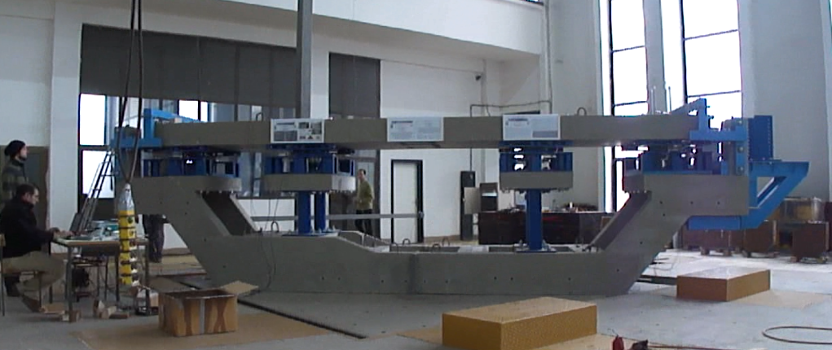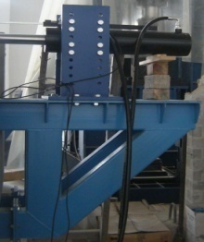
4
8
7
1
5
6
3
2
ISUBRIDGE MODEL AS CYCLIC TESTING PLATFORM
Figure 1. Designed bridge prototype model for testing of the new system on the seismic shaking table under simulated earthquakes: (1) left end support; (2) right end support; (3) support above the shorter middle piers; (4) support above the longer middle piers; (5) steel structure supporting actuator; (6) actuator for application of cyclic loads; (7) steel structure supporting the DL devices; (8) computer control system (used in Ristic et al. 2018).

The presently proposed, new USI-VF system with advanced seismic safety margins for the case of multi-directional seismic action has been created based on knowledge gained from previous experimental research. After the design, the costly fabrication and the cyclic nonlinear quasi-static testing of the developed new original components presented in this paper, assembling and testing of a large-scale experimental USI-VF bridge model as a new technological option is planned. The new USI-VF bridge model will be experimentally tested on a seismic shaking table under simulated real earthquakes. The model assembly and testing will be performed in the Dynamic Testing Laboratory of the Institute of Earthquake Engineering and Engineering Seismology (IZIIS), "Ss. Cyril and Methodius" University in Skopje by use of an advanced modeling process, Candeias et al. (2004). From the performed original quasi-static tests of the VF-ED components and devices and unique shaking table tests of the large-scale USI-VF bridge prototype model under simulated earthquakes, highly valuable experimental data will be obtained. This paper shows the obtained original results from the recently performed testing of the created prototypes of individual vertical (V) and vertical fixed (VF) energy dissipation components that have simultaneously been implemented in assembling the new uniform, vertical fixed (VF), multi-gap (MG), multi-directional (MD) energy dissipation devices.

3. prototypes of THE NEW VF-Mg-MD ENERGY DISSIPATION DEVICES

3.1 Innovative Concept of the VF-MG-MD Devices

Available types of seismic isolators do not possess a sufficient level of damping or seismic energy dissipation capacity. The introduced innovative vertical fixed (VF), multi-gap (MG), multi-directional (MD), energy dissipation (VF-MG-MD) device has been created for advanced application as an additional compact device, representing the so called seismic energy dissipater or added damping device. However, to provide an efficient contribution to improvement of the seismic response of an entire structure, the VF-MG-MD seismic energy dissipation device has been created to have innovative and specific structural characteristics providing advanced behavior properties. Under strong seismic excitations, very large inertial (seismic) forces are inevitably generated from the total mass of a bridge superstructure. The new seismic energy dissipater provides simultaneously harmonization of its stiffness properties, bearing capacity and ductility. The considered larger stiffness of the seismic energy dissipater may produce unfavorable effect involving strong impact and impulsive transfer of inertial forces. Such effect is avoided by the adopted gap-based initial stiffness of the seismic energy dissipater reduced to an acceptable level. The bearing capacity of the new seismic energy dissipater is adjusted to the real conditions in order to avoid transferring of very large forces to the bridge substructure members, which represents a highly favorable option.

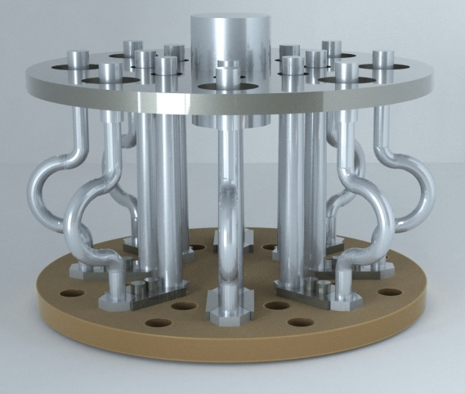 | 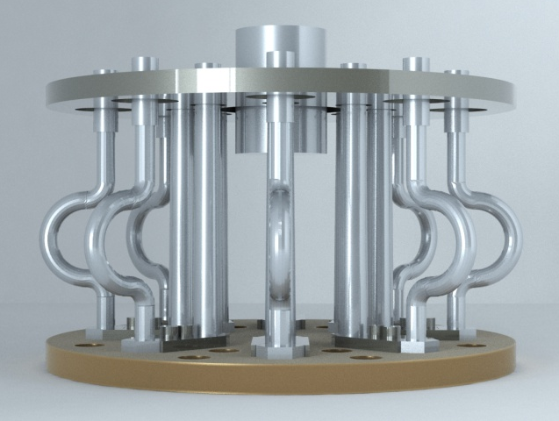
Figure 2. Prototype of the VF-MG-MD energy dissipation device with 8V & 8VF components (view-1). | Figure 3. Prototype of the VF-MG-MD energy dissipation device with 8V & 8VF components (view-2).

Finally, the third technical condition refers to the provided sufficient ductility of the seismic energy dissipater. Under large inertial forces, the induced relative displacements become very large, i.e., of the order of Dmax = 20 – 40 cm. Therefore, the seismic energy dissipaters should possess the ability to sustain large deformations without being damaged. The favorable option includes relatively small elastic deformations that will enable greater absorption and dissipation of seismic energy through nonlinear deformations and establishment of pronounced hysteretic curves. Within the frames of the conducted study, special attention has been paid to the formulation of highly ductile, gap-based VF-MG-MD device of a large seismic energy dissipation capacity. The proposed new vertical-fixed (VF-MG-MD) energy dissipation device is structurally and technologically innovatively composed in a way that it successfully integrates several most important characteristics contained in: (1) providing of a large capacity for seismic energy absorption; (2) possessing the property of being totally inactive in the case of the most frequent slight earthquakes; (3) providing initial activation of only a certain smaller number of seismic energy dissipation components of the type of V-MG-MD-Tij, or activation of level-1 energy dissipation components in the case of moderate earthquakes; (4) providing activation of all components for seismic energy dissipation (V-MG-MD-Tij+VF-MG-MD-Dk), or activation of all energy dissipation components representing level-2 (full capacity of energy dissipation) in the case of very strong earthquakes. The stated characteristics of the seismic energy dissipation device have successfully been achieved by adequate distribution of vertical cantilever components for seismic energy dissipation that are fixed at their lower end, at the base, and free at the upper end. The structure of the seismic energy dissipater generally consists of: (1) a base metal plate for fixation of the vertical cantilever components; (2) adequately distributed vertical energy dissipation components (V-MG-MD-Tij+VF-MG-MD-Dk); and (3) an upper metal plate with openings through which the energy dissipation components are activated in the above mentioned different phases. Characteristic phases include very frequent weak earthquakes, reduced number of moderately strong earthquakes and rare, but possible, very strong and destructive earthquakes. The prototype model of the proposed VF-MG-MD energy dissipation device, Figure 2 and 3, has been created, designed and constructed to have several constituent parts that form a compact ED unit, including:
(1) Base plate: The base plate of the VF-MG-MD energy dissipation device is manufactured in the form of a base circular metal plate (d = 25 mm) with a diameter of D = 450 mm. In the base metal plate, in each of the two concentric circles, eight regularly spaced equal openings with windings are made. The openings with windings are used to fix the vertical components by screwing. In the outer concentric circle with a diameter of d1 = 340 mm, eight openings with windings are made for the fixation of the external eight VF-type energy dissipation components. In the internal concentric circle with a diameter of d2 = 190 mm, spaced are other eight openings with windings for the fixation of the internal eight V-type energy dissipation components. The diameter of the opening with winding is considered standard and provides the possibility of making different combinations of installed types of vertical energy dissipation components.

Figure 4. Geometry of model prototype of the ED component V-MG-MD-T11 tested with a gap G1 & G2. | Figure 5. Geometry of model prototype of the ED component VF-MG-MD-D18 tested with a gap G1 & G2.

(2) Vertical energy dissipation components of type-V: The vertical energy dissipation components of type-V are made of a ductile metal in the form of a moderately steep cut cone. According to the diameter of the cone base (Db), there have been adopted a total of four options from which there have arisen four prototype types of energy dissipation devices, Table 1. For each type of energy dissipation device, there have been designed vertical elements with two alternative variants of cones, i.e., with different diameters of the top (Dt), whereat the diameter of the element at the base has been kept the same. In that way, four types of energy dissipation devices have been formed, each type with two variants of cones of vertical energy dissipation components. The different types of energy dissipation devices have been designated as follows: 1) Prototypes of V-MG-MD energy dissipation device of Type – 1 existing as two component options: a) prototype model V-MG-MD-T11 with base and top diameters Db/Dt = 32.0/25.6 mm and b) prototype model V-MG-MD-T12 with base and top diameters Db/Dt = 32.0/19.2 mm; 2) Prototypes of V-MG-MD energy dissipation device of Type – 2 existing as two component options: a) prototype model V-MG-MD-T21 with base and top diameters Db/Dt = 28.0/22.4 mm and b) prototype model V-MG-MD-T22 with base and top diameters Db/Dt = 28.0/16.0 mm; 3) Prototypes of V-MG-MD energy dissipation device of Type – 3 existing as two component options: a) prototype model V-MG-MD-T31 with base and top diameters Db/Dt = 24.0/19.2 mm and b) prototype model V-MG-MD-T32 with base and top diameters Db/Dt = 24.0/14.4 mm; 4) Prototypes of V-MG-MD energy dissipation device of Type – 4 existing as two component options: a) prototype model V-MG-MD-T41 with base and top diameters Db/Dt = 20.0/16.0 mm and b) prototype model V-MG-MD-T42 with base and top diameters Db/Dt = 20.0/12.0 mm.

Table 1. Prototypes of the tested V-MG-MD components under cyclic loads created for optional
assembling of the new VF-MG-MD energy dissipation devices

Prototype type | Prototype  notation | Geometry form | Geometry of gaps | Activation direction | Base-Db  (mm) | Top-Dt  (mm)
1 | V-MG-MD-T11 | T11 | G1 & G2 | MD | 32.0 | 25.6
 | V-MG-MD-T12 | T12 | G1 & G2 | MD | 32.0 | 19.2
2 | V-MG-MD-T21 | T21 | G1 & G2 | MD | 28.0 | 22.4
 | V-MG-MD-T22 | T22 | G1 & G2 | MD | 28.0 | 16.0
3 | V-MG-MD-T31 | T31 | G1 & G2 | MD | 24.0 | 19.2
 | V-MG-MD-T32 | T32 | G1 & G2 | MD | 24.0 | 14.4
4 | V-MG-MD-T41 | T41 | G1 & G2 | MD | 20.0 | 16.0
 | V-MG-MD-T42 | T42 | G1 & G2 | MD | 20.0 | 12.0

All vertical components have the same height of the cone body of h1 = 190 mm and end with an identical cylinder with a diameter d = 24.0 mm with a constant length of h2 = 60.0 mm. There has been enabled recording of original experimental results with very well organized comparative parameters important for future design and practical application. With the described adapted geometry of the vertical components, there have been provided equivalent conditions for fixation into the base metal plate, while through the standard cylinder at the top of the vertical elements, there have been provided equivalent gap-G1 or gap-G2 conditions for the designed gap-based excitation (repeated alternative contact and activation) of all the components possibly activated in the first, the second, or the third earthquake intensity phase.
(3) Vertical energy dissipation components of type-VF: The vertical energy dissipation components of type-VF are made of the same ductile metal available on the market in the form of a bar or an ideal cylinder with defined diameter Dc, Figure 5. The vertical energy dissipation components of type-VF consist of two straight parts and one curved part between them.

Table 2. Prototypes of the tested VF-MG-MD components under cyclic loads created for optional
assembling of the new VF-MG-MD energy dissipation devices

Prototype model | Prototype  notation | Geometry form | Geometry of gaps | Activation direction | Body-Dc  (mm)
1 | VF-MG-MD-D22 | D22 | - | MD | 22.0
2 | VF-MG-MD-D20 | D20 | - | MD | 20.0
3 | VF-MG-MD-D18 | D18 | - | MD | 18.0
4 | VF-MG-MD-D16 | D16 | - | MD | 16.0

According to the diameter of the cylinder (Dc), there have been adopted a total of four options from which there have arisen four prototype types of energy dissipation devices, Table 2. Model prototype-1 or component VF-MG-MD-D22, model prototype-2 or component VF-MG-MD-D20, model prototype-3 or component VF-MG-MD-D18 and model prototype-4 or component VF-MG-MD-D16 are constructed with a diameter of Dc = 22 mm, Dc = 20 mm, Dc = 18 mm, Dc = 16 mm, respectively. Analogously, all vertical VF components have the same height of the cone body of h1 = 190 mm and end with an identical cylinder with a diameter d = 24.0 mm with a constant length of h2 = 60.0 mm. In this case, the end cylinder is used for fixation of the component to the upper metal plate. So, in the case of possible cyclic negative reaction, the VF component will act by an adaptable hysteretic response. Such behavior and the provided component resistance against tension forces will result in protection of the structure against possible overturning. The study of the cyclic behavior of this specific VF component is a specific task providing original results with well organized comparative parameters important for its future design and practical application. Considering the characteristics of the described and adapted geometry of the vertical VF components, there have been provided equivalent end conditions for their fixation into the base and upper metal plates of the new VF-MG-MD energy dissipation device.
(4) Vertical deformed energy dissipation components of type-VD: The vertical energy dissipation components of type-VD are made with the same geometry as that of the VF components and using the same ductile metal available on the market in the form of a bar or an ideal cylinder with defined diameter Dc, Figure 5. The vertical energy dissipation components of type-VD consist of two straight parts and one curved part between them. According to the diameter of the cylinder (Dc), there have been adopted a total of four options from which there have also arisen four prototype types of energy dissipation devices, Table 3. Model prototype-1 or component VD-MG-MD-D22, model prototype-2 or component VD-MG-MD-D20, model prototype-3 or component VD-MG-MD-D18 and model prototype-4 or component VD-MG-MD-D16 are constructed with a diameter of Dc = 22 mm, Dc = 20 mm, Dc = 18 mm, Dc = 16 mm, respectively. Analogously, all vertical VD components have the same height of the cone body of h1 = 190 mm and end with an identical cylinder with a diameter d = 24.0 mm with a constant length of h2 = 60.0 mm.

Table 3. Prototypes of the tested VD-MG-MD components under vertical cyclic loads created for optional
assembling of the new VF-MG-MD energy dissipation devices

Prototype model | Prototype  notation | Geometry form | Geometry of gaps | Activation direction | Body-Dc  (mm)
1 | VD-MG-MD-D22 | D22 | G1 & G2 | MD | 22.0
2 | VF-MG-MD-D20 | D20 | G1 & G2 | MD | 20.0
3 | VF-MG-MD-D18 | D18 | G1 & G2 | MD | 18.0
4 | VF-MG-MD-D16 | D16 | G1 & G2 | MD | 16.0

Such design enables recording of original experimental results with very well organized comparative parameters important for future design and practical application. With the described adapted geometry of the vertical VD components, there have been provided equivalent conditions for their fixation into the base metal plate, while through the standard cylinder at the top of the vertical elements, there have been provided equivalent gap-G1 or gap-G2 conditions for the designed gap-based excitation (repeated alternative contact and activation) of all the components, which are possibly activated in the first, the second or the third earthquake intensity phase. The hysteretic gap-based response of the VD-MG-MD components actually represents a direct contribution to the gap-based hysteretic response of the standard vertical components of type-V.
(5) Upper metal plate with holes: On the upper side of the seismic energy dissipation device, Figure 2, a metal plate with thickness d = 20.0 mm is also constructed with equivalent concentric circles over which openings of two different diameters are distributed. The inner concentric circle has 8 openings with a diameter of d1 = 34.0 mm in which the standard top cylinders of all vertical components, designed with a diameter of do = 24.0 mm, are centrically accommodated. With such geometry of openings, a gap of G1 = 5.0 mm is provided in all directions. The external concentric circle has 8 openings with a diameter of d1 = 60.0 mm upon which the uniform cylinders on the top of the vertical components with a diameter of do = 24.0 mm are centrically accommodated. With this, a gap of G2 = 18.0 mm is provided in all directions. With such original structure of the seismic energy dissipater, activation of only the components of the inner circle is enabled in the first phase after initiated relative displacement larger than 5 mm (dr ≥ 5.0 mm), i.e., after the exceeding of the designed width of the concentric gap in all directions. In the second phase, if the relative displacement exceeds 18.0 mm, activation of all energy dissipation components located on the external concentric circle takes place. The upper metal plate is parallel with the lower one and is fixed to the upper structure or, in this study, to the superstructure of the large-scale bridge model. Taking advantage of the created very favorable conditions for composing different types of VF-MG-MD energy dissipation devices, the present research included realization of extensive experimental test programme, including performance of experimental tests on all anticipated prototype models of the V, VF and VD energy dissipation components.

3.2 Design and Production of Model Prototypes

(1) Selection of suitable properties of material to be implemented: For the manufacturing of the experimental prototype models of the V-MG-MD, VF-MG-MD and VD-MG-MD energy dissipation components, there has been selected a corresponding metal S-1530 with pronounced ductility and ability not to experience failure under a large number of iterated cyclic loads with pronounced or large amplitudes of displacement. These expected properties of the selected material have been fully proved by the realized extensive experimental tests.
(1) First production of the model prototypes: In the mechanical manufacturing of all prototype models of V-MG-MD, VF-MG-MD and VD-MG-MD energy dissipation components, metal elements with hexagonal cross-section have been used. Such selection created conditions for elaboration of a hexagonal segment necessary for the fixation of the element to the base by screwing. In addition, the selected profile has been used as suitable for manufacturing of all remaining segments of the corresponding V-type prototype models in accordance with their designed geometrical properties. As stated above, the highest segment with a length of lt = 60 mm has been constructed to have the same geometry in all prototype models.

4. nonlinear tests of vf-ed components

4.1 Experimental Testing Program

Within the frames of experimental testing of the produced model prototypes of the specific energy dissipation components, an ample experimental program has been realized whereat each individual component has been tested twice as follows: a) realization of test-1, or the so called original test-a, in order to obtain the hysteretic response under the initial conditions and b) realization of test-2, or the so called repeated test-b, in order to get an insight into the hysteretic response of the model that has already been tested. For testing of 8 prototypes of the V-MG-MD components under cyclic loads, simulating gap-G1 in the first case and gap-G2 in the second case, a total of 16 components of type-V have been produced. With the anticipated realization of the original and the repeated tests of each component, a total of 32 nonlinear cyclic tests have been done for the specific V-component type. For testing of 4 prototypes of the VF-MG-MD components under cyclic loads, a total of 4 components of type-VF have been produced. Similarly, with the anticipated realization of the original and the repeated tests of each component, a total of 8 nonlinear cyclic tests have been carried out for the specific VF-component type. Finally, for testing of 4 prototypes of the VD-MG-MD components under cyclic loads, simulating gap-G1 in the first case and gap-G2 in the second case, a total of 8 components of type-VD have been produced. With the anticipated realization of the original and the repeated tests of each component, a total of 16 nonlinear cyclic tests have been completed for the specific VD-component type. Accordingly, the experimental test program conducted for the present research purposes has been very extensive, including a total of 56 individual nonlinear tests.
The experimental testing platform was created of two global segments: (1) rigid base structure to which the base cross-sections of the experimental model were fixed and (2) mobile lateral structure connected with a horizontal actuator applied for simulation of cyclic loads through simulated cyclic displacements with increasing amplitudes. Figure 6 and Figure 7 respectively show the initial position of the element and the characteristic deformed configuration under the applied considerable horizontal displacement. Using the created experimental platform, all 16 experimental tests anticipated in this phase have been successfully realized.

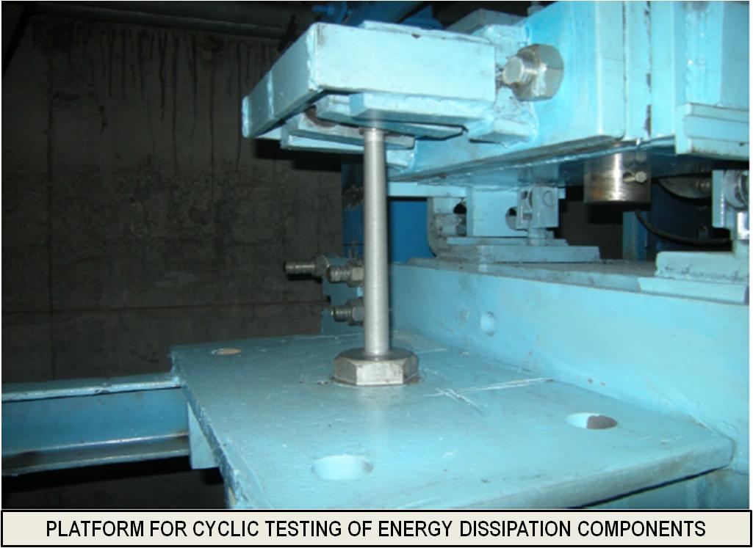 | 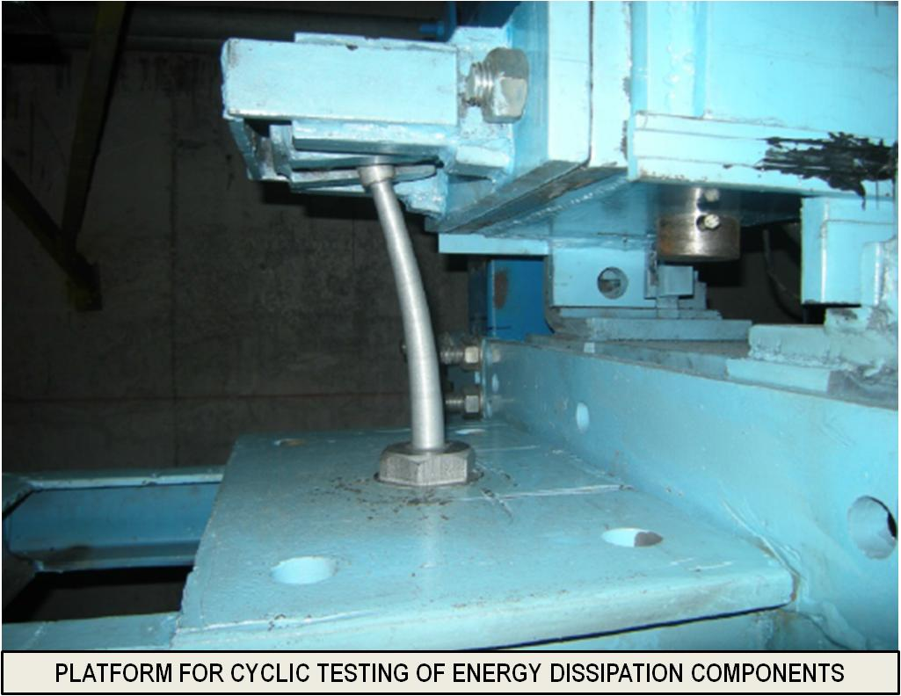
Figure 6. Platform for cyclic testing of ED components of various types and with different gaps. | Figure 7. Typical cyclic deformation during testing of the ED component V-MG-MD-T11 with gap G1.

4.2 Experimental Test Results

4.2.1 Hysteretic Behavior of Vertical Energy Dissipation Components of Type-V:

From the realized 32 experimental tests, original experimental results have been obtained in a digital form. In the course of the experiments, in addition to data acquisition by certain control channels, the measured values of the horizontal deformation at the top D(mm) as well as the corresponding values of the applied horizontal force F(kN) have been recorded successfully. The obtained original results represent an optimal test data base for reliable quantification of the seismic performances under cyclic loads of the proposed new seismic energy dissipation components of type-V. The energy dissipation components of type-V have been tested under the simulated specific, originally proposed, conditions of gap-based response, considering the mechanically present gap-G1, Figure 8, or alternatively, considering the presence of gap-G2, Figure 9.

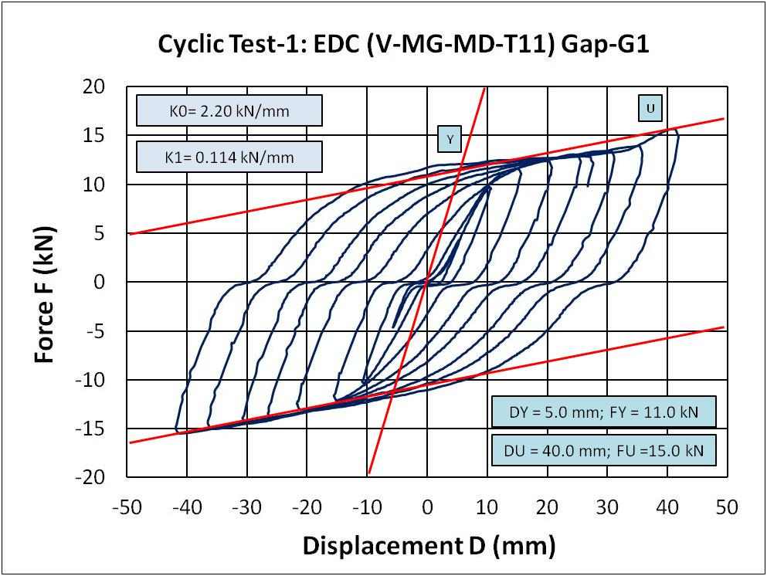 | 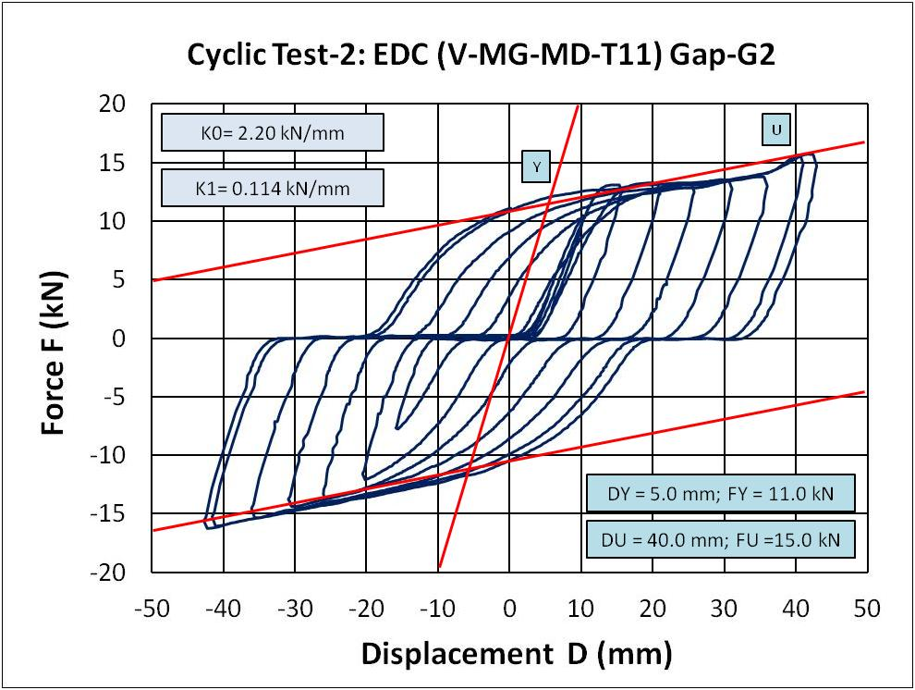
Figure 8. Hysteretic response under cyclic loads of the ED component V-MG-MD-T11 tested with gap G1. | Figure 9. Hysteretic response under cyclic loads of the ED component V-MG-MD-T11 tested with gap G2.

First of all, the obtained experimental results from the original and the repeated tests of all models presented in the respective graphic form, clearly indicate that both plotted nonlinear hysteretic relationships are very similar or nearly identical. This observation is generally confirmed from the tests of all energy dissipation V-type components, both original and repeated. For example, for the tested component prototype type-1 (component V-MG-MD-T11) with simulated gap-G1, during the original test (a), an ultimate point restoring force of FU = 15.00 kN has been obtained, while during the repeated test (b), an ultimate point restoring force of FU = 15.84 kN has been recorded. The difference of the recorded values is very small and it amounts to only 5.6%. Similarly, the obtained experimental results for the same component V-MG-MD-T11, tested with simulated gap-G1 and simulated gap-G2, clearly indicate that both plotted nonlinear hysteretic relationships are also very similar or nearly identical, with a recorded difference in the gap-size effect only. For example, for the tested component prototype type-1, component V-MG-MD-T11, with simulated gap-G1 and also with simulated gap-G2, the same values of ultimate point restoring force of FU = 15.00 kN have been obtained. The difference between the two recorded hysteretic curves is insignificant and only in the respective actual gap-size effect, Figure 8 and Figure 9.

4.2.2 Hysteretic Behavior of Vertical Energy Dissipation Components of Type-VD:

Analogously, from the realized 16 experimental tests, original experimental results have been obtained in a digital form. In the course of the experiments, in addition to data acquisition by certain control channels, there have also been successfully recorded the measured values of the horizontal deformation at the top D(mm) as well as the corresponding values of the applied horizontal force F(kN). The obtained original results represent also an optimal data base for reliable quantification of the seismic performances under cyclic loads of the proposed new seismic energy dissipation components of type-VD. The energy dissipation components of type-VD have been tested under the simulated specific, originally proposed, conditions of gap-based response, considering the mechanically present gap-G1, Figure 10, or alternatively, considering the presence of gap-G2, Figure 11.

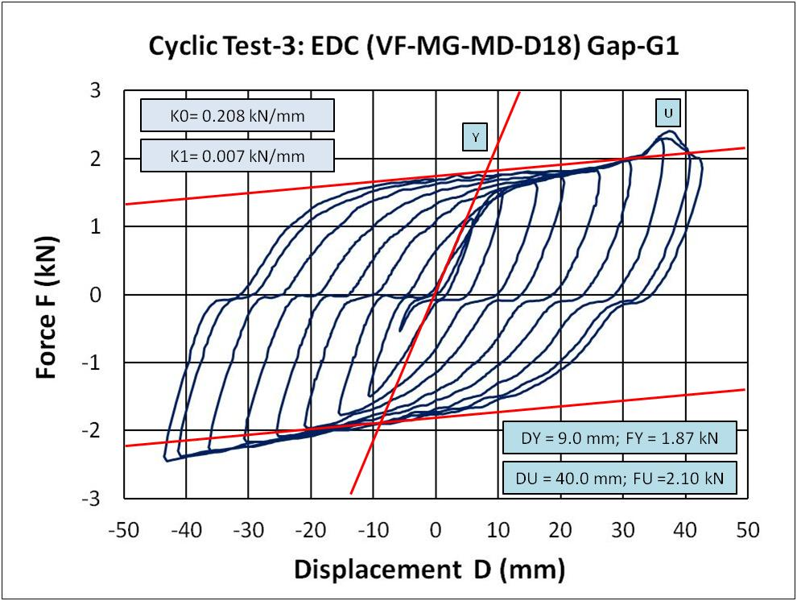 | 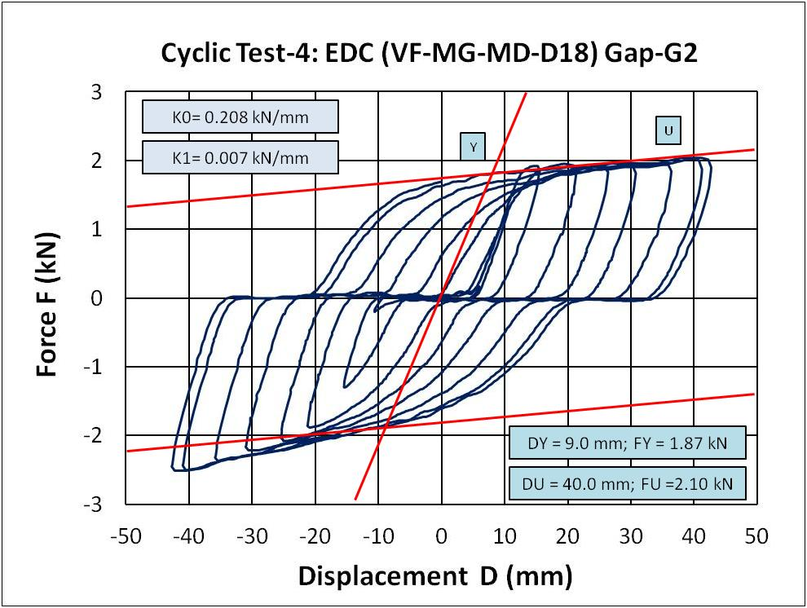
Figure 10. Hysteretic response under cyclic loads of the ED component VF-MG-MD-D18 tested with gap G1. | Figure 11. Hysteretic response under cyclic loads of the ED component VF-MG-MD-D18 tested with gap G2.

In this case, a similar tendency is evident. First, the obtained experimental results from the original and the repeated tests of all models presented in the respective graphic form clearly indicate that both plotted nonlinear hysteretic relationships are very similar or nearly identical. This observation is generally confirmed from the tests of all energy dissipation VD-type components, both original and repeated. For example, for the tested component prototype type-3 (component VF-MG-MD-D18) with simulated gap-G1, during the original test (a), an ultimate point restoring force of FU = 2,10 kN has been obtained, while during the repeated test (b), an ultimate point restoring force of FU = 2,15 kN has been recorded. The difference between the recorded values is very small and amounts to only 2.4%. Similarly, the obtained experimental results for the same component VF-MG-MD-D18, tested with simulated gap-G1 and with simulated gap-G2, clearly indicate that both plotted nonlinear hysteretic relationships are also very similar or nearly identical, with a recorded difference in the gap-size effect only. For example, for the tested component prototype type-3, component V-MG-MD-T11, with simulated gap-G1 and also with simulated gap-G2, the same values of the ultimate point restoring force of FU = 2,10 kN have been obtained. An insignificant difference between the two recorded hysteretic curves only in respect to the actual gap-size effect is very clearly observed also in this case, Figure 10 and Figure 11.

4.2.3 Hysteretic Behavior of Vertical Fixed Energy Dissipation Components of Type-VF:

Finally, from the realized 8 experimental tests, original experimental results have also been obtained in a digital form. In the course of the experiments, in addition to data acquisition by certain control channels, there have also been recorded successfully the measured values of the vertical cyclic deformation at the top D(mm) as well as the corresponding values of the applied vertical cyclic force F(kN). In this specific case, for the tested components representing prototype type-VF, under simulated vertical cyclic loads, highly favorable and unique asymmetric hysteretic curves have been obtained, Figure 13. The obtained experimental data represent highly valuable background evidence for development of experimentally verified analytical simulation models.
The conducted refined nonlinear analytical study and the developed nonlinear micro-models (presented in the next paper), actually represent an important and highly useful research step, providing an important general tool for solving specific problems, including: (1) validation of the capability of the implemented refined 3D nonlinear modeling concept for solving specific research and design tasks and (2) experimental validation of the proposed model for simulation of the complex hysteretic response of the VF-MG-MD device under general cyclic loading up to deep nonlinearity, Figure 12. The integral research activities in this domain have been successfully realized in three consequent phases: (1) Formulation of specific refined 3D nonlinear analytical models; (2) Analysis of nonlinear hysteretic response of individual components and integral devices under simulated cyclic deformations up to deep nonlinearity and (3) Comparative presentation and validation of the obtained original theoretical and experimental results.

 | 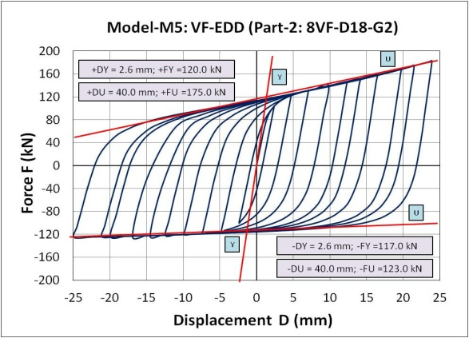
Figure 12. Micro-model of the 8VF-MG-MD-D18 energy dissipation device (8 installed components). | Figure 13. Hysteretic response of the 8VF-MG-MD-D18 device under simulated vertical cyclic loads.

5. Conclusions

Based on the results obtained from the performed quasi-static tests of prototype models of the VF-MG-MD components and VF-MG-MD devices, the following observations can be summarized: (1) The proposed original concept of VF-MG-MD devices with activation of nonlinear response of the created specific device components represents an attractive compact solution with favorable behavior and created possibility for wide application; (2) The application of the devices in real bridges can be successfully assured during the design process by adopting a correct set of geometrical and material properties; (3) Braking and wind forces may be fully controlled by some added common elements; (4) The efficient and stable activation of the VF-MG-MD devices in all directions represents an advanced behavior mode since it protects the system integrity and does not allow an earthquake to detect the “weak points” of the isolated structure; (5) The seismic isolation system created with seismic bearings of different existing types can be implemented and (6) The integrated USI-VF system possesses the capability to assure equal and safe structural response in all directions under very strong earthquakes and induced largest displacement amplitudes.

6. Acknowledgments

Extensive experimental and analytical research has been performed at IZIIS, “Ss. Cyril & Methodius” University, Skopje, in the framework of the three-year innovative NATO Science for Peace and Security Project: Seismic Upgrading of Bridges in South-East Europe by Innovative Technologies (SFP: 983828), with participation of five countries: Macedonia: D. Ristic, Project Leader & PPD-Director; Germany: U. Dorka, NPD-Director; Albania: A. Lako; Bosnia & Herzegovina: D. Zenunovic & Serbia: R. Folic. The creating of the RESIN Laboratory, Skopje, as a new open testing laboratory of the Regional Seismic Innovation Network involving young scientists, has been a specific long-term task. The extensive NATO SfP support for this integral, long-term and costly research project is greatly appreciated.

7. References

ANSYS Mechanical APDL Element Reference, Release 15.0, November 2013.
Candeias P, Costa AC, Coelho E (2004) Shaking Table Tests of 1:3 Reduced Scale Models of Four Story Unreinforced Masonry Buildings. In 13th World Conf. on Earthquake Engineering. Vancouver, BC, pp. 2199.
Constantinou MC, Kartoum A, Reinhorn AM and Bradford P (1992) Sliding Isolation System for Bridges: Experimental Study. Earthquake Spectra Vol. 8(3): 321-344.
Dolce M, Cardone D, Palermo G (2007) Seismic Isolation of Bridges Using Isolation Systems Based on Flat Sliding Bearings. Bull Earthquake Engineering . 5(4): 491-509.
Dolce MZ, Filardi B, Marnetto R, Nigro D (1996) Experimental Tests and Applications of an Advanced Biaxial Elastoplastic Device for the Passive Control of Structures. In Proceedings of the 4th World Congress on Joint Sealants and Bearing Systems for Concrete Structures, Sacramento. Sacramento, California.
Ene D, Yamada S, Jiao Y, Kishiki S, Konishi Y (2017) Reliability of U-shaped Steel Dampers Used in Base-Isolated Structures Subjected to Biaxial Excitation. Earthquake Engineering & Structural Dynamics, 46(4): 621–639.
Guan Z, Li J, Xu Y (2010) Performance Test of Energy Dissipation Bearing and its Application in Seismic Control of a Long-Span Bridge. Journal of Bridge Engineering, 15(6): 622-630.
Iemura H, Taghikhany T, Jain SK (2007) Optimum Design of Resilient Sliding Isolation System for Seismic Protection of Equipments. Bulletin of Earthquake Engineering 5(1):85–103.
Jankowski R, Wilde K and Fujino Y (1998) Pounding of Superstructure Segments in Isolated Elevated Bridge During Earthquakes. Earthquake Engineering & Structural Dynamics, 27(5): 487-502.
Kartoum A, Constantinou M and Reinhorn A (1992) Sliding Isolation System for Bridges: Analytical study, Earthquake Spectra 8(3): 345-372.
Kelly JM (1986) A Seismic Base Isolation: Review and Bibliography, Soil Dynamics and Earthquake Engineering 5(4): 202-216.
Kunde M and Jangid RS (2003) Seismic Behavior of Isolated Bridges: A State-of-the-Art Review. EJSE, Electronic Journal of Structural Engineering 3(2):140-169.
Mayes RL, Buckle IG, Kelly TE and Jones LR (1992) AASHTO Seismic Isolation Design Requirements for Highway Bridges, Journal of Structural Engineering, ASCE, 118(1): 284-304.
Mokha A, Constantinou M and Reinhorn A (1990) Teflon Bearings in Seismic Base Isolation I: Testing. Journal of Structural Engineering, ASCE, 116(2): 438-454.
Oh SH, Song SH, Lee SH et al. (2012) Seismic Response of Base Isolating Systems with U-shaped Hysteretic Dampers. International Journal of Steel Structures, 12(2):285–298.
Ristic D (1988) Nonlinear Behavior and Stress-Strain Based Modeling of Reinforced Concrete Structures under Earthquake Induced Bending and Varying Axial Loads, PhD Dissertation, School of Civil Engineering, Kyoto University, Kyoto, Japan.
Ristic D, Ristic J (2012) New Integrated 2G3 Response Modification Method for Seismic Upgrading of New and Existing Bridges, In 15th World Conference on Earthquake Engineering, (WCEE), Lisbon, Portugal.
Ristic J, Misini M, Ristic D, Guri Z, Pllana N (2017) Seismic Upgrading of Isolated Bridges with SF-ED Devices: Shaking Table Tests of Large-Scale Model, Građevinar, 70 (6): 463-485. doi: https://doi.org/10.14256/JCE.2147.
Ristik J (2011) Comparative Seismic Analysis of RC Bridge Structure Applying Macedonian Seismic Design Regulations and Eurocodes. MSc Thesis, Department for Theory of Structures, “Ss. Cyril and Methodius” University, Skopje, Macedonia.
Ristik J (2016) Modern Technology for Seismic Protection of Bridge Structures Applying New System for Modification of Earthquake Response. PhD Thesis, Institute of Earthquake Engineering and Engineering Seismology (IZIIS), “Ss. Cyril and Methodius” University, Skopje, Macedonia.
Ristic D, Dorka U, Lako A, Zenunovic D, Folic R (2013) Seismic Upgrading of Bridges in South-East Europe by Innovative Technologies, NATO SfP Project 983828, Science for Peace and Security Programme, Final Report.
Robinson WH (1982) Lead-Rubber Hysteretic Bearings Suitable for Protecting Structures During Earthquakes, Earthquake Engineering and Structural Dynamics 10(4): 593-604.
Serino G, Occhiuzzi A (2003) A Semi-Active Oleodynamic Damper for Earthquake Control. Part 1: Design, Manufacturing and Experimental Analysis of the Device. Bulletin of Earthquake Engineering 1(2): 275-302.
Skinner RI, Kelly JM and Heine AJ (1974) Hysteretic Dampers for Earthquake Resistant Structures, Earthquake Engineering and Structural Dynamics 3(3): 287-296.
Tsopelas P, Constantinou MC, Kim YS and Okamoto S (1996) Experimental Study of FPS System in Bridge Seismic Isolation. Earthquake Engineering and Structural Dynamics 25 (1): 65-78.
Tubaldi E, Mitoulis SA, Ahmadi H, Muhr A (2016) A Parametric Study on the Axial Behaviour of Elastomeric Isolators in Multi-span Bridges Subjected to Horizontal Seismic Excitations. Bulletin of Earthquake Engineering 14(4):1285–1310.
Turkington DH, Carr AJ, Cooke N and Moss PJ (1989) Seismic Design of Bridges on Lead-Rubber Bearings. Journal of Structural Engineering, ASCE, 115(12): 3000-3016.
Unjoh S and Ohsumi M (1998) Earthquake Response Characteristics of Super-multispan Continuous Menshin (seismic isolation) Bridges and the Seismic Design. ISET Journal of Earthquake Engineering Technology 35: 95-104.
Wang, YP, Chung L and Wei HL (1998) Seismic Response Analysis of Bridges Isolated with Friction Pendulum Bearings. Earthquake Engineering and Structural Dynamics. 27(10): 1069-1093.
Wilson EL, Habibullah A. SAP2000, Structural and Earthquake Engineering Software. Computers and Structures Inc., Berkeley, CA.
Wilson L Edward (2002) Three-Dimensional Static and Dynamic Analysis of Structures: A Physical Approach With Emphasis on Earthquake Engineering, Berkeley, California: Third Ed.
Zayas, VA, Low SS and Mahin SA (1990) A Simple Pendulum Technique for Achieving Seismic Isolation. Earthquake Spectra. 6(2): 317-333.

Ass. Prof. Dr., Faculty of Engineering, Department of Civil Engineering, International Balkan University (IBU), Skopje, Republic of North Macedonia, jelena.ristic.ibu@gmail.com
Prof. Dr., Ss. Cyril and Methodius University, Institute of Earthquake Engineering and Engineering Seismology (IZIIS), Skopje, Republic of North Macedonia, danilo.ristic.ibu@gmail.com
PhD student, Ss. Cyril and Methodius University, Institute of Earthquake Engineering and Engineering Seismology (IZIIS), Skopje, Republic of North Macedonia, ragip_behrami@hotmail.com

