seismic perFORMance of VERTICAL curved isolated pc bridges based On displacement

DOI 10.13753/2686-7974-2019-16-1172-1181

Galvarino PINTO, Enrique SIMBORT, Erick GONZALES, Michael TICONA

ABSTRACT

The objective of this project is to make the comparison between the different methods of displacement, the Direct Displacement Based Design (DDBD) and the Inelastic Spectrum Method (ISM). These will be compared in a critical way, with the inelastic analysis of the time history (T-H) to determine the efficiency of these methodologies.
The analysis will be applied to a bridge that presents 2 types of boundary conditions, the first with rigid joints and the second isolation with a pendulum of friction system (FPS).
The values of shear force and bending moment obtained for isolated joints with the DDBD and ISM methods are very dispersed with respect to T-H, while the displacement results of the superstructure on top of the isolator for isolated joints are very similar between the methods DDBD and ISM with respect to T-H. In addition to this, the displacements, shear forces and bending moments obtained in the substructure with isolated connections are significantly reduced with respect to those calculated in the bridge with rigid connections.
In conclusion, that the DDBD and ISM are very efficient for the pre-sizing of isolators, however, for the design of structural elements it is recommended to perform more accurate analyzes such as T-H.

Keywords: Isolated Bridge; Displacement Based Design; Seismic Performance; Time-History Analysis.

1. INTRODUCTION

Different design technologies based on displacements have been developed for both rigid connection bridges and bridges with isolated connection. The reason for adopting these procedures is due to the fact that limit states can be related in a better way to deformations. Among the methodologies that can be found in bibliography is the DDBD Priestley (2007) and other variants such as the variants that are based on displacements with the inelastic spectrum Chopra and Goel (2001). These methodologies are initially proposed for bridges with rigid connection although they can also and have been applied for bridges with isolated connection, the efficiency of these methodologies has been recognized so that some of the AASHTO isolated design manuals can incorporate these procedures as recommendations for practicing engineers.
For this reason, this study proposes to compare and verify these methodologies through a more refined analysis, dynamic nonlinear analysis (TH), as a consequence these methodologies can be implemented in the design codes in a more efficient way.

2. Study of the simplified desing methods

2.1 Direct Displacement Based Design

The Direct Displacement-Based Design (DDBD) method, developed by Priestley et al., (2007) applied to structures, is a simplified method that designs a structure to satisfy a desired level of distortion.
For the development of this method, a substitute structure was used, which was developed by Shibata and Sozen (1976) and Gulkan and Sozen (1974), to model the behavior of the structure in its inelastic range, as an elastic system of single degree of freedom (SDOF). In the SDOF system created, the concepts of secant stiffness (Figure 1) are used to calculate the design response (maximum displacement) and viscous equivalent damping concepts to consider the energy that dissipates the structure during its post-yield response.

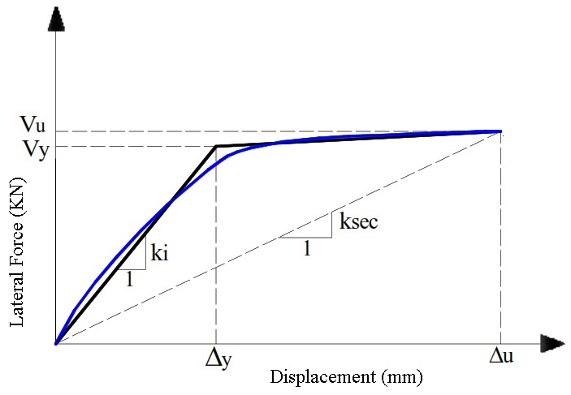

Figure 1. Initial Stiffness and secant stiffness

2.2 Inelastic Spectrum Method

In 2001, researchers Chopra and Goel published the method of the inelastic spectrum (ISM). With this method, it was proposed to control the dynamic response of a structure, starting from the value of its elastic rigidity and at the same time, relations between the elastic and inelastic response were considered. In Figure 1, the stiffness is shown as a function of a final displacement (Δ_{u}) and a force that generates this displacement, in the inelastic range. That is to say that a period can be obtained from the inelastic spectrum of displacement response, with this period obtained the design force can be obtained in proportion to the initial rigidity and yield displacement. This procedure must be iterated until a convergence is reached in order for the design force, the yield displacement and the stiffness value to be the most accurate and compatible. A commonly adopted relationship between the elastic response and the inelastic response is the approximation of equal displacements. This approach argues that the displacement of the elastic system of initial rigidity Ki, will be the same for the inelastic system (Miranda and Bertero, 1994).

2.3 Friction Pendulum System (FPS)

Friction Pendulum Devices (FPS), are based on the properties of movement of a pendulum, the device has a spherical surface, which is covered by a teflon coating, where the isolated structure rests. This surface creates a frictional force proportional to the vertical force contributed by the structure, the displacement capacity for these devices is theoretically unlimited, but it will be restricted to the acceptability of vertical displacements. For there to be displacements on the surface of these isolators, there must be a shear force greater than the friction force existing on the surface, resulting in the oscillation of the structure with a period Tp (figure 2) associated with the radius of curvature and the force of gravity.

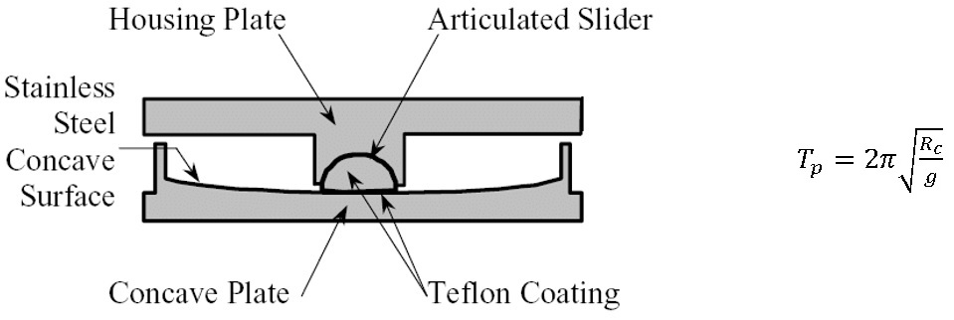

Figure 2. Section of the friction pendulum and equation for the period Tp of friction pendulum.

The characteristic hysteresis cycle of the FPS where there is a certain friction in the sliding interface is shown in figure 3.
The system remains almost rigid until the frictional force is exceeded, then the increase in force will be proportional to the post-yield rigidity of the FPS.
For the analysis, the effective rigidity of the FPS must be calculated. This is a function of the weight received by the isolator (W), the radius of curvature (R), the coefficient of friction (u) and the maximum displacement (Dmax) of the isolator (figure 3).

Figure 3. Hysteresis Loops of FPS System

3. application of the methods to the study structure

The methods based on displacements are applied to a vertical curved PC bridge. Analyzes are made in two directions, longitudinal and transverse, in order to obtain demands in the columns (displacements, accelerations, shear force and bending moments).
The studied bridge "Los Incas" is part of the "Palomar" road exchange, which is located in the city of Arequipa, Peru. The bridge presents a curve in its vertical alignment, figure 4. The superstructure made up of by one box beam; also, the substructure is composed of two columns type "Caltran octagonal" of variable height, table 1. The bridge has three bays of: 25 m, 30 m, 25 m, giving in a total longitude of 80 m.
The section of the columns is shown in the figure 4, this is placed so that the X axis coincides with the longitudinal direction of the bridge. It was analyzed in its transversal direction (critical direction) under the different methods previously described, with and without isolator.
The seismic demand used for the evaluation of the "Los Incas" bridge was extracted from the seismic record of June 23, 2001 (figure 5), of the city of Arequipa, Peru, corresponding to the UNSA station, which is located very close to the bridge studied. The spectrum was extracted from the record of the "Centro Peruano Japones de Investigaciones Sismica y Mitigacion de Desastres" (CISMID). The next step was to construct the design response spectrum (DE) response spectrum according to the ASCE 7-16 code, then the seismic record obtained was matched to the previously performed response spectra (figure 6), for this the period range established in the ASCE code is used, it had a lower limit of 0.2 T and an upper limit of 1.5 T. The period of the structure was obtain using the software Midas Civil (T=0.47 s)
The software used to process the seismic data were Seismo Signal and Seismo Match, the former was used for the filtering and correction of the data extracted from the accelerograms, these were later processed in the latter, escalating the earthquakes to the response spectra DE (figure 7), which were used for the subsequent analysis of the study bridge.

Table 1. Geometric and materials data of the bridge

Concept | Pier 1 (Left) | Pier 2 (Right)
Height at the center of the Superstructure (m) | 6.95 | 14.4
Steel Elasticity Module Es (MPa) | 200000
Steel yield strength fy (MPa) | 420
Concrete compressive strength f'c (MPa) | 35

Figure 4. Structural model of the "Los Incas" bridge in the Midas Civil program and cross section of piers.

Figure 5. Accelerogram of the Arequipa earthquake June 23, 2001

Figure 6. Accelerogram of the Arequipa earthquake June 23, 2001, matched to DE response spectrum

Figure 7. Arequipa earthquake matched to the DE Response Spectrum

3.1 DDBD for isolated connections in structure:

For the application of the DDBD method in the isolated structure, under the DE condition, it was started by establishing a total displacement of the system of 300 mm and a total of two isolators by pier. Then the displacements taken by the piers were calculated, which was 0.8 Δ_{y} on each pier, calculated through the moment-curvature diagram, the displacement for the isolator will be the subtraction of the total displacement, with that assumed by the piers. After that, it creates a response spectra affected by the damping of the equivalent system equal to 16% (figure 8), in this response spectrum is entered with the displacement initially established thus obtaining a period T = 2.00 s. With the period and the effective rigidity of the elements, the shear forces and bending moments that resist the different elements can be calculated (table 2).

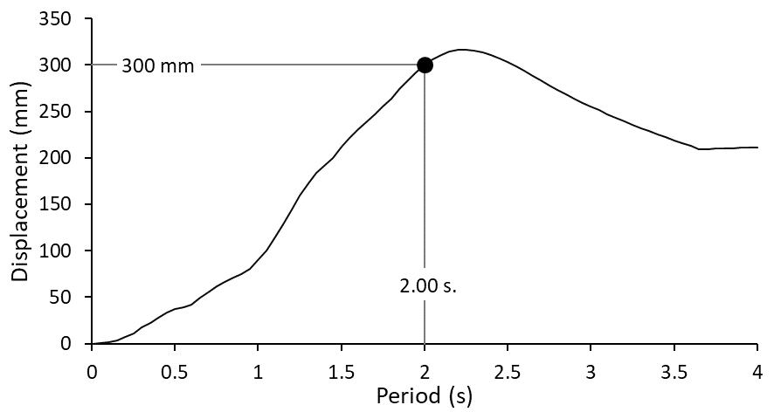

Figure 8. Response spectrum of displacement affected by ξ=16 %.

3.2 IEM for isolated connections in structure:

For this method, the DDBD procedure is followed until the moment of the equivalent damping calculation. A ductility reduction factor will then be calculated, being of μ=1.65 for the case study. A response spectrum is created affected by the calculated ductility, this is entered with the displacement of the system obtaining a period of T = 2.10 s, finally the shear forces and bending moments are calculated in the elements.

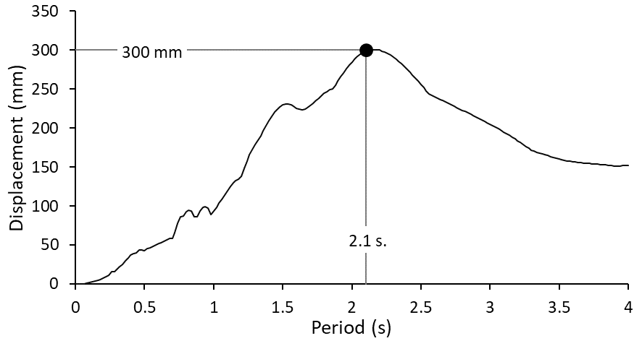

Figure 9. Response spectrum of displacement affected by μ=1.65 (ξ = 5 %).

Finally, the "Frictional Pendulum System Isolator" will be pre-dimensioned, for this step a coefficient of friction μ_{f} = 0.05 is assumed, after that the post-yield stiffness, the radius of curvature and the equivalent viscous damping of each isolator for each element will be calculated (table 2).

Table 2. Geometric and materials data of the bridge

 | DDBD |  | ISM
Concept | Pier 1 | Pier 2 | Pier 1 | Pier 2
Yield Curvature | 0.00263 | 0.00263 | 0.00263 | 0.00263
Yield Displacement at the piers (mm) | 47 | 189 | 47 | 189
Weight (kN) | 6160.5 | 7531.6 | 6160.5 | 7531.6
System Displacement (mm) | 300 |  | 300
Reduction Factor of ductility | 1 |  | 0.616
Viscous equivalent damping of the system | 16% |  | 5%
Equivalent Period of the system (s) | 2.00 |  | 2.10
stiffness of the equivalent System (MN/m) | 19.53 |  | 17.71
Shear at the Base (MN) | 5.86 |  | 5.31
Shear (MN) | 1.86 | 2.27 | 1.68 | 2.01
Moment (MN.m) | 20.64 | 46.41 | 19.00 | 42.45
Post-yield stiffness of the isolator (kN/m) | 2957.9 | 6411.4 | 2628.3 | 5697.1
Radius of curvature of the isolator (mm) | 1050 | 600 | 1170 | 660
Equivalent Viscous Damping of the isolator | 10.5 % | 10.5% | 11.6% | 11.6%

4. evaluation of the simplified methods studied

To evaluate the performance of the isolated bridge behavior, it will be compared with the analysis of rigid connections between superstructure and substructure, in addition to the nonlinear dynamic analysis (TH) to evaluate the effectiveness of the simplified methods.

4.1 Analysis between the structure with rigid connections and isolated connections:

In the figures 10 and 11, the different results obtained for accelerations on the board are shown in points located on the piers, the results obtained for the bridge with rigid connections are presented with a dotted line, and the results shown with solid line correspond to the bridge with isolated connections.

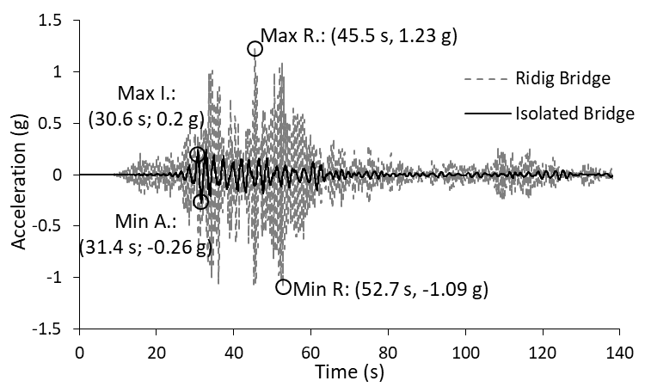

Figure 10. Acceleration in the Pier 1.

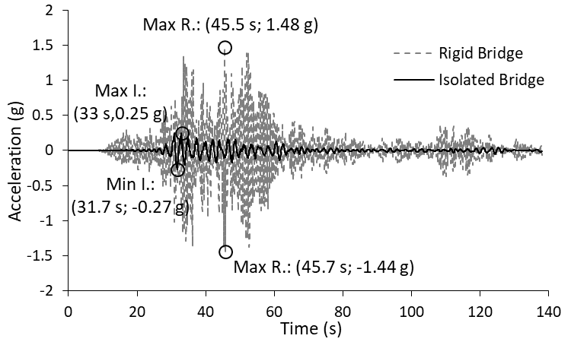

Figure 11. Acceleration in the Pier 2.

As you can see, the accelerations in the superstructure with the use of seismic isolators are reduced to percentages between 79 to 82% of the original acceleration when you have rigid connections, this is an advantage since the sensation of the earthquake on the board will be lower, helping the best vehicle maintain control, avoiding accidents caused by the earthquake.
Next the displacements obtained in four points will be presented, two of them in the tops of the piers and the two remaining ones will be located between deck and piers (isolators), see figures 12, 13, 14, 15.

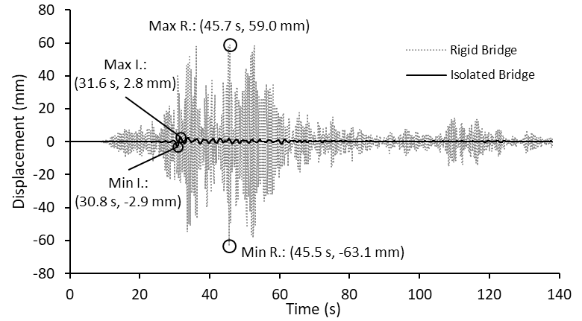

Figure 12. Displacements in the Pier 1.

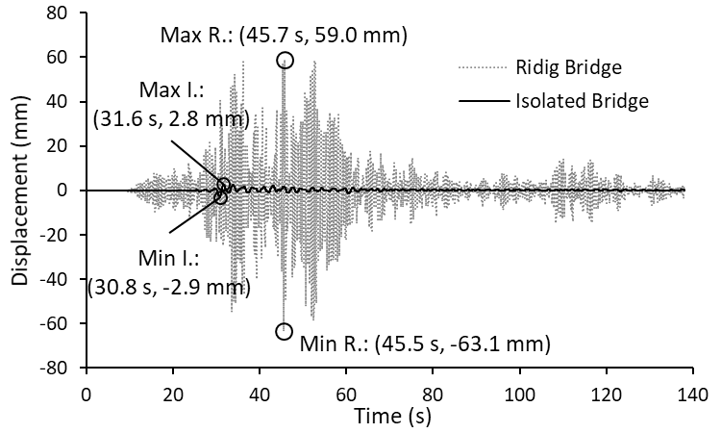

Figure 13. Displacements in the Pier 2.

In the figures 12, 13 we can see how the displacements in the piers decrease drastically, later we will notice the influence of this event on the stressed that each of these supports, the large displacements are now made by the isolators as shown in figures 14, 15. It can also be observed that the displacements are between 98% and 120% of the desired according to the pre-estimate done for the isolators (300 mm).

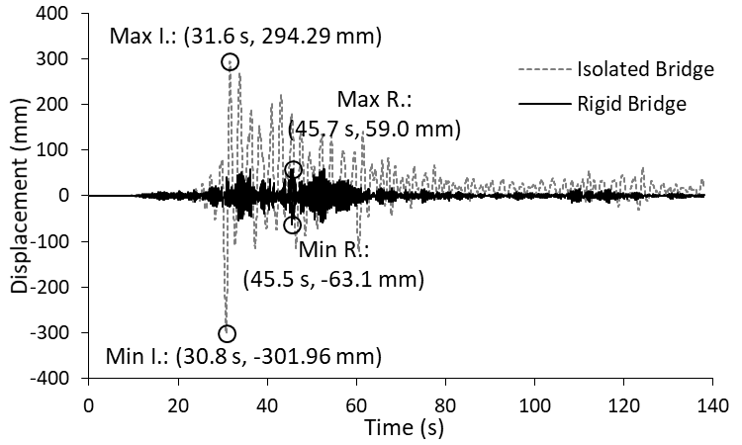

Figure 14. Displacements for the isolator (Pier 1).

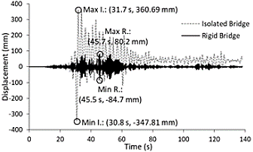

Figure 15. Displacements for the isolator (Pier 2).

Finally, figures 16, 17, 18 and 19 show the shear forces and bending moments obtained at the base of the piers 1 and 2, according to the analysis.

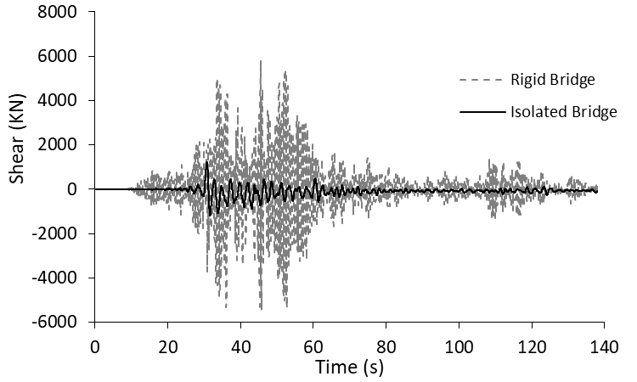

Figure 16. Shear force in the Pier 1.
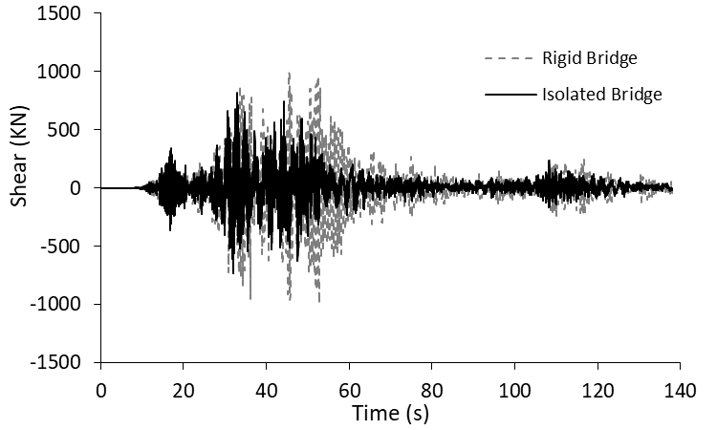

Figure 17. Shear force in the Pier 2.

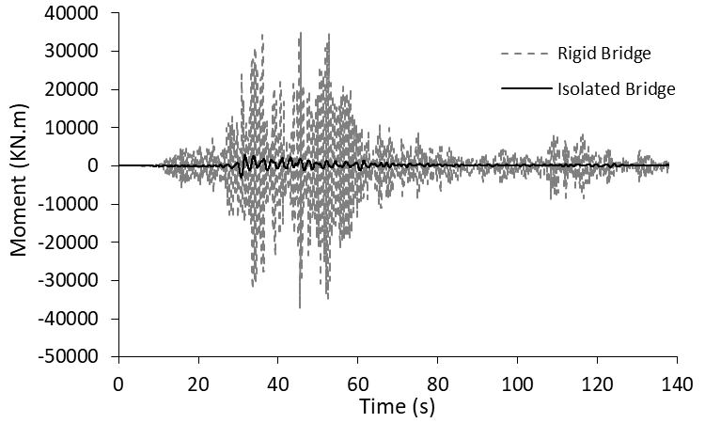

Figure 18. Bending moment on the Pier 1.

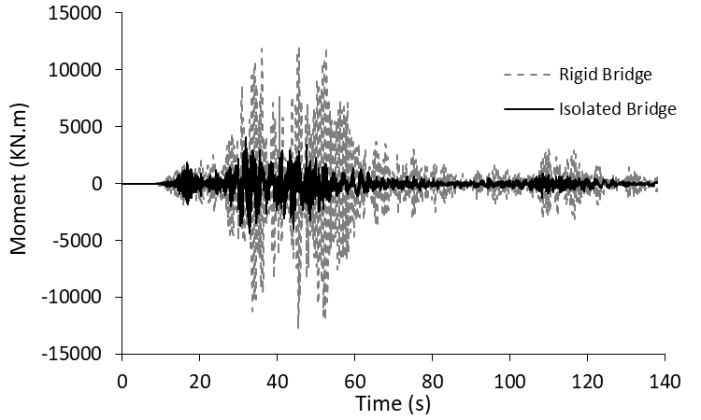

Figure 19. Bending moment on the Pier 2.

It can be seen that pier 1 has a more reduction of shear forces and bending moments with respect to the pier; this feature is due to the difference in heights, being the pier 2 is 7.45 m. higher than the pier 1. This is because the shortest pier, when it has rigid connections, has greater forces demands, due to its lower height, which dissipates the stresses or forces to which it is subjected.

4.2 Analysis of the effectiveness of simplified methods:

To check the effectiveness of the simplified methods on the studied bridge, the results obtained from the nonlinear dynamic analysis (TH) will be compared with those obtained through the simplified DDBD and MEI methods, for this the results obtained for shear force were placed in figure 20 and the results of the bending moment in figure 21.

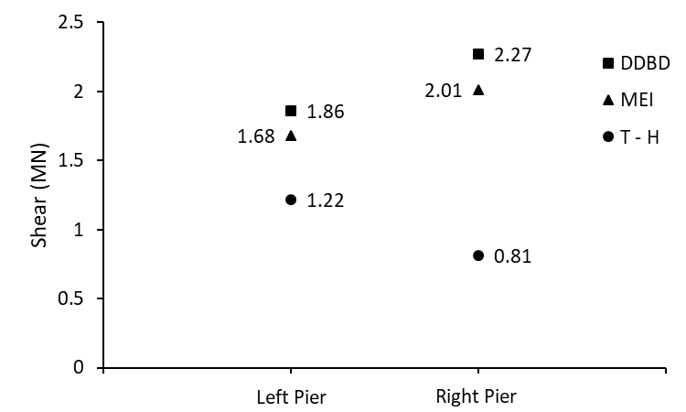
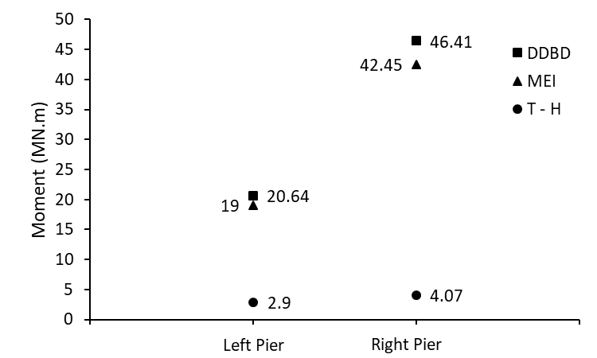

Figure 20. Shear forces of the methods studied. Figure 21. Bending moments of the methods studied.

It can be appreciated that the simplified methods give close results, but these are far from those obtained through the verification analysis (TH), finding very conservative values in the simplified methods, which in shear strength are 280% for the DDBD and 250% for the MEI on the value obtained through the T-H analysis. In the bending moments, the values obtained through the DDBD and MEI methods are up to 10 times those obtained in the TH analysis.

5. Conclusions

As shown in this paper, the simplified methods are not applicable in the estimate of forces for the studied bridge "Los Incas" in its isolated connection condition, since the dispersion in the results obtained indicates erroneous results of shear force and bending moment. However, the pre-dimensioning of isolators can be a starting point, since the accelerations are significantly reduced and the displacements obtained remain close to that established for the design of the isolators. Therefore, it is recommended that, for bridges with vertical curve and different sizes of piers; develop, before the application of simplified methods, a validation of results with the TH analysis. The subsequent realization of more exhaustive studies for the creation and establishment of parameter in which the effectiveness of application of simplified methods used by practicing engineers in the analysis and design process is reflected.
On the other hand, it is said that using isolators in bridges reduces accelerations and increase the displacements in the deck; furthermore, reduce the demands of both shear forces and bending moments in the piers. This being an advantage over bridges with rigid connections for the following reasons, the bridges with isolated connections between substructure and superstructure for the same earthquake will present less damage in the piers after a severe earthquake occurred.

6. References

AASHTO LRFD Bridge Design Specifications, 8th Edition.
AASHTO, Guide Specifications for Seismic Isolation Design, 4th Edition.
ASCE (American Society of Civil Engineers). (2014). Minimum design loads for buildings and other structures, Standard ASCE/SEI 7-10, 3th printing. ASCE, Reston VA.
Centro peruano japonés de investigaciones sísmicas y mitigación de desastres (2019). Red de acelerógrafos. CISMID. Recovered from http://www.cismid-uni.org/
Chopra A. K., Goel R. K. (2001), Direct displacement-based design: Use of inelastic design spectra, Earthquake Spectra, vol. 17, pp. 47-64.
Eduardo Miranda and Vitelmo V. Bertero (1994) Evaluation of strength reduction factors for earthquake‐resistant design. Earthquake Spectra: May 1994, Vol. 10, No. 2, pp. 357-379.
Gulkan and Sozen (1974) Inelastic responses of reinforced concrete structures to earthquake. Journal ACI, ISSN: 0002-8061. (2) 606.
Kowalsky M.J. (2002), A displacement-based approach for the seismic design of continuous concrete bridges, Earthquake Engineering Structural Dynamic, vol.31, pp.719-747.
Midas Civil: Integrated solution system for bridge and civil engineering, http://en.midasuser.com
Newmark N.M., Hall W.J. (1982). “Earthquake spectra and design”, Earthquake Engineering Research Institute. Oakland California, U.S.A. 103pp.
Priestley, M.J.N., Calvi G.M., Kowalsky M.J. (2007), Displacement based seismic design of structures. IUSS 721 pp.
Rivera D., Meli R. (2008), “Procedimiento de diseño símico de columnas de puentes urbanos de concreto reforzado”, Revista de ingeniería sísmica No. 79 pp. 1-23.
SeismoSoft: Earthquake engineering software solutions, www.seismosoft.com
Shibata and Sozen (1976) Substitute structure method for seismic design in R/C. Journal of the Structural Division, ISSN 0044-8001. (3): 25-32
Sullivan T. J., Calvi G. M., Priestley N. M. (2004), Initial stiffness versus secant stiffness in displacement based design. 13th World Conference on Earthquake Engineering. Vancouver, B.C., Canada, paper No. 2888.

Director of School of Civil Engineering, Catholic University of Saint Pablo, Arequipa, Peru, gpinto@ucsp.edu.pe
Director of Department of Civil Engineering, Catholic University of Saint Pablo, Arequipa, Peru, egsimbort@ucsp.edu.pe
Student of School of Civil Engineering, Catholic University of Saint Pablo, Arequipa, Peru, erick.gonzales@ucsp.edu.pe
Student of School of Civil Engineering, Catholic University of Saint Pablo, Arequipa, Peru, michael.ticona@ucsp.edu.pe

