THE NEW UNIFORM VF-ENERGY DISSIPATION DEVICE:

REFINED MODELLING

DOI 10.37153/2686-7974-2019-16-1140-1151

Ragip BEHRAMI, Jelena RISTIC , Danilo RISTIC , Viktor HRISTOVSKI

ABSTRACT

Ample experimental and analytical research has been performed in the framework of the innovative NATO Science for Peace Project “Seismic Upgrading of Bridges in South-East Europe by Innovative Technologies (SFP: 983828)” realized in the Institute of Earthquake Engineering and Engineering Seismology (IZIIS), Ss. Cyril and Methodius University in Skopje. The specific project part included development of an innovative USI-VF system, representing an advanced technology for seismic isolation and seismic protection of bridges. With the integration of the newly developed uniform VF-energy dissipation device, important advances of the USI-VF system have been achieved. This paper presents the refined 3D theoretical modeling of the specific, gap-based hysteretic response of the main components and the integral prototypes of the developed new uniform VF-energy dissipation devices, under simulated earthquake-like cyclic loads up to deep nonlinearity. Successful model validation has been made based on original results obtained from the completed experimental tests. The innovative concept of the new adaptive vertical fixed (VF), multi-gap (MG), multi-directional (MD) energy dissipation device, (VF-MG-MD device) possesses several original, important and advanced seismic response features. The new VF-MG-MD devices actually provide an added "adaptive" damping to the seismically isolated bridge, improving highly its damping capacity.

Keywords: Prototype model; Nonlinear tests; Passive control; Seismic isolation; Energy dissipation

1. INTRODUCTION

Although the most important studies in the field of seismic isolation of bridges have been performed in renowned research centres in Japan, USA, Italy and New Zealand, the contributions from many other countries have recently been increased and have resulted in numerous new ideas and concepts. Detailed reviews of concepts and achievements made in this field are given in comprehensive publications by numerous authors, including Kelly (1986) and Kunde and Jangid RS (2003). Specific hysteretic behaviour characteristics of common rubber and lead-rubber seismic bearings are presented by Robinson (1982) and Turkington et al. (1989). The specific behaviour of sliding seismic bearings has been studied by Kartoum et al. (1992); Dolce et al. (2007) and Iemura et al. (2007). Simple pendulum seismic bearings have been described by Zayas et al. (1990) and Wang et al. (1998). Both types of seismic bearings have been studied and validated comprehensively and experimentally by Mokha et al. (1992) and Constantinou et al. (1992), and have been introduced into current practice. The concept of additional devices for seismic energy dissipation has been investigated by Skinner et al. (1975); Tsopelas et al. (1996); Dolce et al. (1996); Guan et al. (2010); Oh et al. (2012) and Ene et al. (2017). Recently, developments in this innovative earthquake engineering field have been intensified by complementary studies of various related phenomena, including the pounding effect, Jankowski et al. (1998), the axial behaviour of elastomeric isolators, Tubaldi et al. (2016), and semi-active dampers, Serino and Occhiuzzi (2003), as well as by studies devoted to qualitative upgrading of present technologies. Seismic design regulations related to seismically isolated bridges have gradually been upgraded, Mayes et al. (1992), and implemented in many countries in seismically active regions, Unjoh and Ohsumi (1998). Most of these authors provide recommendations about the need for further studies in this field, including the needs for new ideas about upgrading of existing bridge isolation systems. The observed intolerable impacts on bridge systems during recent strong earthquakes have led to strong arguments regarding development and practical implementation of seismic isolation systems in seismic protection of bridges, Ristic, D. (1988), Ristic, J. (2011), Ristic, D. and Ristic, J. (2012), Ristic, J. (2016). This paper shows important results from the realized initial creative research part of the ongoing long-term study devoted to development of new, experimentally verified advanced USI-VF system that can provide qualitative seismic upgrading of isolated bridges with innovative VF-ED energy dissipation devices, Ristic et al. (2018). The analytical micro-modeling concept presented in this paper has been validated experimentally by the conducted nonlinear laboratory quasi-static tests of the created specific individual energy dissipation components. Actually, excellent background conditions have been created for nonlinear micro-modeling of the complete new vertical fixed energy dissipation (VF-ED) devices, assembled with optionally different component arrangements. The present developments have created conditions for realization of the final important study involving shaking table tests of the constructed large-scale bridge prototype model with the applied new USI-VF system.

2. concepT of THE new usi-vf briDge system

The present upgraded, seismically isolated (USI) system integrating the created new, vertical fixed (VF) energy dissipation (ED) devices represents a new technical concept that provides harmonized and improved modifications of the structural seismic response. The USI-VF system has been developed as an advanced alternative method of qualitative improvement of seismic protection of bridge structures by creation of an integrated adaptive system based on global optimization of the seismic energy balance. As to the earlier studies conducted by the authors, Ristic et al. 2018, the seismic performances of the new USI-VF bridge system will be comprehensively studied through seismic shaking table tests of the assembled original, large-scale USI-VF bridge prototype model. The proposed new USI-VF system with advanced seismic safety margins for the case of multi-directional seismic action has been created based on knowledge gained from previous experimental research. After the design, the costly fabrication, quasi-static testing anf modeling of the developed original components presented in this paper, assembling and testing of a large-scale USI-VF bridge model as a new technological option, is planned. The new USI-VF bridge model will be tested on a seismic shaking table under simulated real earthquakes. The model testing will be performed in the Dynamic Testing Laboratory of the Institute of Earthquake Engineering and Engineering Seismology (IZIIS), "Ss. Cyril and Methodius" University, Skopje, by use of an advanced modeling process, Candeias et al. (2004). Presented in this paper are the original results from the recently performed nonlinear micro-modeling of the created prototypes of individual vertical (V), vertical fixed (VF) and vertical deformed (VD) energy dissipation components that have simultaneously been implemented in assembling the new, uniform, vertical fixed (VF), multi-gap (MG), multi-directional (MD) energy dissipation devices.

3. prototypes of THE NEW VF-Mg-MD ENERGY DISSIPATION DEVICES

3.1 Innovative Concept of VF-MG-MD Devices

Seismic isolators of available types do not possess, by themselves, a sufficient level of damping or seismic energy dissipation capacity. The introduced innovative vertical fixed (VF), multi-gap (MG), multi-directional (MD), energy dissipation (VF-MG-MD) device has been created for advanced application as an additional compact device, representing the so called seismic energy dissipater or added damping device. However, to provide an efficient contribution to the improvement of the seismic response of the entire structure, the VF-MG-MD seismic energy dissipation device has been created with innovative and specific structural characteristics providing advanced behavior properties. Under strong seismic excitations, very large inertial (seismic) forces are inevitably generated from the total mass of the bridge superstructure. The new seismic energy dissipater provides simultaneously its harmonized stiffness properties, bearing capacity and ductility. The considered larger stiffness of the seismic energy dissipater may produce unfavorable effect, involving strong impact and impulsive transfer of inertial forces. Such effect is avoided by the adopted gap-based, initial stiffness of the seismic energy dissipater reduced to an acceptable level. The bearing capacity of the new seismic energy dissipater is adjusted to the real conditions in order to avoid transferring of very large forces to the bridge substructure members, which represents a highly favorable option. Finally, the third technical condition refers to the provided sufficient ductility of the seismic energy dissipater. Under large inertial forces, the induced relative displacements become very large, i.e., of the order of Dmax=20-40 cm. Therefore, the seismic energy dissipaters should possess the ability of sustaining large deformations without being damaged. A favorable option involves relatively small elastic deformations to provide greater absorption and dissipation of the seismic energy through nonlinear deformations and establishment of pronounced hysteretic curves. Within the frames of the present study, special attention has been paid to formulation of highly ductile, gap-based VF-MG-MD device with a large seismic energy dissipation capacity.

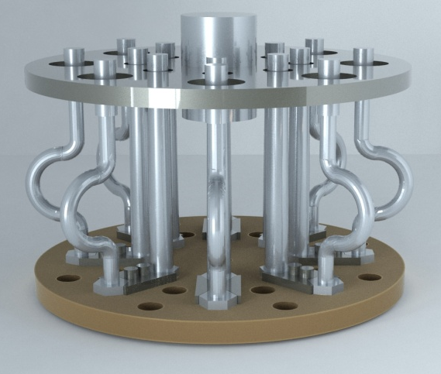 | 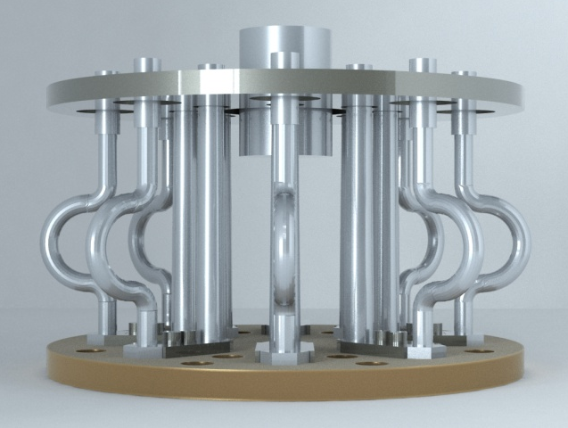
Figure 1. Prototype of the VF-MG-MD energy dissipation device with 8V & 8VF components (view-1) | Figure 2. Prototype of the VF-MG-MD energy dissipation device with 8V & 8VF components (view-2)

The proposed new, vertical-fixed (VF-MG-MD) energy dissipation device is structurally and technologically innovatively composed in a way that it successfully integrates several most important characteristics contained in: (1) providing of a large capacity for seismic energy absorption; (2) possessing the property of being totally inactive in the case of the most frequent slight earthquakes; (3) enabling initial activation of reduced number of ED components of type V-MG-MD-Tij, or ED components of level-1, in the case of moderate earthquakes; (4) enabling activation of all components for seismic energy dissipation (V-MG-MD-Tij+VF-MG-MD-Dk), or activation of all energy dissipation components representing level-2 (full capacity of energy dissipation) in the case of very strong earthquakes. The stated characteristics of the seismic energy dissipation device have been successfully achieved by adequate distribution of the vertical cantilever components for seismic energy dissipation that are fixed at their lower end, at the base, and free at the upper end. The structure of the seismic energy dissipater generally consists of: (1) a base metal plate for fixation of the vertical cantilever components; (2) adequately distributed vertical energy dissipation components (V-MG-MD-Tij+VF-MG-MD-Dk); and (3) upper metal plate with openings through which the energy dissipation components are activated in the above mentioned different phases. Characteristic phases include very frequent weak earthquakes, reduced number of moderately strong earthquakes and rare, but possible, very strong and destructive earthquakes. The prototype model of the proposed VF-MG-MD energy dissipation device, Figure 1 and 2, has been created, designed and constructed of several constituent parts forming a compact ED unit, including:
(1) Base plate: The base plate of the VF-MG-MD energy dissipation device is manufactured in the form of a base circular metal plate (d = 25 mm) with a diameter of D = 450 mm. On the base metal plate, in each of the two concentric circles, eight regularly spaced, equal openings with windings are made. The openings with windings are used to fix the vertical components by screwing. In the outer concentric circle with a diameter of d1 = 340 mm, eight openings with windings are made for the fixation of the external eight VF-type energy dissipation components. In the internal concentric circle with a diameter of d2 = 190 mm, other eight openings with windings are spaced for the fixation of the internal eight V-type energy dissipation components. The diameter of the opening with winding is considered standard and provides the possibility of making different combinations of installed types of vertical energy dissipation components.

Figure 3. Geometry of the model prototype of the ED component V-MG-MD-T11 tested with gap G1&G2 | Figure 4. Geometry of the model prototype of the ED component VF-MG-MD-D18 tested with gap G1&G2

(2) Vertical energy dissipation components of type-V: The vertical energy dissipation components of type-V are made of a ductile metal in the form of a moderately steep cut cone. According to the diameter of the cone base (Db), there have been adopted a total of four options from which there have arisen four prototype types of energy dissipation devices, Table 1. For each type of energy dissipation device, there have been designed vertical elements in two alternative variants of cones, i.e., with different diameters of the top (Dt), whereat the diameter of the element at the base has been kept the same.

Table 1. Prototypes of the tested V-MG-MD components under cyclic loads created for optional
assembling of the new VF-MG-MD energy dissipation devices

Prototype type | Prototype  Notation | Geometry form | Geometry of gaps | Activation direction | Base-Db  (mm) | Top-Dt  (mm)
1 | V-MG-MD-T11 | T11 | G1 & G2 | MD | 32.0 | 25.6
 | V-MG-MD-T12 | T12 | G1 & G2 | MD | 32.0 | 19.2
2 | V-MG-MD-T21 | T21 | G1 & G2 | MD | 28.0 | 22.4
 | V-MG-MD-T22 | T22 | G1 & G2 | MD | 28.0 | 16.0
3 | V-MG-MD-T31 | T31 | G1 & G2 | MD | 24.0 | 19.2
 | V-MG-MD-T32 | T32 | G1 & G2 | MD | 24.0 | 14.4
4 | V-MG-MD-T41 | T41 | G1 & G2 | MD | 20.0 | 16.0
 | V-MG-MD-T42 | T42 | G1 & G2 | MD | 20.0 | 12.0

In that way, four types of energy dissipation devices have been formed, each type with two variants of cones of vertical energy dissipation components. The different types of energy dissipation devices have accordingly been designated as follows: 1) Prototypes of the V-MG-MD energy dissipation device of Type – 1 existing in two component options: a) prototype model V-MG-MD-T11 with base and top diameters Db/Dt = 32.0/25.6 mm and b) prototype model V-MG-MD-T12 with base and top diameters Db/Dt = 32.0/19.2 mm; 2) Prototypes of the V-MG-MD energy dissipation device of Type – 2 existing in two component options: a) prototype model V-MG-MD-T21 with base and top diameters Db/Dt = 28.0/22.4 mm and b) prototype model V-MG-MD-T22 with base and top diameters Db/Dt = 28.0/16.0 mm; 3) Prototypes of the V-MG-MD energy dissipation device of Type – 3 existing in two component options: a) prototype model V-MG-MD-T31 with base and top diameters Db/Dt = 24.0/19.2 mm and b) prototype model V-MG-MD-T32 with base and top diameters Db/Dt = 24.0/14.4 mm; 4) Prototypes of the V-MG-MD energy dissipation device of Type – 4 existing in two component options: a) prototype model V-MG-MD-T41 with base and top diameters Db/Dt = 20.0/16.0 mm and b) prototype model V-MG-MD-T42 with base and top diameters Db/Dt = 20.0/12.0 mm. All vertical components have the same height of the cone body of h1 = 190 mm and end with an identical cylinder with a diameter d = 24.0 mm with a constant length of h2 = 60.0 mm. This enables recording of original experimental results with very well organized comparative parameters important for future design and practical application. With the described adapted geometry of the vertical components, there have been provided equivalent conditions for fixation to the base metal plate, while through the standard cylinder at the top of the vertical elements, there have been provided equivalent gap-G1 or gap-G2 conditions for the designed, gap-based excitation (repeated alternative contact and activation) of all components possibly activated in the first, the second or the third earthquake intensity phase.
(3) Vertical energy dissipation components of type-VF: The vertical energy dissipation components of type-VF have been made of the same ductile metal available on the market in the form of a bar or an ideal cylinder with defined diameter Dc, Figure 4. The vertical energy dissipation components of type-VF consist of two straight parts and one curved part between them. According to the diameter of the cylinder (Dc), there have been adopted a total of four options from which there have arisen four prototype types of energy dissipation devices, Table 2. Model prototype-1 or component VF-MG-MD-D22, model prototype-2 or component VF-MG-MD-D20, model prototype-3 or component VF-MG-MD-D18 and model prototype-4 or component VF-MG-MD-D16 are constructed with a diameter of Dc = 22 mm, Dc = 20 mm, Dc = 18 mm, Dc = 16 mm, respectively.

Table 2 Prototypes of the tested VF-MG-MD components under cyclic loads created for optional
assembling of the new VF-MG-MD energy dissipation devices

Prototype model | Prototype  notation | Geometry form | Geometry of gaps | Activation direction | Body-Dc  (mm)
1 | VF-MG-MD-D22 | D22 | - | MD | 22.0
2 | VF-MG-MD-D20 | D20 | - | MD | 20.0
3 | VF-MG-MD-D18 | D18 | - | MD | 18.0
4 | VF-MG-MD-D16 | D16 | - | MD | 16.0

Analogously, all vertical VF components have the same height of the cone body of h1 = 190 mm and end with an identical cylinder with a diameter d = 24.0 mm with a constant length of h2 = 60.0 mm. In this case, the end cylinder is used for fixation of the component to the upper metal plate. So, in the case of a possible cyclic negative reaction, the VF component will act by an adaptable hysteretic response. Such behavior and the provided component resistance to tension forces will result in protection of the structure against possible overturning. The study of the cyclic behavior of this specific VF component is a specific task providing original results with well-organized comparative parameters important for its future design and practical application. Considering the characteristics of the described and adapted geometry of the vertical VF components, there have been provided equivalent end conditions for their fixation to the base and the upper metal plates of the new VF-MG-MD energy dissipation device.
(4) Vertical deformed energy dissipation components of type-VD: The vertical energy dissipation components of type-VD are made with the same geometry as that of the VF components and using the same ductile metal available on the market in the form of a bar or an ideal cylinder with defined diameter Dc, Figure 4. The vertical energy dissipation components of type-VD consist of two straight parts and one curved part between them. According to the diameter of the cylinder (Dc), there have been adopted a total of four options from which there have also arisen four prototype types of energy dissipation devices, Table 3. Model prototype-1 or component VD-MG-MD-D22, model prototype-2 or component VD-MG-MD-D20, model prototype-3 or component VD-MG-MD-D18 and model prototype-4 or component VD-MG-MD-D16 are constructed with a diameter of Dc = 22 mm, Dc = 20 mm, Dc = 18 mm, Dc = 16 mm, respectively. Also, all vertical VD components have the same height of the cone of h1 = 190 mm and end with an identical cylinder with a diameter d = 24.0 mm with length of h2 = 60.0 mm. Such design enables recording of original experimental results with very well organized comparative parameters important for future design and practical application.

Table 3. Prototypes of the tested VD-MG-MD components under vertical cyclic loads created for optional
assembling of the new VF-MG-MD energy dissipation devices

Prototype model | Prototype  notation | Geometry form | Geometry of gaps | Activation direction | Body-Dc  (mm)
1 | VD-MG-MD-D22 | D22 | G1 & G2 | MD | 22.0
2 | VF-MG-MD-D20 | D20 | G1 & G2 | MD | 20.0
3 | VF-MG-MD-D18 | D18 | G1 & G2 | MD | 18.0
4 | VF-MG-MD-D16 | D16 | G1 & G2 | MD | 16.0

With the described adapted geometry of the vertical VD components, there have been provided equivalent conditions for their fixation to the base metal plate, while through the standard cylinder at the top of the vertical elements, there have been provided equivalent gap-G1 or gap-G2 conditions for the designed gap-based excitation (repeated alternative contact and activation) of all the components which are possibly activated in the first, the second or the third earthquake intensity phase. The hysteretic gap-based response of the VD-MG-MD components actually represents a direct contribution to the gap-based hysteretic response of the standard vertical components of type-V.
(5) Upper metal plate with holes: On the upper side of the seismic energy dissipation device, Figure 1, a metal plate with thickness d = 20.0 mm is also constructed with equivalent concentric circles over which openings of two different diameters are distributed. The inner concentric circle has 8 openings with a diameter of d1 = 34.0 mm in which the standard top cylinders of all vertical components, designed with a diameter of do = 24.0 mm, are centrically accommodated. With such geometry of openings, a gap of G1 = 5.0 mm is provided in all directions. The external concentric circle has 8 openings with a diameter of d1 = 60.0 mm on which the uniform cylinders on the top of the vertical components with a diameter of do = 24.0 mm are centrically accommodated. With this, a gap of G2 = 18.0 mm is provided in all directions. With such original structure of the seismic energy dissipater, activation of only the components of the inner circle is enabled in the first phase after initiated relative displacement larger than 5 mm (dr ≥ 5.0 mm), i.e., after exceeding of the designed width of the concentric gap in all directions. In the second phase, if the relative displacement exceeds 18.0 mm, activation of all energy dissipation components located on the external concentric circle takes place. The upper metal plate is parallel with the lower one and is fixed to the upper structure or, in this study, to the superstructure of the large-scale bridge model. Taking advantage of the created very favorable conditions for composing different types of VF-MG-MD energy dissipation devices, the present research included realization of extensive experimental test programme including completion of experimental tests on all the anticipated prototype models of V, VF and VD energy dissipation components.

3.2 Design and Production of Model Prototypes

(1) Selection of suitable properties of the implemented material: For the manufacturing of the experimental prototype models of the V-MG-MD, VF-MG-MD and VD-MG-MD energy dissipation components, there has been selected a corresponding metal S-1530 with pronounced ductility and ability not to experience failure under a large number of iterated cyclic loads with pronounced or large amplitudes of displacement. These properties of the selected material have fully been proved by the realized extensive experimental tests.
(2) First production of the model prototypes: For mechanical manufacturing of all prototype models of the V-MG-MD, VF-MG-MD and VD-MG-MD energy dissipation components, metal elements with hexagonal cross-section have been used. Such selection created conditions for elaboration of a hexagonal segment necessary for fixation of the element to the base by screwing. In addition, the selected profile has been used as suitable for manufacturing of all remaining segments of the corresponding V-type prototype models in accordance with their designed geometrical properties. As stated above, the highest segment with a length of
lt = 60 mm is constructed with the same geometry in all prototype models.

4. NONLINEAR 3D MICRO-MODELING of THE NEW components AND DEVICES

The numerical simulation of the cyclic nonlinear behavior of the created prototypes of V-type, VF-type and VD-type of energy dissipation components and prototypes of full VF-MG-MD energy dissipation devices represented a very complex modeling task as a consequence of the complex 3D geometrical shape, the introduced innovative gap-based response and the specific boundary and/or installation conditions. To achieve realistic analytical simulation of the nonlinear hysteretic response of the devices and the components and analysis of their nonlinear cyclic response, application of an advanced theoretical background was essential. For example, the conducted analysis of the hysteretic response of the complete VF-MG-MD-T11 device represented a solution of a complex nonlinear problem considering the specific procedure of a multiple loading case. The prescribed loading was numerically simulated by 30000 loading steps and, for each step, a number of equilibrium iterations were used to achieve the prescribed solution accuracy. The conducted study has been highly useful in providing an important general tool for solving specific problems, including: (1) validation of the capability of the implemented refined 3D nonlinear modeling concept in solving specific research and design tasks and (2) experimental validation of the proposed model for simulation of the complex hysteretic response of VF-ED devices and components under general cyclic loading up to deep nonlinearity. The integral research activities in this domain have been successfully realized in three consequent phases: (1) Formulation of a nonlinear refined 3D analytical model; (2) Analysis of the nonlinear hysteretic response of the modeled unit under simulated cyclic deformations, and (3) Comparative presentation of the original theoretical and experimental results.
а) Formulation of the refined nonlinear analytical models of prototype devices and components: Figures 5, 6, 9, 10 and 15 show examples of the formulated refined, three-dimensional, nonlinear finite element model (R3DNL-FE model) of the specific units and the complete device of the type VF-MG-MD-T11 used for its nonlinear analysis with the ABAQUS computer program. For the bottom support plate, ideally fixed boundary conditions have been simulated. For the upper plate, there has been prescribed a permanent horizontal position during simulated cyclic deformation in x-direction, representing a real input for the numerical simulation of the nonlinear cyclic behavior of the modeled device.
b) Analysis of nonlinear hysteretic response of prototype devices and components: To perform this type of a specific, quasi-static, time dependent analysis, the available option of incremental nonlinear static analysis providing simulation of incremental deformation in the specified direction has been implemented. For that purpose, the known predefined history of cyclic displacements, similar to that used during the realization of the corresponding experimental test, has been numerically specified and analytically applied. An appropriate history of deformation increments in the incremental analysis with adopted iterative nonlinear solution procedure, considering an additional step-based iteration process for the achievement of the specified accuracy, has been analytically considered based on known predefined history of cyclic deformations. All results from nonlinear analysis have been obtained in a refined numerical form for all relevant physical quantities (stresses, strains, forces, deformations and alike) thanks to the applied detailed micro-model.

4.1 Micro-Modeling of the Tested V-ED and VF-ED Components

The initial nonlinear numerical analysis has been carried out using the formulated micro-model of the created and tested prototype of the V-MG-MD-T11 single component installed in the inner circle, providing simulation of gap-G1. Cyclic displacement of up to ±45mm in X direction has been simulated through the upper plate, with a step of 5mm increase in each cycle. The mathematical model represented a cantilever (vertical component) fixed to a lower plate and top displacement was applied through the upper plate. Modeling and analysis of the hysteretic response and energy dissipation of the V-MG-MD-T11 component has been done by use of the ABAQUS CAE software, setting the real material characteristics, the element geometry, the contour conditions, the contact conditions, the imposed displacement conditions and other information and providing refined discretization of the component into finite elements, i.e., with a relatively fine mesh to obtain as exact results as possible. The calculations have been performed successfully, without shown any error during the steps-by-step analysis process. In the process of nonlinear micro-model
formulation of the V-ED and VF-ED components, Figure 5 and Figure 6, respectively, the following

Figure 5. Formulated micro-model of the created and tested prototype of the V-MG-MD-T11 component. | Figure 6. Formulated micro-model of the created and tested prototype of the VF-MG-MD-D18 component.

mechanical properties of the structural steel material have been used: (1) density W = 7850 kg/m³; (2) Young's modulus of elasticity E = 2 x 105N/mm²; (3) Poisson's coefficient n=0,3; (4) yielding point of material fy = 420 [N/mm²]; (5) failure limit of material fu = 670 [N/mm²]; (6) tangent modulus of plasticity G = 6000 MPa, and considering (7) the applied nonlinearity option and (7) the plastic hardening of the bilinear kinematic type. The same material characteristics hold also for the bottom and the upper plate, but for these, the failure limit strength has been set at fu = 480 [N/mm²]. The mesh has been generated by discretization of the constituent model components into small size finite elements of the following dimensions: (1) for the V-MG-MD-T11, FE sized 3 mm and was distributed in a radial shape; (2) for the upper plate, FE of a size of 10 mm has been used with a finer mesh at the contact with the VF-component; (3) for the bottom plate, FE sized 13 mm has been used. For the upper and the bottom plate, the applied finite element mesh has not been finer since these elements behave in the elastic range during loading. However, in order to get more accurate results, a fine mesh has been applied in the zone of contact of the component with the opened hole in the upper plate. The number of nodes and various types of finite elements of the model mesh has been quite big, resulting in solution of a large system of nonlinear equations involving a total of 83073 unknown variables.

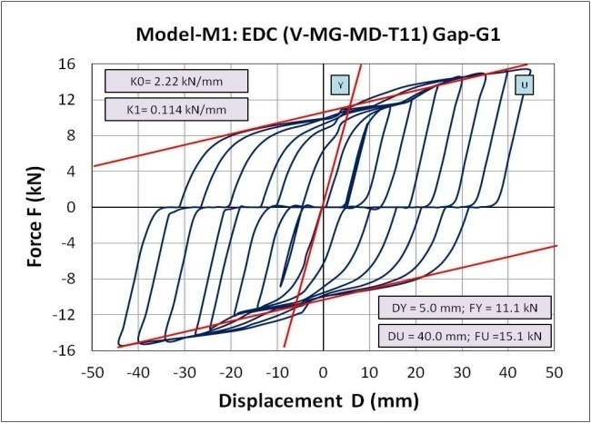 | 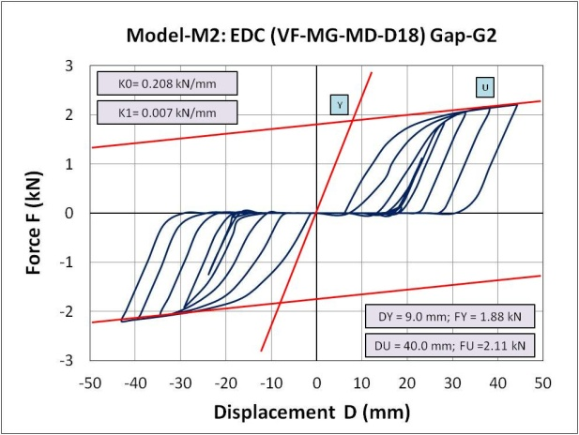
Figure 7. Hysteretic response of the V-MG-MD-T11 component under cyclic loads simulating gap-G1. | Figure 8. Hysteretic response of the VF-MG-MD-D18 component under cyclic loads simulating gap-G2.

The analytically predicted force at the ultimate point with the value of FUp = 15.1 kN, has actually been in a very good correlation with the experimentally defined respective force FUe = 15.0 kN. The difference has been very small, or being only about 1.0 %. Figure 6 shows the micro-model of the tested prototype of the VF-MG-MD-D18 component, formulated by application of a similar concept and modeling procedure, simulating a larger gap-G2. The number of nodes and various types of finite elements of the model mesh has also been large, resulting in a system of nonlinear equations involving, in this case, a total of 43017 unknown variables. Similarly, the analytically predicted force at the ultimate point with the value of FUp = 2.11 kN, has actually been in a very good correlation with the experimentally defined respective force FUe = 2.10 kN. The difference has also been very small, being less than 1.0 %. From the performed analysis, numerical and graphical results, the following main conclusions can be summarized: (1) With the obtained results of high accuracy confirmed are full advances of the applied micro-modeling concept; (2) The results have shown a very stable hysteretic response of the V-ED and VF-ED components; (3) The vertical components respond in the elastic-plastic range, without reaching the failure limit of fu=670 N/mm² during all displacement steps from 0 to total displacement of ±45mm; (4) From the hysteresis curves, it is evident that the components show a large energy dissipation capacity during cyclic response; (5) From the obtained hysteresis curves, it is also evident that the implemented micro-modeling concept possesses an excellent capability for simulation of gap-based response of different components under cyclic loads.

4.2 Micro-Modeling of the Full VF-MG-MD Device

Similarly, hysteretic responses of the full VF-MG-MD device, Figure 9, and the partial device, Figure 10, have been numerically analyzed by use of analogously formulated micro-models of the assembled prototypes. A fine mesh in the zone of contact of the components with the opened holes in the upper plate, has been applied.

Figure 9. Formulated micro-model of the assembled full VF-MG-MD device prototype-1. | Figure 10. Formulated micro-model of the partial set-up of the VF-MG-MD device integrating two components.

 | 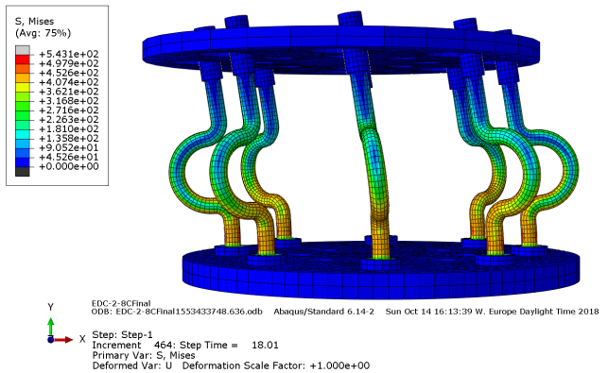
Figure 11. Stress distribution during cyclic response of the full VF-MG-MD device prototype. | Figure 12. Stress distribution during cyclic response of the VF-MG-MD device with 8 VF components.

In the case of modeling of the full VF-MG-MD device, the number of nodes of finite elements mesh has been quite large, resulting in solution of large system of nonlinear equations involving in total 113871 unknown variables. Figure 11 shows the stress distribution recorded during the cyclic response of the full VF-MG-MD device prototype, while Figure 13 displays the computed, gap-based hysteretic response under cyclic loads of the full VF-MG-MD device prototype. The analytically predicted force at the ultimate point FUp = 136.2 kN has been in a very good correlation with the experimentally defined respective force. As a characteristic example, the hysteretic response of the assembled VF-MG-MD device with 8 VF components has also been computed. The typical stress distribution recorded during the cyclic response of the partial VF-MG-MD device with 8 VF components is shown in Figure 12. The computed gap-G2-based hysteretic response of the 8VF-MG-MD device (outer components only) under cyclic loads is shown in Figure 14. The analytically predicted force at the ultimate point with the value of FUp = 17.0 kN has actually been in a very good correlation with the experimentally defined respective force FUe = 8 x 2.10 = 16.8 kN. The difference has been quite small, being only about 1.2 %.

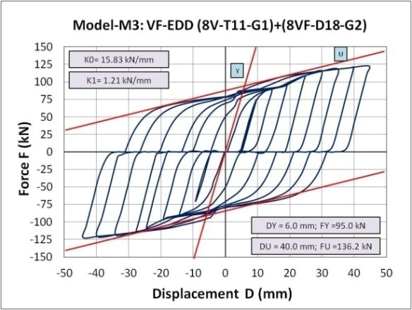 | 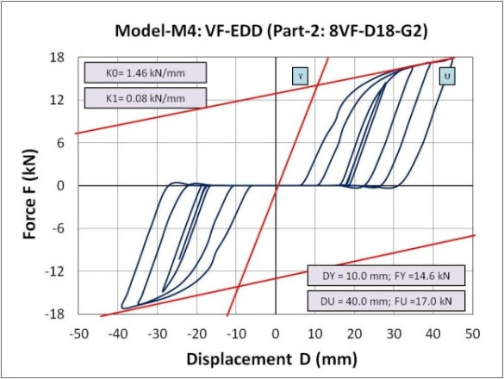
Figure 13. Computed, gap-based hysteretic response of the full VF-MG-MD device prototype under cyclic loads. | Figure 14. Computed, gap-G2-based hysteretic response of the 8VF-MG-MD device (part-2) under cyclic loads.

4.3 Micro-Modeling of the Full VF-MG-MD Device under Cyclic Vertical Load

Finally, from the realized 8 experimental tests, original experimental results have also been obtained in a digital form. In the course of the experiments, in addition to data acquisition through certain control channels, there have also been recorded successfully the measured values of the vertical cyclic deformation at the top D(mm) as well as the corresponding values of the applied vertical cyclic force F(kN).

 | 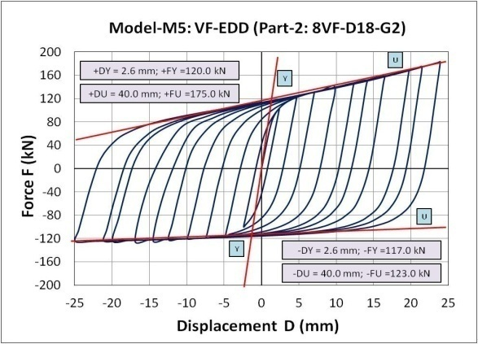
Figure 15. Micro-model of the 8VF-MG-MD-D18 energy dissipation device (8 installed components). | Figure 16. Hysteretic response of the 8VF-MG-MD-D18 device under simulated vertical cyclic loads.

In this specific case, using the formulated micro-model of the 8VF-MG-MD-D18 energy dissipation device (composed of 8 installed components), Figure 15, its hysteretic response under simulated vertical cyclic loads has been analyzed. Highly favorable and unique asymmetric hysteretic curves have been obtained, Figure 16. The obtained analysis results represent highly valuable background evidence and a full verification of the developed and implemented nonlinear micro-analytical simulation model. However, refined modeling and analysis of 8VF-MG-MD-D18 device under vertical cyclic loads also resulted in numerical solution of very large system of nonlinear equations.

5. Conclusions

Based on the results obtained from the conducted extensive analytical study, the following main observations can be summarized: (1) With the conducted specific experimental cyclic tests of the created prototypes of V-type, VF-type and VD-type of energy dissipation components and prototypes of the full VF-MG-MD energy dissipation devices, a valuable experimental evidence has been obtained for validation of the formulated analytical models, simulating the originally introduced gap-based hysteretic response; (2) With the conducted detailed analytical modeling study, it has been confirmed that the refined or micro nonlinear 3D analytical model represents the most powerful, generally applicable and advanced modeling option for simulation of the general, gap-based hysteretic response of new devices with very high accuracy; (3) The implemented micro-modeling approach also represents the most advanced modeling concept capable of realistic simulation of the complex multi-gap and multi-directional nonlinear hysteretic response of the originally introduced VF-MG-ED devices; (4) The presently implemented modeling approach represents an advanced modeling option, providing advanced conditions for its further upgrading toward coping with the analytical simulation of the new complex aspect connected with the specific assembling, construction and structural details; (5) Finally, the application of the experimentally verified concept for refined nonlinear analysis of geometrically complex components and devices up to deep nonlinearity opens a new opportunity for introducing the advanced USI-VF systems in qualitatively improved seismic protection of bridge structures based on optimal modification of the system seismic response.

6. Acknowledgments

Extensive experimental and analytical research has been performed at IZIIS, “Ss. Cyril & Methodius” University, Skopje, in the framework of the three-year innovative NATO Science For Peace and Security Project: Seismic Upgrading of Bridges in South-East Europe by Innovative Technologies (SFP: 983828), with participation of five countries: Macedonia: D. Ristic, Project Leader & PPD-Director; Germany: U. Dorka, NPD-Director; Albania: A. Lako; Bosnia & Herzegovina: D. Zenunovic & Serbia: R. Folic. The creating of the RESIN Laboratory, Skopje, as a new open testing laboratory of the Regional Seismic Innovation Network involving young scientists, was a specific long-term task. The NATO SfP support to this long-term and costly research project is greatly appreciated.

7. References

ANSYS Mechanical APDL Element Reference, Release 15.0, November 2013.
Candeias P, Costa AC, Coelho E (2004) Shaking Table Tests of 1:3 Reduced Scale Models of Four Story Unreinforced Masonry Buildings. In 13th World Conf. on Earthquake Engineering. Vancouver, BC, pp. 2199.
Constantinou MC, Kartoum A, Reinhorn AM and Bradford P (1992) Sliding Isolation System for Bridges: Experimental Study. Earthquake Spectra Vol. 8(3): 321-344.
Dolce M, Cardone D, Palermo G (2007) Seismic Isolation of Bridges Using Isolation Systems Based on Flat Sliding Bearings. Bull. Earthquake Engineering . 5(4): 491-509.
Dolce MZ, Filardi B, Marnetto R, Nigro D (1996) Experimental Tests and Applications of an Advanced Biaxial Elastoplastic Device for the Passive Control of Structures. In the Proceedings of the 4th World Congress on Joint Sealants and Bearing Systems for Concrete Structures, Sacramento. Sacramento, California.
Ene D, Yamada S, Jiao Y, Kishiki S, Konishi Y (2017) Reliability of U-shaped Steel Dampers Used in Base-Isolated Structures Subjected to Biaxial Excitation. Earthquake Engineering & Structural Dynamics, 46(4): 621–639.
Guan Z, Li J, Xu Y (2010) Performance Test of Energy Dissipation Bearing and its Application in Seismic Control of a Long-Span Bridge. Journal of Bridge Engineering, 15(6): 622-630.
Iemura H, Taghikhany T, Jain SK (2007) Optimum Design of Resilient Sliding Isolation System for Seismic Protection of Equipments. Bulletin of Earthquake Engineering 5(1):85–103.
Jankowski R, Wilde K and Fujino Y (1998) Pounding of Superstructure Segments in Isolated Elevated Bridge During Earthquakes. Earthquake Engineering & Structural Dynamics, 27(5): 487-502.
Kartoum A, Constantinou M and Reinhorn A (1992) Sliding Isolation System for Bridges: Analytical study, Earthquake Spectra 8(3): 345-372.
Kelly JM (1986) A Seismic Base Isolation: Review and Bibliography, Soil Dynamics and Earthquake Engineering 5(4): 202-216.
Kunde M and Jangid RS (2003) Seismic Behavior of Isolated Bridges: A-State-of-the-Art Review. EJSE, Electronic Journal of Structural Engineering 3(2):140-169.
Mayes RL, Buckle IG, Kelly TE and Jones LR (1992) AASHTO Seismic Isolation Design Requirements for Highway Bridges, Journal of Structural Engineering, ASCE, 118(1): 284-304.
Mokha A, Constantinou M and Reinhorn A (1990) Teflon Bearings in Seismic Base Isolation I: Testing. Journal of Structural Engineering, ASCE, 116(2): 438-454.
Oh SH, Song SH, Lee SH et al. (2012) Seismic Response of Base Isolating Systems with U-shaped Hysteretic Dampers. International Journal of Steel Structures, 12(2):285–298.
Ristic D (1988) Nonlinear Behavior and Stress-Strain Based Modeling of Reinforced Concrete Structures under Earthquake Induced Bending and Varying Axial Loads, PHd Dissertation, School of Civil Engineering, Kyoto University, Kyoto, Japan.
Ristic D, Ristik J (2012) New Integrated 2G3 Response Modification Method for Seismic Upgrading of New and Existing Bridges, In the Proceedings of the 15th World Conference on Earthquake Engineering, (WCEE), Lisbon, Portugal.
Ristic J, Misini M, Ristic D, Guri Z, Pllana N (2017) Seismic Upgrading of Isolated Bridges with SF-ED Devices: Shaking Table Tests of Large-Scale Model, Građevinar, 70 (6): 463-485. doi: https://doi.org/10.14256/JCE.2147.
Ristik J (2011) Comparative Seismic Analysis of RC Bridge Structure Applying Macedonian Seismic Design Regulations and Eurocodes. MSc Thesis, Department of Theory of Structures, “Ss. Cyril and Methodius” University, Skopje, Macedonia.
Ristik J (2016) Modern Technology for Seismic Protection of Bridge Structures Applying New System for Modification of Earthquake Response. PhD Thesis, Institute of Earthquake Engineering and Engineering Seismology (IZIIS), “Ss. Cyril and Methodius” University, Skopje, Macedonia.
Ristic D, Dorka U, Lako A, Zenunovic D, Folic R (2013) Seismic Upgrading of Bridges in South-East Europe by Innovative Technologies, NATO SfP Project 983828, Science for Peace and Security Programme, Final Report.
Robinson WH (1982) Lead-Rubber Hysteretic Bearings Suitable for Protecting Structures During Earthquakes, Earthquake Engineering and Structural Dynamics 10(4): 593-604.
Serino G, Occhiuzzi A (2003) A Semi-active Oleodynamic Damper for Earthquake Control. Part 1: Design, Manufacturing and Experimental Analysis of the Device. Bulletin of Earthquake Engineering 1(2): 275-302.
Skinner RI, Kelly JM and Heine AJ (1974) Hysteretic Dampers for Earthquake Resistant Structures, Earthquake Engineering and Structural Dynamics 3(3): 287-296.
Tsopelas P, Constantinou MC, Kim YS and Okamoto S (1996) Experimental Study of FPS System in Bridge Seismic Isolation. Earthquake Engineering and Structural Dynamics 25 (1): 65-78.
Tubaldi E, Mitoulis SA, Ahmadi H, Muhr A (2016) A Parametric Study on the Axial Behaviour of Elastomeric Isolators in Multi-span Bridges Subjected to Horizontal Seismic Excitations. Bulletin of Earthquake Engineering 14(4):1285–1310.
Turkington DH, Carr AJ, Cooke N and Moss PJ (1989) Seismic Design of Bridges on Lead-Rubber Bearings. Journal of Structural Engineering, ASCE, 115(12): 3000-3016.
Unjoh S and Ohsumi M (1998) Earthquake Response Characteristics of Super-Multispan Continuous Menshin (Seismic Isolation) Bridges and the Seismic Design. ISET Journal of Earthquake Engineering Technology 35: 95-104.
Wang, YP, Chung L and Wei HL (1998) Seismic Response Analysis of Bridges Isolated with Friction Pendulum Bearings. Earthquake Engineering and Structural Dynamics. 27(10): 1069-1093.
Wilson EL, Habibullah A. SAP2000, Structural and Earthquake Engineering Software. Computers and Structures Inc., Berkeley, CA.
Wilson L Edward (2002) Three-Dimensional Static and Dynamic Analysis of Structures: A Physical Approach with Emphasis on Earthquake Engineering, Berkeley, California: Third Ed.
Zayas, VA, Low SS and Mahin SA (1990) A Simple Pendulum Technique for Achieving Seismic Isolation. Earthquake Spectra. 6(2): 317-333.

PhD student, Ss. Cyril and Methodius University, Institute of Earthquake Engineering and Engineering Seismology (IZIIS), Skopje, Republic of North Macedonia, ragip_behrami@hotmail.com
Ass. Prof. Dr., Faculty of Engineering, Department of Civil Engineering, International Balkan University (IBU), Skopje, Republic of North Macedonia, jelena.ristic.ibu@gmail.com
Prof. Dr., Ss. Cyril and Methodius University, Institute of Earthquake Engineering and Engineering Seismology (IZIIS), Skopje, Republic of North Macedonia, danilo.ristic@gmail.com
Prof. Dr., Ss. Cyril and Methodius University, Institute of Earthquake Engineering and Engineering Seismology (IZIIS), Skopje, Republic of North Macedonia, viktor@iziis.ukim.edu.mk

